Шаблон отчёта по лабораторной работе №1
  - Practical scientific writing
  - надиа эззакат
Содержание
Цель работы 1
Теоретическое введение 1
Installing TeXlive 1
Manual installation 2
Updating to the next version of TeXlive 2
1 LaTeX basics 3
Выполнение лабораторной работы 3
Перед установка teXlive 3
После установки teXlive 4
Проверка установление teXlive 5
Выводы 6
Список литературы 6

Цель работы
Целью данной лабораторной работы является установка TexLive

Теоретическое введение

Installing TeXlive
TeX Live — the most complete LaTeX distribution supported by the TeX community. • Supports a large number of operating systems. • Developed since 1996. • Based on the teTeX distribution. • MacTeX — a variant for MacOS. • Main page: https://www.tug.org/texlive/.• • TeX Live — is a distribution with continuous updates as part of the annual version of the distribution.
Installation from distribution packages [@lections]
• Ubuntu: apt install texlive-full
• Windows. Use the Chocolatey package manager. choco install texlive

Manual installation
• Links on the site are to mirrors. The mirror is selected automatically. • Download the installer: • Unix: https://mirror.ctan.org/systems/texlive/tlnet/install-tl-unx.tar.gz cd /tmp/ wget
https://mirror.ctan.org/systems/texlive/tlnet/install-tl-unx.tar.gz • Windows: https://mirror.ctan.org/systems/texlive/tlnet/install-tl-windows.exe • For Windows: run the executable file and install. • For Linux • Unpack the downloaded file: tar xzvf install-tl-unx.tar.gz • Go to the unpacked directory and run the installer: cd install-tl-[0-9]* sudo ./install-tl • It is recommended to create links to executable files in the /usr/local/bin directory. To do this, in the console version of the utility, select the O option, and then L. To return to the previous menu, use R.

Updating to the next version of TeXlive
It is recommended to install the new version of TeX Live separately.
• But you can do a manual update using an existing installation. • Let’s assume that our architecture is x86_64-linux. • If you have installed symbolic links to system directories (via installer option or tlmgr path add), remove them:
1.1 Installing TeX Live
tlmgr path remove
• Move the entire TeX Live directory to match the new version, for example:
mv /usr/local/texlive/2024/ /usr/local/texlive/2025
• Remove package backups:
rm /usr/local/texlive/2025/tlpkg/backups/*
• Create links to executables:
/usr/local/texlive/2025/bin/x86_64-linux/tlmgr path add
• Download the latest version of the script update-tlmgr-latest.sh:
wget https://mirror.ctan.org/systems/texlive/tlnet/update-tlmgr-latest.sh \
-O /tmp/update-tlmgr-latest.sh
• Run the script:
sh /tmp/update-tlmgr-latest.sh --upgrade
• If you do not want to use the default repository for downloading new files, then replace it:
tlmgr option repository <reponame>
• Update the TeX Live package manager:
tlmgr update --self
• Update TeX Live packages:
tlmgr update --all
• Set symbolic links to executables in system directories (/usr/local/bin):
tlmgr path add

1 LaTeX basics
• You can recreate the cache lualatex under the user:
mv ~/.texlive2024 ~/.texlive2025
luaotfload-tool -fu
• If you don’t do this, the cache will be recreated on the first run of lualatex.

Выполнение лабораторной работы

Перед установка teXlive
(см. Рис. [-@fig:001]).
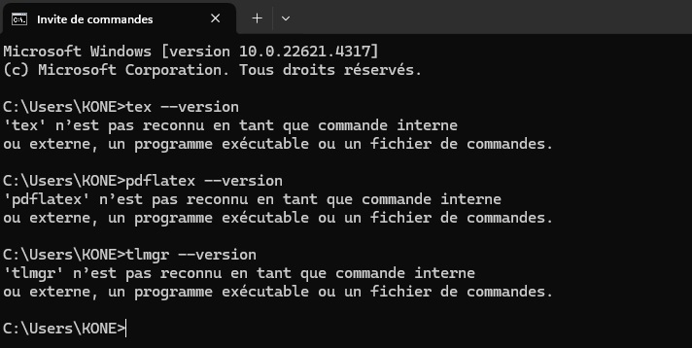

После установки teXlive
(см. Рис. [-@fig:002]).
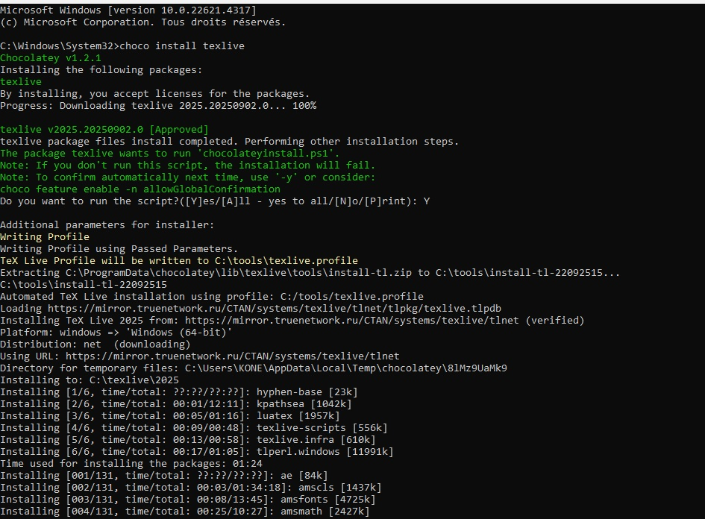
(см. Рис. [-@fig:003]).
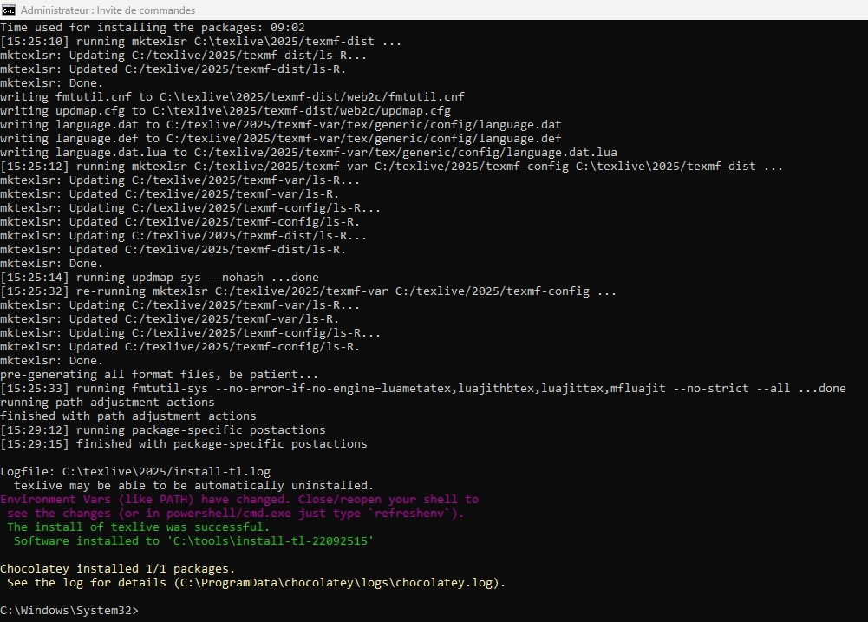

Проверка установление teXlive
(см. Рис. [-@fig:004]).
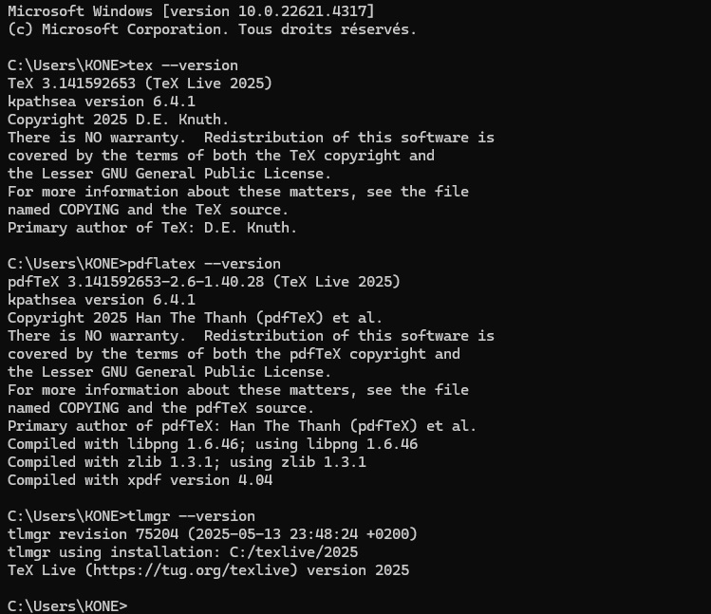

Выводы
Таким образом, была достигнута цель установил TeXlive.

Список литературы

