report.md 2025-11-08

Laboratory Work №5 — Tables

Course

Practical Scientific Writing

Author

Nadia El Fe

Academic Year

2025–2026

- Purpose of the Work

The purpose of this laboratory assignment is to learn and practice creating tables in LaTeX.

The experiment includes using different column alignments, understanding row item mismatches, and
\multicolumn
applying the command to span multiple columns.

- Tasks

. Create a simple table with three columns.
l c r
. Experiment with the , , and alignment options.

. Observe what happens when a row has too few or too many items.
\multicolumn
. Apply the command to merge several columns.

- Tools and Environment

Operating System: macOS

Editor: VS Code / Nano
pdflatex
Compiler: (MacTeX 2025 distribution)

Version Control: Git + GitHub

Conversion Tool: Pandoc

- Procedure

4.1 Simple Table Example

{l l l}
A three-column table was created with the column specification .

Result: all cells are left-aligned as expected.

1 / 4

report.md 2025-11-08
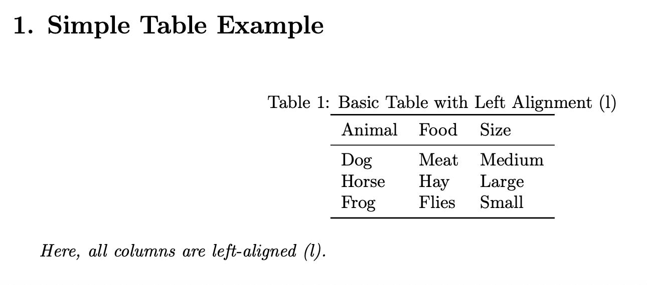

4.2 Testing Different Alignments

{c c c} {r r r}
Two additional tables were built with and specifications.

Result:

c
The alignment centered each cellʼs content.
r
The alignment right-justified all entries.
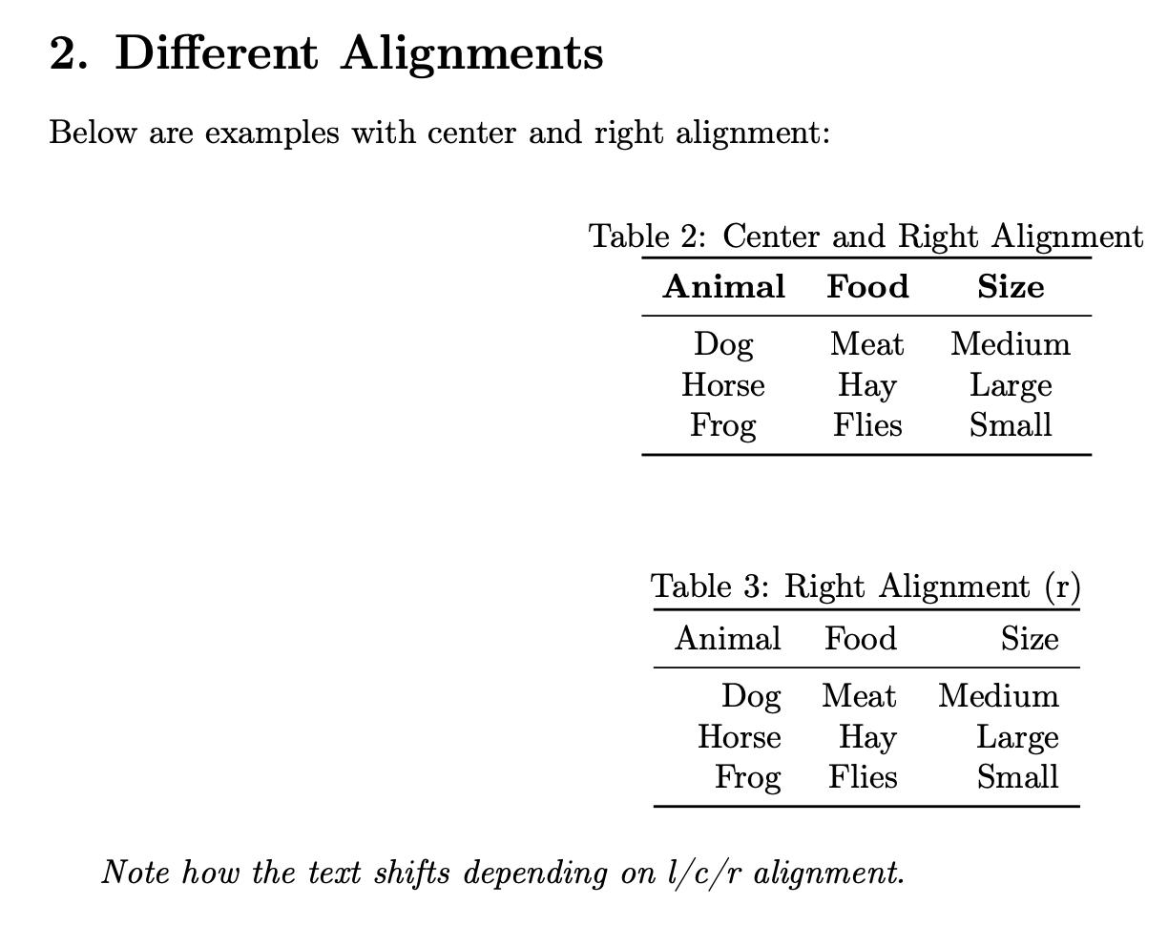

2 / 4

report.md 2025-11-08

4.3 Too Few or Too Many Items

Rows with fewer or extra cells were tested.

Result:

Too few items: missing cells are left empty.

Too many items: LaTeX displayed a warning

(“Extra alignment tab has been changed to \cr”).
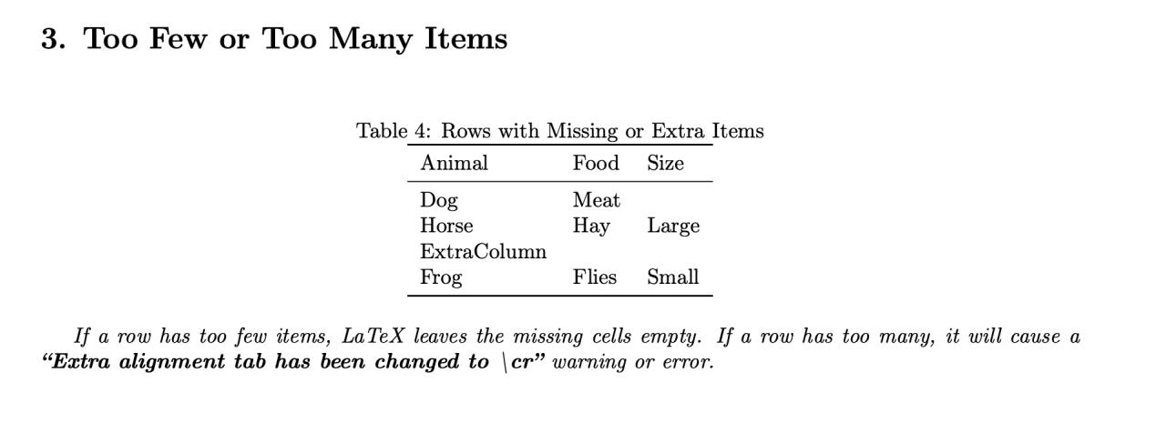

\multicolumn
4.4 Using

\multicolumn{3}{c}{Animals and Food}
The command successfully merged three columns into one

centered heading.
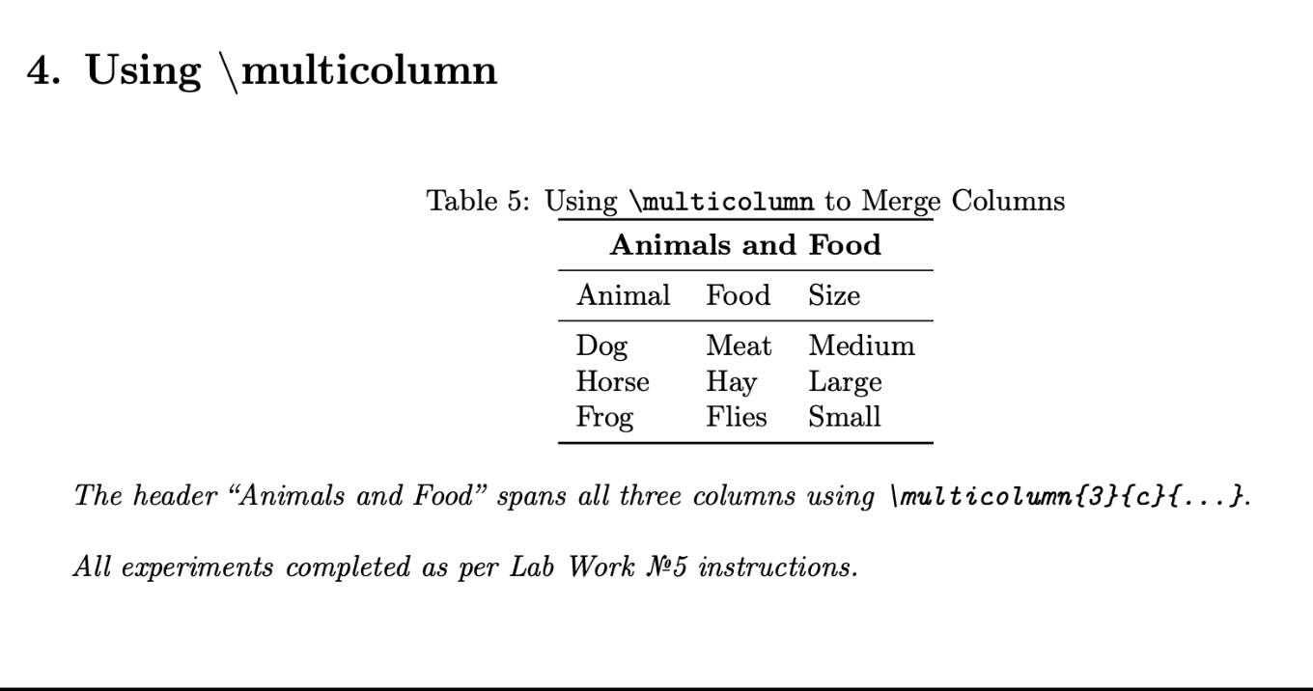

- Results

All required experiments were performed successfully.

Tables compiled without critical errors, and the output verified expected alignment and merging behavior.

3 / 4

report.md 2025-11-08

Experiment Description Result

 | l c r
Alignment | Tested , ,columns | Works correctly
Missing / Extra itemsChecked behavior with uneven cells |  | As expected
\multicolumn | Spanned cells across columns | Works correctly

- Conclusion

The laboratory work confirmed the ability to design professional tables in LaTeX and understand alignment rules, spacing, and column-merging features.

This knowledge forms the foundation for producing clean, publication-ready scientific documents.

- References

- Practical Scientific Writing – Section 5: Tables

  - LaTeX Documentation: https://www.latex-project.org/help/documentation/

- Repository Information

Full Repository: https://github.com/nadiaelfe/lab05

Release (to be added after upload): TBD

- 2025 Nadia Ezzakate — Practical Scientific Writing, Moscow

4 / 4

