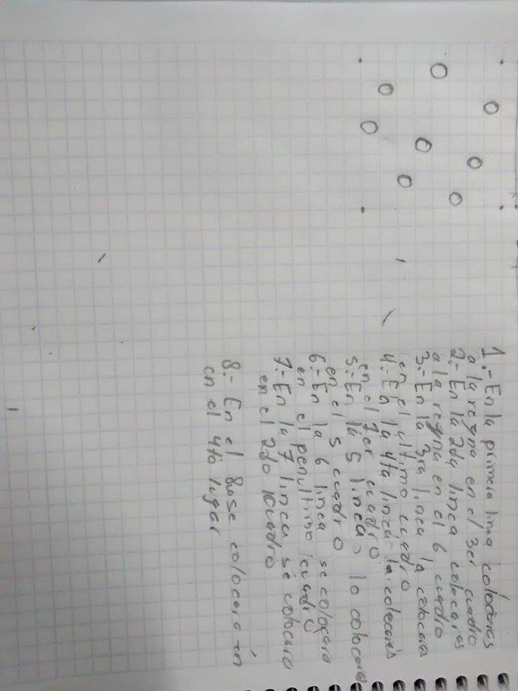Jorge Loya Herrera_ie703043