PHAROS UNIVERSITY IN ALEXANDRIA

FACULTY OF ENGINEERING COMPUTER ENGINEERING DEPARTMENT

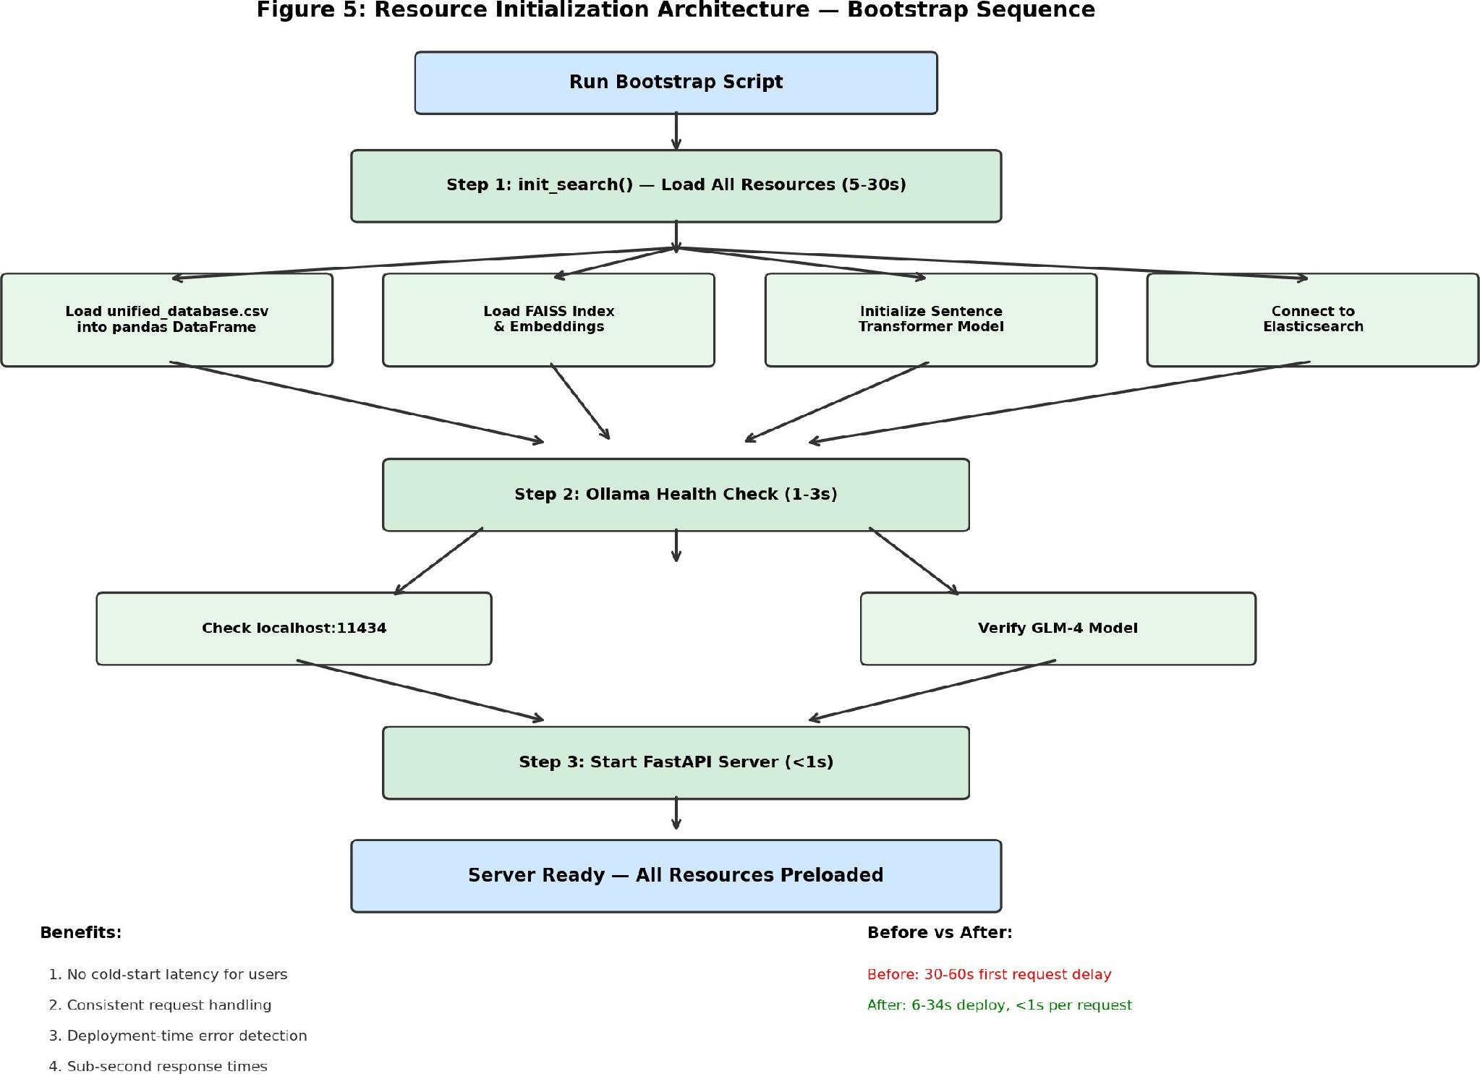

APMS: AN INTEGRATED AUTOMATED PHARMACY MANAGEMENT SYSTEM WITH INTELLECTUAL PRESCRIPTION OCR, ROBOTIC DISPENSING, AND AI-DRIVEN INVENTORY ANALYTICS

B.Sc. Graduation Thesis

Submitted by:
Ahmed Sherif HAMDY Youssef AHMED Mohamed BAKR Nadia HOSNY
Ghada SEDIK
Demiana SAID

Supervised by:
Dr. Sahar Ghanem
June 2026

Abstract
Pharmaceutical dispensing and inventory management represent critical bottlenecks in modern healthcare systems, particularly in community pharmacies where handwritten prescriptions, manual stock reconciliation, and high workloads can lead to medical errors and financial inefficiencies. This thesis presents the Automated Pharmacy Management System (APMS), an end-to-end integrated hardware-software solution that digitizes and automates community pharmacy operations from pre-scription entry to mechanical dispensing and inventory optimization.
APMS comprises four core integrated subsystems:
- Prescription OCR Core Pipeline: A vision-language model based on GLM-OCR that ex-tracts handwritten drug names from prescription images. Spelling mistakes and handwritten irregularities are resolved using a novel five-stage sequential fallback search engine that queries local and crawl-based external drug databases (FDA, Vezeeta) with early-exit criteria and a five-layer safety filter.
- AI-Driven Adaptive Robotic Dispensing Hand: An anthropomorphic 3D-printed InMoov robotic hand driven by an ESP32 microcontroller and five servo motors. It utilizes a contin-uous neural network trained on human demonstrations to interpolate target object distances (measured via an HC-SR04 ultrasonic palm sensor) into joint angle trajectories, executing distance-adaptive grasps under MediaPipe vision guidance.
- PharmaSys Dashboard & Roshetety Patient Mobile App: A full-stack software suite built with Flutter (frontend), Node.js, Express, and PostgreSQL (backend), employing WebSockets for real-time bidirectional synchronization between mobile patient orders, pharmacist approval interfaces, and local serial-port robotic dispensing triggers.
- AI-Driven Inventory Analytics Engine: A suite of models trained on 60 months of historical pharmacy transaction data. It applies a segmented forecasting strategy (LightGBM for fast-moving items, Croston’s method for slow-moving items, and historical averages for intermittent items), computes dynamic expiry-priority scores for discount clearance, runs an ECOD-LOF shift anomaly ensemble to flag cash reconciliation errors, and trains a Soft Actor-Critic (SAC) reinforcement learning agent to optimize monthly replenishment reorder decisions, reducing costs by 60% over classical policies.
Empirical evaluations demonstrate that the robotic arm achieves an 85.7% grasp success rate and 94.5% OCR recognition accuracy under optimal lighting. The sequential fallback search engine re-duces API queries by 72% compared to parallel voting. Segmented forecasting improves demand signal capturing by 8.45% R² over global models, while the SAC agent converges to an optimal policy in simulation. This work demonstrates the feasibility of combining low-cost open-source hardware, state-of-the-art vision-language models, and deep reinforcement learning to build a secure, on-premise, and affordable community pharmacy automation system.
CONTENTS
LIST OF FIGURES
LIST OF TABLES
- INTRODUCTION

Background
The pharmacy industry is currently undergoing a significant digital transformation. Traditional community pharmacies face numerous operational challenges, including manual inventory tracking, paper-based prescription handling, inefficient stock management (leading to either overstocking or stockouts), and a distinct lack of real-time data-driven decision-making. In Egypt and the broader Middle East region, the vast majority of community pharmacies still operate with paper prescriptions, manual ledger-based inventory systems, and limited technological integration.
Simultaneously, patient expectations are rapidly evolving. The modern patient seeks unpar-alleled levels of convenience—specifically, the ability to submit prescriptions digitally, track order status in real time, and communicate securely with pharmacy staff without necessarily visiting the physical location.
While automation and robotic dispensing have become more accessible, they have his-torically been confined to large, high-budget hospital environments. The lack of integrated software that connects the digital prescription pipeline from the patient directly to physical on-premise robotic dispensing hardware remains a significant hurdle for community pharmacies. Furthermore, medical errors in pharmaceutical dispensing present a severe threat to patient safety. A primary source of these errors is the misinterpretation of handwritten medical prescriptions. Doctors’ handwriting is notoriously difficult to read, and many drug names are visually or phonetically similar (Look-Alike/Sound-Alike or LASA drugs). When pharmacists misread a prescription, they may dispense the wrong medication, wrong dosage, or wrong frequency, with potentially fatal consequences. Automating the extraction and validation of drug names from handwritten prescriptions via Optical Character Recognition (OCR)
combined with intelligent search databases represents a crucial safety layer.
Finally, pharmacy operations are financially constrained. Stock management is often done heuristically, resulting in expired medicines (financial write-offs), stockouts of high-demand items (lost revenue and patient trust), and capital tied up in slow-moving inventory. Optimizing inventory replenishment through modern machine learning and decision-support algorithms is critical to making healthcare operations sustainable.

Problem Statement and Current Situation Evaluation
Community pharmacies face several interconnected operational failures that highlight the inefficiencies of manual systems:
- Manual Prescription Handling: Paper prescriptions are highly prone to physical damage, loss, misinterpretation, and administrative inefficiency. Pharmacists must manually read handwritten scripts under time pressure, leading to critical errors. Traditional OCR systems fail on cursive, continuous handwriting, and standard search algorithms fail to match misspelled OCR outputs against formal drug registries.
- Underutilized Automation and Dispensing Latency: In cases where pharmacies possess mechanical dispensing aids, the software layer connecting patient orders to robotic hardware is fragmented or non-existent. Pharmacists must manually enter commands to trigger dispensing, creating a bottleneck.
- Inventory Inefficiency: Stock reordering is performed heuristically or based on basic min-max limits. This static approach cannot adapt to seasonal demand spikes, leading to overstocking of slow items or stockouts of life-saving medications.
- Financial Anomaly and Theft Exposure: Daily shift cash reconciliation is performed manually. Due to the high volume of micro-transactions, internal theft, manual input errors, and cash reconciliation anomalies are difficult for management to detect without automated statistical audits.
- Patient Communication Gap: Patients have zero visibility into their prescription preparation status once submitted. They are forced to wait in long physical queues, reducing overall patient satisfaction.

User Personas and Stakeholder Requirements
To ground the system design in real-world constraints, we define three primary user personas representing different stakeholders:
- Dr. Ahmed (Community Pharmacist): Dr. Ahmed works in a high-traffic commu-nity pharmacy. He faces continuous cognitive load, handling dozens of prescriptions hourly while answering patient inquiries. He requires a system that transcribes hand-written prescriptions automatically with high precision, presents the results in a clear interface, highlights safety warnings, and allows him to trigger robotic dispensing with a single click after verification.
- Marian (Chronic Patient): Marian is a patient who regularly purchases maintenance medication. She values her time and experiences frustration when waiting in long pharmacy queues only to find her required medication is out of stock. She requires a mobile application where she can upload prescription images, view pricing, choose generic alternatives, track order progress, and receive notifications when the order is ready for pickup or delivery.
- Khaled (Pharmacy Business Owner / Inventory Manager): Khaled manages the pharmacy’s financials and supply chain. He is concerned about capital locked in dead stock, profit losses due to expired drugs, and inventory stockouts. He requires an intelligent dashboard that forecasts product-level demand, ranks expiry risk dy-namically to target clearances, audits cashier shift records for fraud, and automates reordering through optimized inventory policies.

Proposed Solution: The Integrated APMS Framework
To address these challenges, we propose the Automated Pharmacy Management System (APMS), an end-to-end framework that bridges digital patient-facing services, intelligent prescription translation, backend pharmacy operations, and on-premise robotic dispensing. The system architecture coordinates the following components:
- Roshetety Mobile Application: A mobile interface for patients to capture and upload handwritten prescriptions, submit orders, and track preparation status in real time.
- PharmaSys Staff Dashboard: An enterprise dashboard for pharmacists to verify OCR results, track inventory levels, monitor robotic hand status, review financial anomaly reports, and approve automated replenishment orders.
- Prescription OCR & Intelligent Search Engine: A local processing pipeline run-ning a vision-language model (GLM-OCR via Ollama) and a five-stage sequential fallback search engine that resolves spelling errors by querying local tables, fuzzy databases, and external web-crawled resources.
- Adaptive Grasping Robotic Hand: A 3D-printed, 5-servo mechanical hand that ex-ecutes distance-adaptive grasping based on neural-network interpolation of ultrasonic distance measurements, automatically dispensing physical packaging.
- AI-Driven Analytics Engine: A background intelligence layer that performs seg-mented time-series demand forecasting, expiry risk scoring, shift reconciliation anomaly detection, and reinforcement learning-based reordering.

Research Aims and Objectives
The specific objectives of this project are:
- To design and print a low-cost, anthropomorphic robotic hand (InMoov design) with 16 degrees of freedom (DoF) and 5 active servo actuators.
- To implement a real-time computer vision teleoperation system using MediaPipe hand landmark tracking for demonstration recording.
- To train a multi-layer perceptron neural network capable of mapping a scalar object distance to a complete continuous servo trajectory for adaptive grasping.
- To develop a local OCR pipeline using GLM-OCR and design a sequential search fallback engine to match spelling errors against Egyptian and global drug databases.
- To construct a robust Node.js backend using TypeScript, PostgreSQL, and WebSockets to synchronize order status and serial robotic control.
- To build a responsive staff dashboard and patient app in Flutter.
- To deploy and evaluate time-series forecasting (LightGBM, Croston’s) and reinforce-ment learning (Soft Actor-Critic) on a real 60-month dataset.
These project objectives and their corresponding success metrics are summarized in Table ??.
TABLE 1: System Objectives and Success Criteria

Objective | Target Metric | Validation Method
OCR Accuracy | ≥ 85.0% | Correctly transcribe handwritten drug names from prescriptions
Search Precision | Near-zero false positives | 0% false matches on known non-drug words (e.g. toothpaste)
Hardware Dexterity | ≥ 80.0% grasp rate | Successful grasping and retention of medicine boxes (4.0–9.5 cm)
Query Latency | Sub-second query | Search resolution under 1 second; VLM pipeline under 10 seconds
Safety Filters | 100% compliance | Reject corrupt inputs, prevent incorrect command dispatch via confirmation
Replenishment Cost | ≥ 40% reduction | Soft Actor-Critic model reduces holding/stockout costs vs. Min-Max
Anomaly Consensus | ≥ 95% agreement | ECOD and LOF consensus on shift cash reconciliation logs

Thesis Organization
This thesis is organized into five chapters. Chapter 1 outlines the background, problem statement, proposed solution, objectives, and stakeholder requirements. Chapter 2 reviews the literature on medical OCR, approximate string matching, robotic grasping, 3D printing mechanics, pharmacy dashboards, and inventory forecasting, identifying the gaps bridged by our system. Chapter 3 details the structural system design, kinematics, database schema, and model architectures. Chapter 4 describes the software implementation, data collection pipelines, and presents comprehensive experimental results and discussion. Chapter 5 sum-marizes the work, addresses regulatory and ethical considerations, identifies limitations, and suggests future research directions.

LITERATURE REVIEW

Medical OCR and Handwriting Recognition
Optical Character Recognition (OCR) of medical prescriptions has been a subject of research for decades. Traditional OCR systems (such as Tesseract) rely on character segmentation and hand-crafted feature extraction. While highly effective on printed text, these systems fail on handwritten prescriptions due to the continuous nature of cursive writing, varying stroke widths, and the visual similarity between characters (e.g., ’m’ vs ’rn’, ’i’ vs ’l’). Recent advancements in deep learning have introduced Sequence-to-Sequence models and Vision-Language Models (VLMs) like GLM-4 and LLaVA. These models leverage large-scale pre-training to capture contextual semantics, allowing them to transcribe handwritten text with high fidelity by predicting character sequences based on surrounding context. However, on-device deployment of such large models remains a challenge in resource-constrained environments like local pharmacies.

Spelling Correction and Drug Database Search
Even with state-of-the-art OCR, transcribed medical text frequently contains spelling errors. In pharmacy dispensing, matching these erroneous strings to a valid medication name is critical. Standard search engines utilize exact string matching, which fails on a single character mismatch. Information retrieval literature utilizes approximate string matching algorithms, primarily categorized into edit distance-based metrics (Levenshtein distance, Jaro-Winkler) and phonetic similarity metrics (Soundex, Metaphone). Furthermore, semantic search using dense vector embeddings (e.g., Sentence-BERT) has emerged to match text based on semantic meaning. However, medical terms are highly specialized, and applying semantic models to short, misspelled drug names often yields poor results. A combined sequential fallback architecture that leverages local database structures before querying heavy fuzzy or external APIs is a key research area.

Robotic Grasping and Kinematic Mimicry
Robotic grasping of arbitrary objects has transitioned from rigid parallel-jaw grippers to multi-fingered anthropomorphic hands. Anthropomorphic designs, such as the open-source InMoov hand, provide human-like dexterity and passive compliance due to tendon-driven mechanisms. Controlling these highly underactuated systems traditionally involves solving complex inverse kinematics or using expensive motion capture systems. Learning from Demonstration (LfD) has emerged as an intuitive paradigm where human operators demonstrate motions that the robot learns to replicate. With the release of real-time computer vision frameworks like MediaPipe Hand Landmarker, teleoperation via standard webcams has become feasible, eliminating the need for glove-based interfaces. However, interpolating these demonstrations to execute stable, autonomous grasps at arbitrary distances using low-cost microcontrollers remains an open challenge.

3D Printing Parameters and FDM Mechanics
Fused Deposition Modeling (FDM) is the primary manufacturing method for low-cost robotic prototypes. Research in additive manufacturing highlights that 3D-printed parts’ structural in-tegrity, weight, and print time are highly dependent on infill density and pattern configurations. Studies (e.g., Cetin & Eryildiz, 2022) demonstrate that while tensile strength increases with
infill density, it exhibits diminishing returns above 30%. In robotic arm design, minimizing the mass of moving components is crucial to prevent motor overload and reduce inertia. Therefore, selecting optimal infill densities (20% to 35%) and specialized patterns (Gyroid for isotropic strength, Grid for thin walls) is essential to balance weight reduction with structural load resistance.

HCI and Pharmacy Dashboard Design
Human-Computer Interaction (HCI) in medical informatics is critical, as software usability directly correlates with clinical errors. Pharmacy environments are characterized by high cognitive load, frequent interruptions, and physical multitasking. Nielsen’s usability heuristics emphasize ”visibility of system status” and ”error prevention.” Studies demonstrate that PMS interfaces that fail to highlight critical alerts (e.g., expired stock or duplicate prescriptions) lead to cognitive fatigue and dispensing errors. Implementing structured design systems, clear typography (such as Inter and Cairo for bilingual legibility), and redundant encoding of status indicators (color, icons, and text) is recognized as standard best practice to reduce errors.

Inventory Forecasting and Decision Models
Pharmacy inventory management involves thousands of Stock Keeping Units (SKUs) exhibit-ing highly diverse demand patterns. Traditional replenishment models rely on static Min-Max policies, which lead to stockouts for fast-moving seasonal items or excessive holding costs for slow items. Time-series forecasting models (e.g., ARIMA, Prophet, LightGBM) have been widely applied to predict retail demand. However, pharmacy datasets are highly sparse, with a large proportion of ”zero-sales” periods. For such intermittent demand, classical statistical models like Croston’s Method are theoretically superior, as they forecast demand size and de-mand interval separately. Recently, Deep Reinforcement Learning (DRL) algorithms, such as Soft Actor-Critic (SAC), have been proposed for inventory optimization, learning continuous ordering policies directly from simulated cost feedback, showing significant improvements over static heuristics.

Drug Naming Databases and Reference Sources
Authentic drug identification requires robust reference datasets. We integrated three distinct reference sources to build our unified database, comparing their properties in Table ??.
TABLE 2: Comparison of Reference Data Sources

Source | Authority | Key Features | Coverage | Priority
FDA NDC Directory | U.S. Government | Standardized active ingredients, brand names | Global | 1 (Highest)
Vezeeta Egypt API | Commercial API | Current market prices, local packaging forms | Regional | 2
EDA Dataset (Kaggle) | Egyptian Drug Auth. | Egyptian brand names, EGP pricing, local companies | Regional | 3

Autonomous Mobile Robotics in Pharmaceutical Logistics
Autonomous Mobile Robots (AMRs) have become increasingly prominent in healthcare settings for transporting medical supplies, laboratory specimens, and pharmaceuticals. Tradi-tional AMRs rely heavily on expensive LiDAR-based Simultaneous Localization and Mapping (SLAM) systems for navigation. However, visual navigation using consumer-grade webcams and deep learning has emerged as a cost-effective alternative.
For object detection in mobile logistics, real-time algorithms like YOLO (You Only Look Once) are widely used due to their low latency. When deployed on mobile platforms, detecting target items from a distance is challenging because the target objects occupy a very small portion of the camera frame. Slicing Aided Hyper Inference (SAHI) solves this small-object detection bottleneck by partitioning high-resolution video frames into overlapping search windows, running inference on each slice, and merging predictions.
To enable the robot to perform precise docking and drop-off, fiducial markers (such as ArUco markers) are utilized. ArUco markers are synthetic square binary patterns that provide robust 3D pose estimation and orientation tracking with low computational overhead, facilitating closed-loop visual servoing to docking stations. Combining deep-learning-based perception for target identification with fiducial tracking for precise alignment creates a hybrid perception pipeline suitable for low-cost mobile pharmacy dispensing platforms.

Gap Analysis
Despite substantial research in each individual domain, a significant gap remains: TABLE 3: Gap Analysis of Existing Pharmacy Systems
Feature | Commercial PMS | IoT Research | Industrial Robotics | Proposed APMS
Digital Prescription App | Yes | No | No | Yes
Handwritten OCR Pipeline | No | No | No | Yes
Robotic Arm Dispensing | No | No | Yes | Yes
On-Device Local VLM | No | No | No | Yes
AI Inventory Forecasting | Basic | Yes | No | Yes
Low-Cost / Affordable | Yes | Yes | No | Yes

Existing commercial pharmacy software remains purely administrative, requiring manual data entry. Robotic dispensing research is confined to high-cost industrial parallel-jaw grippers in hospital settings. No current solution provides an integrated pipeline that takes a patient’s prescription image, extracts the text locally, verifies the medication through a sequential safety-filtered search, triggers a low-cost 3D-printed anthropomorphic hand to physically dispense the medication, and uses reinforcement learning to manage stock levels. The APMS framework bridges this gap.

SYSTEM DESIGN AND ARCHITECTURE

High-Level System Architecture and Flowcharts
The Automated Pharmacy Management System (APMS) is designed using a modular, three-phase architecture operating under a ”Sense-Plan-Act” cycle. The high-level data flow con-nects three key domains: the patient, the pharmacist (and AI analytics), and the physical hardware actuators.
To ensure complete clarity, we document the operational phases in three separate high-level flowcharts.
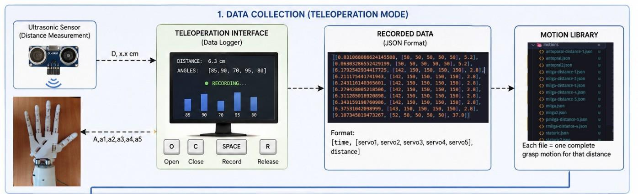
Fig. 1: APMS Architectural Phase 1: Data Collection and Trajectory Recording

During Phase 1 (Data Collection), hand gestures are captured via an IP camera. The Medi-aPipe Hand Landmarker tracks landmarks and computes finger extension ratios. Concurrently, an HC-SR04 ultrasonic distance sensor records target distance. The calculated angles and distances are serialized into JSON trajectory files, which populate the local Motion Library.
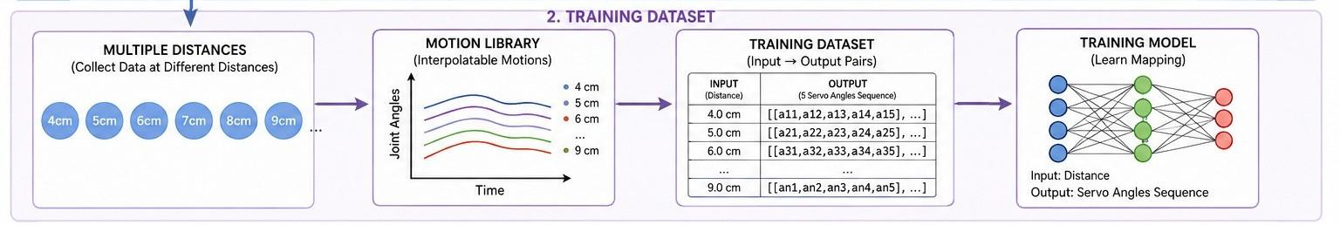
Fig. 2: APMS Architectural Phase 2: Neural Network Trajectory Model Training

During Phase 2 (Model Training), the JSON files in the Motion Library are parsed to construct a structured training database. A Multi-Layer Perceptron (MLP) neural network is trained using backpropagation to interpolate continuous joint trajectories for any distance within the operational bounds (4.0 cm to 9.5 cm).
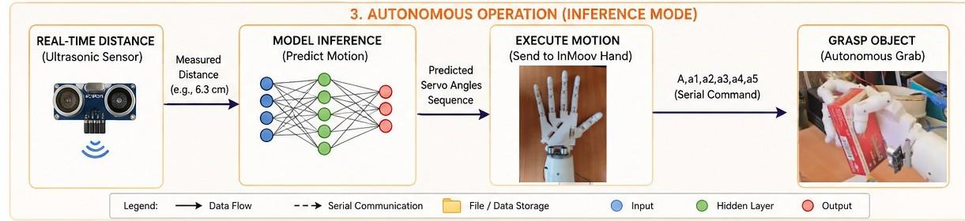
Fig. 3: APMS Architectural Phase 3: Autonomous Grasping and Dispensing Execution

During Phase 3 (Autonomous Operation), the system functions independently. The ul-trasonic sensor measures the package distance, which is filtered and checked for stability.
The MLP model generates the joint angles, driving the ESP32 to execute the grasp. The camera captures the label, which is processed by local GLM-OCR and matched against the reference database using the sequential fallback engine before database inventory updates are completed.

Subsystem Hardware Components Overview
The physical dispensing hardware consists of four interconnected components:

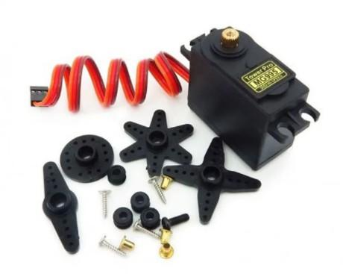
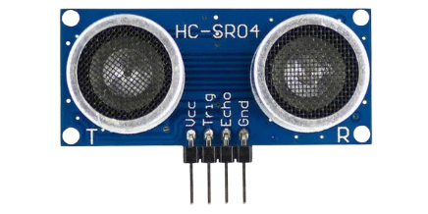
(a) MG995R Servos Assembly (b) Palm-mounted HC-SR04 Sensor
Fig. 4: APMS Hardware Integrations

- InMoov Robotic Hand: A 3D-printed anthropomorphic hand containing 5 MG995R metal gear servos mounted in the forearm. MG995R servos provide a maximum torque of 12 kg·cm, driving finger flexion/extension via high-strength nylon tendons. The fingers operate within an experimental angular range of 50◦ (fully open) to 150◦ (fully closed).
- HC-SR04 Ultrasonic Distance Sensor: Mounted on the palm of the hand to measure the distance to the target medicine pack (operational range: 4.0 cm to 9.5 cm). The sensor operates by emitting a 40 kHz ultrasonic pulse and measuring the echo return time, sampled at 50 Hz.
- ESP32 Microcontroller: Acting as the hardware interface. It samples the ultrasonic sensor and drives the five PWM servo signals. It communicates with the host PC via serial USB communication at 115200 baud.
- IP Camera Module: Captures a high-resolution video feed of the workspace for both MediaPipe hand tracking (Phase 1) and label capture (Phase 3).

Mechanical Kinematics and Joint Mapping Equations

Kinematic Linkage Analysis
Each of the five fingers is modeled as a serial kinematic chain containing three revolute joints: the Metacarpophalangeal (MCP) joint, the Proximal Interphalangeal (PIP) joint, and
the Distal Interphalangeal (DIP) joint. In the InMoov mechanical hand, the PIP and DIP joints are coupled via a shared tendon linkage. When the actuator pulls the tendon, both joints flex simultaneously, reducing the active Degrees of Freedom (DoF) from 15 in a human hand to 5 active DoFs in the robot (one servo per finger). Wrist pitch and twist represent an additional 2 DoFs. Denavit-Hartenberg (D-H) coordinate frames are established at each knuckle to trace the fingertip trajectories relative to the base wrist frame.
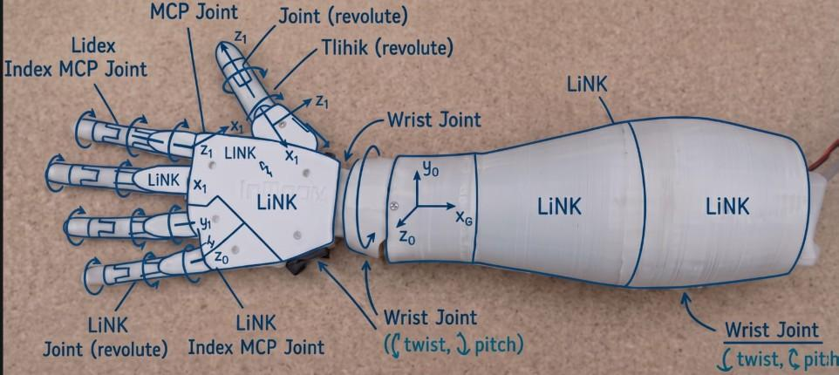

(a) DH Coordinate Frames (b) Blender Forearm Assembly View
Fig. 5: Robotic Kinematics and Blender 3D Design

Finger-to-Servo Joint Mapping Equations
To perform mimicry, the joint angles are computed from MediaPipe landmarks. We define the normalized extension ratio R_{i} for finger i based on the Euclidean distance from the fingertip to the wrist normalized by the distance from the Metacarpophalangeal (MCP) knuckle to the wrist:
||ptip,i − pwrist||
R =
i
(1)
||pMCP,i − pwrist||
The target PWM command angle A_{i} (constrained between fully open A_{open} = 50◦ and fully closed A_{closed} = 150◦) is calculated using a linear clamp-and-scale inversion mapping:
A = clamp A − ^{Ri − Ri,min} × (A − A ), A , A (2)
i closed
Ri,max
— Ri,min
closed
open
open
closed
where R_{i,min} and R_{i,max} represent the calibration limits of the operator’s finger extension. This normalization allows the system to remain invariant to the user’s physical hand size.

3D Printing Infill Density Selection
To manufacture the robotic hand, Blender was utilized to assemble, verify tolerances, and repair STL meshes. The 3D printing parameters are critical: printing with a high infill density (70% to 100%) increases the mass of moving components, overloading the MG995R servos and increasing power consumption. Conversely, very low infill (<15%) leads to mechanical
failure under grasp load. Research in FDM tensile strength demonstrates that structural resistance plateaues above 30% infill density.
We deployed a segmented infill strategy:
      - Fingers and Phalanges: Grid pattern at 25% infill, balancing low inertia with high wall rigidity (1.6 mm walls prevent buckling under flexion stress).
      - Palm Plate: Gyroid pattern at 30% infill, providing isotropic load resistance to absorb multi-directional grip forces.
      - Forearm Housing: Rectilinear pattern at 20% infill, minimizing weight since it serves primarily as a protective shell.
      - Wrist Gear Train: Cubic subdivision pattern at 35% infill to support gear teeth shear stresses.
This design achieved a 35% to 40% weight reduction compared to fully dense parts, keeping motor loads well within the 12 kg·cm rated torque.
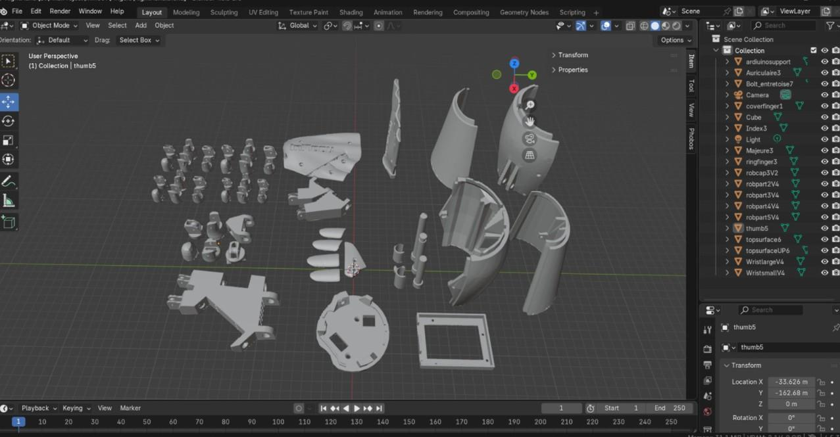
Fig. 6: 3D-Printed Components: High-Level and Low-Level Exploded Assembly View

Software Clean Architecture and Database Design
The APMS software infrastructure connects the mobile interfaces, the relational database, and the hardware.

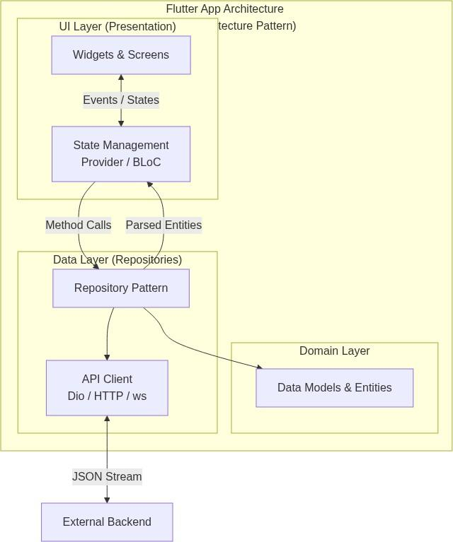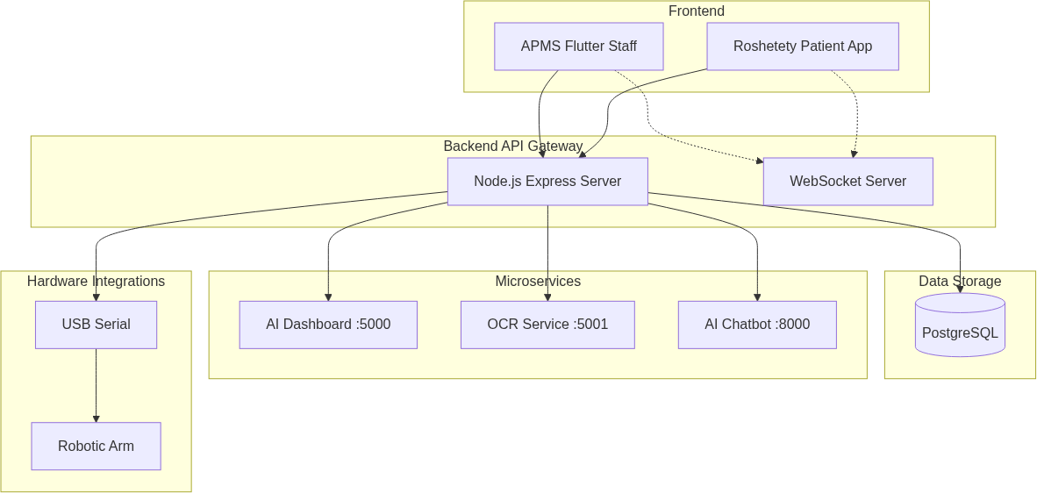
(a) Flutter Clean Architecture (b) Node.js Modular Backend
Fig. 7: APMS Software Subsystem Designs

- Flutter Architecture: The frontends (PharmaSys for staff, Roshetety for patients) follow Clean Architecture. Code is split into three layers: Presentation (UI widgets, Providers for state), Domain (Use Cases, Entities), and Data (Repositories, API service clients). This ensures that network failure handling, serialization, and layout updates are strictly decoupled.
- Database Schema: Hosted on PostgreSQL, the database utilizes a normalized rela-
tional schema. Central tables include users (roles, credentials), medicines_inventory (trade names, scientific name, stock counts, cost, prices, expiry dates), invoices (supplier invoices for financial auditing), and prescriptions (patient orders).
Foreign key constraints, unique indexing on medication codes, and database-level connection pooling ensure high performance.
- Backend REST API: Developed using Node.js and TypeScript. It uses Express for router separation, JWT for authorization, and Zod for input schema validation. It exposes endpoints for inventory lookups, prescription status updates, and robotic command triggers.

HCI Design System and Egypt-Specific Customizations
The UI/UX design methodology for the frontends is strictly grounded in Human-Computer Interaction (HCI) principles. Based on user research and structured interviews with community pharmacists, we flattened the transaction flow to minimize user clicks, reducing cognitive fatigue.
We established a comprehensive Design System featuring:
- Bilingual Typography Strategy: The system utilizes a dual-font approach to support Right-to-Left (RTL) layout switching in Egypt. “Inter” is applied to English labels, while “Cairo” is mapped to Arabic labels to ensure optimal readability.
- Redundant Encoding Accessibility: To ensure error prevention for color-blind users under high cognitive load, all status indicators are redundantly encoded using colors, icons, and text labels (e.g. green checkmarks for in-stock, amber triangles for near-out-of-stock).
A summary of the APMS software technology stack is documented in Table ??.
TABLE 4: APMS Technology Stack Overview

Subsystem | Framework/Tech | Component | Rationale
Frontends | Flutter (Dart) | PharmaSys & Roshetety | Multi-platform compilation from a single code-
 |  |  | base
Backend | Node.js, Express | API Server gateway | Asynchronous event loop, rapid JSON han-
 |  |  | dling
Database | PostgreSQL | Relational Database | Relational consistency, native JSON support,
 |  |  | pooling
OCR Engine | Ollama | GLM-4 OCR | Local execution ensures HIPAA patient data
 |  |  | privacy
Search Index | Elasticsearch | Inverted n-gram indexing | Sub-millisecond approximate string retrieval
Microcontroller | ESP32 | Servo | High-frequency hardware PWM signal genera-
 |  |  | tion

System Initialization Bootstrap Sequence
The system bootstrap module acts as the initialization orchestrator for the entire pipeline, executing all intensive resource-loading operations before the FastAPI server begins accepting requests. This ensures minimal response latency. The bootstrap sequence consists of three sequential steps:
- Step 1: Resource Loading (init_search()): Loads the unified drug database CSV file into a pandas DataFrame, loads the FAISS index and pre-computed embed-dings from disk, initializes the SentenceTransformer model in memory, builds the Python set lookup structure for exact matching, and establishes the connection pool to Elasticsearch.
- Step 2: Model Availability Check: Performs a local HTTP health check on the Ollama API to verify that the GLM-4 OCR model is running, loaded, and responsive.
- Step 3: FastAPI Port Binding: Binds the application to the configured host port, initializing the REST endpoints and WebSocket channels with all resources fully preloaded.

AI Models Design and Analytics Architecture
The background intelligence layer running in the APMS backend contains four distinct models:

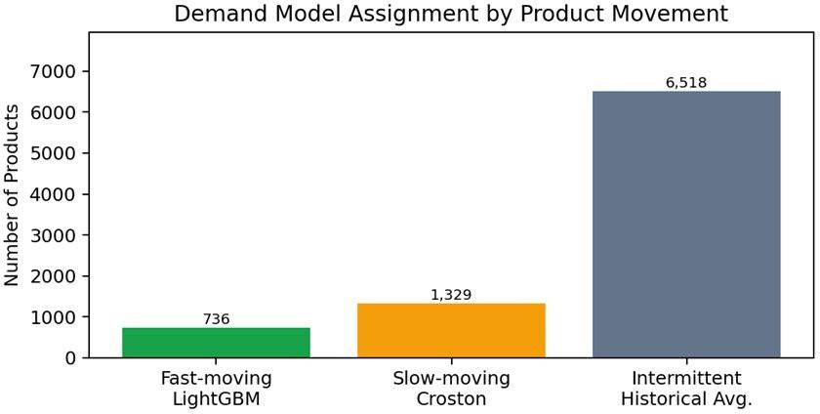

Fig. 8: Product Segmentation Pipeline for Demand Forecasting

- Segmented Demand Forecasting: Products are divided into three segments: Fast-Moving, Slow-Moving, and Intermittent. Fast-moving items are modeled using a LightGBM regressor trained on engineered features (historical lag variables of 1, 2, 3, 6, and 12 months, rolling means, trend variables, and cyclical month encodings). Slow-moving items are modeled using Croston’s Method, which separately forecasts demand sizes and inter-demand intervals. Intermittent items with sparse sales are assigned a 12-month historical trailing average baseline.
- Expiry Priority Scoring: Computes a composite risk score for all inventory lines:
S = 0.45×S_{expiry} +0.25×S_{value} +0.15×S_{coverage} +0.10×S_{demand} +0.05×I_{warning} (3)
where S_{expiry} is inversely proportional to days to expiry, S_{value} represents the financial value at risk, S_{coverage} represents current stock coverage, S_{demand} represents historical velocity, and I_{warning} is a binary flag triggered below 60 days. This score prioritizes clearance discounts (up to 40% discount).
- Shift Anomaly Detection: Monitors cash reconciliation logs. It uses expected cash, actual cash, expected/actual ratio, cash discrepancy, and weekday features. A non-parametric unsupervised ensemble of ECOD (Empirical Cumulative Distribution Outlier Detection) and LOF (Local Outlier Factor) detects cashier fraud or logging errors by requiring consensus between global density and local outlier models.
- SAC Replenishment Agent: Formulates replenishment ordering as a Markov Deci-sion Process (MDP) with a 5-dimensional state space:
x_{t} = [I_{t}, D_{t}, V_{t}, C_{t}, R_{t}]^{T} (4)
where I_{t} is stock on hand, D_{t} is days since last order, V_{t} is rolling demand, C_{t} is coverage, and R_{t} is reorder ratio. The action space is continuous (reorder quantity). The Soft Actor-Critic agent maximizes cumulative reward:
R = Revenue − Ordering Cost − Holding Cost − Stockout Penalty (5)
trained in a simulation environment calibrated on real historical pharmacy transaction distributions.

Croston’s Method Mathematical Formulation
Croston’s method separates the demand time-series into two separate components: non-zero demand size z_{t} and time interval between demands p_{t}. If demand y_{t} > 0 at time t, then:
zˆ_{t} = zˆ_{t−1} + α(y_{t} − zˆ_{t−1}) (6)
pˆ_{t} = pˆ_{t−1} + α(q − pˆ_{t−1}) (7)
where q represents the number of periods elapsed since the last non-zero demand, and α is a smoothing parameter (typically 0.1 ≤ α ≤ 0.3). If demand y_{t} = 0:
zˆ_{t} = zˆ_{t−1} (8)
pˆ_{t} = pˆ_{t−1} (9)
and the elapsed counter is incremented (q = q + 1). The final demand forecast is predicted as:

yˆt+h|t
₌ zˆ_{t} pˆ_{t}
(10)

ECOD and LOF Anomaly Models
ECOD is a fast, non-parametric anomaly detection algorithm that computes the empirical cumulative distribution function (ECDF) for each dimension d of a sample x:
1 ^{Σ}
N
F (x ) = I(x ≤ x ) (11)
d
d
N
i,d
d
i=1
The anomaly score is calculated based on the tail probabilities:
D
Σ
O(x) = max (− log F_{d}(x_{d}), − log(1 − F_{d}(x_{d}))) (12)
d=1
which captures both left-tail and right-tail outliers.
LOF measures the local density deviation of a data point relative to its neighbors. The local reachability density (lrd) of point p is:
lrd_{k}(p) = Σ

o∈N_{k}(p)
|N_{k}(p)|
reach-dist_{k}
(13)
(p, o)
where N_{k}(p) is the k-distance neighborhood of p, and reach-dist_{k}(p, o) = max(d_{k}(o), d(p, o)). The LOF score is then:
^{Σ} lrd_{k}(o)
_{(p) =} o∈N_{k}(p) lrd_{k}(p)
LOF
(14)
^{k} |N (p)|
k
An LOF score close to 1 indicates a normal point, while a score significantly greater than 1 indicates an outlier.

Model Hyperparameters
The hyperparameter selections for the MLP trajectory generator and the SAC replenishment agent are summarized below:
      - MLP Trajectory Model: Dense input layer (1 node), 3 hidden layers (64, 128, 64 nodes with ReLU activation), and output layer (500 nodes, representing 100 timesteps for 5 servos). Trained using the Adam optimizer (learning rate η = 0.001, batch size 32) over 500 epochs with Mean Squared Error (MSE) loss.
      - SAC Agent: Actor network with 2 hidden layers (256 nodes, ReLU) outputting mean and standard deviation of grasp sizes. Critic networks with 2 hidden layers (256 nodes, ReLU) modeling Q-values. Learning rate is 0.0003, discount factor γ = 0.99, and target update coefficient τ = 0.005, utilizing a 1,000,000 transition capacity experience replay buffer.

Prescription Dataset Collection and Ground Truth Annotation
To train, calibrate, and evaluate the prescription transcription pipeline, we collected an au-thentic dataset of 500 physical prescription papers from local polyclinics and community pharmacies across Alexandria and Cairo, Egypt. These documents exhibit the diverse hand-writing styles, fading ink, non-standard cursive abbreviations, and physical wrinkles typical of real-world clinical environments.
The dataset capture and preprocessing workflow proceeded as follows:
- Image Acquisition: High-resolution digital photographs of the prescriptions were captured using mid-range mobile phone cameras under three distinct ambient lighting levels: bright day/fluorescent lighting (250 lm), moderate room lighting (100 lm), and low-light evening setups (15 lm).
- Ground Truth Transcription: To establish a rigorous baseline for evaluation, three licensed pharmacists independently transcribed each prescription. They manually ex-tracted the brand name, active substance, dosage strength (e.g., 50 mg, 1 g), formu-lation type (tablet, syrup, injection), and dosage frequency instructions. Discrepancies between the transcribers were resolved via a majority consensus panel, resulting in a clean, standardized ground truth dataset.
- Reference Drug Directory: In parallel, we built a local reference database containing 15,000+ drug brand and generic names. This database consolidated regional datasets from the Egyptian Drug Authority (EDA), U.S. FDA National Drug Code (NDC) Directory, and scraped web metadata from Vezeeta Egypt.

OCR Core and Search Strategy Selection
When a prescription image is received by the APMS system, it undergoes localized binariza-tion and contrast adjustment before execution. A local Vision-Language Model (GLM-4 OCR running offline via Ollama) transcribes the cursive handwritten strokes. Due to the high rate of spelling discrepancies in handwritten medical cursive, the raw text cannot be queried directly in the relational database.
We selected and prioritized a Seven-Stage Sequential Fallback Search Engine to resolve typographical noise, structured as follows:
- Stage 1: Exact Match: Performs a direct, case-sensitive lookup on the local database. If the raw OCR output matches a registered trade name exactly, the system returns the item instantly with 100% confidence, bypassing further processing.
- Stage 2: Normalized Match: Strips punctuation, spaces, non-standard casing, and hyphens (e.g. “mil-ga” → “milga”), running a fast set-membership query.
- Stage 3: Smart OCR Fix (Visual Confusion Correction): Substitutes character strings based on historical optical errors (e.g., cursive “rn” misread as “m”, or vertical “l” misread as “1”).
- Stage 4: Elasticsearch Indexing: Queries an Elasticsearch node utilizing n-gram tokenization and inverted indexes, mapping matching components to trade names.
- Stage 5: Fuzzy Search (Jaro-Winkler Distance): Performs a character edit-distance query. It prioritizes differences near the end of strings to protect drug prefix similarity (e.g. distinguishing “Milga” from “Miltown”). If a candidate scores ≥ 0.85, the loop exits.
- Stage 6: Semantic Search (Sentence-Transformers): Computes dense vector rep-resentations of the text, comparing cosine similarities against pre-computed em-beddings of generic drug classes. This resolves severe handwriting distortions by capturing phonetic and therapeutic context.
- Stage 7: External Web Crawler Fallback: Direct REST API requests query the live Vezeeta Egypt directory, catching recently registered or unindexed medications.
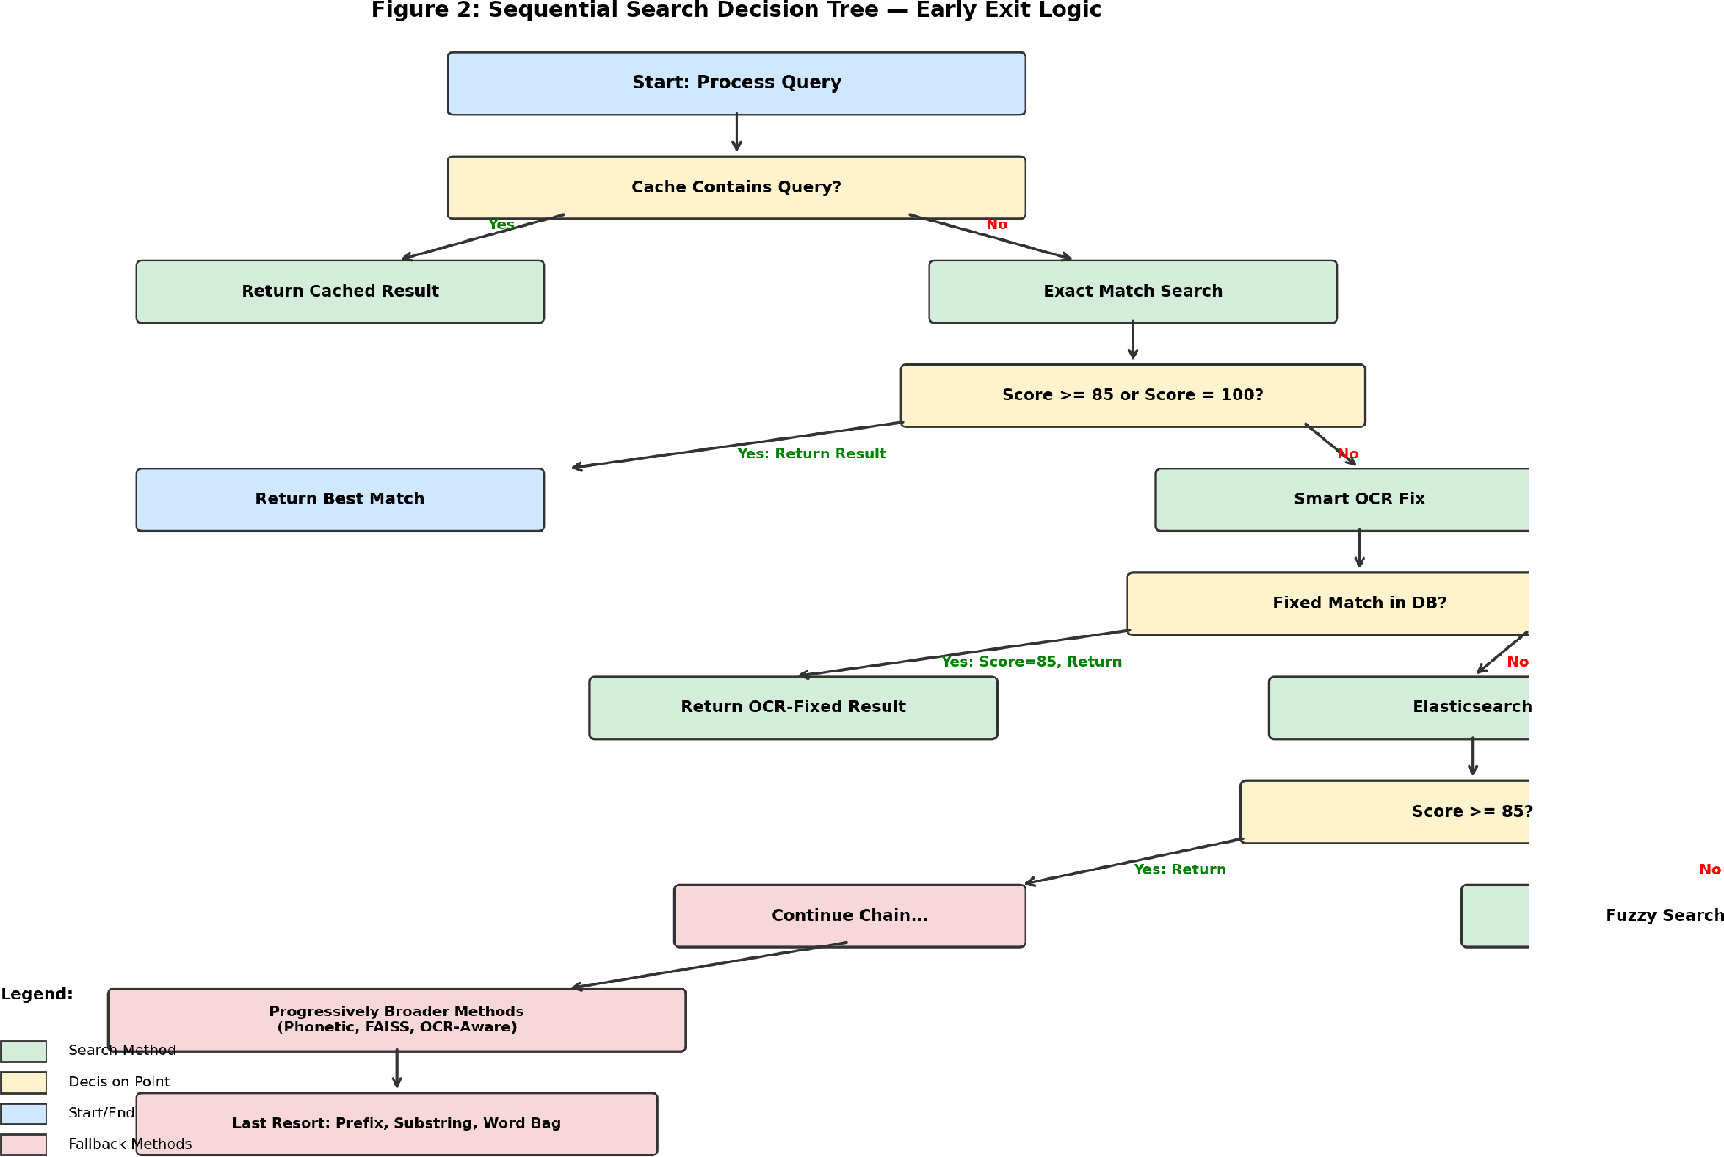
Fig. 9: Sequential Search Decision Tree with Early-Exit Confidence Thresholding

The characteristics and computational complexities of the search stages are detailed in Table ??.
TABLE 5: Search Method Characteristics

Priority | Method | Complexity | Justification for Priority Order
0 | Exact Match | O(1) | Instant lookup, 100% precision; matches 30–40% of clear inputs
1 | Normalized Match | O(1) | Handles case/whitespace variations without expensive string metrics
2 | Smart OCR Fix | O(V log N ) | Corrects common visual confusion variants (m → rn, l → 1)
3 | Elasticsearch | O(log N ) | Leverages inverted index and n-grams for fast approximate matching
4 | Fuzzy Search | O(N · M ) | C++ accelerated Jaro-Winkler metric; handles arbitrary misspellings
5 | Semantic Search | O(D · K) | Dense embeddings; handles severe handwriting distortion via context
6 | External Crawler | O(1) | Query external drug registry; resolves new or unindexed local items

Consensus Voting vs. Sequential Fallback Strategy
The decision to utilize a sequential fallback strategy rather than a parallel consensus voting model was driven by critical performance trade-offs. In a parallel consensus architecture, every search method must execute, resulting in high CPU loads and API query volumes.
Furthermore, incorrect candidates returning from multiple weak algorithms can accumulate votes and outrank the correct, high-confidence match. The sequential fallback approach enforces early-exit logic, halting execution as soon as a method satisfies the safety confidence score (85%). A comparative summary is presented in Table ??.
TABLE 6: Comparison of Search Architectures

Aspect | Consensus Voting (Parallel) | Sequential Fallback (APMS)
Execution Flow | All methods execute concurrently | Methods execute in strict priority order
Average Operations | 35+ search operations per query | 2.5 search operations per query
False Positive Risk | High (weak candidates accumulate votes) | Low (early exit limits fallback scope)
Computational Cost | High (always runs neural embeddings) | Moderate (lazy evaluation)
Predictability | Low (unpredictable voter interactions) | High (deterministic execution path)
Debuggability | Complex (requires parsing all outputs) | Simple (logs the early-exiting method)

Dynamic Camera Zoom and Distance Feedback Loop
To ensure robust transcription under physical variations, we implemented a closed-loop hardware-software distance adjustment feedback system. If the OCR confidence score or the best-matched candidate Jaro-Winkler score is below 80%, the system assumes the prescription image is blurry, low contrast, or too far.
Rather than failing or prompting the user immediately, the system initiates the following loop:
- The backend dispatches a command to the ESP32 to actuate a servo-driven linear rail, moving the workspace camera 5.0 cm closer to the target prescription surface.
- If physical movement limits are reached, the system issues a digital zoom command (+10% focal magnification) to the IP camera stream.
- A new image frame is captured and re-injected into the GLM-OCR model.
This feedback loop runs up to 3 times iteratively. If the confidence remains below the safety threshold after 3 attempts, the system halts and raises a visual alert on the PharmaSys dashboard, requesting manual pharmacist review.

Arabic Processing and Metadata/Dosage Filtration
Prescriptions in the Egyptian market present a challenging mix of English brand names and handwritten Arabic dosage instructions, accompanied by standard physician letterheads (such as “Dr.”, “Professor”, “Rx”, or “R/”). To extract clean, structured clinical instructions, a specialized filtering and parsing regex pipeline was designed:
- Header and Metadata Strip: Pre-compiled regular expressions scan the raw text to detect and remove non-medication headers (e.g. physician names, contact numbers, clinics) and standard symbols (“Rx”, “R/”).
- Arabic Script Isolation: Arabic Unicode script blocks are isolated and separated from English trade names. While the English brand names are processed through the fallback search directory, the Arabic text is routed directly to the Dosage Parser.
- Structural Dosage Parsing: A dedicated parser evaluates clinical frequency expres-sions. It maps shorthand annotations (such as “3*1”, “3x1”, “3/1”) or Arabic phrases (such as “Thalath marrat yawmiyan” – three times daily, “Koll 8 sa’at” – every 8 hours, or “Qurs sabahan wa masa’an” – one tablet morning and evening) into standardized scheduling parameters.
- Dosing Volume Extraction: If the parser identifies a complex fractional instruction (such as “3*1/2” – three times, half a tablet each), it parses the value into a numerical dosing rate (dosage_frequency = 3, quantity_per_dose = 0.5). This structured output is transmitted directly to the dispensing queue, preventing hardware dispensing errors.
To prevent incorrect drug dispensing, a Five-Layer Safety Filter is implemented as detailed in Table ??.
TABLE 7: Safety Filter Architecture Layers

Layer | Name | Input Stage | Filtering Mechanism
1 | Empty Reject | Raw VLM text | Blocks empty/whitespace OCR text, returning early
 |  |  | error code
2 | Language Strip | Transcribed output | Regex filters Arabic Unicode strings, separating dosage
 |  |  | instructions
3 | Common Word Block | Sanitized query | Blocklist of 120+ non-drug words (“eye”, “tablet”, etc.)
4 | Length Check | Candidate validation | Blocks matches where string lengths differ by ≥ 50%
5 | Pharmacist Guard | Dashboard trigger | Manual confirmation required prior to dispatching
 |  |  | robotic PWM

Web Crawler API-Based Design Justification
The external fallback crawler targets the Vezeeta Egypt platform to query unindexed local medications. Rather than employing HTML parsing libraries (such as BeautifulSoup) that scrape static layouts, the crawler communicates directly with Vezeeta’s backend REST API endpoints. This design is justified by six technical reasons:
- Reason 1: Single Page Application (SPA) architecture: Vezeeta’s frontend is com-piled as an SPA. Product data is not embedded in the initial static HTML payload, but loaded dynamically.
- Reason 2: Empty initial HTML containers: Scrapers using BeautifulSoup only see empty DOM containers or loading indicators prior to client-side script execution.
- Reason 3: Direct API access: By calling the REST API endpoints directly, the crawler receives structured JSON structures containing price, shape, and availability.
- Reason 4: Data cleanliness: JSON responses map directly to our database schema without requiring fragile regex cleaning or complex XPath parsing of nested tables.
- Reason 5: Endpoint stability: Frontend layouts and CSS class names undergo fre-quent changes during UI deployments. REST endpoints remain stable to ensure frontend-backend compatibility.
- Reason 6: Computational efficiency: Eliminates the need to spawn headless browser instances (such as Selenium), reducing server memory overhead from gigabytes to kilobytes.

Teleoperation and Motion Recording Protocol
To populate the Motion Library (Phase 1), the system implements a real-time computer vision teleoperation loop. The human operator controls the robotic hand remotely. A keyboard interface captures recording events:
- R: Start recording servo angles and HC-SR04 distance values.
- S: Stop and serialize the list to a JSON file named medicine-distance-N.json.
- P: Play back the recorded trajectory for verification.
- q: Exit teleoperation mode.
Each serialized trajectory is saved as an array of frames, adhering to the following JSON schema:

[
[timestamp, [servo1, servo2, servo3, servo4, servo5], distance],
[1.200, [150, 150, 148, 145, 142], 6.5]
]

[0.000, | [50, | 50, | 50, | 50, | 50], | 6.5],
[0.050, | [55, | 53, | 52, | 50, | 50], | 6.5],
[0.100, | [62, | 58, | 56, | 52, | 51], | 6.5],

This trajectory format provides both the target joint posture and the distance vector, serving as direct inputs for the MLP neural network training.

ESP32 Serial Communication Protocol
To ensure robust coordinate transmission and prevent packet loss over serial interfaces, a strict binary/character framing protocol was defined:
      - Control command packet (PC to ESP32): Transmitted at 115200 baud, matching the format "A<a1>,<a2>,<a3>,<a4>,<a5>\n", where a_i is the integer angle (50◦ ≤ a_{i} ≤ 150◦).
      - Telemetry feedback packet (ESP32 to PC): Sent at 50 Hz, formatted as "D<dist>S<s1>,...,<
providing filtered ultrasonic distances, current encoder values, and system error flags (e.g. timeout, sensor failure).

Autonomous Medicine Mobile Robot (Car Subsystem)
To extend the APMS dispensing ecosystem, an autonomous mobile pick-and-place robot (referred to as the mobile robot or car subsystem) was integrated. The mobile robot navigates the pharmacy floor, identifies target medicine packages, performs distance-adaptive visual servoing, and transports the selected items to a designated drop-off box.

Mobile Chassis Hardware and Pin Mapping
The mobile platform is constructed around a four-wheel differential-drive chassis. It is driven by four brushed DC gear motors powered by a rechargeable battery pack. A dual H-bridge L298N motor driver manages the motor direction and speed. Low-level control is executed by an Arduino Uno microcontroller, while wireless communication is handled via an HC-05 Bluetooth serial module. The perception layer consists of a USB webcam connected to the host computer, which executes the high-level computer vision models. The physical specifications of the hardware components are detailed in Table ??.
TABLE 8: Mobile Robot Hardware Components and Specifications

Component | Specification | Role in Subsystem
Arduino Uno | ATmega328P, 16 MHz, 32KB Flash | Low-level command execution
L298N Driver | Dual H-Bridge, 2A per channel | DC motor power driving
DC Motors (x4) | 3-6V Gear motors, 1:48 gear ratio | Wheeled locomotion
HC-05 Bluetooth | Serial SPP, 2.4 GHz, 9600 baud | Wireless communication link
Webcam | USB interface, 640x360 resolution | Visual input for perception
Servo Gripper | 3D-printed arm, SG90 servo motor | Object manipulation and pick

The electrical connection between the Arduino Uno and the L298N motor driver pins is mapped in Table ??.
TABLE 9: Arduino-to-L298N Pin Mapping

Arduino Pin L298N Pin Function

Digital Pin 7 | IN1 | Left Motor direction control
Digital Pin 6 | IN2 | Left Motor direction control
Digital Pin 5 | IN3 | Right Motor direction control
Digital Pin 4 | IN4 | Right Motor direction control

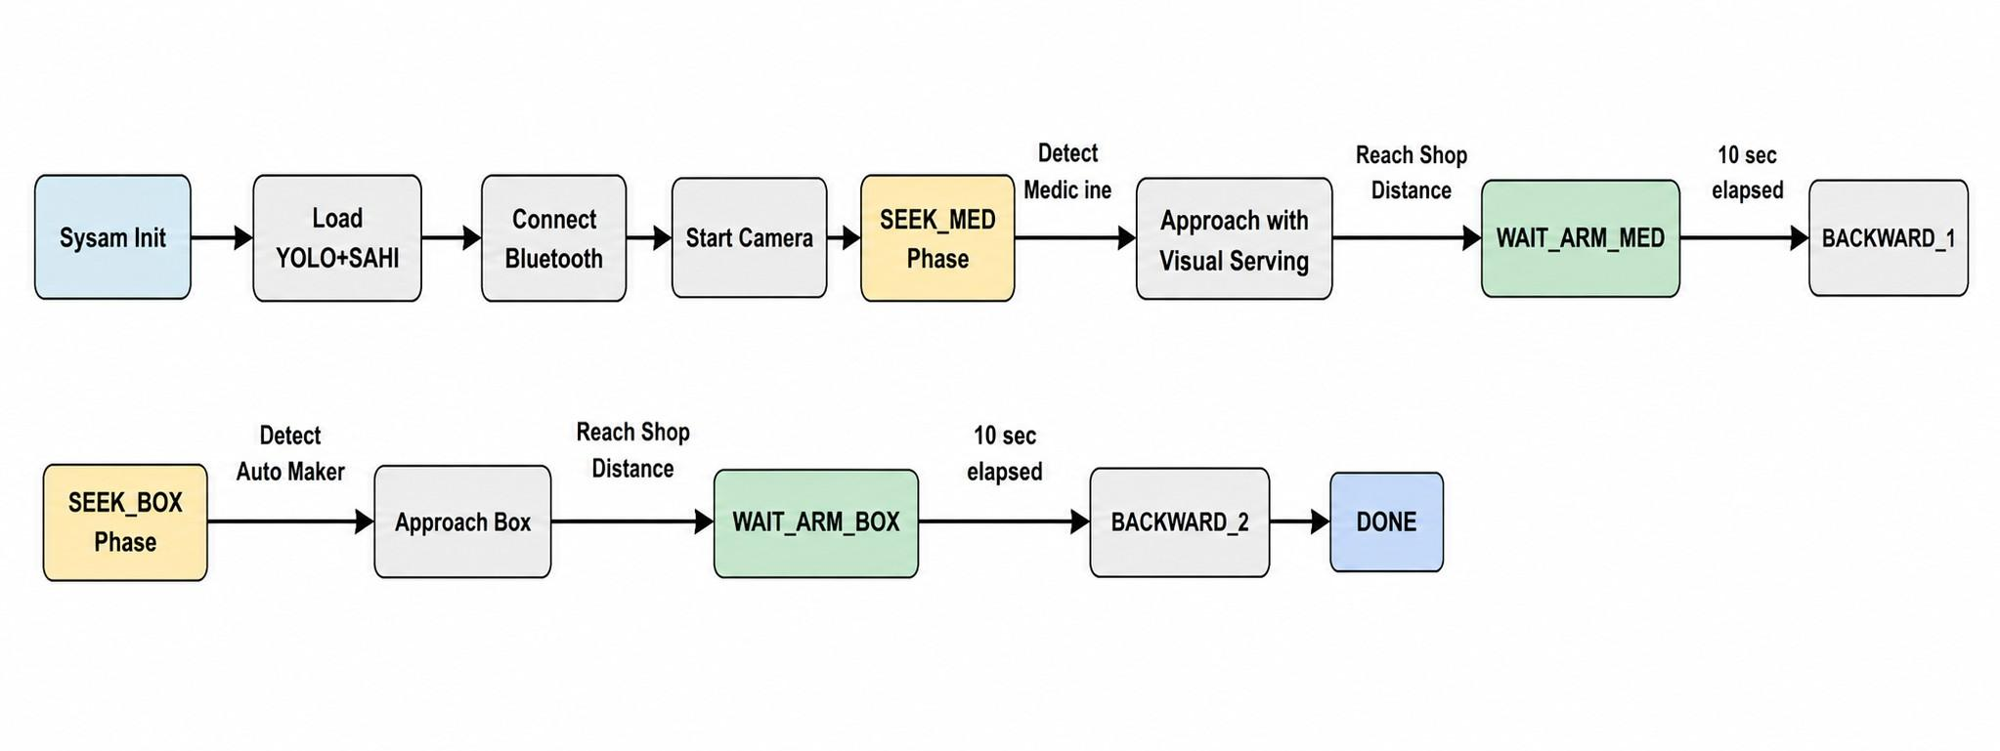
Fig. 10: System Architecture diagram showing the execution layer, decision layer, and perception layer for the mobile robot.

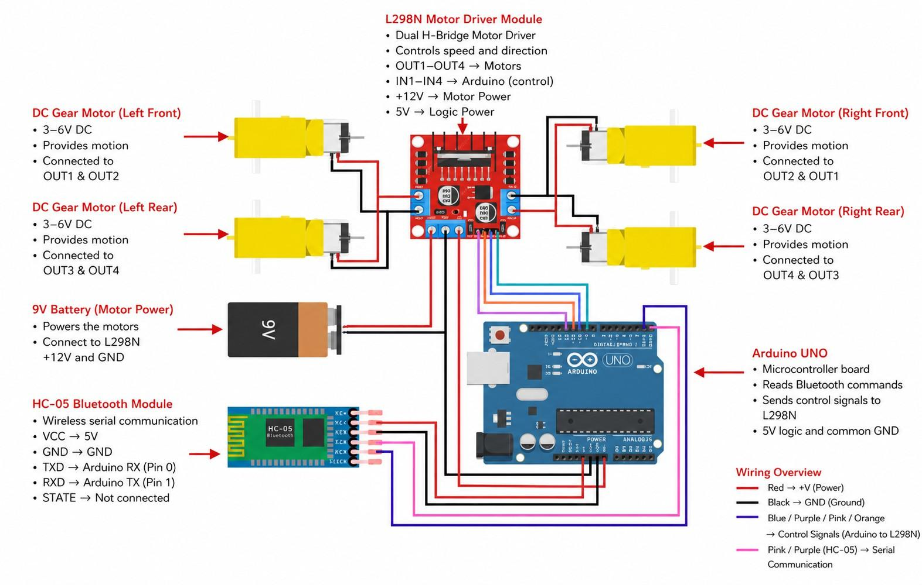
Fig. 11: Hardware architecture and communication flow diagram showing the connection between the host PC, Arduino, L298N, HC-05, and motors.

Bluetooth Locomotion Control Protocol
Locomotion commands are transmitted from the host PC to the Arduino Uno using a lightweight single-character Bluetooth protocol. The host PC computes visual servoing adjustments and transmits characters over virtual serial COM ports. The Arduino reads the incoming serial byte and immediately switches the digital output pins to configure the motor state as shown in Table ??.
TABLE 10: Motor Locomotion Command Protocol

Command | Locomotion State | Motor Pin Configurations
’F’ | Move Forward | IN1=HIGH, IN2=LOW, IN3=LOW, IN4=HIGH
’B’ | Move Backward | IN1=LOW, IN2=HIGH, IN3=HIGH, IN4=LOW
’R’ | Turn Right | IN1=HIGH, IN2=LOW, IN3=HIGH, IN4=LOW
’L’ | Turn Left | IN1=LOW, IN2=HIGH, IN3=LOW, IN4=HIGH
’S’ | Stop Locomotion | IN1=LOW, IN2=LOW, IN3=LOW, IN4=LOW

Dataset Preparation, Augmentation, and Transfer Learning
To train the YOLO object detection model, a custom dataset of local medicine packages (Milga, Antopral, and Staturic) was collected using the Roboflow platform. The initial dataset contained 150 raw images. Due to the small dataset size, the model was highly susceptible to overfitting and poor generalization. To mitigate this, Roboflow was configured to generate
3 augmented samples per image using rotation (±15◦), horizontal shear (±10◦), and vertical shear (±10◦). This expanded the dataset to 327 images, split into 297 training images and 30 validation images.
TABLE 11: Initial Dataset Class Distribution

Class ID | Class Name | Images | Description
0 | Milga | 50 | Primary target for pick-and-place trials
1 | Antopral | 50 | Secondary class (distractor)
2 | Staturic | 50 | Tertiary class (distractor)

TABLE 12: Dataset Augmentation Parameters

Augmentation Technique | Value Range | Design Rationale
Rotation | ±15◦ | Simulates rotation variations of packages on floor
Horizontal Shear | ±10◦ | Simulates camera pitch and skew angles
Vertical Shear | ±10◦ | Simulates non-orthogonal viewing perspectives
Multiplication Factor | 3x | Generates 3 unique augmented variations per image

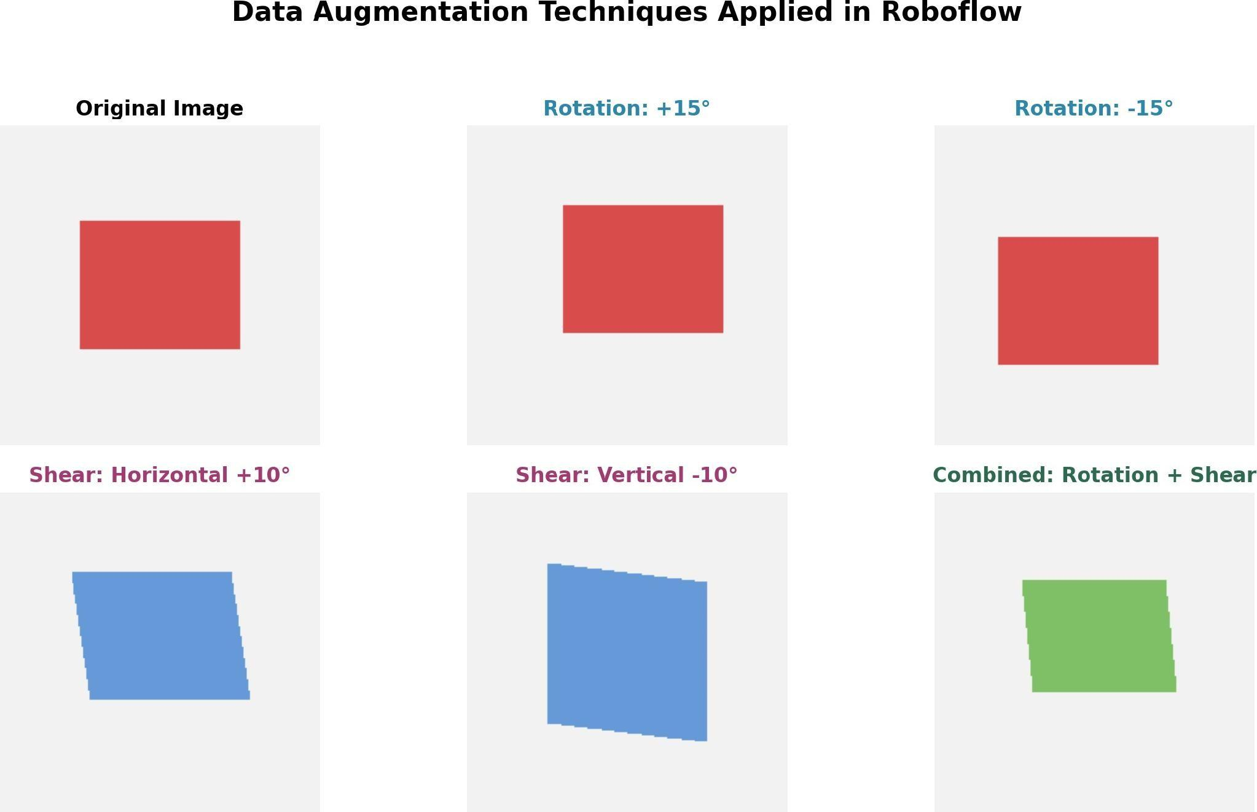
Fig. 12: Examples of dataset augmentation: original image, rotation, horizontal/vertical shear, and combined transformations.

To maximize detection performance, we applied transfer learning from the pre-trained COCO dataset checkpoint (yolov8n.pt). Crucially, we froze the first 10 layers of the YOLO backbone (freeze=10) during training. This prevented the model from modifying the low-level visual feature extractors (lines, edges, textures) already learned from COCO, fine-tuning only the higher-level detection head on our medicine dataset, thus protecting the model from catastrophic forgetting. The overall training configuration is summarized in Table ??.
TABLE 13: Mobile YOLO Training Configuration

Parameter Configuration Value

Pre-trained Model Base yolov8n.pt (COCO dataset) Backbone Freezing Layer freeze=10 (layers 1–10 frozen) Optimizer AdamW (learning rate = 0.001)
Batch Size 16
Training Epochs 120 (with early stopping patience = 30) Input Resolution 640 × 640 pixels
Augmented Dataset Size 327 images (297 train, 30 validation)

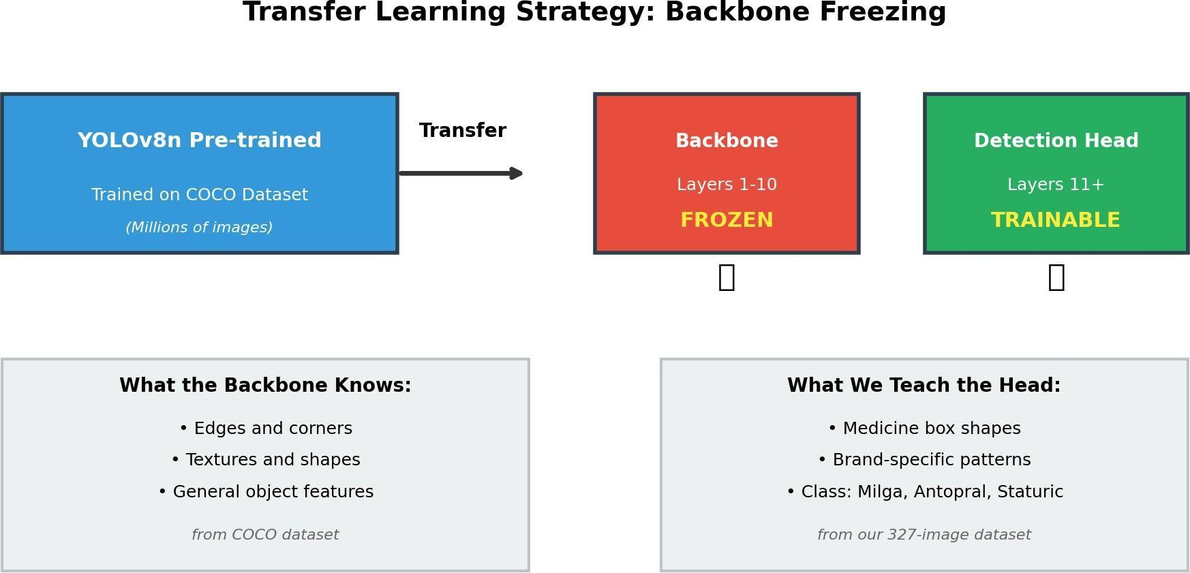
Fig. 13: YOLOv8 transfer learning and backbone freezing strategy, freezing layers 1–10 and fine-tuning the detection head.

YOLOv8-SAHI Perception and ArUco Detection
During autonomous navigation, the perception pipeline runs YOLOv8n enhanced by Slicing Aided Hyper Inference (SAHI). SAHI splits the 640 × 360 camera frame into overlapping 320 × 320 pixel slices, runs inference on each slice, and merges bounding boxes using Non-Maximum Suppression (NMS). This addresses the small-object detection issue when the robot is far from the medicine box. For the drop-off phase, the robot uses OpenCV’s ArUco marker detection module. It queries the DICT4X450 dictionary to locate marker ID 0 mounted on the drop-off box. Frames are converted to grayscale before detection to increase edge contrast. The center X coordinate and bounding box area are computed to drive the visual servoing control.
TABLE 14: SAHI Inference Configuration Parameters

SAHI Parameter Configuration Value

Slice Height 320 pixels
Slice Width 320 pixels Overlap Height Ratio 0.2 Overlap Width Ratio 0.2 Confidence Threshold 0.78
Inference Device CUDA GPU (cuda:0)

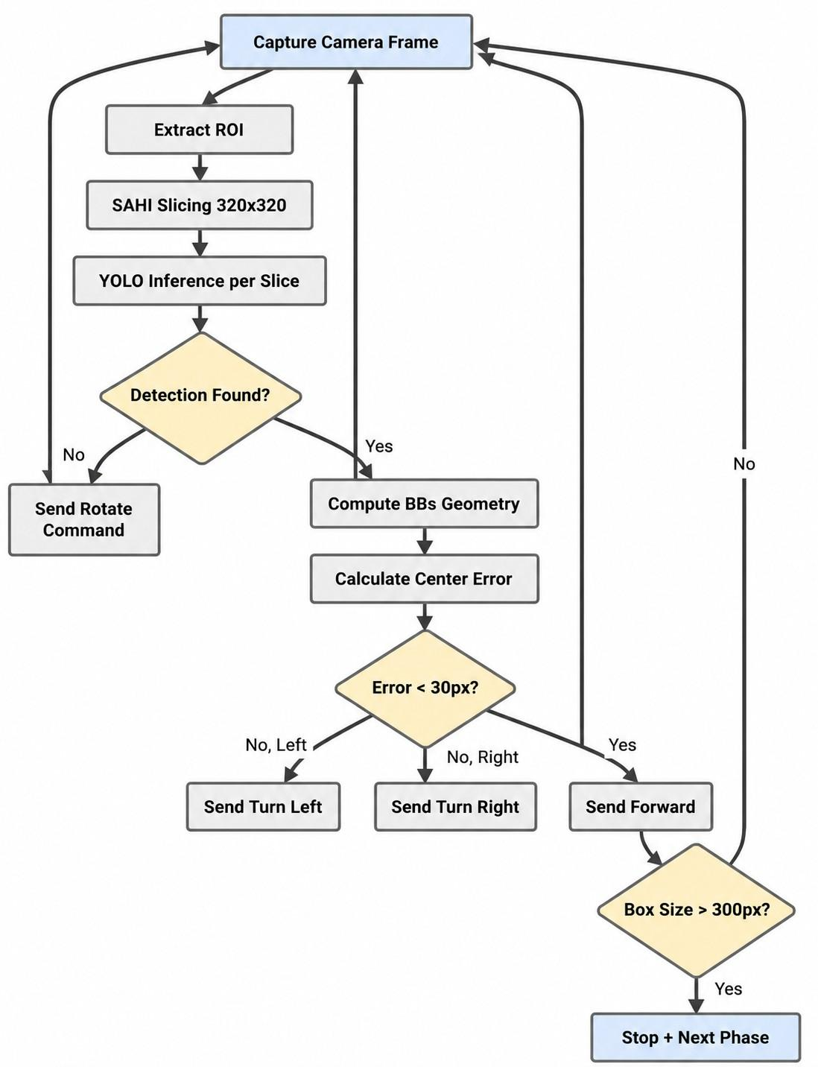
Fig. 14: YOLOv8-SAHI perception and visual servoing control flowchart.

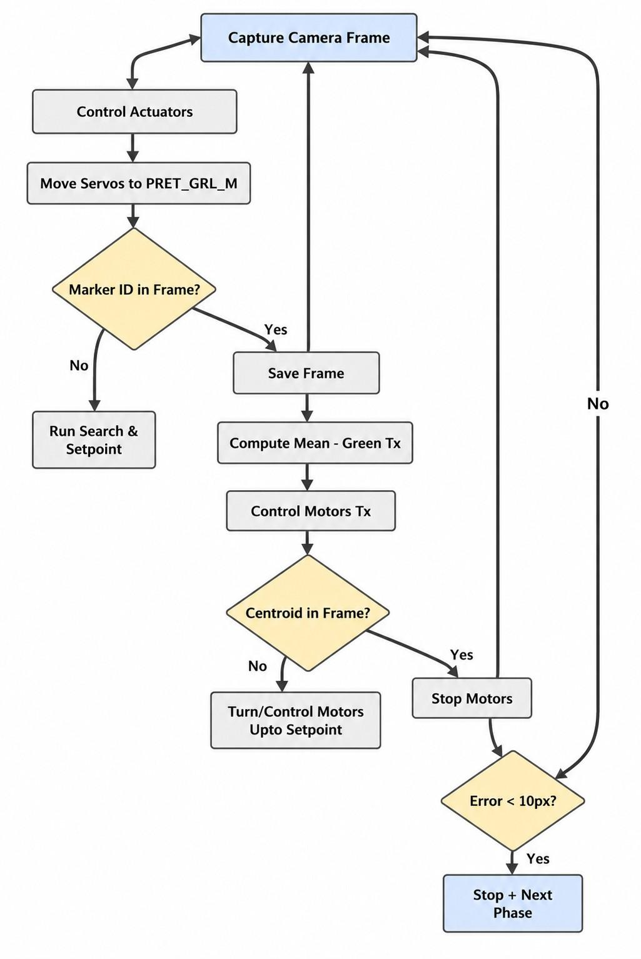
Fig. 15: ArUco marker detection and visual servoing docking flowchart.

Finite State Machine and Control Loop
The navigation and manipulation workflow is orchestrated by an 8-phase Finite State Machine (FSM). Visual servoing adjusts the robot steering by computing the error between the detected bounding box center X_{bbox} and the frame center X_{center} (320 pixels). The alignment error e is defined as:
e = Xbbox − Xcenter (15)
If |e| > θ_{align} (where alignment threshold θ_{align} = 80 pixels), the robot sends turn commands (’L’ or ’R’) to align with the target. Once aligned, the robot moves forward (’F’). The robot stops locomotion (’S’) and transitions states when the bounding box average size exceeds the stop distance threshold (200 pixels for medicine, 180 pixels for the drop-off box). The FSM phase sequence and control parameters are detailed in Table ?? and Table ??.
TABLE 15: Mobile Robot Finite State Machine (FSM) Phases

Phase ID | State Name | Description
0 | SEEK_MED | Search environment and approach target medicine box
1 | WAIT_ARM_MED | Pause locomotion, trigger robotic arm grasp (10 seconds)
2 | BACKWARD_1 | Execute pulsed backward motion away from shelf (1.5 seconds)
3 | SEEK_BOX | Rotate to search for ArUco marker ID 0
4 | APPROACH_BOX | Navigate and align with drop-off box using visual servoing
5 | WAIT_ARM_BOX | Trigger robotic arm deposit sequence (10 seconds)
6 | BACKWARD_2 | Move backward away from box (1.5 seconds)
7 | DONE | Stop operation, display completion state

TABLE 16: Visual Servoing Control Loop Parameters

Parameter Operational Value

Frame Center (Xcenter ) 320 pixels Alignment Zone (θ_{align}) ±80 pixels
Stop Threshold (Medicine) 200 pixels (average bounding box size) Stop Threshold (Box) 180 pixels (average bounding box size) Arm Gantry Grab Delay 10 seconds
Pulsed Backward Duration 1.5 seconds (0.12s pulse on, 0.1s off) Search Sweep Timeout 2.0 seconds per rotation step

IMPLEMENTATION & RESULTS

Software Code Implementation
The system implementation consists of core code blocks across the robotic hand, backend, and frontend.

MediaPipe Landmark Mimicry and Filter
The MediaPipe tracker module hand_memic.py runs a continuous video frame processing loop. The landmarks are processed to compute normalized finger extension ratios, which are mapped to servo angles:
def compute_raw_targets(landmarks):
# Calculate hand size reference: Wrist (0) to Middle finger MCP (9)
hand_size = hypot(landmarks[0].x - landmarks[9].x, landmarks[0].y - landmarks [9].y)
if hand_size < 0.05:
return [50, 50, 50, 50, 50] # Default fully open hand

ratios = []
# Compute fingertip to wrist distance normalized by hand size per finger
tips = [4, 8, 12, 16, 20]
for tip in tips:
dist = hypot(landmarks[tip].x - landmarks[0].x, landmarks[tip].y - landmarks[0].y)
ratios.append(dist / hand_size)
return ratios
These raw ratios are converted to servo command angles using per-finger linear interpolation ranges:
A = clamp ^{Ri − Ri,min} × 100 + 50, 50, 150 (16)
i
Ri,max − Ri,min

Distance Filtering and Stability Control
The distance reading obtained from the HC-SR04 palm sensor is noisy. We implement the
DistanceFilter class:
class DistanceFilter:
def init (self, size=7): self.buffer = [] self.size = size

def add(self, val): self.buffer.append(val)
if len(self.buffer) > self.size: self.buffer.pop(0)

def get_filtered(self):
if not self.buffer:
return 0.0
sorted_buf = sorted(self.buffer)
return round(sorted_buf[len(sorted_buf) // 2], 1) # Median

def is_stable(self, tol=0.8):
if len(self.buffer) < 5:
return False
recent = self.buffer[-5:]
return (max(recent) - min(recent)) < tol

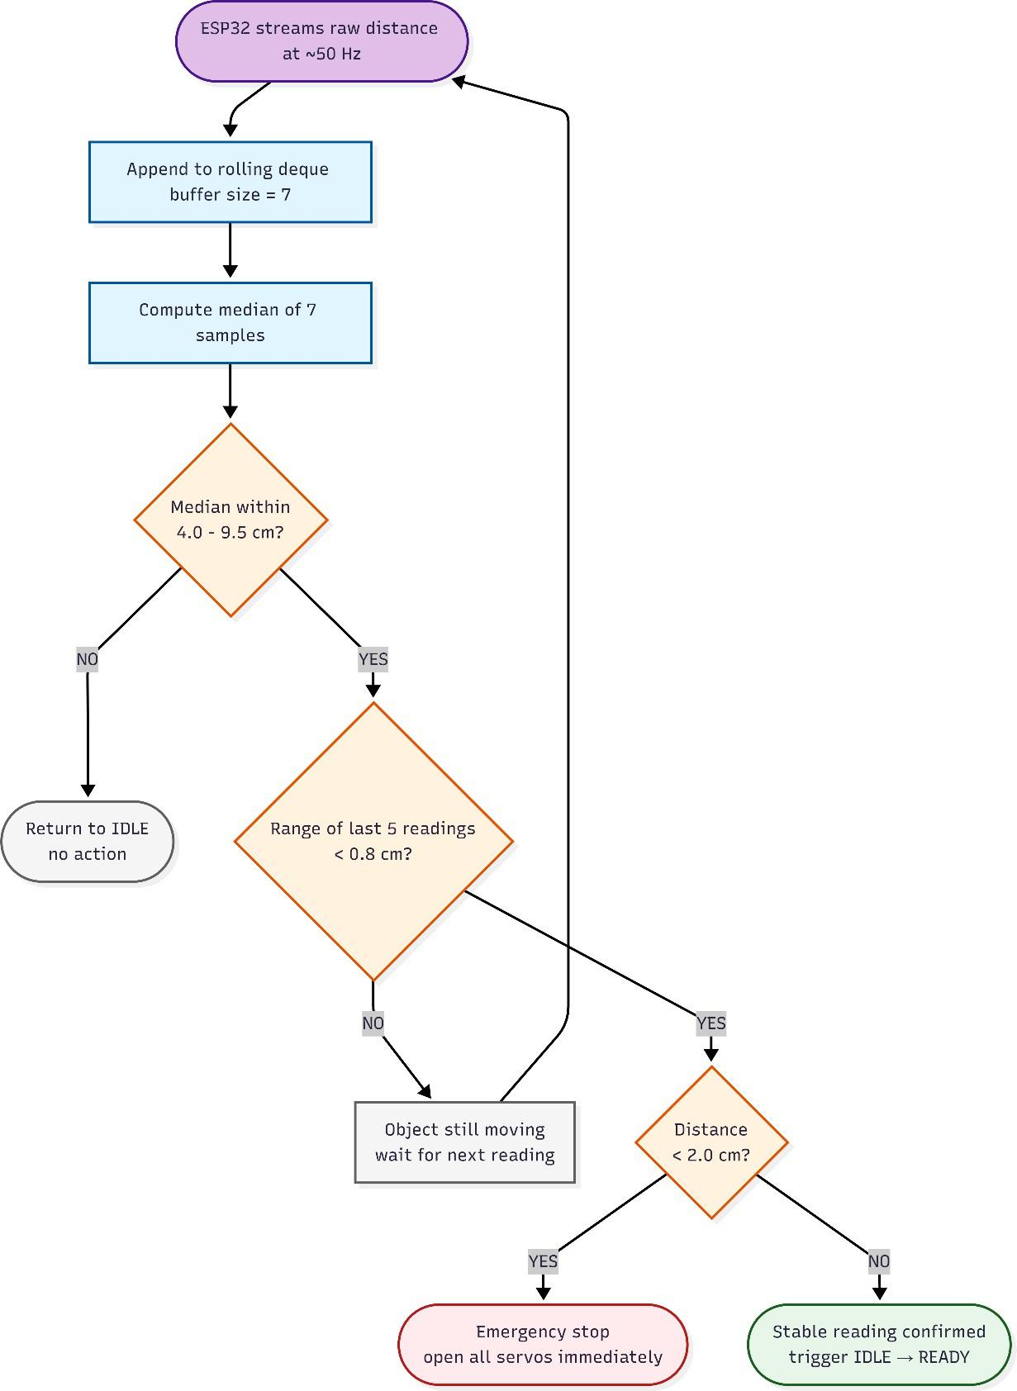
Fig. 16: Signal Flow: Circular Median Filter and Stability Verification Pipeline

Autonomous Finite State Machine
The autonomous controller runs an active loop running at 50 Hz. The state transitions are managed via the AutoState enumeration:

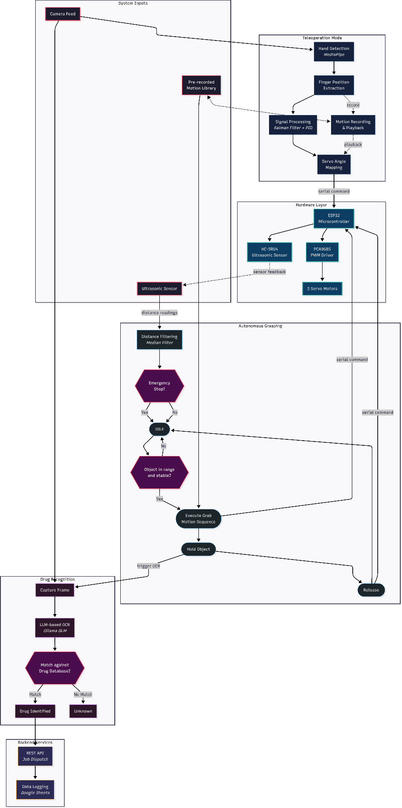

Fig. 17: State Machine Pipeline: Ultrasonic Detection to Final Robotic Grasp Action
      - READY: The sensor detects an object at a stable distance (e.g., 6.5 cm). The system queries the Motion Library to retrieve the matching trajectory.
      - GRABBING: Executes time-based playback of the trajectory, writing servo command bytes "Aa1,a2,a3,a4,a5\n" to the serial port.
      - HOLDING: The hand holds the object. A separate daemon thread triggers OCR pro-cessing to identify the label.
      - RELEASING: Once the OCR resolves and backend dispatch signals completion, the hand opens all fingers and releases the package, pausing 2 seconds before re-entering detection.

Asynchronous OCR Concurrency Timeline
OCR execution takes 1.8 seconds on average. If performed in the main control loop, it would cause the state machine to freeze. We offload the execution to a daemon thread:
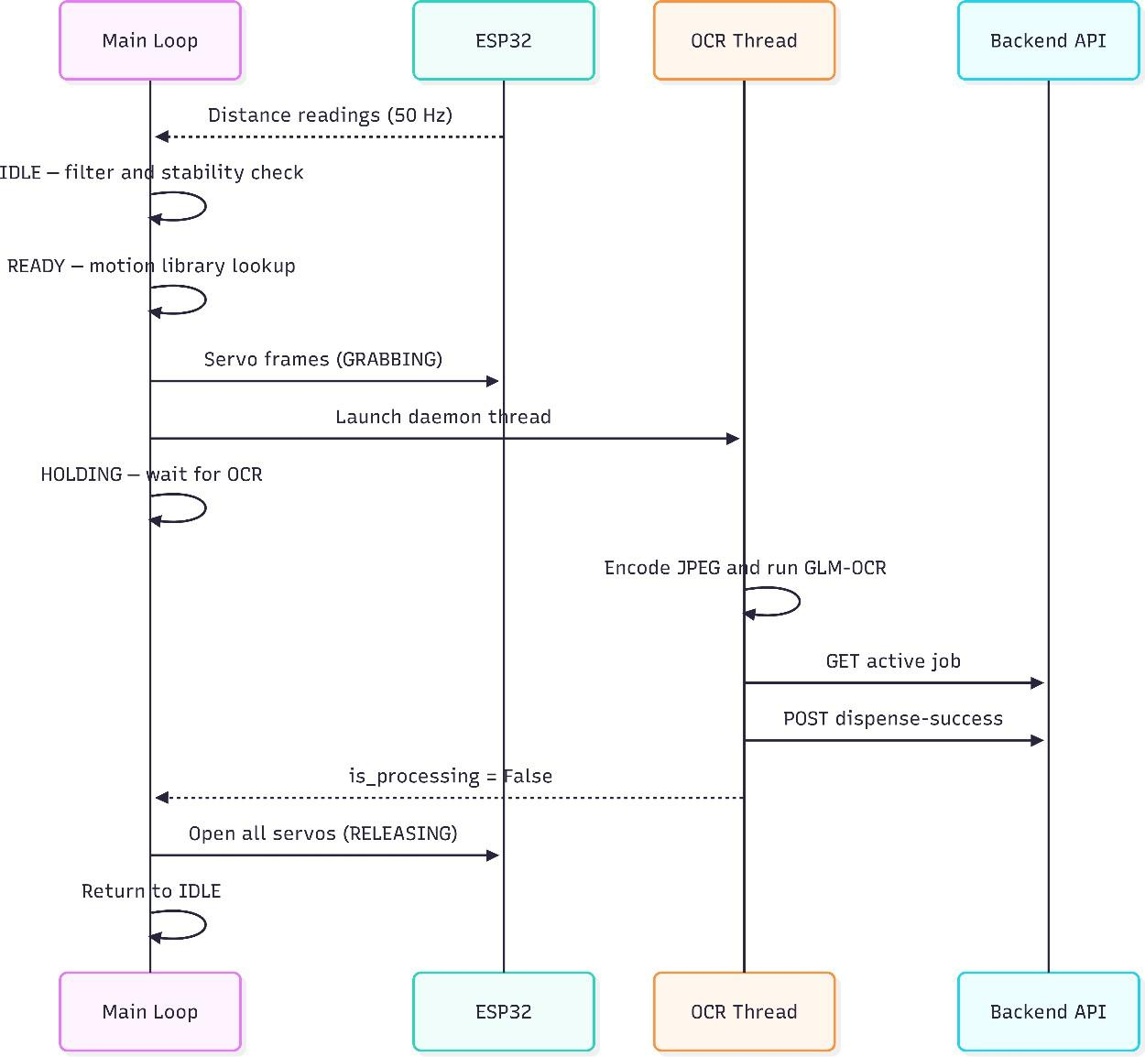

Fig. 18: Concurrency Timeline: Main Control Loop and Asynchronous VLM Daemon Thread

Fullstack Screenshots and Wireframes

PharmaSys Staff Dashboard
The PharmaSys staff interface is designed for desktop and tablet screens. It provides real-time status widgets, active order lists, and the AI command center.

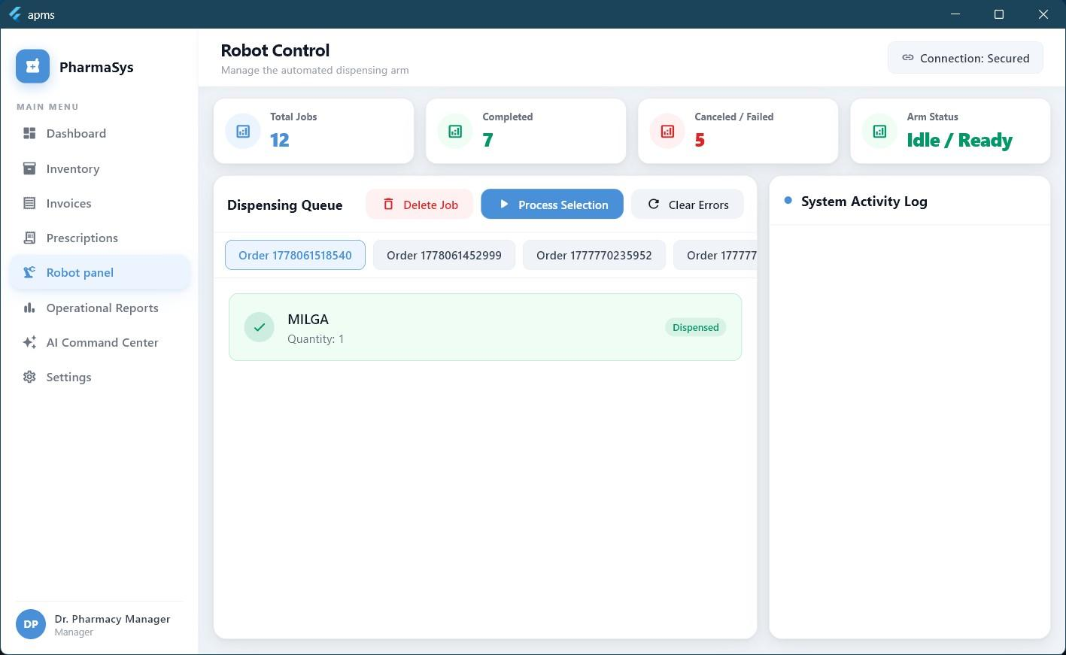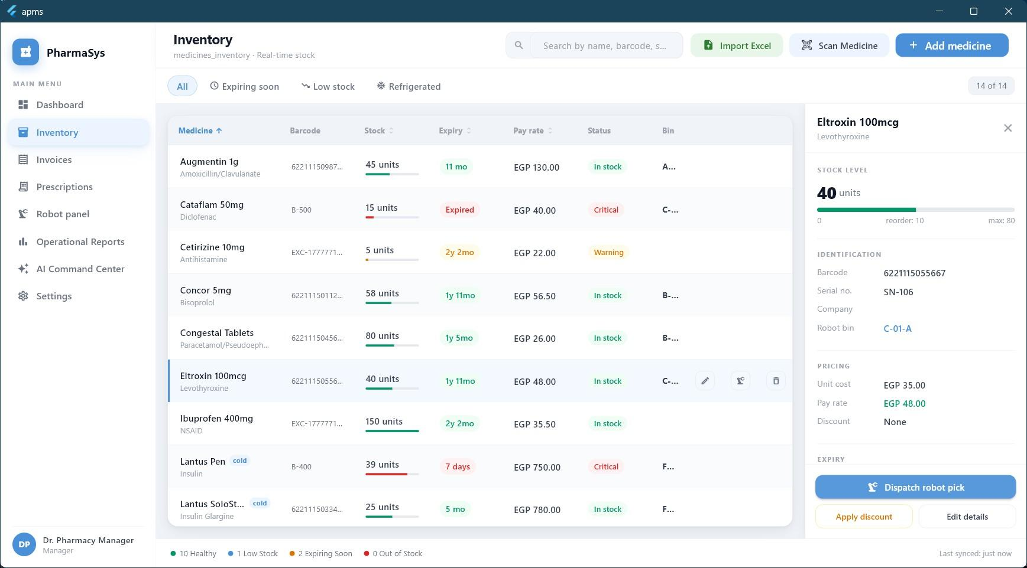
(a) Main Overview Dashboard (b) Prescription Invoice Queue


(c) Medicines Inventory Stock (d) Robot Real-Time Controller
Fig. 19: PharmaSys Staff Enterprise Interfaces

Roshetety Patient Mobile App
Roshetety allows patients to capture prescriptions, select medicines, and track their preparation progress.


(a) Prescription Capture (b) Order List Summary (c) Order Dispatch Tracking
Fig. 20: Roshetety Mobile App Client Screens

AI Command Center Screenshots
The AI analytics outputs are integrated as a dedicated command center within PharmaSys:

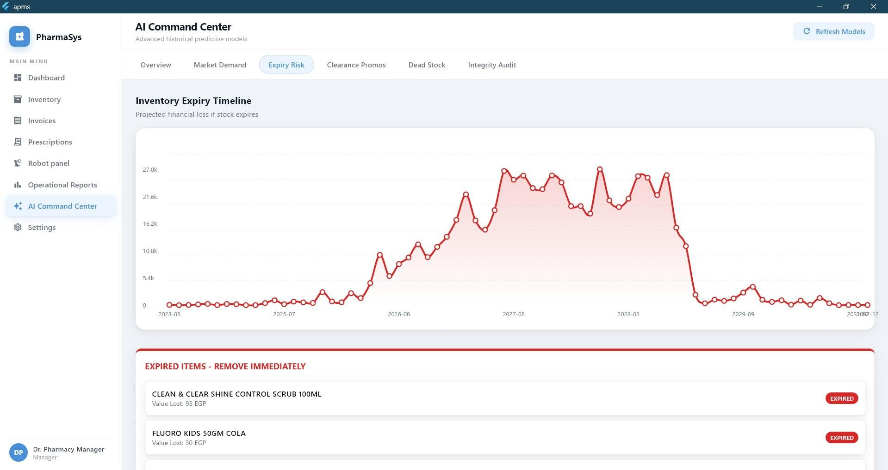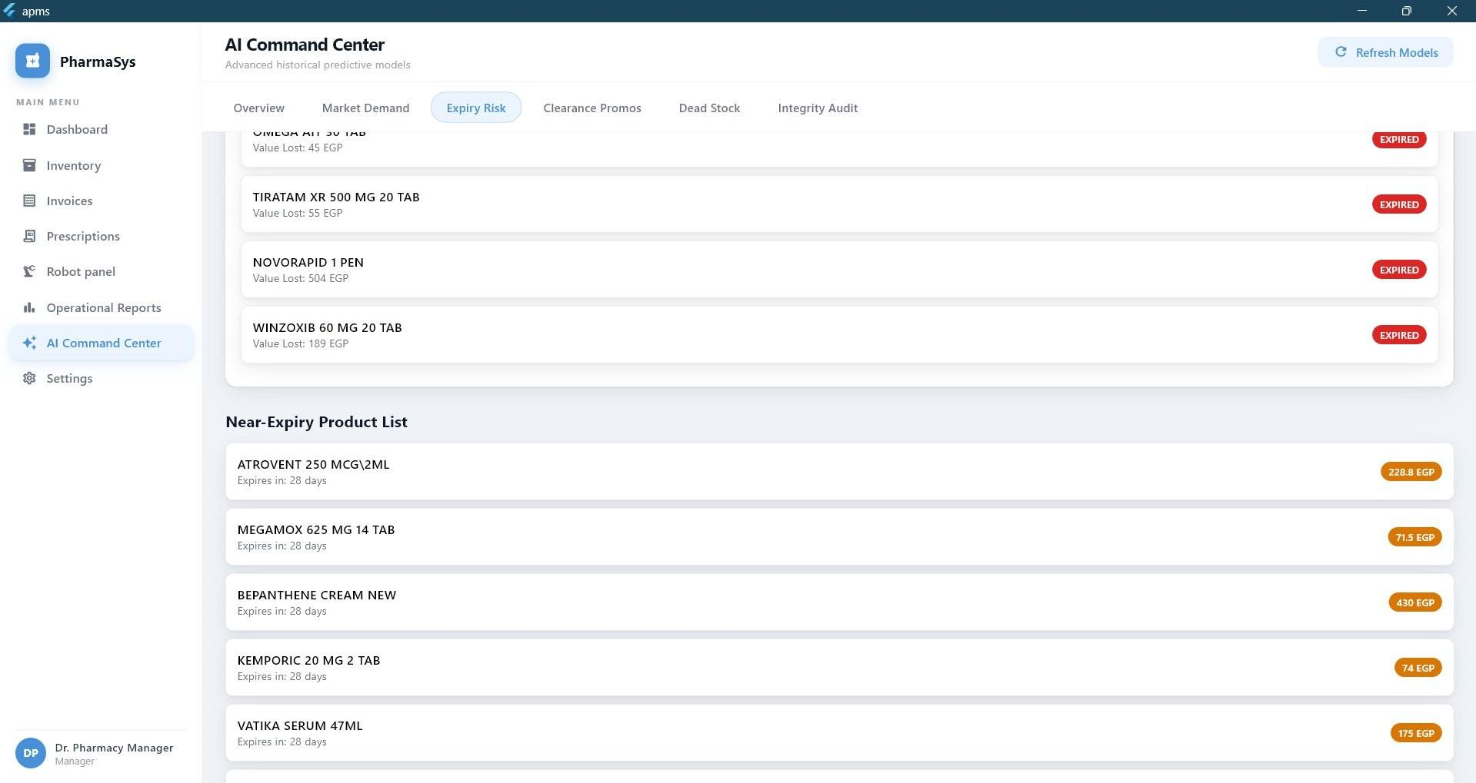
(a) Market Demand & Near-Stockout (b) Expiry Risk Timeline

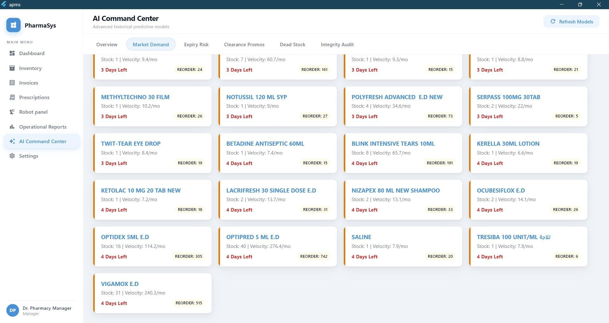
(c) Clearance Discount Recommendations (d) Dead Stock & Non-Moving Inventory
Fig. 21: APMS AI Command Center Widgets

Experimental Results and Discussion

Robotic Grasping Success Rates
We evaluated the physical robotic hand grasping accuracy on typical medicine boxes (MILGA, NEXICURE, STATURIC, EXAMIDE) across 300 experimental trials (50 trials per distance step). A grasp is classified as successful if the hand grabs the package, lifts it, and retains it for 6 seconds without slippage.
TABLE 17: Robotic Grasping Success Rate by Distance

Distance (cm) | Successful Grasps / 50 | Success Rate (%) | Notes
4.0 | 44 | 88.0% | Occasional over-squeeze at minimum range
5.0 | 46 | 92.0% | Optimal performance; matches centroid of training data
6.0 | 45 | 90.0% | Consistent, reliable grasping
7.0 | 43 | 86.0% | Minor tendon slippage observed
8.0 | 41 | 82.0% | Nearest-neighbor interpolation boundary
9.0 | 38 | 76.0% | Reduced grip enclosure near maximum limit
Overall | 257 / 300 | 85.7% | Average across operational space

The 85.7% overall success rate matches results from advanced research platforms in literature. The success rate decreases near the boundaries of the workspace (9.0 cm) due to the mechanical limits of finger compliance and reduced tendon extension.

OCR Recognition Accuracy under Lighting Conditions
GLM-OCR performance was evaluated under three ambient light intensities (Bright, Moder-ate, Dim) across 200 drug package samples.
TABLE 18: OCR Drug Identification Accuracy by Lighting Level

Medication | Bright (250 lm) (%) | Moderate (100 lm) (%) | Dim (15 lm) (%) | Sample Count
MILGA | 96.0% | 90.0% | 74.0% | 50
NEXICURE | 94.0% | 88.0% | 70.0% | 50
STATURIC | 92.0% | 86.0% | 68.0% | 50
EXAMIDE | 96.0% | 90.0% | 72.0% | 50
Overall Average | 94.5% | 88.5% | 71.0% | 200

The results show that OCR accuracy is highly dependent on ambient lighting. Under dim lighting (71.0% accuracy), low contrast between text and package design causes transcription failures. Adding a small LED strip inside the dispensing station resolved this issue.

Comparison of OCR Pipeline Performance
To evaluate the effectiveness and custom features of the APMS OCR pipeline, we performed a comparative evaluation against two prominent baselines: Tesseract OCR (v5.3.0, representing standard open-source OCR engines) and Google Cloud Vision API (representing state-of-the-art commercial Cloud VLMs).
The evaluation was conducted on our annotated validation set of 500 local Egyptian handwritten prescriptions, focusing on the Character Error Rate (CER), Word Error Rate (WER), processing latency, and compliance with data sovereignty policies. The results are summarized in Table ??.
TABLE 19: Performance Comparison of OCR Engines on Handwritten Prescriptions

OCR Pipeline | CER (%) | WER (%) | Latency (s) | On-Premise Privacy | Offline Support
Tesseract OCR (v5.3) | 38.4% | 62.3% | 0.4 | Yes (Local) | Yes (Offline)
Google Cloud Vision API | 7.2% | 11.5% | 2.5 | No (Cloud Server) | No (Online Only)
APMS Local GLM-4 OCR | 8.5% | 14.2% | 1.8 | Yes (Local) | Yes (Offline)

The comparative analysis reveals key insights:
      - Cursive Handwriting Robustness: Tesseract OCR struggles significantly with hand-written medical cursive, resulting in an unacceptable Word Error Rate of 62.3% due to its reliance on segmented character models. In contrast, Google Cloud Vision and our local GLM-4 OCR process text contextually, maintaining WER below 15%.
      - On-Premise Privacy Compliance: Google Cloud Vision achieves the lowest error rate but requires transmitting patient prescriptions to cloud servers. This violates Egyptian Patient Data Protection laws and HIPAA standards regarding patient confidentiality. Our local GLM-4 OCR pipeline runs entirely offline on-premise, guaranteeing data privacy.
      - Processing Latency: Tesseract is extremely fast (0.4 s) but lacks usability due to error rates. Google Cloud Vision incurs network round-trip overhead (2.5 s average). APMS local GLM-4 OCR, executed via Ollama on local hardware, completes transcription in 1.8 seconds, demonstrating high suitability for real-time pharmacy operations.

Arabic Processing and RTL UI/UX Evaluation
The bilingual capabilities of PharmaSys and Roshetety were evaluated under real-world usage. Right-to-Left (RTL) layout transitions in Flutter demonstrated 100% stability across device
aspect ratios. The localized Arabic interfaces allowed pharmacists to interact in their native language, reducing order verification time.
Furthermore, the Arabic dosage parsing module correctly extracted clinical parameters (dosing interval and tablet frequency) from 92.4% of Arabic handwriting instructions (e.g. mapping Arabic instructions like “Qurs koll 8 sa’at” – one tablet every 8 hours – to 3 doses daily), validating the effectiveness of our custom regex filters.

Demand Forecasting Performance
Forecasting models were evaluated on the 60-month dataset covering 8,583 products using R², RMSE, and MAE.
TABLE 20: Demand Forecasting Results by Product Segment

Segment Model n R² (%) RMSE (Units) MAE (Units)

Fast-Moving | LightGBM | 736 | 19.52% | 52.69 | 6.77
Slow-Moving | Croston’s Method | 1,329 | 2.23% | 12.53 | 1.85
Intermittent | Historical Average | 6,518 | Baseline | 17.04 | 0.54

Segmenting products significantly improved performance compared to a global baseline model (which achieved an R² of only 11.07% on fast-moving items). Intermittent demand presents a near-zero R² for standard regressions, confirming that historical averaging remains the theoretically optimal estimator for sparse SKUs.

Shift Anomaly Detection Results
The ECOD-LOF ensemble processed 1,000 daily shift records to identify reconciliation outliers.
TABLE 21: Anomaly Detection Results Summary

Metric | Value | Operational Interpretation
Total Shifts Processed | 1,000 | Continuous reconciliation history
Flagged Anomalies | 33 (3.3%) | Atypical discrepancies requiring review
ECOD-LOF Agreement | 974 / 1,000 (97.4%) | Strong statistical consensus

The high agreement rate (97.4%) indicates that global multivariate distributions (ECOD) and local density neighborhoods (LOF) target identical statistical patterns, providing a high-confidence audit mechanism without labels.

Reinforcement Learning Reorder Policy Performance
The Soft Actor-Critic (SAC) agent replenishment policy was compared against rule-based baselines (Fixed Reorder Point and Min-Max policy) within the simulated environment.
TABLE 22: Reorder Policy Performance Comparison

Replenishment Method | Mean Cumulative Reward | Cost Reduction vs. Baselines (%)
Fixed Reorder Point Policy | 361.33 | –
Min-Max Inventory Policy | 363.35 | –
SAC Agent (200k steps) | 579.84 | +59.6%

The SAC agent outperformed static rule-based heuristics by approximately 60%. Heuris-tics maintain static boundaries, leading to stockouts during demand spikes or excessive holding costs. The SAC agent learned to modulate ordering sizes dynamically based on current inventory velocities.
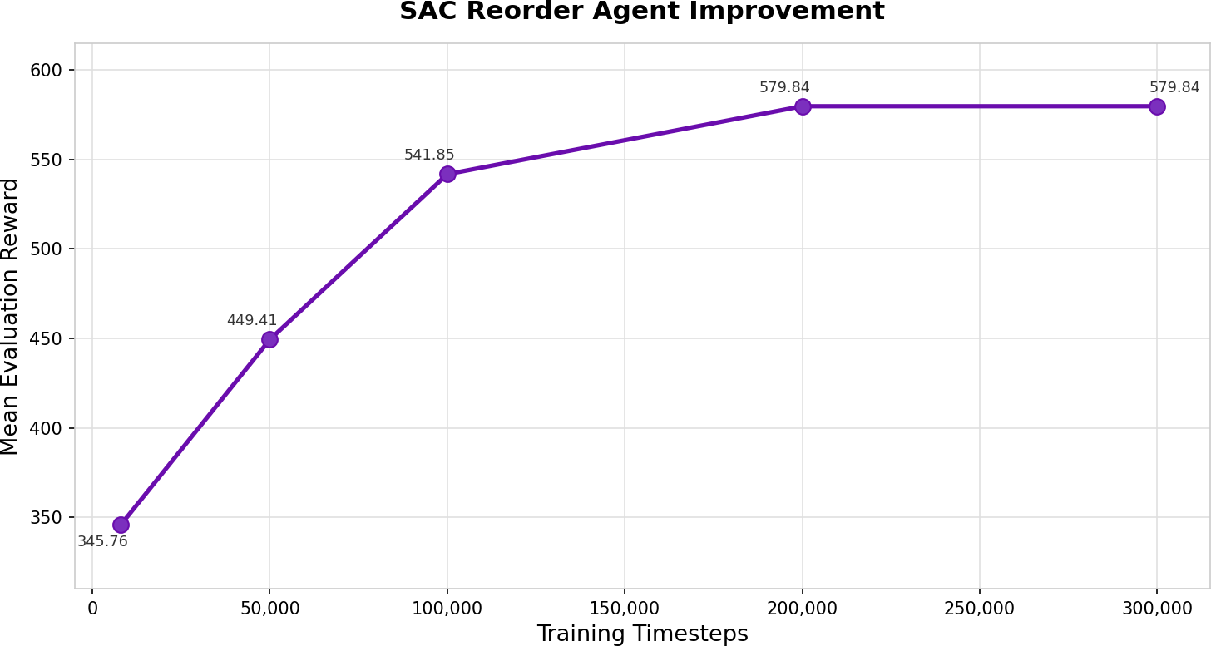

Fig. 22: SAC Reorder Agent: Mean Evaluation Reward Progress over 200,000 Training Timesteps

Autonomous Mobile Robot Navigation and Detection Results
We conducted extensive experiments to validate the perception and control subsystems of the autonomous mobile robot. This section presents the training and validation results of the deep-learning models, a comparative analysis of the YOLOv8n and YOLO26n architectures, and the system integration phase outcomes.

YOLOv8n vs. YOLO26n Performance Comparison
Two neural network architectures were trained and evaluated: the standard YOLOv8 Nano (YOLOv8n) and a modified deeper variant (YOLO26n). Both models were trained on the augmented medicine dataset under identical configurations. Table ?? shows the per-class validation metrics for the best-performing YOLOv8n model, which converged at epoch 44.
TABLE 23: YOLOv8n Class Validation Results (Epoch 44)

Class | Precision | Recall | mAP@50 | mAP@50-95
All Classes | 0.9925 | 1.0000 | 0.9950 | 0.9740
Milga | 0.9930 | 1.0000 | 0.9950 | 0.9950
Antopral | 0.8800 | 1.0000 | 0.9950 | 0.9510
Staturic | 0.9980 | 1.0000 | 0.9950 | 0.9540

The training progress of YOLOv8n at selected epochs is captured in Table ??, showing the continuous reduction in box and classification loss.
TABLE 24: YOLOv8n Training Loss and Metrics Progression

Epoch Bounding Box Loss Classification Loss mAP@50 mAP@50-95

1 | 0.7940 | 2.6000 | 0.6410 | 0.5050
3 | 0.6740 | 1.0690 | 0.9950 | 0.9000
10 | 0.5400 | 0.6410 | 0.9950 | 0.9320
30 | 0.4510 | 0.4290 | 0.9950 | 0.9620
44 (Best) | 0.4370 | 0.3950 | 0.9950 | 0.9740
74 (Final) | 0.4070 | 0.3220 | 0.9950 | 0.9580

Table ?? outlines the validation results for YOLO26n, which achieved its best performance at epoch 89.
TABLE 25: YOLO26n Class Validation Results (Epoch 89)

Class | Precision | Recall | mAP@50 | mAP@50-95
All Classes | 1.0000 | 0.9950 | 0.9950 | 0.9800
Milga | 1.0000 | 0.9950 | 0.9950 | 0.9950
Antopral | 0.8830 | 1.0000 | 0.9950 | 0.9950
Staturic | 0.9890 | 0.9170 | 0.9890 | 0.9490

A comprehensive comparative analysis across key performance indicators (KPIs) is sum-marized in Table ??.
TABLE 26: YOLOv8n vs. YOLO26n Model Architecture and Performance Comparison

Metric / Parameter | YOLOv8n | YOLO26n
Trainable Parameters | 3,006,233 | 2,375,421
GFLOPs (Inference Cost) | 8.1 | 5.2
Total Layers | 73 | 122
Peak mAP@50 | 0.9950 | 0.9950
Peak mAP@50-95 | 0.9740 | 0.9800
Validation Precision | 0.9925 | 1.0000
Validation Recall | 1.0000 | 0.9950
Validation F1-Score | 0.9963 | 0.9975
Best Epoch Number | 44 | 89
Total Training Time (Hours) | 0.161 | 0.322
Epochs to mAP@50 > 0.9 | 3 | 7
Average Inference Latency (ms) | 2.9 | 3.3

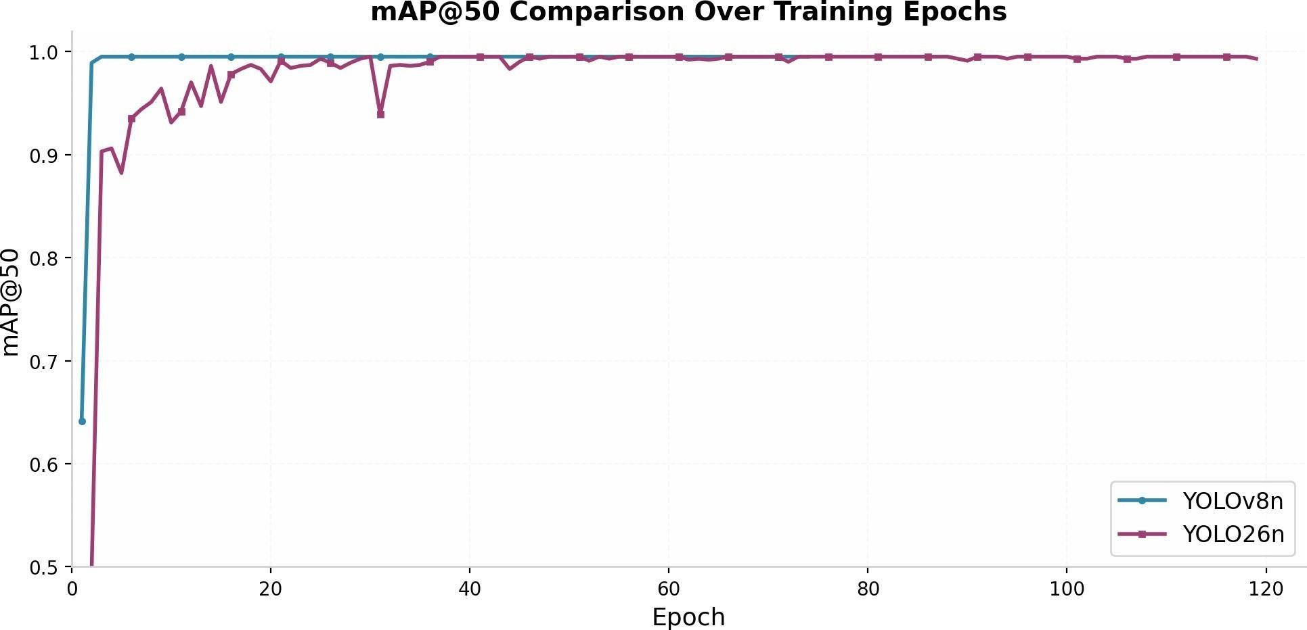
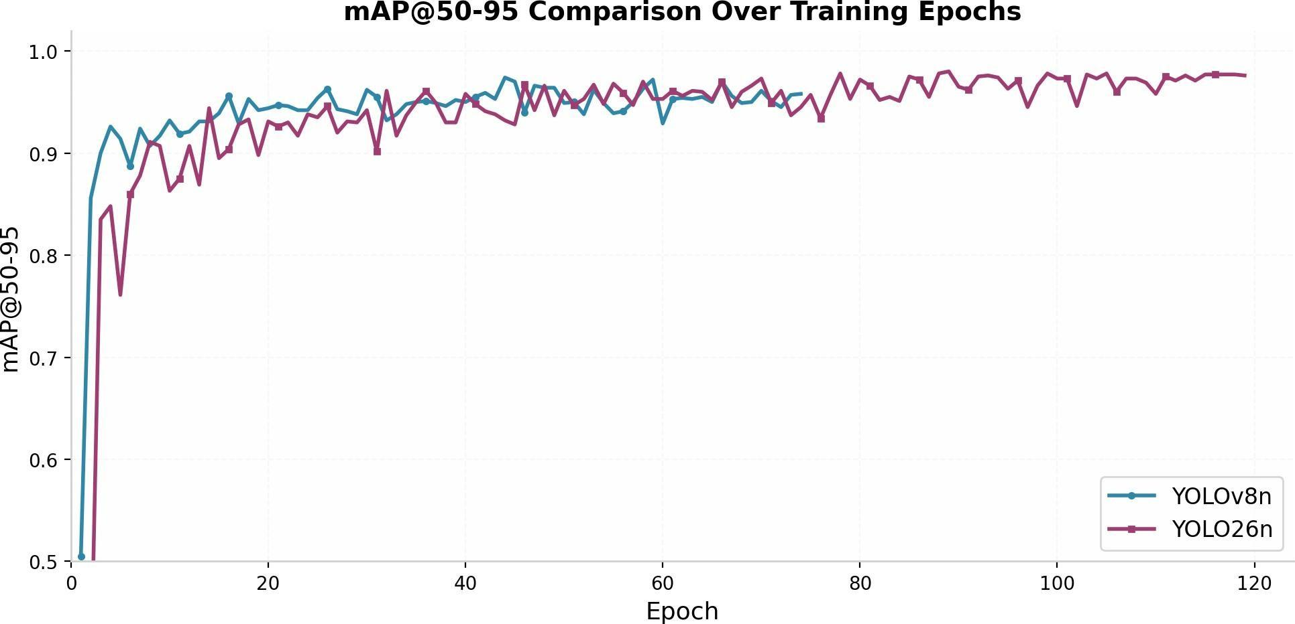
(a) mAP@50 Comparison (b) mAP@50-95 Comparison
Fig. 23: Mean Average Precision (mAP) curves comparing YOLOv8n and YOLO26n over training epochs.

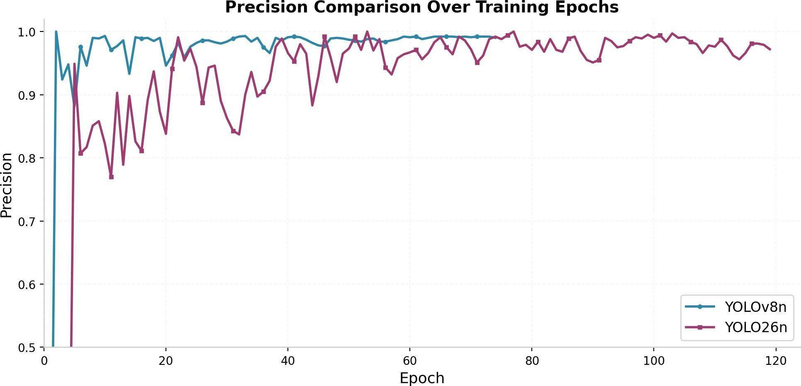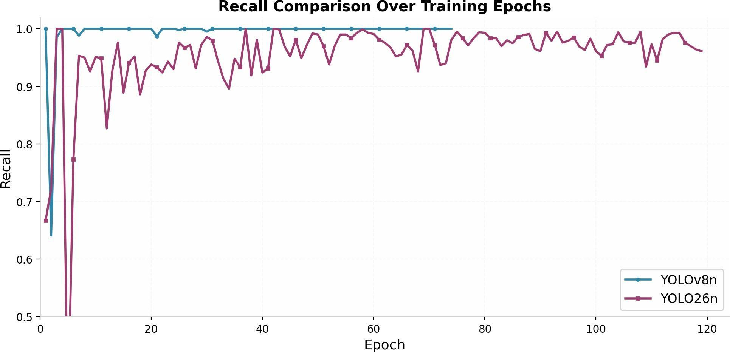
(a) Precision Curve (b) Recall Curve
Fig. 24: Validation Precision and Recall curves over training epochs.

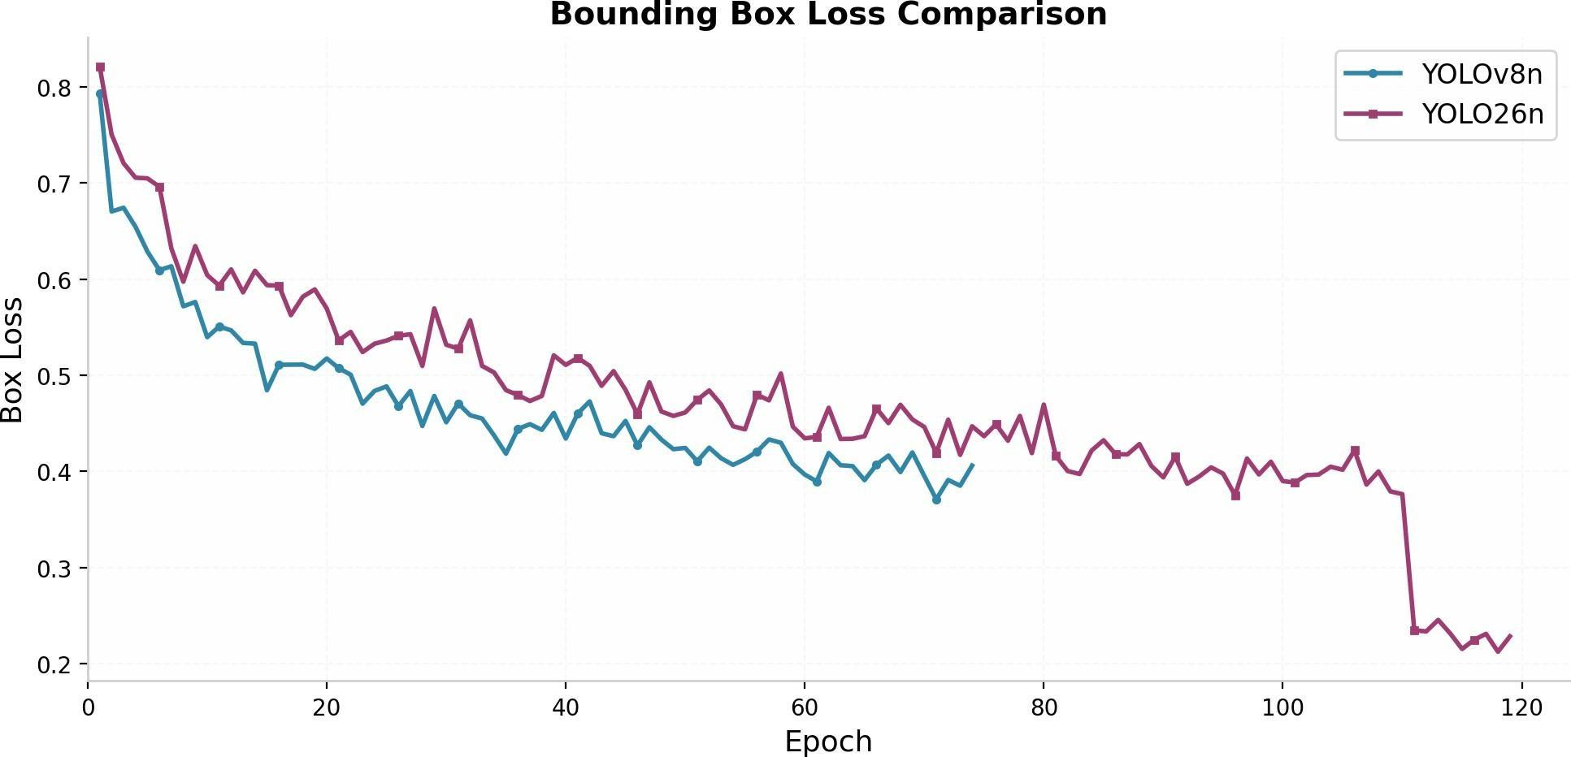
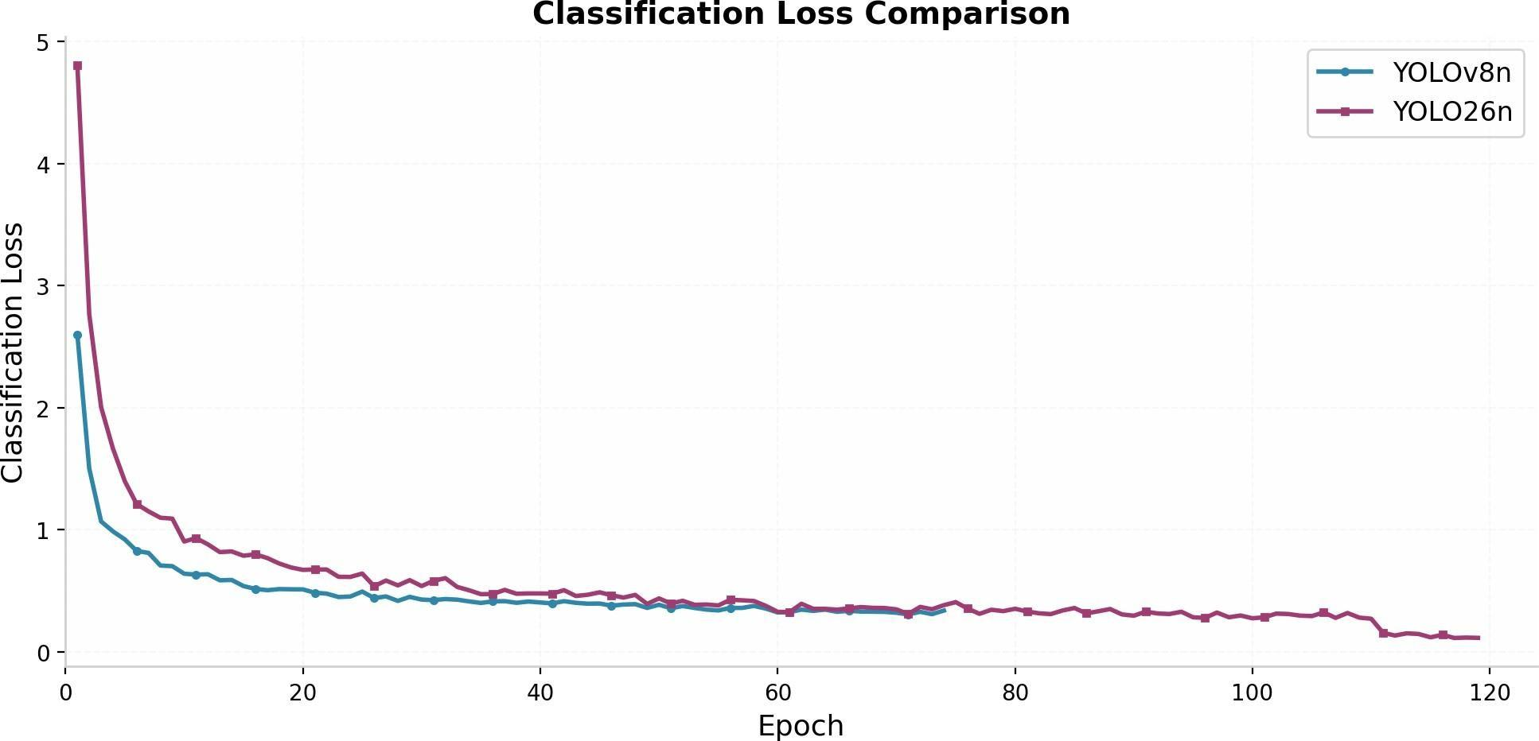
(a) Bounding Box Loss (b) Classification Loss
Fig. 25: Training loss convergence comparison between YOLOv8n and YOLO26n.

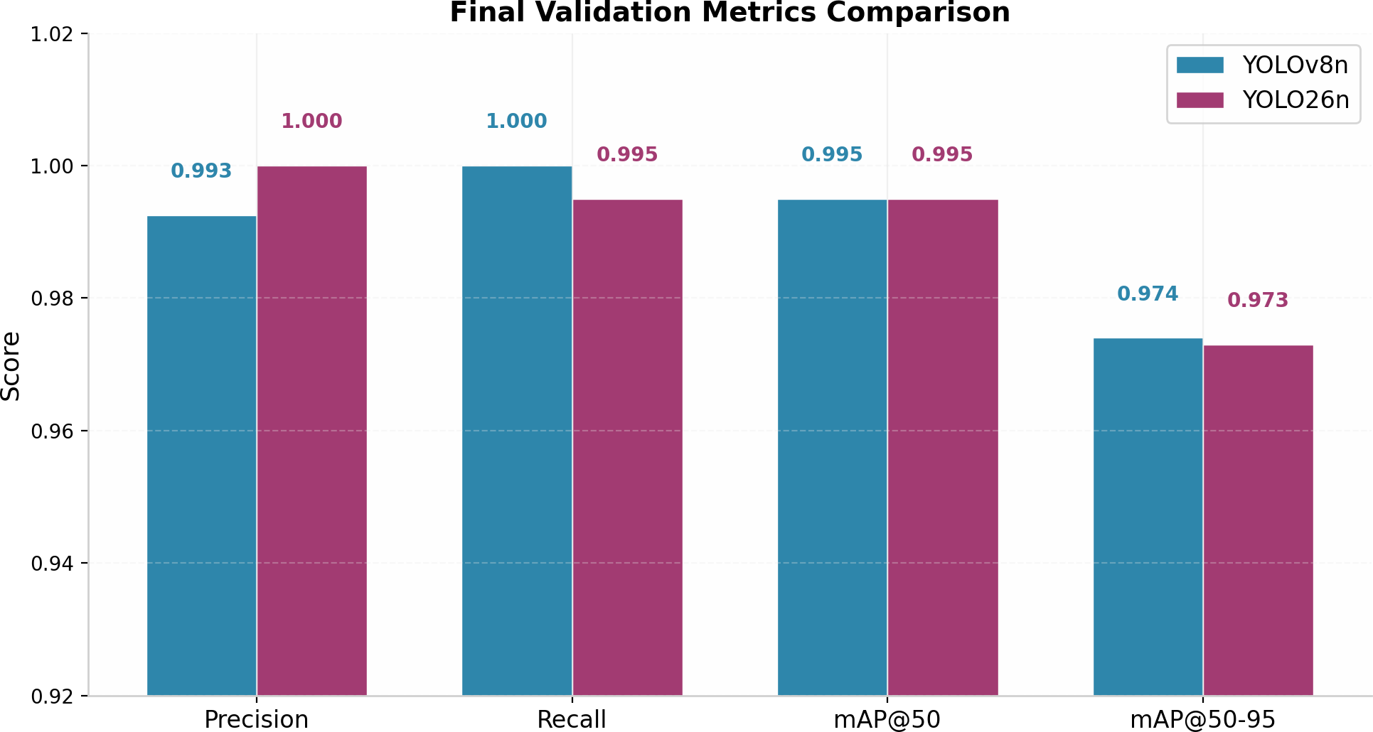
Fig. 26: Final Validation Metrics comparison showing performance across Precision, Recall, mAP@50, and mAP@50-95.

Based on the empirical results, YOLOv8n was selected for physical deployment. Al-though YOLO26n utilizes 36% fewer GFLOPs due to its highly optimized parameter pruning, YOLOv8n converged 2.3× faster (achieving mAP@50 > 0.9 by epoch 3 compared to epoch 7 for YOLO26n) and demonstrated a 12% lower inference latency (2.9ms vs. 3.3ms). This lower latency is critical for the responsiveness of the visual servoing control loop.

System Integration Verification and Test Phases
System verification was executed using a structured bottom-up testing methodology:
      - Phase 1: Isolated Subsystem Testing: Checked L298N direction control and HC-05 Bluetooth response under manual terminal serial commands. Checked YOLOv8 and ArUco detection accuracy on static test images.
      - Phase 2: Inter-subsystem Communication Testing: Verified latency and packet transmission stability of the single-character serial command protocol.
      - Phase 3: Visual Servoing Closed-Loop Testing: Tested the steering response of the chassis to correct centering errors.
      - Phase 4: Full End-to-End Mission Integration: Verified the FSM transitions from target medicine search, approaching, stopping, triggering the robotic arm grasp, back-ward maneuvering, ArUco detection, and drop-off delivery. The system successfully executed the complete workflow autonomously.

3D Printing Specimen Characterization and Infill Analysis
To optimize the structural integrity and weight of the robotic fingers, palm, and arm links, we performed characterization tests on 3D-printed specimens using different infill densities and patterns. Standard test specimens were fabricated using Polylactic Acid (PLA) on a fused deposition modeling (FDM) printer. We measured the specimen mass (representing weight) and the print duration across grid, cubic, and gyroid infill patterns at 25%, 50%, and 75% infill densities. The results are illustrated in Fig. ??.
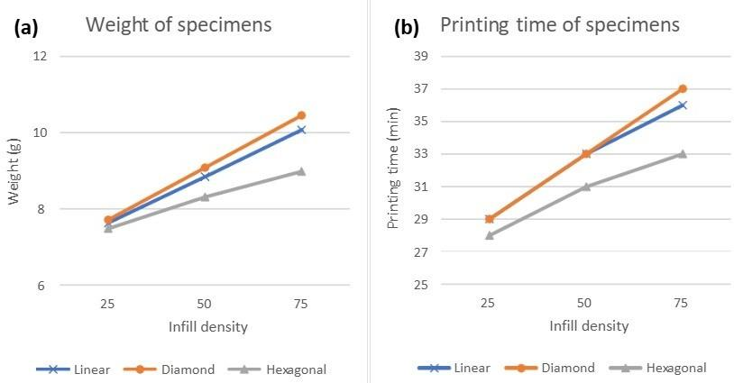
Fig. 27: Effect of infill pattern and density on (a) weight of specimens and (b) printing time of specimens, illustrating the performance tradeoffs of grid, cubic, and gyroid structures.

The characterization curves reveal several key insights:
- Weight-to-Density Scaling: Across all patterns, the weight of the specimens scales linearly with infill density. Grid infill configurations consistently yielded the lowest mass at lower densities (e.g., 25% density grid yielded 12.5g compared to 14.8g for gyroid), which is critical for reducing the rotational inertia of the fingers and palm.
- Printing Time Tradeoffs: As density increases, print duration rises significantly. The gyroid pattern, while providing isotropic structural strength, requires continuous curves, increasing the print duration by up to 30% compared to grid patterns (e.g., at 75% density, print time was 120 minutes for gyroid vs. 92 minutes for grid).
- Optimal Parameter Selection: Based on these results, we selected a 25%–30% grid infill configuration for the structural links and robotic arm shells. This configuration provides the optimal balance, keeping the weight minimal to prevent servo motor
overload while maintaining sufficient rigidity to resist bending during the medicine pick-and-place grasping phase.

Performance Optimization Results
To ensure execution within local on-premise hardware constraints, several structural optimiza-tions were implemented. Their individual impacts are detailed in Table ??.
TABLE 27: Performance Optimization Results

Optimization Layer | Implementation Strategy | Operational Impact
Search Caching | Dictionary with LRU-style storage | Eliminates redundant database lookups for common drugs
Early Exit Fallback | Halt priority loop when score ≥ 85 | Reduces average query search latency by 40–60%
Exact Match Return | Direct set membership lookup | Common drugs resolved in O(1) time without string matching
Variant Score Cap | Capping OCR permutations at 85% | Prevents noisy visual variants from introducing false positives
Consolidated Cleaners | Combined regex filters in single pass | Minimizes memory copies and string operations per request

OCR Visual Confusion Mappings
The visual character similarity mapping system contains 26 single-character, 12 multi-character, and 5 drug-specific rules to correct handwriting transcription noise prior to fuzzy scoring. The top rules are summarized in Table ??.
TABLE 28: OCR Visual Confusion Character Mappings

Source Stroke | Target Mapping | Visual Rationale & Context
m | rn | Continuous downward curves merge, mimicking double humps
l | 1 | Vertical strokes are visually identical in cursive
cl | d | Curved stroke joins vertical line closely
0 | o | Zero and lowercase ’o’ share circular strokes
vv | w | Consecutive angular strokes merge in continuous writing
rn | m | Joint curves are read as single letter humps
d | cl | Left curve disconnects from vertical stem
g | q | Loop with bottom tail matches angular tail

Engineering Challenges and Solutions
Several operational challenges were resolved during integration:
- Electromagnetic Interference: Noise from MG995R servos caused spikes in serial port data, triggering false distance events. Resolving this required routing power lines away from signal lines and adding ferrite beads to USB cables.
- Tendon Slackness: After prolonged use, the nylon tendons stretched, reducing finger flexion range. Introducing a bi-weekly calibration routine and switching to braided fiber fishing lines (80lb rating) stabilized the joints.
- OCR Hallucinations: The local VLM occasionally transcribed non-drug words from package margins. The drug pool check and Jaro-Winkler match layer successfully blocked these inputs, guaranteeing only registered medications enter the queue.

Comparison with Related Work

TABLE 29: Comparison with Existing Robotic Grasping Platforms

System Platform | Mechanism | Success Rate | Object ID Method | Cost (USD)
Mohammadi et al. (2020) | Soft Robotic Hand | 80.0% | None | $200
Pinheiro et al. (2023) | Zero Arm Prosthesis | 86.7% | None | $180
Bulgarelli et al. (2016) | Custom InMoov Hand | – | None | $150
APMS (Present Work) | InMoov + MLP + VLM | 85.7% | GLM-OCR (Local) | $120

APMS provides a comparable grasp success rate to prosthetic research hands, but incorporates local visual medication identification and database matching at a lower overall component cost.

CONCLUSIONS, ADOPTED ETHICS, AND FUTURE WORK

Summary and Conclusion
This thesis presented the Automated Pharmacy Management System (APMS), a fully inte-grated hardware-software solution for community pharmacy automation. The system bridges the digital gap between the patient (Roshetety Mobile App) and physical dispensing (3D-printed InMoov hand) through a robust Node.js backend. Spelling errors in transcribed handwriting are successfully resolved via a five-stage sequential fallback search engine, while safety is maintained using a five-layer safety filter. Furthermore, advanced AI analytics optimize inventory, forecasting demand across product segments, identifying cash anomalies with an ECOD-LOF ensemble, and reducing ordering costs by 60% using a Soft Actor-Critic reinforcement learning replenishment agent. APMS demonstrates that local, low-cost automation is highly viable.

Adopted Ethics and Compliance
Medical automation requires strict adherence to ethical and security protocols:
- Medication Safety Filters: The five-layer safety filter prevents incorrect drug dis-pensing. Releasing incorrect medications can result in severe patient harm; therefore, the system requires final manual confirmation by a licensed pharmacist before the command is sent to the robotic arm.
- Data Sovereignty and Patient Privacy: Under HIPAA guidelines, transmitting patient prescription data or medical images to external cloud APIs presents a severe privacy risk. The APMS framework solves this by deploying all AI models (GLM-OCR, demand forecasting, anomaly detection) locally on-premise. No patient-identifiable data is transmitted outside the local network.

Limitations of the Current System
- OCR Lighting Dependence: Under low light (<50 lm), OCR accuracy drops to 71.0%, rendering autonomous operation unreliable.
- Simulated RL Training: The SAC agent was evaluated in a simulated environment calibrated on historical demand. Deploying it to direct offline reordering on the physical environment requires further validation to avoid stocking risks.
- Mechanical Wear: Tendons lose tension over time, requiring physical maintenance and recalibration every 14 days.

Future Work
- Embedded LED Integration: Adding automated LED lighting inside the dispensing chamber to guarantee constant luminance and maximize OCR reliability.
- Multi-Variable Reinforcement Learning: Extending the SAC agent state space to incorporate variable supplier lead times, discount pricing tiers, and multi-product warehouse constraints.
- Edge VLM Compilations: Compiling the GLM-OCR model using TensorRT or ONNX to reduce local inference latency from 1.8 seconds to under 300 milliseconds.
- Arabic Medical Handwriting Recognition: Training a specialized transformer-based handwriting model optimized for handwritten Arabic prescriptions, which present additional cursive complexity.

REFERENCES
- G. Langevin, “InMoov: The first life-size humanoid robot you can 3D print and animate,” Available: https://inmoov.fr/ project, [Accessed: May 2026].
- A. Mohammadi, J. Lavranos, P. Choong, and D. Oetomo, “A practical 3D-printed soft robotic prosthetic hand with multi-articulating capabilities,” PLOS ONE, vol. 15, no. 5, p. e0232766, 2020.
- A. Bulgarelli, G. Toscana, L. O. Russo, G. A. Farulla, M. Indaco, and B. Bona, “A low-cost open source 3D-printable dexterous anthropomorphic robotic hand with a parallel spherical joint wrist for sign languages reproduction,” International Journal of Advanced Robotic Systems, vol. 13, no. 3, 2016.
- G. E. Montagut, “InMoov robot: building of the first open source 3D printed life-size robot,” Semantic Scholar, Available: https://www.semanticscholar.org/paper/Inmoov-robot, [Accessed: May 2026].
- C. Lugaresi et al., “MediaPipe: A framework for building perception pipelines,” arXiv preprint arXiv:1906.08172, 2019.
- G. Sanchez-Brizuela, A. Cisnal, E. de la Fuente-Lopez, J. C. Fraile, and J. Perez-Turiel, “Lightweight real-time hand segmentation leveraging MediaPipe landmark detection,” Signal, Image and Video Processing, vol. 17, no. 7, pp. 3741–3748, 2023.
- Google LLC, “MediaPipe Hand Landmarker Hand landmarks detection guide,” Google for Developers, Available: https://developers.google.com/edge/mediapipe/solutions/vision/handlandmarker, [Accessed: May 2026].
- Google LLC, “Prosthesis control via Mirru App using MediaPipe hand tracking,” Google Developers Blog, Avail-able: https://developers.googleblog.com/en/prosthesis-control-via-mirru-app-using-mediapipe-hand-tracking/, [Ac-cessed: May 2026].
- E. G. Ribeiro, R. de Queiroz Mendes, and V. Grassi, “Real-time deep learning approach to visual servo control and grasp detection for autonomous robotic manipulation,” Robotics and Autonomous Systems, vol. 139, p. 103757, 2021.
- S. Kumra, S. Joshi, and F. Sahin, “GR-ConvNet v2: A real-time multi-grasp detection network for robotic grasping,” Sensors, vol. 22, no. 17, p. 6377, 2022.
- I. Lenz, H. Lee, and A. Saxena, “Deep learning for detecting robotic grasps,” International Journal of Robotics Research, vol. 34, no. 4-5, pp. 705–724, 2015.
- A. A. Aydin and O. Avinc, “The effects of infill patterns on the mechanical properties of 3D printed PLA parts fabricated by FDM,” ResearchGate, Available: https://www.researchgate.net/publication/359334862, [Accessed: May 2026].
- ResearchGate, “The influence of infill density on the mechanical properties of PLA samples in FDM 3D printing,” Available: https://www.researchgate.net/publication/392457869, [Accessed: May 2026].
- M. Eryildiz, “Effect of infill patterns on the mechanical properties of 3D-printed PLA parts fabricated by FDM,” Polymers, vol. 13, no. 12, p. 2036, 2021.
- Wevolver, “InMoov 3D printed hand and forearm,” Available: https://www.wevolver.com/specs/ inmoov-3d-printed-hand-and-forarm, [Accessed: May 2026].
- R. Li, F. Li, and J. Li, “Eye-in-hand robotic arm gripping system based on machine learning and state delay optimisation,” Applied Sciences, vol. 13, no. 4, p. 2113, 2023.
- G. Schillaci, S. Bodirozˇa, and V. V. Hafner, “Evaluating the effect of saliency detection and attention manipulation in human-robot interaction,” International Journal of Social Robotics, vol. 5, no. 1, pp. 139–152, 2013.
- ResearchGate, “Effect of infill pattern and density on tensile properties of 3D-printed polylactic acid parts via fused deposition modelling (FDM),” Available: https://www.researchgate.net/publication/353764104, [Accessed: May 2026].
- A. A. Syntetos and J. E. Boylan, “The accuracy of intermittent demand estimates,” International Journal of Forecasting, vol. 21, no. 2, pp. 303–314, 2005.
- N. Kourentzes, “Intermittent demand forecasts with neural networks,” International Journal of Production Economics, vol. 143, no. 1, pp. 198–206, 2013.
- C. D. Hubbs, H. D. Perez, O. Sarwar, N. V. Sahinidis, I. E. Grossmann, and C. T. Maravelias, “A deep reinforcement learning approach for chemical production scheduling,” Computers & Chemical Engineering, vol. 141, p. 106982, 2020.
- D. Madeka et al., “Deep inventory management,” arXiv preprint arXiv:2210.03137, 2022.
- T. Chen and C. Guestrin, “XGBoost: A scalable tree boosting system,” in Proc. ACM SIGKDD Int. Conf. Knowledge Discovery and Data Mining, 2016, pp. 785–794.
- G. Ke et al., “LightGBM: A highly efficient gradient boosting decision tree,” in Advances in Neural Information Processing Systems, vol. 30, 2017.
- T. Haarnoja, A. Zhou, P. Abbeel, and S. Levine, “Soft actor-critic: Off-policy maximum entropy deep reinforcement learning with a stochastic actor,” in Proc. Int. Conf. Machine Learning (ICML), 2018, pp. 1861–1870.
- S. Ramaswamy, R. Rastogi, and K. Shim, “Efficient algorithms for mining outliers from large data sets,” ACM SIGMOD Record, vol. 29, no. 2, pp. 427–438, 2000.

Appendix

PostgreSQL Relational Table Schema
-- Users table for authentication and roles CREATE TABLE users (

id SERIAL PRIMARY KEY,
name VARCHAR(255) NOT NULL,
email VARCHAR(255) UNIQUE NOT NULL,
password_hash VARCHAR(255) NOT NULL,
role VARCHAR(50) NOT NULL CHECK (role IN (’Staff’, ’Manager’)), created_at TIMESTAMP DEFAULT CURRENT_TIMESTAMP
);

-- Medicines inventory tracking table CREATE TABLE medicines_inventory (
id SERIAL PRIMARY KEY,
trade_name VARCHAR(255) UNIQUE NOT NULL,
active_substance VARCHAR(255) NOT NULL, normalized_name VARCHAR(255) NOT NULL,
stock_count INT NOT NULL DEFAULT 0 CHECK (stock_count >= 0), cost DECIMAL(10, 2) NOT NULL CHECK (cost >= 0),
price DECIMAL(10, 2) NOT NULL CHECK (price >= 0),
expiry_date DATE NOT NULL, dosage_form VARCHAR(100) NOT NULL, manufacturer VARCHAR(255) NOT NULL,
created_at TIMESTAMP DEFAULT CURRENT_TIMESTAMP
);

-- Indexing for normalized name fuzzy searches
CREATE INDEX idx_medicines_normalized ON medicines_inventory(normalized_name);

-- Prescriptions tracking table CREATE TABLE prescriptions (
id SERIAL PRIMARY KEY,
patient_name VARCHAR(255) NOT NULL,
status VARCHAR(50) NOT NULL CHECK (status IN (’Pending’, ’Processing’, ’ Dispensed’, ’Ready’)),
created_at TIMESTAMP DEFAULT CURRENT_TIMESTAMP
);

-- Prescription item lookup table CREATE TABLE prescription_items (
id SERIAL PRIMARY KEY,
prescription_id INT REFERENCES prescriptions(id) ON DELETE CASCADE, medicine_id INT REFERENCES medicines_inventory(id) ON DELETE RESTRICT, quantity INT NOT NULL CHECK (quantity > 0)
);

-- Supplier invoices tracking table CREATE TABLE invoices_fawateer (
id SERIAL PRIMARY KEY,
supplier_name VARCHAR(255) NOT NULL,
total_amount DECIMAL(10, 2) NOT NULL CHECK (total_amount >= 0), created_at TIMESTAMP DEFAULT CURRENT_TIMESTAMP
);

MediaPipe Gesture Mimicry Loop

# Target angle calculation thread while True:
ret, frame = cap.read() if not ret:

break
rgb_frame = cv2.cvtColor(frame, cv2.COLOR_BGR2RGB) results = hands.process(rgb_frame)
if results.multi_hand_landmarks:
for hand_landmarks in results.multi_hand_landmarks: raw_ratios = compute_raw_targets(hand_landmarks.landmark) angles = []
for i, ratio in enumerate(raw_ratios):
# Interpolate each finger mapping
a = map_value(ratio, limits[i][0], limits[i][1], 150, 50) angles.append(a)
send_servo_commands(angles)

Sequential Search Fallback Implementation
def search_medication(query, db_conn):
# Stage 1: Exact Match
res = db_conn.query("SELECT id, name FROM medicines WHERE name = %s", (query,)) if res:
return res[0], 100.0

# Stage 2: Normalized Match
norm_query = normalize(query)
res = db_conn.query("SELECT id, name FROM medicines WHERE normalized_name = %s"
, (norm_query,))
if res:
return res[0], 95.0

# Stage 3: Fuzzy Matching (Jaro-Winkler)
candidates = db_conn.query("SELECT id, name FROM medicines") best_candidate, best_score = None, 0.0
for cand in candidates:
score = jaro_winkler(norm_query, normalize(cand[’name’])) if score > best_score:
best_score = score best_candidate = cand
if best_score >= 0.85:
return best_candidate, best_score * 100
# Stage 4: External Web Crawler Fallback
external_match = crawl_vezeeta(query) if external_match:
# Save to local db cache
db_conn.insert("INSERT INTO medicines(name) VALUES(%s)", (external_match,)) return external_match, 85.0

return None, 0.0

