Football Deformation and Contact Analysis System

1. Project Overview
This project aims to analyze the deformation and contact characteristics of a football during impact with a surface. The system processes video frames to detect the ball, measure its deformation, and track contact points with the surface. The processed data is used to extract insights into football dynamics, including contact length and shape deformation.

2. System Workflow
- Video Frame Processing: The system loads a sequence of images containing the football in motion.
- Surface Line Detection: Uses Hough Transform to detect the surface for reference.
- Football Detection:
  - Detects the ball using Hough Circles.
  - Applies a Kalman Filter to stabilize detection.
- Feature Extraction:
  - Identifies key points (top, bottom, and contact points).
  - Measures ball diameter and deformation.
  - Tracks contact length when the ball touches the surface.
- Data Storage:
  - Saves processed data in CSV format.
  - Generates graphs for insights.

3. Input and Output Details

Input
- Sequential frames of a football drop (image files in .bmp format).

Output
- CSV Files:
  - ball_deformation_data.csv (Frame-wise ball position, diameter, and contact length)
  - dot_positions.csv (Frame-wise positions of top, bottom, and contact points)
- Graphs:
  - X-coordinates of dots over time
  - Diameter changes over time
  - Contact time changes over time
  - Y-coordinates of dots over time
  - Trajectories of dots (X vs Y)
- Images with Detected Features:
  - Sample processed frames showing ball detection and contact points

4. Key Features and Methodologies

4.1. Circle Detection and Stabilization
- Uses cv2.HoughCircles for football detection.
- Implements a Kalman Filter for smoothing the detected center and radius.

4.2. Contact Detection
- Identifies when the football touches the surface.
- Extracts the contact length by solving the circle-surface intersection.

4.3. Data Visualization
Below are the graphs representing the football deformation analysis:

X-Coordinates of Dots Over Time
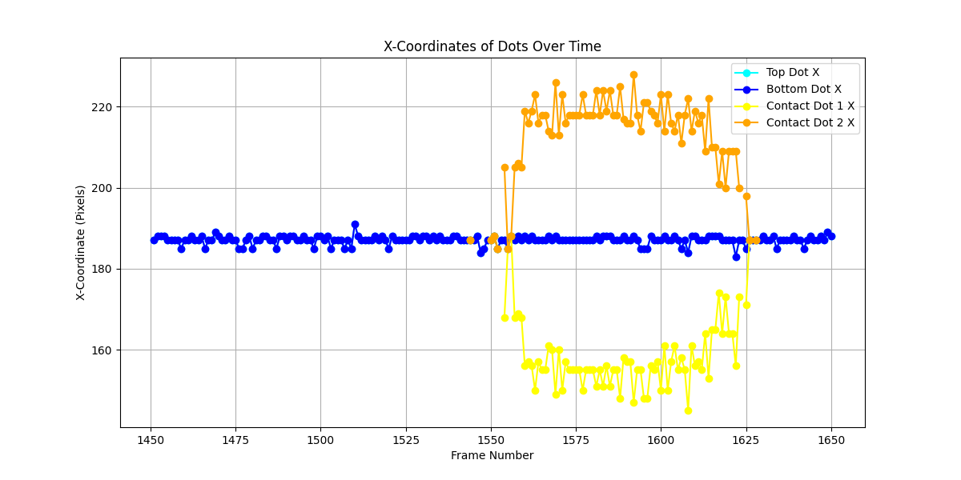

Diameter Changes Over Time
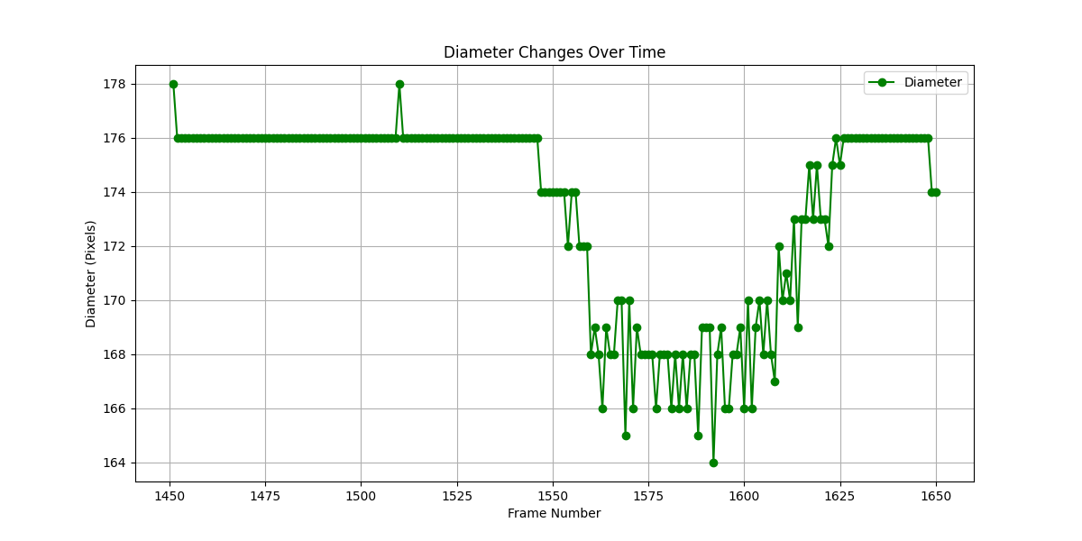
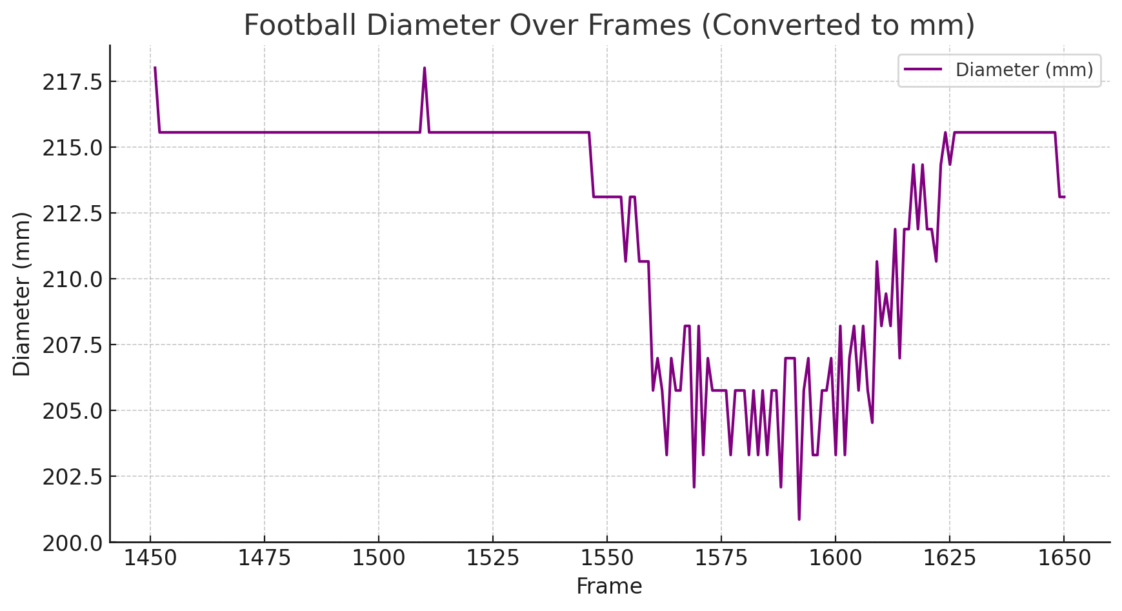

Contact Time Changes Over Time
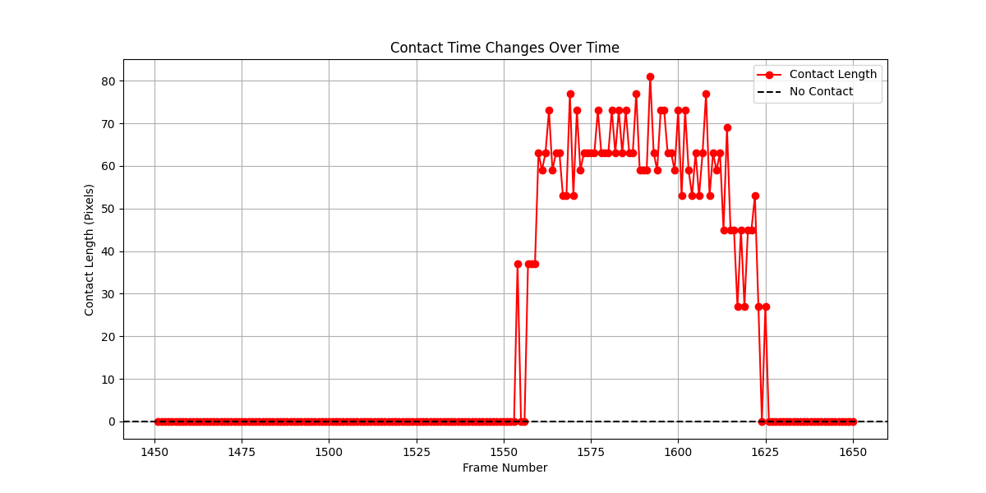

Trajectories of Dots (X vs Y)
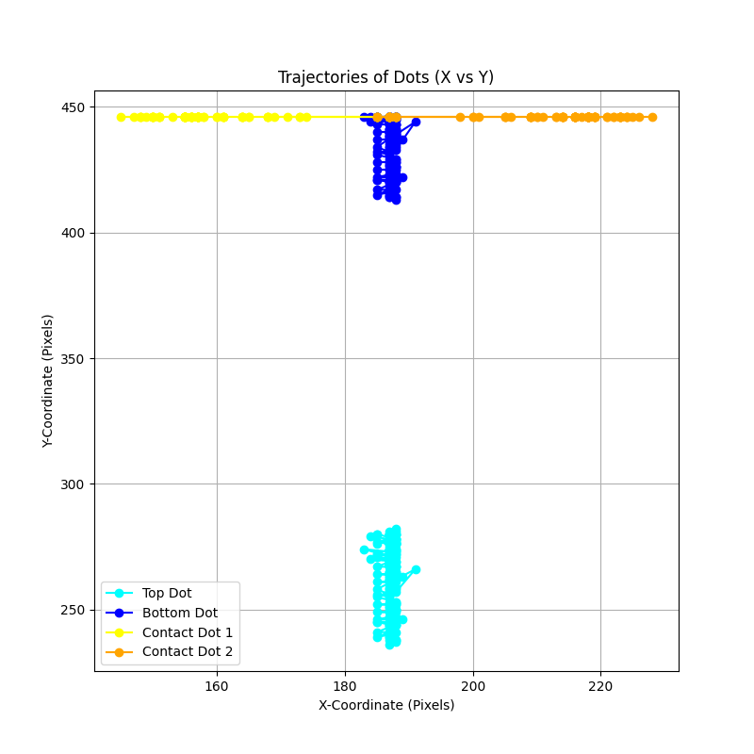

5. Mathematical Formulations

5.1. Ball Detection Using Hough Circles
The ball is detected using the Hough Circle Transform:
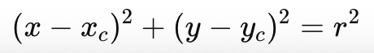
Where:
- xc, yc is the center of the detected circle,
- r is the detected radius of the football.

5.2. Contact Length Calculation
When the football contacts the surface, we solve for the contact points 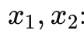:
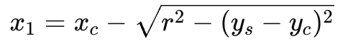
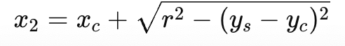
The contact length is then given by:
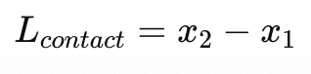
Where:
- y_{s} is the y-coordinate of the surface.

5.3. Ball Compression Measurement
The compression of the football during contact is estimated as:
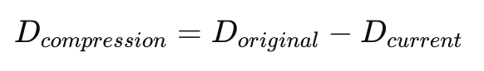
Where:
- D_{original} is the ball's diameter before contact,
- D_{current} is the ball's diameter during impact.

5.4. Kalman Filter Prediction and Correction
The Kalman filter is used to smooth the detected position x_{c}, y_{c}:
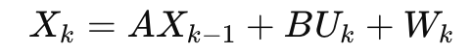
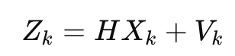
Where:
- X_{k}is the predicted state (position and velocity),
- Z_{k}is the measured state,
- A is the state transition matrix,
- H is the measurement matrix,
- Wk, V_{k}are process and measurement noise.

6. Data Processing and Analysis
- The contact duration and ball compression are key parameters.
- The system ensures accurate real-time tracking of football deformation.

Sample Data from CSV Files

ball_deformation_data.csv
Frame | Ball_X | Ball_Y | Diameter | Contact_Length
1522 | 200 | 150 | 176 | 0
1544 | 200 | 152 | 176 | 0
1581 | 198 | 158 | 166 | 73
1606 | 199 | 159 | 170 | 53
1616 | 200 | 160 | 173 | 45
1633 | 200 | 162 | 176 | 0
1640 | 201 | 163 | 178 | 0
1650 | 202 | 165 | 176 | 0

dot_positions.csv
Frame | Top_  Dot_X | Top_  Dot_Y | Bottom_  Dot_X | Bottom_  Dot_Y | Contact_  Dot1_X | Contact_  Dot1_Y | Contact_  Dot2_X | Contact_  Dot2_Y
1522 | 200 | 90 | 200 | 176 | None | None | None | None
1544 | 200 | 91 | 200 | 176 | None | None | None | None
1581 | 198 | 88 | 198 | 166 | 150 | 200 | 220 | 200
1606 | 199 | 87 | 199 | 170 | 155 | 200 | 215 | 200
1616 | 200 | 86 | 200 | 173 | 160 | 200 | 210 | 200
1633 | 200 | 85 | 200 | 176 | None | None | None | None
1640 | 201 | 84 | 201 | 178 | None | None | None | None
1650 | 202 | 83 | 202 | 176 | None | None | None | None

7. Challenges and Improvements

Challenges
- Ensuring stable ball detection in varying lighting conditions.
- Handling frames where the ball is partially visible.

Improvements
- Machine Learning-based Ball Detection: Future versions could use deep learning models (e.g., YOLO/Omni motion) for improved detection.
- Real-time Processing: Integrating GPU acceleration for live tracking.
- Advanced Contact Analysis: Incorporating material science properties for deformation modelling.

8. Summary and Next Steps
This system successfully tracks the deformation of a football and provides detailed contact analysis. Future enhancements will focus on improving detection accuracy, incorporating real-time processing, and expanding the system for different surfaces and impact angles.

Next Steps
- Improve the stability of circle detection.
- Extend the system to analyze different football materials.
- Validate the results with high-speed camera footage.

9. Sample Processed Frames

Frame 1522: Initial Detection
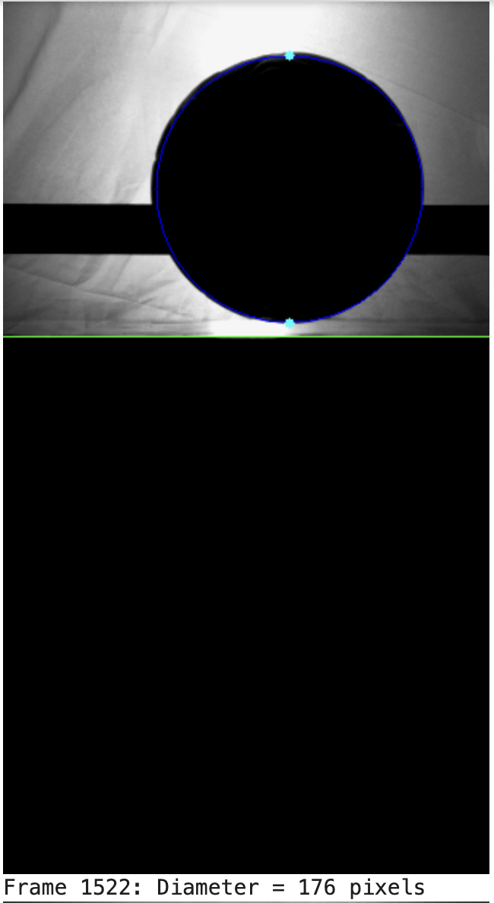
=============================================================

Frame 1581: Contact Detected

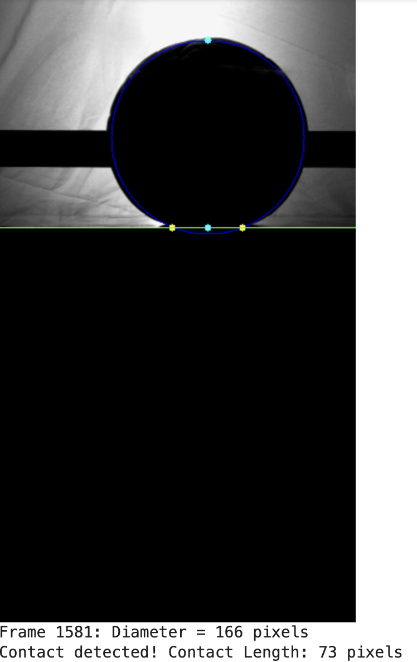
=============================================================

Frame 1616: Maximum Deformation
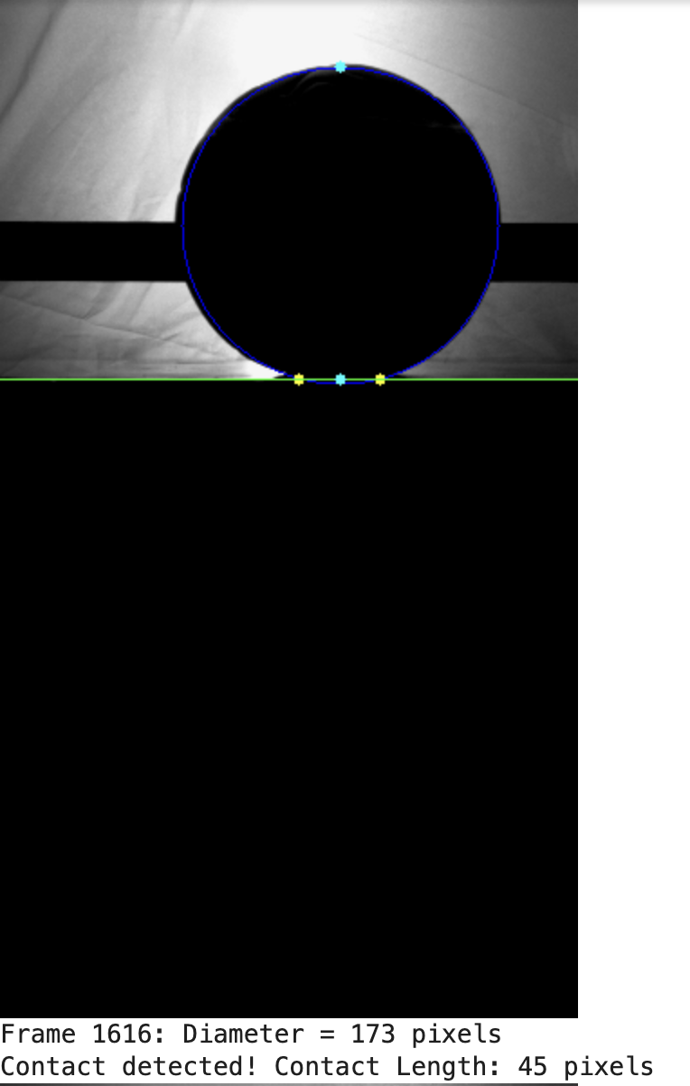
=============================================================

Frame 1633: Ball Returns to Original Shape
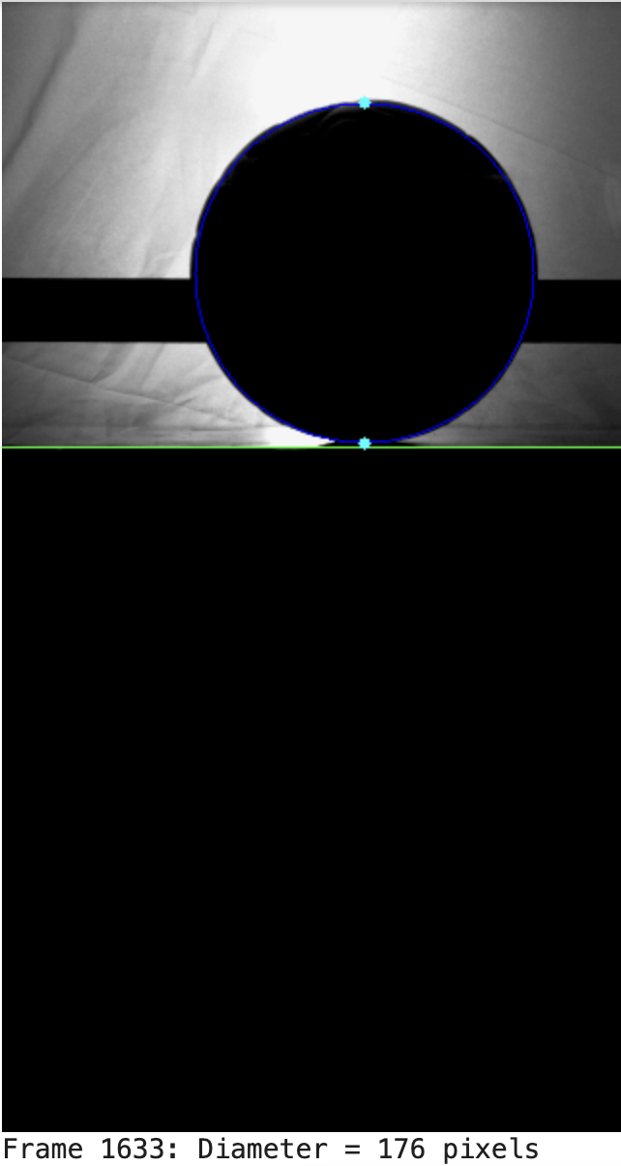

DROP 1 MIN VS MAX VALUE
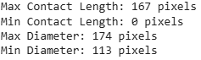

DROP 2 MIN VS MAX VALUE
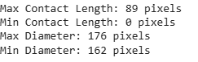

DROP 3 MIN VS MAX VALUE
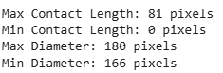
COMPARISION GRAPHS BETWEEN 3 DROPS
