Description of the diet problem
The goal of the diet problem is to find the cheapest combination of foods that will satisfy all the daily nutritional requirements of a person.
The diet problem is one of the first optimization problems to be studied back in the 1930's and 40's. It was first motivated by the Army's desire to meet the nutritional requirements of the field GI's while minimizing the cost. One of the early researchers to study this problem was George Stigler. He made an educated guess of the optimal solution to linear program using a heuristic method. His guess for the cost of an optimal diet was $39.93 per year (1939 prices). In the fall of 1947, Jack Laderman of the Mathematical Tables Project of the National Bureau of Standards undertook solving Stigler's model with the new simplex method. It was the first "large scale" computation in optimization. The linear program consisted of nine equations in 77 unknowns. It took nine clerks using hand-operated desk calculators 120 days to solve for the optimal solution of $39.69. Stigler's guess for the optimal solution was off by only 24 cents per year.
Mathematical Model
The problem is formulated as a linear program where the objective is to minimize cost and meet constraints which require that nutritional needs be satisfied. They include constraints that regulate the number of calories and amounts of vitamins, minerals, fats, sodium and cholesterol in the diet.

Linear program formulation suitable for solving by software
m-number of nutrients, n-number of foods
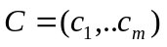- vector of food unit costs
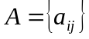 - amount of nutrient j in food i
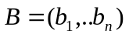-vector of nutrients demand

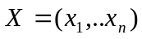 - decision vector ( numbers of servings of each food)

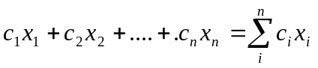 - cost of daily diet
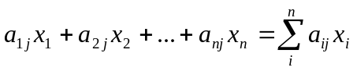 - amount of nutrient j in daily diet
Objective function: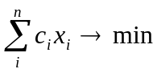 (1)
Constraints: 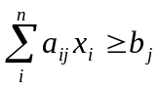 j=1,m (2)
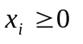 i=1,n (3)

Lagrange function minimization
Introducing – cost of a pill of nutrient j , ,j=1,m

- amount of nutrient j in the daily diet

if then is positive.

Let us consider this function (Lagrange function):
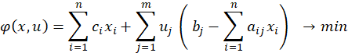

- cost of the difference between the actual amount of nutrient j in a diet and the daily requirement of nutrient j

is the penalty we pay in addition to the required price
Under certain conditions minimization of Lagrange function under constraints (3) is equivalent to solving (1)-(3). Rigorous prove can be found in [1]. Intuitively, as we try to minimize the function the (positive) penalty term should be as small as possible. We try to find such values of decision variables that make Lagrange function value as small as possible. Same considerations for decision variables work when solving (1)-(3).
Rearranging terms in Lagrange function we obtain:
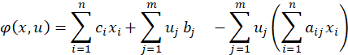
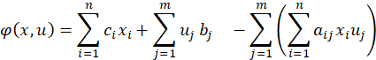
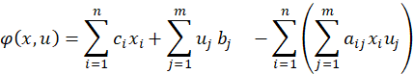
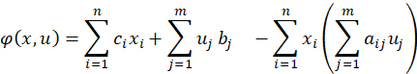
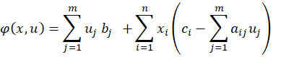 (4)

Maximizing Lagrange function in form (4) is equivalent to solving the following constraint optimization problem

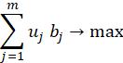 (5)

, i=1,n (6)

(7)
Optimization problem (5)-(7) is called dual problem to problem (1)-(3).
It can be interpreted as follows:
A pharmaceutical company is developing the pills for meal replacement:
It is trying to maximize its profit under the requirement that the price paid for the nutritional value found in the food item (but replaced by a pill) is not exceeding the cost of the food item.
Under certain conditions the solutions of dual and primal problems are equal.

Solving with Excel Solver
We use Excel Solver to solve the Diet Problem.
The following is the image of the spreadsheet (yellow cells -input, blue -output)
 | Daily diet cost minimization under nutrition intake constraints
 |  | fat | vitA | vitC | protein | calories | servings | $1.95 | → | min
item | cost per serv. |  |  |  |  |  |  |  | max serv.
broccoli | $0.16 | 0.80 | 5700.00 | 160.20 | 8.00 | 74.00 | 3 | $0.48 | 4
apple | $0.24 | 0.50 | 73.10 | 7.90 | 0.30 | 81.40 | 0 | $0.00 | 7
cookie | $0.09 | 3.3 | 2.9 | 0.1 | 1.1 | 81 | 7 | $0.63 | 7
milk | $0.23 | 4.7 | 500.2 | 2.3 | 8.1 | 121.2 | 0 | $0.00 | 0
chicken | $0.84 | 11 | 77.4 | 0 | 42.2 | 227.2 | 1 | $0.84 | 10
 |  |  | fat constraints
 | 20 | < | 36.3 | < | 65
 |  |  | protein constraints
 | 50 | < | 73.9 | < | 110
 |  |  | vitA constraints
 | 500 | < | 17197.7 | < | 50000
 |  |  | vitC constraints
 | 50 | < | 481.3 | < | 20000
 |  |  | calories constraints
 | 1000 | < | 1016.20 | < | 2250

Dual problem formulation and interpretation
Let us consider a problem of revenue maximization so that artificial foods are competitive against the real foods in price,
where the variables y are interpreted as unit prices of
nutrient pills and b is interpreted as the demand of nutrients.

m-number of nutrients, n-number of foods
- vector of food unit costs
- amount of nutrient j in food i
-vector of nutrients demand

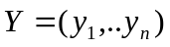 - decision vector ( unit prices of nutrient pills)

Objective function: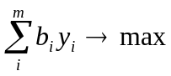
Constraints: 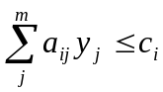 i=1,n
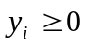 i=1,n

The above optimization problem is called dual problem to problem (1) and plays an important role in the analysis of the primal problem (1).

Solver Sensitivity Report
Along with the solution to problem (1) Solver produces Sensitivity Report.
One of the most important sensitivity characteristics computed by Solver is Lagrange Multipliers, or Shadow Prices.
Lagrange multiplier for constraint j shows how much the objective function value change if demand for nutrient j is changed by 1. Lagrange Multiplier = 0 means that solution is not sensitive to this constraint – demand for nutrient j can be changed but the optimal value will not change.
The described fact is very important. In real life problems the demand is usually an estimated value and will likely to change during the analysis of the problem. If the problem has many dimensions it is not practical to solve it from scratch each time the demand j changes. Sensitivity analysis allows to adjust value of the target function (adding Lagrange Multiplier times number of units of change in demand) rather than solving the problem again. Lagrange Multipliers are variables in the dual problem!
It is practical to solve only one problem, and Sensitivity report will show optimal values of the dual problem.
The primal value of the target function Solver found for the original constraints is $1.215
Protein demand in the original problem is 50mg, and Lagrange Multiplier for protein is 0.0111 according to a Solver Sensitivity Report.
If demand changes from 50 to 51, the optimal value of objective function will be 1.215+0.0111=1.227
Exercise: verify that if demand becomes 51 then optimal value becomes 1.227 by running Solver again, for the changed constraint.

 |  | Sensitivity Report
Adjustable Cells
 |  |  | Final | Reduced
 | Cell | Name | Value | Gradient
 | $H$5 | broccoli servings | 1.384222 | 0
 | $H$6 | apple servings | 0 | 0.158511123
 | $H$7 | oatm. cookie servings | 4.932933 | 0
 | $H$8 | milk servings | 0 | 0
 | $H$9 | chicken servings | 0 | 0.152642424
 | $H$10 | omelette servings | 5 | -0.060124246
 | $H$11 | cheerios servings | 0 | 0.125615952
 | $H$12 | Taco servings | 0 | 0.005171873
 | $H$13 | rice crispies servings | 0 | 0.191149303
Constraints
 |  |  | Final | Lagrange
 | Cell | Name | Value | Multiplier
 | $D$18 | < fat constraints | 53.88606 | 0
 | $D$18 | < fat constraints | 53.88606 | 0
 | $D$21 | < protein constraints | 50 | 0.011118954
 | $D$27 | < vitC constraints | 222.7456 | 0
 | $D$30 | < calories constraints | 1000.00 | 0.00

Graphical solution
For 2 – dimensional case the problem can be solved graphically.
First , find a feasible region by solving a system of linear inequalities (constraints) graphically.
Second, draw the line that represents the target function and find its minimum within a feasible region.
Example: Let us consider a diet that consists from milk and cookies only (Say, this is breakfast diet). For breakfast people must get no less than 3mg of fat, 10mg of vitamin C and 5mg of protein. One serving of milk contains 1mg of fat, 2mg of vitamin C and 3mg of protein. One cookie contains 2mg of fat, 1mg of vitamin C and 4mg of protein. The goal is to minimize a cost of breakfast while fulfilling the nutritional needs. In other words how many servings of milk and how many cookies should we eat.
Let X be a number of milk servings and Y –a number of cookies. Here is the system of inequalities that represents the problem:X+2Y>3, 2X+Y>10, 3X+4Y>5
Find a solution to each inequality separately (regions above or below the lines X+2Y=3, 2X+Y=10, 3X+4Y=5), and then find a feasible region as a region common to all solutions.
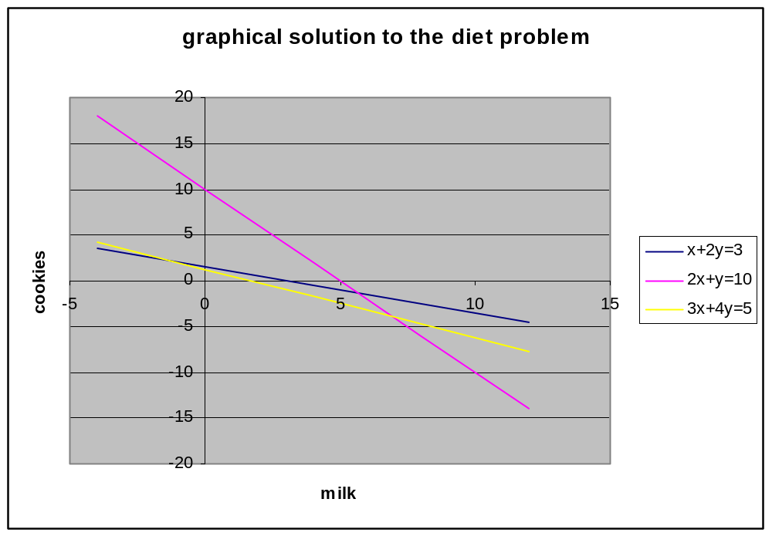

Exercise: Draw the line that represents a target function

Recommended reading
[1]Operations Research Models and Methods by Jensen Bard
http://www.me.utexas.edu/~jensen/ORMM/frontpage/contents/index.html
[2]Diet Problem Demonstration from NEOS Solvers
http://www-neos.mcs.anl.gov/CaseStudies/dietpy/WebForms/index.html
[3]Excel Solver Documentation from Frontline Systems
http://www.solver.com/tutorial.htm
[4]Linear Programming test
http://cwx.prenhall.com/bookbind/pubbooks/heizer2/chapter24/deluxe.html
[4]Interpretation of duality
http://pages.cs.wisc.edu/~swright/525/handouts/dualexample.pdf

