# **Blazor User Form**

# **Web Application**

# This web application is designed for managing user records on a website. The application includes functionality for creating, reading, updating, and deleting user information. Below is an overview of the key components and features of the application.

## **User Entity**

The User entity is defined in the root project within the "User.cs" file. The entity includes properties such as ID, First Name, Middle Name, Last Name, Gender, City, and Occupation.

## **Database Configuration**

The application uses Entity Framework Core for database operations. The ApplicationDbContext class, located in the BlazorAppUserPortal.DataContext namespace, establishes a connection to a SQL Server database and specifies a table named "Users" for storing user entities. The database connection string is configured in the appsettings.json file.

|  |
| --- |
| "ConnectionStrings":  {  "DefaultConnection": "Server=localhost\\SQLEXPRESS;Database=BlazorApp;Trusted_Connection=True;MultipleActiveResultSets=true;TrustServerCertificate=True"  } |

## **Dependency Injection and DbContext Registration**

The UserService class is responsible for CRUD operations on the User entity within the Blazor application. It is registered as a transient service for dependency injection. Additionally, the ApplicationDbContext is registered with Entity Framework Core to connect to the SQL Server database.

|  |
| --- |
| // Register the UserService as a transient service  builder.Services.AddTransient<UserService>();  // Register the ApplicationDbContext with Entity Framework Core  builder.Services.AddDbContext<ApplicationDbContext>(item => item.UseSqlServer(builder.Configuration.GetConnectionString("DefaultConnection"))) |

);

## **User List Component**

The UsersList component displays a list of users, providing options to add, edit, and delete users. It utilizes the UserService for data operations.In the Following, screenshots of each operation are attached.

This screenshot shows the webpage for adding a new user to the system. Users can fill out the form with user details and click the "Save" button.

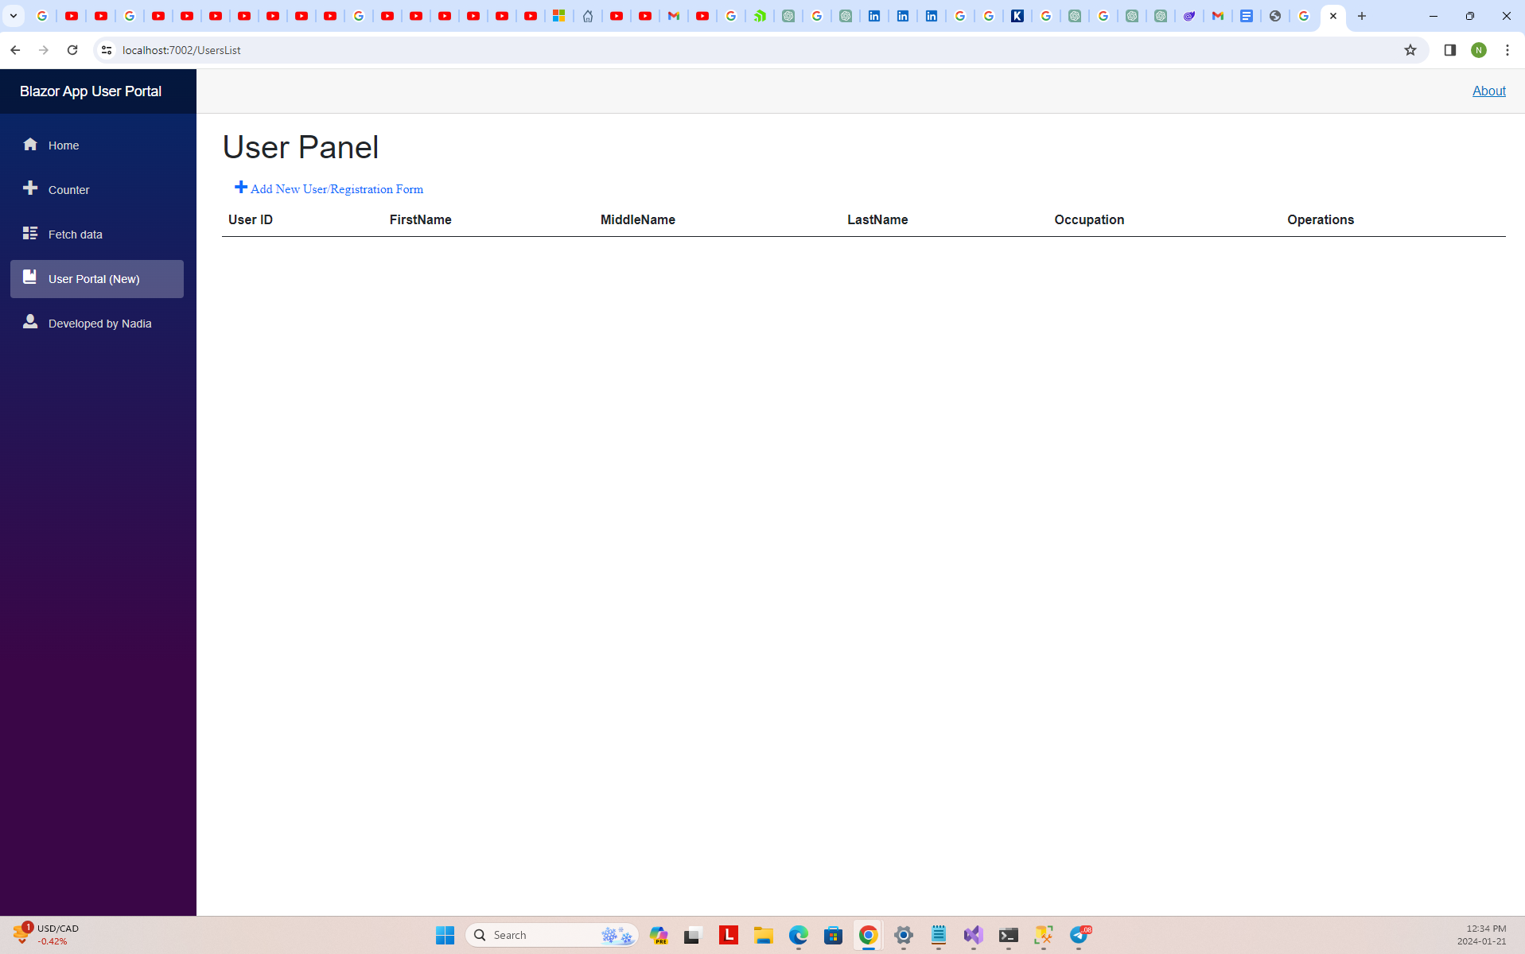

Figure ‑: The List of User

## **Add User Page**

The AddUser page presents a user registration form with fields for First Name, Middle Name, Last Name, Gender, City, and Occupation. The form allows users to save a new user or cancel the operation. The CreateUser method triggers the insertion of a new user, while the Cancel method navigates back to the user list without saving changes.

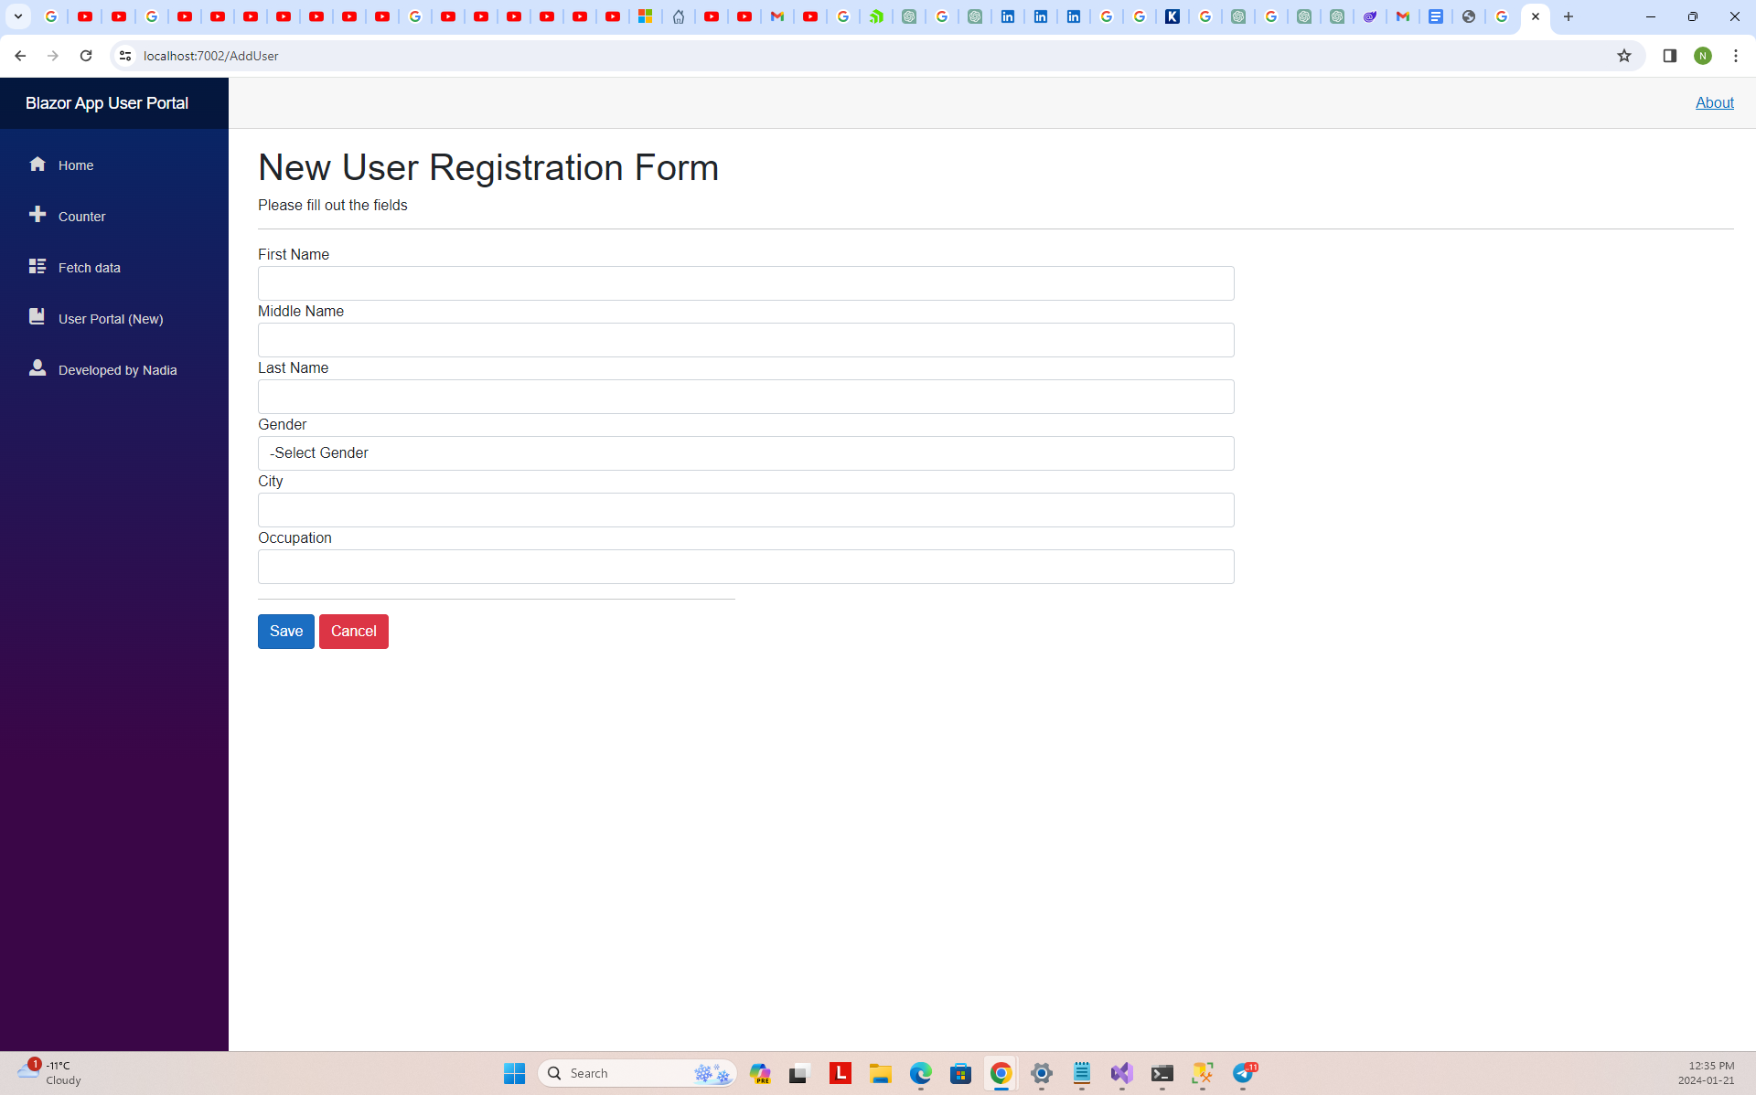

Figure ‑ Add New User to List / Form

## 

Figure ‑ the List of Users

## **Delete User Page**

The DeleteUser page is designed for deleting a user record. It displays user details and a confirmation message. Users can choose to proceed with the deletion or cancel the operation. Upon deletion, the user is navigated back to the user list.

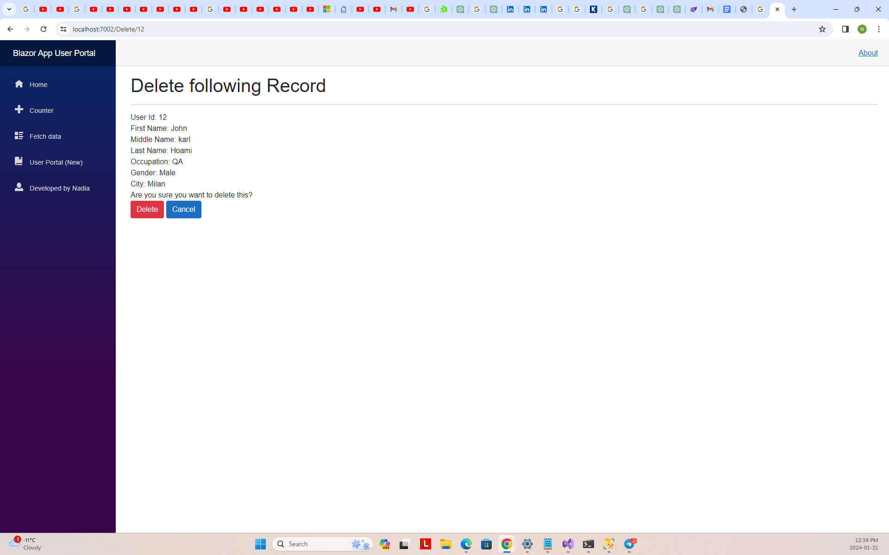

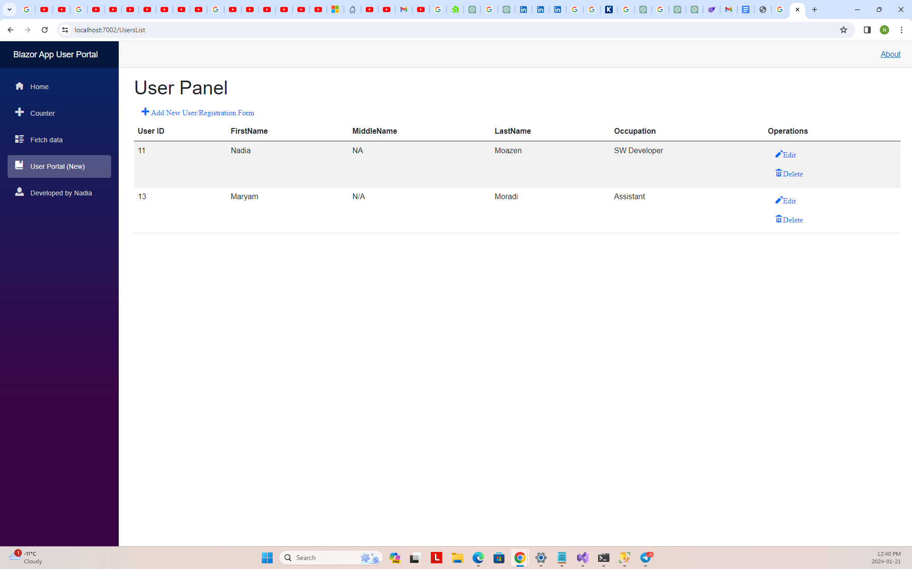

## **Edit User Page**

The EditUser component serves as an interface for editing user details. It fetches user details based on the provided ID, allowing users to make changes. The component provides options to update the user information or cancel the operation.

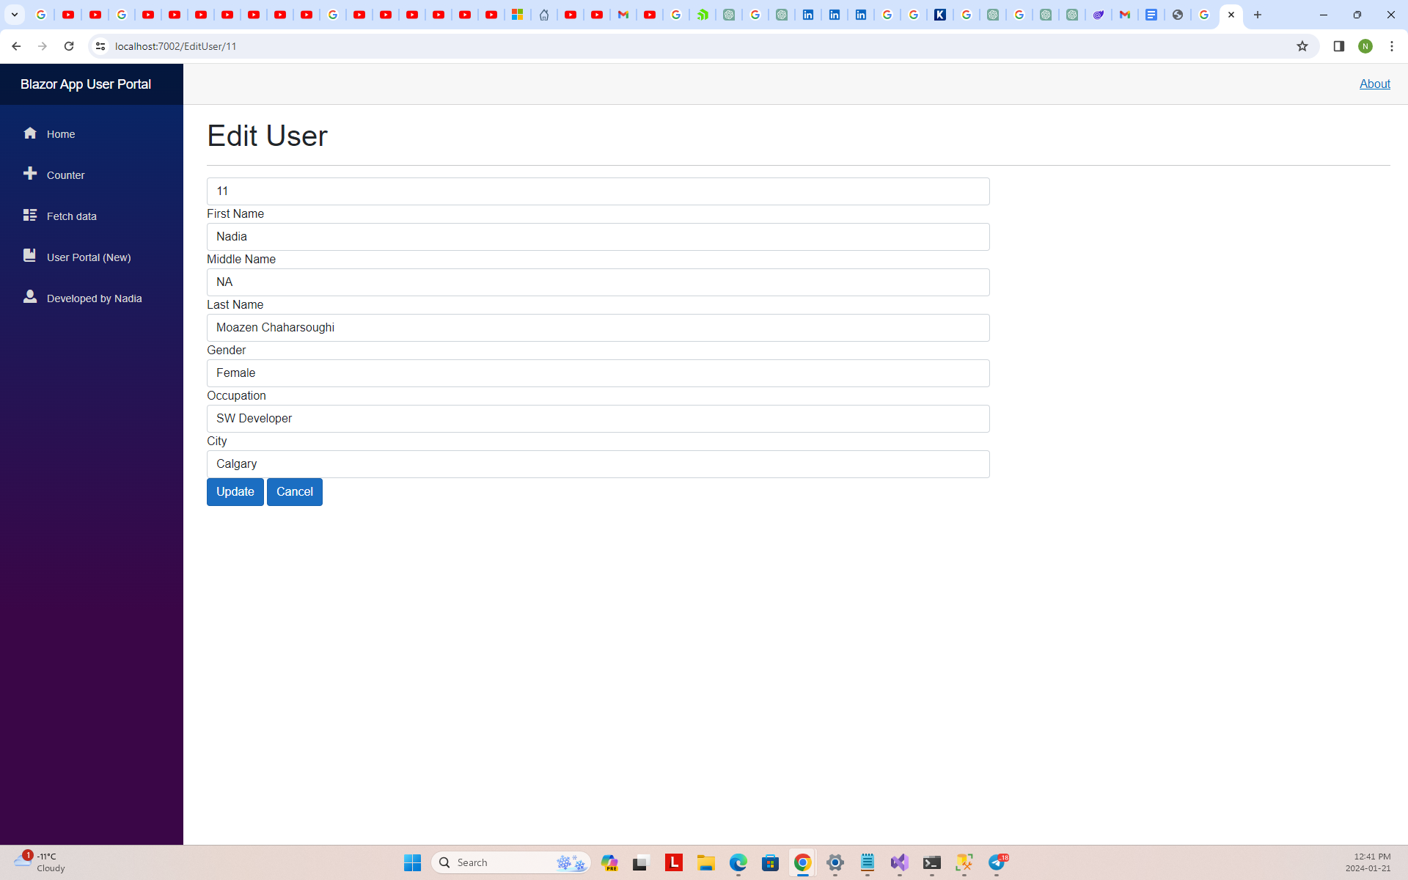

Figure ‑ The Modification Form/Page

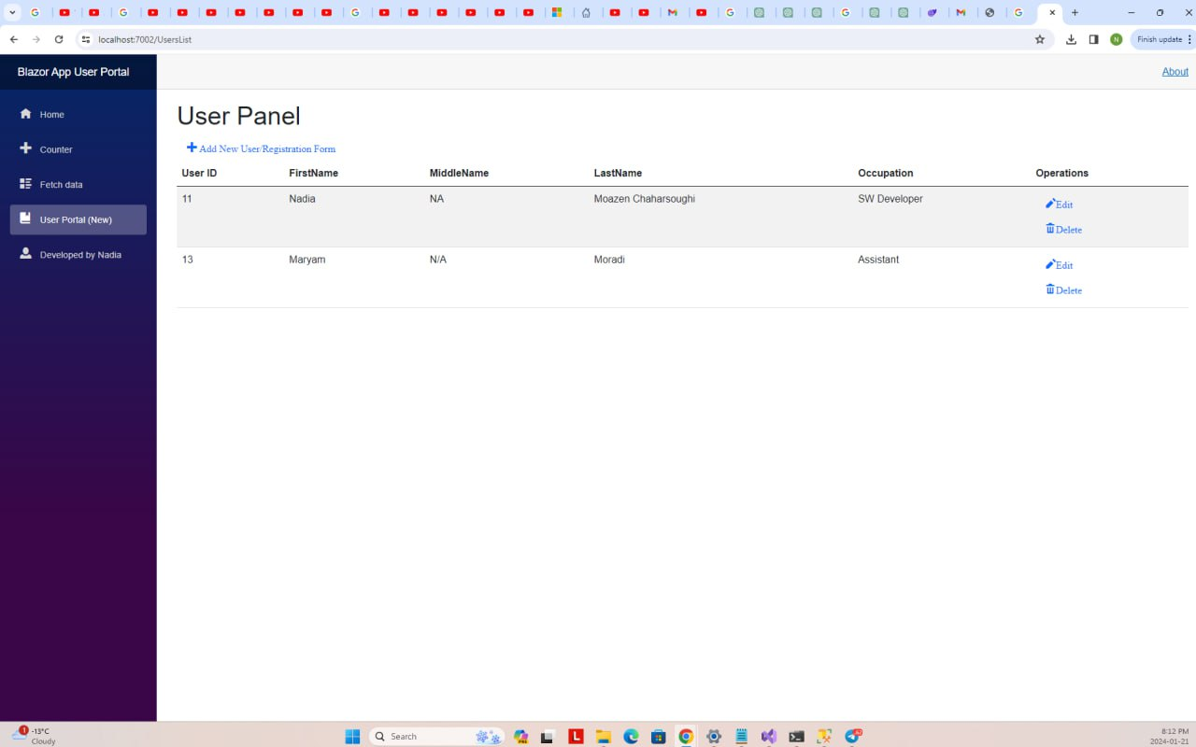

Figure ‑ The List of User after a Modification operation

## **Getting Started**

* Ensure the database connection string in appsettings.json is configured correctly.
* Run the Entity Framework Core migration to create the database schema.
  + Open the Package Manager Console and runAAdd-Migration InitialMigration and Update-Database.
* Build and run the Blazor application.