


INFORMATICS INSTITUTE OF TECHNOLOGY

Department of Computing

Bsc(Hons) Artificial Intelligence and Data Science

Module: CM2604 - Machine Learning
Module Coordinator: Mr. Sahan Priyanayana

Individual Coursework
RGU Student ID – 2522857
IIT Student ID – 20240696
Student Name – R.D. Nadija Prabashana Ranawaka

TABLE OF CONTENT

I. TABLE OF CONTENT i
II. LIST OF FIGURES ii
III. LIST OF TABLES ii
IV. ABBREVIATIONS iii
1. INTRODUCTION 1
2. CORPUS PREPARATION AND EXPLORATORY DATA ANALYSIS 2
2.1. Dataset Description and Preparation 2
2.2. Exploratory Data Analysis 2
3. SOLUTION METHODOLOGY 7
3.1. Data Preprocessing 7
3.2. Classification Models 7
3.3. Hyperparameter Tuning 7
4. EVALUATION CRITERIA AND EXPERIMENTAL RESULTS 9
4.1. Evaluation Criteria 9
4.2. Experimental Results 9
4.3. Results Discussion 10
5. ETHICAL CONSIDERATIONS 11
5.1. Ethical Considerations During Development 11
5.2. Ethical Considerations After Deployment 11
6. LIMITATIONS AND FUTURE ENHANCEMENTS 12
6.1. Limitations 12
6.2. Future Enhancements 12
7. APPENDIX A: SOURCE CODE 13

LIST OF FIGURES
Figure 1 - Customer Churn Distribution 3
Figure 2 - Churn rate by contract type 4
Figure 3 - Churn rate by internet service type 5
Figure 4 - Churn rate by payment method 5
Figure 5 - Comparison of the three classification models using F1-score and ROC-AUC 10

LIST OF TABLES
Table 1 - Hyperparameters Tested 8
Table 2 - Best Hyperparameteres for each model 9
Table 3 - Model Performance Comparison 9

ABBREVIATIONS

EDA | Exploratory Data Analysis
KNN | K-Nearest Neighbours
ROC-AUC | Receiver Operating Characteristic – Area Under the Curve
CV | Cross-Validation
F1-score | F1-score (the harmonic mean of precision and recall)
C | Regularization parameter in Logistic Regression
p | Distance parameter used by KNN
ID | Identifier
SHAP | SHapley Additive exPlanations
df | DataFrame (variable name used in the code, not a formal abbreviation in the report)
X | Input features (variable name)
y | Target variable (variable name)

INTRODUCTION
Customer churn occurs when customers discontinue a company's products or services. Predicting churn is important for telecommunications companies because identifying customers who are likely to leave can support proactive retention strategies and improve customer relationships.
This project uses the Telco Customer Churn dataset to develop a binary classification system that predicts whether a customer will churn. Exploratory Data Analysis (EDA) is first conducted to identify patterns in customer characteristics and churn behavior. The dataset is then preprocessed, and three machine learning algorithms—K-Nearest Neighbors (KNN), Logistic Regression, and Random Forest—are implemented and optimized through hyperparameter tuning. Their performance is evaluated and compared using accuracy, precision, recall, F1-score, and ROC-AUC. Finally, the project considers ethical responsibilities associated with model development and deployment, alongside limitations and opportunities for future improvement.
The source code and implementation for this project are available in the following GitHub repository: Machine-Learning-Coursework

CORPUS PREPARATION AND EXPLORATORY DATA ANALYSIS

Dataset Description and Preparation
The Telco Customer Churn dataset contains 7,043 customer records and 21 attributes, including demographic information, subscribed services, contract details, tenure, and billing information. The target variable, Churn, indicates whether a customer discontinued the service.
During preprocessing, 11 records containing blank TotalCharges values were identified and removed, leaving 7,032 records. The customerID attribute was excluded because it uniquely identifies customers rather than providing meaningful predictive information. The target variable was encoded as 0 for customers who remained and 1 for customers who churned.
The data was divided into training and testing sets using an 80:20 stratified split, resulting in 5,625 training records and 1,407 testing records. Numerical features were standardized using StandardScaler, while categorical features were transformed using OneHotEncoder. These transformations were incorporated into Scikit-learn pipelines to prevent information leakage during cross-validation.

Exploratory Data Analysis
EDA revealed that 26.54% of customers churned, compared with 73.46% who remained. This class imbalance makes it important to evaluate metrics beyond accuracy.
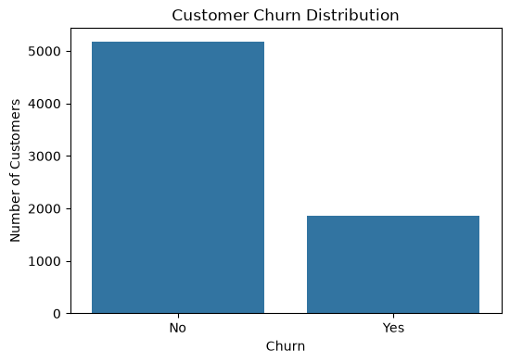
Figure 1 - Customer Churn Distribution
Customers who churned generally had shorter tenures and higher monthly charges than those who remained. Contract type showed a substantial association with churn: the churn rate was 42.71% for month-to-month contracts, 11.27% for one-year contracts, and 2.83% for two-year contracts.
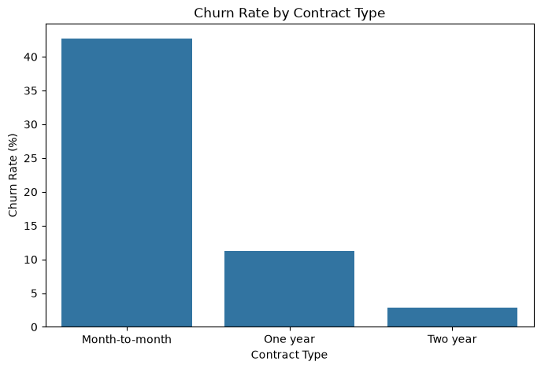
Figure 2 - Churn rate by contract type
Internet service and payment method also showed differences in churn rates. Fiber optic customers had a churn rate of 41.89%, compared with 18.96% for DSL customers and 7.40% for customers without internet service. Customers paying by electronic check had the highest observed churn rate at 45.29%, while those using automatic credit card payments had the lowest at 15.24%.
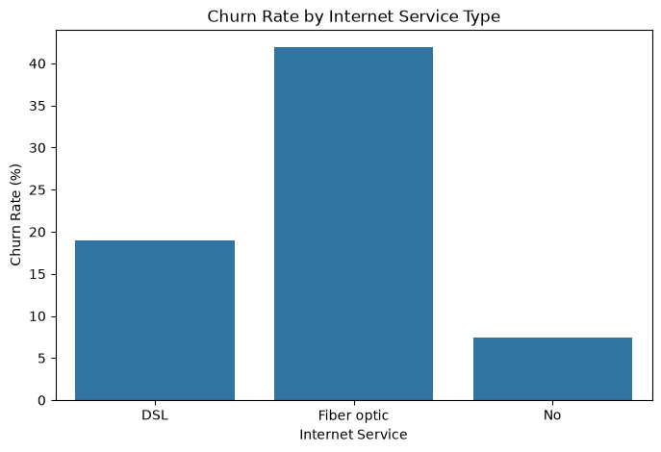
Figure 3 - Churn rate by internet service type
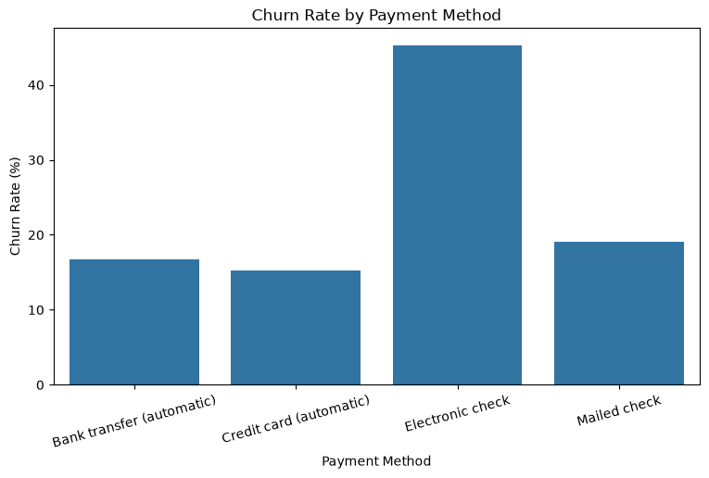
Figure 4 - Churn rate by payment method

These findings identify patterns that may help the classification models distinguish between churned and retained customers. However, the observed associations do not establish causation.

SOLUTION METHODOLOGY

Data Preprocessing
The dataset was cleaned before model development. Eleven records containing missing values in TotalCharges were removed, and the customerID attribute was excluded because it was a unique identifier. The target variable was encoded as 0 for customers who remained and 1 for customers who churned.
An 80:20 stratified train-test split was applied, producing 5,625 training records and 1,407 testing records. Numerical features were standardized using StandardScaler, while categorical features were converted into binary indicator variables using OneHotEncoder. A Scikit-learn ColumnTransformer and pipeline were used to apply these transformations consistently while preventing data leakage during cross-validation.

Classification Models
Three supervised classification algorithms were implemented.
- K-Nearest Neighbors (KNN): Classifies customers based on the labels of their nearest neighbors. The number of neighbors, voting weights, and distance metric were tuned.
- Logistic Regression: Estimates the probability of customer churn. The regularization parameter C and class-weighting strategy were tuned.
- Random Forest: Combines multiple decision trees to capture potentially complex relationships between customer attributes. The number of trees, maximum tree depth, minimum samples required for a split, and class-weighting strategy were considered during tuning.

Hyperparameter Tuning
GridSearchCV was used to evaluate combinations of hyperparameters through five-fold cross-validation. F1-score was selected as the optimization metric because it balances precision and recall, which is important given the imbalance between churned and non-churned customers.
The best configurations were KNN with 15 neighbors, uniform voting, and Euclidean distance; Logistic Regression with C = 1 and balanced class weights; and Random Forest with 100 trees, maximum depth 10, minimum split size 5, and balanced class weights.
The selected configurations were evaluated on the held-out test set. Keeping this test set separate from hyperparameter tuning provides a more independent assessment of the models' predictive performance.
Table 1 - Hyperparameters Tested
Model | Hyperparameters tested
KNN | Neighbors: 5, 7, 9, 11, 15; weights: uniform, distance; distance parameter \(p\): 1, 2
Logistic Regression | Regularization \(C\): 0.01, 0.1, 1, 10; class weights: None, balanced
Random Forest | Trees: 100; maximum depth: None, 10, 20; minimum split samples: 2, 5; class weights: None, balanced

EVALUATION CRITERIA AND EXPERIMENTAL RESULTS

Evaluation Criteria
The models were evaluated using accuracy, precision, recall, F1-score, and ROC-AUC. Accuracy measures the proportion of correctly classified customers, while precision measures how many customers predicted to churn actually churned. Recall measures how many actual churn cases were correctly identified. F1-score balances precision and recall, making it useful for the imbalanced dataset. ROC-AUC measures how effectively a model distinguishes between churned and non-churned customers across different classification thresholds.

Experimental Results
The best hyperparameter configurations were selected using five-fold cross-validation with F1-score as the optimization metric. The selected models were then evaluated on the held-out test set.
Table 2 - Best Hyperparameteres for each model
Model | Best hyperparameters
KNN | Neighbours = 15; weights = uniform; p = 2
Logistic Regression | C = 1; class weights = balanced
Random Forest | Trees = 100; maximum depth = 10; minimum split samples = 5; class weights = balanced

Table 3 - Model Performance Comparison
Model | CV F1 | Accuracy | Precision | Recall | Test F1 | ROC-AUC
KNN | 0.582 | 0.773 | 0.574 | 0.570 | 0.572 | 0.816
Logistic Regression | 0.633 | 0.726 | 0.490 | 0.797 | 0.607 | 0.835
Random Forest | 0.632 | 0.746 | 0.515 | 0.773 | 0.618 | 0.830
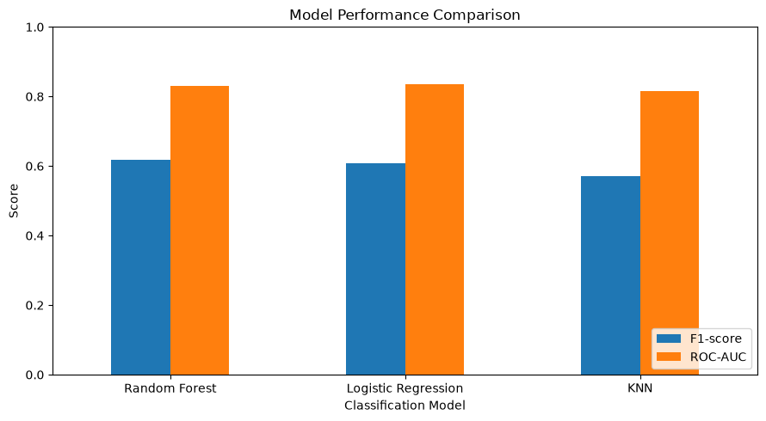
Figure 5 - Comparison of the three classification models using F1-score and ROC-AUC

Results Discussion
Random Forest achieved the highest test F1-score (0.618), indicating the strongest balance between precision and recall among the evaluated models. Its ability to capture nonlinear relationships and interactions between customer attributes may have contributed to its performance, although this was not directly tested.
Logistic Regression achieved the highest recall (0.797) and ROC-AUC (0.835). Its balanced class weights may have helped it identify more churn cases, but this came with lower precision (0.490), meaning more customers who would not churn were incorrectly flagged. Its ROC-AUC result indicates strong discrimination across thresholds, rather than necessarily the best performance at the default classification threshold.
KNN achieved the highest accuracy (0.773) but the lowest test F1-score (0.572) and recall (0.570). Because most customers did not churn, accuracy alone does not adequately reflect its ability to identify churners. One possible explanation is that distances in the one-hot encoded feature space may be less effective at distinguishing customer groups.
Overall, Random Forest is the strongest choice when F1-score is the main selection criterion, while Logistic Regression may be preferable when identifying a larger proportion of churners is the priority. However, the difference between their F1-scores is small, and further validation would be needed before concluding that one model is consistently superior.

ETHICAL CONSIDERATIONS

Ethical Considerations During Development
Privacy and data protection: Customer datasets may contain sensitive information. Data should be handled securely, and personally identifying attributes should be excluded when they are unnecessary for prediction. In this project, customerID was removed because it was a unique identifier rather than a meaningful predictive feature.
Fairness and bias: The model may produce different error rates across customer groups, potentially leading to unfair retention decisions. Future evaluation should examine whether predictions disproportionately affect particular demographic groups and whether any differences can be justified.
Transparency and responsible evaluation: Model performance should be reported using multiple metrics rather than accuracy alone. Precision, recall, F1-score, and ROC-AUC provide a more balanced assessment of performance. The limitations of the dataset and the possibility of incorrect predictions should also be communicated clearly.

Ethical Considerations After Deployment
Human oversight: Predictions should support, rather than replace, human decision-making. Customers should not be unfairly penalized or denied services solely because a model predicts that they may churn.
Monitoring and maintenance: Model performance should be monitored over time because customer behavior and service conditions may change. If performance deteriorates, the model should be reviewed and retrained using appropriate data.
Security and accountability: Access to customer data and prediction results should be restricted to authorized personnel. The organization should establish clear responsibility for decisions based on model predictions and provide a process for reviewing potentially unfair or incorrect outcomes.
These measures are recommendations for responsible deployment. The project evaluates models using a public dataset and does not implement a live customer prediction service.

LIMITATIONS AND FUTURE ENHANCEMENTS

Limitations
The dataset contains an imbalance between customers who churned (26.54%) and those who remained (73.46%). Although F1-score was used for model optimization, the models may still misclassify certain customer groups.
The evaluation used a single stratified train-test split and one public dataset. Therefore, the results may not generalize to other telecommunications companies or future customer behaviour. Furthermore, the difference between the test F1-scores of Random Forest (0.618) and Logistic Regression (0.607) is relatively small, and additional validation is required to determine whether this difference is consistent.
The models were evaluated using their default classification thresholds. Adjusting these thresholds may improve performance for a particular business objective, such as identifying more customers at risk of leaving. The project also did not conduct a comprehensive fairness audit or deploy the models in a live environment.

Future Enhancements
Future work could use repeated cross-validation and external or time-based validation to assess model reliability and generalizability. Classification thresholds could be tuned according to the relative costs of missed churn cases and false alarms.
Feature-importance methods or explainability techniques such as SHAP could help clarify which customer characteristics influence predictions. Fairness assessments across relevant customer groups should also be conducted before operational use. Finally, a deployed system could incorporate ongoing performance monitoring, data-drift detection, and scheduled model reviews to maintain reliability over time.

APPENDIX A: SOURCE CODE

import pandas as pd
import numpy as np
from sklearn.model_selection import train_test_split
import matplotlib.pyplot as plt
import seaborn as sns
from sklearn.compose import ColumnTransformer
from sklearn.preprocessing import OneHotEncoder, StandardScaler
from sklearn.pipeline import Pipeline
from sklearn.model_selection import GridSearchCV
from sklearn.neighbors import KNeighborsClassifier
from sklearn.linear_model import LogisticRegression
from sklearn.ensemble import RandomForestClassifier
from sklearn.metrics import (
accuracy_score, precision_score, recall_score,
f1_score, roc_auc_score, classification_report
)

df = pd.read_csv("../data/WA_Fn-UseC_-Telco-Customer-Churn.csv")
df.head()
df.shape
dataset_info = pd.DataFrame({
"Column": df.columns,
"Data Type": df.dtypes.astype(str).values,
"Non-Null Count": df.notnull().sum().values,
"Missing Values": df.isnull().sum().values
})

dataset_info.style.hide(axis="index")
statistical_summary = df.describe().T

statistical_summary = statistical_summary[
["count", "mean", "std", "min", "25%", "50%", "75%", "max"]
]

statistical_summary
attribute_description = pd.DataFrame({
"Attribute": [
"customerID",
"gender",
"SeniorCitizen",
"Partner",
"Dependents",
"tenure",
"PhoneService",
"MultipleLines",
"InternetService",
"OnlineSecurity",
"OnlineBackup",
"DeviceProtection",
"TechSupport",
"StreamingTV",
"StreamingMovies",
"Contract",
"PaperlessBilling",
"PaymentMethod",
"MonthlyCharges",
"TotalCharges",
"Churn"
],
"Description": [
"Unique identifier assigned to each customer.",
"Customer's gender.",
"Indicates whether the customer is a senior citizen.",
"Indicates whether the customer has a partner.",
"Indicates whether the customer has dependents.",
"Number of months the customer has been with the company.",
"Indicates whether the customer has a phone service.",
"Indicates whether the customer has multiple phone lines.",
"Type of internet service used by the customer.",
"Indicates whether the customer has online security.",
"Indicates whether the customer has online backup.",
"Indicates whether the customer has device protection.",
"Indicates whether the customer has technical support.",
"Indicates whether the customer has a streaming TV service.",
"Indicates whether the customer has a streaming movie service.",
"Type of contract held by the customer.",
"Indicates whether the customer uses paperless billing.",
"Payment method used by the customer.",
"Monthly amount charged to the customer.",
"Total amount charged to the customer.",
"Indicates whether the customer has left the company."
]
})

attribute_description.style.hide(axis="index")
missing_values = pd.DataFrame({
"Attribute": df.columns,
"Missing Values": df.isnull().sum().values
})

missing_values.style.hide(axis="index")
duplicate_count = df.duplicated().sum()

duplicate_summary = pd.DataFrame({
"Measure": ["Duplicate Records"],
"Count": [duplicate_count]
})

duplicate_summary.style.hide(axis="index")
churn_counts = df["Churn"].value_counts()

churn_counts
churn_percentages = df["Churn"].value_counts(normalize=True) * 100

churn_percentages
plt.figure(figsize=(6, 4))

sns.countplot(data=df, x="Churn")

plt.title("Customer Churn Distribution")
plt.xlabel("Churn")
plt.ylabel("Number of Customers")

plt.show()
plt.figure(figsize=(8, 5))

sns.boxplot(data=df, x="Churn", y="tenure")

plt.title("Customer Tenure by Churn Status")
plt.xlabel("Churn")
plt.ylabel("Tenure (Months)")

plt.show()
plt.figure(figsize=(8, 5))

sns.boxplot(data=df, x="Churn", y="MonthlyCharges")

plt.title("Monthly Charges by Churn Status")
plt.xlabel("Churn")
plt.ylabel("Monthly Charges")

plt.show()
contract_churn_rate = pd.crosstab(
df["Contract"],
df["Churn"],
normalize="index"
) * 100

contract_churn_rate
plt.figure(figsize=(8, 5))

sns.barplot(
x=contract_churn_rate.index,
y=contract_churn_rate["Yes"]
)

plt.title("Churn Rate by Contract Type")
plt.xlabel("Contract Type")
plt.ylabel("Churn Rate (%)")

plt.show()
internet_churn_rate = pd.crosstab(
df["InternetService"],
df["Churn"],
normalize="index"
) * 100

internet_churn_rate
plt.figure(figsize=(8, 5))

sns.barplot(
x=internet_churn_rate.index,
y=internet_churn_rate["Yes"]
)

plt.title("Churn Rate by Internet Service Type")
plt.xlabel("Internet Service")
plt.ylabel("Churn Rate (%)")

plt.show()
payment_churn_rate = pd.crosstab(
df["PaymentMethod"],
df["Churn"],
normalize="index"
) * 100

payment_churn_rate
plt.figure(figsize=(9, 5))

sns.barplot(
x=payment_churn_rate.index,
y=payment_churn_rate["Yes"]
)

plt.title("Churn Rate by Payment Method")
plt.xlabel("Payment Method")
plt.ylabel("Churn Rate (%)")
plt.xticks(rotation=15)

plt.show()
df["TotalCharges"].isna().sum(), (df["TotalCharges"] == " ").sum()
df["TotalCharges"] = df["TotalCharges"].replace(" ", np.nan)
df["TotalCharges"] = pd.to_numeric(df["TotalCharges"])
df["TotalCharges"].isna().sum()
df = df.dropna(subset=["TotalCharges"])
df["TotalCharges"].isna().sum()
df = df.drop(columns=["customerID"])
df.columns
X = df.drop(columns=["Churn"])
y = df["Churn"]
X.shape, y.shape
y = y.map({"No": 0, "Yes": 1})
y.value_counts()
numerical_features = X.select_dtypes(include=["int64", "float64"]).columns.tolist()
categorical_features = X.select_dtypes(include=["str"]).columns.tolist()

print("Numerical features:", numerical_features)
print("Categorical features:", categorical_features)
X_train, X_test, y_train, y_test = train_test_split(
X,
y,
test_size=0.20,
random_state=42,
stratify=y
)

X_train.shape, X_test.shape, y_train.shape, y_test.shape
preprocessor = ColumnTransformer(
transformers=[
("num", StandardScaler(), numerical_features),
("cat", OneHotEncoder(handle_unknown="ignore"), categorical_features)
]
)
knn_pipeline = Pipeline([
("preprocessor", preprocessor),
("model", KNeighborsClassifier())
])
knn_param_grid = {
"model__n_neighbors": [5, 7, 9, 11, 15],
"model__weights": ["uniform", "distance"],
"model__p": [1, 2]
}

knn_search = GridSearchCV(
estimator=knn_pipeline,
param_grid=knn_param_grid,
scoring="f1",
cv=5,
n_jobs=-1
)

knn_search.fit(X_train, y_train)
print("Best parameters:", knn_search.best_params_)
print("Best cross-validation F1-score:", knn_search.best_score_)

knn_best = knn_search.best_estimator_

y_pred_knn = knn_best.predict(X_test)
y_prob_knn = knn_best.predict_proba(X_test)[:, 1]

print("Accuracy:", accuracy_score(y_test, y_pred_knn))
print("Precision:", precision_score(y_test, y_pred_knn, zero_division=0))
print("Recall:", recall_score(y_test, y_pred_knn, zero_division=0))
print("F1-score:", f1_score(y_test, y_pred_knn, zero_division=0))
print("ROC-AUC:", roc_auc_score(y_test, y_prob_knn))

print("\nClassification Report:")
print(classification_report(y_test, y_pred_knn, zero_division=0))
logreg_pipeline = Pipeline([
("preprocessor", preprocessor),
("model", LogisticRegression(max_iter=2000, random_state=42))
])

logreg_param_grid = {
"model__C": [0.01, 0.1, 1, 10],
"model__class_weight": [None, "balanced"]
}

logreg_search = GridSearchCV(
estimator=logreg_pipeline,
param_grid=logreg_param_grid,
scoring="f1",
cv=5,
n_jobs=-1
)

logreg_search.fit(X_train, y_train)
print("Best parameters:", logreg_search.best_params_)
print("Best cross-validation F1-score:", logreg_search.best_score_)
logreg_best = logreg_search.best_estimator_

y_pred_logreg = logreg_best.predict(X_test)
y_prob_logreg = logreg_best.predict_proba(X_test)[:, 1]

print("Accuracy:", accuracy_score(y_test, y_pred_logreg))
print("Precision:", precision_score(y_test, y_pred_logreg, zero_division=0))
print("Recall:", recall_score(y_test, y_pred_logreg, zero_division=0))
print("F1-score:", f1_score(y_test, y_pred_logreg, zero_division=0))
print("ROC-AUC:", roc_auc_score(y_test, y_prob_logreg))

print("\nClassification Report:")
print(classification_report(y_test, y_pred_logreg, zero_division=0))
rf_pipeline = Pipeline([
("preprocessor", preprocessor),
("model", RandomForestClassifier(random_state=42))
])

rf_param_grid = {
"model__n_estimators": [100],
"model__max_depth": [None, 10, 20],
"model__min_samples_split": [2, 5],
"model__class_weight": [None, "balanced"]
}

rf_search = GridSearchCV(
estimator=rf_pipeline,
param_grid=rf_param_grid,
scoring="f1",
cv=5,
n_jobs=-1
)

rf_search.fit(X_train, y_train)
print("Best parameters:", rf_search.best_params_)
print("Best cross-validation F1-score:", rf_search.best_score_)
rf_best = rf_search.best_estimator_

y_pred_rf = rf_best.predict(X_test)
y_prob_rf = rf_best.predict_proba(X_test)[:, 1]

print("Accuracy:", accuracy_score(y_test, y_pred_rf))
print("Precision:", precision_score(y_test, y_pred_rf, zero_division=0))
print("Recall:", recall_score(y_test, y_pred_rf, zero_division=0))
print("F1-score:", f1_score(y_test, y_pred_rf, zero_division=0))
print("ROC-AUC:", roc_auc_score(y_test, y_prob_rf))

print("\nClassification Report:")
print(classification_report(y_test, y_pred_rf, zero_division=0))
results = pd.DataFrame([
{
"Model": "KNN",
"CV F1-score": knn_search.best_score_,
"Accuracy": accuracy_score(y_test, y_pred_knn),
"Precision": precision_score(y_test, y_pred_knn, zero_division=0),
"Recall": recall_score(y_test, y_pred_knn, zero_division=0),
"F1-score": f1_score(y_test, y_pred_knn, zero_division=0),
"ROC-AUC": roc_auc_score(y_test, y_prob_knn)
},
{
"Model": "Logistic Regression",
"CV F1-score": logreg_search.best_score_,
"Accuracy": accuracy_score(y_test, y_pred_logreg),
"Precision": precision_score(y_test, y_pred_logreg, zero_division=0),
"Recall": recall_score(y_test, y_pred_logreg, zero_division=0),
"F1-score": f1_score(y_test, y_pred_logreg, zero_division=0),
"ROC-AUC": roc_auc_score(y_test, y_prob_logreg)
},
{
"Model": "Random Forest",
"CV F1-score": rf_search.best_score_,
"Accuracy": accuracy_score(y_test, y_pred_rf),
"Precision": precision_score(y_test, y_pred_rf, zero_division=0),
"Recall": recall_score(y_test, y_pred_rf, zero_division=0),
"F1-score": f1_score(y_test, y_pred_rf, zero_division=0),
"ROC-AUC": roc_auc_score(y_test, y_prob_rf)
}
])

results = results.sort_values("F1-score", ascending=False)
results.round(3)

results.plot(
x="Model",
y=["F1-score", "ROC-AUC"],
kind="bar",
figsize=(9, 5),
ylim=(0, 1),
rot=0
)

plt.title("Model Performance Comparison")
plt.ylabel("Score")
plt.xlabel("Classification Model")
plt.legend(loc="lower right")
plt.tight_layout()
plt.show()
best_settings = pd.DataFrame([
{
"Model": "KNN",
"Best Hyperparameters": str(knn_search.best_params_),
"Best CV F1-score": knn_search.best_score_
},
{
"Model": "Logistic Regression",
"Best Hyperparameters": str(logreg_search.best_params_),
"Best CV F1-score": logreg_search.best_score_
},
{
"Model": "Random Forest",
"Best Hyperparameters": str(rf_search.best_params_),
"Best CV F1-score": rf_search.best_score_
}
])

best_settings.round(3)

