**TITLE OF PROJECT**

END TERM REPORT

***by***

**Subhash Suthar and Md Nadim Akhtar, Divyanshu Vats**

K22AP

61,63 and 70



**Department of Intelligent Systems**

**School of Computer Science Engineering**

**Lovely Professional University, Jalandhar**

December-2022

**Student Declaration**

This is to declare that this report has been written by me/us. No part of the report is copied from other sources. All information included from other sources have been duly acknowledged. I/We aver that if any part of the report is found to be copied, I/we are shall take full responsibility for it.

Subhash Suthar

61

Md Nadim Akhtar

63

Divyanshu Vats

70

Lovely Professional University, Jalandhar, Punjab

05 December 2022

**TABLE OF CONTENTS**

**TITLE PAGE NO.**

1. **Introduction 1**

**1.1**

**1.1.1 Topic 1**

**1.1.2 Objective 1**

**1.2 HTML Introduction 2**

**1.3 CSS Introduction 3**

**1.4 JavaScript Introduction 4**

**2. Objectives of the Project 5**

**3. Features of Project 6**

**4. Projects Screenshots 7**

**5. Future Scope of Work 10**

BONAFIDE CERTIFICATE

Certified that this project report “Grocery Store Website” is the bonafide work of “Subhash Suthar, Md Nadim Akhtar and Divyanshu Vats” who carried out the project work under my supervision.

**1** **Introduction**

1.1.1 Online grocery shopping is a form of electronic commerce where the buyer is directly online to the seller's computer usually via the internet. There is no intermediary service. The sale and purchase transaction is completed electronically and interactively in real- time such as Amazon.com for new books. If an intermediary is present, then the sale and purchase transaction is called electronic commerce such as eBay.com .It also include recipes page along with various quizzes to increase one's knowledge. So customer can easily shop according to the need of different recipes. It is time-saving and efficient.

1.1.2 The Project was assigned to our team by our teacher.

The objective of the project was to create a responsive and an attractive online grocery store website by using various HTML tags, CSS and JavaScript.

The website which we created has many features. We concentrated mainly on the looks of the website by HTML and CSS, but we still used a bit of JavaScript to put some finishing touches on the website.

It contains of 4 pages total including the index and a contact us page.

*Images used in the project are not ours, they are taken from the different sources, but the code is all ours.*

Some of the technical languages used in the project are mentioned and explained below.

**1.2 HTML Introduction**

HTML is the standard markup language for creating Web pages.

## **HTML**

* HTML stands for Hyper Text Markup Language
* HTML is the standard markup language for creating Web pages
* HTML describes the structure of a Web page
* HTML consists of a series of elements
* HTML elements tell the browser how to display the content
* HTML elements label pieces of content such as "this is a heading", "this is a paragraph", "this is a link", etc.

## **HTML Element**

An HTML element is defined by a start tag, some content, and an end tag:

<tagname> Content goes here... </tagname>

The HTML **element** is everything from the start tag to the end tag:

<h1>My First Heading</h1>

# HTML5

HTML5 is a markup language used for structuring and presenting content on the World Wide Web. It is the fifth and final major HTML version that is a World Wide Web Consortium (W3C) recommendation. The current specification is known as the HTML Living Standard. It is maintained by the Web Hypertext Application Technology Working Group (WHATWG), a consortium of the major browser vendors (Apple, Google, Mozilla, and Microsoft).

# 1.3 CSS Introduction

# CSS is the language we use to style a Web page.

## **CSS**

* CSS stands for Cascading Style Sheets
* CSS describes how HTML elements are to be displayed on screen, paper, or in other media
* CSS saves a lot of work. It can control the layout of multiple web pages all at once
* External stylesheets are stored in CSS files

## **Use of CSS**

CSS is used to define styles for your web pages, including the design, layout and variations in display for different devices and screen sizes.

### **CSS Example**

body {  
  background-color: lightblue;  
}

#### **CSS 4**

There is no single, integrated CSS4 specification, because the specification has been split into many separate modules which level independently.

Modules that build on things from CSS Level 2 started at Level 3. Some of them have already reached Level 4 or are already approaching Level 5. Other modules that define entirely new functionality, such as Flexbox, have been designated as Level 1 and some of them are approaching Level 2.

The CSS Working Group sometimes publishes "Snapshots", a collection of whole modules and parts of other drafts that are considered stable enough to be implemented by browser developers. So far, five such "best current practices" documents have been published as Notes, in 2007, 2010, 2015, 2017, and 2018.

# 1.4 JavaScript Introduction

## **JavaScript Can Change HTML Content**

One of many JavaScript HTML methods is getElementById().

The example below "finds" an HTML element (with id="demo"), and changes the element content (innerHTML) to "Hello JavaScript":

### Example

# document.getElementById("demo").innerHTML = "Hello JavaScript";

## JavaScript Can Change HTML Attribute Values

## JavaScript Can Change HTML Styles (CSS)

## JavaScript Can Hide HTML Elements

## JavaScript Can Show HTML Elements

**JavaScript**, often abbreviated as **JS**, is a programming language that is one of the core technologies of the World Wide Web, alongside HTML and CSS. As of 2022, 98% of websites use JavaScript on the client side for webpage behaviour, often incorporating third-party libraries. All major web browsers have a dedicated JavaScript engine to execute the code on users' devices.

JavaScript is a high-level, often just-in-time compiled language that conforms to the ECMAScript standard. It has dynamic typing, prototype-based object-orientation, and first-class functions. It is multi-paradigm, supporting event-driven, functional, and imperative programming styles. It has application programming interfaces (APIs) for working with text, dates, regular expressions, standard data structures, and the Document Object Model (DOM).

**2 Objectives of the Project**

* To make an Attractive Grocery Store Website
* To make Different Categories of Product
* To display Current Offers
* To display Product Details
* To take users data to make account
* To display the Websites Features
* To have a movable header with scrolling
* To have navigable Design with different webpages
* To display different products and their offers
* To display different means of communication

**3 Features of the Project**

* Responsive Website. Used CSS to have change the layout of webpage so its compatible different screen sizes.
* Can navigate to different webpages. Made 4 Different webpages, has option to navigate to any webpage on any webpage by using Anchor tag in HTML.
* Has different hover effect on items. Used the hover side class in CSS to add Hover effects to the Products to make the website more Attractive.
* Has a Sign-Up form. Has a form of signing up and a Submit button.
* Displays different Types and Products. Also changes appearance when mouse hovers over it by using hover side class.
* Can display drop-down menu. By using CSS and JavaScript, The website consists of a drop-down menu.
* A Search Bar. Consists of a search bar in the header.
* A contact Us Page. Has a contact us page will option to chat or email to the website email.
* Movable Header. A movable header on webpages by using position fixed in CSS.

**4 Project Screenshots**

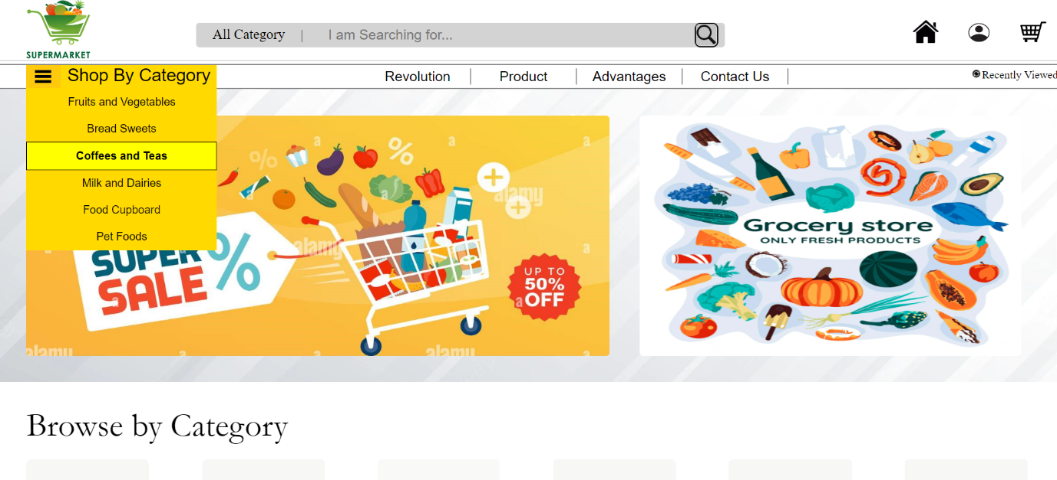

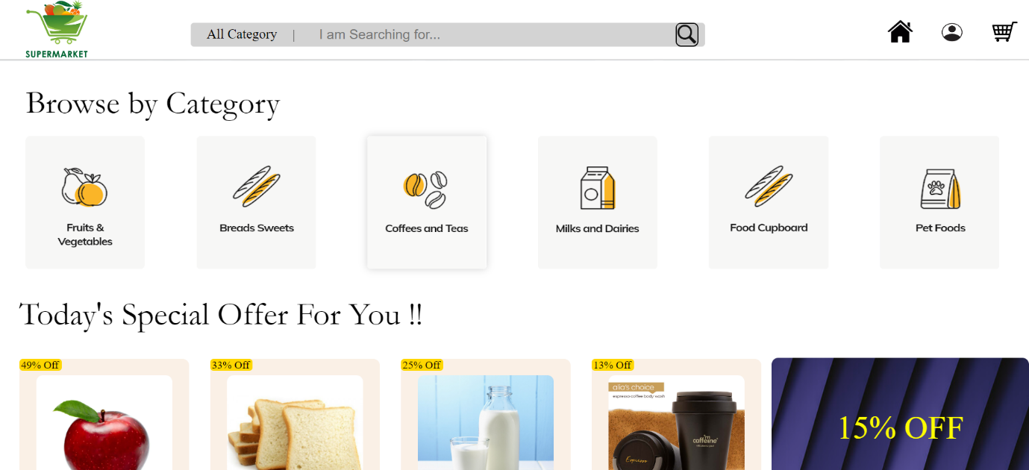

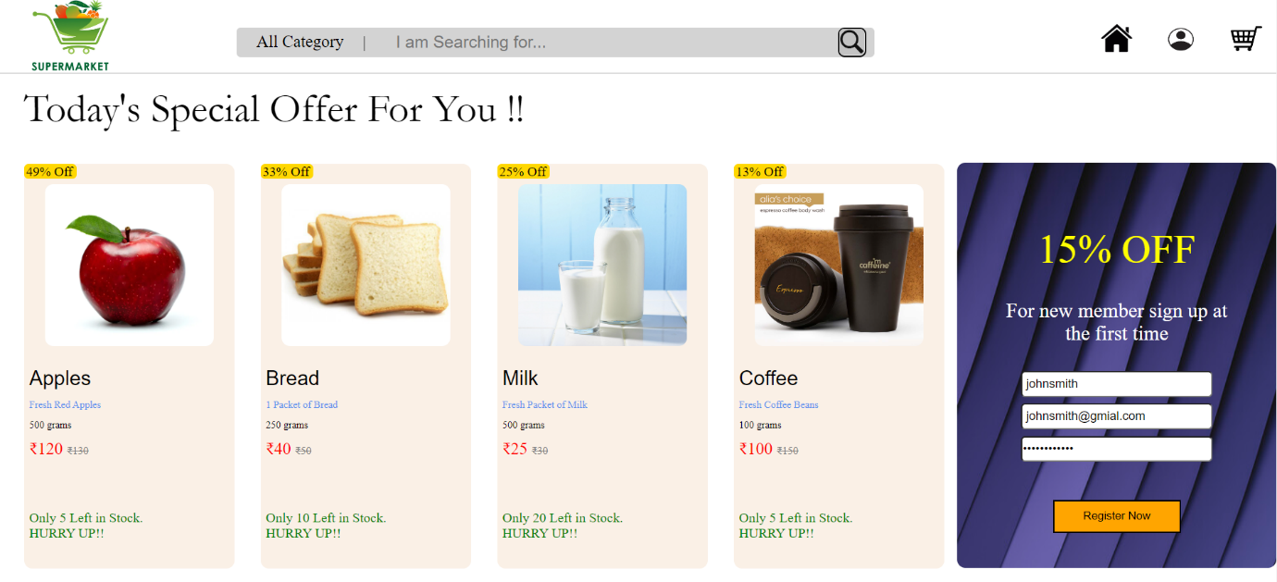

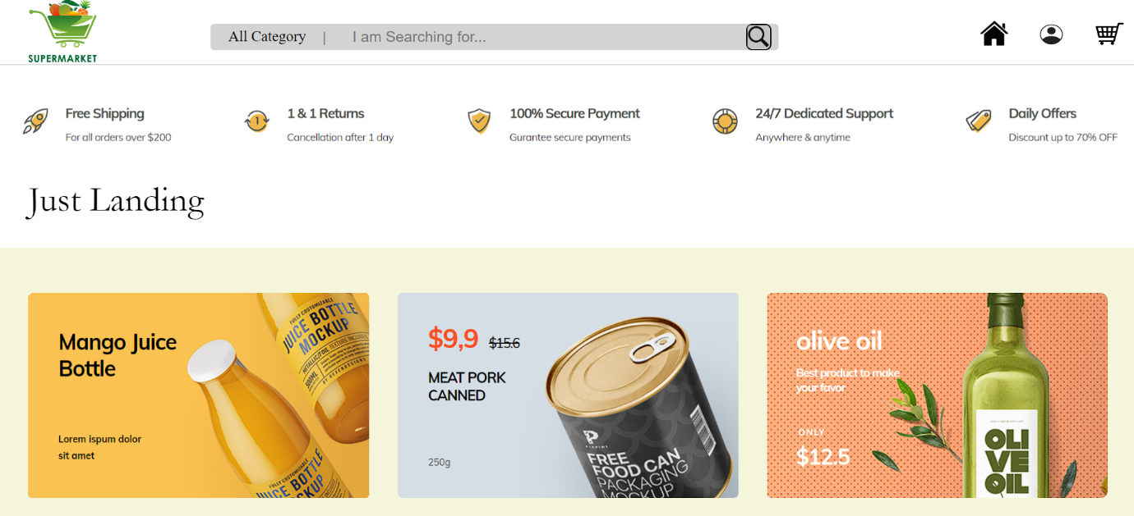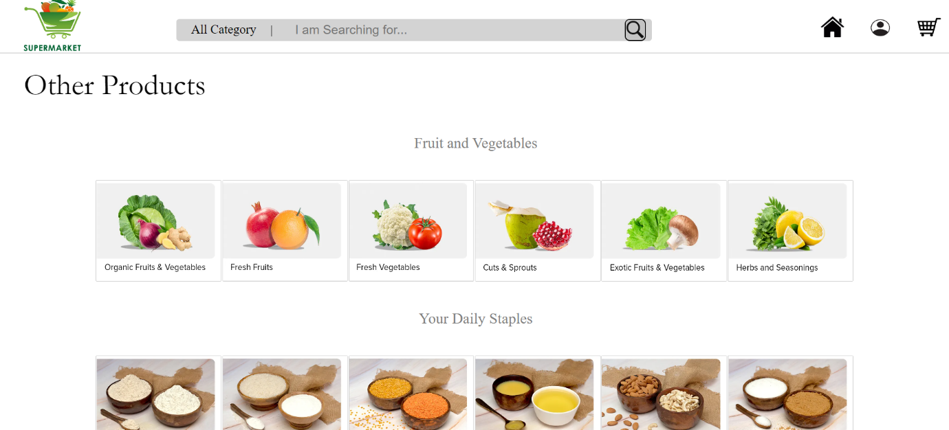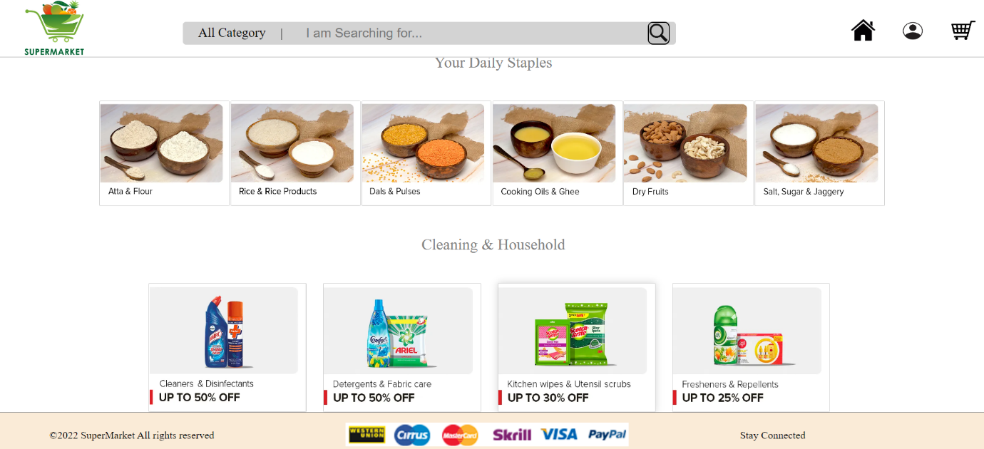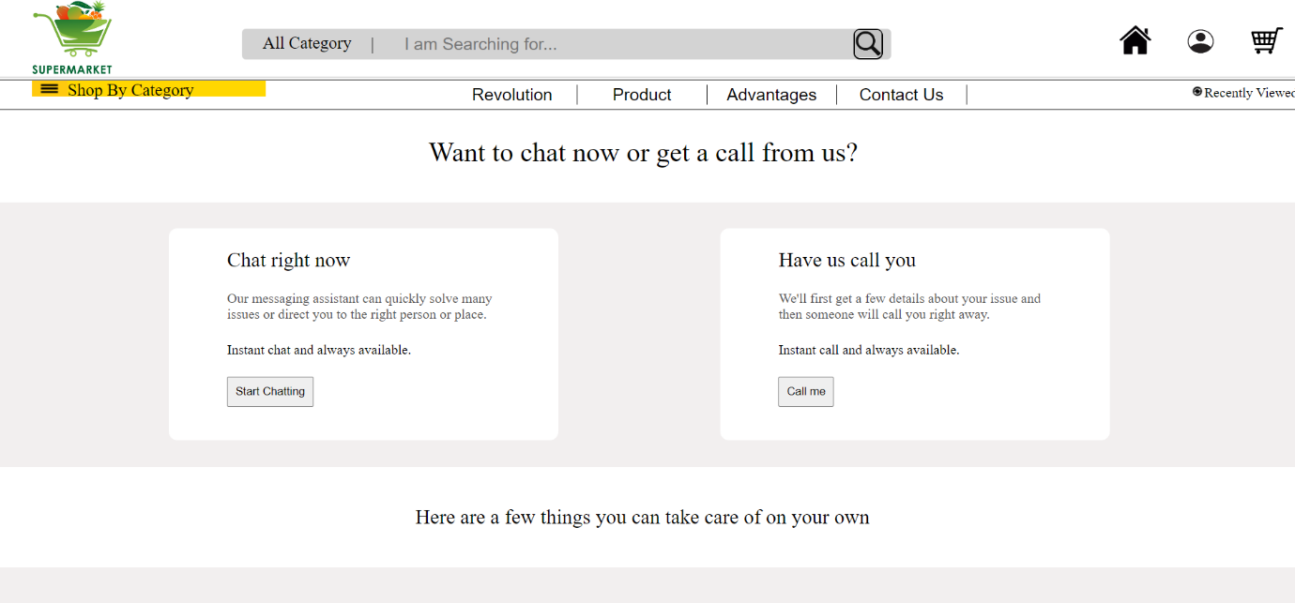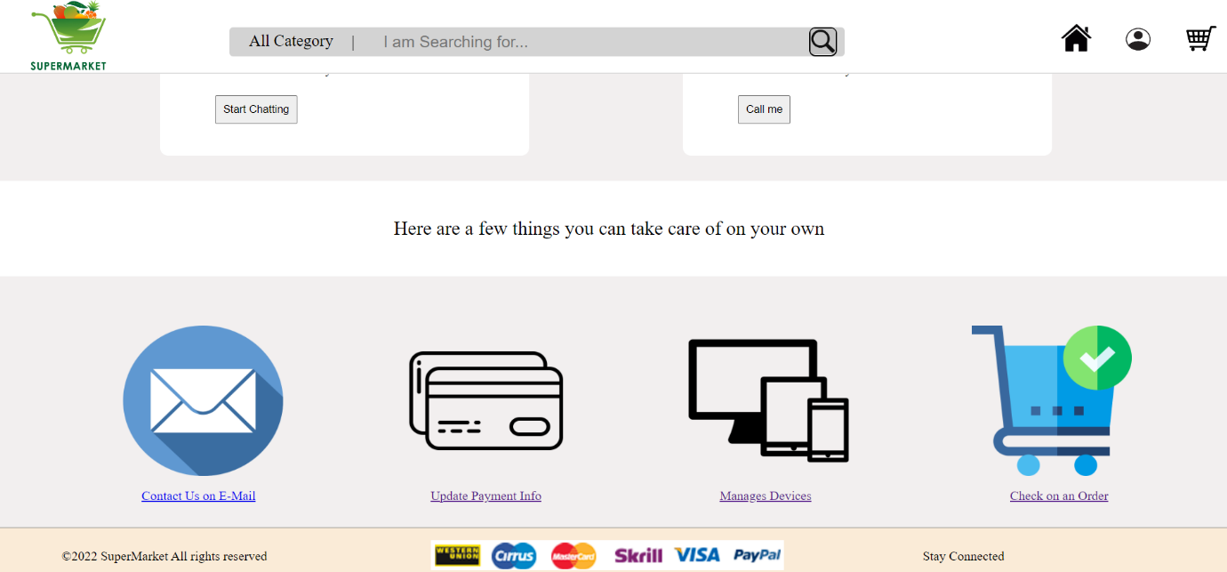

**5 Future Scope of Work**

* Can get the data in form by using JavaScript and store it in a Database.
* Can Add more products and offers to enlarge the list.
* Can add code to make functioning account.
* Can add a functioning cart function connected to Cart.
* Can make the search bar functionable.
* Can make individual product Pages.
* Can make a making order page.
* Can add new CSS side classes to make the webpage more attractive.
* Can add different webpages for each category.
* Can add feature to see recently viewed items.
* Can add favourite items.
* Can add filters while searching for products.