Go to :

<https://cloud.google.com/sdk/docs/install>

download the windows :

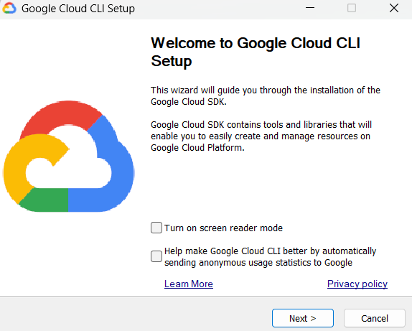

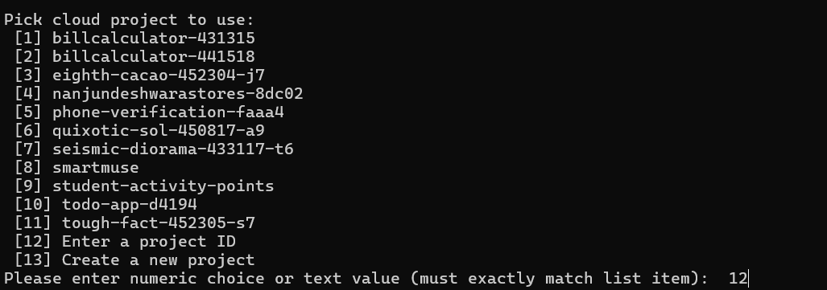

If you don’t have a project, create a new one!

gcloud components install app-engine-python  
  
execute in terminal

Now create a folder in local

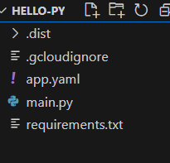

runtime: python39

handlers:

- url: /.*

  script: main.app  # Replace 'main.app' with your entry point (filename.app)

from flask import Flask

app = Flask(__name__)

@app.route('/')

def hello():

    return "Hello Immanu"

if __name__ == '__main__':

    app.run(host='0.0.0.0', port=8080)

Flask==2.2.5

Paste these three codes into the respective files.

Now go to

<https://console.cloud.google.com/iam-admin/iam>  
  
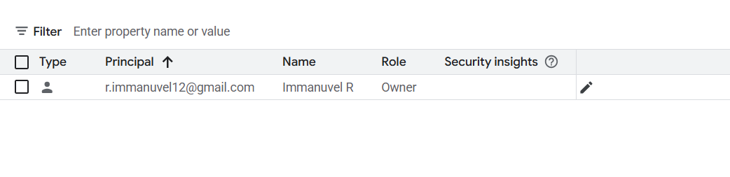click on the pencil and add a role

