Chat Room Documentation

Ștreangă Nadina 11.01.2018
UPT AC CTI Eng.
3rd year, Gr. 2.2

1.Introduction

Chat Room is a client-server chat application that allows users from the local area network to connect to a chat room and send text messages to each other. The application works best when only two users are connected, however it will allow multiple connections to the server. It is an application that mirrors the chat applications around the 2000’s. It is a cool way to connect with people around you and chat with them.

2.Implementation and Design

Both client and server were developed using C#. On the client side, the GUI was made using Windows forms, having a simple and clean design.

The client side
The client application was developed using C#’s Windows Forms and is comprised of 5 components. The first is the section where the user is prompted that he/she has connected to the server. The next is the actual chat box, where the messages appear. Below is the text box for user entry and right next to it are the two buttons that allow the user to send and receive messages. The client is single threaded and requires the user to press a button in order to receive all communication between them and the other clients.
The code snippets below show the implementation behind the GUI:

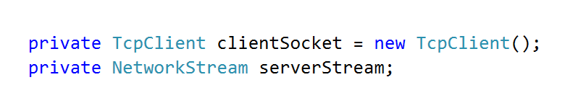

Data structures used

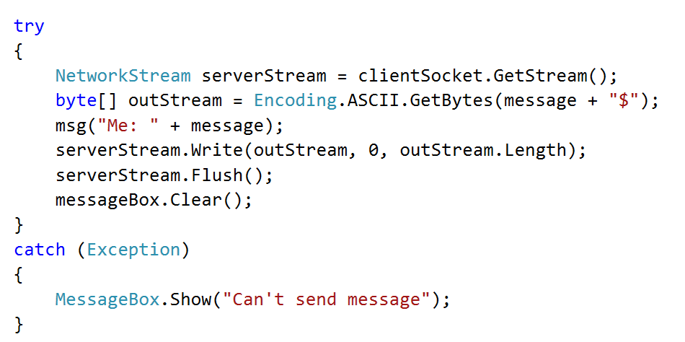

Sending bytes through the NetworkStream

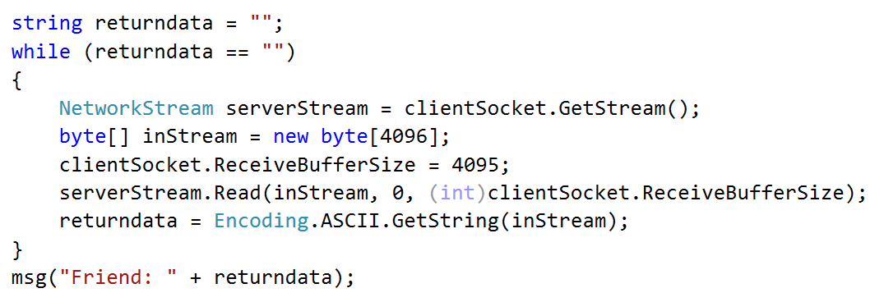

Receiving the bytes through the NetworkStream

The server side:
The server application is a console application that prints in the terminal all established connections and all messages sent to the server. For each client that the server establishes a connection with, it creates a separate thread on which communication between the two is established. All TCP clients of the server are saved in a list and shared with each thread. From there on, it is each thread’s job to handle the broadcasting of the messages it receives. Therefore each thread opens a stream of communication with the client and waits to receive messages. When a message is received, it broadcasts to all the clients from the client list that it received (besides itself).
The code snippets below show the implementation of the server:

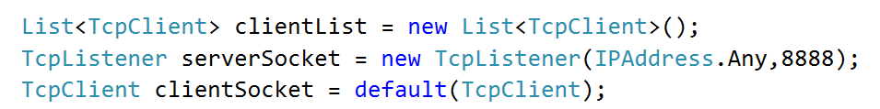

The data structures for the TCP connection

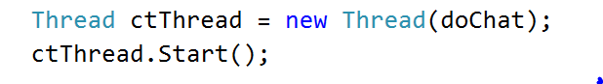
The creation of the new thread that will actually handle chat events
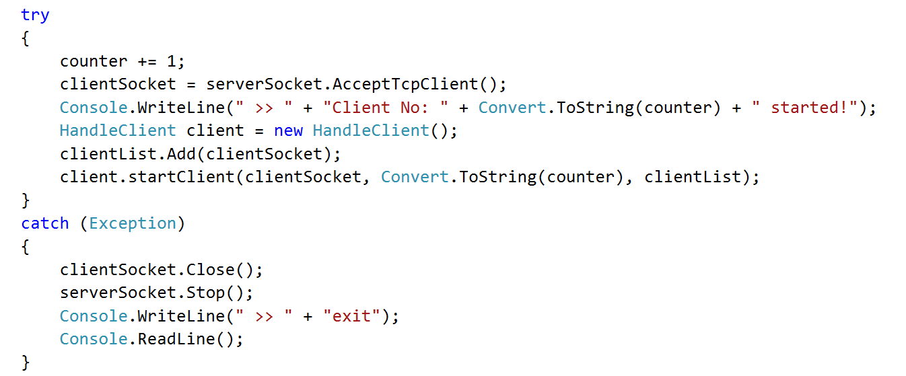
Establishing the connection to the client and delegating to a thread through HandleClient

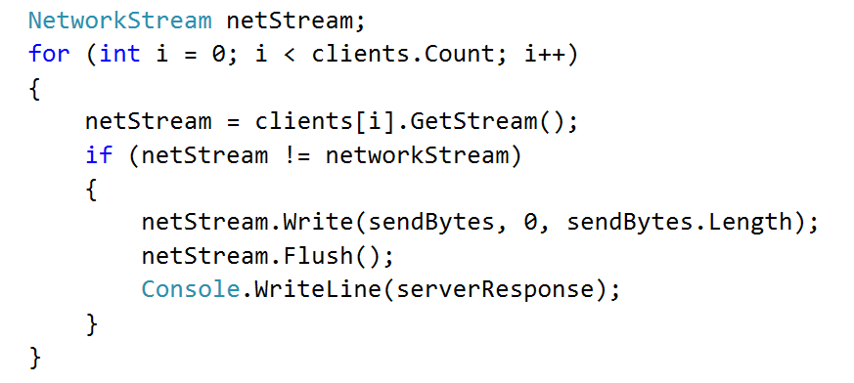

Send message to all clients

The logic of the connection between the server and its clients is simple. The server listens on port 8888 and waits for clients to connect to it. Each connection is a separate instance on the server. Once a client emits a message, the server immediately handles the message emitted, and broadcasts it. The client then handles the message by writing it to its text box. Before this step, the client also locally writes the message it sent.

Project hierarchy:
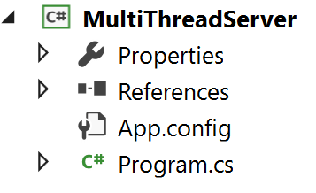
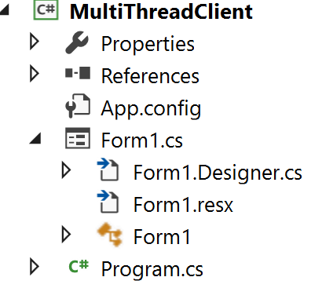

3.Usage

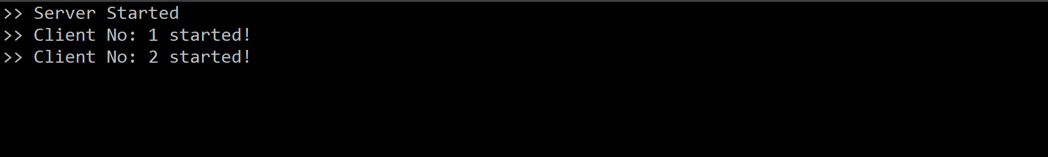
Server side console application logs

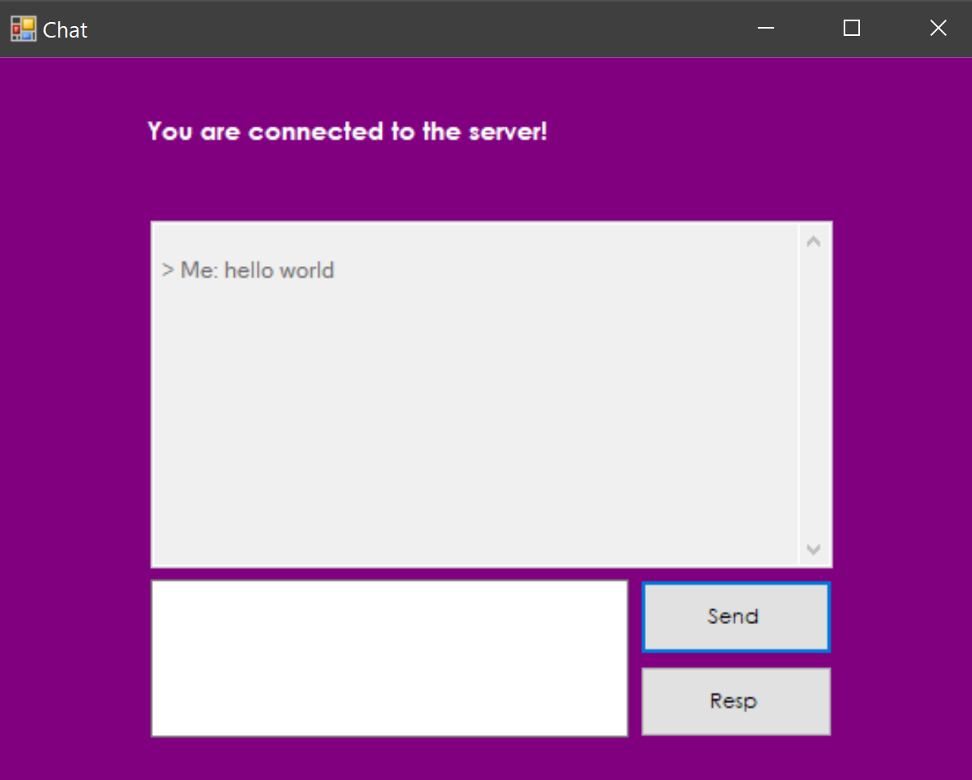
Chat box that displays the messages
User prompt area
Area to enter the message
Send and receive buttons

4. State of the art

The Chat Room had two sources of inspiration: Yahoo Messenger and early 2000’s chat rooms. The application is aimed towards the users that reminisce the old days when chatting with friends through a network connection was a lot more complex, but also a bit more exciting than the routine chat possibilities than we have today.

Compared to Yahoo Messenger or any other current messaging application, the Chat Room is much simpler. It offers only the basic text messaging, while others also offer file upload, emojis etc. This is one area where the app could be improved. Also, the application does not allow P2P communication, compared to the other messaging apps. But this is not something that the chat wants to target. However, another improvement could be the addition of various chat rooms. As an upside, compared to other apps, the Chat Room is much easier to use. It does not require the users to provide an email or any personal details.

5.Analysis

The application is deployed on the web using Heroku. An in-depth analysis of the packets sent and received by the application on the web was made using Wireshark.
Local IPv4 Address

The security key is established between server and client

Packets exchanged while the connection the is active
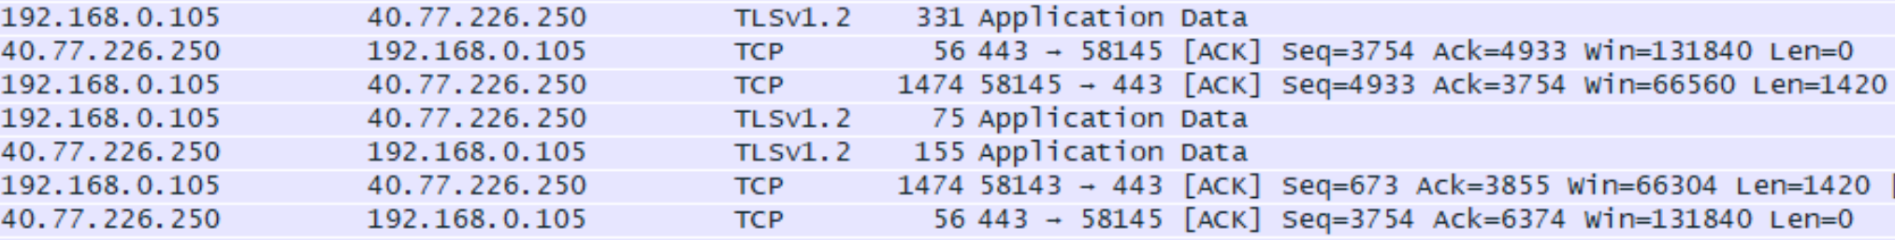

From the Wireshark analysis, it could be seen the TCP and TLS protocols are used in order to establish the connection between the client and the server. The TLS is the protocol that encrypts the data sent over the connection. Both server and client, agree through a “handshake” on the security key, as shown in the pictures above. Through TCP, the data and the TCP header are sent and received to and by the client from and to the server. The flags of the header are easily visible (ACK etc).

6.Conclusions

The Chat Room application is a chat application that allows its users to connect to each other and chat on a local network. Even though there are still many other additional features that could be added to the chat, the application keeps its simplicity as one of its main attributes. Anyone can join and anyone can send messages, which makes it even more interesting.

