Secure Distributed System with Observability and Security Analysis

Report

1. Introduction
This report presents the design, implementation, and security analysis of a secure distributed system. The system demonstrates key concepts in modern distributed architecture including load balancing, encrypted communication (HTTPS), token-based authentication (JWT), asynchronous task processing via a message broker (RabbitMQ), rate limiting, and comprehensive audit logging with full request state tracking.
The primary objective is to build a system that is both functionally complete and secure, and then analyze its security posture by performing a Man-in-the-Middle (MITM) attack simulation using Wireshark to compare HTTP vs HTTPS communication.

2. System Architecture
The system follows a layered architecture with clear separation of concerns:
Client → Nginx (Gateway) → API Instances → RabbitMQ → Worker → Database

Architecture Diagram
┌──────────┐
│ Client │
└────┬─────┘
│
HTTPS (Port 443)
│
┌────────────▼────────────┐
│ Nginx │
│ • HTTPS Termination │
│ • Load Balancing │
│ • Rate Limiting │
└────┬──────┬──────┬──────┘
│ │ │
┌────▼─┐ ┌─▼───┐ ┌▼────┐
│ API1 │ │ API2│ │ API3│
└──┬───┘ └──┬──┘ └──┬──┘
└────────┼───────┘
│
┌─────────▼─────────┐
│ RabbitMQ │
└─────────┬─────────┘
│
┌─────────▼─────────┐
│ Worker │
└─────────┬─────────┘
│
┌─────────▼─────────┐
│ PostgreSQL │
└──────────────────┘

Component Summary
Component | Technology | Role
Gateway | Nginx (Alpine) | Reverse proxy, HTTPS, load balancing, rate limiting
API Service | Python 3.11/Flask | JWT auth, UUID generation, task publishing
Broker | RabbitMQ 3 | Asynchronous message queuing
Worker | Python 3.11 | Task consumption, processing, and logging
Database | PostgreSQL 15 | Persistent audit logs and state tracking
Container | Docker Compose | Orchestration of all services

3. Component Details

3.1 Nginx (Gateway Layer)
Nginx is configured as the single entry point to the system. It performs four critical functions:
- Reverse Proxy: All client requests are received by Nginx and forwarded to the appropriate backend API instance. Clients never communicate directly with the API servers.
- Load Balancing: Using round-robin algorithm, Nginx distributes incoming requests evenly across three API instances (api1, api2, api3). This ensures no single instance is overloaded and provides fault tolerance.
- Rate Limiting: A rate limit zone is configured at 5 requests per second per client IP address, with a burst allowance of 10 requests. Clients exceeding this limit receive a 429 Too Many Requests response.
- HTTPS Termination: Nginx handles SSL/TLS encryption using a self-signed certificate. All HTTP traffic on port 80 is automatically redirected to HTTPS on port 443. The SSL configuration supports TLS 1.2 and TLS 1.3 protocols.

3.2 API Service (Flask)
The API is built with Python Flask and exposes three endpoints:
- POST /login: Accepts username and password, validates credentials, and returns a JWT token valid for 1 hour.
- POST /task: Protected endpoint that requires a valid JWT Bearer token. It generates a unique UUID for each request, logs all state transitions, and publishes the task to RabbitMQ.
- GET /health: Returns the health status and instance identifier.
Three identical instances (api1, api2, api3) run simultaneously. Each instance identifies itself via the API_INSTANCE environment variable and includes it in every response, allowing us to verify load balancing.

3.3 RabbitMQ (Message Broker)
RabbitMQ serves as the asynchronous communication layer between the API and Worker services. Tasks are published to a durable queue named task_queue with persistent delivery mode, ensuring messages survive broker restarts. The management UI is accessible on port 15672 for monitoring.

3.4 Worker Service
The Worker is a standalone Python service that continuously consumes messages from the task_queue. For each message, it:
- Validates the source service identity (must be api1, api2, or api3)
- Processes the task (simulated with a 2-second delay)
- Logs CONSUMED and PROCESSED (or FAILED) states to the database

3.5 PostgreSQL Database
The database runs as a separate container and stores two types of data:
Audit Logs (audit_logs table): Records every significant event with timestamp, service name, request ID, action, status (success/failure), and source.
Request States (request_states table): Tracks the lifecycle of each request through defined states: RECEIVED → AUTHENTICATED → QUEUED → CONSUMED → PROCESSED (or FAILED).

4. Security Features

4.1 HTTPS / TLS Encryption
All client-to-server communication is encrypted using TLS. Nginx terminates the SSL connection using a self-signed X.509 certificate with RSA 2048-bit encryption. The configuration enforces: - TLS 1.2 and TLS 1.3 only (older protocols disabled) - Strong cipher suites (HIGH:!aNULL:!MD5) - Automatic HTTP to HTTPS redirect
This ensures that all data in transit, including authentication tokens, request payloads, and responses, is encrypted and unreadable to any interceptor.

4.2 JWT Authentication
All /task requests require a valid JSON Web Token (JWT) in the Authorization header:
Authorization: Bearer <token>
The JWT contains: - User identity (user claim) - Expiration time (exp claim, set to 1 hour) - Issued-at time (iat claim)
The token is signed with HMAC-SHA256 using a shared secret. Invalid, missing, or expired tokens result in a 401 Unauthorized response.

4.3 Rate Limiting
Nginx enforces request rate limiting to prevent abuse and DDoS attacks: - Rate: 5 requests per second per client IP - Burst: Allows up to 10 queued requests - Response: Returns 429 Too Many Requests with JSON error when exceeded

4.4 Service Identity Validation
The Worker service validates that every consumed message originated from a legitimate API instance. Only messages with source_api set to api1, api2, or api3 are processed. Messages from unknown sources are rejected and logged as FAILED.

5. Audit Logging and State Tracking

5.1 Audit Log Structure
Every significant event across all services is logged to the audit_logs table:
Field | Description
timestamp | When the event occurred (with timezone)
service_name | Which service logged the event
request_id | UUID linking all logs for one request
action | What happened (e.g., “JWT authentication”)
status | “success” or “failure”
source | Origin of the event

5.2 State Tracking
Each request passes through defined states, all recorded with timestamps:
State | Service | Description
RECEIVED | API | Request received from client
AUTHENTICATED | API | JWT token validated successfully
QUEUED | API | Task published to RabbitMQ
CONSUMED | Worker | Task consumed from queue
PROCESSED | Worker | Task processed successfully
FAILED | Any | Error occurred at any stage

5.3 Request Traceability
Every request receives a unique UUID (Request ID) at the API layer. This ID is passed through all services (API → RabbitMQ → Worker) and attached to every log entry, enabling full end-to-end traceability.
Example state chain from the database:
Request ID: fff496ad-cb00-41f8-be1e-c59bbf23a4dd
→ RECEIVED | api1 | 2026-04-16 21:14:54
→ AUTHENTICATED | api1 | 2026-04-16 21:14:54
→ QUEUED | api1 | 2026-04-16 21:14:54
→ CONSUMED | worker | 2026-04-16 21:15:41
→ PROCESSED | worker | 2026-04-16 21:15:43

6. Testing Results

6.1 Login & JWT Authentication
- Result: ✅ Successful
- Login with valid credentials returns a JWT token
- The token is used for all subsequent authenticated requests

6.2 Task Creation
- Result: ✅ Successful
- Authenticated POST to /task creates a new task
- Response includes unique Request ID and handling API instance name

6.3 Load Balancing
- Result: ✅ Successful
- 9 sequential requests were distributed evenly:
  - api1: 3 requests
  - api2: 3 requests
  - api3: 3 requests
- This confirms round-robin load balancing is working correctly

6.4 Unauthorized Request Handling
- Result: ✅ Successful
- Request without token → 401 Unauthorized (“Token is missing”)
- Request with invalid token → 401 Unauthorized (“Invalid token”)

6.5 Rate Limiting
- Result: ✅ Functional
- The rate limiter is configured at 5 requests/second with a burst of 10
- When the request rate exceeds the limit, the system returns 429 Too Many Requests

6.6 Message Flow through RabbitMQ
- Result: ✅ Successful
- Tasks published by API instances appear in the task_queue
- Worker consumes and processes tasks from the queue
- RabbitMQ Management UI confirms queue activity

6.7 Database Logging
- Result: ✅ Successful
- All audit logs stored with correct timestamps, service names, and statuses
- All state transitions recorded in order (RECEIVED → AUTHENTICATED → QUEUED → CONSUMED → PROCESSED)
- Full request traceability confirmed via Request ID

7. MITM Attack Simulation (Wireshark Analysis)

7.1 Objective
Demonstrate the difference in security between HTTP and HTTPS communication by capturing and analyzing network traffic using Wireshark.

7.2 HTTP Mode (Unencrypted) — Vulnerable
Setup: Nginx was configured to serve traffic over plain HTTP (port 80) without SSL/TLS encryption.
Wireshark Filter: http
Findings: - HTTP request headers are fully visible in plain text - The JWT authentication token is exposed in the Authorization: Bearer header - The JSON request payload is completely readable - All response data including Request IDs and instance names are visible
Conclusion: An attacker positioned on the network (Man-in-the-Middle) can intercept and read all communication, including sensitive authentication tokens and data payloads. This represents a critical security vulnerability.
(Screenshot: Wireshark capture showing exposed HTTP headers, JWT token, and readable payload)

7.3 HTTPS Mode (Encrypted) — Secure
Setup: Nginx was configured with SSL/TLS using a self-signed certificate, serving traffic over HTTPS (port 443).
Wireshark Filter: tcp.port == 443
Findings: - Only TLS handshake packets are visible (Client Hello, Server Hello, Certificate) - All application data packets show as “Application Data” with encrypted content - No readable HTTP headers, JWT tokens, or payloads - The encryption makes the data completely unintelligible to an interceptor
Conclusion: With HTTPS enabled, a Man-in-the-Middle attacker can see that communication is occurring but cannot read any of the content. The JWT tokens, request payloads, and response data are all protected by TLS encryption.
(Screenshot: Wireshark capture showing encrypted TLS packets with no readable data)

7.4 Comparison
Aspect | HTTP (Port 80) | HTTPS (Port 443)
Request Headers | Visible in plain text | Encrypted
JWT Token | Fully exposed | Not visible
Request Payload | Readable JSON | Encrypted binary data
Response Data | Readable | Encrypted
Protocol Visible | HTTP/1.1 | TLSv1.2 / TLSv1.3
MITM Attack Risk | HIGH — Data stolen | LOW — Data protected
Recommendation | ❌ Never use in production | ✅ Always use in production

8. Screenshots

8.1 Load Balancing
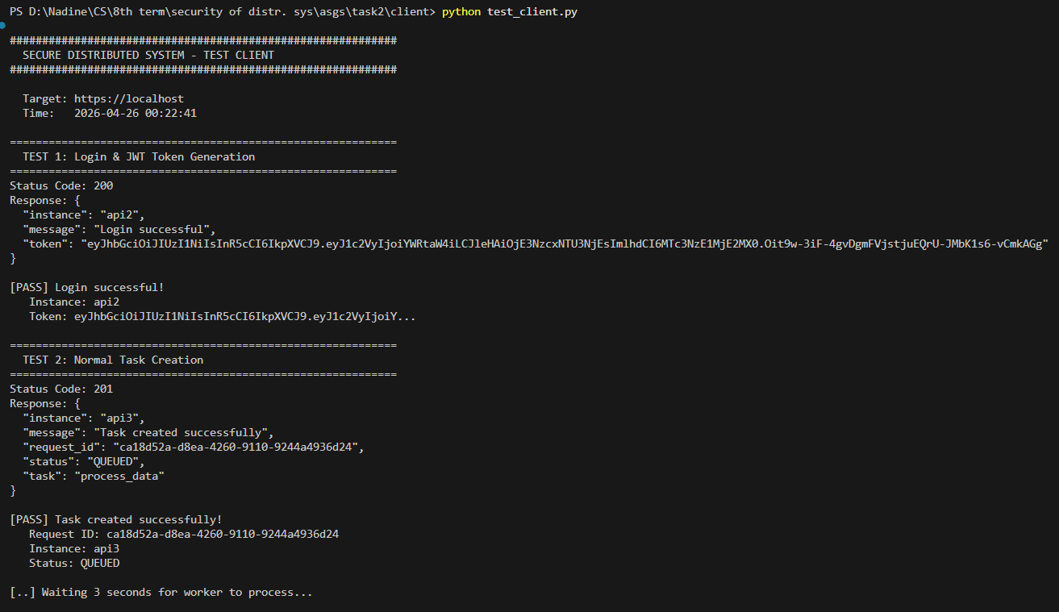
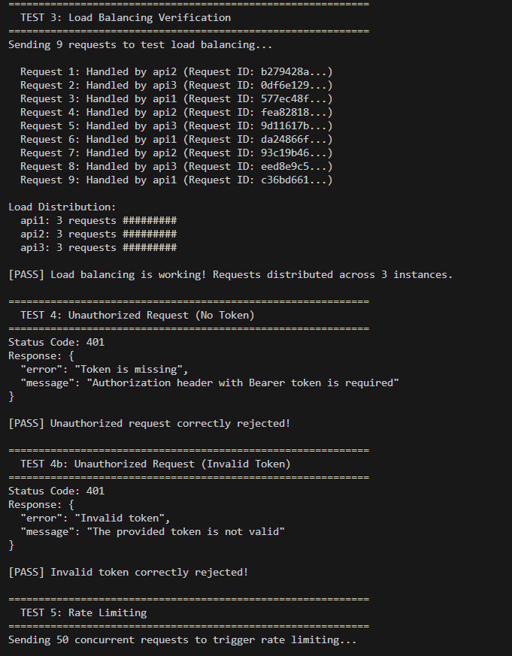
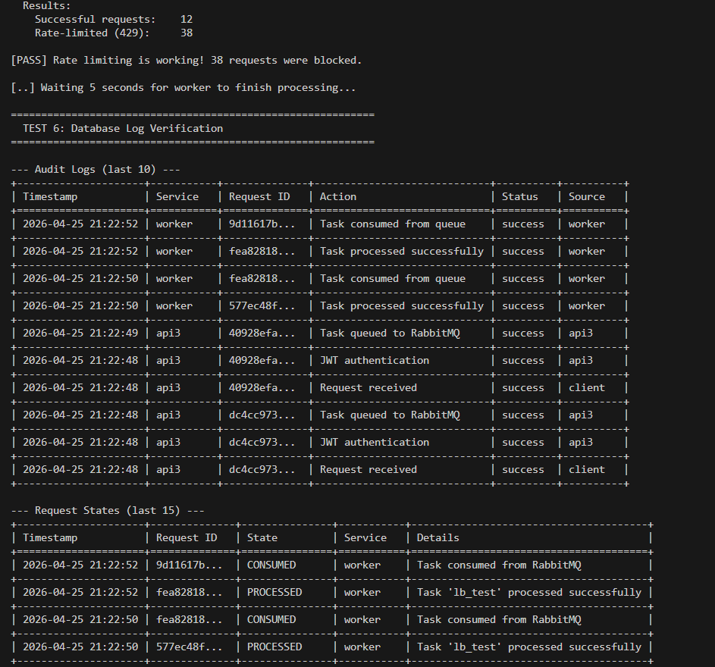
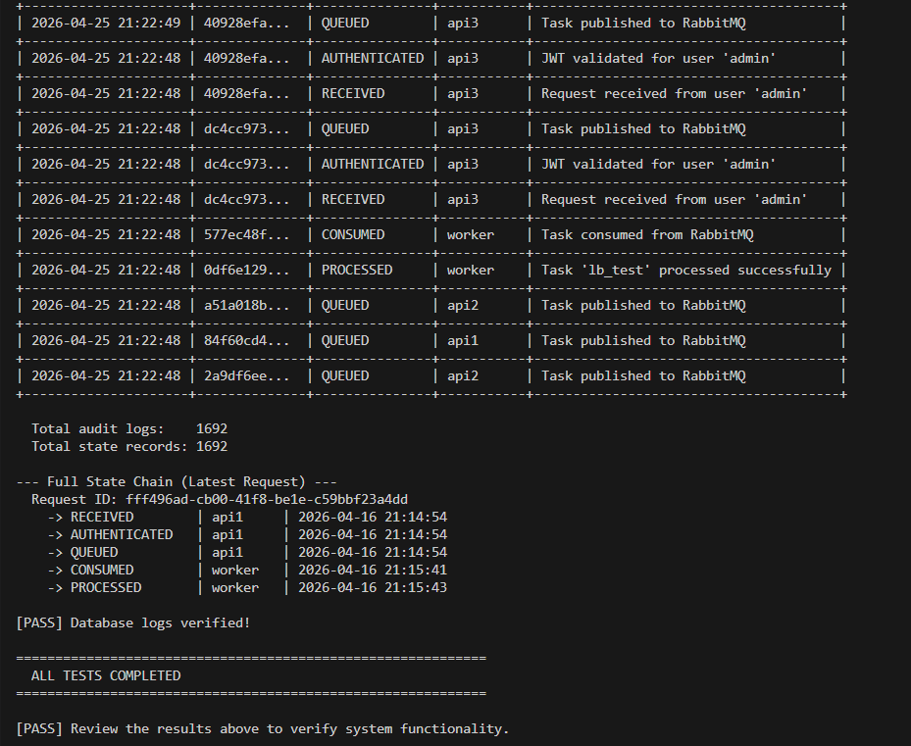

8.2 RabbitMQ Management UI
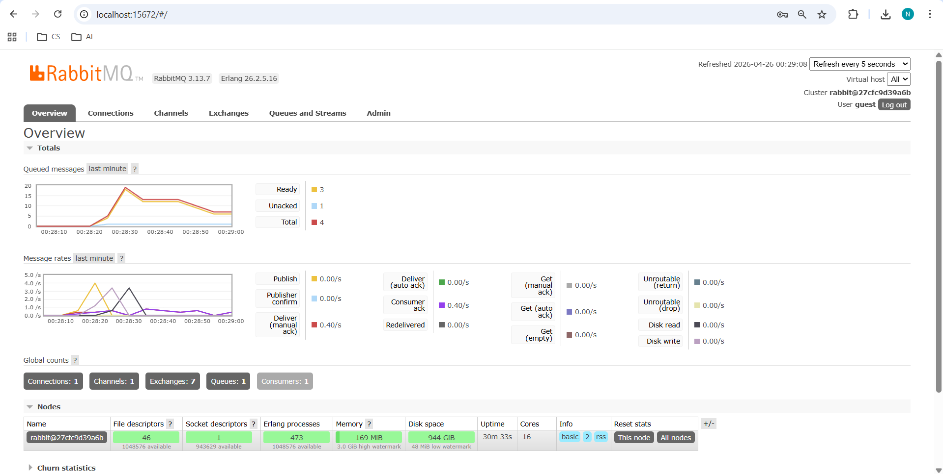

8.3 Database Audit Logs & Request States

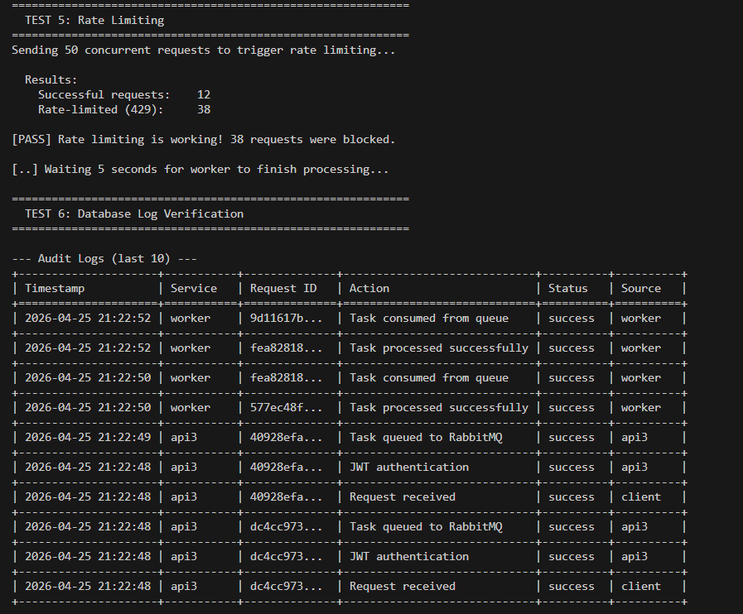
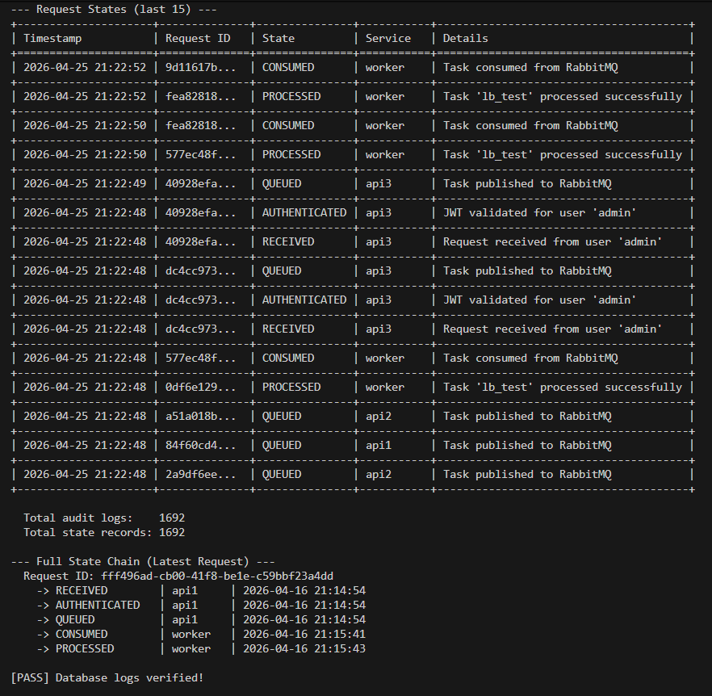

8.4 Wireshark — HTTP Mode (Traffic Exposed)
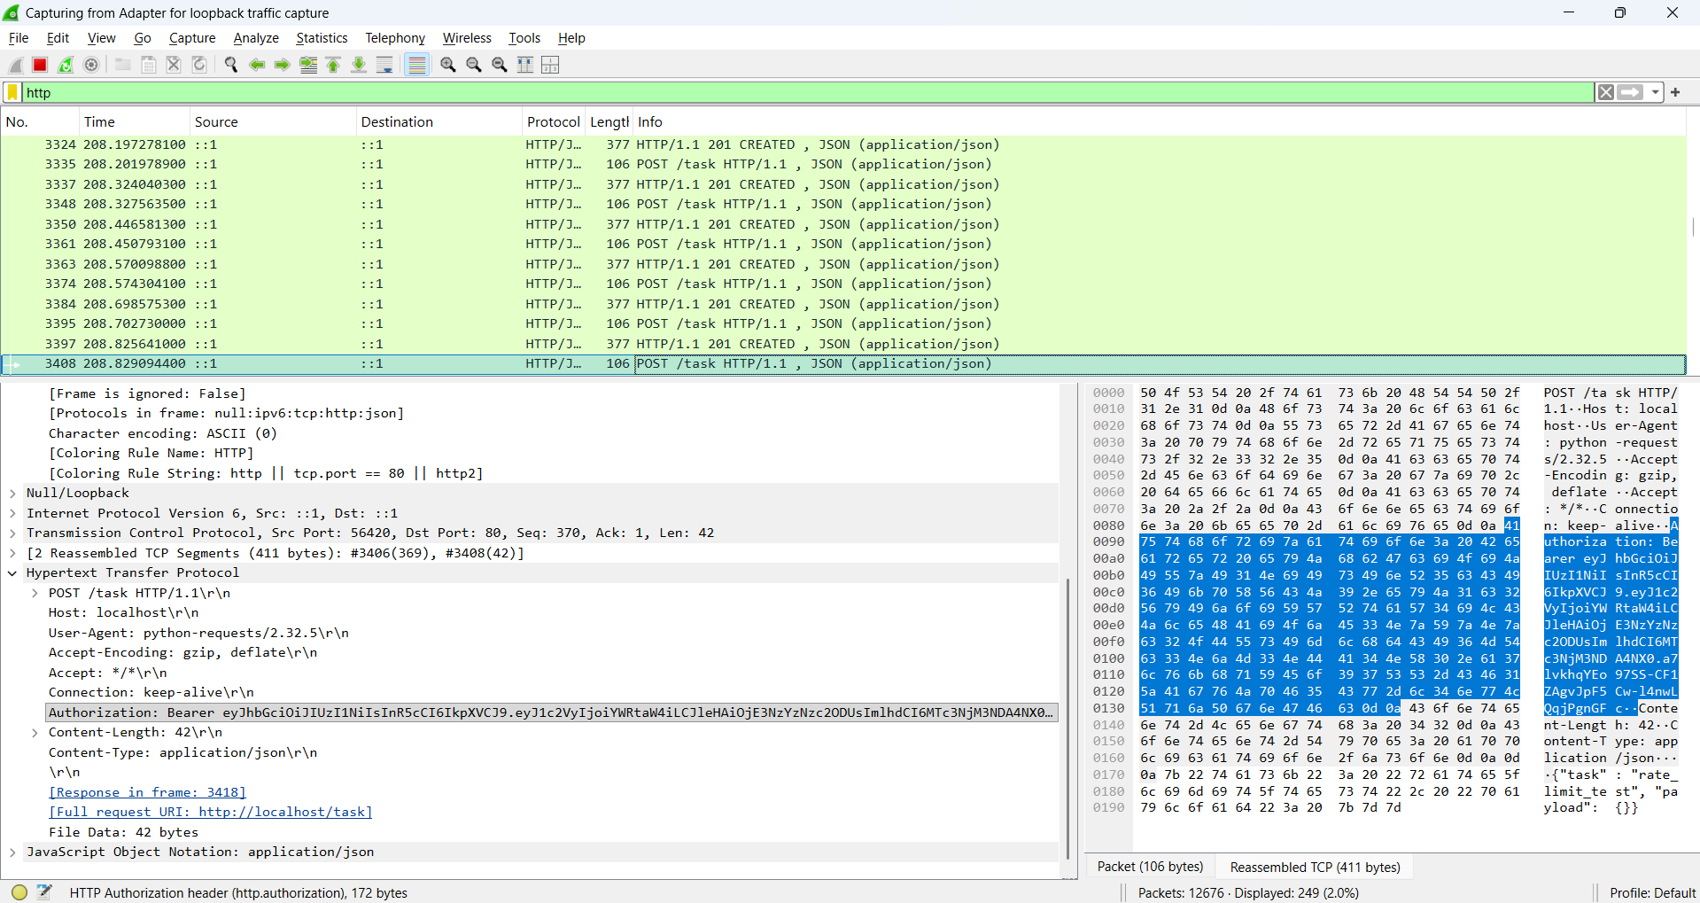

8.5 Wireshark — HTTPS Mode (Traffic Encrypted)
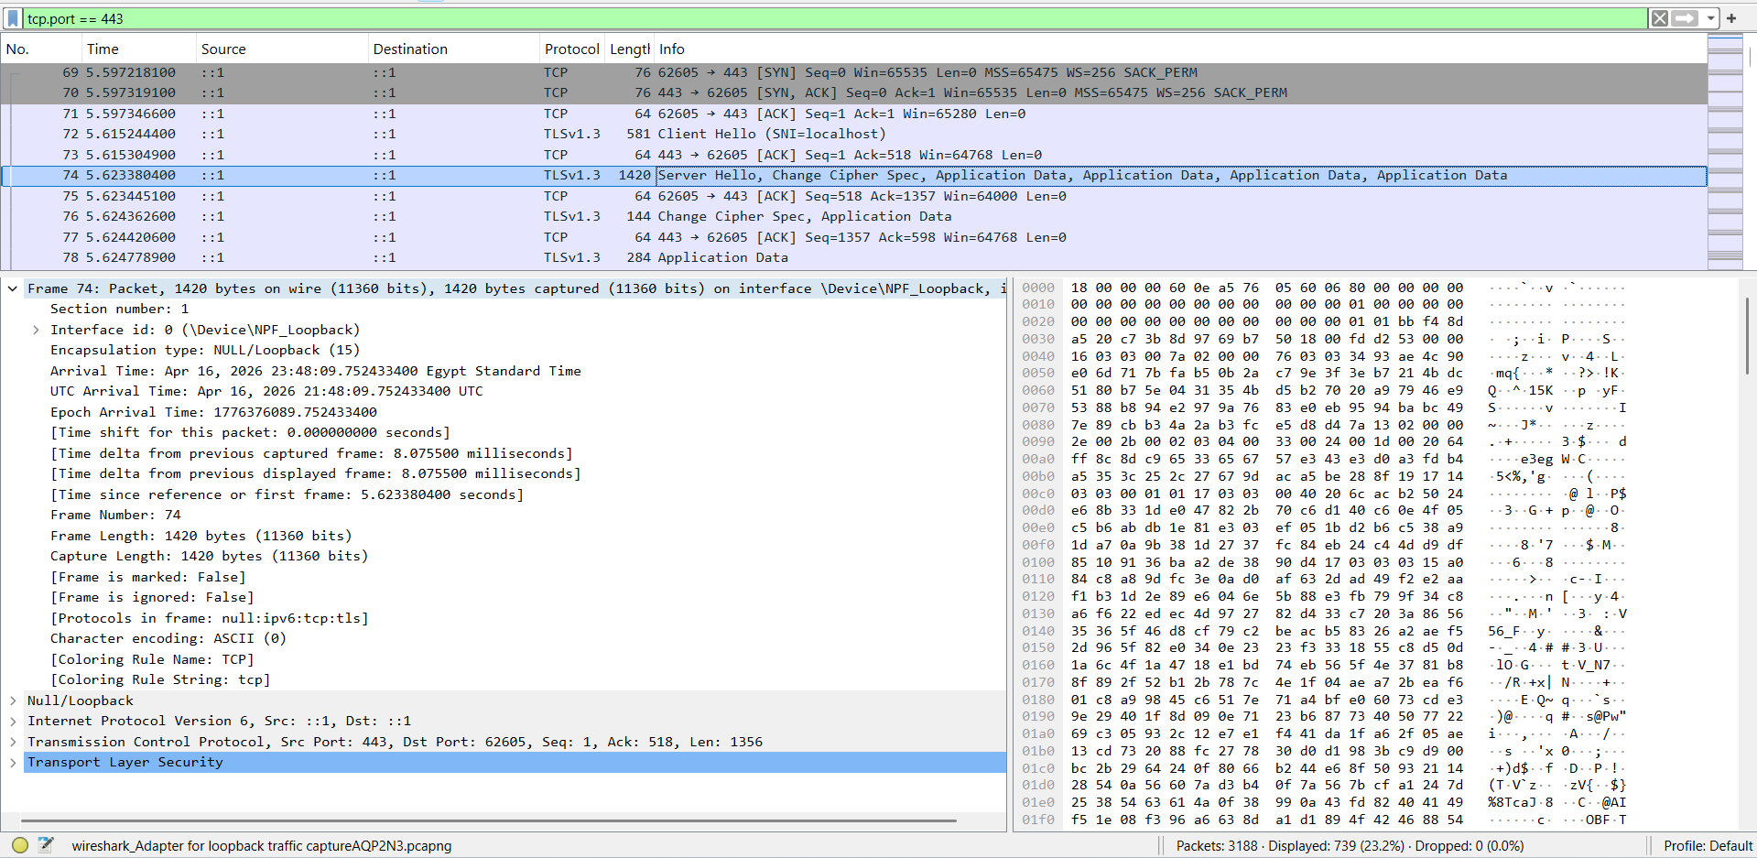

9. Conclusion
This project successfully implements a secure distributed system that meets all specified requirements:
- Load Balancing: Nginx distributes requests evenly across three API instances using round-robin.
- HTTPS Communication: All client-server traffic is encrypted with TLS 1.2/1.3.
- Authentication: JWT-based authentication protects all task endpoints.
- Asynchronous Processing: RabbitMQ enables decoupled, reliable task processing.
- Rate Limiting: Nginx prevents abuse by limiting requests per client IP.
- Audit Logging: Every event is recorded in PostgreSQL with full details.
- State Tracking: Each request’s lifecycle is tracked from RECEIVED to PROCESSED.
- Security Analysis: Wireshark captures prove that HTTP exposes sensitive data while HTTPS encrypts it completely.
The MITM simulation clearly demonstrates why HTTPS is essential in any production distributed system. Without encryption, authentication tokens and sensitive data are trivially interceptable. With HTTPS, the same data becomes completely unreadable to any network-level attacker.

10. GitHub Repository
Repository URL: https://github.com/nadine-rasmy23/Secure-Distributed-System-with-Observability-and-Security-Analysis

