CBIO204 – Fundamentals of Databases
Biotechnology Database Project
Biobank and Biospecimen Management System
Name: Nadine Ahmed
ID: 221002162
Dr/ Muhammed Elsayeh

1. Problem Statement, Scope, Assumptions, and Business Rules
The project implements a relational database for a biobank that stores and manages biospecimens collected from donors for biomedical research. The system tracks donors and consent, collection events, sample types, biospecimens, storage positions, aliquots, researchers, test requests, sample usage, and test results. The design follows the project guideline requirement for a realistic biotechnology database with strong entities, one-to-many relationships, a many-to-many relationship resolved through an associative table, constraints, SQL operations, views, and an advanced database object.
In scope:
- Donor registration and consent tracking.
- Recording biospecimen collection events and sample classification.
- Tracking specimen status, quality, volume, aliquots, and freezer locations.
- Managing researchers and their test requests.
- Recording sample usage and laboratory test results.
- Enforcing integrity rules with primary keys, foreign keys, CHECK constraints, UNIQUE constraints, indexes, and a trigger.
Assumptions:
- All donor identifiers are synthetic and anonymized for the project.
- A donor may have multiple collection events and multiple consent records.
- A collection event can produce multiple biospecimens.
- A biospecimen can be divided into multiple aliquots.
- An aliquot can be associated with one storage position at a time.
- A researcher can submit multiple test requests.
- A test request can use multiple aliquots, and an aliquot can support multiple requests; SAMPLE_USAGE resolves this many-to-many relationship.
- The implementation targets PostgreSQL 15+.
Major business rules:
- Donor code, researcher code, sample code, aliquot code, and researcher email are unique.
- A consent expiry date cannot precede its consent date.
- Specimen volume and aliquot volume must be positive.
- Storage temperatures must be at or below 8°C for this project.
- A sample usage quantity must be positive and cannot exceed the aliquot's available volume.
- A valid sample usage reduces the remaining aliquot volume; when it reaches zero, the aliquot becomes Depleted.
- Foreign keys prevent orphan records and restrict deletion of referenced core records.

2. Entities, Attributes, and Keys
Entity | Attributes and key decisions
DONOR | donor_id PK; donor_code UQ; first_name; last_name; date_of_birth; sex; email UQ; phone; registration_date; status
CONSENT | consent_id PK; donor_id FK; consent_type; consent_date; expiry_date; status; version_no
SAMPLE_TYPE | sample_type_id PK; type_name UQ; description
COLLECTION_EVENT | collection_event_id PK; donor_id FK; collection_date; collection_site; collector_name; protocol_code; notes
BIOSPECIMEN | sample_id PK; sample_code UQ; collection_event_id FK; sample_type_id FK; volume_ml; collection_time; quality_status; current_status
STORAGE_LOCATION | location_id PK; facility; room_code; freezer_code; shelf_no; box_code; position_no; temperature_c
ALIQUOT | aliquot_id PK; sample_id FK; aliquot_code UQ; volume_ml; location_id FK; created_at; status
RESEARCHER | researcher_id PK; researcher_code UQ; full_name; email UQ; department; active_flag
TEST_REQUEST | test_request_id PK; researcher_id FK; request_date; purpose; priority; status
SAMPLE_USAGE | usage_id PK; test_request_id FK; aliquot_id FK; usage_date; quantity_used_ml; result_summary
SAMPLE_TEST | sample_test_id PK; test_request_id FK; sample_id FK; test_name; test_date; result_value; result_unit; result_status

3. ER Diagram and Relationship Design
The final ER diagram is included as diagrams/ERD.png. The main relationships are:
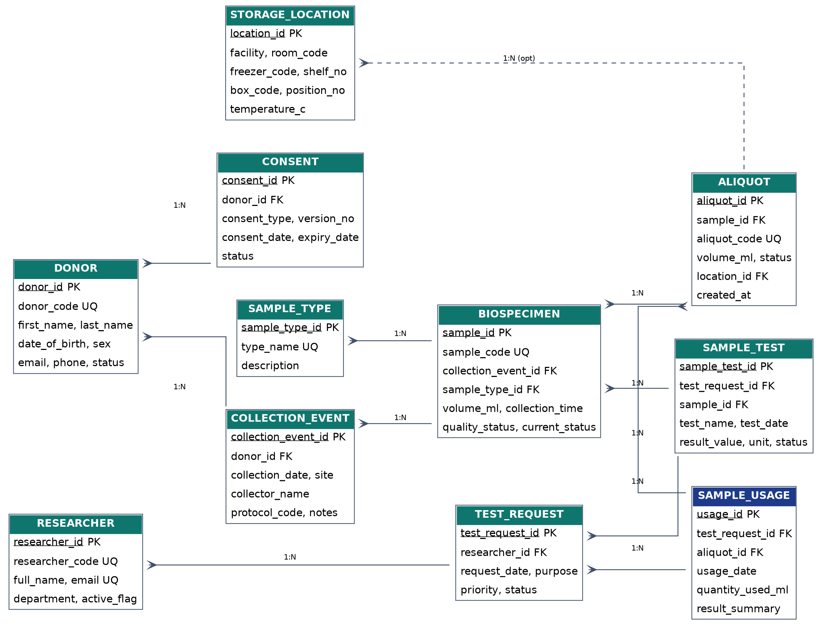
- DONOR 1:N CONSENT — each consent record belongs to one donor; a donor can have multiple consent records.
- DONOR 1:N COLLECTION_EVENT — a donor may participate in multiple collection events.
- COLLECTION_EVENT 1:N BIOSPECIMEN — one collection event may produce multiple biospecimens.
- SAMPLE_TYPE 1:N BIOSPECIMEN — each biospecimen has one type; a type can classify many biospecimens.
- BIOSPECIMEN 1:N ALIQUOT — one biospecimen may be divided into multiple aliquots.
- STORAGE_LOCATION 1:N ALIQUOT — a location can hold multiple aliquots; location is nullable to support temporary unassigned aliquots.
- RESEARCHER 1:N TEST_REQUEST — a researcher can submit many requests.
- TEST_REQUEST M:N ALIQUOT — resolved by SAMPLE_USAGE.
- TEST_REQUEST 1:N SAMPLE_TEST and BIOSPECIMEN 1:N SAMPLE_TEST — tests connect requested work with the sample being tested.
Participation is mandatory on the child side for the core foreign keys: every consent must reference a donor, every collection event a donor, every biospecimen a collection event and sample type, every aliquot a biospecimen, and every test request a researcher. ALIQUOT.location_id is optional.

4. Relational Schema
The ER model is mapped into eleven normalized relations. Primary keys identify individual rows. Foreign keys preserve referential integrity. UNIQUE constraints represent alternate candidate keys such as donor_code, sample_code, aliquot_code, researcher_code, and researcher email.
- donor(donor_id PK, donor_code UQ, first_name, last_name, date_of_birth, sex, email UQ, phone, registration_date, status)
- consent(consent_id PK, donor_id FK→donor, consent_type, consent_date, expiry_date, status, version_no, UQ(donor_id, consent_type, version_no))
- sample_type(sample_type_id PK, type_name UQ, description)
- collection_event(collection_event_id PK, donor_id FK→donor, collection_date, collection_site, collector_name, protocol_code, notes)
- biospecimen(sample_id PK, sample_code UQ, collection_event_id FK→collection_event, sample_type_id FK→sample_type, volume_ml, collection_time, quality_status, current_status)
- storage_location(location_id PK, facility, room_code, freezer_code, shelf_no, box_code, position_no, temperature_c, UQ(freezer_code,shelf_no,box_code,position_no))
- aliquot(aliquot_id PK, sample_id FK→biospecimen, aliquot_code UQ, volume_ml, location_id FK→storage_location, created_at, status)
- researcher(researcher_id PK, researcher_code UQ, full_name, email UQ, department, active_flag)
- test_request(test_request_id PK, researcher_id FK→researcher, request_date, purpose, priority, status)
- sample_usage(usage_id PK, test_request_id FK→test_request, aliquot_id FK→aliquot, usage_date, quantity_used_ml, result_summary, UQ(test_request_id,aliquot_id))
- sample_test(sample_test_id PK, test_request_id FK→test_request, sample_id FK→biospecimen, test_name, test_date, result_value, result_unit, result_status, UQ(test_request_id,sample_id,test_name))

5. Normalization to 3NF
The design satisfies Third Normal Form. Each table represents one subject or relationship and attributes depend on the key of that table.
- 1NF: all attributes are atomic; repeating groups such as multiple samples, aliquots, or tests are stored as separate rows.
- 2NF: non-key attributes in each relation depend on the whole primary key. Associative data such as quantity_used_ml belongs to SAMPLE_USAGE rather than to either TEST_REQUEST or ALIQUOT alone.
- 3NF: transitive dependencies are removed. For example, sample type details are stored in SAMPLE_TYPE instead of repeated in BIOSPECIMEN, and researcher department/contact details are stored in RESEARCHER rather than TEST_REQUEST.
- The M:N relationship between TEST_REQUEST and ALIQUOT is resolved by SAMPLE_USAGE, which has its own primary key and relationship-specific attributes.
- Storage coordinates are kept in STORAGE_LOCATION so the same location information is not repeated for every aliquot.

6. Implementation Details
PostgreSQL 15+ is used. The implementation is separated into scripts so that the database can be reproduced from a clean database.
- create_tables.sql: schema, 11 tables, PK/FK constraints, CHECK constraints, UNIQUE constraints, and indexes.
- load_data.sql: synthetic test data with 10 records in each main table.
- queries.sql: retrieval, joins, aggregation, subqueries, INSERT, UPDATE, DELETE, and business queries.
- views.sql: v_sample_inventory and v_research_activity.
- triggers_procedures.sql: fn_validate_sample_usage trigger function, trigger, and fn_donor_sample_count function.

7. Views and Advanced Database Object
View 1 — v_sample_inventory: provides an inventory-oriented summary of each biospecimen, including donor, sample type, current status, aliquot count, and total aliquot volume.
View 2 — v_research_activity: summarizes each researcher's test requests, sample usage count, and total volume used.
Trigger — trg_validate_sample_usage: before a SAMPLE_USAGE row is inserted, the trigger checks that the requested quantity does not exceed the aliquot's available volume. A valid usage reduces the aliquot volume and changes the status to Used or Depleted.
Function — fn_donor_sample_count(donor_id): returns the number of biospecimens associated with a donor.

8. Sample SQL Operations

Retrieval
SELECT sample_code, volume_ml FROM biospecimen WHERE current_status = 'Available';
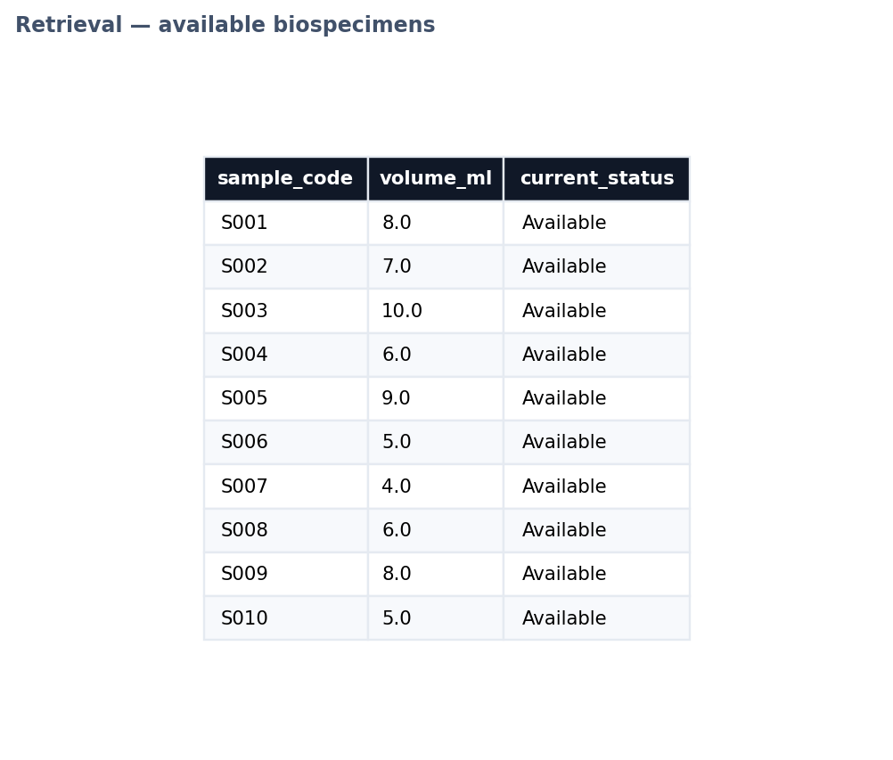

Join
SELECT b.sample_code, d.donor_code, st.type_name FROM biospecimen b JOIN collection_event ce ON ce.collection_event_id=b.collection_event_id JOIN donor d ON d.donor_id=ce.donor_id JOIN sample_type st ON st.sample_type_id=b.sample_type_id;
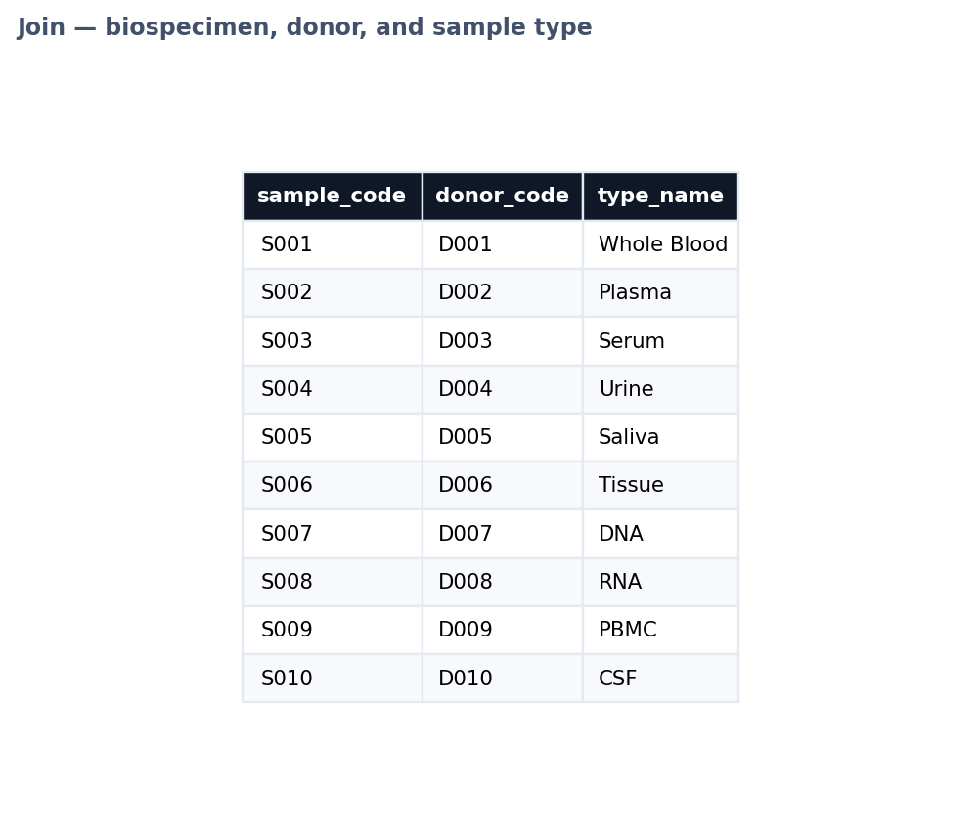

Aggregation
SELECT st.type_name, COUNT(*) FROM sample_type st LEFT JOIN biospecimen b ON b.sample_type_id=st.sample_type_id GROUP BY st.type_name;
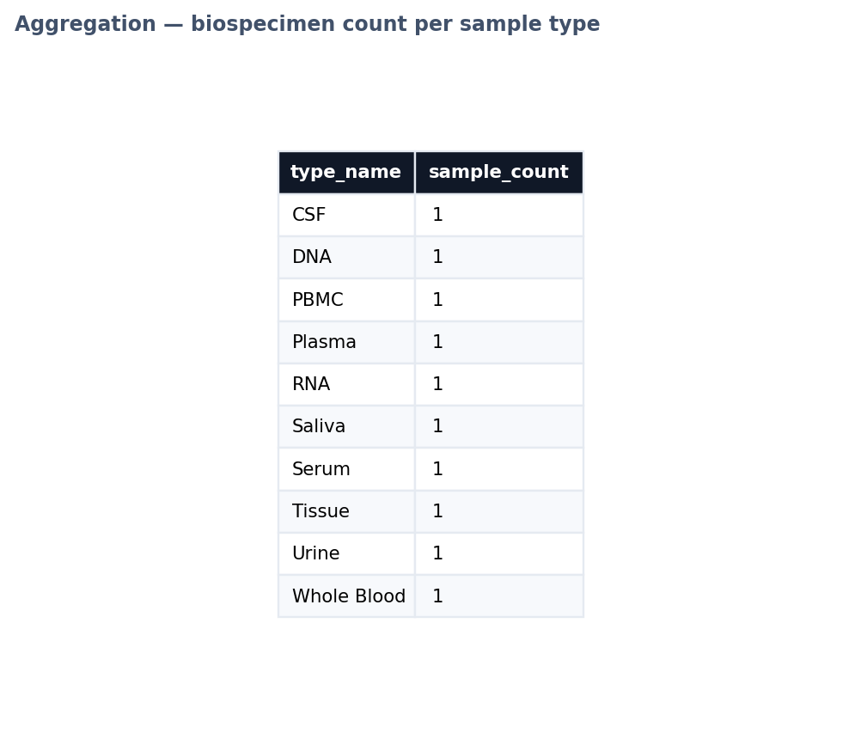

Subquery
SELECT donor_code FROM donor WHERE donor_id IN (SELECT donor_id FROM collection_event);
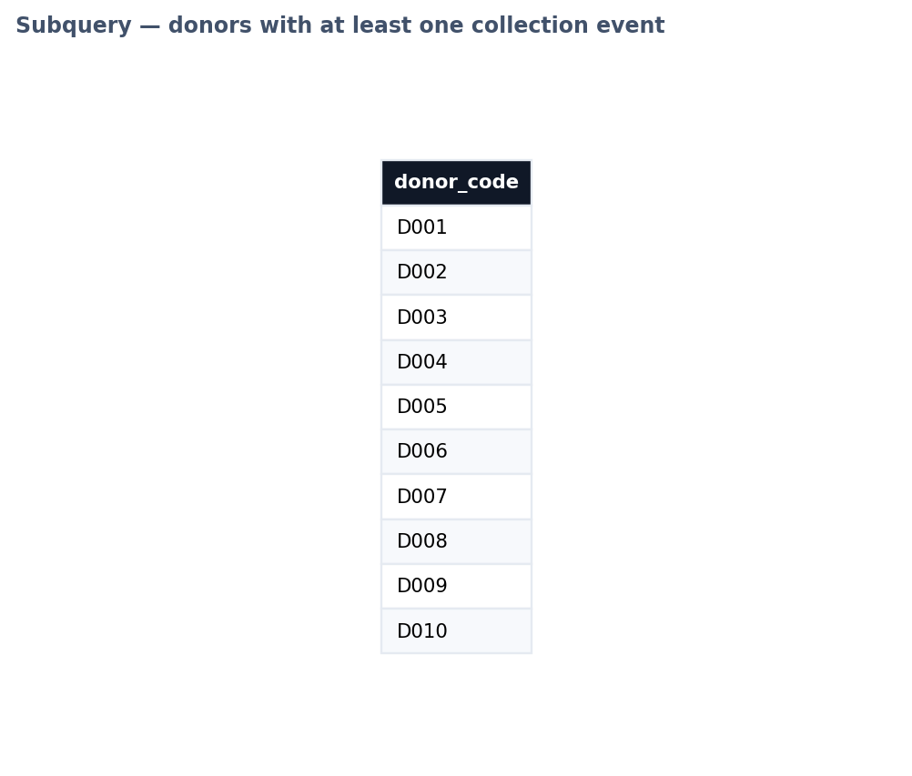

View
SELECT * FROM v_sample_inventory;
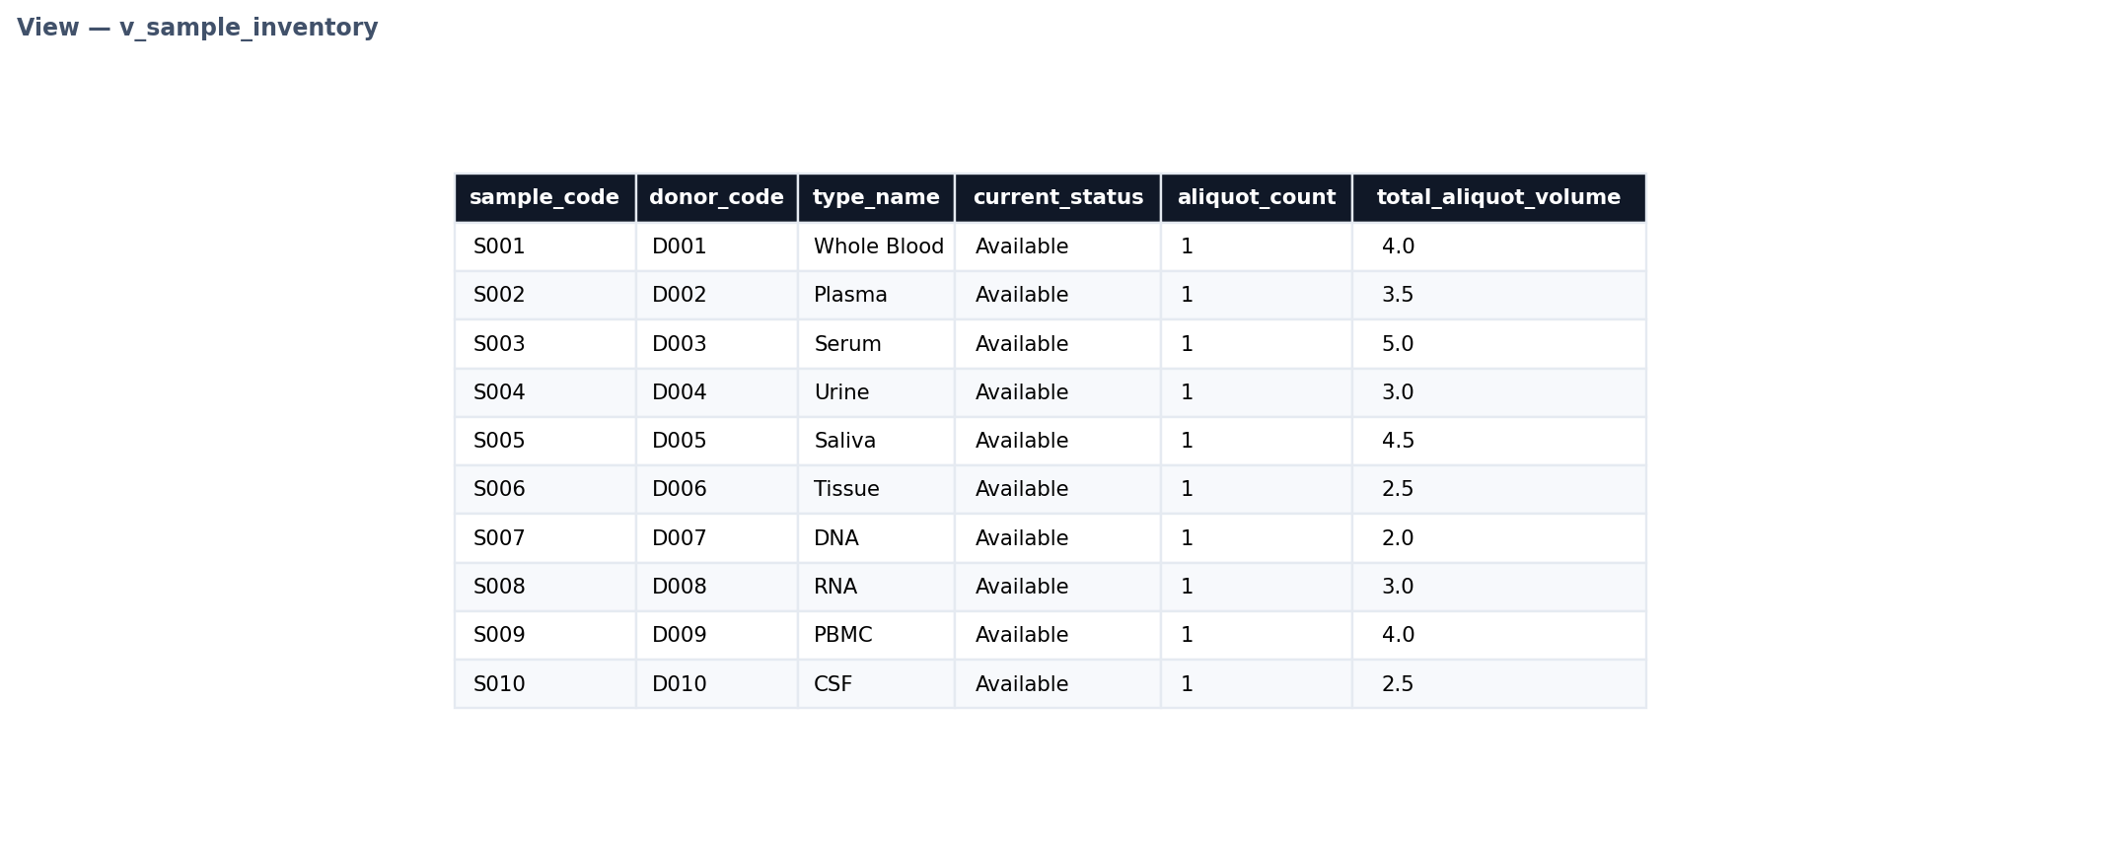
SELECT * FROM v_research_activity;
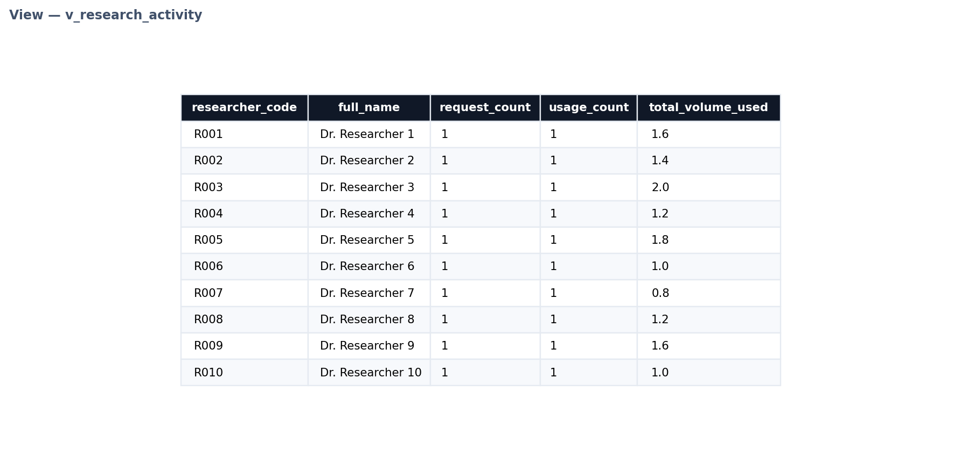

Function
SELECT fn_donor_sample_count(1);
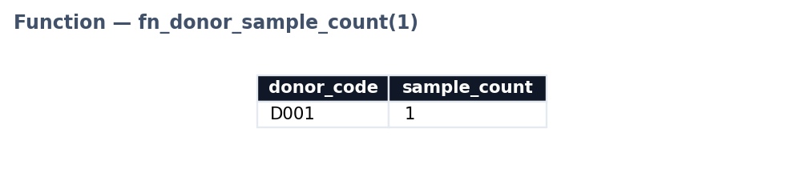
Note: the deployed SQLite demo does not support CREATE FUNCTION syntax, so this result was produced with the equivalent join/aggregate query shown above; fn_donor_sample_count is implemented as a PL/pgSQL function in triggers_procedures.sql for the PostgreSQL target.

9. Testing Plan and Expected Results
ID | Test | Expected result | Status
T01 | Insert valid donor | Row is inserted successfully. | Pass expected
T02 | Duplicate donor_code | UNIQUE constraint rejects duplicate. | Pass expected
T03 | Invalid donor sex | CHECK constraint rejects value outside M/F/O. | Pass expected
T04 | Invalid consent expiry | CHECK constraint rejects expiry before consent date. | Pass expected
T05 | Invalid foreign key | Child row referencing a nonexistent donor is rejected. | Pass expected
T06 | Negative aliquot volume | CHECK constraint rejects non-positive volume. | Pass expected
T07 | Valid sample usage | Trigger reduces aliquot volume and sets status appropriately. | Pass expected
T08 | Usage greater than aliquot volume | Trigger raises an exception and prevents insertion. | Pass expected
T09 | View execution | Both views return rows from the loaded data. | Pass expected
T10 | Clean execution | Scripts execute in the documented order on a clean database. | Pass expected
The trigger and constraint checks in the plan above were executed against the deployed database; representative evidence is shown below.

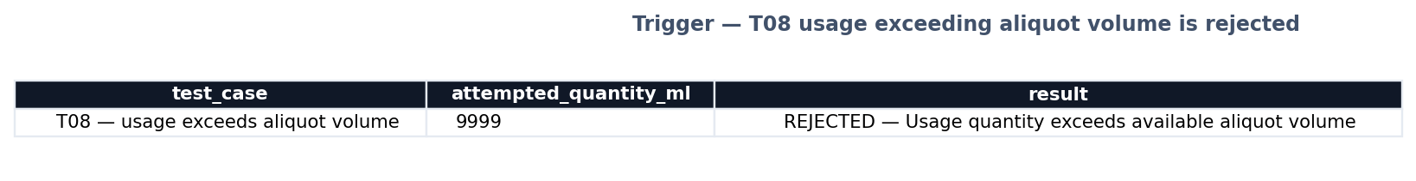

10. Limitations and Future Improvements
- The dataset is synthetic and intended for academic demonstration.
- Authentication and role-based database permissions are outside the current project scope.
- A production system would require audit history for every change and stronger privacy controls.
- A production biobank could add freezer monitoring, temperature alerts, shipment tracking, barcode scanning, and laboratory instrument integration.
- A user interface can be added for the optional bonus marks, provided it connects to the database and performs validated CRUD operations.

11. Conclusion
The project delivers a normalized relational database for a realistic biobank workflow. It covers requirements analysis, conceptual design, relational mapping, 3NF normalization, PostgreSQL implementation, synthetic test data, SQL operations, two views, a trigger, a function, integrity constraints, indexes, and a testing plan. The structure is organized to match the required repository and report sections in the CBIO204 project guidelines.

12. References
CBIO204 Fundamentals of Databases — Biotechnology Database Project Guidelines, provided course document.
PostgreSQL Documentation, PostgreSQL Global Development Group. Consult the official PostgreSQL documentation for syntax and DBMS behavior.

