WeRateDogs Report

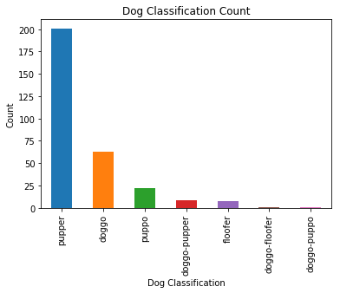[WeRateDogs](https://twitter.com/dog_rates) is a popular Twitter account that rates cute dogs with funny comments. The great thing about this account is that almost all dogs get ratings above 10. Since I am a dog lover myself, I decided to create some data visualizations and get some data insights for dog ratings that were posted from 2015 to 2017 that can be found below:

Based on the ‘Dog Classification Count’ chart, most dogs who were classified were classified as “pupper”, followed by “doggo”, followed by “puppo”, etc.

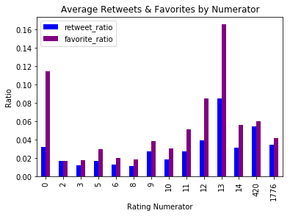

From the ‘Average Retweets & Favorites by Numerator’ graph, we can conclude that the highest average of retweets and favorites were given for dogs with ratings 13/10

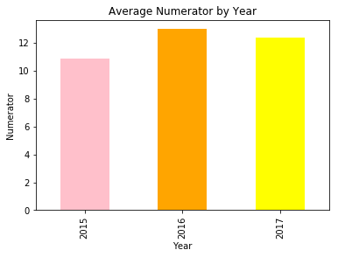

In the ‘Average Numerator by Year’ chart, the dogs with the highest ratings were in 2016, followed by 2017, followed by 2015

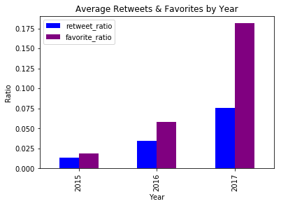

For the ‘Average Retweets & Favorites by Year’ graph, it can be concluded that dogs in 2017 received the highest number of retweets and favorites, followed by 2016, followed by 2015. This could be a result of the page gaining popularity over the years

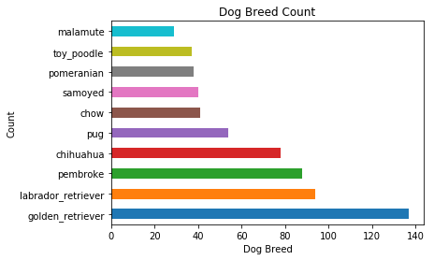

Based on the above chart, the most popular dog breed was the Golden Retriever, followed by the Labrador Retriever, Pembroke, Chihuahua, etc. This data is reasonable because Golden Retrievers and Labrador Retrievers are two of the most popular dog breeds that are loved by everyone.

In conclusion, it can be agreed upon that all dogs are good dogs and deserve the highest ratings. I hope you had fun with these data visualizations and insights as much as I had fun creating them. Have a great day!