CSE343 Web Development
Lab 3 Report
Nadine Radwan 22P0214
JavaScript, DOM Manipulation & Interactive Calculator

1. Objective
The objective of Lab 3 was to build an interactive calculator webpage that replicates the look and feel of the iOS Calculator application. The task required creating three separate files — an HTML structure file, a CSS styling file, and a JavaScript logic file — that work together to produce a fully functional client-side calculator capable of performing the four basic arithmetic operations.
The exercise introduced the core concepts of JavaScript in the browser: DOM selection, event-driven programming, state management, and pure-function computation.

2. Concepts Covered

2.1 JavaScript Fundamentals
- Variables declared with let and const for block-scoped, reassignable and immutable bindings.
- Primitive data types: Number, String, Boolean, Null, Undefined.
- Arithmetic and comparison operators: +, -, *, /, %, ===, !==.
- Conditional logic using if / else if / else and the ternary operator (condition ? a : b).
- Template literals with ${expression} placeholders for dynamic string construction.

2.2 Functions
- Function declarations, function expressions, and arrow functions (=>) — three equivalent declaration styles with different hoisting and this-binding behaviour.
- Pure functions: a function that always returns the same output for the same input and has no side effects. The calculate() helper in lab3.js is a pure function.
- Closures: the entire DOMContentLoaded callback wraps the calculator state (currentValue, previousValue, operator, waitingForNext) in a closed scope, preventing global namespace pollution.
- Scope: local variables inside the event-listener closure are private; no global variables are used.

2.3 DOM Manipulation
- document.getElementById() to select the display element and the button container.
- element.textContent to read and update visible text content without HTML injection risks.
- The DOM tree model: Document → HTML → Body → .calculator → #display / #keys → <button> elements.

2.4 Events & Event Delegation
- addEventListener('DOMContentLoaded', ...) to defer script execution until the DOM is fully parsed.
- Event delegation: a single 'click' listener is attached to the #keys container instead of one listener per button, leveraging event bubbling so all child button clicks propagate up and are handled centrally.
- e.target.matches('button') guard to ignore clicks on non-button elements inside the container.
- dataset attributes (data-number, data-operator, data-action) on each <button> to carry semantic metadata read directly in the event handler.

3. File Descriptions

3.1 lab3.html — Structure
The HTML file defines the skeleton of the calculator. Key structural decisions include:
- A single .calculator wrapper <div> containing a #display <div> and a #keys <div>.
- Each button carries only data-* attributes (data-number, data-operator, data-action) rather than inline onclick handlers, achieving clean separation of concerns between HTML and JavaScript.
- The external stylesheet is linked in <head> via <link rel="stylesheet"> and the external script is loaded at the end of <body> via <script src="lab3.js"> to ensure the DOM is available when the script runs.
- The grid layout is driven entirely by CSS (grid-template-columns: repeat(4, 1fr)), keeping layout concerns out of the HTML.

3.2 style.css — Presentation
The CSS replicates the visual identity of the iOS Calculator using only core CSS properties:
- body uses display: grid with place-items: center on a black background to perfectly centre the calculator on any screen size.
- .keys uses CSS Grid (repeat(4, 1fr) with gap: 12px) to arrange all 19 buttons in a four-column layout. The '0' button uses grid-column: span 2 and border-radius: 40px to achieve the elongated pill shape.
- Three button colour classes — .number (#333 dark grey), .function (#a5a5a5 light grey), and .operator (#ff9500 orange) — map directly to iOS Calculator conventions.
- .btn:active { filter: brightness(120%) } provides immediate visual feedback on press without JavaScript.
- Buttons are circles (border-radius: 50%; height/width both 65px) matching the iOS aesthetic.

3.3 lab3.js — Logic
All calculator logic lives inside a single DOMContentLoaded closure, ensuring no global variables are leaked. The state model uses four variables:
Variable | Purpose
currentValue | The number currently shown on the display (string).
previousValue | The left-hand operand stored after an operator is pressed.
operator | The pending arithmetic operator as a string (+, -, *, /).
waitingForNext | Boolean flag; true means the next digit press starts a fresh number instead of appending.

The calculate() function is intentionally kept pure — it accepts two operands and an operator, performs no side effects, and returns a result or the string "Error" for division by zero. This makes the arithmetic logic independently testable.

4. Key Code Walkthrough

4.1 Event Delegation Pattern
Instead of attaching 19 separate event listeners, a single listener on the parent #keys container handles all button clicks. This is more memory-efficient and supports dynamically added buttons:
keys.addEventListener('click', function (e) {
const button = e.target;
if (!button.matches('button')) return; // guard
const number = button.dataset.number;
const op = button.dataset.operator;
const action = button.dataset.action;
// ... handle each case
});

4.2 Pure calculate() Function
All arithmetic is isolated in a side-effect-free helper, consistent with the pure-functions principle taught in the lab:
function calculate(a, op, b) {
const x = Number(a), y = Number(b);
if (op === '+') return x + y;
if (op === '-') return x - y;
if (op === '*') return x * y;
if (op === '/') return y === 0 ? 'Error' : x / y;
return y;
}

4.3 Operator Chaining
When the user presses an operator while a previous operation is already pending (previousValue !== null && operator !== null && !waitingForNext), the pending calculation is evaluated first and its result becomes the new left-hand operand. This mirrors how a physical calculator chains operations without needing the equals key.

5. Features Implemented
Feature | Implementation Detail | Status
Addition, Subtraction, Multiplication, Division | Pure calculate() dispatches on operator string. | ✓ Done
AC (All Clear) | Resets all four state variables to initial values. | ✓ Done
+/− Sign Toggle | Prepends or removes a leading '-' from currentValue. | ✓ Done
% Percent | Divides currentValue by 100 in place. | ✓ Done
Decimal Point | Appends '.' only if one does not already exist. | ✓ Done
Chained Operations | Evaluates pending op before storing new operator. | ✓ Done
Division by Zero Guard | Returns the string 'Error'; further input is blocked. | ✓ Done
iOS Visual Design | Black background, circular buttons, orange operators. | ✓ Done
Pill-shaped Zero Button | grid-column: span 2 with border-radius: 40px. | ✓ Done
Press Feedback | filter: brightness(120%) on :active pseudo-class. | ✓ Done

6. GUI
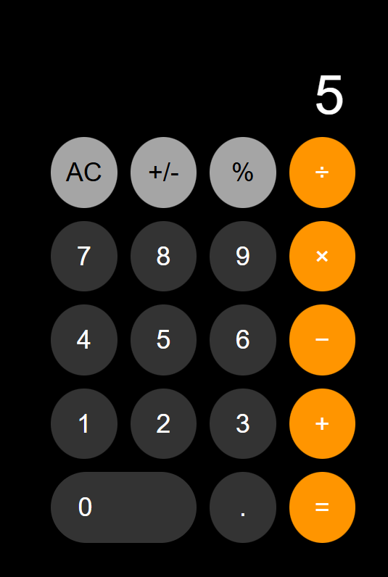

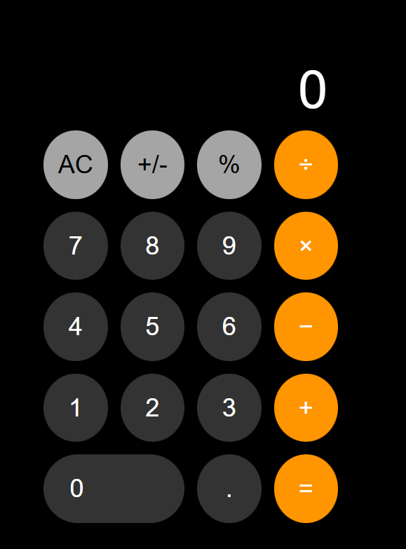

7. Conclusion
Lab 3 successfully demonstrated the integration of HTML structure, CSS presentation, and JavaScript behaviour to create a fully interactive webpage. The calculator project put into practice the key concepts from the lab slides: DOM selection and manipulation, event-driven programming via addEventListener and event delegation, pure functions, closures for state encapsulation, and the separation of concerns between the three web technologies.
The final result is a pixel-faithful reproduction of the iOS Calculator that handles all basic arithmetic operations, edge cases such as division by zero and decimal-point deduplication, and chained multi-step calculations — implemented cleanly within approximately 100 lines of well-structured JavaScript.

