CSE343 – Internet Programming
Lab 2 Report: HTML & CSS – Portfolio Page
Nadine Radwan 22P0214

1. Objective
The objective of Lab 2 was to gain hands-on experience with HTML and CSS by building a personal portfolio webpage from scratch. The lab required students to apply the foundational concepts covered in the lecture, including page structure, semantic elements, CSS selectors, the box model, and layout techniques.

2. Background
This lab was based on the following core topics taught in the lecture:

2.1 HTML
HTML (HyperText Markup Language) provides the structural foundation of any web page. Key concepts used in this lab include:
- Tags and Elements: HTML tags wrap content and define its semantic role (e.g., <h1> for headings, <p> for paragraphs, <a> for links).
- Document Structure: Every HTML file begins with <!DOCTYPE html> and contains <html>, <head>, and <body> sections.
- Attributes: Tags can carry attributes like href, src, id, and class to provide additional information.
- Block vs. Inline Elements: Block elements (e.g., <div>, <h1>) occupy a full row; inline elements (e.g., <span>, <a>) flow within text.
- Forms: <input>, <textarea>, and <button> elements collect and submit user data.

2.2 CSS
CSS (Cascading Style Sheets) controls the visual presentation of HTML elements. Key concepts used include:
- External CSS: Styles are written in a separate .css file and linked via <link rel='stylesheet' href='lab2.css'>.
- Selectors: Element selectors, class selectors (.), and ID selectors (#) target specific elements for styling.
- Box Model: Every element is composed of content, padding, border, and margin areas.
- Flexbox: display: flex enables responsive, row-based layouts such as the project card grid.
- Pseudo-classes: :focus and ::placeholder allow styling of interactive states.

3. Task Description
The task required building a personal portfolio page consisting of the following sections:
- Header – Displays the student's name, title, and navigation links.
- About Section – Contains a short biography paragraph.
- Projects Section – Presents project cards arranged in a responsive grid.
- Contact Section – Provides a simple form with name, email, message fields, and a submit button.
- Footer – Shows a copyright notice.

The page had to be styled using an external CSS file (lab2.css) linked from the HTML document.

4. Implementation

4.1 HTML Structure (LAB_2_TASK.html)
The HTML file follows the standard document structure. The <head> contains metadata and the link to the external stylesheet. The <body> is divided into five semantic sections using <div> elements with descriptive class names.

Navigation links inside the header use anchor tags with href values that point to the id attributes of each section, enabling smooth in-page navigation:
<a href="#about">About</a>
<a href="#projects">Projects</a>
<a href="#contact">Contact</a>

Each project is represented by a card <div> containing an <h3> title and a <p> description:
<div class="card">
<h3 class="card-title">HR Management System</h3>
<p class="card-text">A Java-based system for managing employees...</p>
</div>

The contact form uses three separate input elements — two <input> fields (text and email) and one <textarea> for the message — followed by a <button>:
<input type="text" placeholder="Your Name">
<input type="email" placeholder="Your Email">
<textarea placeholder="Your Message"></textarea>
<button>Send Message</button>

4.2 CSS Styling (lab2.css)
The CSS file applies a cohesive purple-gray color palette throughout the page. Key styling decisions are described below.

Universal Reset – Removes default browser margins and padding and sets box-sizing to border-box so padding is included within element dimensions:
* { margin: 0; padding: 0; box-sizing: border-box; font-family: Arial, sans-serif; }

Header – Uses a linear gradient background from a light purple (#978fdc) to a darker tone (#746c89), with white text centered on the page.

Project Grid – Uses Flexbox to lay out the three project cards in a row, with wrapping enabled for smaller screens:
.project-grid { display: flex; justify-content: center; gap: 20px; flex-wrap: wrap; }

Contact Inputs – Inputs are styled as centered blocks with a box-shadow on focus and a styled placeholder color, improving usability:
.contact input:focus { outline: none; box-shadow: 0 0 5px #555; }

Anchor Tags – Navigation links are displayed inline, spaced with margin, and colored white to contrast with the header gradient.

5. Results
The resulting portfolio page displays correctly in a web browser. The following behavior was verified:
- Clicking the navigation links (About, Projects, Contact) scrolls the page to the corresponding section.
- The three project cards render side-by-side using Flexbox and wrap on smaller viewports.
- The contact form fields are styled, centered, and respond visually on focus.
- The header gradient, footer color, and button color all use the consistent #746c89 accent color.
- The footer remains at the bottom of the page with the copyright notice.

6. GUI
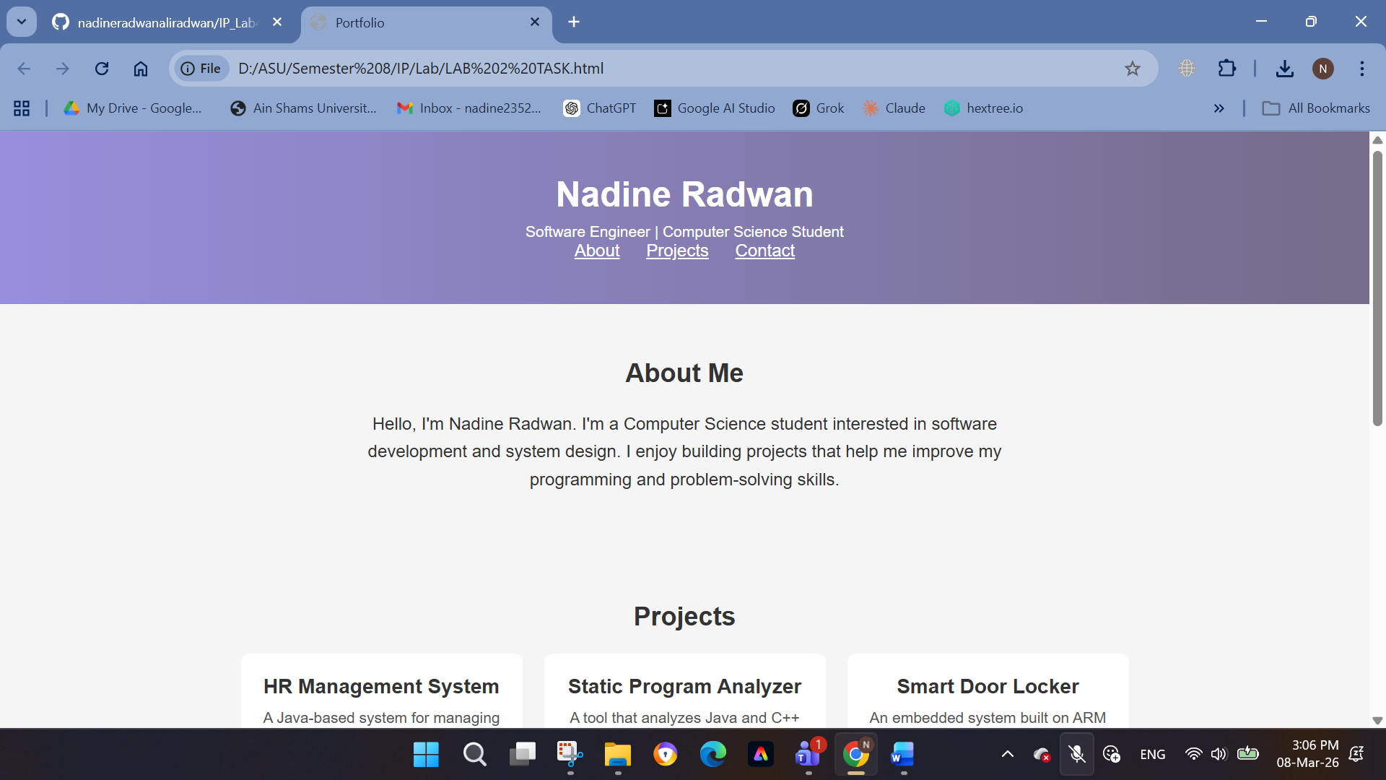
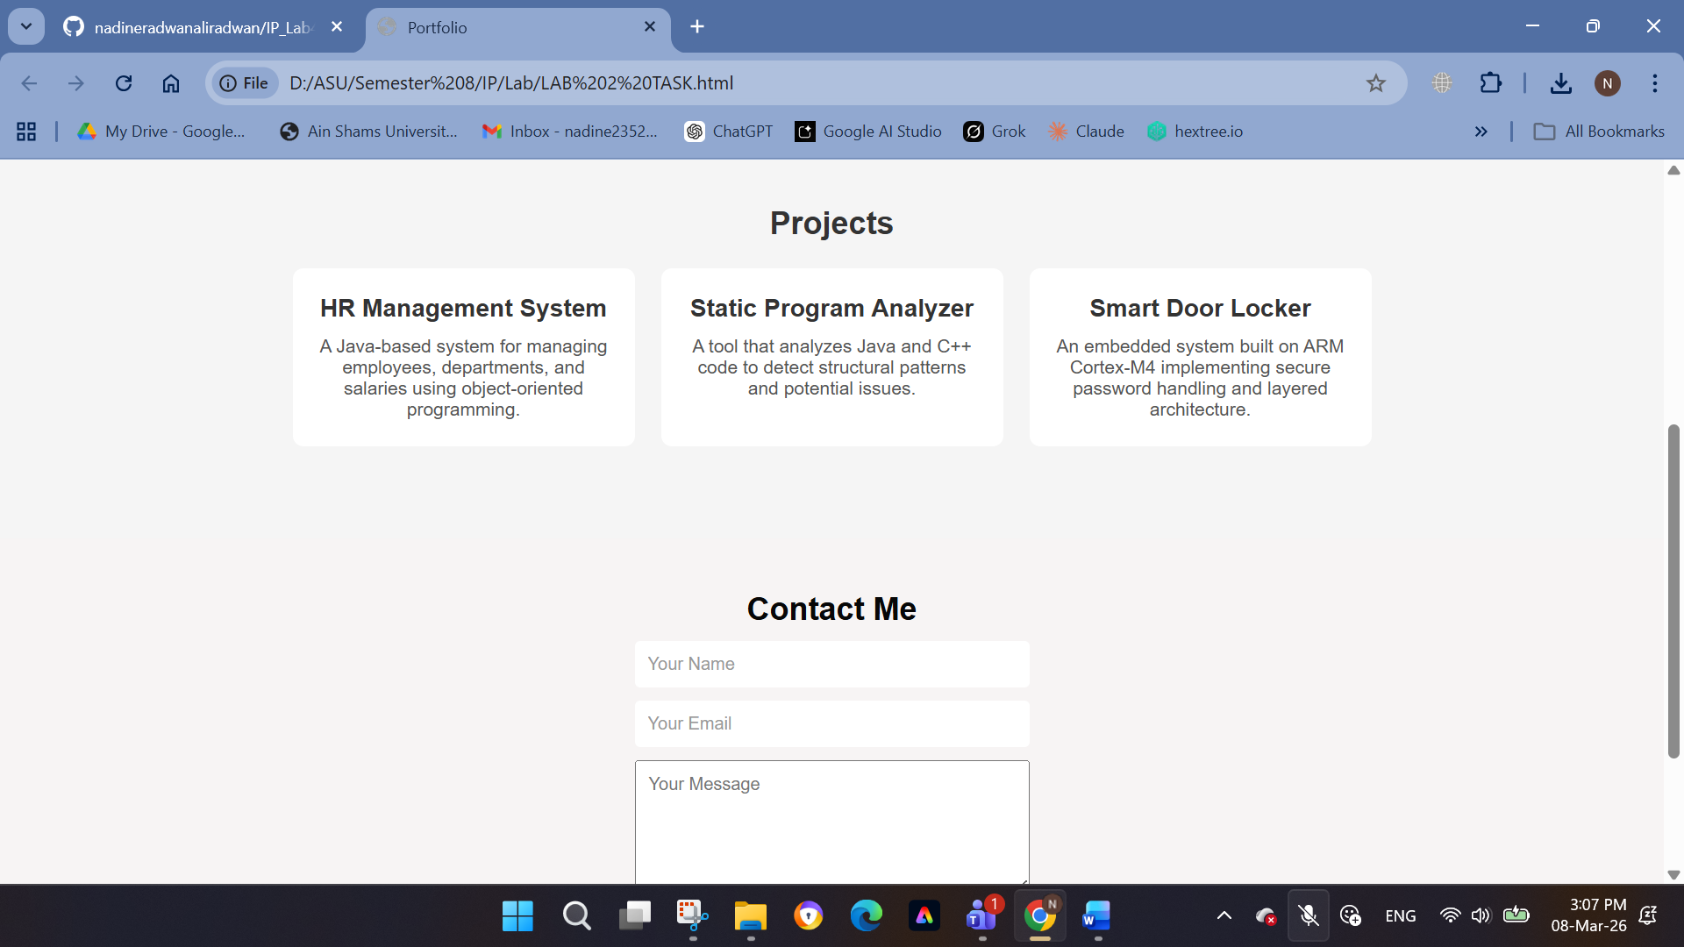
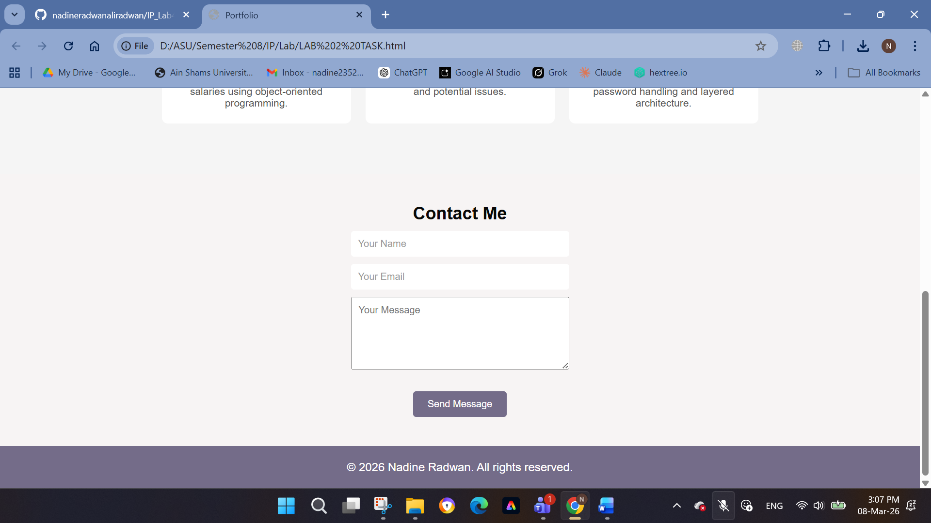

7. Conclusion
This lab successfully demonstrated the fundamentals of HTML and CSS through the construction of a multi-section personal portfolio page. The exercise reinforced the separation of structure (HTML) from presentation (CSS), the use of Flexbox for responsive layouts, and the application of various CSS selector types. The resulting page is functional, visually consistent, and correctly linked to an external stylesheet.

Key takeaways from this lab include the importance of the box model in controlling spacing, the power of Flexbox for multi-column layouts, and how external CSS files promote maintainability across large projects.

