NAME: Angel Nadine Rivera COURSE AND SECTION: BSIT 3B
Course: Web Systems Technology
Objective: Students will install, configure, and run Laravel or CodeIgniter on their local machine while demonstrating understanding of MVC structure, routing, and configuration files.
Rules:
1. Student must do it and be able to demonstrate how to setup the environment
2. Official documentation is allowed.
3. Each milestone must be signed off by the instructor.
4. Handwritten logs and reflections required.
5. Students must demonstrate working outputs live for verification.
CodeIgniter
Phase 1 – Environment Setup (Checkpoint 1)
Tasks | Progress Log | Comments/Feedback
Download CodeIgniter. | 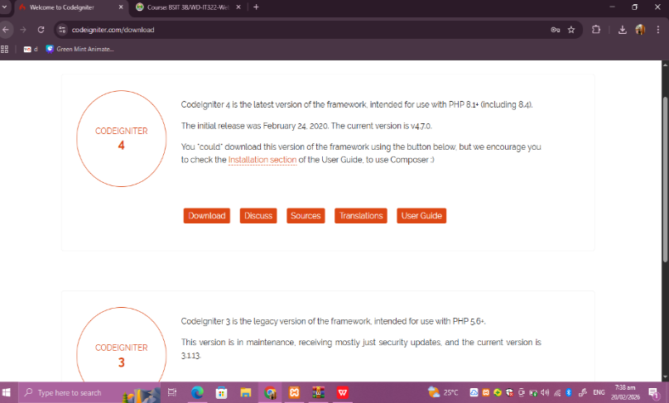 | On this step I downloaded the codeigniter in its official website and downloaded the codeigniter version 4
Extract to htdocs (or local server folder). | 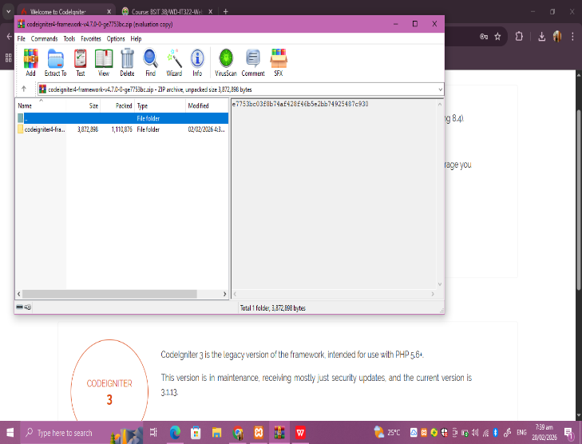 | After downloading the version 4 I extracted the file to my desktop first
Open project and display default page | 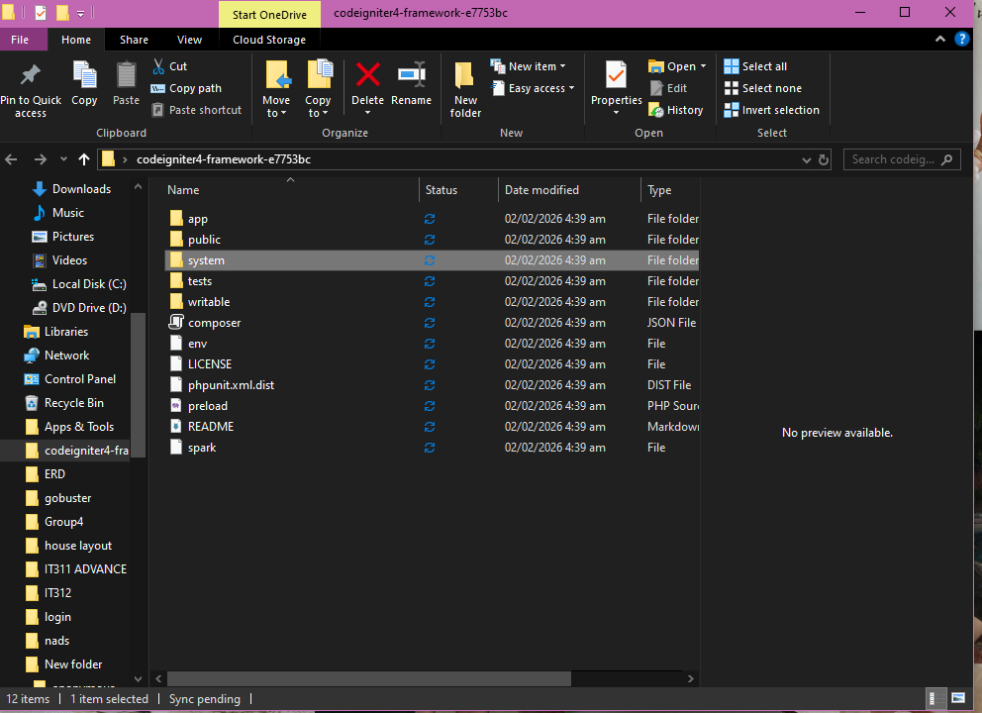 | I checked my extracted folder and copied all the the inner files in it.
Correct folder placement | 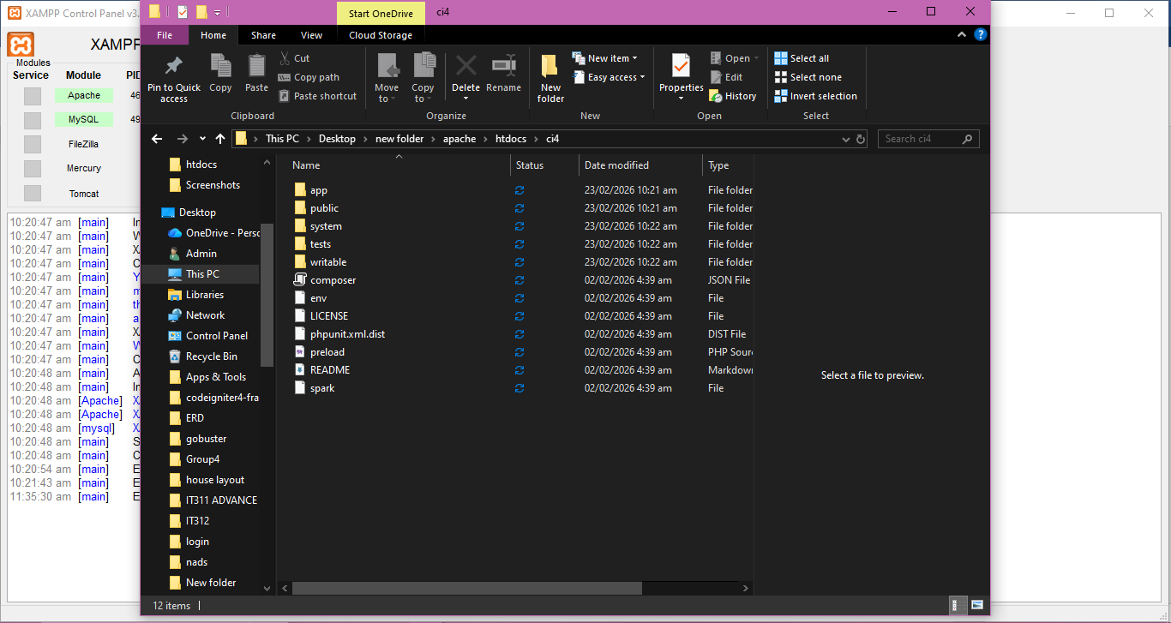 | To ensure that the placement of the folder is correct I opened xampp, then on the apache I clicked config the then <Browse>[Apache] look for htdocs folder and created a new folder then named it ci4. These steps help me ensure that the folder placement is correct
Working URL access. | 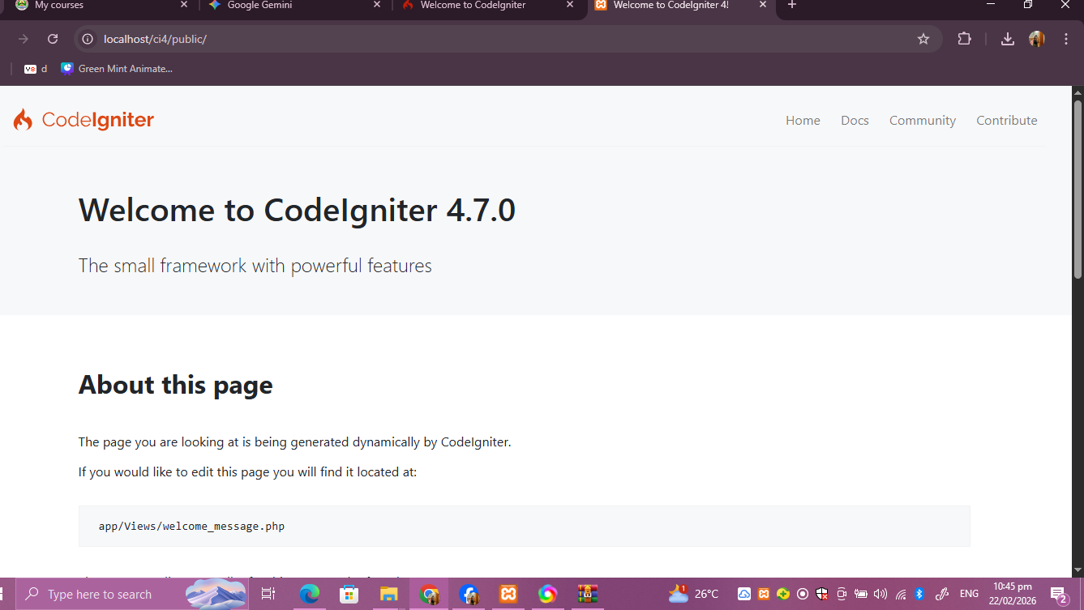 | Lastly I go to my browser then type to the search bar and typed http://localhost/ci4/public then run it properly

Step-by-step installation summary:

Phase 2 – Environment Configuration (Checkpoint 2)
Tasks | Progress Log | Comments/Feedback
Configure baseURL.
Configure database connection.
Remove index.php from URL using .htaccess
- Explain baseURL.
_
- Explain public folder and writable folder.
_

Phase 3 – Structure Understanding (Checkpoint 3)
Identify and write:
1. Controllers folder
2. Views folder:
3. Models folder:
4. Routing configuration file
5. Purpose of writable folder: _____
Explain auto-routing vs defined routes.

Phase 4 – Mini Functional Output (Checkpoint 4)
Tasks | Progress Log | Comments/Feedback
Create a controller.
Create a view.
Define /profile route.
Pass dynamic data to view (full name, course/year, date).
Verify proper data passing and MVC connection.

- Draw the MVC diagram.
- 3 common errors and solutions.
- How to troubleshoot project load failures.

