Frontend

🡪 Theorie onderdelen uitwerken

* [Chapter 13: JavaScript And The Browser](https://eloquentjavascript.net/13_browser.html)
* [Chapter 14: The Document Object Model](https://eloquentjavascript.net/14_dom.html)
* [Chapter 15: Handling Events](https://eloquentjavascript.net/15_event.html)
* [Chapter 18: HTTP and Forms](https://eloquentjavascript.net/18_http.html)
* Research Looping and Higher Order functions, document your findings in your Wiki and think about the implementation of these two concepts into your Feature
* Research the following JavaScript concepts and document these in your Wiki, it is important to encorporate these concepts in your JavaScript feature and/or explain how these concepts work:

1. Prototypes in JavaScript
2. Hoisting
3. Closures

# **Frontend week 5**

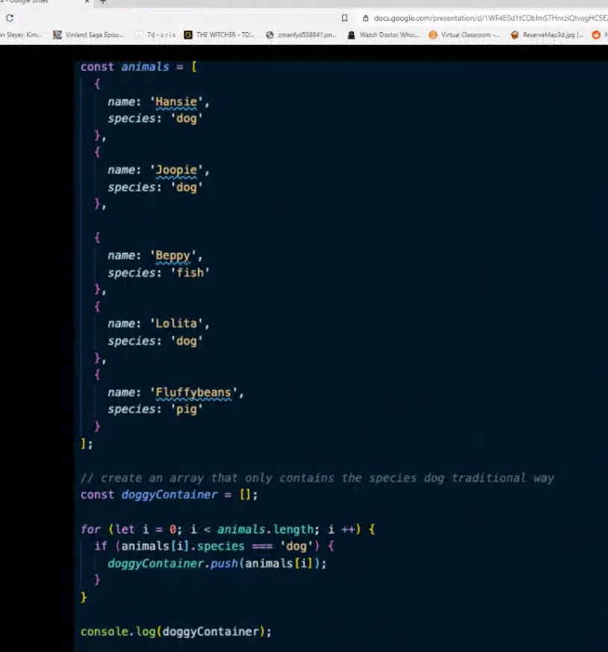

Filters 🡪 verkorte manier ( is een higher order function)

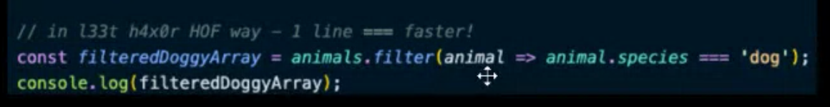

Functie kan ook opgeslagen worden in een const (ook higher order function)

