Ellie and Max: The Trail of the Midnight Map

# Page 1

Ellie loved maps. Max loved snacks.  
One summer night, while cleaning the attic, they found a rolled-up parchment marked “For Brave Explorers Only.”

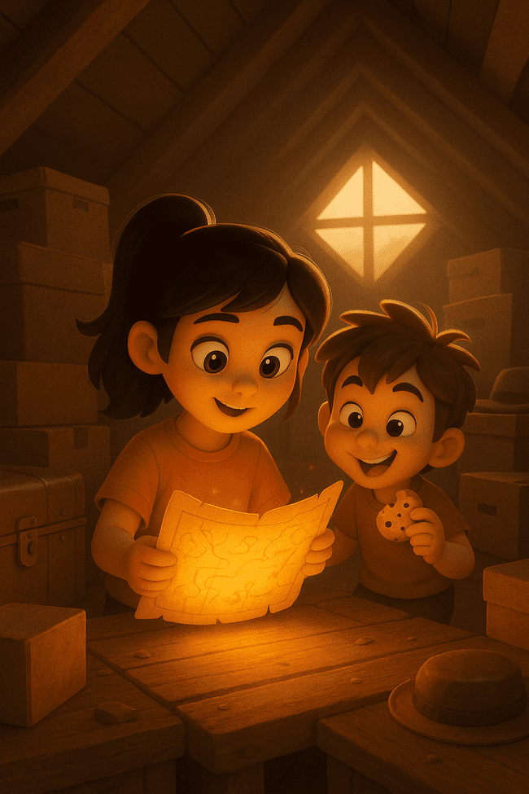

# Page 2

The map shimmered. Lines and symbols shifted on the paper.  
Suddenly, it drew a glowing path—straight out the attic window.

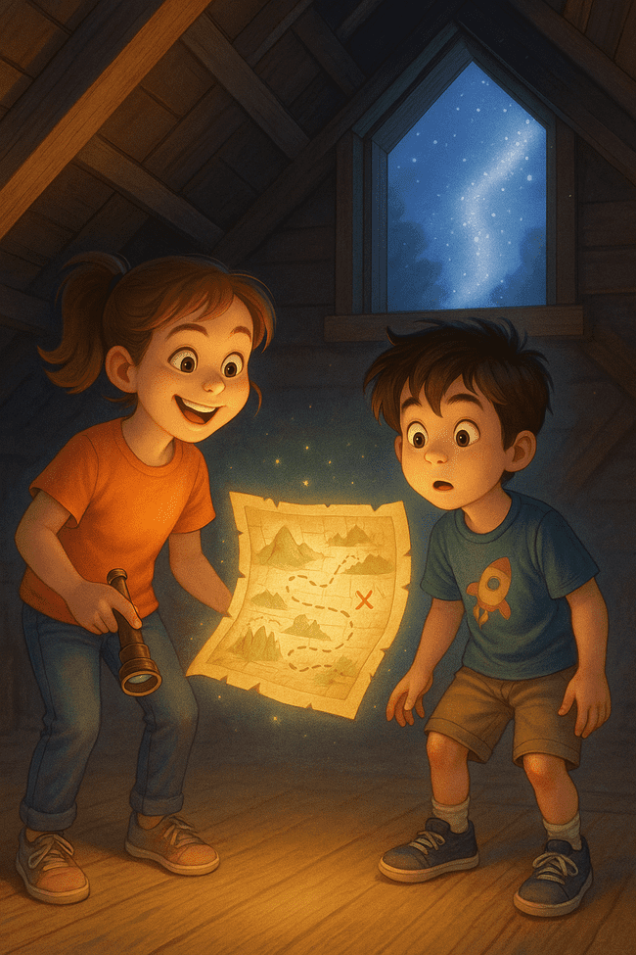

# Page 3

Wearing pajamas and backpacks, they followed the trail through their backyard, past the sleepy dog, and over garden gnomes.

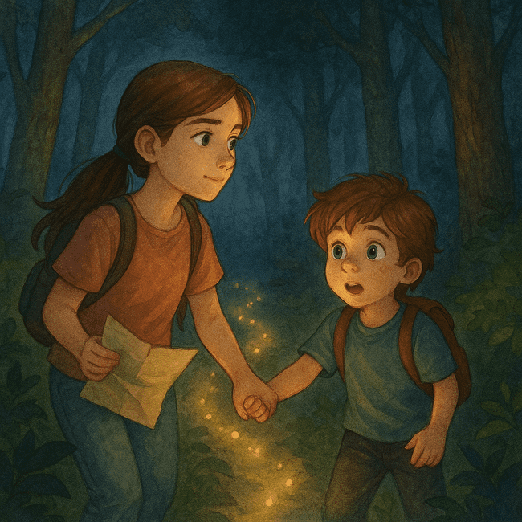

# Page 4

The trail sparkled into the forest. “Stay close,” Ellie whispered.  
“I’m not scared!” Max whispered louder.

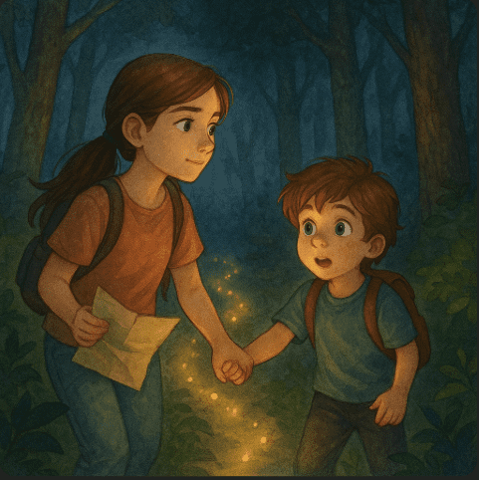

# Page 5

Between tall trees, they found a treehouse glowing with lanterns.  
On the door: “Midnight Explorers Only.”

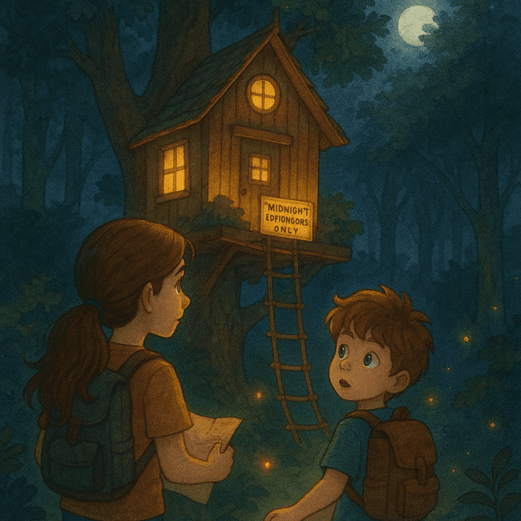

# Page 6

Inside, they discovered explorer badges, snacks, and a riddle:  
“To find the Moon Mirror, follow the Fire Fern’s glow.”

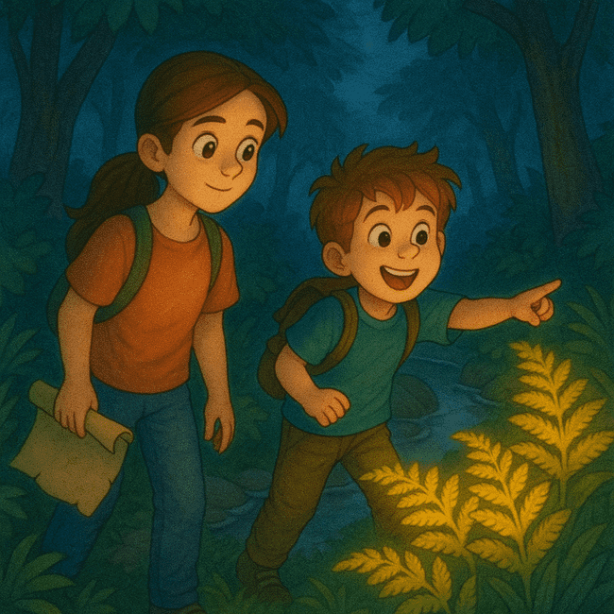

# Page 7

They tiptoed deeper into the woods. Max spotted glowing ferns near a stream.  
“They’re fire ferns!” he grinned.

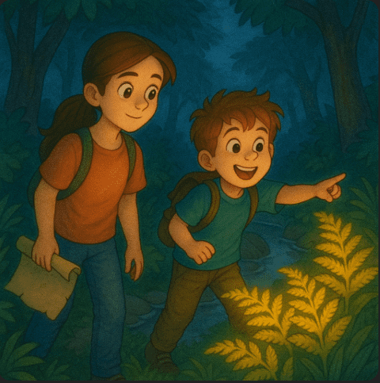

# Page 8

Before they could step through, the map folded itself.  
A new note appeared: “Adventure saved for next time.”

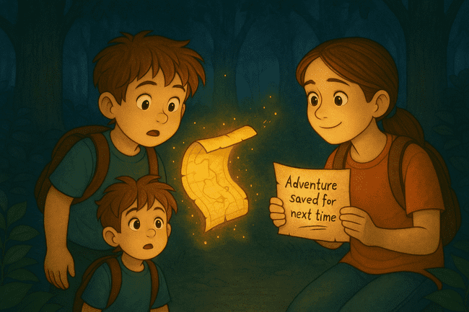

# Page 9

They grinned at each other. This was just the beginning.

