Luna and the Cloud Carousel

# Page 1

On a breezy hill above her quiet town, Luna twirled with her paper kite.  
She laughed as the clouds danced and changed shapes in the sky.

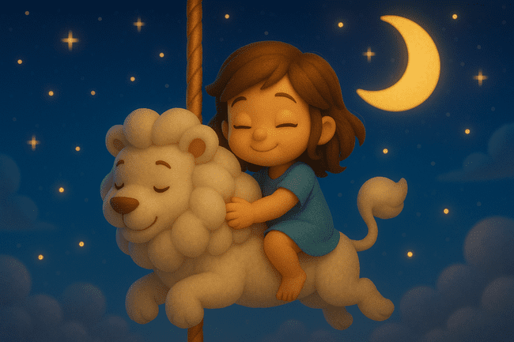

# Page 2

As Luna spun and giggled, her kite pulled harder and harder—until her feet lifted off the ground!  
She soared gently into the sky, carried by a breeze that smelled like vanilla and cotton.

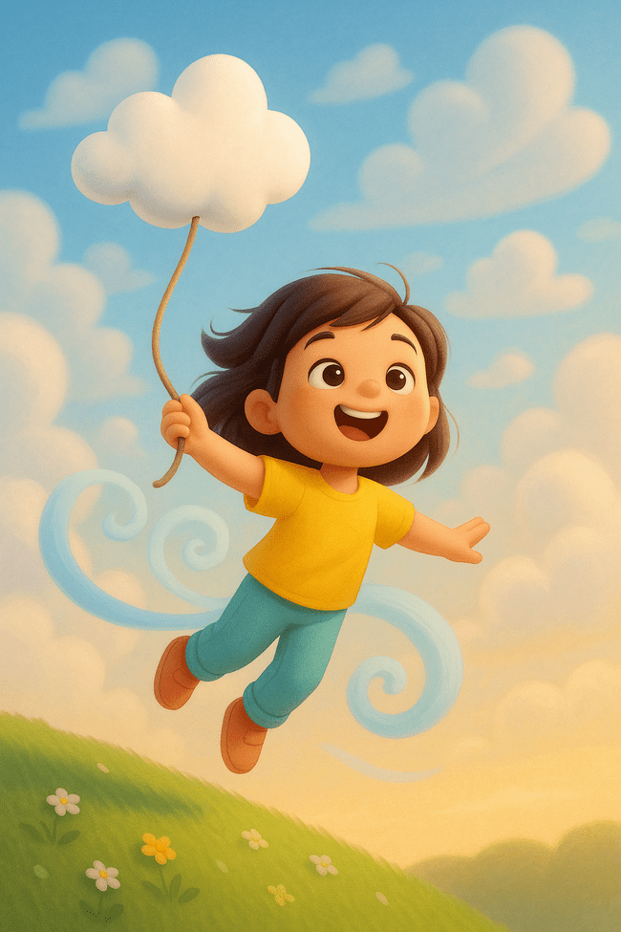

# Page 3

Through the clouds, she saw a carousel made of mist.  
Cloud horses, lions, and dolphins twirled in slow, dreamy circles.

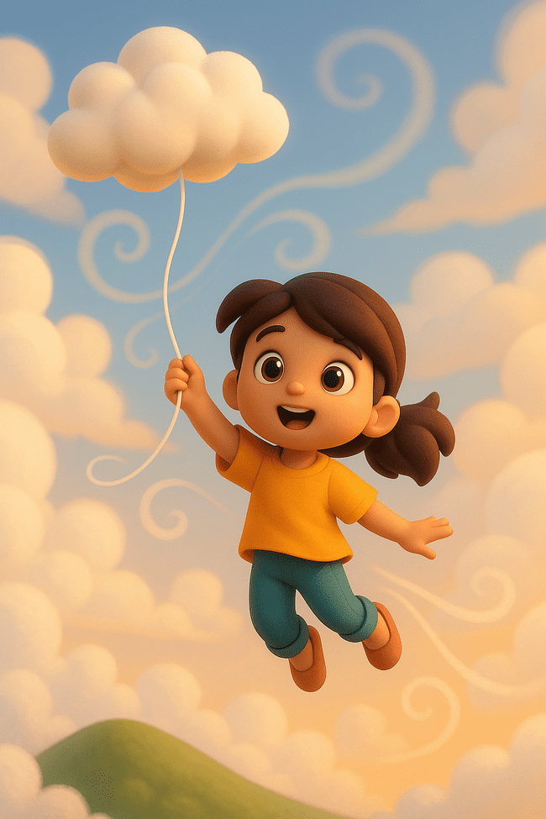

# Page 4

“Welcome, Luna!” boomed a fluffy polar bear from the center.  
“This is the Cloud Carousel. You’re just in time!”

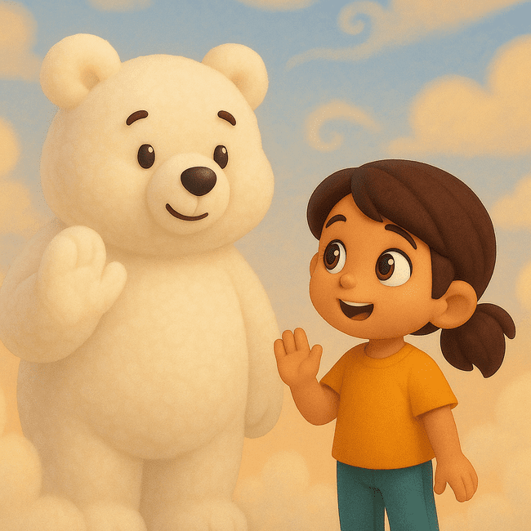

# Page 5

Luna climbed onto a gentle cloud-lion, who purred like thunder.  
The carousel spun slowly, and stars began to shimmer into view.

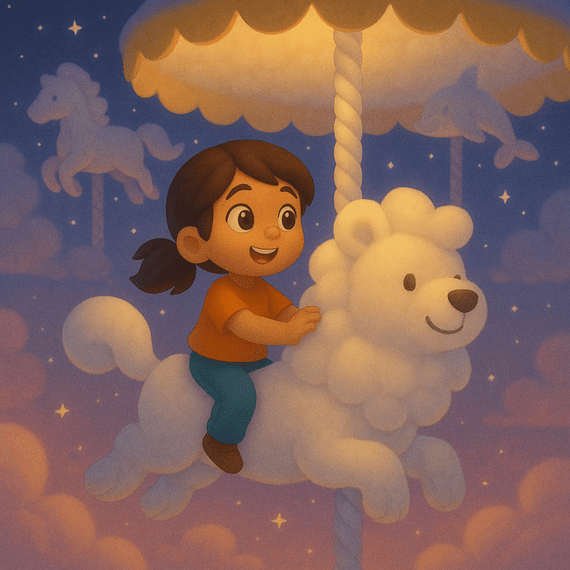

# Page 6

The carousel lifted higher into the sky.  
The stars whispered lullabies, and the clouds glowed soft gold.

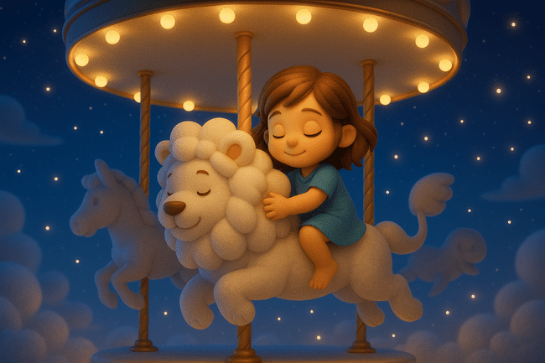

# Page 7

Then, the clouds began to change—into slides, swings, and trampolines!  
Luna bounced from one to another, laughing with joy.



# Page 8

Suddenly, the wind changed. “Time to return,” it hummed.  
The playground began to dissolve into sparkles.

# Page 9

Luna floated downward, the stars waving goodbye.  
The cloud-lion roared a soft farewell from the sky.

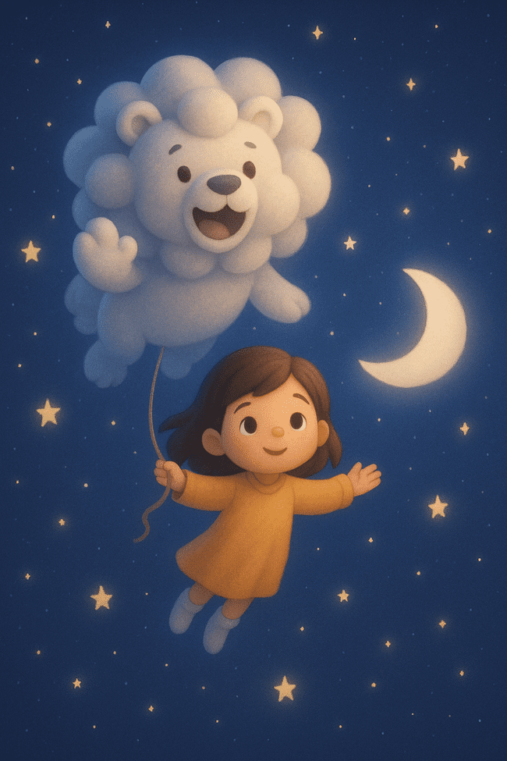

# Page 10

Back on her hilltop, Luna yawned and stretched.  
She hugged her kite and whispered, “Thank you.”

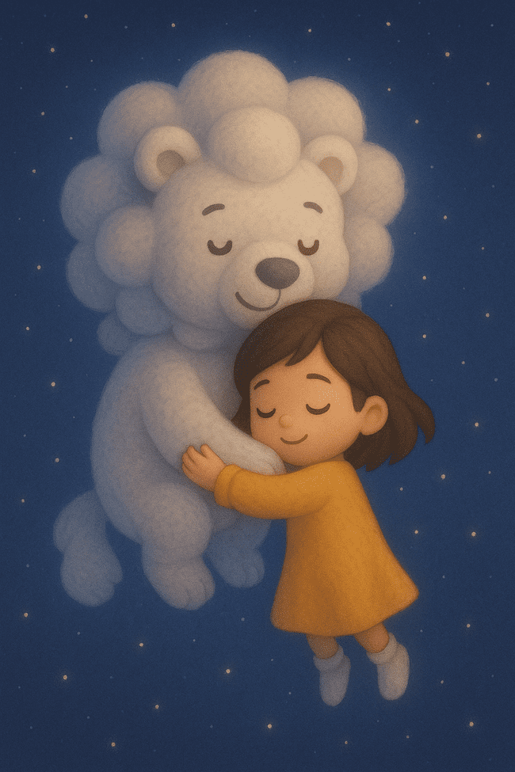

# Page 11

Snuggled in bed, Luna dreamed of slides and soaring skies.  
Her kite, resting nearby, glowed faintly.

# Page 12

And high above, the Cloud Carousel waited, turning slowly,  
ready for its next visitor.

