Milo and the Moonlight Map

# Page 1

In a cozy village nestled beneath a silver hill, lived a curious raccoon named Milo. Every night, he’d stare at the stars and wonder what secrets the moon might hold.



# Page 2

Back in his cozy bed, the Moonlight Map tucked under his pillow, Milo smiled.

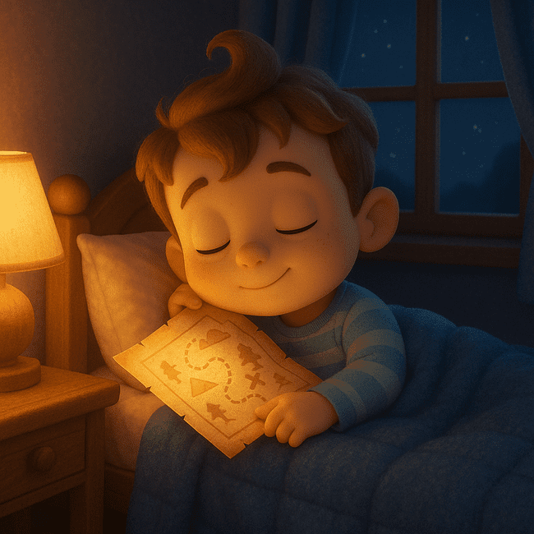

# Page 3

One night, a shimmering scroll floated down from the sky. It landed gently beside Milo. Unrolling it with his tiny paws, Milo gasped—it was a glowing Moonlight Map!

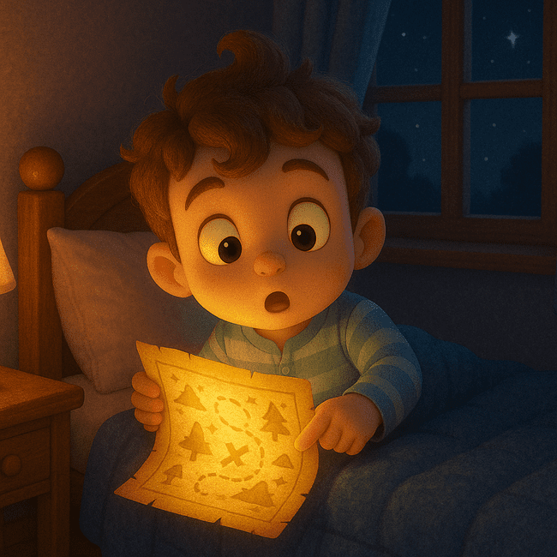

# Page 4

The map pointed toward the Whispering Woods, beyond the twinkling brook. Milo packed some snacks, grabbed his flashlight, and tiptoed into the night.

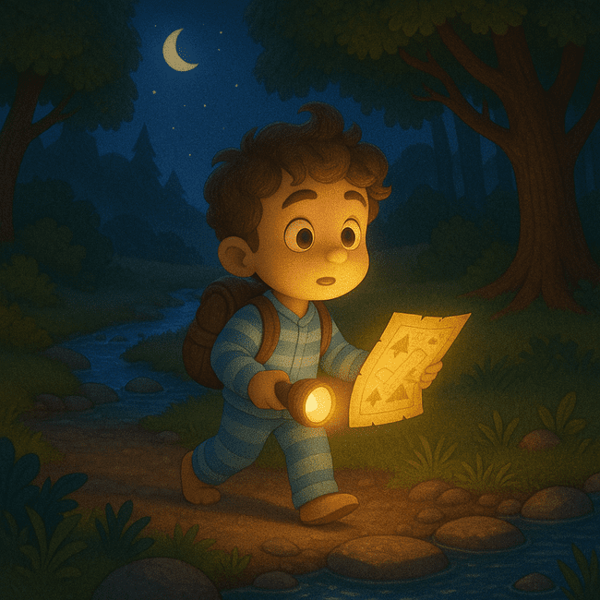

# Page 5

In the woods, fireflies lit his path. He followed the glowing trail until he heard a gentle hoot.  
“Where are you headed, little one?” asked Olive the Owl.

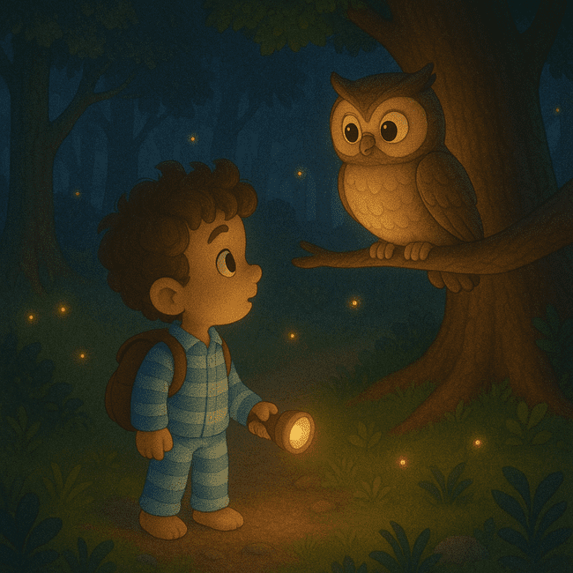

# Page 6

“To the moon!” said Milo, showing her the map.  
Olive hooted softly, “Then take the moonbridge through Starflower Field.”

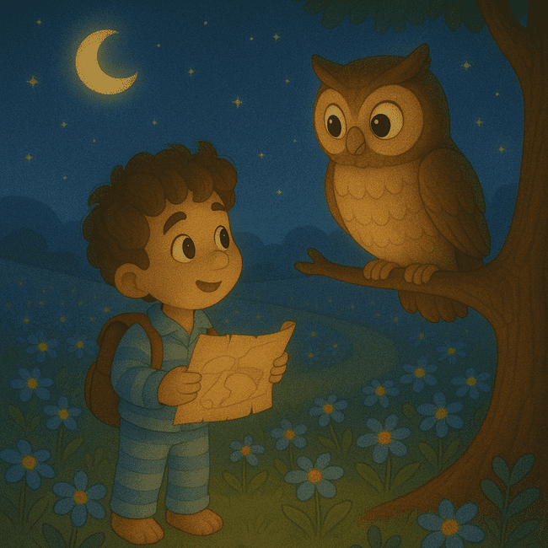

# Page 7

Milo hurried on. In the Starflower Field, blossoms swayed and shimmered.  
At the center stood the Moonbridge—sparkling and arched like a rainbow of light.

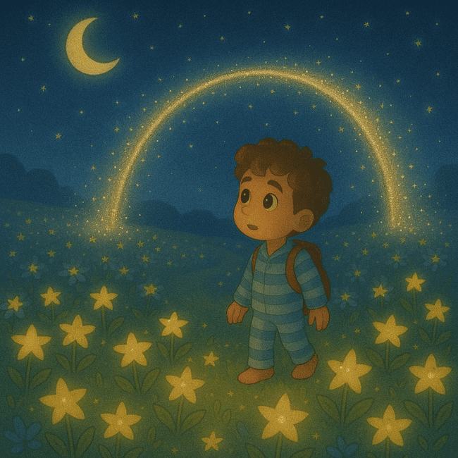

# Page 8

He stepped on the bridge. WHOOSH! The world spun, stars zipped by, and suddenly—he landed softly on the moon.

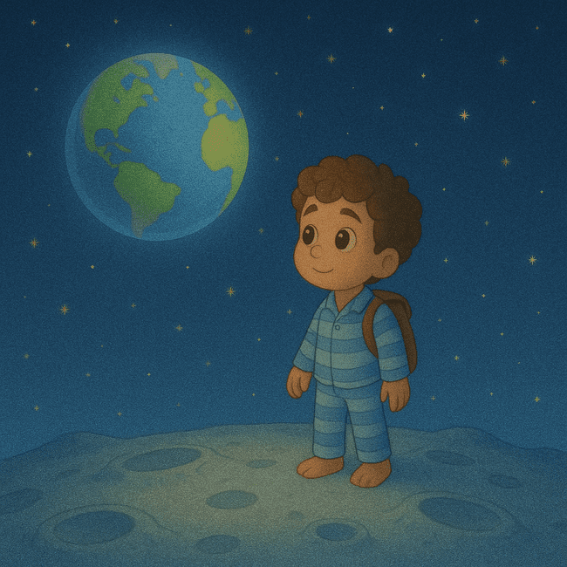

# Page 9

This map led to a silver tree that grew Moonberries!  
He climbed the tree, plucked a berry, and took a bite—it tasted like stardust and dreams.

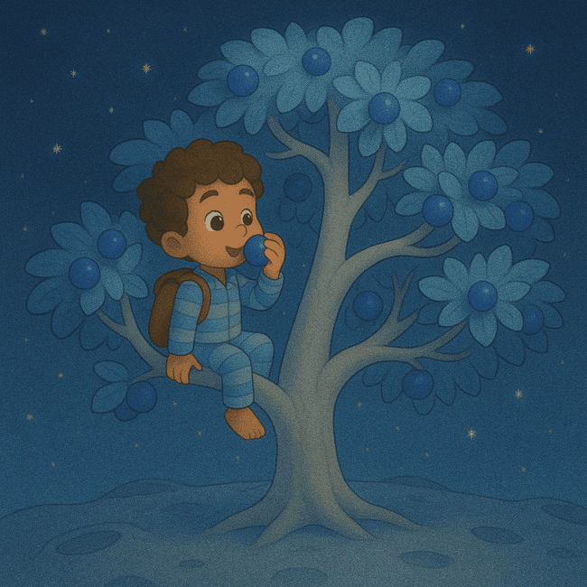

# Page 10

A gentle breeze whispered, “It’s time to go home.”  
Milo followed moonlight paths back to the bridge.



# Page 11

Back in his cozy bed, the Moonlight Map tucked under his pillow, Milo smiled.

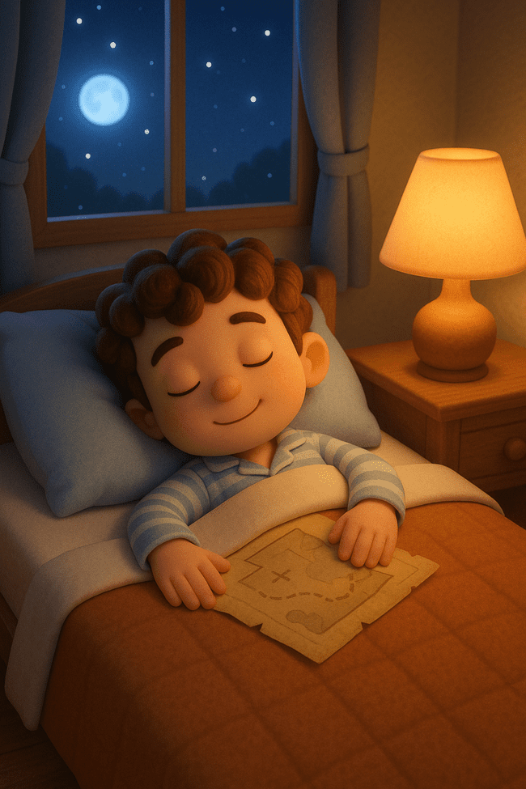

# Page 12

And in the sky above, the moon winked—until next time, little traveler.

