The Clockmaker’s Secret

# Page 1

Leo and Mira spent their summer in their grandfather’s old clock shop.  
Ticking filled the air, but one clock—an iron one with golden gears—never ticked.

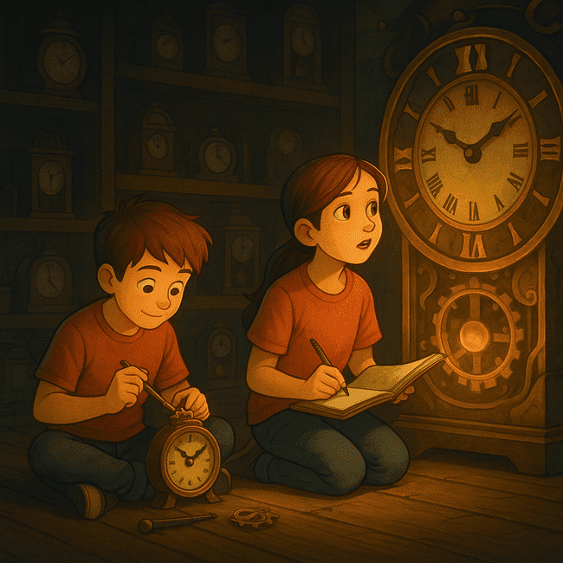

# Page 2

One evening, a bolt fell loose. The iron clock creaked open.  
Inside was a brass key… and a tiny glowing map.

# Page 3

When they turned the key, gears whirred.  
The floor split—and they fell into the Clockwork City.

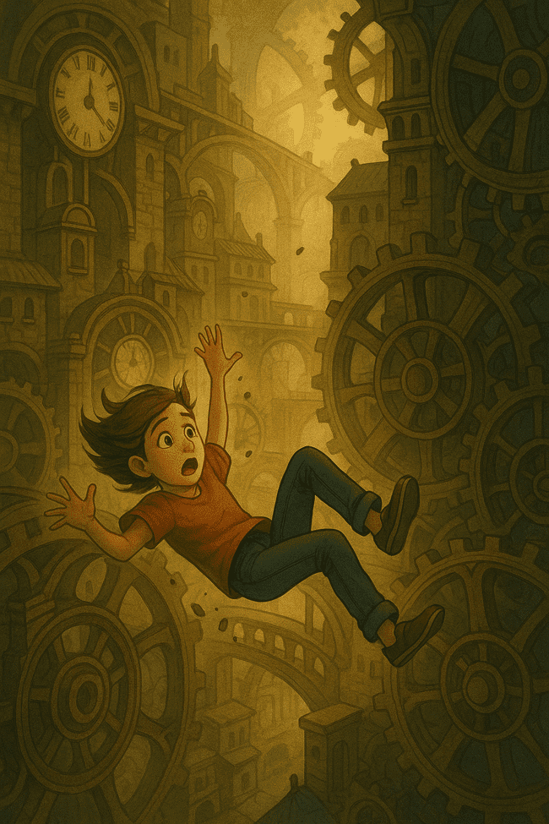

# Page 4

The city buzzed with machines and timekeepers.  
Mira asked, “Why is everything… counting down?”

# Page 5

They met Tikk, a cog-eyed girl who said,  
“Time here runs on balance. But someone’s stealing hours.”



# Page 6

They followed Tikk into the Undergears.  
Pipes hissed. Shadows moved. Clocks ticked… backward.

# Page 7

“The Thief of Time,” whispered Tikk. “He wants to rewind the city for himself.”



# Page 8

They snuck into the Chrono Vault, where all city time was stored.  
The vault was almost… empty.

# Page 9

Mira spotted a loose coil near the vault’s heart.  
She rewired it—click! Time surged back.



# Page 10

The thief appeared—but the vault clock struck twelve.  
His mask cracked. He vanished in gears and smoke.

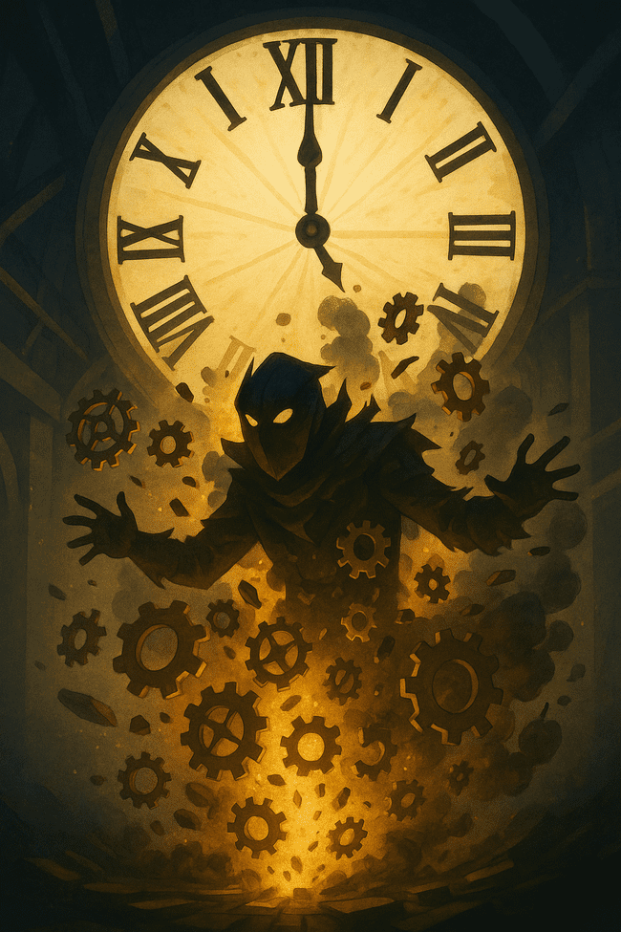

# Page 11

Tikk handed them the brass key.  
“You fixed time. That makes you part of it now.”

# Page 12

Back in the shop, the iron clock ticked once.  
Then stopped.

# Page 13

Mira locked the key in her journal.  
Leo whispered, “I think we’ll be back.”

# Page 14

Beneath the floorboards, a second clock began to glow…

