The Last Emberlight

# Page 1

Kael was the quietest in the Ember Orphanage.  
But when the Flame Tree dimmed for the first time in centuries, the last ember chose him.

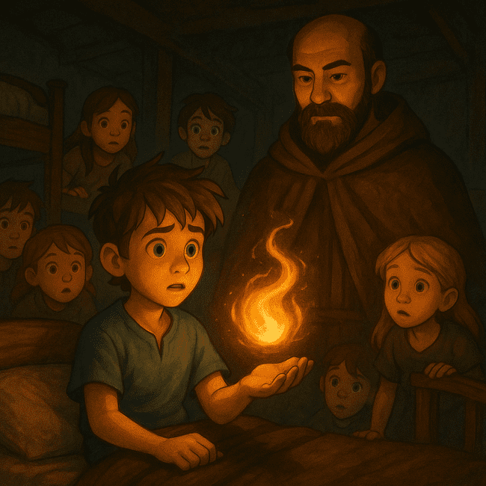

# Page 2

He was handed a fire-glass orb—inside, a tiny swirling flame.  
“Guard it with your life,” whispered the Flamekeeper.

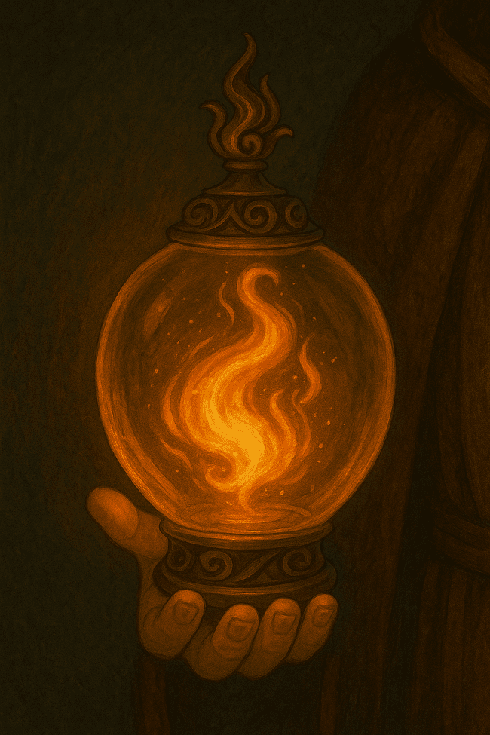

# Page 3

With a cloak, map, and lantern, Kael set out.  
Shadows watched from the trees. The fire flickered.

# Page 4

He crossed the Cracking River, where fireflies swarmed.  
One landed on the ember and whispered, “They’re coming.”

# Page 5

At Emberpass, ash wolves attacked.  
Kael ran—until a girl with flame-colored hair saved him.

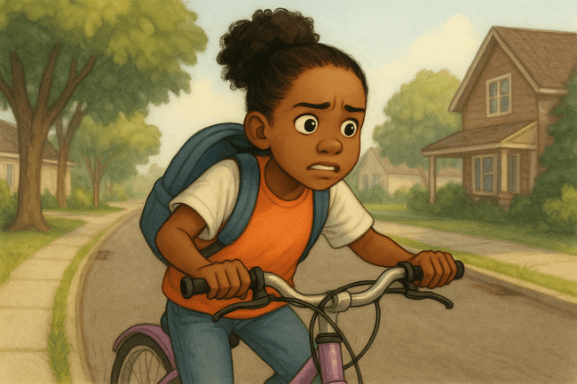

# Page 6

“I’m Reya,” she said. “You carry the light. I’ll help you get it there.”  
The ember pulsed in agreement.

# Page 7

They scaled fireless cliffs and slid through obsidian caves.  
Reya’s torch never lasted long. Kael’s ember never went out.

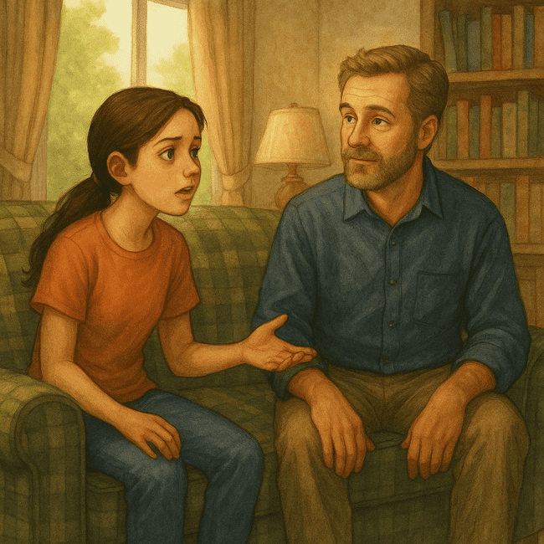

# Page 8

They reached the Ember Tree. A black mist coiled around its roots.  
The ember dimmed.

# Page 9

“Too late,” hissed a voice. A Shadow Warden rose from the roots.  
Kael shielded the ember as the mist lashed out.

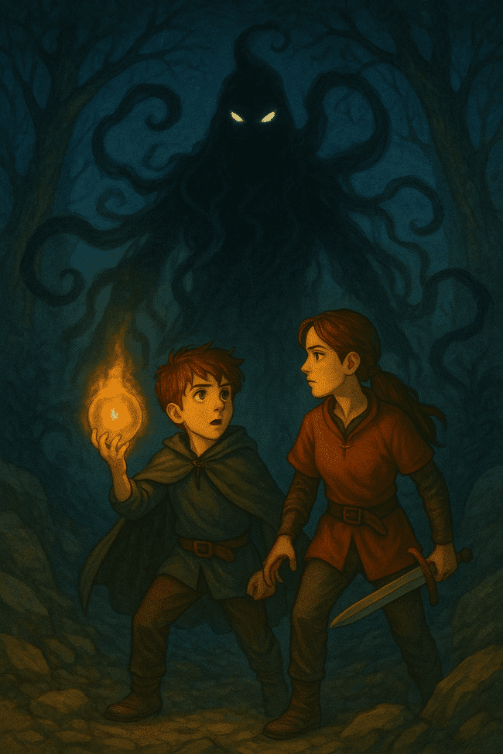

# Page 10

Reya leapt forward, blocking the blow. Her flame went out.  
Kael screamed—and the ember blazed.

# Page 11

He ran to the tree, held the ember high.  
The mist recoiled. The roots caught fire.

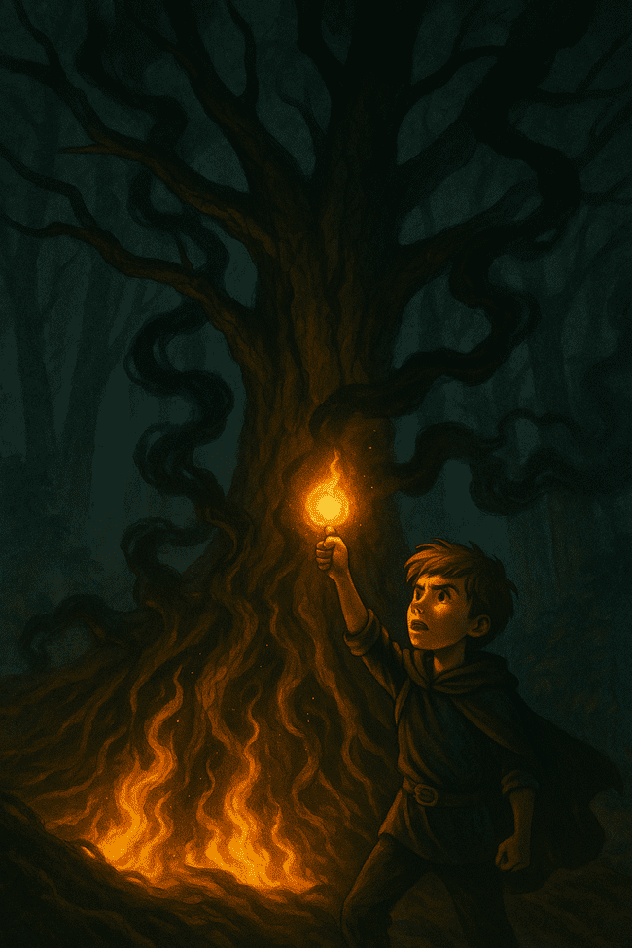

# Page 12

The tree flared gold. Shadows scattered.  
The flame leapt from branch to branch, roaring to life.

# Page 13

Reya opened her eyes. The ember floated between them, now whole flame.  
Kael smiled. “We lit the world again.”

# Page 14

Light returned to the skies.  
And in the center of the tree, a new ember began to grow.

