Theo and the Pocket Planet

# Page 1

Theo was a quiet boy with a loud imagination.  
One day, he found a shiny marble in his coat pocket that wasn't there before.



# Page 2

Theo leaned closer. Inside the marble, he saw tiny trees, rivers, and even clouds.  
“It’s a whole planet!” he whispered.



# Page 3

The marble pulsed with light—FLASH!  
Theo shrank down and fell right into the tiny world with a bounce!



# Page 4

Theo landed in a tiny village with talking ladybugs and mushroom houses.  
“Welcome to Pocket Planet!” they cheered.

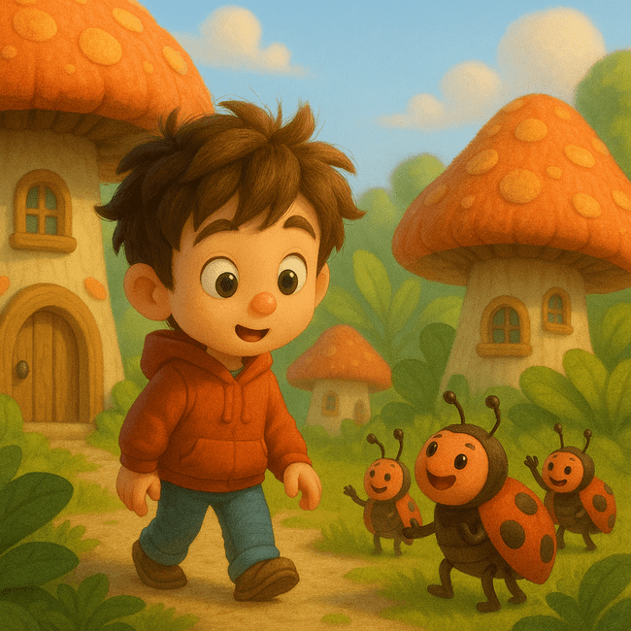

# Page 5

A brave beetle named Bix offered Theo a ride.  
They zipped through winding leaf tunnels and over bubble streams.

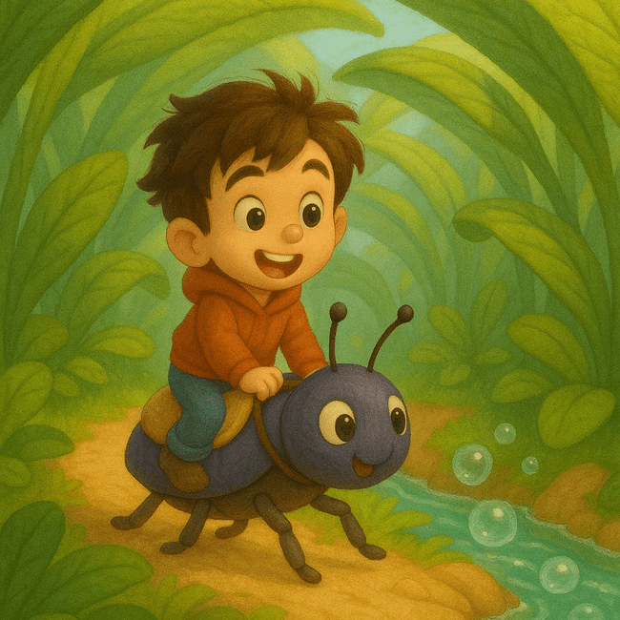

# Page 6

In a glowing meadow, Theo found a crystal flower.  
Tiny creatures hovered nearby, giggling as it shimmered.



# Page 7

Bix led Theo through mushroom forests and rainbow ponds.  
A turtle joined them for the journey.

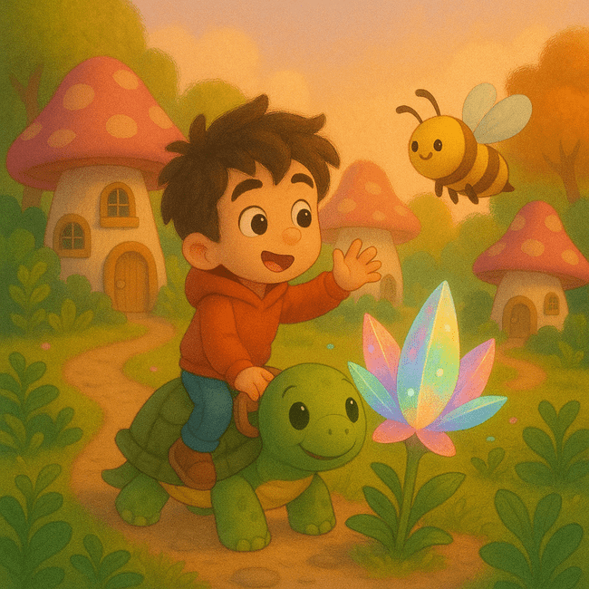

# Page 8

The crystal flower blinked once, then twice.  
“It’s time,” said Bix. “The portal is opening.”

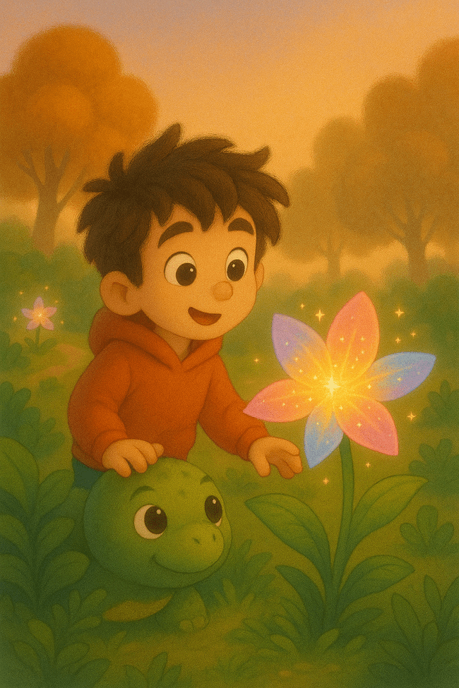

# Page 9

Theo blinked—and found himself home.  
His mom hugged him tight. "Where were you, dreamer?"



# Page 10

That night, Theo curled up in bed.  
The marble sat glowing gently on his shelf.



# Page 11

Far away, the Pocket Planet carousel spun slowly among the stars.



# Page 12

And the little planet shimmered, waiting for its next visitor.

