

Computer Networks

Assignment 01



March 10, 2021

023-18-0025

1. **Write an analogy of your own for Communication Protocol.**

We can express communication protocol with analogy of Human communication.

Humans have set communication rules, protocols. These rules must be followed to carry on the communication.

**Let Ali and Ahmed want to communicate.**

* Ali Says Hi, Ahmed Listens
* Ahmed Checks communication rule(Grammar, sequence, ethics etc.), which is valid for now.
* Ahmed replies with a message Hello, Ali listens and checks the grammar rules.
* Ali proceeds with next message
* Ali says Can I know the time, please?
* Ahmed Listens and checks the protocol. Ahmed replies with the requested data and says “It’s 12 O clock”
* Ali Thanks and says bye, and communication ends.

Computers also work in the same manner to communicate with each other using Different protocols.

1. **There are both analog and digital transmission system. Explore both and find what is performance measure of each. Why SNR can not be used as a performance measure of digital transmission system?**

**Analog Signals**

An analog signal is unquantized set of values. Unquantized means the data is saved as collection of continuous values.

* Continuous wave form signals, have frequency and amplitude
* Frequency must be defined to transmit signals from one medium toanothe, exp Human can produce sound with frequency between 100Hz and 10000Hz, but human ear can understand sound of frequency between 250Hz and 3000Hz.
* Low network capacity, only one signal can travel from medium at one time. Exp: Telephone channel can carry only one call at one time.
* Human voice is analog signal which is converted into current and voltage when transmitted over network.

**Digital Signals**

A digital signal is quantized set of values. Quantized means the data is saved as collection of discrete values.

* Discrete signals, represented by one’s and zeros.
* High pulse represents one and low pulse represents 0.
* Used by computer systems to receive and send text messages over network. The receiver decrypts the signal received and extracts 0’s and 1’s.
* Measured in bit/second
* Have high network capacity, due to multiplexers which allow to share communication channels.
* The digital transmission system is cheaper.
* **Transmission quality is higher.** With the digital transmission system, transmission noise is not accumulated with the use of a repeater. A repeater recovers an [incoming signal](https://www.sciencedirect.com/topics/computer-science/incoming-signal) based on the content and regenerates a fresh signal; an amplifier used by an analog transmission system amplifies a noise component as well so that noises are accumulated in an analog transmission system.

**Performance Measure of Analog Signals:**

*Analog signals are prone to noise so we calculate the noise to signal ratio to evaluate the performance measure of Analog signals.*

**SNR= Psignal/Pnoise**

And performance of signals also depends on the medium through which signals travel. Exp: Fobre optics have higher speed than Ethernet.

**Performance Measure of Digital Signals:**

*Following are the methods to measue the performance of digital signals .*

Bit error rate (BER), modulation error ratio (MER), and error vector magnitude (EVM)

**BER:**

**Bit error rate** (**BER**) is defined as the **percentage** of **bits** that have **errors** relative to the total number of **bits** received in a transmission. **BER** is usually expressed as 10 to a negative power. For example, if a transmission has a **BER** of 10 to the minus 4, this means that of 10,000 **bits** transmitted, 1 had an **error**.

**MER:**

Calculated from average power of signals

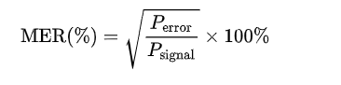

MER is similar to EVM but works on average power percentage of signal

**EVM:**

**Error vector magnitude**

A signal sent by transmitter and received by receiver have all constellation points but imperfections in data cause them to deviate. So EVM is measurement of how far these constellations are from their ideal locations.

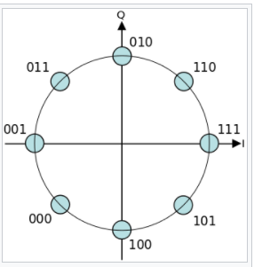

Constellation points at their ideal locations, EVM measures how far are they from deal locations.

**SNR:**

Signal to noise ratio: Used to calculate the meaningful and meaningless signal ration. 1:1 ration means meaningful signals are more than meaniningless( noise ) signals:

**Why SNR can not be used as a performance measure of digital transmission system?**

The reason of not using SNR as performance measure of digital transmission system is that the digital transmission system is noiseless. While SNR is used to compare the signal with the background noise.

1. **What is the significance of a Standard?**

Standard have utmost importance in computer networks, to ensure the security, communication, and data travel there are many standards defined. For example, IETF has defined many standards which are to be followed to carry on the communication over network. These standards include protocols like Http is standardized by RFC documentation. Further, IEEE has also defined many standards for internet and computers like WiMax( Wireless networking) and configuration management in Systems.

1. **Why some signals and data packets fail to reach destination?**

The frequency of message is too low so that the signals does not reach the destination as those were sent. When we does not choose the suitable carrier for transmission or when the size of receiver is not considered. When the signals does not reach the destination some packets of data are lost, the loss can be the error in data or because of any other reason. When the intensity of traffic is increased the loss of data packets also increases. Loss of packets also depends on switch queue. Other reasons can be low signal strength, interference and overburdened network.

1. **Study about data rates and performance of a network. What is bandwidth delay product and why is it important for network performance?**

**Data Rates:**

Amount of data transmitted during an specified time period over a network.

It is the speed at which data is transferred from one device to another device of from peripheral device to the computer. Is can be measured in

**Kbps, Mbps, Gbps etc.**

**Performance of a network:**

Measure of service quality of network is actually performance of that network. It can be measured in many ways, some are:

**Bandwidth:**

The maximum rate that information can be transferred over the network.

*Measured in bits/second.*

**Throughput:**

Actual rate by which data is transmitted

*Measured in kbps, or Mbps or bits/second*

**Latency:**

Delay between the sender and receiver decoding time, it is caused by the Transmission time, propagation time, processing time and maybe queying time at any node.

Latency and throughput are directly coupled and may affect each other.

**What is bandwidth delay product and why is it important for network performance?**

Bandwidth delay product is the capacity of link. That it is the number of bits that haven’t reach the destination but traveling toward that. Exp, let’s consider 2 PCs



PC2

PC1

Suppose the bandwidth of Cable is 1bit/second and the time a bit takes from PC1 to PC2 is 8 seconds and suppose we want to send 8 bits from PC1 to P2

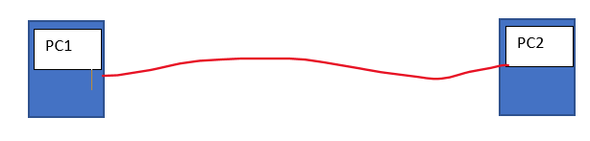

10010101

Then the bit 1 will start travel, after 1 second bit 2 will also start travel though bit 1 haven’t reached the destination, bit 3 will also start travel and it will look like



0

1

1

0

1

0

0

1

So we can see that the bits are not waiting for acknowledgment from PC2 and start travelling immediately after first bit is on transmission line. So it increases the data travel and is of utmost importance. Large Bandwidth delay product means large capacity of transferring data.

1. **Explore Virtual Circuits and elaborate this concept graphically (in one page).**

**Virtual Circuits:**

Virtual circuits network is a cross between Circuit switched network and Packet switched network. That means virtual circuit makes use of dedicated path and packet flow in the network. Virtual circuit setup needs a connection between the end systems before starting the data transmission. It is connection oriented approach of communication, where data travels through one path in a sequence unlike packet switching.

A virtual connection must be built before proceding communication.

Typically a VC consists of

1. Path between source and destination
2. VC numbers, One number for each link along the path
3. Enteries in routing table for each router

Then a packet transferred over Virtual network will carry a VC number in the header, that will be compared on each router and forwarded to next router with outgoing interface which is stored in routing table.

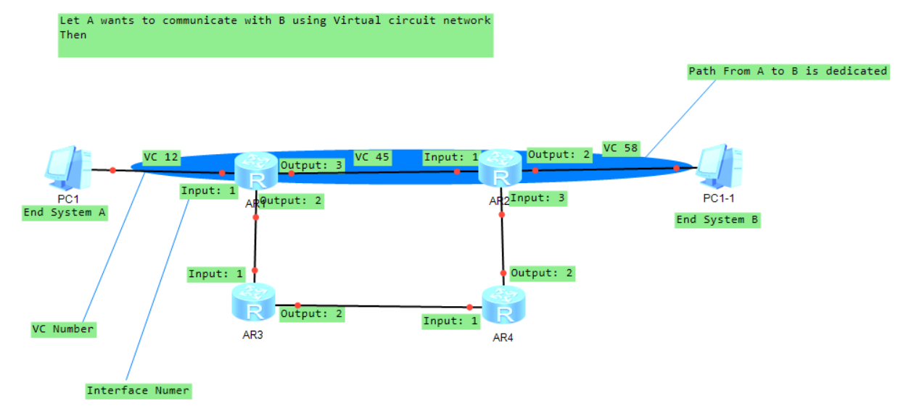

**VC Forwarding Table for router1**

|  |  |  |  |
| --- | --- | --- | --- |
| Incoming Interface # | Incoming VC # | Outgoing Interface # | Outgoing VC# |
| 1 | 12 | 3 | 45 |
|  |  |  |  |

**VC Forwarding Table for router2 . AR2**

|  |  |  |  |
| --- | --- | --- | --- |
| Incoming Interface # | Incoming VC # | Outgoing Interface # | Outgoing VC# |
| 1 | 45 | 2 | 58 |
|  |  |  |  |

The packet reached from A to B.

References

<https://en.wikipedia.org/wiki/Network_performance>

<https://www.youtube.com/watch?v=vPCKWhXSAEo>

<https://en.wikipedia.org/wiki/Bandwidth-delay_product>

<https://www.informit.com/articles/article.aspx?p=24687&seqNum=5>

<https://www.pearson.ch/download/media/9780137439157.pdf>

<https://en.wikipedia.org/wiki/Modulation_error_ratio#:~:text=The%20modulation%20error%20ratio%20or,modulation%20(such%20as%20QAM)>.

<https://en.wikipedia.org/wiki/Error_vector_magnitude>

**The End**