4/11/2021

Nadir Hussain

023-18-0025

Computer Networks

Assignment 02

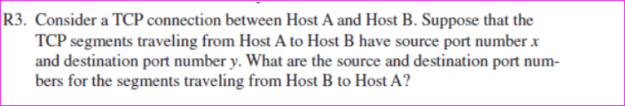

**Solution:**

Source Port number from Host B to Host A will be y and Destination port from Host B to A will be x.

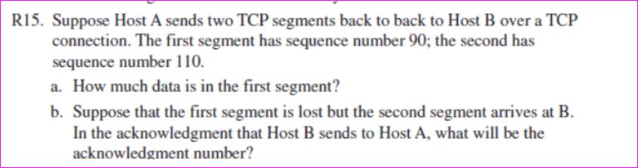

Solution

Sequence number for first segment is 90

Sequence number for second segment 110

Data in the first segment will be 110-90 Which is 20 maybe Mbs or kbs or maybe any



When the first segment is lost and second arrives at B the acknowledgement that B sends to A will have number 90.

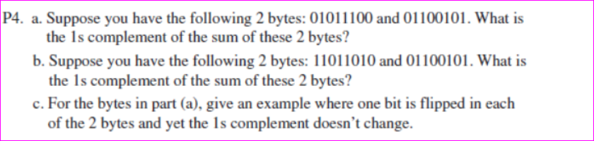

|  |  |  |  |  |  |  |  |  |
| --- | --- | --- | --- | --- | --- | --- | --- | --- |
| Byte1 | 0 | 1 | 0 | 1 | 1 | 1 | 0 | 0 |
| Byte2 | 0 | 1 | 1 | 0 | 0 | 1 | 0 | 1 |
| Sum | 1 | 1 | 0 | 0 | 0 | 0 | 0 | 1 |
| 1’s Complement | 0 | 0 | 1 | 1 | 1 | 1 | 1 | 0 |

|  |  |  |  |  |  |  |  |  |
| --- | --- | --- | --- | --- | --- | --- | --- | --- |
| Byte1 | 1 | 1 | 0 | 1 | 1 | 0 | 1 | 0 |
| Byte2 | 0 | 1 | 1 | 0 | 0 | 1 | 0 | 1 |
| Sum | 0 | 0 | 1 | 1 | 1 | 1 | 1 | 1 |
| Wrap around 1 | 0 | 1 | 0 | 0 | 0 | 0 | 0 | 0 |
| 1’s Complement | 1 | 0 | 1 | 1 | 1 | 1 | 1 | 1 |

1. Let we flip LSB of byte1 to 1 and LSB of byte2 to 0

|  |  |  |  |  |  |  |  |  |
| --- | --- | --- | --- | --- | --- | --- | --- | --- |
| Byte1 | 0 | 1 | 0 | 1 | 1 | 1 | 0 | 1 |
| Byte2 | 0 | 1 | 1 | 0 | 0 | 1 | 0 | 0 |
| Sum | 1 | 1 | 0 | 0 | 0 | 0 | 0 | 1 |
| 1’s Complement | 0 | 0 | 1 | 1 | 1 | 1 | 1 | 0 |

The 1’s complement remains same still



The receiver FSM for rdt3.0 is same as that of rdt2.0

Wait for 0 from below

Wait for 1 from below



rdt_rcv(rcvpkt) && notcorrupt(rcvpkt) && has_seq0(rcvpkt)

extract(rcvpkt,data)

deliver_data(data)

sndpkt=make_pkt(ACK,0,checksum)

udt_send(sndpkt)

rdt_rcv(rcvpkt) && notcorrupt(rcvpkt) && has_seq1(rcvpkt)

extract(rcvpkt,data)

deliver_data(data)

sndpkt=make_pkt(ACK,1,checksum)

udt_send(sndpkt)

rdt_rcv(rcvpkt)&& (corrupt(rcvpkt)|| has_seq1(rcvpkt))

then sndpkt=make_pkt(ACK,1,che)

udt_send(sndpkt)

rdt_rcv(rcvpkt)&& (corrupt(rcvpkt)|| has_seq0(rcvpkt))

then sndpkt=make_pkt(ACK,0,che)

udt_send(sndpkt)

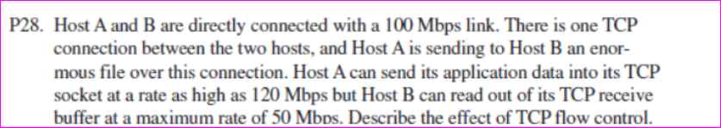

**Solution**

The Host A is sending data faster than the Host B’s receiving buffer size. As soon as data is sent at rate of 120 Mbps rate, the receiver buffer(which has capability of receiving 50Mbps ) will fill up. When buffer is filled up, Host B will send a message to A to slow down or stop sending further data until its buffer becomes empty or (become synchronous if A decreases the sending rate to 50Mbps). This is the flow control provided by TCP connection.

**The End**