5/15/2021

Nadir Hussain

023-18-0025

Computer Networks

Assignment 03

1. **Discuss the effects of scalability of the Internet on routing algorithms, routing table and forwarding. Your answer should reflect your own thinking as computer scientist considering the view points of analysis of algorithms, computer architecture, OS support and computer networking. ( I expect creative and critical analysis of your own in terms of thinking and writing)**

The scalability of internet means growing number of new devices joining the already existing network. These devices can be end systems, routers, switches etc. Before discussing its effect on routing algorithms, routing table and forwarding we must understand each of them; how they work and how much complicated and complex they already are.

* The routing algorithm works on a graph of nodes, to derive the routing table for each router with possible minimum cost/path from source to destination. This may be done by applying Dijkstra’s or Bellman ford or any other graph algorithm on centralized device or on each router.
* Routing table keeps the information about change in network topology.
* Forwarding is the local action on router that directs the incoming packet to appropriate outgoing link by looking into forwarding/routing table.

Now we discuss effects of scalability on each of them.

Suppose a new router is added to already existing network, then it is assigned the Ip address to be recognized, the routing algorithm will need to be executed again because new router may be providing good trip from source to destination. So cost of routing algorithm or say iteration is increased as one node is increased in the graph. Now assume this same scenario when we have hundreds of new devices! Definitely it will increase execution time. Dijkstra’s algorithm typically take O(n2) time complexity to execute. So it will affect when large number of new devices are connected to network.

As the more devices connected to router, there will be more entries in the routing table and forwarding table and it will take much more time to search for appropriate outgoing link which is forwarding function performed by looking into forwarding table.

So we can conclude that scalability will make the routing algorithms to take more time, increase their complexity, will add more entries into routing table and hence causes inefficiency of search for forwarding which will cause some delay on routers, which will ultimately cause congestion, packet loss, and other issues.

We can also view scalability with respect to end systems as they are increasing day by day. We will need our algorithms to perform efficiently, may also need to alter the architecture and infrastructure as it has been done earlier with scalability.

**2. What could be the ethical, social and legal aspects of control-plane of network layer?   (I expect creative and critical analysis of your own in terms of thinking and writing)**

We know that control plane determines the routing of packets along the path from source to destination. We also know that packets/datagrams need to pass from routers to travel from one network to another, and these datagrams are managed or observed by ISPs on routers. So this observation on datagrams is provided by algorithms that execute on routers by the virtue of control plane. We can in this way control the social, ethical and legal aspects of traffic flowing through network. When it comes to legal aspects of control plane we can say that some sort of packets may not be allowed to travel from a particular region or routers. For example: Many websites that share sexual content are banned in Pakistan, here comes the role of control plane, the ISPs might have defined that if destination IP in some requested datagram header is that which is not legal, then datagram is dropped or some error message is returned. Locally, we can say that Government may have set some rule for service providers i.e PTA, to deny access to some websites or apps. When a search is made from browser, the destination IP address is determined, if it is of banned site, the that datagram is not transferred further.

Similarly, packets/datagrams flowing through routers may be violating social and ethical rules , i.e hatred speeches against specific communities etc, then Control plane helps us to prevent their flow over network by filtering methods executed on routers, and we can save from multiple social and ethical violations.

1. **The world has witnessed transition from IPv4 to IPv6. Do you see yet another transition to IP version in future? Justify you answer.**

The first formal version of IPv4 was created/ allocated in 1980, and it’s last address was assigned in 2011 to RRs by ICANN. As it is 32-bit address there are total 4294967295 possible combinations of unique IP addresses. While IPv6 was invented in 1998 which is a 128-bit hexa decimal address format and it has 340282366920938463463374607431768211455 combinations. We can note that IPv4 took 30+ years to allocate all combinations, which are much more less than IPv6. We must also note that we haven’t completely transitioned to IPv6 yet, but in near future we maybe using IPv6, so it will take years and years to transit to new version from IPv6 , but I can’t see the transition to new IP version in near future because in fact if each individual has 43073717331764362463718304738 devices connected to internet via IPv6 then only we can run out of Ipv6 addresses. Can we just imagine how large is this number? Even if all of our households are connected to internet via unique IP address, we still will not reach the end of IPv6 as we can’t have such many widgets. So no transition is expected in the future( atleast in this century).

**4. Make an IP plan for an enterprise of your own choice. Mention all the assumptions and limitations.**

**Background:**

Let we have an educational organization with 3 departments say Computer science, Business Administration, and Mathematics. This organization have total 3 buildings, separate for each department. We also assume that CS department has 5 PCS, BBA 3 and mathematics has 2 PCS. We further assume that buildings are at some distance from each other. Now we want to plan an IP address for the organization so each PC is available on the network.

**IP PLAN**

As building are at some distance, we will choose to create three LANs, for that we will use 3 routers. We will not connect PCs directly to routers, so we use Switches for each LAN. We use this convention

**Router1---LAN1---CS Department**

**Router2---LAN2---Business Administration dept**

**Router3---LAN3---Mathematics Department**

First of all we will contact ISP to get a block of IP address for our organization. The ISP wil contact ICANN to get a public IP adress, lets say ISP gets block of IP address as

**11001001. 0010011. 00100000.00000000**

*In CIDR notation*

201.19.32.0/19

Now suppose ISP further wants to distribute this IP address to 2 organization, one is ours, then it will use next 1 bit(2 possible subnets). We get one block out of them

**For example**

**Org1: 11001001. 0010011. 0010**0000.00000000 201.19.32.0/20

**Org2: 11001001. 0010011. 0011**0000.00000000 201.19.48.0/20

Let our organization is Org1, then we have IP block as

**11001001. 0010011. 0010**0000.00000000

201.19.32.0/20

Now we will assign this address to our three routers/LANs , we use remaining 4 bits of network

**For router1**

**11001001. 0010011. 0010**0000.00000000/24

201.19.32.0/24

**For router2**

**11001001. 0010011. 0010**0001.00000000/24

201.19. 33.0/24

**For router3**

**11001001. 0010011. 0010**0010.00000000/24

201.19. 34.0/24

Now we will need to connect PCs to each router for each department. But we will use switch to connect PCs and Switch will be connected to Router.

On router1

**We will use host part i.e 8 bits to assign IPs to PCs, we have 5 PCs on router1 for CS department, note we will need to define gateway address to which switch will be connected**

**11001001. 0010011. 0010**0000.00000001/24

201.19.32.1/24 ***Gateway for Router1***

PC1

**11001001. 0010011. 0010**0000.00000010/24

201.19.32.2/24

PC2

**11001001. 0010011. 0010**0000.00000011/24

201.19.32.3/24

PC3

**11001001. 0010011. 0010**0000.00000100/24

201.19.32.4/24

PC4

**11001001. 0010011. 0010**0000.00000101/24

201.19.32.5/24

PC5

**11001001. 0010011. 0010**0000.00000110/24

201.19.32.6/24

On router2 we will do similar work, we connect a switch to router, define gateway and assign IPs to PCs.

**On Router2**

**11001001. 0010011. 0010**0001.00000001/24

201.19. 33.1/24 ***Gateway address***

PC1

**11001001. 0010011.0010**0001.00000010/24

201.19.33.2/24

PC2

**11001001. 0010011. 0010**0001.00000011/24

201.19.33.3/24

PC3

**11001001. 0010011. 0010**0001.00000100/24

201.19.33.4/24

On router3 we will do similar work, we connect a switch to router, define gateway and assign IPs to PCs.

**For router3**

**11001001. 0010011. 0010**0010.00000001/24

201.19. 34.1/24 ***gateway address***

PC1

**11001001. 0010011. 0010**0010.00000010/24

201.19.34.2/24

PC2

**11001001. 0010011. 0010**0010.00000011/24

201.19.34.3/24

Now we have defined the whole IP plan for our education organization. PCs will be configured on router as they are in different LANs and will be able to communicate over network.

**The above plan topology can be designed as**

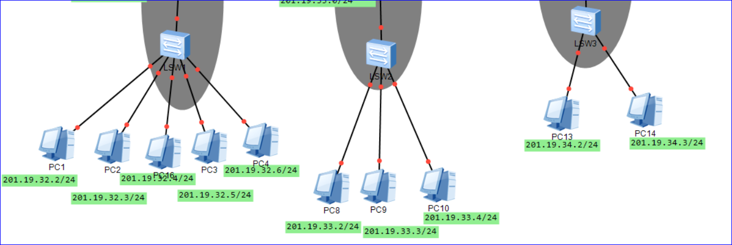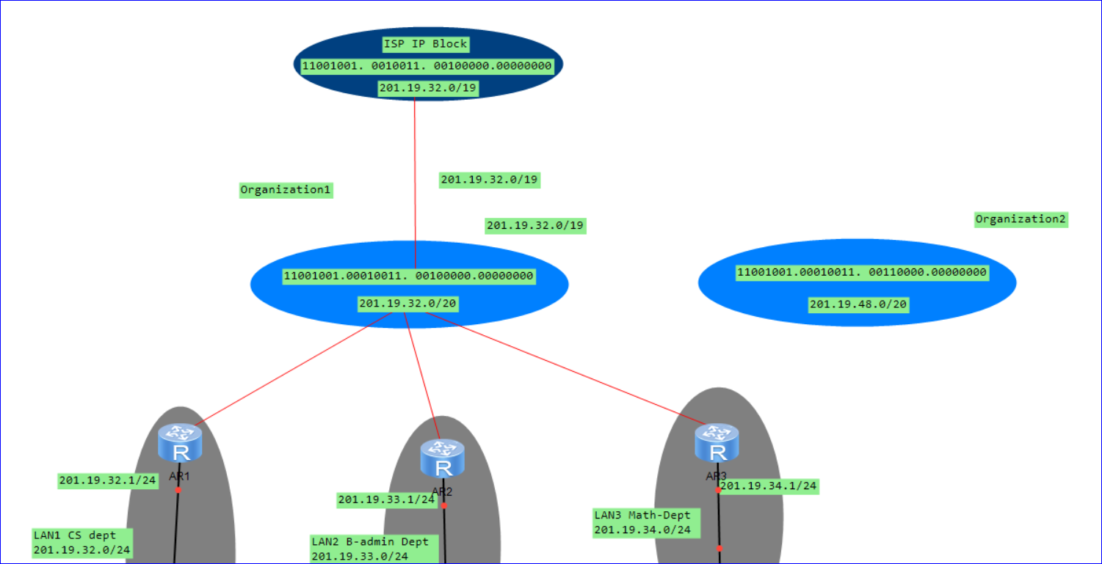

**The End**