SOFTWARE USAGE

GRAPHICAL USER INTERFACE

The first thing to download is the Python interpreter. The software is compatible with Python version2.x. In Linux and Mac-OS it is already present with the operating system. In Windows it is downloadable by the official webpage: http://www.python.it/download/

In order to work, the software needs some python libraries:

* Numpy
* Scipy
* Matplotlib
* Igraph

For windows it is enough to download them from the official sites or from the unofficial but well working webpage: <http://www.lfd.uci.edu/~gohlke/pythonlibs/>

For linux use the usual sudo apt-get, synaptics or pip.

For mac-os use easy_install or macports.

DA COMPLETARE LA GUIDA PER LINUX E MAC

To launch the program, open a shell and type:

python main.py

When the program is launched it opens with a GUI as in the figure:

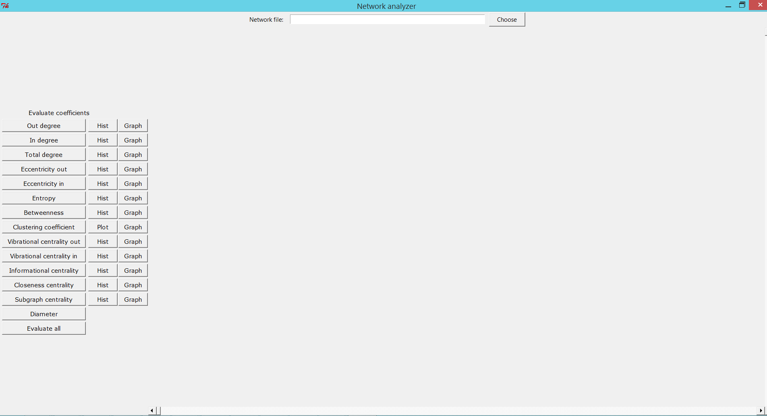

On the centre top there is the “Choose” button that let to choose a network and ask if the network is directed or not, the answer, as suggested is y for yes and n for no.

The network is then inserted in the centre of the page with a table that contains the centrality measures and some buttons on the right panel. On the top of each table, there is the name of the file that has been loaded.

On the left, there are some buttons, divided in 3 columns:

1. The first for the evaluation of each centrality measure that will be inserted in the table.
2. The plot of the distribution in a histogram of the corresponding centrality measure.
3. The plot of the graph with each node coloured with its centrality value normalized in [0,1], like in figure:

More networks can be loaded in the software. In this case, the click of a button will take into account all the networks loaded.

The table is a very powerful tool, it can be customized, columns can be moved, sorted. All the table can be saved as a csv. These and many other functions are usable with a right click.

We can see in the figure two networks loaded with a table for each one. 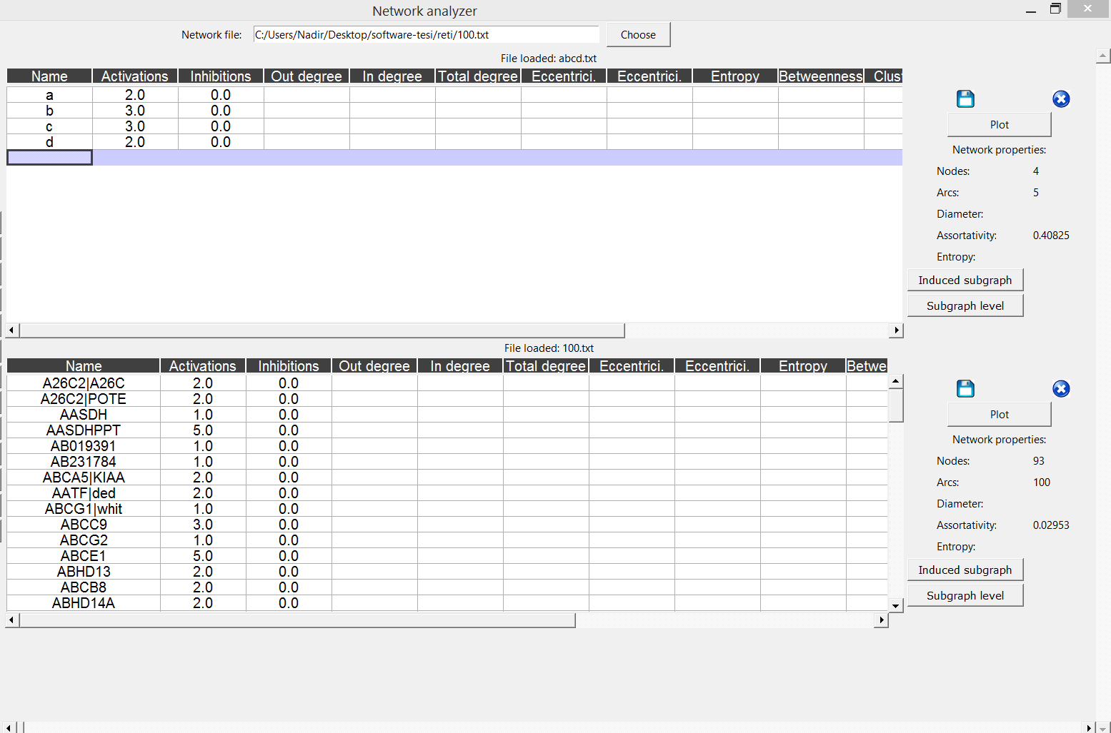

On the right we have some buttons:

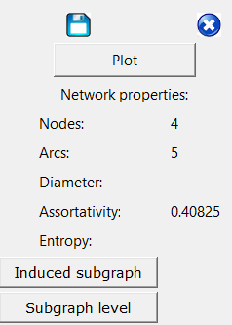

* the Save button to save the network in a ncol formatPlot button for the plot of the whole network
* the delete button to remove a network, the network will be discarded and hence not analysed anymore
* the plot button for the plot of the network
* An area for the number of nodes, arcs, the diameter, the assortativity and the network entropy.
* “Indiced subgraph” and “Subgraph level” works if and only if some rows of the table are clicked (to click more rows use Ctrl). The first creates a network with only the selected nodes. The second asks for a level and add a network with all the nodes that are reachable in the chosen number of steps, using only outgoing arcs. In both cases the networks are loaded above and can be studied, saved and analysed.

COMMAND LINE

The command line version is launched with the shell command:

python thread-command-line.py -n networkfile -n networkfile

-d y -d y -o folder_name -t number_of_threads

where:

-n: network to analyze

-d: y if the network is directed, n if not directed

-o: name of the folder where to save the results

-t: number of threads to be created, a good number is 8.

If something went wrong during the command launch, a usage help will be displayed:

USAGE:

Python thread-command-line.py -n network -o result_directory -t threads_number -v verbosity -h help

PARAMS:

-n The path of the network file.

-o The path to the directory in which the results will be stored.

-d If the network is directed: y/n.

-t The number of threads to create.

-v The verbosity of the log (optional)

-h This tutorial

Read_csv.py

This program creates the plots of the distribution of the centrality indexes.

Usage:

python read_csv.py –n network_analysed_filename –n network_analysed_filename1 –o output_folder

If more networks are given with the –n, they will be plot together in the same plot.