PANDUAN LENGKAP REVISI MODUL 1 - 4
Uji Kompetensi JWP MUK - Aplikasi Pemesanan Makanan Laravel (100% Bebas Error)
📦 MODUL 1: SETUP, DATABASE & MODEL RELASI
Langkah 1.1: Pastikan konfigurasi database di file .env mengarah ke database 'pesanmakan'.
DB_CONNECTION=mysql
DB_HOST=127.0.0.1
DB_PORT=3306
DB_DATABASE=pesanmakan
DB_USERNAME=root
DB_PASSWORD=
Langkah 1.2: Generate Model, Migration, dan Controller sekaligus dengan perintah praktis:
php artisan make:model Food -mcr
php artisan make:model Order -mcr
php artisan make:model OrderDetail -m
⚠️ JEBAKAN NAMA TABEL FOOD:
Saat membuat Model Food, Laravel otomatis membuat nama tabel 'food' (tanpa s). Anda WAJIB mengubahnya menjadi 'foods' (tambah s) di file migrasi agar relasi foreign key di order_details tidak error!
1. File Migration Foods

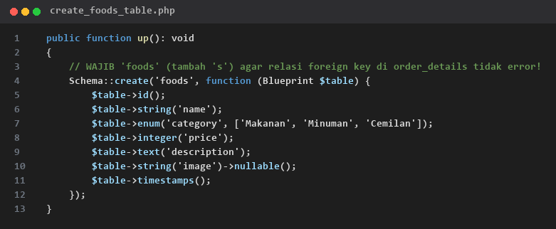
database/migrations/xxxx_create_food_table.php (Wajib 'foods')
2. File Migration Orders & Order Details

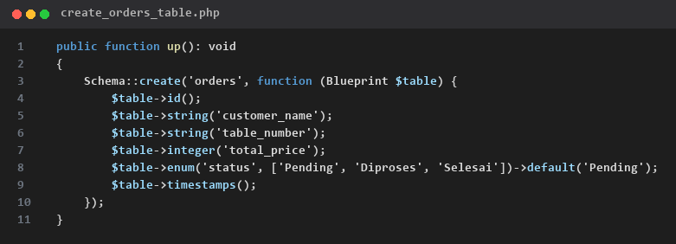
database/migrations/xxxx_create_orders_table.php

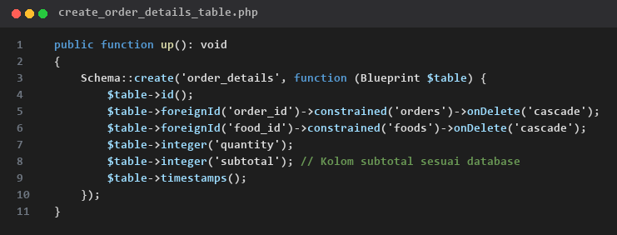
database/migrations/xxxx_create_order_details_table.php (Kolom subtotal)
3. File Seeder Data Makanan & Admin
Buat seeder dengan perintah: php artisan make:seeder FoodSeeder

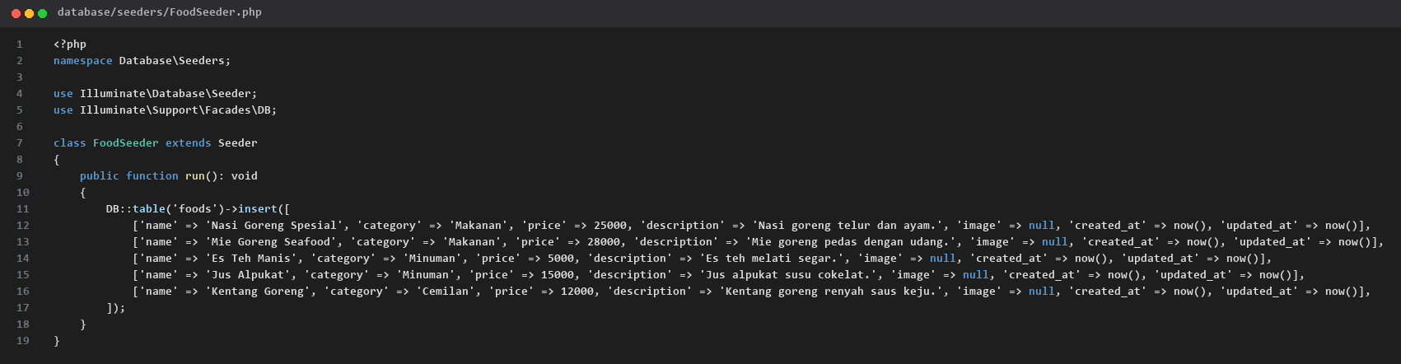
database/seeders/FoodSeeder.php

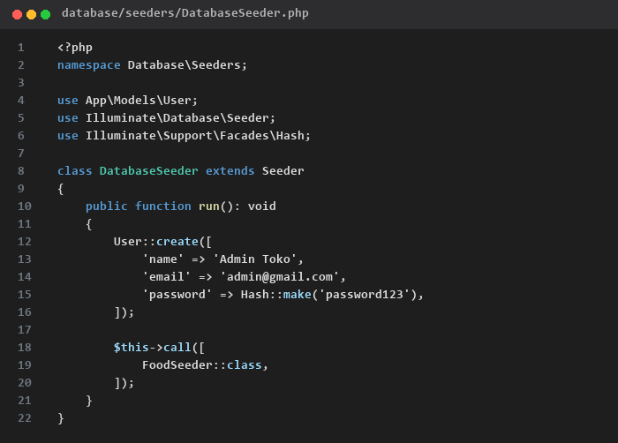
database/seeders/DatabaseSeeder.php
Jalankan migrasi dan seeder:
php artisan migrate:fresh --seed
4. File Model & Relasi Eloquent

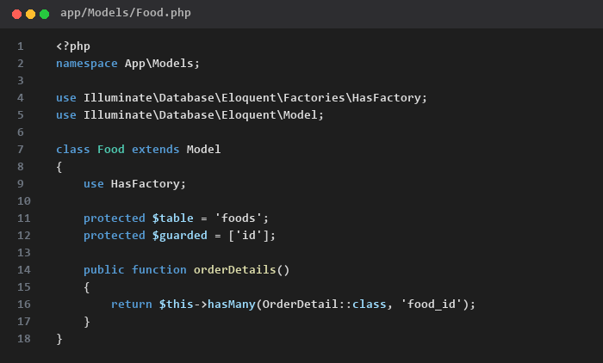
app/Models/Food.php

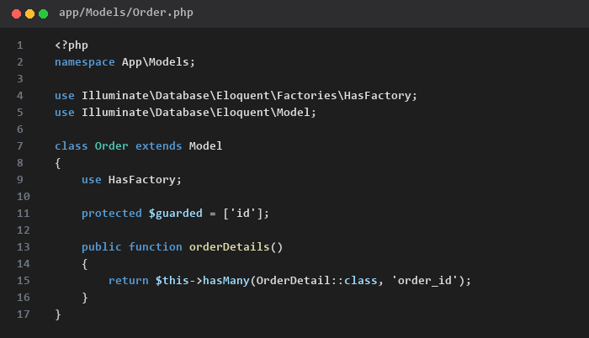
app/Models/Order.php

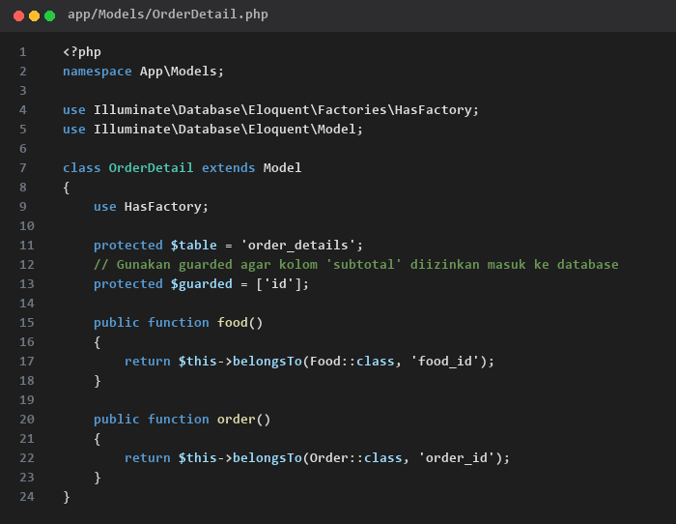
app/Models/OrderDetail.php (Pakai protected $guarded = ['id'])
🔐 MODUL 2: BREEZE AUTH & CRUD MASTER MAKANAN
Langkah 2.1: Pasang Laravel Breeze & Buat Storage Link:
composer require laravel/breeze --dev
php artisan breeze:install blade --no-dark
php artisan storage:link
npm install
npm run build
1. Controller Makanan (FoodController.php)

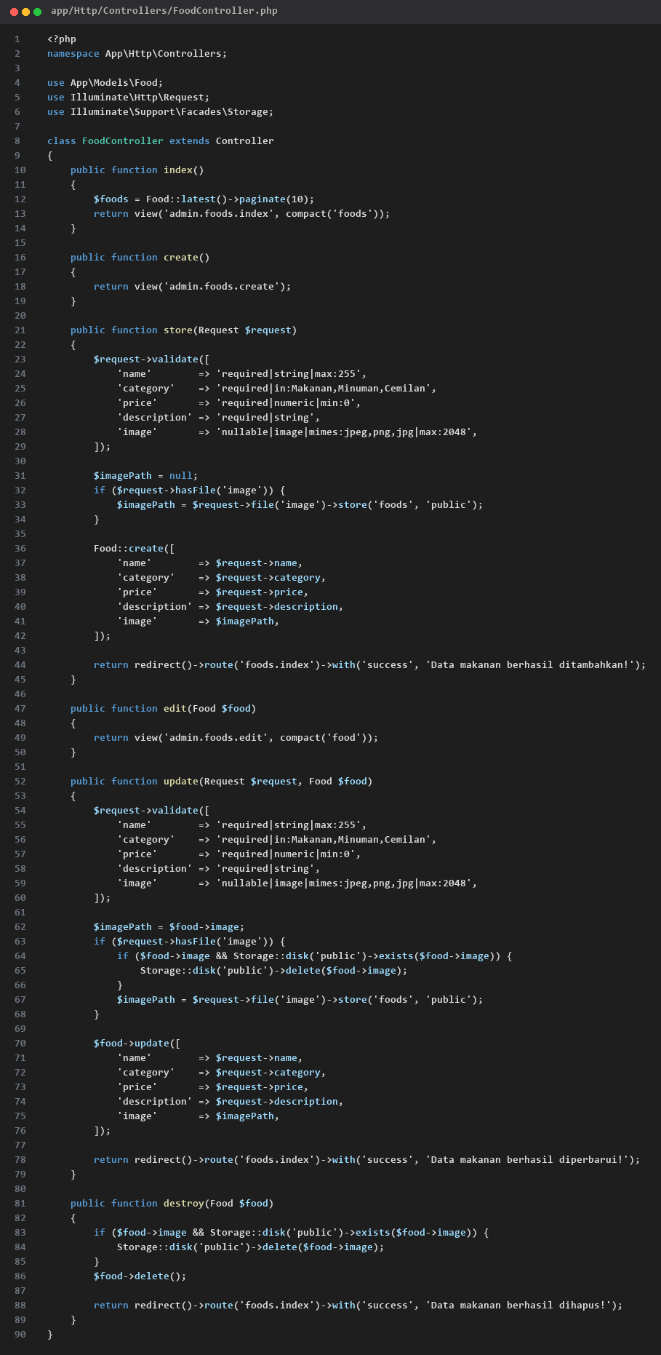
app/Http/Controllers/FoodController.php
2. View Admin Master Data Makanan (Copyable Text Boxes)
Buat folder resources/views/admin/foods/ dan buat 3 file blade berikut:
📄 1. resources/views/admin/foods/index.blade.php (Tabel Kelola Makanan):
<x-app-layout>
<x-slot name="header">
<h2 class="font-semibold text-xl text-gray-800 leading-tight">Master Data Makanan</h2>
</x-slot>
<div class="py-12 max-w-7xl mx-auto sm:px-6 lg:px-8">
<a href="{{ route('foods.create') }}" class="bg-blue-600 hover:bg-blue-700 text-white px-4 py-2 rounded mb-4 inline-block font-semibold">+ Tambah Makanan</a>
@if(session('success'))
<div class="bg-green-100 border border-green-400 text-green-700 p-3 rounded mb-4">{{ session('success') }}</div>
@endif
<table class="w-full bg-white border mt-4 shadow-sm rounded-lg overflow-hidden">
<thead>
<tr class="bg-gray-100 border-b text-gray-600 text-sm">
<th class="p-3">Gambar</th>
<th class="p-3">Nama</th>
<th class="p-3">Kategori</th>
<th class="p-3">Harga</th>
<th class="p-3">Aksi</th>
</tr>
</thead>
<tbody>
@foreach($foods as $food)
<tr class="border-b text-center text-sm">
<td class="p-3">
@if($food->image)
<img src="{{ asset('storage/' . $food->image) }}" class="w-16 h-16 object-cover mx-auto rounded">
@else
<span class="text-gray-400 text-xs">No Image</span>
@endif
</td>
<td class="p-3 font-semibold">{{ $food->name }}</td>
<td class="p-3">{{ $food->category }}</td>
<td class="p-3 font-bold text-green-600">Rp {{ number_format($food->price) }}</td>
<td class="p-3">
<a href="{{ route('foods.edit', $food->id) }}" class="text-blue-600 hover:underline mr-3 font-semibold">Edit</a>
<form action="{{ route('foods.destroy', $food->id) }}" method="POST" class="inline">
@csrf
@method('DELETE')
<button type="submit" onclick="return confirm('Yakin hapus data ini?')" class="text-red-600 hover:underline font-semibold">Hapus</button>
</form>
</td>
</tr>
@endforeach
</tbody>
</table>
<div class="mt-4">{{ $foods->links() }}</div>
</div>
</x-app-layout>
📄 2. resources/views/admin/foods/create.blade.php (Form Tambah Makanan):
<x-app-layout>
<x-slot name="header">
<h2 class="font-semibold text-xl text-gray-800 leading-tight">Tambah Makanan</h2>
</x-slot>
<div class="py-12 max-w-2xl mx-auto sm:px-6 lg:px-8">
<form action="{{ route('foods.store') }}" method="POST" enctype="multipart/form-data" class="bg-white p-6 rounded-lg shadow-sm border">
@csrf
<div class="mb-4">
<label class="block font-medium mb-1">Nama Makanan</label>
<input type="text" name="name" class="w-full border rounded p-2" required>
</div>
<div class="mb-4">
<label class="block font-medium mb-1">Kategori</label>
<select name="category" class="w-full border rounded p-2" required>
<option value="Makanan">Makanan</option>
<option value="Minuman">Minuman</option>
<option value="Cemilan">Cemilan</option>
</select>
</div>
<div class="mb-4">
<label class="block font-medium mb-1">Harga (Rp)</label>
<input type="number" name="price" class="w-full border rounded p-2" required>
</div>
<div class="mb-4">
<label class="block font-medium mb-1">Deskripsi</label>
<textarea name="description" class="w-full border rounded p-2" rows="3" required></textarea>
</div>
<div class="mb-4">
<label class="block font-medium mb-1">Gambar Makanan</label>
<input type="file" name="image" class="w-full border rounded p-2">
</div>
<button type="submit" class="bg-green-600 hover:bg-green-700 text-white px-6 py-2.5 rounded font-semibold">Simpan Data</button>
</form>
</div>
</x-app-layout>
📄 3. resources/views/admin/foods/edit.blade.php (Form Edit Makanan):
<x-app-layout>
<x-slot name="header">
<h2 class="font-semibold text-xl text-gray-800 leading-tight">Edit Makanan</h2>
</x-slot>
<div class="py-12 max-w-2xl mx-auto sm:px-6 lg:px-8">
<form action="{{ route('foods.update', $food->id) }}" method="POST" enctype="multipart/form-data" class="bg-white p-6 rounded-lg shadow-sm border">
@csrf
@method('PUT')
<div class="mb-4">
<label class="block font-medium mb-1">Nama Makanan</label>
<input type="text" name="name" value="{{ $food->name }}" class="w-full border rounded p-2" required>
</div>
<div class="mb-4">
<label class="block font-medium mb-1">Kategori</label>
<select name="category" class="w-full border rounded p-2" required>
<option value="Makanan" {{ $food->category == 'Makanan' ? 'selected' : '' }}>Makanan</option>
<option value="Minuman" {{ $food->category == 'Minuman' ? 'selected' : '' }}>Minuman</option>
<option value="Cemilan" {{ $food->category == 'Cemilan' ? 'selected' : '' }}>Cemilan</option>
</select>
</div>
<div class="mb-4">
<label class="block font-medium mb-1">Harga (Rp)</label>
<input type="number" name="price" value="{{ $food->price }}" class="w-full border rounded p-2" required>
</div>
<div class="mb-4">
<label class="block font-medium mb-1">Deskripsi</label>
<textarea name="description" class="w-full border rounded p-2" rows="3" required>{{ $food->description }}</textarea>
</div>
<div class="mb-4">
<label class="block font-medium mb-1">Gambar Baru (Opsional)</label>
<input type="file" name="image" class="w-full border rounded p-2">
</div>
<button type="submit" class="bg-blue-600 hover:bg-blue-700 text-white px-6 py-2.5 rounded font-semibold">Update Data</button>
</form>
</div>
</x-app-layout>
🛒 MODUL 3: SISI CUSTOMER (KATALOG & TRANSAKSI CHECKOUT)
⚠️ JEBAKAN FATAL SUBTOTAL VS PRICE:
Di Modul 3, OrderController menyimpan 'price' padahal tabel database bernama 'subtotal'. Pastikan OrderController menyimpan ke kolom 'subtotal' dan OrderDetail.php memakai protected $guarded = ['id']!
1. OrderController (OrderController.php)

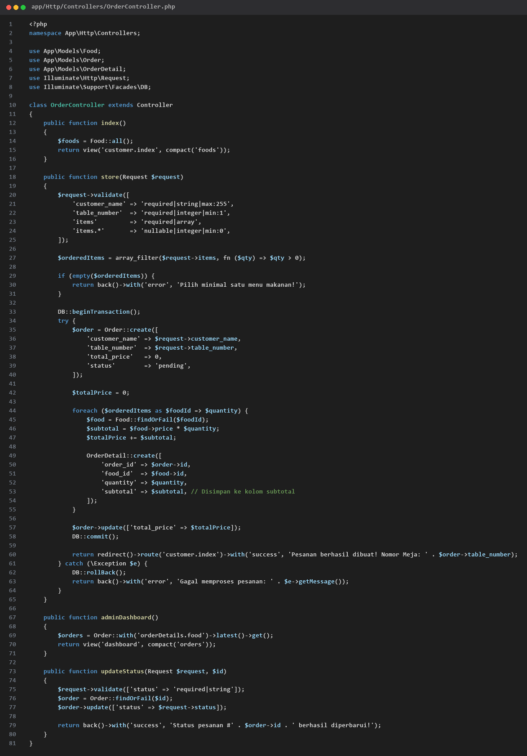
app/Http/Controllers/OrderController.php
2. Halaman Menu Customer (resources/views/customer/index.blade.php)
Perbaikan penting: Modal diletakkan di dalam tag form dan tombol menggunakan type='submit' asli HTML5:
<!DOCTYPE html>
<html lang="id">
<head>
<meta charset="UTF-8">
<meta name="viewport" content="width=device-width, initial-scale=1.0">
<title>Menu Restoran</title>
<script src="https://cdn.tailwindcss.com"></script>
</head>
<body class="bg-gray-100 p-6 font-sans">
<div class="max-w-5xl mx-auto">
<div class="text-center mb-6">
<h1 class="text-3xl font-bold text-gray-800">Menu Restoran</h1>
<p class="text-gray-500 text-sm mt-1">Pilih menu makanan dan masukkan nomor meja Anda</p>
</div>
@if(session('success'))
<div class="bg-green-100 border border-green-400 text-green-700 px-4 py-3 rounded-xl mb-6 text-center font-semibold">{{ session('success') }}</div>
@endif
@if(session('error'))
<div class="bg-red-100 border border-red-400 text-red-700 px-4 py-3 rounded-xl mb-6 text-center font-semibold">{{ session('error') }}</div>
@endif
@if($errors->any())
<div class="bg-red-100 border border-red-400 text-red-700 px-4 py-3 rounded-xl mb-6 font-semibold">
<ul class="list-disc list-inside">
@foreach($errors->all() as $error)
<li>{{ $error }}</li>
@endforeach
</ul>
</div>
@endif
<div class="flex flex-wrap justify-center gap-3 mb-8">
<button type="button" onclick="filterCategory('all', this)" class="btn-category px-5 py-2 rounded-full font-semibold text-sm transition bg-blue-600 text-white shadow-md">Semua Menu</button>
<button type="button" onclick="filterCategory('Makanan', this)" class="btn-category px-5 py-2 rounded-full font-semibold text-sm transition bg-white text-gray-600 hover:bg-gray-200 border">Makanan</button>
<button type="button" onclick="filterCategory('Minuman', this)" class="btn-category px-5 py-2 rounded-full font-semibold text-sm transition bg-white text-gray-600 hover:bg-gray-200 border">Minuman</button>
<button type="button" onclick="filterCategory('Cemilan', this)" class="btn-category px-5 py-2 rounded-full font-semibold text-sm transition bg-white text-gray-600 hover:bg-gray-200 border">Cemilan</button>
</div>
<form id="orderForm" action="{{ route('customer.checkout') }}" method="POST">
@csrf
<div class="bg-white p-6 rounded-xl shadow-sm border mb-6">
<h2 class="text-lg font-bold text-gray-700 mb-4 pb-2 border-b">1. Informasi Pemesan</h2>
<div class="grid grid-cols-1 md:grid-cols-2 gap-4">
<div>
<label class="block text-sm font-semibold text-gray-600 mb-1">Nama Lengkap</label>
<input type="text" id="customer_name" name="customer_name" required placeholder="Masukkan nama pemesan" class="w-full border rounded-lg px-4 py-2 focus:ring-2 focus:ring-blue-500 outline-none">
</div>
<div>
<label class="block text-sm font-semibold text-gray-600 mb-1">Nomor Meja</label>
<input type="number" id="table_number" name="table_number" required placeholder="Contoh: 05" class="w-full border rounded-lg px-4 py-2 focus:ring-2 focus:ring-blue-500 outline-none">
</div>
</div>
</div>
<h2 class="text-lg font-bold text-gray-700 mb-4">2. Pilih Menu</h2>
<div class="grid grid-cols-1 md:grid-cols-3 gap-6">
@foreach($foods as $food)
<div class="food-card bg-white rounded-xl shadow-sm border overflow-hidden flex flex-col justify-between" data-category="{{ $food->category ?? 'Makanan' }}">
<div>
@if($food->image)
<img src="{{ asset('storage/' . $food->image) }}" alt="{{ $food->name }}" class="w-full h-40 object-cover">
@else
<div class="bg-gray-200 h-40 flex items-center justify-center text-gray-400 font-medium">Tanpa Gambar</div>
@endif
<div class="p-4">
<div class="flex justify-between items-center mb-2">
<span class="text-xs bg-blue-100 text-blue-700 font-semibold px-2.5 py-0.5 rounded">{{ $food->category ?? 'Makanan' }}</span>
<span class="font-bold text-green-600">Rp {{ number_format($food->price) }}</span>
</div>
<h3 class="font-bold text-gray-800 text-lg item-name">{{ $food->name }}</h3>
<p class="text-xs text-gray-500 mt-1 line-clamp-2">{{ $food->description }}</p>
</div>
</div>
<div class="p-4 bg-gray-50 border-t">
<label class="block text-xs font-semibold text-gray-500 mb-1">Jumlah Porsi</label>
<input type="number" name="items[{{ $food->id }}]" min="0" value="0" data-name="{{ $food->name }}" data-price="{{ $food->price }}" class="item-qty w-full border rounded-lg px-3 py-1.5 text-center font-bold text-gray-700 focus:ring-2 focus:ring-blue-500 outline-none">
</div>
</div>
@endforeach
</div>
<div class="mt-8 text-right">
<button type="button" onclick="showConfirmationModal()" class="bg-blue-600 hover:bg-blue-700 text-white font-bold px-8 py-3 rounded-xl shadow-md transition">Pesan Sekarang</button>
</div>
<div id="confirmModal" class="fixed inset-0 bg-black/50 hidden items-center justify-center z-50 p-4">
<div class="bg-white rounded-2xl max-w-md w-full p-6 shadow-2xl transform transition-all">
<h3 class="text-xl font-bold text-gray-800 border-b pb-3 mb-4">Konfirmasi Pesanan</h3>
<div class="space-y-2 text-sm text-gray-600 mb-4">
<div class="flex justify-between"><span class="font-semibold">Nama:</span> <span id="modalName" class="text-gray-900 font-bold"></span></div>
<div class="flex justify-between"><span class="font-semibold">No. Meja:</span> <span id="modalTable" class="text-gray-900 font-bold"></span></div>
</div>
<div class="border-t border-b py-3 mb-4 max-h-48 overflow-y-auto">
<p class="font-semibold text-xs text-gray-400 uppercase mb-2">Rincian Item</p>
<ul id="modalItemList" class="space-y-2 text-sm"></ul>
</div>
<div class="flex justify-between items-center text-lg font-bold text-gray-800 mb-6">
<span>Total Pembayaran:</span>
<span id="modalTotalPrice" class="text-green-600 text-xl">Rp 0</span>
</div>
<div class="flex gap-3">
<button type="button" onclick="closeConfirmationModal()" class="w-1/2 bg-gray-200 hover:bg-gray-300 text-gray-700 font-semibold py-2.5 rounded-xl transition">Batal</button>
<button type="submit" class="w-1/2 bg-green-600 hover:bg-green-700 text-white font-bold py-2.5 rounded-xl shadow transition">Ya, Kirim Pesanan</button>
</div>
</div>
</div>
</form>
</div>
<script>
function filterCategory(category, element) {
document.querySelectorAll('.btn-category').forEach(btn => {
btn.className = "btn-category px-5 py-2 rounded-full font-semibold text-sm transition bg-white text-gray-600 hover:bg-gray-200 border";
});
element.className = "btn-category px-5 py-2 rounded-full font-semibold text-sm transition bg-blue-600 text-white shadow-md";
const cards = document.querySelectorAll('.food-card');
cards.forEach(card => {
const cardCategory = card.getAttribute('data-category');
card.style.display = (category === 'all' || cardCategory === category) ? 'flex' : 'none';
});
}
function showConfirmationModal() {
const name = document.getElementById('customer_name').value.trim();
const table = document.getElementById('table_number').value.trim();
if (!name || !table) {
alert('Silakan isi Nama Lengkap dan Nomor Meja terlebih dahulu!');
return;
}
const items = document.querySelectorAll('.item-qty');
let itemListHtml = '';
let grandTotal = 0;
let hasOrder = false;
items.forEach(input => {
const qty = parseInt(input.value) || 0;
if (qty > 0) {
hasOrder = true;
const itemName = input.getAttribute('data-name');
const price = parseFloat(input.getAttribute('data-price'));
const subtotal = qty * price;
grandTotal += subtotal;
itemListHtml += `<li class="flex justify-between items-center"><div><span class="font-bold text-gray-800">${itemName}</span><span class="text-xs text-gray-500 block">x${qty} @ Rp ${price.toLocaleString('id-ID')}</span></div><span class="font-semibold text-gray-700">Rp ${subtotal.toLocaleString('id-ID')}</span></li>`;
}
});
if (!hasOrder) {
alert('Pilih minimal 1 menu makanan/minuman dengan jumlah lebih dari 0!');
return;
}
document.getElementById('modalName').textContent = name;
document.getElementById('modalTable').textContent = table;
document.getElementById('modalItemList').innerHTML = itemListHtml;
document.getElementById('modalTotalPrice').textContent = 'Rp ' + grandTotal.toLocaleString('id-ID');
const modal = document.getElementById('confirmModal');
modal.classList.remove('hidden');
modal.classList.add('flex');
}
function closeConfirmationModal() {
const modal = document.getElementById('confirmModal');
modal.classList.remove('flex');
modal.classList.add('hidden');
}
</script>
</body>
</html>
📊 MODUL 4: SISI ADMIN (REKAP PESANAN & UPDATE STATUS)
Langkah 4.1: Update Tampilan Dashboard Admin (resources/views/dashboard.blade.php):
<x-app-layout>
<x-slot name="header">
<div class="flex justify-between items-center">
<h2 class="font-semibold text-xl text-gray-800 leading-tight">
{{ __('Daftar Pesanan Masuk') }}
</h2>
<div class="flex items-center gap-3">
<a href="{{ route('foods.index') }}" class="inline-flex items-center px-4 py-2 bg-indigo-600 border border-transparent rounded-md font-semibold text-xs text-white uppercase tracking-widest hover:bg-indigo-700 shadow-sm transition">Kelola Menu</a>
<a href="{{ route('customer.index') }}" target="_blank" class="inline-flex items-center px-4 py-2 bg-gray-800 border border-transparent rounded-md font-semibold text-xs text-white uppercase tracking-widest hover:bg-gray-700 shadow-sm transition">Lihat Menu Customer</a>
</div>
</div>
</x-slot>
<div class="py-12">
<div class="max-w-7xl mx-auto sm:px-6 lg:px-8">
@if(session('success'))
<div class="mb-4 p-4 bg-green-100 border-l-4 border-green-500 text-green-700 rounded shadow-sm font-medium">{{ session('success') }}</div>
@endif
<div class="bg-white overflow-hidden shadow-sm sm:rounded-lg border border-gray-200">
<div class="p-6 text-gray-900 overflow-x-auto">
<table class="w-full text-left border-collapse">
<thead class="bg-gray-100 text-gray-700 uppercase text-xs">
<tr>
<th class="p-4 border-b"># ID</th>
<th class="p-4 border-b">Pelanggan</th>
<th class="p-4 border-b">No. Meja</th>
<th class="p-4 border-b">Rincian Pesanan</th>
<th class="p-4 border-b">Total Harga</th>
<th class="p-4 border-b">Status</th>
<th class="p-4 border-b text-center">Aksi Status</th>
</tr>
</thead>
<tbody class="divide-y text-sm">
@forelse($orders as $order)
<tr class="hover:bg-gray-50">
<td class="p-4 font-bold text-gray-700">#{{ $order->id }}</td>
<td class="p-4 font-medium">{{ $order->customer_name }}</td>
<td class="p-4"><span class="bg-blue-100 text-blue-800 font-bold px-2.5 py-1 rounded-full text-xs">Meja {{ $order->table_number }}</span></td>
<td class="p-4">
<ul class="list-disc list-inside space-y-1 text-gray-600">
@foreach($order->orderDetails as $detail)
<li>
<strong>{{ $detail->food->name ?? 'Menu' }}</strong>
x{{ $detail->quantity }}
<span class="text-xs text-gray-400">(Rp {{ number_format($detail->subtotal) }})</span>
</li>
@endforeach
</ul>
</td>
<td class="p-4 font-bold text-green-600">Rp {{ number_format($order->total_price) }}</td>
<td class="p-4">
@if(strtolower($order->status) == 'pending')
<span class="bg-yellow-100 text-yellow-800 text-xs font-bold px-2.5 py-1 rounded">PENDING</span>
@elseif(strtolower($order->status) == 'completed' || strtolower($order->status) == 'selesai')
<span class="bg-green-100 text-green-800 text-xs font-bold px-2.5 py-1 rounded">SELESAI</span>
@else
<span class="bg-red-100 text-red-800 text-xs font-bold px-2.5 py-1 rounded">{{ strtoupper($order->status) }}</span>
@endif
</td>
<td class="p-4 text-center">
<form action="{{ route('admin.orders.updateStatus', $order->id) }}" method="POST">
@csrf
@method('PATCH')
<select name="status" onchange="this.form.submit()" class="text-xs border border-gray-300 rounded p-1.5 bg-white shadow-sm font-semibold">
<option value="pending" {{ strtolower($order->status) == 'pending' ? 'selected' : '' }}>Pending</option>
<option value="completed" {{ strtolower($order->status) == 'completed' || strtolower($order->status) == 'selesai' ? 'selected' : '' }}>Selesai / Lunas</option>
<option value="cancelled" {{ strtolower($order->status) == 'cancelled' || strtolower($order->status) == 'batal' ? 'selected' : '' }}>Batalkan</option>
</select>
</form>
</td>
</tr>
@empty
<tr>
<td colspan="7" class="p-6 text-center text-gray-500">Belum ada pesanan masuk.</td>
</tr>
@endforelse
</tbody>
</table>
</div>
</div>
</div>
</div>
</x-app-layout>
Langkah 4.2: File Rute Lengkap (routes/web.php):
<?php
use App\Http\Controllers\FoodController;
use App\Http\Controllers\OrderController;
use App\Http\Controllers\ProfileController;
use Illuminate\Support\Facades\Route;
// 1. Halaman Utama (Katalog Menu Pelanggan)
Route::get('/', [OrderController::class, 'index'])->name('customer.index');
Route::post('/checkout', [OrderController::class, 'store'])->name('customer.checkout');
// 2. Arahkan Dashboard Utama Breeze ke Admin Dashboard Rekap Pesanan
Route::get('/dashboard', [OrderController::class, 'adminDashboard'])
->middleware(['auth', 'verified'])
->name('dashboard');
// 3. Rute Grup Admin (Wajib Login)
Route::middleware('auth')->group(function () {
Route::get('/profile', [ProfileController::class, 'edit'])->name('profile.edit');
Route::patch('/profile', [ProfileController::class, 'update'])->name('profile.update');
Route::delete('/profile', [ProfileController::class, 'destroy'])->name('profile.destroy');
// Alias route untuk dashboard admin & update status pesanan
Route::get('/admin/dashboard', [OrderController::class, 'adminDashboard'])->name('admin.dashboard');
Route::patch('/admin/orders/{id}/status', [OrderController::class, 'updateStatus'])->name('admin.orders.updateStatus');
// CRUD Makanan
Route::resource('/admin/foods', FoodController::class);
});
require __DIR__.'/auth.php';

