**Deep Skilling - Week 3 Mandatory Hands-on Exercises**

**Skill : Spring Core and Maven**

**Exercise - 1: Configuring a Basic Spring Application**

**Code:**

**Pom.xml**

**<project xmlns="http://maven.apache.org/POM/4.0.0"**

**xmlns:xsi="http://www.w3.org/2001/XMLSchema-instance"**

**xsi:schemaLocation="http://maven.apache.org/POM/4.0.0**

**http://maven.apache.org/xsd/maven-4.0.0.xsd">**

**<modelVersion>4.0.0</modelVersion>**

**<groupId>DigitalNurture</groupId>**

**<artifactId>LibraryManagement</artifactId>**

**<version>0.0.1-SNAPSHOT</version>**

**<packaging>jar</packaging>**

**<name>LibraryManagement</name>**

**<url>http://maven.apache.org</url>**

**<properties>**

**<project.build.sourceEncoding>UTF-8</project.build.sourceEncoding>**

**</properties>**

**<dependencies>**

**<!-- JUnit for testing -->**

**<dependency>**

**<groupId>junit</groupId>**

**<artifactId>junit</artifactId>**

**<version>3.8.1</version>**

**<scope>test</scope>**

**</dependency>**

**<!-- Spring Core Context -->**

**<dependency>**

**<groupId>org.springframework</groupId>**

**<artifactId>spring-context</artifactId>**

**<version>5.3.33</version>**

**</dependency>**

**<!-- Spring AOP -->**

**<dependency>**

**<groupId>org.springframework</groupId>**

**<artifactId>spring-aop</artifactId>**

**<version>5.3.33</version>**

**</dependency>**

**<!-- Spring Web MVC -->**

**<dependency>**

**<groupId>org.springframework</groupId>**

**<artifactId>spring-webmvc</artifactId>**

**<version>5.3.33</version>**

**</dependency>**

**</dependencies>**

**<build>**

**<plugins>**

**<!-- Maven Compiler Plugin for Java 1.8 -->**

**<plugin>**

**<groupId>org.apache.maven.plugins</groupId>**

**<artifactId>maven-compiler-plugin</artifactId>**

**<version>3.10.1</version>**

**<configuration>**

**<source>1.8</source>**

**<target>1.8</target>**

**</configuration>**

**</plugin>**

**</plugins>**

**</build>**

**</project>**

**com.library.repository.BookRepository.java**

**package com.library.repository;**

**public class BookRepository{**

**public void display() {**

**System.*out*.println("Book repository!");**

**}**

**}**

**com.library.main.App.java**

**package DigitalNurture.LibraryManagement;**

**import com.library.service.*;**

**import org.springframework.context.ApplicationContext;**

**import org.springframework.context.support.ClassPathXmlApplicationContext;**

**public class App**

**{**

**public static void main(String[] args) {**

**ApplicationContext context = new ClassPathXmlApplicationContext("applicationContext.xml");**

**BookService bookService = (BookService) context.getBean("bookService");**

**// BookRepository bookRepository = (BookRepository) context.getBean("bookRepository");**

**// bookRepository.display();**

**bookService.display();**

**}**

**}**

**com.library.service.BookService.java**

**package com.library.service;**

**import com.library.repository.*;**

**public class BookService{**

**private BookRepository bookRepository;**

**public void setBookRepository(BookRepository bookRepository) {**

**this.bookRepository = bookRepository;**

**}**

**public void display() {**

**System.*out*.println("Book Service!");**

**bookRepository.display();**

**}**

**}**

**src/main/resources/applicationContext.xml**

**<?xml version=*"1.0"* encoding=*"UTF-8"*?>**

**<beans xmlns=*"http://www.springframework.org/schema/beans"***

**xmlns:xsi=*"http://www.w3.org/2001/XMLSchema-instance"***

**xsi:schemaLocation=*"***

***http://www.springframework.org/schema/beans***

***http://www.springframework.org/schema/beans/spring-beans.xsd"*>**

**<bean id=*"bookRepository"* class=*"com.library.repository.BookRepository"*/>**

**<bean id=*"bookService"* class=*"com.library.service.BookService"*>**

**<property name = *"bookRepository"* ref = *"bookRepository"*></property>**

**</bean>**

**</beans>**

**Output:**

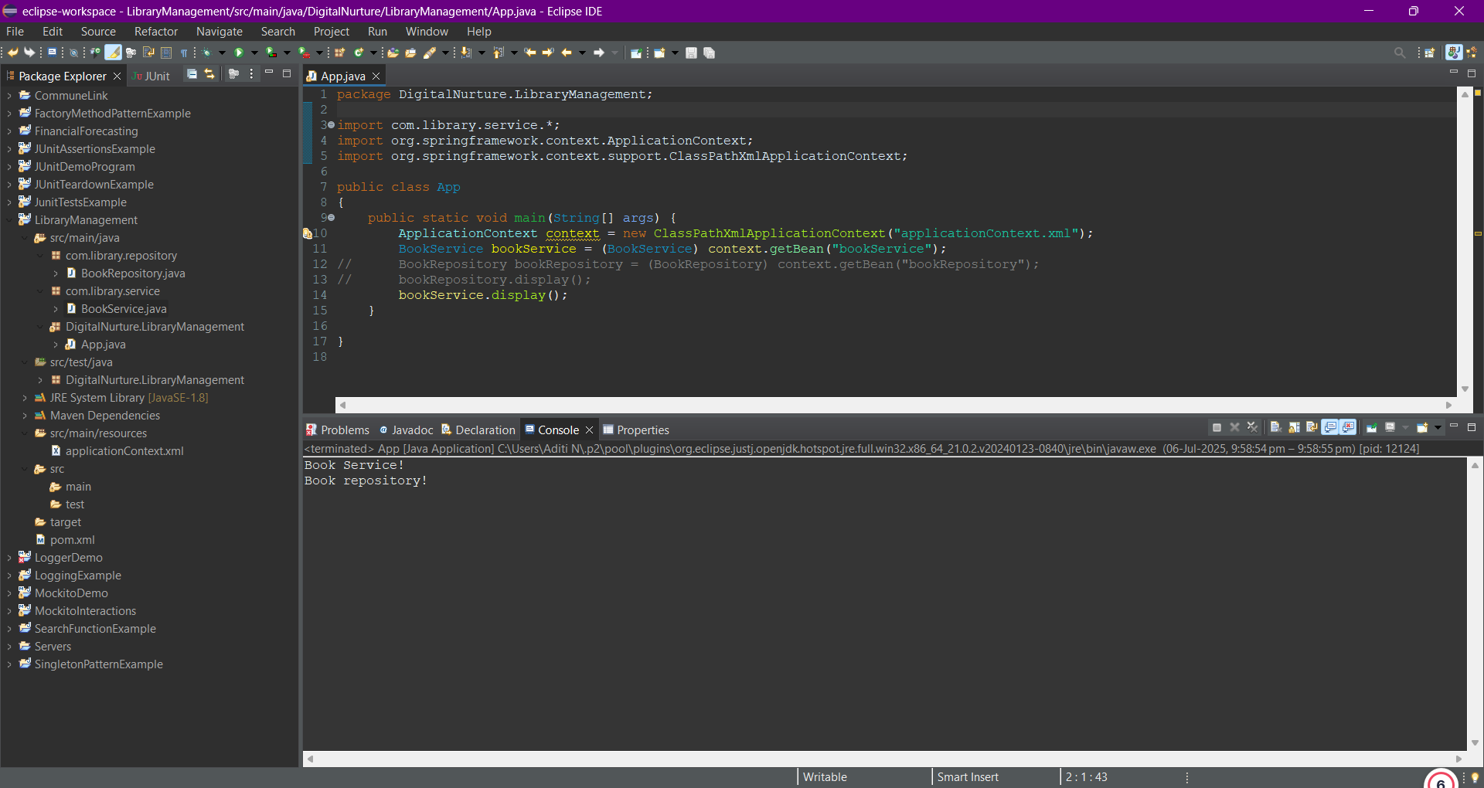

**Exercise - 2: Implementing Dependency Injection**

**Code:**

**Pom.xml**

**<project xmlns="http://maven.apache.org/POM/4.0.0"**

**xmlns:xsi="http://www.w3.org/2001/XMLSchema-instance"**

**xsi:schemaLocation="http://maven.apache.org/POM/4.0.0**

**http://maven.apache.org/xsd/maven-4.0.0.xsd">**

**<modelVersion>4.0.0</modelVersion>**

**<groupId>DigitalNurture</groupId>**

**<artifactId>LibraryManagement</artifactId>**

**<version>0.0.1-SNAPSHOT</version>**

**<packaging>jar</packaging>**

**<name>LibraryManagement</name>**

**<url>http://maven.apache.org</url>**

**<properties>**

**<project.build.sourceEncoding>UTF-8</project.build.sourceEncoding>**

**</properties>**

**<dependencies>**

**<dependency>**

**<groupId>org.springframework</groupId>**

**<artifactId>spring-context</artifactId>**

**<version>5.3.33</version>**

**</dependency>**

**<!-- Spring AOP -->**

**<dependency>**

**<groupId>org.springframework</groupId>**

**<artifactId>spring-aop</artifactId>**

**<version>5.3.33</version>**

**</dependency>**

**<!-- Spring Web MVC -->**

**<dependency>**

**<groupId>org.springframework</groupId>**

**<artifactId>spring-webmvc</artifactId>**

**<version>5.3.33</version>**

**</dependency>**

**</dependencies>**

**<build>**

**<plugins>**

**<!-- Maven Compiler Plugin for Java 1.8 -->**

**<plugin>**

**<groupId>org.apache.maven.plugins</groupId>**

**<artifactId>maven-compiler-plugin</artifactId>**

**<version>3.10.1</version>**

**<configuration>**

**<source>1.8</source>**

**<target>1.8</target>**

**</configuration>**

**</plugin>**

**</plugins>**

**</build>**

**</project>**

**com.library.repository.BookRepository.java**

**package com.library.repository;**

**public class BookRepository{**

**public void display() {**

**System.*out*.println("Book repository!");**

**}**

**public void saveBook(String bookName) {**

**System.*out*.println("Book '" + bookName + "' saved to the repository.");**

**}**

**}**

**com.library.main.App.java**

**package DigitalNurture.LibraryManagement;**

**import com.library.service.*;**

**import org.springframework.context.ApplicationContext;**

**import org.springframework.context.support.ClassPathXmlApplicationContext;**

**public class App**

**{**

**public static void main(String[] args) {**

**ApplicationContext context = new ClassPathXmlApplicationContext("applicationContext.xml");**

**BookService bookService = (BookService) context.getBean("bookService");**

**// BookRepository bookRepository = (BookRepository) context.getBean("bookRepository");**

**// bookRepository.display();**

**bookService.addBook("Algorithms and Data Structures");**

**}**

**}**

**com.library.service.BookService.java**

**package com.library.service;**

**import com.library.repository.*;**

**public class BookService{**

**private BookRepository bookRepository;**

**public void setBookRepository(BookRepository bookRepository) {**

**this.bookRepository = bookRepository;**

**}**

**public void display() {**

**System.*out*.println("Book Service!");**

**bookRepository.display();**

**}**

**public void addBook(String name) {**

**System.*out*.println("Adding book: " + name);**

**bookRepository.saveBook(name);**

**}**

**}**

**src/main/resources/applicationContext.xml**

**<?xml version=*"1.0"* encoding=*"UTF-8"*?>**

**<beans xmlns=*"http://www.springframework.org/schema/beans"***

**xmlns:xsi=*"http://www.w3.org/2001/XMLSchema-instance"***

**xsi:schemaLocation=*"***

***http://www.springframework.org/schema/beans***

***http://www.springframework.org/schema/beans/spring-beans.xsd"*>**

**<bean id=*"bookRepository"* class=*"com.library.repository.BookRepository"*/>**

**<bean id=*"bookService"* class=*"com.library.service.BookService"*>**

**<property name = *"bookRepository"* ref = *"bookRepository"*></property>**

**</bean>**

**</beans>**

**Output:**

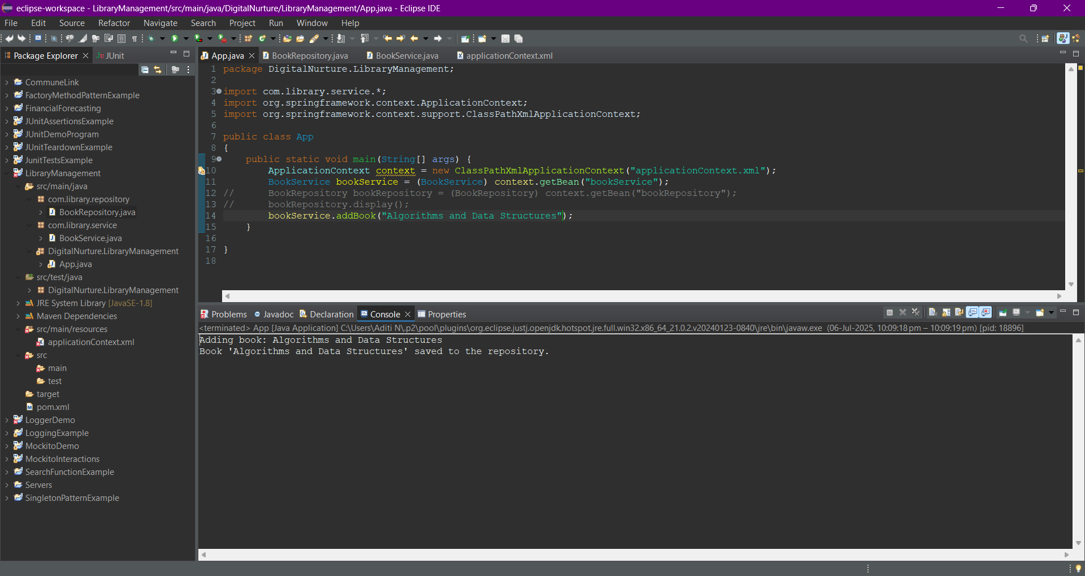

**Exercise - 4: Creating and Configuring a Maven Project**

**Code:**

**Pom.xml**

**<project xmlns="http://maven.apache.org/POM/4.0.0"**

**xmlns:xsi="http://www.w3.org/2001/XMLSchema-instance"**

**xsi:schemaLocation="http://maven.apache.org/POM/4.0.0**

**https://maven.apache.org/xsd/maven-4.0.0.xsd">**

**<modelVersion>4.0.0</modelVersion>**

**<groupId>com.library</groupId>**

**<artifactId>LibraryManagement</artifactId>**

**<version>1.0-SNAPSHOT</version>**

**<properties>**

**<maven.compiler.source>1.8</maven.compiler.source>**

**<maven.compiler.target>1.8</maven.compiler.target>**

**</properties>**

**<dependencies>**

**<!-- Spring Core and Context -->**

**<dependency>**

**<groupId>org.springframework</groupId>**

**<artifactId>spring-context</artifactId>**

**<version>5.3.34</version>**

**</dependency>**

**<!-- Spring AOP -->**

**<dependency>**

**<groupId>org.springframework</groupId>**

**<artifactId>spring-aop</artifactId>**

**<version>5.3.34</version>**

**</dependency>**

**<!-- Spring Web MVC -->**

**<dependency>**

**<groupId>org.springframework</groupId>**

**<artifactId>spring-webmvc</artifactId>**

**<version>5.3.34</version>**

**</dependency>**

**<!-- Servlet API (needed for Spring WebMVC) -->**

**<dependency>**

**<groupId>javax.servlet</groupId>**

**<artifactId>javax.servlet-api</artifactId>**

**<version>4.0.1</version>**

**<scope>provided</scope>**

**</dependency>**

**</dependencies>**

**<!-- Maven Compiler Plugin -->**

**<build>**

**<plugins>**

**<plugin>**

**<artifactId>maven-compiler-plugin</artifactId>**

**<version>3.8.1</version>**

**<configuration>**

**<release>8</release>**

**</configuration>**

**</plugin>**

**</plugins>**

**</build>**

**</project>**

**com.library.repository.BookRepository.java**

**package com.library.repository;**

**public class BookRepository{**

**public void display() {**

**System.*out*.println("Book repository!");**

**}**

**public void saveBook(String bookName) {**

**System.*out*.println("Book '" + bookName + "' saved to the repository.");**

**}**

**}**

**com.library.main.App.java**

**package com.library.main;**

**import org.springframework.context.support.ClassPathXmlApplicationContext;**

**import com.library.service.BookService;**

**public class App {**

**public static void main(String[] args) {**

**ClassPathXmlApplicationContext context = new ClassPathXmlApplicationContext("applicationContext.xml");**

**BookService bookService = context.getBean(BookService.class);**

**bookService.addBook("Test Book");**

**context.close();**

**}**

**}**

**com.library.service.BookService.java**

**package com.library.service;**

**import com.library.repository.*;**

**public class BookService{**

**private BookRepository bookRepository;**

**public void setBookRepository(BookRepository bookRepository) {**

**this.bookRepository = bookRepository;**

**}**

**public void display() {**

**System.*out*.println("Book Service!");**

**bookRepository.display();**

**}**

**public void addBook(String name) {**

**System.*out*.println("Adding book: " + name);**

**bookRepository.saveBook(name);**

**}**

**}**

**src/main/resources/applicationContext.xml**

**<?xml version=*"1.0"* encoding=*"UTF-8"*?>**

**<beans xmlns=*"http://www.springframework.org/schema/beans"***

**xmlns:xsi=*"http://www.w3.org/2001/XMLSchema-instance"***

**xsi:schemaLocation=*"***

***http://www.springframework.org/schema/beans***

***http://www.springframework.org/schema/beans/spring-beans.xsd"*>**

**<bean id=*"bookRepository"* class=*"com.library.repository.BookRepository"*/>**

**<bean id=*"bookService"* class=*"com.library.service.BookService"*>**

**<property name = *"bookRepository"* ref = *"bookRepository"*></property>**

**</bean>**

**</beans>**

**Output:**

