**Deep Skilling - Week 6 Mandatory Hands-on Exercises**

**Skill : React**

**Exercise - 1:**

**Code:**

[**App.js**](http://app.js)

**import './App.css';**

**function App() {**

**return (**

**<h1>Welcome to the first session of React</h1>**

**);**

**}**

**export default App;**

**Output:**

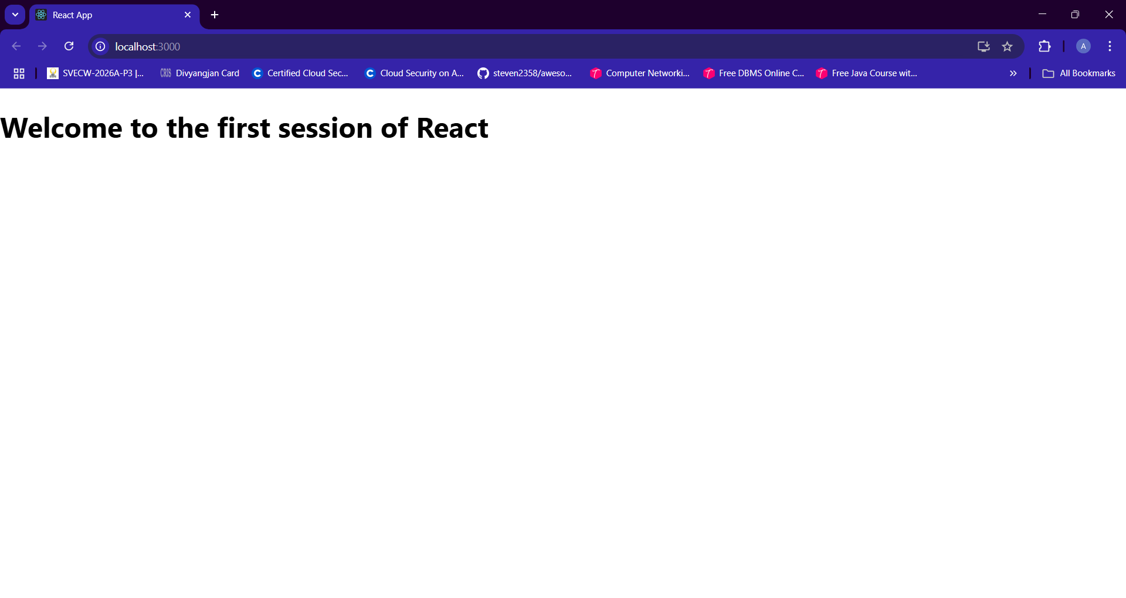

**Exercise - 2:**

**Code:**

[**App.js**](http://app.js)

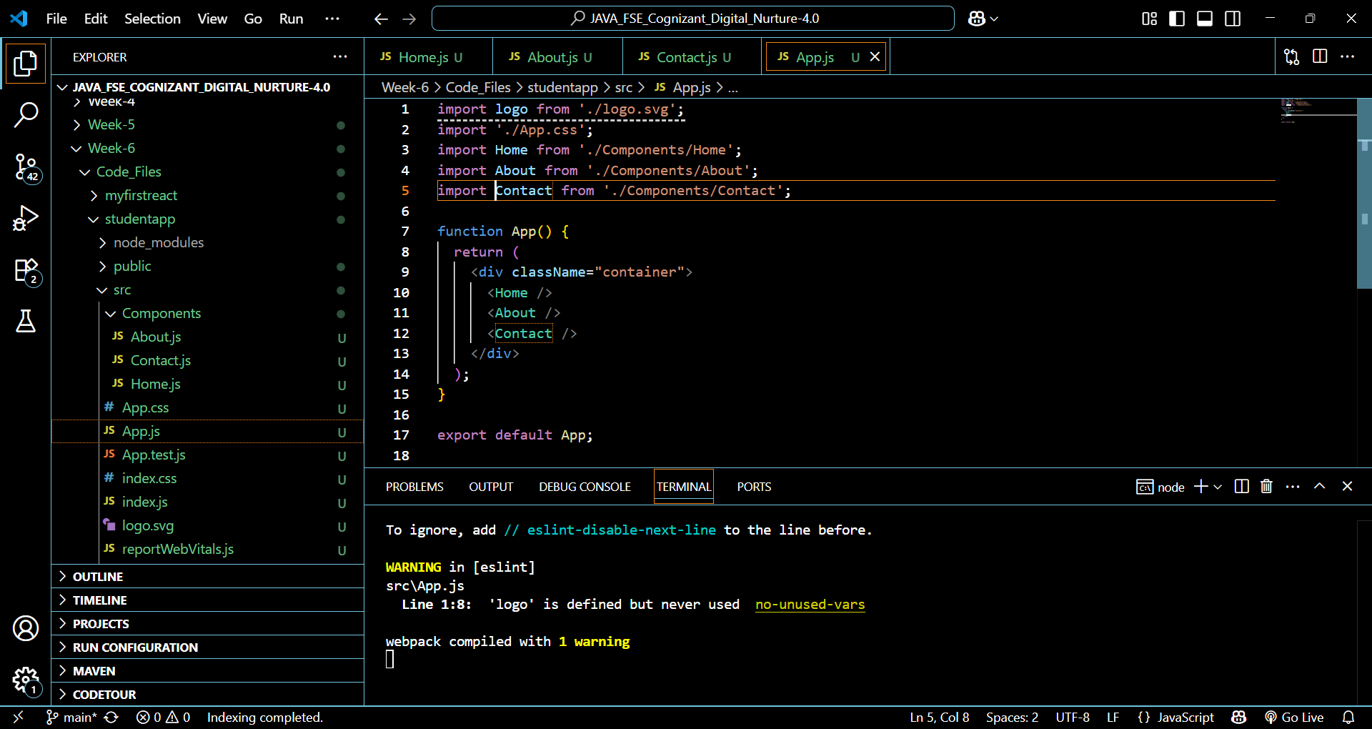

[**Home.js**](http://home.js)

**import React, { Component } from 'react';**

**class Home extends Component {**

**render() {**

**return (**

**<div>**

**<h1>Welcome to the Home Page of Student Management Portal</h1>**

**</div>**

**);**

**}**

**}**

**export default Home;**

[**Contact.js**](http://contact.js)

**import React, { Component } from 'react';**

**class Contact extends Component {**

**render() {**

**return (**

**<div>**

**<h1>Welcome to the Contact Page of Student Management Portal</h1>**

**</div>**

**);**

**}**

**}**

**export default Contact;**

[**About.js**](http://about.js)

**import React, { Component } from 'react';**

**class About extends Component {**

**render() {**

**return (**

**<div>**

**<h1>Welcome to the About Page of Student Management Portal</h1>**

**</div>**

**);**

**}**

**}**

**export default About;**

**Output:**

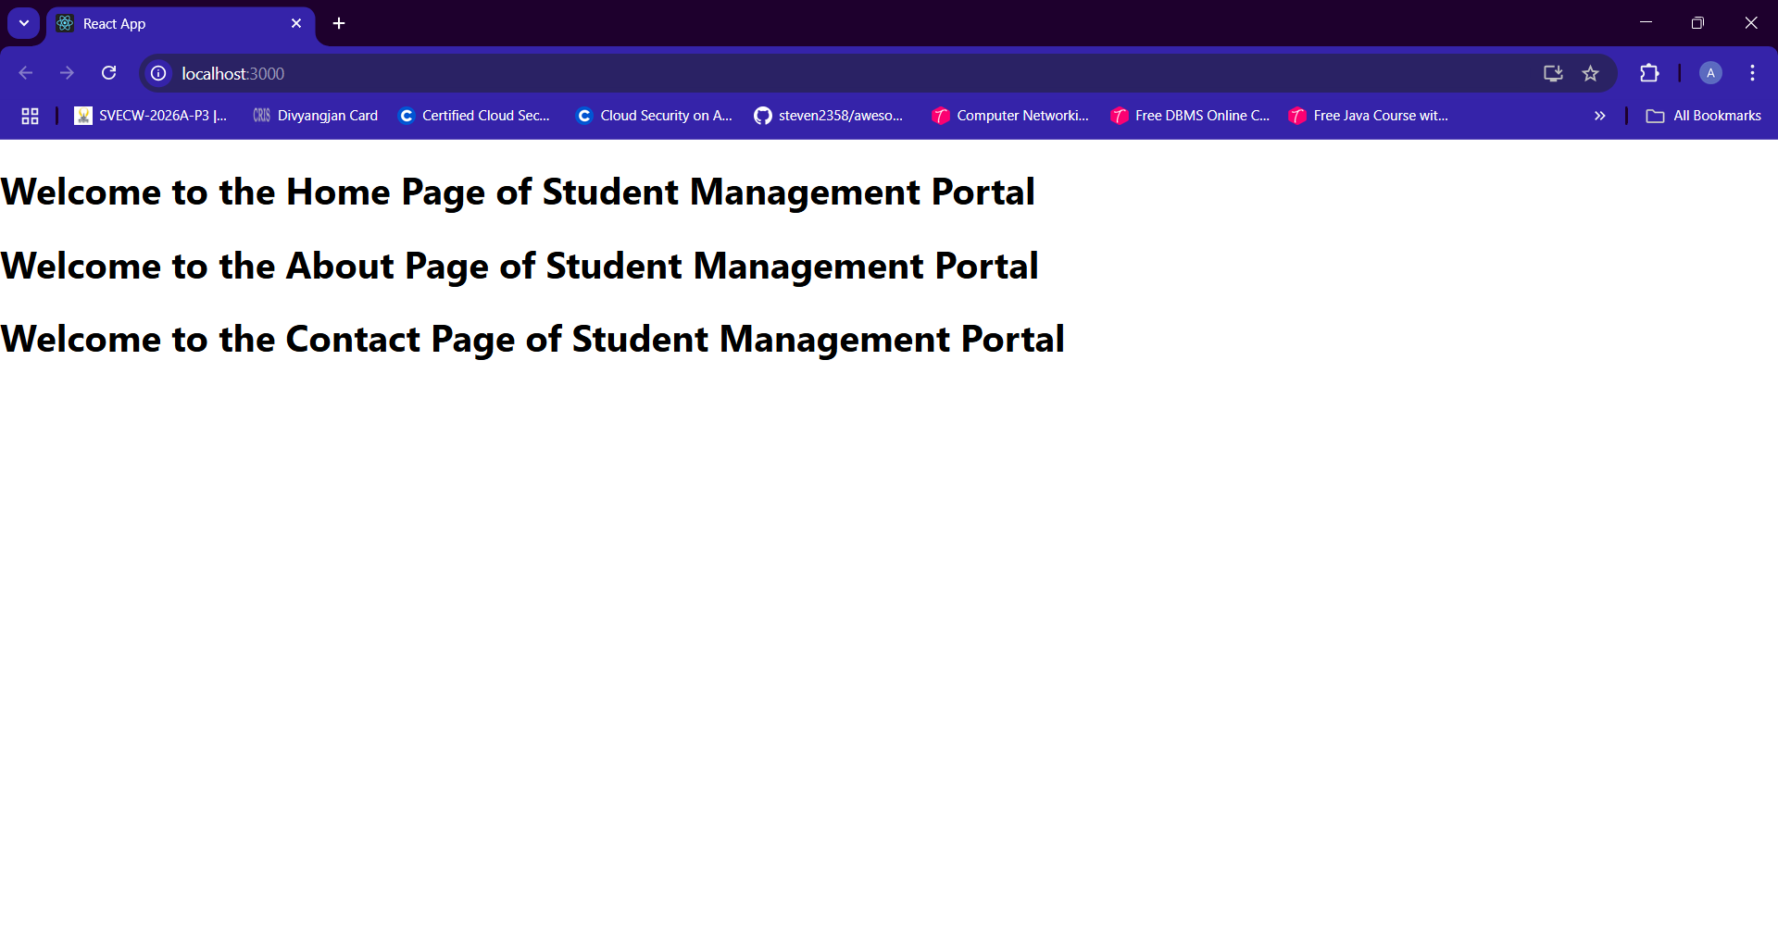

**Exercise - 3:**

**Code:**

[**App.js**](http://app.js)

**import { CalculateScore } from "./Components/CalculatorScore";**

**function App() {**

**return (**

**<div>**

**<CalculateScore**

**Name={"Nadupuru Aditi"}**

**School={"Shri Vishnu Engineering College for Women"}**

**total={284}**

**goal={3}**

**/>**

**</div>**

**);**

**}**

**export default App;**

[**CalculatorScore.js**](http://calaculatorscore.js)

**import '../Stylesheets/mystyle.css';**

**const percentToDecimal = (decimal) => {**

**return (decimal.toFixed(2) + '%');**

**}**

**const calcScore = (total, goal) => {**

**return percentToDecimal(total / goal);**

**}**

**export const CalculateScore = ({Name, School, total, goal}) => (**

**<div className="formatstyle">**

**<h1><font color="Brown">Student Details:</font></h1>**

**<div className="Name">**

**<b> <span> Name: </span> </b>**

**<span>{Name}</span>**

**</div>**

**<div className="School">**

**<b> <span> School: </span> </b>**

**<span>{School}</span>**

**</div>**

**<div className="Total">**

**<b><span>Total:</span> </b>**

**<span>{total}</span>**

**<span>Marks</span>**

**</div>**

**<div className="Score">**

**<b>Score:</b>**

**<span>**

**{calcScore( total, goal )}**

**</span>**

**</div>**

**</div>**

**);**

**mystyle.css**

**.Name{**

**font-weight: 300;**

**color: blue;**

**}**

**.School{**

**color: crimson;**

**}**

**.Total{**

**color: darkmagenta;**

**}**

**.formatstyle{**

**text-align: center;**

**font-size: large;**

**}**

**.Score{**

**color: forestgreen;**

**}**

**Output:**

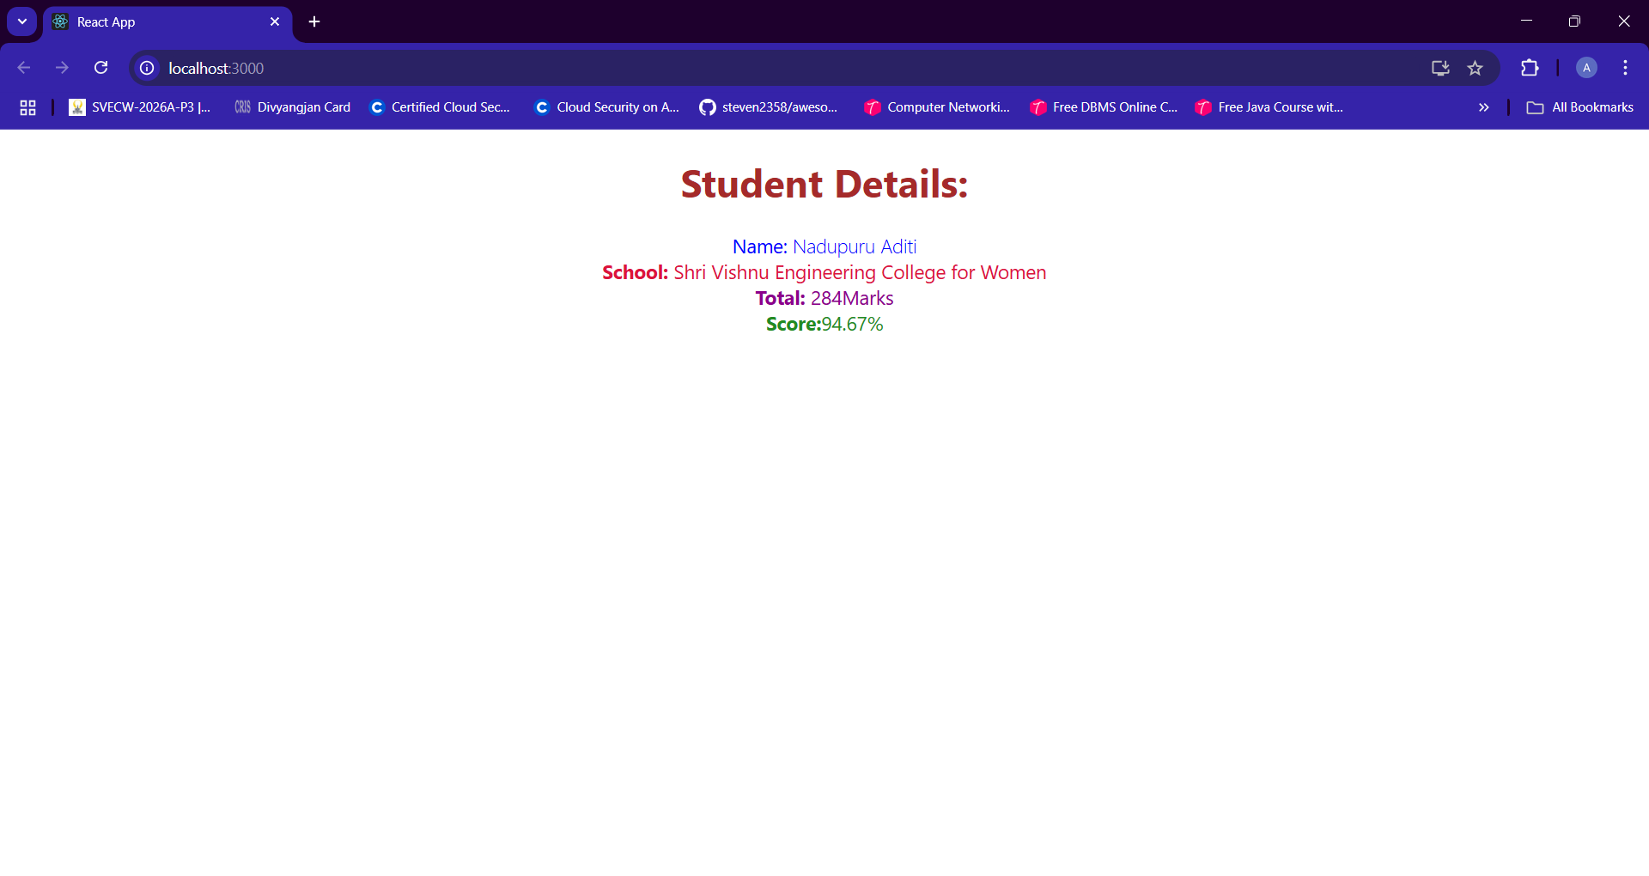

**Exercise - 4:**

**Code:**

[**App.js**](http://app.js)

**import React from 'react';**

**import Posts from './Posts';**

**function App() {**

**return (**

**<div className="App">**

**<Posts />**

**</div>**

**);**

**}**

**export default App;**

[**Post.js**](http://post.js)

**import React, { Component } from 'react';**

**class Post extends Component {**

**render() {**

**return (**

**<div style={{ border: '1px solid #ccc', marginBottom: '10px', padding: '10px' }}>**

**<h3>{this.props.title}</h3>**

**<p>{this.props.body}</p>**

**</div>**

**);**

**}**

**}**

**export default Post;**

[**Posts.js**](http://posts.js)

**import React, { Component } from 'react';**

**import Post from './Post';**

**class Posts extends Component {**

**constructor(props) {**

**super(props);**

**this.state = {**

**posts: [],**

**hasError: false,**

**errorMessage: ''**

**};**

**}**

**loadPosts = () => {**

**fetch('https://jsonplaceholder.typicode.com/posts')**

**.then((res) => res.json())**

**.then((data) => {**

**this.setState({ posts: data });**

**})**

**.catch((error) => {**

**this.setState({ hasError: true, errorMessage: error.toString() });**

**});**

**};**

**componentDidMount() {**

**this.loadPosts();**

**}**

**componentDidCatch(error, info) {**

**this.setState({ hasError: true, errorMessage: error.toString() });**

**alert(`Error occurred: ${error.toString()}`);**

**}**

**render() {**

**if (this.state.hasError) {**

**return <h2>Error: {this.state.errorMessage}</h2>;**

**}**

**return (**

**<div>**

**<h1 style={{ textAlign: 'center' }}>Blog Posts</h1>**

**{this.state.posts.map((post) => (**

**<Post key={post.id} title={post.title} body={post.body} />**

**))}**

**</div>**

**);**

**}**

**}**

**export default Posts;**

**Output:**

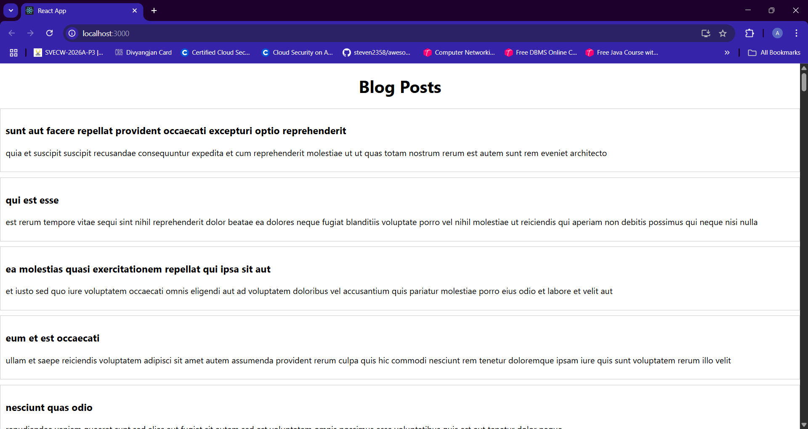

**Exercise - 5:**

**Code:**

[**App.js**](http://app.js)

**import './App.css';**

**import { CohortsData} from './Cohort'**

**import CohortDetails from './CohortDetails';**

**function App() {**

**return (**

**<div>**

**<h1>Cohorts Details</h1>**

**{CohortsData.map(cohort => <CohortDetails cohort={cohort}/>)}**

**</div>**

**);**

**}**

**export default App;**

[**CohortDetails.js**](http://cohortdetail.js)

**import styles from './CohortDetails.module.css';**

**function CohortDetails(props) {**

**const { cohort } = props;**

**const headingStyle = {**

**color: cohort.currentStatus === 'Ongoing' ? 'green' : 'blue'**

**};**

**return (**

**<div className={styles.box}>**

**<h3 style={headingStyle}>**

**{cohort.cohortCode} - <span>{cohort.technology}</span>**

**</h3>**

**<dl>**

**<dt>Started On</dt>**

**<dd>{cohort.startDate}</dd>**

**<dt>Current Status</dt>**

**<dd>{cohort.currentStatus}</dd>**

**<dt>Coach</dt>**

**<dd>{cohort.coachName}</dd>**

**<dt>Trainer</dt>**

**<dd>{cohort.trainerName}</dd>**

**</dl>**

**</div>**

**);**

**}**

**export default CohortDetails;**

**CohortDetails.module.css**

**.box {**

**width: 300px;**

**display: inline-block;**

**margin: 10px;**

**padding: 10px 20px;**

**border: 1px solid black;**

**border-radius: 10px;**

**}**

**dt {**

**font-weight: 500;**

**}**

**Output:**

