

|  |  |
| --- | --- |
| **Web technologies | Front-End** | |
| Student(s’) name(s): | Nadiya Kadyrzhan |
| Teacher name: | Zhandos Seraliyev |
| Project name: | Macbook |
| Project type: | Group / Individual |

**INTRODUCTION**

This project about Macbook. There are features, types and prices of Macbook in my project.

**MAIN PART (Practical) | Information about developers and their responsibilities.**

This project was done by myself. In this project I used Bootstrap Buttons, Navigation bar, Containers, Grid layout system and title section, feature section and testimonials section in the main page.

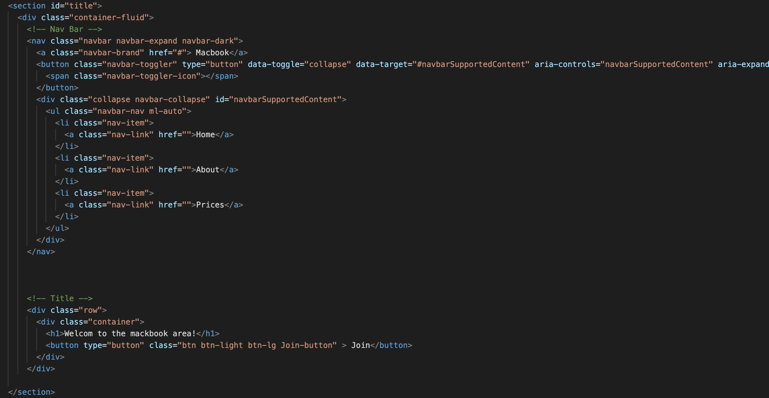

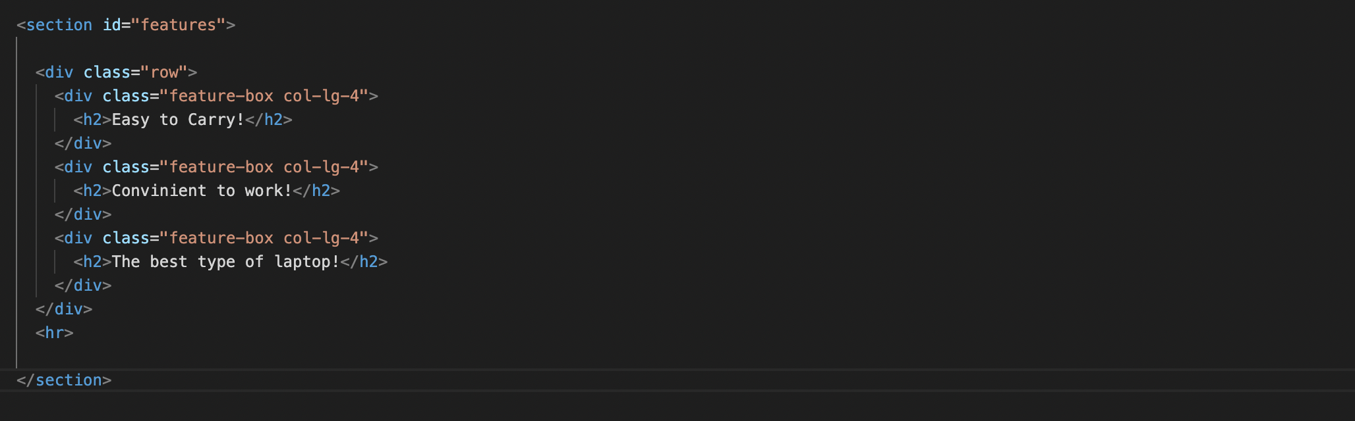

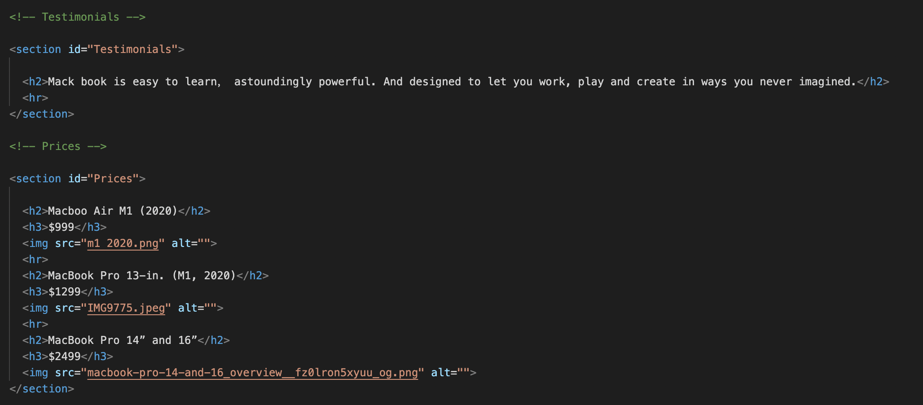

And also I made the wireframe.

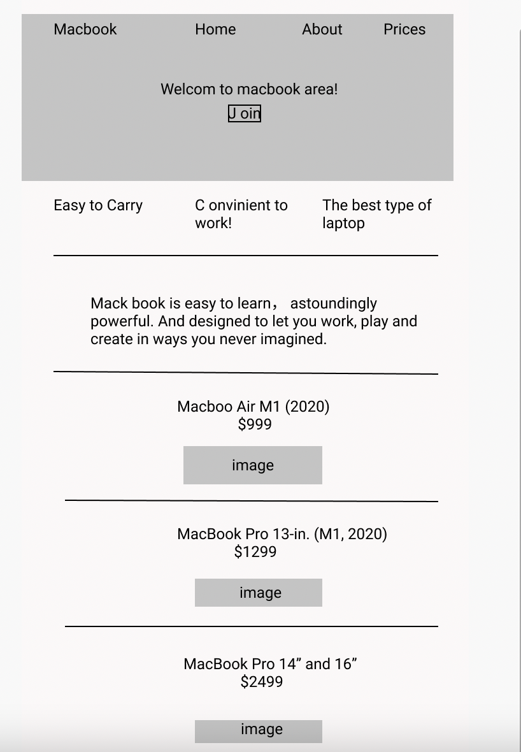

**PROGRESS [optional]**

|  |  |
| --- | --- |
| 11.01.2022 | I choose the tittle of my project. |
| 12.01.2022 | I made a wireframe. |
| 13.01.2022 | I started coding the html and bootstrap part. |
| 15.01.2022 | I coded CSS. |
| 16.01.2022 | I finished my project. |