A24 COM QuickTimeEntry Requirements

|  |  |  |
| --- | --- | --- |
| Responsible | nadjbabi@anywhere24.com | |
| Created date | 26.07.2016 | |
| Updated date | 01.08.2016 13:38 | |
| Status | X | Draft |
|  |  |
|  | Freigegeben (Version ≥ 1.00) |

Index

1. General 3

2. Requirements 5

1.1 Installer 5

1.2 Multilanguage support 5

# General

QuickTimeEntry is a windows application, connected to Microsoft Dynamics CRM, that provides the ability to record time entries based on existing opportunities, projects or other entities online or offline.

If you start the application the first time, a connection window will appear, where you have to type in the CRM connection data.

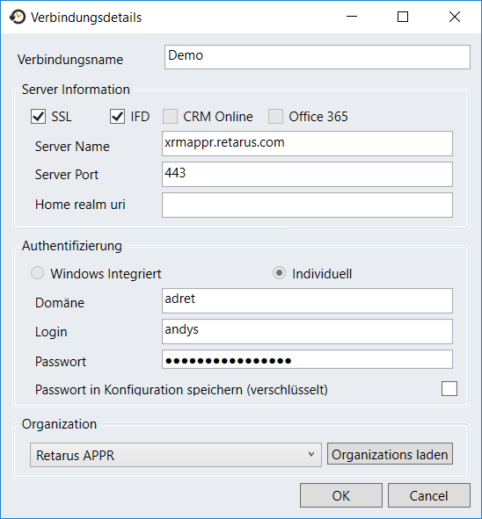

After typing in these information and clicking on OK, the main screen appears, where you are able to create, modify and view time entries. The window is divided into a command bar on the top, the list view in the middle and a status bar at the bottom.

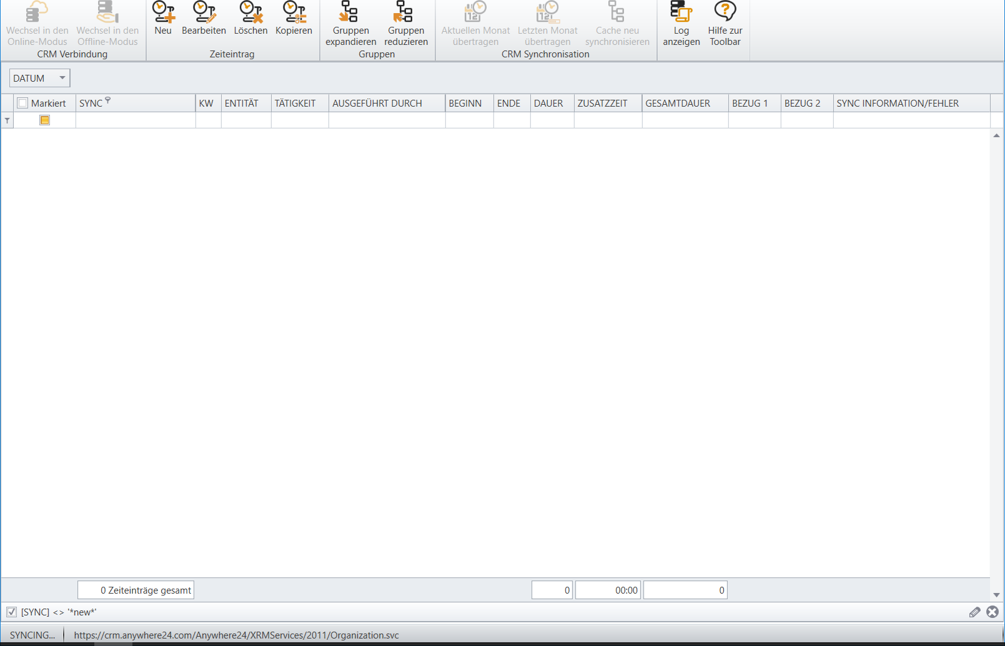

Clicking on “New” (“Neu”) will open a new time entry record that looks like that.

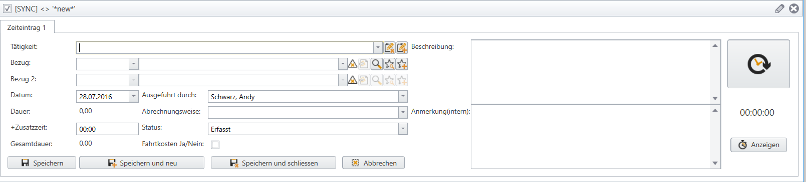

Here you can enter your time record, save and close it. After a few seconds, the record gets synchronized.

Beside the possibility to type in the needed time, you can also use the button on the upper right to start tracking the work. Clicking the button again will stop the track and the time entry can be saved.

# Requirements

## Installer

The installer should provide the possibility to install the application on a client windows system. Either by using an UI or automated via console. Within the wizard, the initial crm connection configuration should be configurable.

The installation package is intended to be used in software distribution scenarios.

## Multilanguage support

Currently the solution is hardcoded in german language, All labels of the application should be changed to be localizable. The language must be selectable within the application, therefore please provide a “Settings” button with a new window where the user can select the desired language. EN and DE in the first phase. Translations take place on our site, because the current base language is German. A restart of the application after language change should not happen, because of possibly cached data. The following screenshots will give you a sneek preview on the potential labels in the application.

