Technology Used:-
Server Technology
Database | Programming Language | Java Framework | Java Message Service | ORM
MySQL | JAVA | Spring Mvc |  | sql
 |  | Spring Boot

Client Technology (Web)
Markup Language | Scripting Language | Scripting Framework
HTML | CSS | Jquery
 | JavaScript

Onboarding Api For Card Account Creation:-

JspFile Name:- createCreditCardCustomerAccount.jsp
Table Name :- customer_details/customer_address/customer_contact/customer_document/customer_email

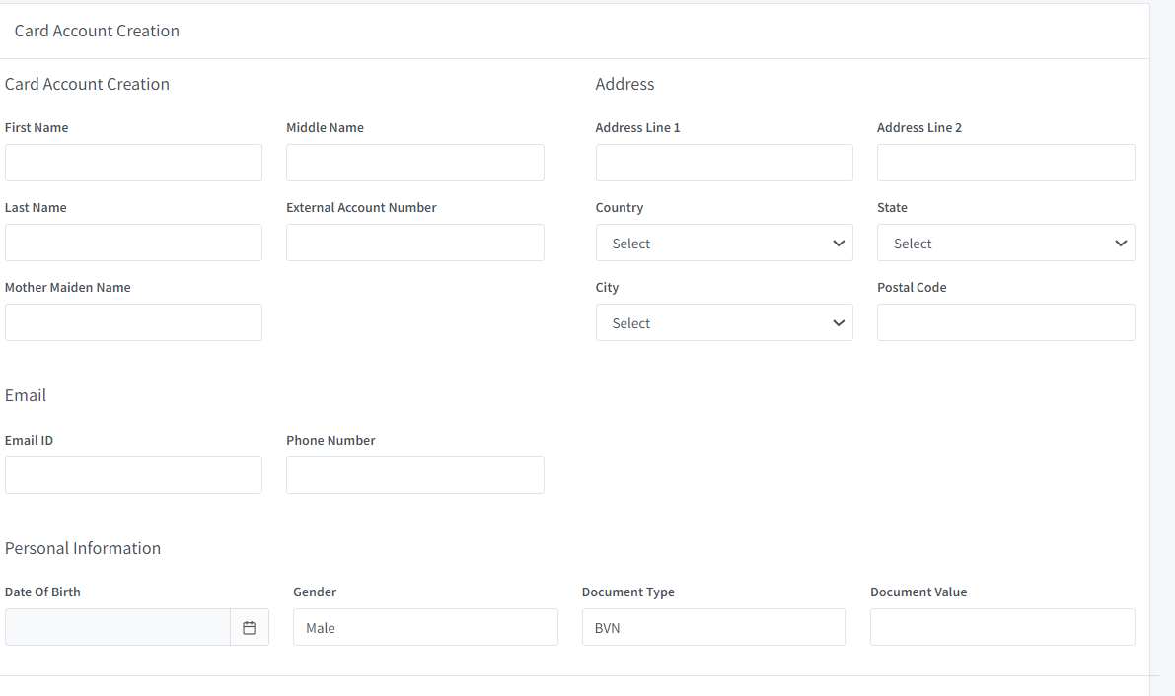

Package Name :- package com.traneco.service.controller;
File Name :- ServiceController.java
Method Name :-public String generateCardAccount(Model model, CreditCardCustomerAccountCreationModel creditCardCustomerAccountCreation)

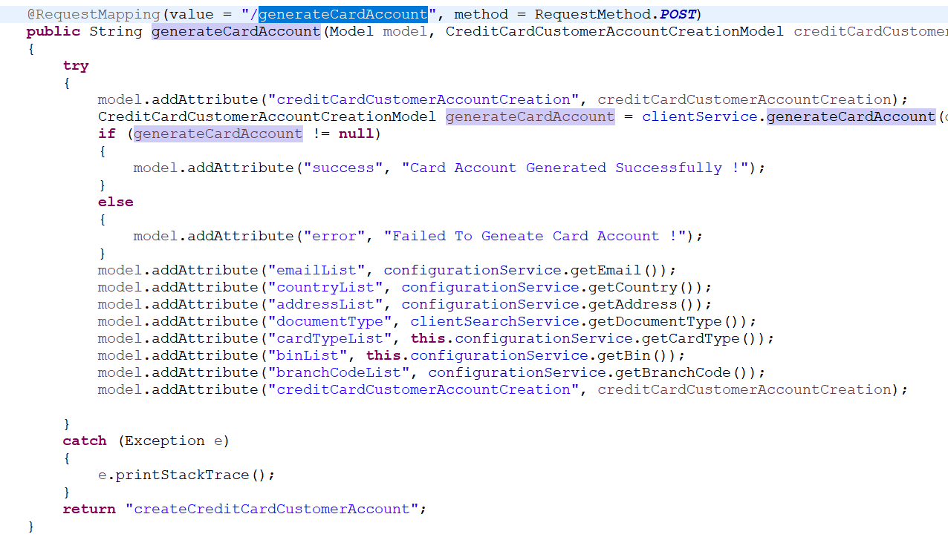

CMS Service Calling VIA CMS (For Generating Card)

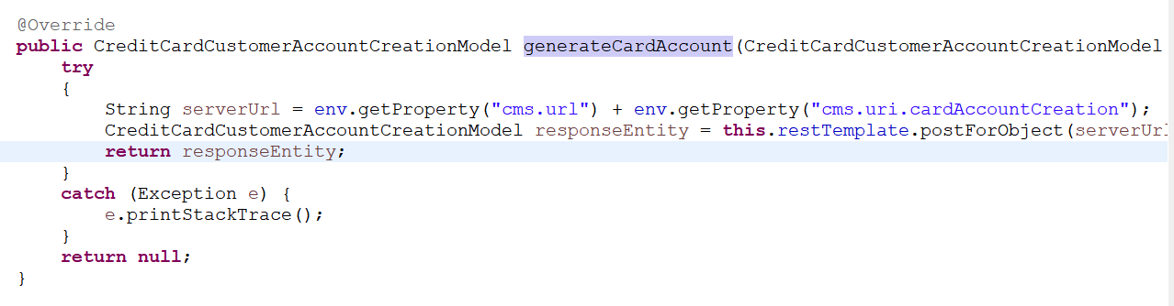

File Name :- config.properties

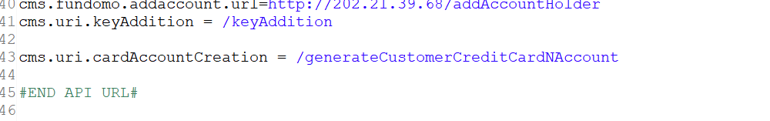

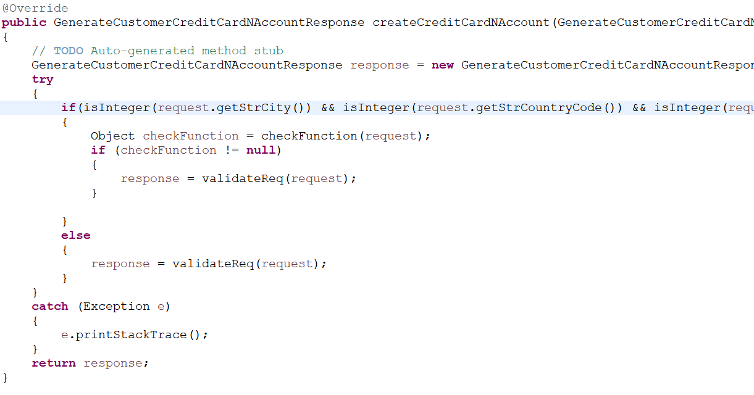

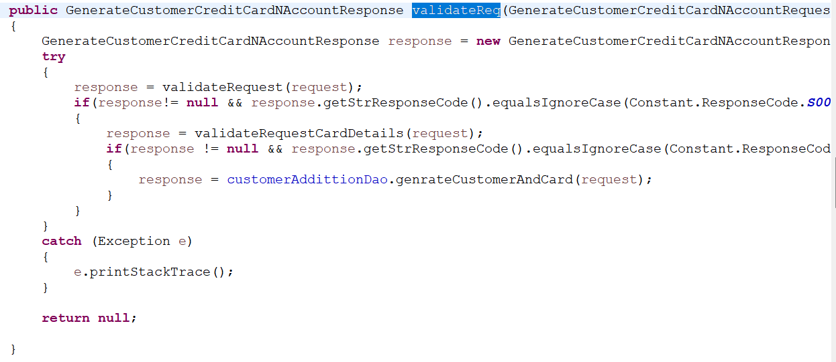

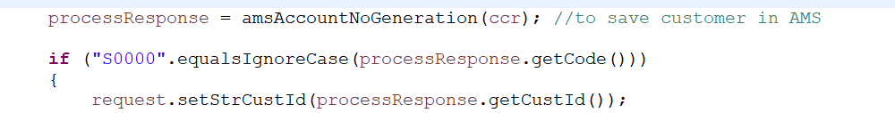

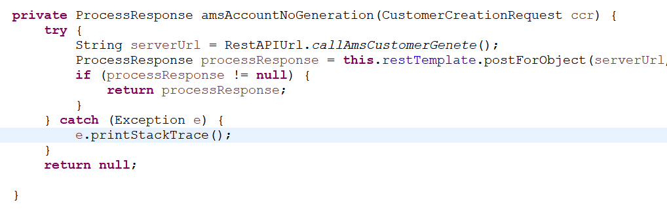

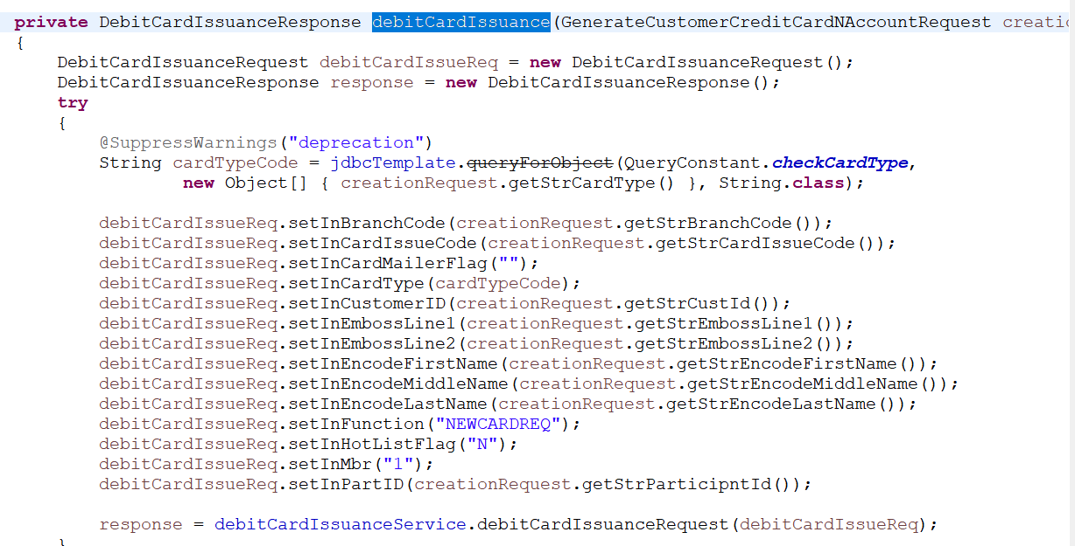

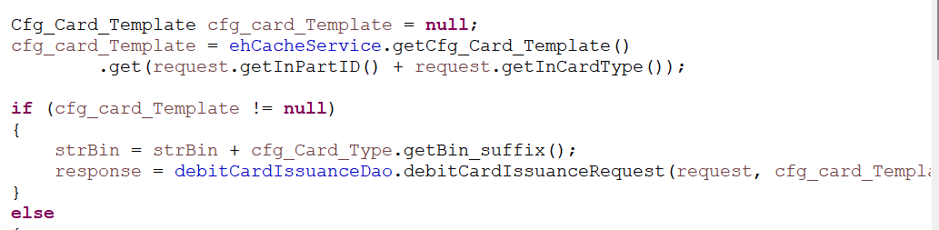

Table Mapping:- card_details/card_plastic_details/card_token
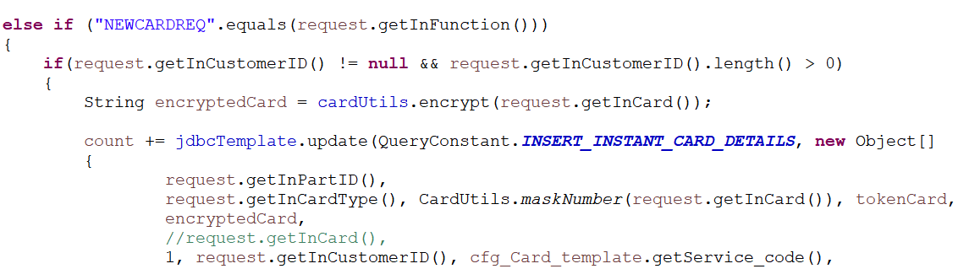

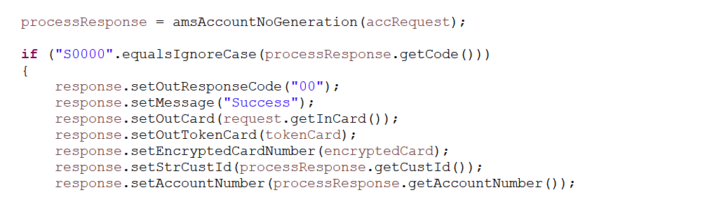

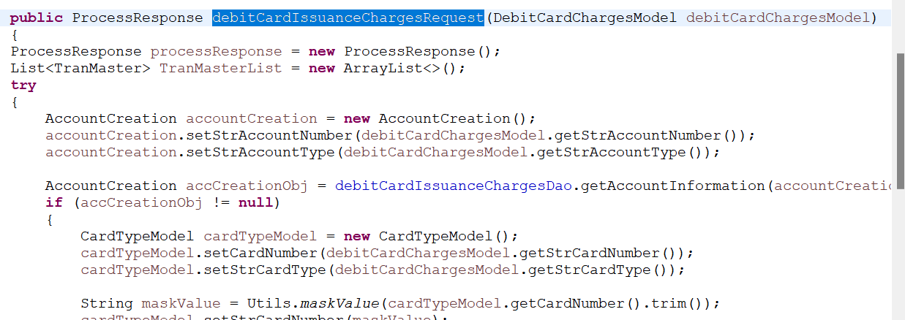

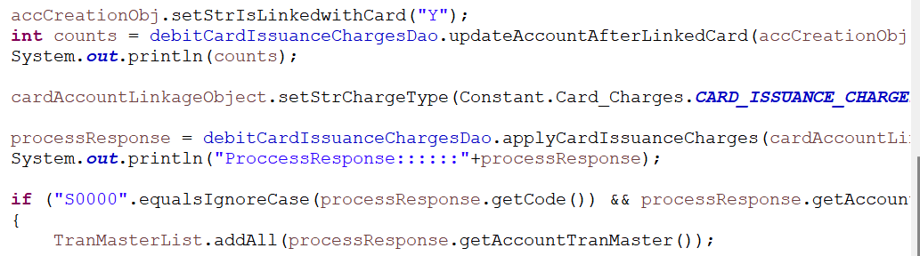

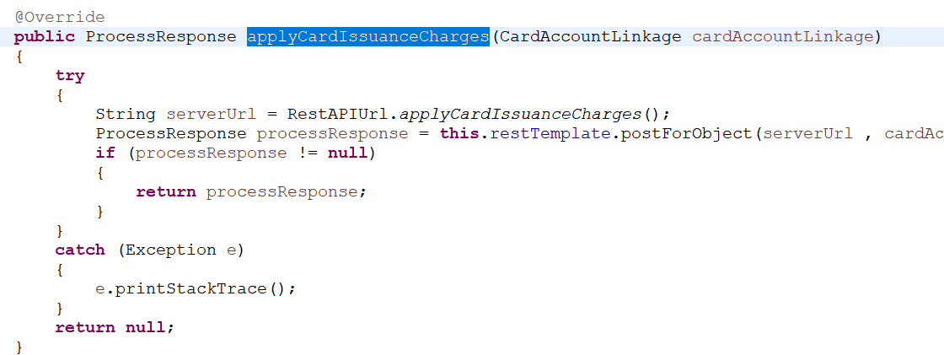

Request For API:-

http://10.11.153.212:8445/CardManagementAPI/generateCustomerCreditCardNAccount

{
"strFirstName": "Pramod",
"strMiddleName": ".",
"strLastName": "Shirke",
"strExtAccount": "0770370166",
"strAddress1": "Mulund West",
"strAddress2": "Neat Station",
"strAddress3": "",
"strCity": "MUMBAI",
"strState": "MAHARASHTRA",
"strCountryCode": "INDIA",
"strPinCode": "400042",
"strPhoneNo": "7777777777",
"strEmailID": "pshirke@sequrotechnologies.com",
"strDOB": "1995/10/23",
"strGender": "M",
"strMotherMaidenName": "",
"strDocumentType": "PAN",
"strDocumentNumber": "AVWPT3602J",
"strBranchCode": "33333",
"strCardIssueCode": "V",
"strCardType": "MONTR",
"strEmbossLine1": "PRAMOD",
"strEmbossLine2": "",
"strEncodeFirstName": "Pramod",
"strEncodeMiddleName": ".",
"strEncodeLastName": "Shirke",
"strFunction": "NEWCARDREQ",
"strCardBIN": "666666",
"strBVN": "1234",
"debitAccount": "566532211",
"bankCustomerID": "867666",
"institutionID": "161661",
"requestId": "100017"
}

