Kiran Nadkarni

Collaborators: Dominic Zacharewski, Tedros Beyan

10/24/18

ECE2001-002L

Microphone Speaker Mixer Design Project

**Abstract:**

In this experiment we are building an operational amplifier circuit that combines the voltages of a microphone and auxiliary input, and puts them through a speaker, with potentiometers used as volume controls. Our main hurdle in this experiment will be to find values for resistors in this circuit, which we can do with Ohm’s Law, Kirchhoff’s Voltage and Current Laws, and also the Rules of Operational Amplifiers which we have recently learned. Our results show that our circuit does work based on the qualitative observation of it working and the quantitatively calculated max gain of both parts of the circuit being 3.12dB and .12dB for the Music Channel and the Microphone Channel respectively. For recommendations for further work, I would suggest conducting similar experiments with a better-quality speaker and microphone to see if that can provide some leniency with the calculations necessary for finding proper resistor values, and even make a circuit like this usable for the real world, since it is essentially the basis of a PA system or even a Karaoke machine.

**Introduction:**

This experiment is based on the principles of Ohm’s Law, Kirchhoff’s Laws, and the conventions for measuring voltage, current, and resistance in Operational Amplifier circuits, since that is what we are working with. Our basic objective in this experiment is to create an op amp circuit using cascaded op amps, resistors, and potentiometers to connect a computer aux port and microphone to a speaker to create a mixer of sorts. Once we create our circuit and make sure it works under normal conditions, we want to perform a series of tests on it using the function generator and oscilloscope. We are going to see how these wave-based pieces of equipment are able to help us find gain related values from our circuit that we have tested with AC and DC voltages up until now.

**Theory:**

As previously mentioned, there are a few relevant laws and theories to the design of our circuit. The core of our circuit design relies on the properties of Ohm’s Law and Kirchhoff’s Voltage and Current Laws. We have worked extensively with these laws, but Ohm’s Law states that voltage divided by resistance in a circuit is equal to the current. KVL states that the sum of the voltages in a circuit through any loop is always equal to zero. KCL states that the sum of currents in any single node in a circuit will also equal zero. We are also using basic properties of Op Amps in our design to decide what the values of the resistors in our circuit will be. Our circuit was required to take an input voltage of 1V from the computer and 0.01V from the microphone we had. We then had to amplify the microphone voltage through the use of an inverting amplifier, because it was so much smaller than the computers, and put them both through a variable gain summing amplifier to combine the voltages in one amplifier, but still allowing them both to control their volume through the use of a pair of potentiometers.

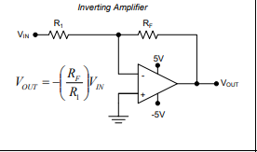

Figure 1: This is the diagram of the generic form of an inverting amplifier and the equation to calculate its output voltage.

The equation of Figure 1 is how we are going to calculate the voltage going into the second op amp in our circuit, since we are given Vin­. We also want to make sure that neither of the op amps we are working with reach saturation, because that could stop our speaker from working.

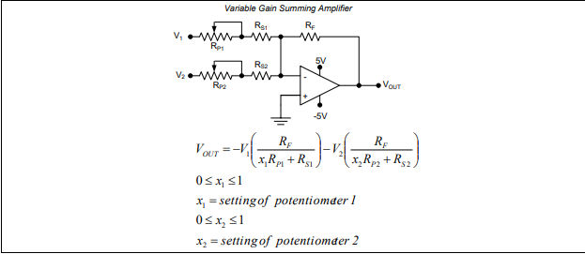

Figure 2: This is a diagram of the variable gain summing amplifiers we used, with Rp standing for the value of resistance for the potentiometer, since it changes based on where the white knob is rotated.

The equation of Figure 2 is a bit more complicated because it involves the position of the potentiometers, but for the purposes of just setting up the circuit, we can match the resistor values in the equation to the resistor values on the circuit itself. X represents the setting of the potentiometer, and we can assume it is set to 1 for the purposes of calculating resistor values because that would represent the maximum value of the volume of the speaker.

**Design:**

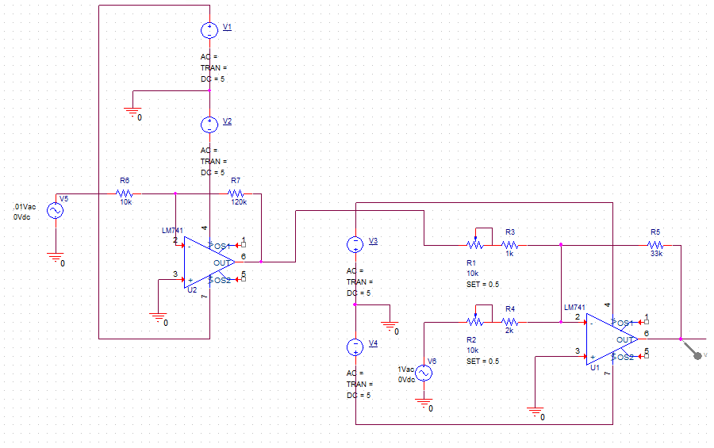Figure 3: This is the diagram of the design we came up with for our circuit. This is what the circuit looked like after all of the resistor values had been written in. It is essentially a combination of the previous two figures with those values and the values for all of the voltages put in place. Also take note of the two sets of two 5V and -5V saturation voltage inputs. If the op amp gets saturated (which it will not in these experiments) these are the values Vout would become.

Our initial constraints for this circuit said that we could not have resistors less than 1KΩ or greater than 1MΩ in our circuit because it would mess with the voltage values and the quality of our speaker’s sound. Knowing this, we did not directly create equations to calculate the values of these resistors, but we created an equation to look for the final voltage we wanted coming out of the circuit. We did this using the principle of gain. We found that the gain between the microphone and speaker was 2/3 from a previous lab, and we realized that because we had to deliver 350mW of power to our 8Ω speaker, we were going to have to set up a proportion to calculate the voltage we wanted. We set it up as 2/3 = 1.6/V, where V ended up being 2.4V, which is what we then looked for as our output voltage in the circuit.

The next step is to put in resistor values into the circuit that would give us the desired output of 2.4V when we have our given inputs of 0.01V from the microphone and 1V from the computer. We start with the first op amp and model the equation using the model shown in Figure 1 and a model shown in lecture as a guide.

(V1 – Vin)/R1 + (V1 – Vout)/R2 = 0, where V1 is the value of the voltage through the first node of the first circuit. We want V1 to be 0 here to make our calculations easier, so our first equation becomes -Vin/R1 + -Vout/R2 = 0. We then set R1 = 10KΩ and R2 = 120KΩ because they seemed like reasonable values to get a Vout that is less than 1V. Once we include the microphone voltage as Vin we get the equation

-0.01V/10KΩ + Vout/120KΩ = 0, where Vout = 0.12V

Now we can move on to our second Op Amp, where we this time use our equation for a summing amplifier. We already know the Vout we want of 2.4V, and we are putting 1V in from the computer in one input and .12V in from the previous Op Amp.

Our equation is now:

Vout = -V1(RF/(RP1 + RS1) – V2(RF/(RP2 + RS2)

Where RP1 and RS1 are the resistance of the potentiometer and the resistor in series with that potentiometer respectively, both for the microphone input voltage. RP2 andRS2 are the same type of values, just only for the computer input voltage. For this part, we assigned the resistor values of RF = 33KΩ, RP1 = RP2 = 10KΩ, RS1 = 1KΩ, RS2 = 2KΩ.

Once all of the values have been plugged into the equation, it becomes,

.12V(33KΩ/11KΩ) – 1V(33KΩ/12KΩ) = -2.39V = VOUT. This answer is within 1% of the target VOUT value of 2.4V, which makes this circuit work theoretically.

All of the resistors used here have a tolerance of ±5% because they are gold band resistors, which does translate into the model being fairly accurate.

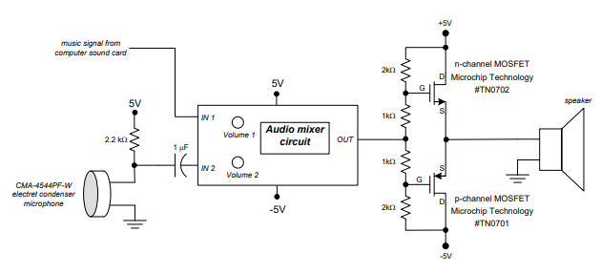

Figure 4: This is a diagram of the surroundings of the mixer circuit, including the music input form the computer, the microphone input, and the final product output of the speaker. Both the speaker and microphones are grounded.

An important thing to note in Figure 4 is the 5V input into the microphone and over the 2.2KΩ resistor, as well as the array resistors displayed with the two MOSFET and the 5V and -5V saturation inputs leading from the output of the audio mixer circuit to the input of the speaker.

**Experimental:**

Now that we have the circuit built, we want to experimentally test it and get some information from it. Now is the time we use our Oscilloscope and Function Generator to input sinusoidal waves on the circuit.

For our first experiment, we want to find the range of adjustable gain for both the microphone and the computer sound card inputs. To measure the gain of the microphone input, we are going to ground the sound card input, and use the function generator to input a 2kHz sinusoid into the microphone, which should give us two different VOUT values depending on whether our potentiometer is set to 0 or 1, but a consistent VIN value. We can then calculate the gain from this, which will be elaborated on in the discussion of results.

The second experiment follows the exact same logic as the first, but instead of grounding the sound card and measuring the microphone, we are measuring the sound card and grounding the microphone. We are also keeping it consistent and using a 2kHz sinusoid on the soundcard as well.

For the third experiment, we want to measure and plot the frequency response for the music channel. This is essentially the gain vs frequency and the phase shift vs frequency plots, which we should have all the data for because we just took the range of the gain. We want to look at the graph and data table and try to look for any cutoff frequencies where the gain is not affected by the frequency change much, but we can match the phase shift to that same frequency because we have the plot of it as well.

The fourth experiment is virtually the same as the third, but we are grounding the music channel and measuring and plotting the frequency response for the microphone. This would lead us to create the same graph of gain vs frequency and phase shift vs frequency, which we also should have also the data for because we already took the range. We should also do all of the previous work from experiment three’s cutoff frequency investigation with experiment four.

Lastly, we try to play some music on the circuit, to see if the music is audible, which will be a true test of if this circuit works or not. No diagrams are really necessary for this section of the report because we have worked with all of this equipment previously and setting up the equipment should be the same way the it has been set up in the previous diagrams.

**Results and Discussion:**

Table 1: These are all the tabulated values from Experiment 1 through 4, organized from top to bottom.



Table 2: This is the tabulated values of the gain from PSpice with the same values of frequency as experiment 3 and 4

The results for the first experiment show that there is an adjustable maximum gain of 7.56dB and an adjustable minimum gain of 3.05dB. This is computed by dividing the VOUT by VIN at that specific location for the potentiometer.

The second experiment also had data similar to this. The adjustable maximum gain was 108.33dB and the adjustable minimum gain was 10dB. This was calculated the same way as the previous experiment, but just using the microphone instead of the music channel.

The results for the third experiment we plotted the data from Table 1 in Graphs 1 and 2. Our data did have a cutoff value in both the bottom and the top of the data. The bottom cutoff occurred at 200Hz because the value of gain did not change from 100 to 200 Hz, and the top cutoff occurred at 5000 Hz. The phase shift at the bottom cutoff is -178.56 degrees and the top cutoff would be at -3.6 degrees. Although we have faith in our answers for the gain at that specific frequency, we do not have as much faith in the graph of our Phase shift. We realized that despite the graph of gain looking similar to its PSpice counterpart, the graph of phase does not look like the PSpice graph that we had for phase. Our phase graphs had points plotted at somewhat random points and this might be attributed to the calculations resulting from the bad quality in sound of our circuit and speaker.

The results for the fourth experiment were also similar to the third, and we plotted the data from Table 1 in Graphs 3 and 4 for this experiment. Our data did not seem to have a cutoff value for the bottom but at the top of our observed data there was one. The cutoff value seemed to be at 10000Hz because the gain dropped after that point, and the phase at that point was also at 0 degrees. We do not have that much confidence in the phase graph for this part of the experiment too however, because it is not in the same exponential form as the model shows. This can be attributed to the same error that we mentioned in the previous experiment.

There weren’t resistive tolerances that we had to consider in these experiments because our circuit did work qualitatively, but we did previously address the error and potential sources of error that were shown in our graphs of phase specifically.

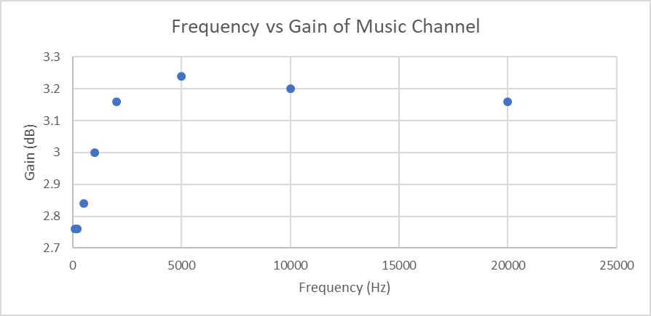

Graph 1: This is the graph of Frequency vs Gain for the Music Channel with a noticeable standstill in the first point and drop in the second two points.

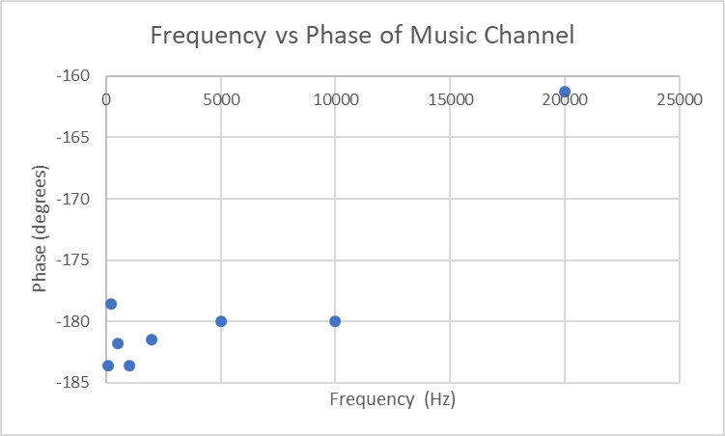

Graph 2: This is the graph of the Frequency vs Phase shift of the Music Channel

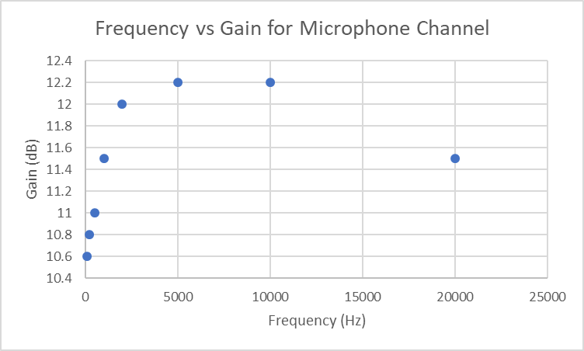

Graph 3: This is the graph of the Frequency vs Gain for the Microphone Channel, with a noticeable drop off in the second two points.

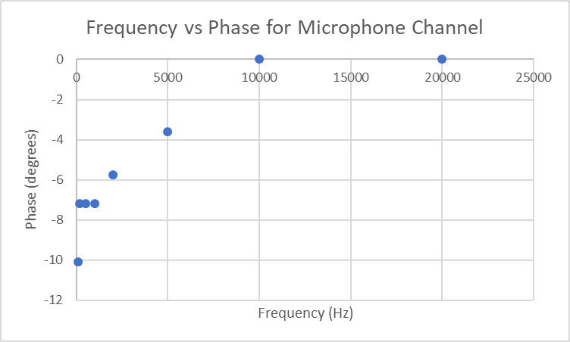

Graph 4: This is the graph of the Frequency vs the Phase shift for the Microphone channel.

It should be noted that for all of our graphs 1-4, the last two points were removed for clarity for the rest of the points, as with all ten points on the line, the 8 leftmost points were very bunched up because of the accelerated x axis logarithmic scale for frequency.

**Conclusion:**

In this experiment, we created and tested an op amp circuit with an audio jack input, a microphone, and a speaker by using the concepts of Ohm’s Law, KCL, and KVL. We also used physical components of the lab such as the Function Generator, the Digital Multimeter, and the Oscilloscope to measure DC Currents and waves that we input into the circuit using the Oscilloscope. We would say that we did achieve the goal we set out for, because we proved that our op amp circuit would work, even if some of the graphical elements do not support that, the qualitative observations that we made of our circuit working do support that idea. We did find that our circuit worked in the end, and despite the lack of clarity and volume in sound, we believe that our goal was achieved because of it. For recommendations for further work, I would suggest conducting similar experiments with a better-quality speaker and microphone to see if that can provide some leniency with the calculations necessary for finding proper resistor values, and even make a circuit like this usable for the real world, since it is essentially the basis of a PA system or even a Karaoke machine.