6 Frontend and User Experience
Chrono is a web application for organising tasks, planning time, and building focused work habits. Its workspace brings task management, a calendar, focus sessions, productivity insights, notifications, and Personal Forest progress together. This chapter introduces the main areas of the app and describes how its desktop and mobile interface has developed. Compared with the earlier prototype, the current design reduces repeated information, adds a light theme, and gives common actions and account preferences clearer places.

6 1 Main areas of Chrono
Home gives people an overview of daily progress, focus goals, streaks, and upcoming work. Tasks and Calendar support planning and scheduling; Focus provides a dedicated work timer, and Analytics summarises productivity patterns. Notifications surface reminders, while Account brings profile details and personal preferences together. Personal Forest adds a visual way to track growth earned through completed work.

6 2 A clearer and more consistent interface
The current interface builds on the earlier prototype while keeping Chrono’s recognisable navy and green identity. Recent design changes make pages easier to scan, reduce duplicate labels and controls, introduce a coordinated light theme, and adapt content placement to desktop and mobile screens. The following sections describe the experience people see when they use the app.

6 2 1 Focused information and clear actions
The design follows a less is more approach: each card has a clear purpose, with its title close to the information it describes. Task cards prioritise the task name, due date, priority, project, and next action. On mobile, secondary details and repeated controls are reduced so people can scan their work without opening every task. Compact cards use only the space their content needs, while dates and status colours keep important context visible.
On mobile, the bottom navigation provides direct access to Home, Tasks, Calendar, and Account, with task creation at the centre. Desktop navigation offers more direct links to supporting views, taking advantage of the wider screen. The same features remain available across screen sizes; only their placement changes to keep the mobile view focused.

6 2 2 Light and dark themes
Chrono now offers both dark and light themes. Dark mode pairs deep navy surfaces with bright green accents; light mode uses pale backgrounds, white cards, and dark text with a deeper green accent. The themes retain the same hierarchy and controls, so changing appearance does not change how a page works.
Green marks primary actions, selected navigation, and completed work. Red, yellow, and green distinguish Pending, In Progress, and Done; separate text labels keep status clear without relying on colour alone. Priority badges use their own High, Medium, and Low labels, while project colours identify task groups. Theme selection is available from the desktop header and from Account Settings on mobile. The authentication artwork retains its dark presentation in both themes.

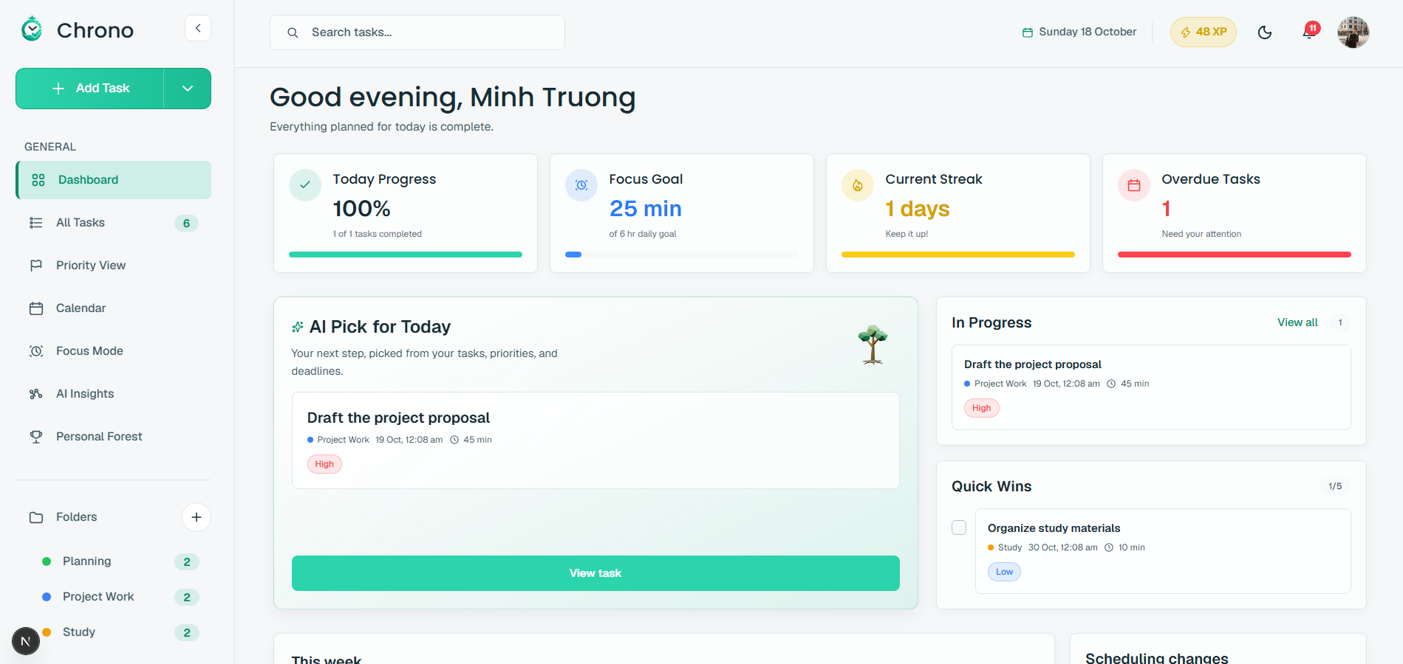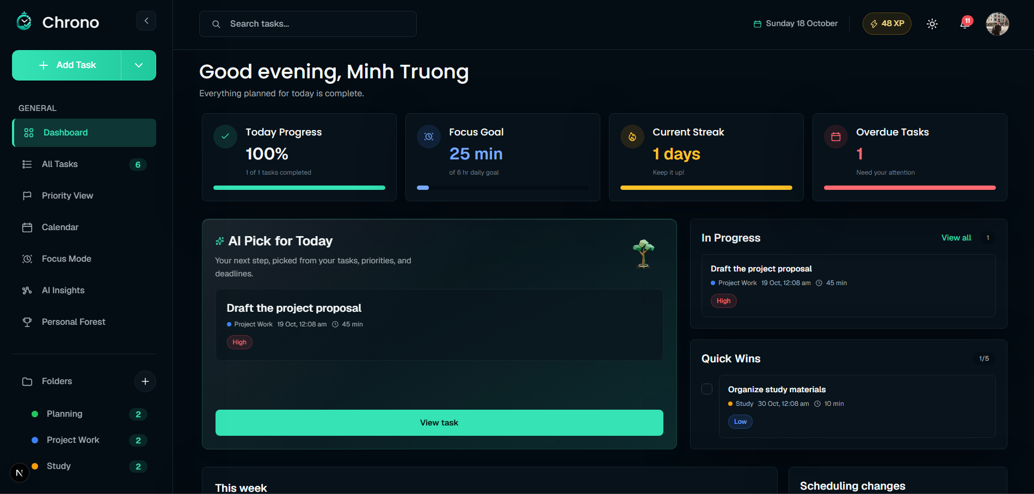
Figure 6 1 Dark and light workspace themes

6 2 3 Sign in and account creation
Sign-in and account-creation pages use short, direct headings and retain Chrono’s mountain artwork. On desktop, the illustration fills about 60 percent of the layout and the form 40 percent, with a soft transition between them. The logo sits at the upper left and the supporting slogan at the lower left. On mobile, the artwork moves above the form and the page becomes a single vertical flow.
Filled input bars, leading icons, and rounded corners create a consistent form style. The main action spans the form width, with the link to the alternate account flow beneath it. Google and Facebook appear as equal-width buttons for demonstration; they are visual mock-ups and do not currently sign users in through those providers. The main design changes are the clearer image-to-form balance, softer transition, and mobile-first vertical arrangement.
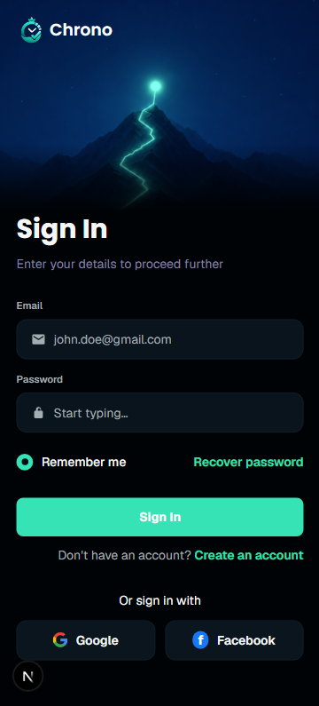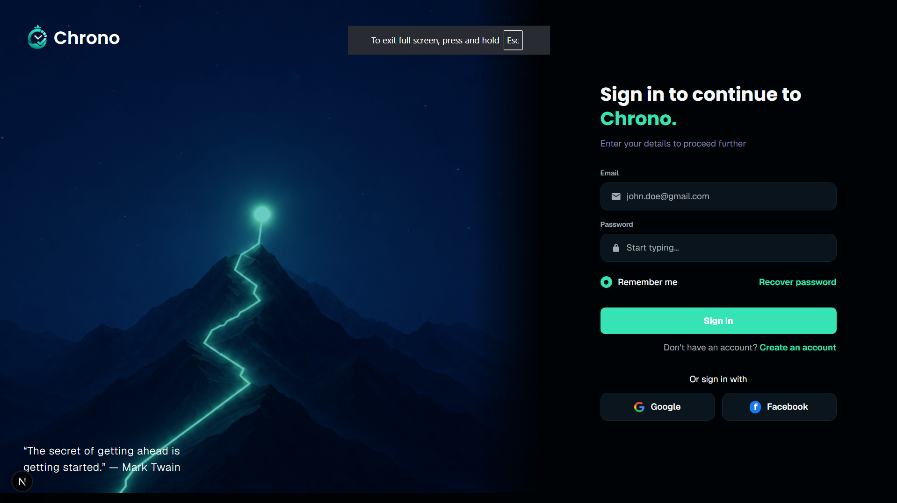
Figure 6 2 Responsive authentication layout

6 2 4 Home dashboard
The Home dashboard brings daily progress, focus goal, streak, and overdue tasks into summary cards, followed by AI Pick for Today, In Progress, Quick Wins, and weekly activity. Each title sits inside its card beside the information it describes. Duplicate page-level labels are removed, and related actions such as View all stay with the card they affect. The result is a calmer overview that still offers a quick route from progress to the next task.
The dashboard adapts to the available space: desktop arranges cards in a grid, while mobile stacks the main sections and keeps the compact overview cards easy to scan. Notification and XP controls keep alerts and growth feedback visible. The card layout gives the daily overview room to breathe while keeping the next task close at hand.
Poppins gives prominent card titles a clear hierarchy, while the app’s body type is used for supporting copy and controls. The AI recommendation and weekly insight use a small sparkle icon to identify AI-generated guidance. Short titles sit above concise explanations, making each card easy to understand at a glance.
Personal Forest displays the available Growth Points beside the page introduction on desktop, with the balance aligned to the right. On narrower screens, the balance moves beneath the title and supporting text. This keeps the points easy to find while leaving room for the forest and plant choices.
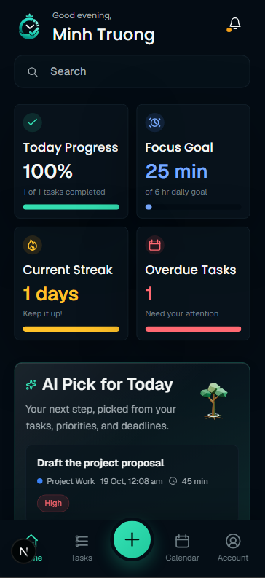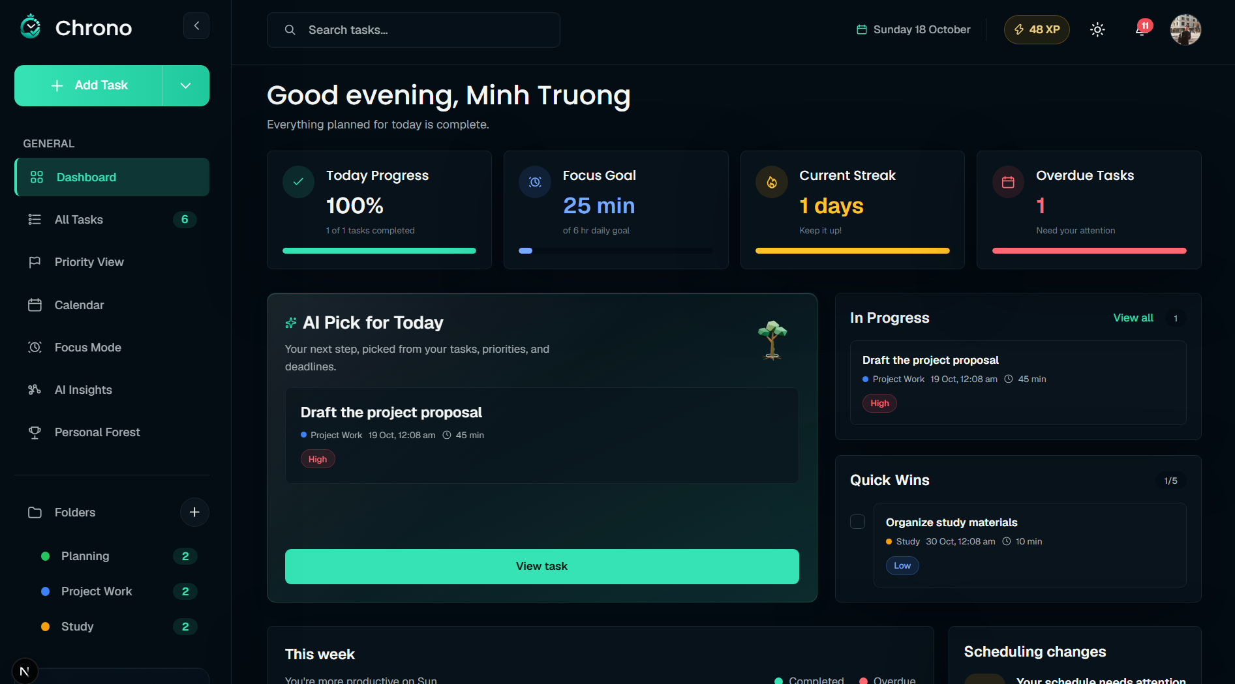
Figure 6 3 Home dashboard cards and daily planning

6 2 5 Tasks and calendar
Tasks combines search, status and priority filters, sorting, and task actions. On desktop, a table supports scanning and comparing many tasks; on mobile, compact cards put the task name, due date, project, priority, and completion action within easy reach. Overdue information appears beside the task where relevant. Filter and sort controls remain together and can scroll horizontally when space is limited, avoiding awkward wrapping at narrow widths or high zoom.
Calendar uses the same task-card treatment, so people can recognise and complete a task without learning a second interaction pattern. Date groups and calendar placement provide the time context that does not need to be repeated on every card. Together, the table, compact cards, and calendar views support both broad planning and quick task updates.
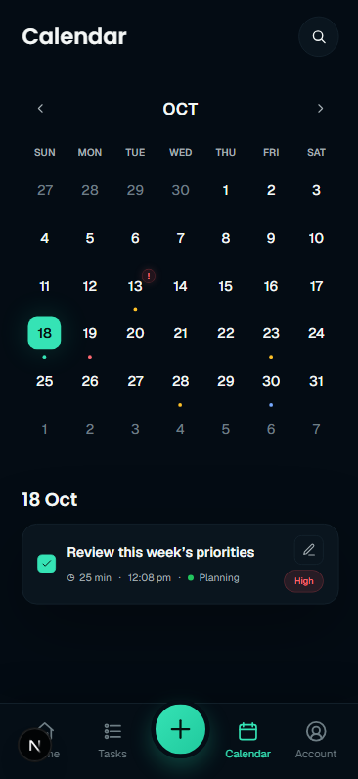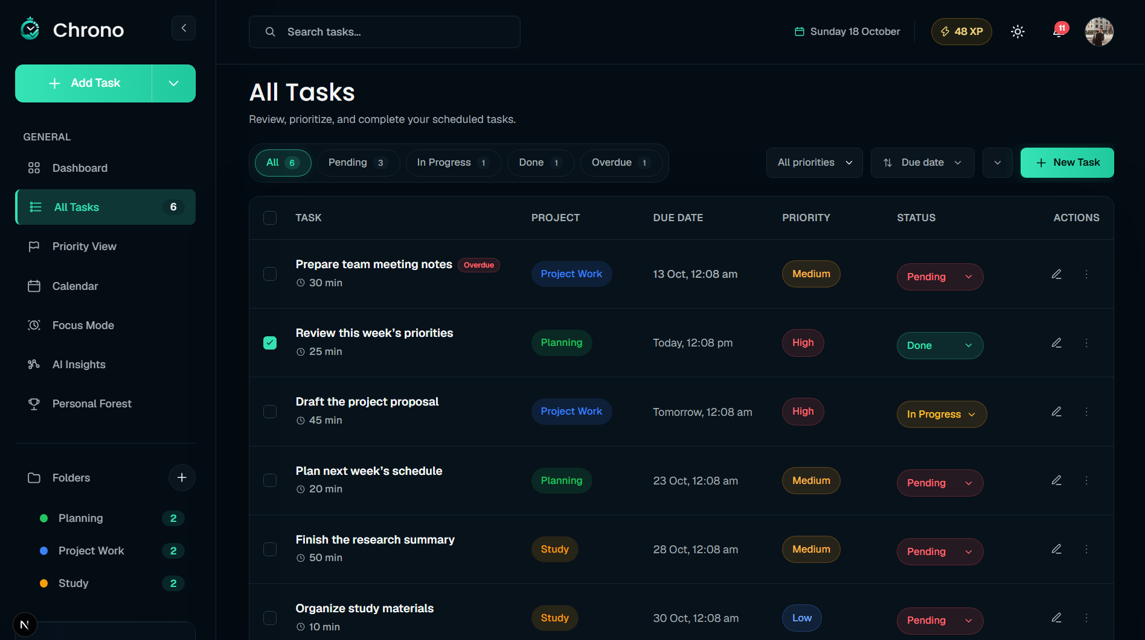
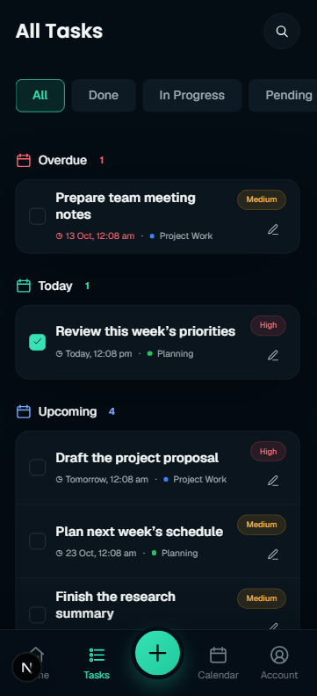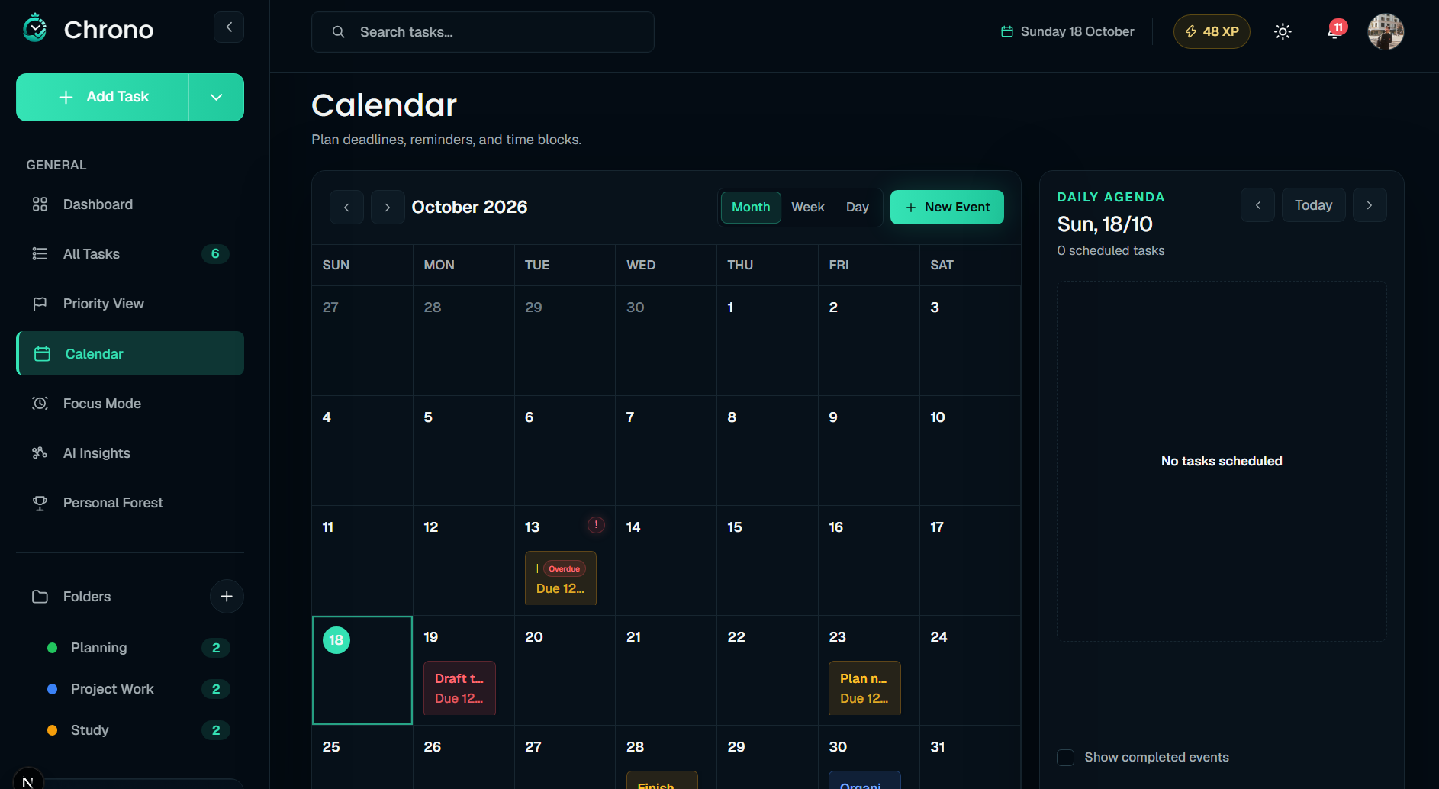
Figure 6 4 Task management and calendar cards
Task creation opens without leaving the current page, so people can return to the list or calendar where they started. The dialog offers Generate tasks, Break down, and manual entry. AI-suggested content is presented for review and confirmation before it is added. Typography and selection colour distinguish the dialog title, active mode, and supporting controls while keeping them consistent with the wider app.

6 2 6 Account settings
Account Settings brings profile information and personal preferences together. On desktop, a navigation column lists Account, Notifications, Theme, Work preferences, and Scheduling priorities beside the selected content. Log out appears beneath the navigation. On mobile, the account summary leads into Private information, Your progress, and Preferences; preference rows open within the page, and Log out remains at the bottom of the scrolling content above the bottom navigation.
The Account view presents a profile summary, private information, and links to AI Insights and Personal Forest. Mobile uses clear section labels and separators while preserving the app’s spacing; desktop uses full-width content cards beside the settings navigation. People can update their name, while email is displayed as account information. Profile, insights, and forest pages provide a clear route back to Account.
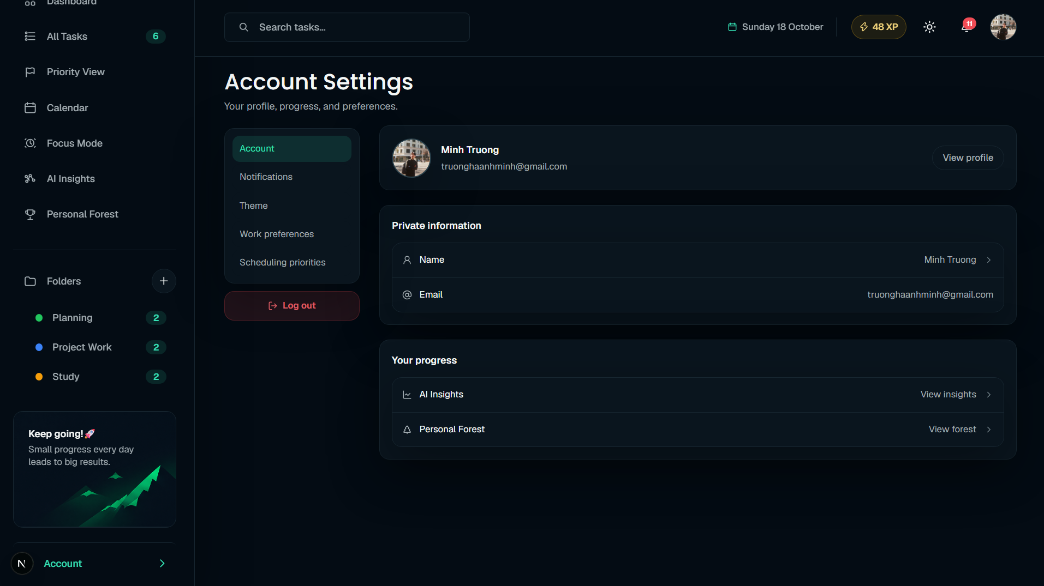
Figure 6 5 Account settings navigation and content

6 2 7 Profile details
Profile details separate identity editing from account information. On desktop, My Profile occupies one column, with Account Security and Account Access in the other; on mobile, the sections stack vertically. First name and Last name appear together, followed by a full-width Save changes action.
A green camera icon over the avatar opens image selection without adding a separate image button. Account Security shows read-only email and account type, while Account Access shows account status and membership details. The page focuses on profile editing and account information; it does not currently provide password-change, two-step verification, or support-access controls.
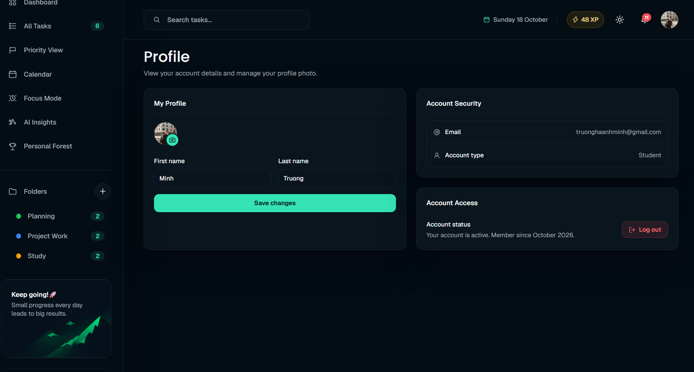
Figure 6 6 Profile editing and account information

