  - CHRONO A5

Database Architecture
and Deployment Report
  - Minh contribution to the final project report
AI Smart Scheduling Web Application
17 October 2026

Report purpose
CHRONO stores personal tasks, schedules, focus activity and progress in a PostgreSQL database behind a FastAPI service. This report explains how those records relate, how access is controlled, and how another team member can install and maintain the demonstration system. The database design preserves tasks when a project is deleted and keeps completion times separate from general update times so that reporting remains meaningful.

Contribution scope
Final report chapter | Minh contribution
5 System Architecture | Shared architecture contribution covering persistence, service boundaries and deployment topology.
8 Database and Data Dictionary | Database structure, relationships, field definitions, constraints, migrations and demonstration data.
9 Security and Data Handling | Shared contribution covering data ownership, storage, deletion, uploads, secrets and recovery.
11 Installation Deployment and Maintenance | Installation runbook, operational limitations, maintenance and source handover.

The chapter numbers follow the final A5 report. Chapter 6 Frontend and UI UX Design belongs to Anh Minh and Vinh and is outside this contribution. Shared chapters should be combined with Duy and the other architecture contributors before the complete report is submitted.
Implementation baseline: develop working tree based on commit 86a507f, including local changes. A release identifier should be recorded after the team freezes and validates the final submission.

5 System Architecture

5 1 Architecture overview
The application uses a browser frontend, an API service and a relational database. Next.js supplies the web interface, while FastAPI authenticates requests and runs task, scheduling, notification, analytics, focus and gamification services. SQLAlchemy maps domain records to PostgreSQL, and Alembic controls changes to the schema. The browser does not connect directly to PostgreSQL.
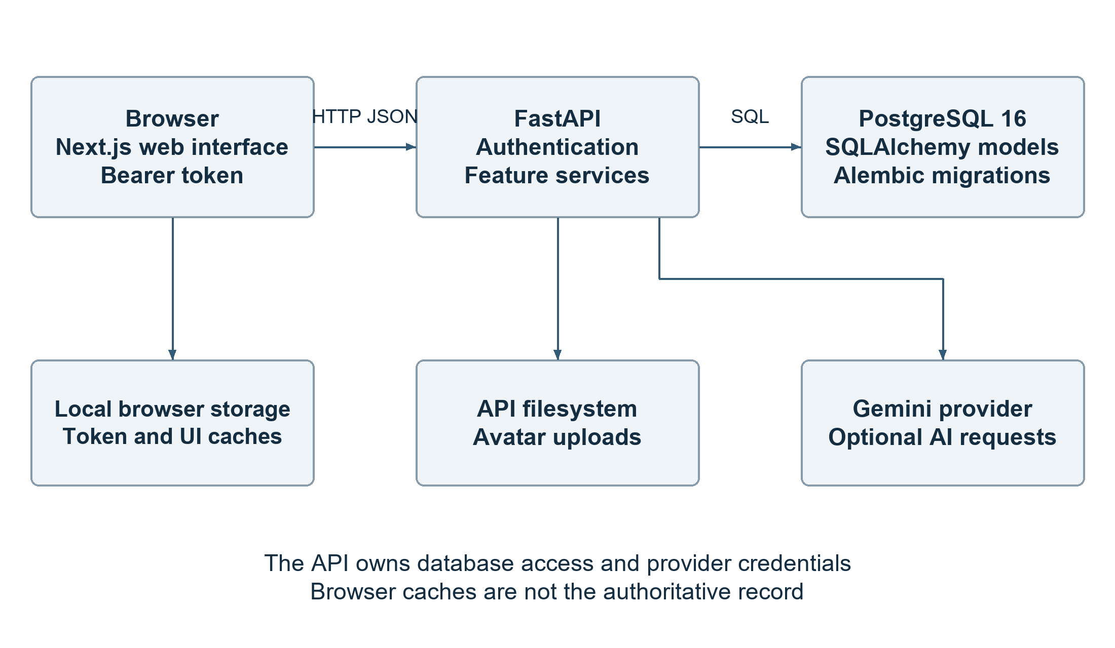
Figure 5 1 Application components and data boundaries
The frontend sends JSON requests to the API address configured by NEXT_PUBLIC_API_URL and adds the current access token as a Bearer credential. API routes resolve the user before accessing that user's records. The database is the authoritative store; local browser caches and session state support interface behaviour but do not replace persisted records. [R2, R3, R4]

5 2 Persistence and feature boundaries
The API modules separate identity, projects, tasks, settings, focus, notifications, scheduling, analytics and gamification. Their tables share one SQLAlchemy metadata collection and one PostgreSQL database. This is a modular backend within a single application, rather than a set of independently deployed microservices. The folders API delegates to the project service, so the interface label Folder does not introduce a separate folders table.
Calendar views use task deadlines and scheduled intervals. The dashboard combines current task and focus information through GET /dashboard/summary. Weekly AI insights store a metrics snapshot and generated narrative, but the dashboard is not maintained as a separate dashboard table. Avatar files are stored outside PostgreSQL; only their paths are saved in users.avatar_path. [R3, R5, R6]

5 3 Request and transaction lifecycle
A task creation request passes through schema validation, authentication and service-level checks before the service adds the task to the database. The task service also coordinates notifications and schedule revision changes. After a successful commit, the API returns the saved record and the frontend refreshes affected views. Invalid input should be rejected before persistence, and a reference to another user's project must not be accepted.
The database dependency opens a SQLAlchemy session for the request and closes it afterwards. Services explicitly commit their changes; the session dependency does not automatically commit every successful HTTP request. Some related work uses separate transactions, including AI generation telemetry. Consequently, the application must not be described as making every request and every side effect one atomic transaction. The engine uses pool_pre_ping to check connections before reuse. [R4, R6, R8]

5 4 Deployment boundary
The supplied Compose configuration starts PostgreSQL, FastAPI and the web application. PostgreSQL has a health check, and the API waits for it before running migrations and starting Uvicorn. The web service has a start-order dependency on the API, but no equivalent API readiness condition. The current API command enables reload and mounts source directories, which makes this configuration suitable for development and demonstrations rather than a completed production deployment. [R10]
Optional Gemini calls originate from the API. Provider credentials must remain server-side. PostgreSQL and uploaded avatar files have different backup requirements, and the current Compose configuration persists only PostgreSQL. These boundaries affect both recovery and the source handover described in Chapter 11.

8 Database and Data Dictionary

8 1 Database organisation
The current ORM defines 22 application tables. PostgreSQL additionally stores Alembic revision bookkeeping in alembic_version. UUID keys identify most user-owned records, while plant species and achievement catalogues use stable string identifiers. Relational columns represent ownership and core associations; JSON and JSONB fields store structured recommendation, proposal and metrics payloads whose shapes vary by feature. [R4, R5, R6, R7, R8]
Area | Tables | Purpose
Identity and preferences | users; user_settings | Accounts, profile details and user-specific work and notification preferences.
Task organisation | projects; tasks; subtasks | Project grouping, deadlines, priority, completion and ordered task steps.
Notifications and focus | notifications; focus_sessions; focus_session_tasks | In-app notification records and focus sessions linked to one or several tasks.
Scheduling | user_schedule_states; ai_recommendations; ai_schedule_suggestions; reschedule_proposals | Schedule revisions, ranked recommendations, suggested intervals and preview or undo snapshots.
Duration and AI reporting | duration_estimate_decisions; task_duration_baselines; weekly_ai_insights; ai_generation_events | Duration decisions, reference estimates, weekly narratives and provider telemetry.
Gamification | user_gamification_profiles; plant_species; user_plants; achievements; user_achievements; reward_events | Growth points, forest objects, unlocks, reward claims and duplicate-award protection.

8 2 Entity relationships
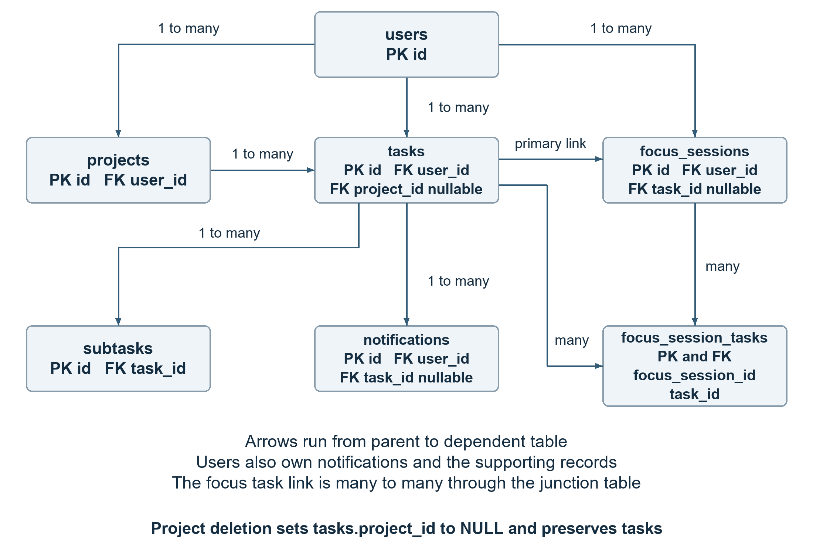
Figure 8 1 Core entity relationships with the focus task junction
A user owns many projects and tasks. A task may belong to one project or have no project, which represents Inbox. A task has many subtasks. A focus session keeps an optional primary task reference and can also link to several tasks through focus_session_tasks. Settings, schedule revision state and the gamification profile are user-specific singleton records, enforced by a unique user reference or a user primary key.
Relationship | Cardinality | Foreign key deletion rule
users to projects tasks settings notifications focus and supporting user records | 1 to many or 1 to 0 or 1 | CASCADE on user-owned foreign keys.
projects to tasks | 1 to many; task project optional | SET NULL on tasks.project_id. The tasks remain in Inbox.
tasks to subtasks | 1 to many | CASCADE; the ORM also uses delete-orphan for subtasks.
tasks to focus_sessions notifications ai_recommendations | 1 to many; reference optional | SET NULL preserves the dependent record without its task link.
tasks to focus_session_tasks ai_schedule_suggestions duration_estimate_decisions task_duration_baselines | 1 to many or 1 to 0 or 1 | CASCADE removes task-dependent links and records.
focus_sessions to focus_session_tasks | 1 to many | CASCADE removes junction rows.
ai_recommendations to ai_schedule_suggestions | 1 to many; recommendation optional | SET NULL keeps the suggestion when its recommendation is removed.
plant_species to user_plants | 1 to many | RESTRICT prevents deleting a species while plants reference it.
achievements to user_achievements | 1 to many | CASCADE removes the unlock link if the catalogue achievement is deleted.

These are database deletion behaviours, not a claim that an account-deletion screen exists. A database cascade cannot remove avatar files from the filesystem. References stored inside JSON snapshots, reward_events.source_id and reschedule_proposals.selected_option_id do not have the same foreign-key enforcement as relational references.

8 3 Dictionary conventions
The following dictionary covers every application table. PK means primary key, FK means foreign key and NULL means an optional value. TIMESTAMPTZ denotes a timezone-aware timestamp. Unless an exception is stated, id is a non-null UUID primary key generated by the application with uuid4; user_id is a non-null UUID FK to users.id with CASCADE deletion. Creation and update timestamps are non-null and initially use the database current time; updated_at is refreshed by ORM-managed updates, not by a universal database trigger.
Defaults below describe the model or service contract. An ORM default applies when SQLAlchemy inserts a row and is not automatically a PostgreSQL server default. Raw SQL loaders must supply fields without a server default. Grouped fields retain their exact names and use the same type and nullability unless the description states otherwise. The migration history must also be consulted because it contains constraints that are not repeated in every ORM model. [R4, R9]

8 3 1 users
Account identity and authentication data.
Field | Type | Nullability | Meaning and constraints
id | UUID PK | Required | Application-generated account identifier.
email | VARCHAR 320 | Required unique | Normalised to trimmed lowercase on registration and indexed for account lookup.
first_name / last_name | VARCHAR 100 | Required | Profile names; model defaults are empty strings.
role | VARCHAR 32 | Required | Default student. CHECK allows student, teacher, other and admin; public registration excludes admin.
password_hash | VARCHAR 255 | Required | Password hash only; excluded from public user responses.
avatar_path | VARCHAR 512 | NULL | Filesystem reference exposed through the media URL; image bytes are not in this table.
is_active | BOOLEAN | Required | Default true; inactive users cannot resolve as authenticated users.
created_at / updated_at | TIMESTAMPTZ | Required | Account creation and ORM update timestamps.

8 3 2 projects
Project records presented as folders in the interface.
Field | Type | Nullability | Meaning and constraints
id / user_id | UUID PK / FK | Required | Project identifier and owning account.
name | VARCHAR 100 | Required | Project display name.
color | VARCHAR 7 | Required | Hex colour; default #6366F1.
created_at / updated_at | TIMESTAMPTZ | Required | Project creation and update times.

8 3 3 tasks
Primary task state and scheduling fields.
Field | Type | Nullability | Meaning and constraints
id / user_id | UUID PK / FK | Required | Task identifier and owning account; user_id is indexed.
project_id | UUID FK | NULL | Indexed reference to projects.id; SET NULL on project deletion.
title | VARCHAR 255 | Required | Task label.
description | TEXT | NULL | Optional task details.
status | task_status ENUM | Required | pending, in_progress or done; default pending. Overdue is derived, not stored here.
priority | task_priority ENUM | Required | no_priority, low, medium or high; default no_priority.
due_date | TIMESTAMPTZ | NULL | Deadline instant; null means no deadline.
estimated_duration_minutes | INTEGER | NULL | Estimated effort in minutes, not a timestamp.
scheduled_start / scheduled_end | TIMESTAMPTZ | NULL | Proposed or applied calendar interval. Locked schedules require both and end greater than start.
schedule_locked | BOOLEAN | Required | Default false. Locks an assigned schedule against unrequested changes.
completed_at | TIMESTAMPTZ | NULL | Recorded when entering done; cleared when reopened.
created_at / updated_at | TIMESTAMPTZ | Required | Record creation and latest ORM update times.

8 3 4 subtasks
Ordered checklist entries belonging to one task.
Field | Type | Nullability | Meaning and constraints
id | UUID PK | Required | Subtask identifier.
task_id | UUID FK | Required | Indexed parent task reference with CASCADE deletion.
title | VARCHAR 255 | Required | Checklist entry text.
is_completed | BOOLEAN | Required | Default false; independent checklist completion flag.
position | INTEGER | Required | Default 0; controls ordering within the task.
created_at / updated_at | TIMESTAMPTZ | Required | Subtask creation and update times.

8 3 5 user settings
One settings record per user.
Field | Type | Nullability | Meaning and constraints
id / user_id | UUID PK / FK | Required | Unique and indexed user_id prevents duplicate settings records.
work_start / work_end | TIME | Required | Local working hours; defaults 09:00 and 17:00.
timezone | VARCHAR 64 | Required | IANA timezone identifier; default UTC. Validated with ZoneInfo.
timezone_source | VARCHAR 16 | Required | default, detected or user; default default.
pomodoro_minutes | INTEGER | Required | Default 25; database CHECK restricts to 1 through 240.
daily_work_limit_minutes | INTEGER | Required | Default 480; CHECK restricts to 30 through 1440.
ai_assistant_enabled | BOOLEAN | Required | Default true; per-user AI preference.
ai_deadline_urgency_weight / ai_priority_weight / ai_estimated_duration_weight | INTEGER | Required | Defaults 80, 70 and 50 respectively. Each CHECK is 0 through 100.
notify_task_reminders / notify_productivity_reminders / notify_daily_digest | BOOLEAN | Required | Each defaults true.
notify_overdue_alerts / notify_focus_do_not_disturb | BOOLEAN | Required | Each defaults true.
notify_weekly_report | BOOLEAN | Required | Default false.
channel_desktop / channel_push / channel_email | BOOLEAN | Required | Defaults false, true and true. Stored preferences do not prove each delivery channel is implemented.
created_at / updated_at | TIMESTAMPTZ | Required | Preference creation and update times.

8 3 6 notifications
In-app messages and reminder state.
Field | Type | Nullability | Meaning and constraints
id / user_id | UUID PK / FK | Required | Notification identifier and indexed owner reference.
task_id | UUID FK | NULL | Indexed task reference with SET NULL deletion.
type / title | VARCHAR 64 / 255 | Required | Notification category, default general, and heading.
message | TEXT | NULL | Optional message body.
metadata | JSON | NULL | Physical SQL column name; mapped as data in Python.
scheduled_for | TIMESTAMPTZ | NULL | Reminder scheduling instant.
dedupe_key | VARCHAR 255 | NULL unique | Prevents duplicate notifications for the same non-null key.
read_at | TIMESTAMPTZ | NULL | Null means unread; the is_read property is derived.
created_at | TIMESTAMPTZ | Required | Database creation timestamp.

8 3 7 focus sessions
Persisted focus timer lifecycle and effort.
Field | Type | Nullability | Meaning and constraints
id / user_id | UUID PK / FK | Required | Session identifier and indexed owner reference.
task_id | UUID FK | NULL | Indexed optional primary task; SET NULL deletion.
started_at / ended_at | TIMESTAMPTZ | Start required | Session start; end remains null while no end is recorded.
duration_minutes | INTEGER | Required | Legacy duration field retained for compatibility.
planned_duration_minutes | INTEGER | Required | Planned session length; migration CHECK requires a positive value.
actual_duration_seconds | INTEGER | Required | Recorded effort; default 0 and migration CHECK requires nonnegative.
status | VARCHAR 24 | Required indexed | Default active; service lifecycle uses active, paused, completed and cancelled.
completed | BOOLEAN | Required | Legacy completion flag. Model default true must not be treated as proof that every new lifecycle session completed.
created_at / updated_at | TIMESTAMPTZ | Required | Session record timestamps.

8 3 8 focus session tasks
Many to many link between sessions and tasks.
Field | Type | Nullability | Meaning and constraints
focus_session_id | UUID PK and FK | Required | References focus_sessions.id with CASCADE; part of the composite PK.
task_id | UUID PK and FK | Required indexed | References tasks.id with CASCADE; the pair cannot repeat.

8 3 9 user schedule states
Per-user scheduling revision counter.
Field | Type | Nullability | Meaning and constraints
user_id | UUID PK and FK | Required | One revision state per account; CASCADE.
revision | BIGINT | Required | Default 0; changes when schedule-related state is revised.
updated_at | TIMESTAMPTZ | Required | Latest revision update time.

8 3 10 ai recommendations
Saved recommendation explanation and ranking.
Field | Type | Nullability | Meaning and constraints
id / user_id | UUID PK / FK | Required | Recommendation identifier and indexed owner.
task_id | UUID FK | NULL | Optional referenced task with SET NULL deletion.
kind / title | VARCHAR 64 / 255 | Required | Recommendation kind and display title.
explanation | TEXT | Required | User-facing explanation.
reasons / based_on | JSON | Required | Structured lists; defaults are empty lists.
score | FLOAT | Required | Ranking score; default 0.
status | VARCHAR 32 | Required indexed | Default pending; recommendation workflow state.
weights_snapshot | JSON | Required | Weight configuration at generation time; default empty object.
generated_at / updated_at | TIMESTAMPTZ | Required | Generation and update timestamps.

8 3 11 ai schedule suggestions
Candidate intervals for individual tasks.
Field | Type | Nullability | Meaning and constraints
id / user_id | UUID PK / FK | Required | Suggestion identifier and indexed owner.
recommendation_id | UUID FK | NULL | SET NULL when the referenced recommendation is deleted.
task_id | UUID FK | Required | References tasks.id with CASCADE.
suggested_start / suggested_end | TIMESTAMPTZ | Required | Suggested interval boundaries.
explanation | TEXT | Required | Reason for the proposed placement.
status | VARCHAR 32 | Required indexed | Default pending.
position | INTEGER | Required | Default 0; suggestion display order.
generated_at / updated_at | TIMESTAMPTZ | Required | Generation and update times.

8 3 12 reschedule proposals
Preview state and reversible rescheduling records.
Field | Type | Nullability | Meaning and constraints
id / user_id | UUID PK / FK | Required | Proposal identifier and owning account.
status | VARCHAR 32 | Required | Default preview. CHECK allows preview, applied, undone, superseded and expired.
state_fingerprint | VARCHAR 64 | Required | Fingerprint of the state used to build the proposal.
detected_context / state_snapshot | JSON | Required | Detected conditions and input snapshot; default empty objects.
alternatives | JSON | Required | Candidate alternatives; default empty list.
selected_option_id | UUID | NULL | Selected alternative identifier within the proposal; not an SQL FK.
before_snapshot / after_snapshot / ai_explanations | JSON | NULL | Apply or undo state and optional AI explanation payloads.
expires_at | TIMESTAMPTZ | Required | Proposal expiry instant.
applied_at / undone_at | TIMESTAMPTZ | NULL | Lifecycle event timestamps.
created_at / updated_at | TIMESTAMPTZ | Required | Record timestamps. Composite index covers user, status and creation time.

8 3 13 duration estimate decisions
Recorded user response to an estimated duration.
Field | Type | Nullability | Meaning and constraints
proposal_id | UUID PK | Required | Client or service supplied proposal identifier; no automatic UUID default.
user_id / task_id | UUID FK | Required | Both references use CASCADE deletion.
action | VARCHAR 16 | Required | CHECK permits accepted, changed or ignored.
applied_duration_minutes | INTEGER | NULL conditional | Must be null for ignored; accepted or changed requires 1 through 10080.
request_fingerprint / task_snapshot_after | VARCHAR 64 | Required | Request and resulting task snapshot identifiers.
estimate / response | JSONB | Required | Structured estimate and stored response payloads.
resolved_at | TIMESTAMPTZ | Required | Resolution time; indexed with user_id and task_id.

8 3 14 task duration baselines
Reference estimate used for duration evaluation.
Field | Type | Nullability | Meaning and constraints
task_id | UUID PK and FK | Required | One baseline per task, CASCADE on deletion.
user_id | UUID FK | Required indexed | Owning account, CASCADE.
estimated_minutes | INTEGER | NULL | Reference estimate captured before the first recorded focus effort.
reference_source | VARCHAR 32 | Required | Origin of the baseline value.
created_at | TIMESTAMPTZ | Required | Baseline creation time.

8 3 15 weekly ai insights
Cached weekly metrics and generated narrative.
Field | Type | Nullability | Meaning and constraints
id / user_id | UUID PK / FK | Required | Insight identifier and indexed owner.
period_start / period_end | TIMESTAMPTZ | Required | Reporting interval. Unique together with user_id.
cache_week_start | DATE | Required | Local week identity; unique with user_id.
metrics | JSON | Required | Persisted metrics snapshot used to produce the narrative.
narrative | TEXT | Required | Generated weekly explanation.
model / prompt_version | VARCHAR 128 / 64 | Required | Provider model and prompt version identifiers.
created_at | TIMESTAMPTZ | Required | Cache creation timestamp; indexed with user_id.

8 3 16 ai generation events
Provider generation metrics without prompt text.
Field | Type | Nullability | Meaning and constraints
id / user_id | UUID PK / FK | Required | Event identifier and owning account.
feature / prompt_version | VARCHAR 64 | Required | Feature and prompt revision identifiers.
outcome | VARCHAR 16 | Required | CHECK permits success, fallback or failure.
source / model | VARCHAR 32 / 128 | Required | Generation source and model identifiers.
latency_ms | INTEGER | Required | Default 0; nonnegative provider latency.
input_tokens / output_tokens / thinking_tokens / total_tokens | INTEGER | Required | Each defaults 0 and must be nonnegative.
error_code | VARCHAR 64 | NULL | Diagnostic code without a stored raw prompt.
created_at | TIMESTAMPTZ | Required | Event time; composite indexes support user or feature plus time.

8 3 17 user gamification profiles
Per-user growth point and activity totals.
Field | Type | Nullability | Meaning and constraints
user_id | UUID PK and FK | Required | One profile per user; CASCADE.
total_growth_points / unassigned_growth_points | INTEGER | Required | Both default 0. CHECK prevents negative unassigned points.
current_streak / longest_streak / total_trees_grown | INTEGER | Required | Each defaults 0; accumulated progress measures.
forest_name | VARCHAR 48 | NULL | Optional user-defined forest name.
last_activity_date | DATE | NULL | Date associated with the most recent qualifying activity.
created_at / updated_at | TIMESTAMPTZ | Required | Profile timestamps.

8 3 18 plant species
Shared catalogue of available plant types.
Field | Type | Nullability | Meaning and constraints
id | VARCHAR 64 PK | Required | Stable species code; not a UUID.
name / description | VARCHAR 120 / TEXT | Required | Catalogue title and description.
image_key | VARCHAR 64 | Required | Application asset identifier.
required_growth_points | INTEGER | Required | Points needed to grow the species.
unlock_requirement | JSON | Required | Structured species unlock condition.
sort_order / is_default | INTEGER / BOOLEAN | Required | Defaults 0 and false; catalogue ordering and default availability.

8 3 19 user plants
Plant progress and forest placement for a user.
Field | Type | Nullability | Meaning and constraints
id / user_id | UUID PK / FK | Required | Plant instance identifier and indexed owner.
species_id | VARCHAR 64 FK | Required indexed | References plant_species.id with RESTRICT deletion.
current_growth_points | INTEGER | Required | Default 0; allocated plant growth.
growth_stage / status | VARCHAR 32 | Required | Defaults seedling and growing.
custom_name | VARCHAR 48 | NULL | Optional plant name.
tasks_contributed / focus_sessions_contributed | INTEGER | Required | Both default 0; contribution counters.
position_x / position_y / position_z | FLOAT | NULL | Optional 3D forest coordinates.
rotation_x / rotation_y | FLOAT | Required | Both default 0; forest orientation.
is_placed_in_forest | BOOLEAN | Required | Default false; whether placement is assigned.
started_at / completed_at | TIMESTAMPTZ | Start required | Growth start defaults to database time; completion remains optional.

8 3 20 achievements
Shared achievement catalogue.
Field | Type | Nullability | Meaning and constraints
id | VARCHAR 64 PK | Required | Stable achievement code.
name / description | VARCHAR 120 / TEXT | Required | Display title and explanation.
icon / category | VARCHAR 64 | Required | Icon identifier and category; category defaults getting_started.
requirement_type | VARCHAR 64 | Required | Kind of progress evaluated.
requirement_value | INTEGER | Required | Threshold for unlocking.
reward_growth_points / sort_order | INTEGER | Required | Defaults 5 and 0; reward and display order.

8 3 21 user achievements
Unlock and claim state for an account.
Field | Type | Nullability | Meaning and constraints
id / user_id | UUID PK / FK | Required | Unlock identifier and indexed owner.
achievement_id | VARCHAR 64 FK | Required indexed | References achievements.id with CASCADE; user and achievement pair is unique.
unlocked_at | TIMESTAMPTZ | Required | Default database time.
claimed_at | TIMESTAMPTZ | NULL | Null means the unlocked reward has not been claimed.

8 3 22 reward events
Deduplicated reward award records.
Field | Type | Nullability | Meaning and constraints
id / user_id | UUID PK / FK | Required | Reward event identifier and indexed owner.
source_type / source_id | VARCHAR 64 | Required | Origin type and source identifier. source_id is not a relational FK.
growth_points | INTEGER | Required | Growth points awarded by this event.
metadata_json | JSON | Required | Additional award context; default empty object.
created_at | TIMESTAMPTZ | Required | Award creation time. The unique user, source type and source id combination prevents duplicate source awards.

8 4 Data lifecycle and reporting semantics
Task creation assigns the authenticated owner, validates the project reference and stores the supplied task fields. Updates preserve the record identity. Moving a task into done sets completed_at to the current UTC time; reopening it clears completed_at. A done task with a missing completion timestamp is repaired on update. Analytics use completion timestamps rather than treating every edit as a new completion. [R6]
Overdue is computed when an unfinished task has a non-null deadline earlier than the current UTC time. It is not a fourth database status. A completed task therefore does not remain overdue merely because its deadline is in the past. A task without a deadline is also not overdue. Deleting a project clears its tasks' project references and exposes those tasks in Inbox; it must not remove the tasks themselves.
Timestamp columns use timezone-aware database types. The API normalises deadline instants to UTC, while user_settings.timezone supplies the IANA timezone for local dates and reporting boundaries. The timezone helpers derive adjacent local midnights and convert them to UTC, allowing daylight saving days to differ from 24 hours. Work_start and work_end are local times of day, not absolute timestamp values. [R5, R6]
Focus sessions distinguish planned minutes from actual recorded seconds and from lifecycle status. Dashboard and analytics calculations must use the relevant completed activity rather than assuming the legacy completed flag alone describes every timer state. Scheduling proposals preserve input and before or after snapshots to support state validation and undo behaviour. Reward uniqueness keys protect against awarding the same source event twice; they do not replace ownership checks. [R7, R8]

8 5 Integrity rules and indexes
Foreign keys prevent orphan relational references, while unique constraints protect one settings record per account, one achievement unlock per user and achievement, duplicate reward source events, and duplicate weekly insight cache identities. Task status and priority use PostgreSQL enum types. Additional CHECK constraints restrict user roles, settings ranges, proposal states, nonnegative AI telemetry and valid duration decisions.
The locked-task constraint requires both scheduled endpoints and a positive interval when schedule_locked is true. Focus lifecycle migrations also add positive planned duration and nonnegative actual duration checks. Those focus constraints are present in migrations but are not restated in the current ORM table arguments; schema maintenance must compare both sources rather than assuming the model file is the complete deployed schema. [R9]
Indexes commonly support user-scoped lookups and task or project references. Composite indexes support AI generation history by user or feature and time, proposals by user and status and creation time, duration decisions by user and task and resolution time, and weekly insight history by user and time. These choices match the application's access patterns, but do not establish measured performance at production scale. Query plans and timings should be collected before adding speculative indexes.

8 6 Migration management
Alembic imports the application models into shared metadata and enables type comparison. The source history currently contains 32 revisions, with one root a374ab74f829, one head d7b2a6e14f09 and no missing parent references in a static graph check. Merge revisions preserve earlier parallel feature histories. The number of migration files reflects schema evolution, not 32 databases or duplicate active schemas. [R9]
Existing revision files must remain available for installation and upgrade. Deleting old files to reduce clutter can break a database that records an earlier revision. A new schema change should add a reviewed migration with a clear upgrade path, data backfill where necessary, and a documented rollback consequence. A downgrade is not a substitute for a backup.
The latest weekly insight migration derives a local week key, retains the newest cache entry for each user and week, removes older duplicates, and adds uniqueness. Because deleted duplicate rows cannot be reconstructed by simply reversing the schema change, take a backup before upgrading existing data. Focus lifecycle migrations similarly backfill new duration and status fields from legacy records. These examples require data verification as well as structural verification.
A migration graph check does not prove a fresh database can upgrade successfully. The release procedure must test both a clean database and a copy of any supported earlier database. Record the starting revision, target revision, row counts for important entities and representative task, focus and cache values. Chapter 11 provides the commands and acceptance checks.

8 7 Demonstration data
The seed script creates or reuses a synthetic demo account and six projects named University, Internship, Personal, Research, Health and Creative. It supplies tasks with different priorities, statuses, relative deadlines, durations and subtasks, including unassigned tasks. Dates are generated relative to the execution date, so the resulting overdue and upcoming examples remain useful for a demonstration. [R11]
Run the script only in an isolated demonstration database. A rerun updates matching projects and tasks, moves relative dates, resets task fields and rebuilds subtasks. It is therefore not a read-only fixture loader. If the demo email already exists, the script reuses that user without resetting its password. The script alone does not provide every focus, AI and forest scenario; those should be prepared through the supported application flows. A separate new account should be retained for empty-state checks.

9 Security and Data Handling

9 1 Authentication and storage of credentials
Passwords are hashed through pwdlib's recommended password hasher using the installed Argon2 support. The database stores password_hash rather than plaintext passwords, and public user schemas omit the hash. Registration validates email, password length, allowed public roles and timezone input. Duplicate normalised email addresses are rejected. [R5]
After a successful login, the API issues a signed JWT containing the user identifier, issue time and expiry. The configured default is HS256 with a 30 minute lifetime. Authentication verifies the configured algorithm, decodes the user UUID and checks that the account exists and is active. Invalid or expired credentials lead to an authentication error. An administrative role helper supplies a further 403 response where restricted access is required.
The browser stores the access token locally and clears local session state on logout or credential recovery. This storage is accessible to JavaScript, so preventing script injection remains important. Local logout is not server-side revocation of an already issued token. The implementation should not be described as providing refresh tokens, a revocation blacklist or centrally invalidated sessions. [R2, R5]

9 2 Ownership and authorisation
Routes and services derive ownership from the authenticated user rather than trusting a caller-supplied user identifier. Project and task lookups filter by user_id; cross-account resources are normally treated as unavailable. Task creation and update must also validate that any project belongs to the same user. A valid project foreign key alone cannot guarantee that task and project owners match, because that rule is enforced at the service layer. [R6]
Database cascades control dependent records when their parents are deleted. They do not grant permission to delete the parent. Negative tests should attempt to read, modify and delete another account's task, project, notification and focus records and confirm that no data is returned or changed. These checks belong in the shared security evidence with Duy and in Phat's testing results.

9 3 Data classification and external processing
Data class | Storage or movement | Handling requirement
Credentials and secrets | Password hashes in PostgreSQL; signing and provider secrets in server environment | Never place secrets in browser bundles, report examples, logs or version control. Use fresh values for each environment.
Personal productivity data | Tasks, names, deadlines, focus history, settings and schedule snapshots in PostgreSQL | Limit access by owner and restrict database and backup access.
Profile media | Avatar bytes in API upload directory; path in users | Treat images and filenames as personal data. Protect backups and apply a defined cleanup policy.
AI inputs and outputs | Selected request context may leave the API for Gemini; narratives and snapshots may be persisted | Explain third-party processing and send only required context. User preferences and global configuration control AI availability.
Generation telemetry | Feature, prompt version, outcome, model, latency, token counts and diagnostic code | Telemetry does not store raw prompts, but other application tables do store user content and generated text.

9 4 Avatar validation and retention
Avatar upload handling restricts supported formats to JPEG, PNG and WebP, checks extension, declared MIME type and file signatures, and enforces a default maximum of 2 MiB. Generated UUID filenames reduce reliance on user-supplied names. These checks reduce upload risk but are not evidence of antivirus scanning or image re-encoding. [R5]
The API serves media through a static /media mount, which does not perform per-file ownership authentication. Anyone who knows a valid media URL may request the file. An avatar-removal operation clears the stored path, but does not unlink the old file, and replacements can leave old files behind. A retention and orphan-file cleanup procedure is therefore a maintenance requirement, not an implemented deletion guarantee.

9 5 Configuration boundaries and remaining controls
Environment files are excluded from normal source tracking, with example files retained for setup. Before handover, example secrets should be replaced with clear placeholders and fresh secrets generated for the receiving environment. Keep the JWT signing value consistent between API startup settings and Compose overrides. Provider keys remain in the API environment. Never include real environment files or personal database dumps in the submission.
The present CORS configuration is designed for local browser origins and local ports. It is not a production origin policy. The AI request limiter is process-local and therefore cannot be treated as a distributed account-wide limit across multiple API workers. No equivalent login rate limiting should be claimed without an implementation and verification record. [R3, R8]
A public deployment should add TLS termination, an explicit origin allowlist, private database networking, managed secrets, restricted upload access if private avatars are required, authentication abuse controls and scheduled backup and retention jobs. These are deployment hardening actions, not controls already supplied by the demonstration Compose file. Encryption at rest, a completed restore drill and a formal retention schedule must be evidenced separately.

11 Installation Deployment and Maintenance

11 1 Environment and prerequisites
Two installation paths are supported by the repository structure: run the database in Docker while running the API and frontend on the host for development, or build all three services with Docker Compose. The host development path below uses frontend port 3001 to match the demonstration workflow. The Compose web service uses port 3000. [R10, R12]
Dependency | Repository baseline | Use
Node.js | 22 series in the frontend Docker image | Build and run the Next.js frontend.
pnpm | 10.33.2 declared at the repository root | Install workspace packages with pnpm-lock.yaml.
Python | 3.12 or later in pyproject.toml; 3.12 image | Run FastAPI, SQLAlchemy, Alembic and test tools.
PostgreSQL | 16 Alpine image | Persist application records.
Docker and Compose | Compose-capable local installation | Start PostgreSQL or the complete application stack.
Git | Repository access and chosen release revision | Obtain and identify the submission source.

The frontend manifest specifies Next.js ^16.0.8 and React ^19.2.3; the lockfile determines the resolved package versions. Backend dependencies have version ranges and uv lockfiles are present, but the current Docker build installs through pip without enforcing those locks. Record the actual resolved Python environment during handover instead of presenting a dependency range as an exact reproduced build.

11 2 Source and environment setup
Start from a clean checkout of the agreed submission revision. Use develop during continuing development, then record a final commit or tag once the team freezes the release. The current working tree contains local changes, so its base commit alone is not the final release identifier. The commands below are a runbook and should be executed by the installer in that clean checkout.
git clone <repository-url> CHRONO
Set-Location CHRONO
git switch develop
git rev-parse HEAD
corepack enable
corepack pnpm install --frozen-lockfile
py -3.12 -m venv backend/api/.venv
backend/api/.venv/Scripts/python.exe -m pip install -e "backend/api[dev]"
Create the root .env, backend/api/.env and frontend/web/.env.local from the corresponding examples only if those destination files do not already exist. Do not overwrite a teammate's environment file. Replace sample signing values and database passwords. Set the backend database URL for the selected runtime, then configure the browser-visible API URL. [R10, R12]
Setting | Host development | Compose
DATABASE_URL | PostgreSQL URL with psycopg driver, host localhost and port 5433 | API environment points to postgres port 5432 through DATABASE_URL_DOCKER.
JWT_SECRET_KEY | Fresh server-side value in backend/api/.env | Fresh root value used by Compose API environment override.
NEXT_PUBLIC_API_URL | http://localhost:8000 in frontend/web/.env.local | http://localhost:8000 for a browser on this host; set the actual public API URL before building elsewhere.
GEMINI_API_KEY and AI_ENABLED | Server-only provider key when AI is enabled; disable AI for an offline setup | Read by the API from its environment; never use NEXT_PUBLIC for secrets.
UPLOAD_DIR | Defaults to backend/api/uploads | Defaults inside the API container; persistent media mounting must be added for durable container storage.

A NEXT_PUBLIC value is exposed to browser code. In a production frontend build, changing only the container runtime environment may not replace an API URL already embedded in the client bundle; rebuild with the intended public address. A browser cannot use the Compose-only service name api as though it were a public hostname.

11 3 Database startup and migrations
From the repository root, start only PostgreSQL for host development. The published database port is 5433, while PostgreSQL listens on 5432 inside its container. Configure the host API URL accordingly before running Alembic.
docker compose up -d postgres
docker compose ps
Set-Location backend/api
.\.venv\Scripts\python.exe -m alembic heads
.\.venv\Scripts\python.exe -m alembic upgrade heads
.\.venv\Scripts\python.exe -m alembic current
.\.venv\Scripts\python.exe -m alembic check
The source head is d7b2a6e14f09. Confirm the installed database reports that revision after a successful upgrade. The check command compares metadata and database structure; investigate any reported differences, especially constraints introduced by migrations but absent from models. Do not generate or apply an unreviewed migration merely to silence a difference.
For fresh-install evidence, use a new isolated database and record the complete upgrade result. For upgrade evidence, restore a supported older backup into a separate database, record its revision, apply the migration chain and verify data preservation. Run the test suite only against a dedicated test database; test fixtures use transactions and savepoints and are not a reason to point tests at the shared demonstration database. [R9, R13]

11 4 Start the application
In a backend terminal at backend/api, run the development API. Keep this process running.
.\.venv\Scripts\python.exe -m uvicorn app.main:app --reload --port 8000
In a second terminal at the repository root, run the frontend on port 3001.
corepack pnpm --filter @ai-smart-scheduling/web dev --port 3001
Open http://localhost:3001 for the interface and http://localhost:8000/docs for API documentation. Both API and browser must agree on the configured API address. If the browser runs on another device, localhost refers to that device and must be replaced with a reachable host address together with an appropriate origin policy.
For the complete container path, return to the repository root and run the following command after preparing the environment files. This starts the web interface on port 3000, the API on port 8000 and PostgreSQL on host port 5433. The API startup command automatically applies Alembic migrations before Uvicorn starts.
docker compose up --build
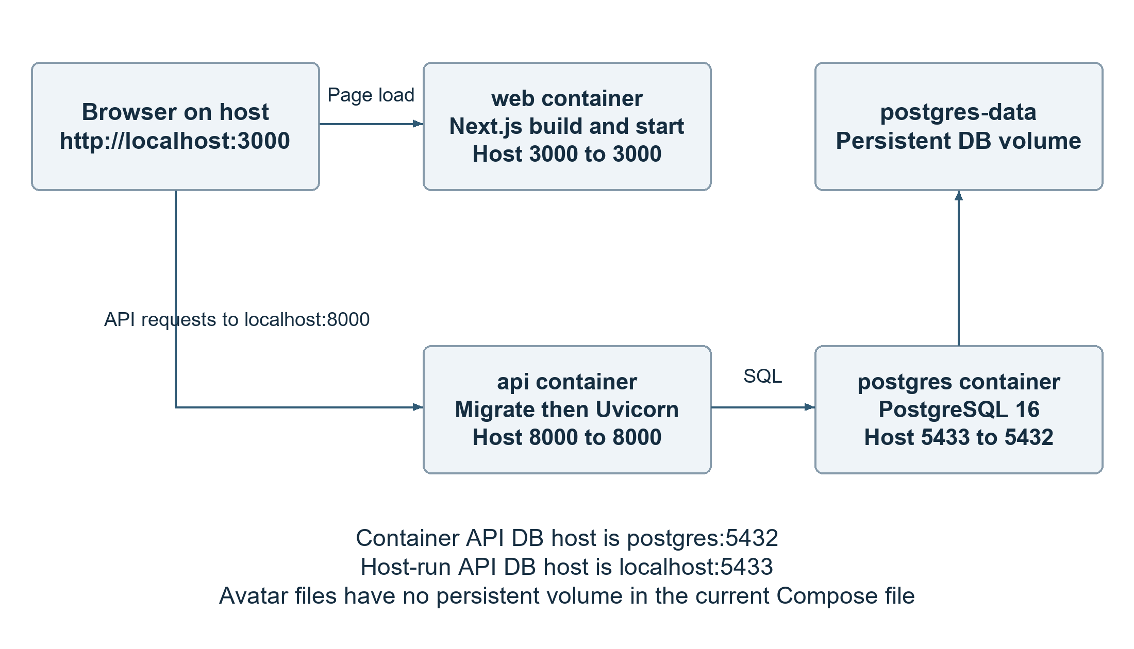
Figure 11 1 Current Compose services ports and persistence

11 5 Prepare the demonstration account
With the host API environment configured and migrations complete, run the seed module from backend/api in an isolated demo database. Do not run it against a personal or production dataset.
.\.venv\Scripts\python.exe -m scripts.seed_mock_data
The synthetic account is demo@example.com with the script-defined demonstration password DemoPassword123 when the user is first created. These credentials are public demo fixtures and must never be reused for a deployed account. An existing user with that email retains its existing password. A rerun modifies matching fixture records, so prepare or back up the demo state before rehearsal. [R11]
For a complete rehearsal, add a completed focus session through the interface and verify any expected growth point or forest state. Use a separate newly registered account for empty dashboard and no-task scenarios. Prepare a timezone example and a project deletion example without removing the main demonstration data.

11 6 Installation acceptance checks
Check | Expected result | Evidence to retain
API and database | API documentation opens and Alembic current equals the intended head. | Console output, runtime versions and revision identifier.
Registration and login | A new synthetic account can log in and retrieve its own profile. Invalid credentials do not grant access. | Test case and result from an isolated environment.
Task persistence | Create and update a task, refresh the browser and confirm stored values remain. | Task identifier and before or after values.
Project deletion | Deleting a disposable project moves its tasks to Inbox without deleting them. | Task count and project_id becoming null.
Cross-account isolation | A second user cannot read or mutate the first user's task or project. | Request and status without exposing another user's data.
Time and reporting | Deadline, completion and dashboard totals match the configured timezone and stored timestamps. | Chosen timezone, input values and expected totals.
Focus and media | A recorded focus session is reflected in activity; supported avatars load and invalid uploads are rejected. | Session fields, upload cases and persistence check.
AI and fallback | Enabled AI uses configured credentials; disabled or unavailable AI follows the implemented fallback behaviour. | Configuration mode and observed result without provider secrets.

Record actual outcomes with Phat's testing chapter. The expected results above are acceptance criteria, not completed test results. A successful source review or migration graph check must not be substituted for a clean installation, data upgrade or restore test.

11 7 Common installation problems
Symptom | Likely cause and response
Database connection refused | Check postgres container health and host port 5433. Use postgres:5432 only from the Compose network.
Missing tables or columns | Check the target DATABASE_URL, then Alembic current and heads. Back up existing data before applying migrations.
Frontend cannot reach the API | Confirm API port 8000, NEXT_PUBLIC_API_URL and browser reachability. Rebuild a production bundle after changing its public API URL.
Could not validate credentials | Check expiry, signing configuration and account activity. Clear the stale browser session and sign in again; do not disable token verification.
Seeded account password fails | An existing demo user is reused without resetting its password. Use the known isolated fixture account or recreate only the disposable demo environment.
Avatar disappears after container replacement | The current Compose file has no upload volume. Restore media from backup and add durable upload storage before relying on container recreation.
AI unavailable or limited | Check server-side AI configuration, provider credentials and request limits. Do not expose the key in frontend configuration.
Port already in use | Check existing processes or containers and choose a nonconflicting frontend port; update the browser address and relevant origin configuration.

11 8 Deployment and production readiness
The supplied Compose file is a local deployment configuration. PostgreSQL uses a named volume and an explicit health check. The API runs migrations before startup, but also enables reload and mounts source code. The frontend is built and started as a Next.js application. These facts do not establish a hosted production service, an automated deployment pipeline or an availability target.
Before public deployment, choose the hosting environment and public API address, remove development reload and source mounts, configure HTTPS and a restricted CORS allowlist, and isolate PostgreSQL from public access. Add durable storage for avatars and verify both database and media backups. Use a controlled release migration step rather than allowing multiple new API instances to compete for schema changes. Record the exact dependencies, runtime versions and image identifiers used for that deployment.
The root pnpm lockfile supports a frozen frontend install. Backend reproducibility needs additional attention because the Dockerfile currently installs declared dependency ranges through pip rather than enforcing an existing lockfile. The handover should resolve and validate that build policy before claiming that a later rebuild must install identical packages. No CI pipeline or production hosting result is established by the current local configuration. [R10, R12]

11 9 Backups recovery and maintenance
Back up PostgreSQL before migration or substantial demonstration-data changes, and keep a separate copy of the upload directory. Database backups contain account details, task content and password hashes and must be access-restricted. Record backup time, application revision, database revision and media location together. Define retention and deletion rules for backups as well as for the live database.
For a container database, the following example creates a PostgreSQL custom-format dump inside the container and copies it to a local backups directory that the operator creates beforehand. This avoids treating binary dump data as a PowerShell text stream. The dump file is an internal recovery artefact, not part of the submission.
docker compose exec -T postgres sh -lc '
pg_dump -U "$POSTGRES_USER" -d "$POSTGRES_DB" \
-Fc -f /tmp/chrono-backup.dump'
docker compose cp postgres:/tmp/chrono-backup.dump ./backups/chrono-backup.dump
A recovery drill should restore that dump into a separate empty recovery database using pg_restore, restore the matching media copy, apply only required subsequent migrations and run the acceptance checks against the restored instance. Verify ownership, project-to-Inbox behaviour, task totals, focus history and media URLs before considering any switch to the restored service. Do not overwrite the live demonstration database during a drill.
Normal docker compose down preserves the named PostgreSQL volume, but commands that remove volumes can destroy the stored database. API uploads are not protected by that volume and may disappear when the API container is replaced. A database-only backup cannot reconstruct those files. Avatar cleanup must distinguish currently referenced images from orphan files and follow an agreed retention policy.
Routine maintenance should check disk space, connectivity, migration state, API errors and upload growth. Review orphan images, protect telemetry and test dependency updates. Keep schema changes in reviewed migrations. If an upgrade fails, stop mutations, preserve logs and recover from a verified backup or a reviewed corrective migration; a downgrade cannot recover deleted data.

11 10 Source code handover
Minh's handover joins the source code, schema history, environment examples and operating instructions into a reproducible package. The receiving member should be able to start the same application without using the original developer's environment files or personal database. A clean checkout and a second-member installation are the final practical checks.
Handover item | Required content or action | Status for final submission
Release identity | Agree the final commit or tag with Nhan after local changes are reviewed and included. | Record at release freeze.
Source and dependencies | Include application source, package manifests, pnpm lockfile, Python dependency or lock policy and Dockerfiles. | Source present; resolved build must be recorded.
Schema history | Retain all 32 migrations and verify the final head against a clean installation and supported upgrade copy. | Static graph checked; runtime evidence required.
Environment templates | Provide placeholders and explain URLs, secret generation, optional AI configuration and ports. | Review example values and remove reusable secrets.
Demo and clean states | Provide isolated seed instructions, synthetic login and prepared focus or forest scenarios; retain a blank account. | Seed source present; rehearse and record results.
Recovery package | Document DB and media backup locations, retention and a restore drill. | Create and verify before operational handover.
Security review | Exclude personal data, real environment files, tokens, keys and private dumps from the submission. | Complete review before distribution.
Independent reproduction | Ask another member to install from the final source package and record issues and fixes. | Attach actual reproduction result.
Report integration | Supply database and deployment facts to Chapters 4 and 13 and merge shared Chapters 5 and 9. | Confirm with Nhan, Duy and the team.

Source References
Repository paths below are relative to the project root. Source references identify implementation locations for integration into the final report; the team should attach the agreed release revision when the submission is frozen.
[R1] CHRONO A5 - Task allocation.pdf, pages 5 and 6 for Nhat Minh responsibilities and page 12 for report chapter ownership.
[R2] frontend/web/lib/api.ts; frontend/web/lib/auth-session.ts; frontend/web/components/auth/current-user-provider.tsx. Browser API address, tokens and session recovery.
[R3] backend/api/app/main.py; backend/api/app/config.py. Route composition, local CORS, media mount and environment settings.
[R4] backend/api/app/database.py; backend/api/alembic/env.py. Engine, request sessions, shared metadata and migration configuration.
[R5] backend/api/app/auth/models.py, schemas.py, security.py, dependencies.py and service.py; backend/api/app/settings/models.py; backend/api/app/timezones.py. Account controls, profile handling and timezones.
[R6] backend/api/app/projects/models.py and service.py; backend/api/app/folders/router.py; backend/api/app/tasks/models.py, service.py and overdue.py; backend/api/app/notifications/models.py; backend/api/app/dashboard. Core records, task lifecycle and aggregation.
[R7] backend/api/app/focus/models.py; backend/api/app/gamification/models.py. Focus records, forest data and reward constraints.
[R8] backend/api/app/scheduling/models.py; backend/api/app/ai/models.py and README.md; backend/api/app/tasks/duration_estimation/models.py. Scheduling proposals, weekly insights, telemetry and duration decision persistence.
[R9] backend/api/alembic/versions. Full 32 revision history, including e7f4a2c91b63, a3f7c2e91b64 and d7b2a6e14f09.
[R10] docker-compose.yml; backend/api/Dockerfile; frontend/web/Dockerfile; .dockerignore. Ports, startup commands, volumes and build behaviour.
[R11] backend/api/scripts/seed_mock_data.py. Synthetic demo account, project and task fixtures and rerun behaviour.
[R12] package.json; pnpm-lock.yaml; backend/api/pyproject.toml; backend/api/uv.lock; uv.lock; .gitignore; environment example files. Runtime and dependency configuration and handover exclusions.
[R13] backend/api/tests/conftest.py; backend/api/tests/infrastructure/test_database.py. Database fixtures and infrastructure checks; fresh migration and restore results require separate execution evidence.

