5 System Architecture
Chrono combines task planning, scheduling, focus sessions, productivity insights, and Personal Forest progress in a responsive web application. Its architecture separates the browser interface, application services, and saved records. Desktop and mobile layouts use the same services, so a task has one stored identity whether it is viewed in a list, calendar, or dashboard.

5 1 Overall architecture
Next.js and React provide the browser interface. FastAPI authenticates requests, checks record ownership, and runs the feature services. SQLAlchemy connects those services to PostgreSQL, while Alembic manages changes to the database schema. The browser communicates with the API rather than connecting directly to the database.
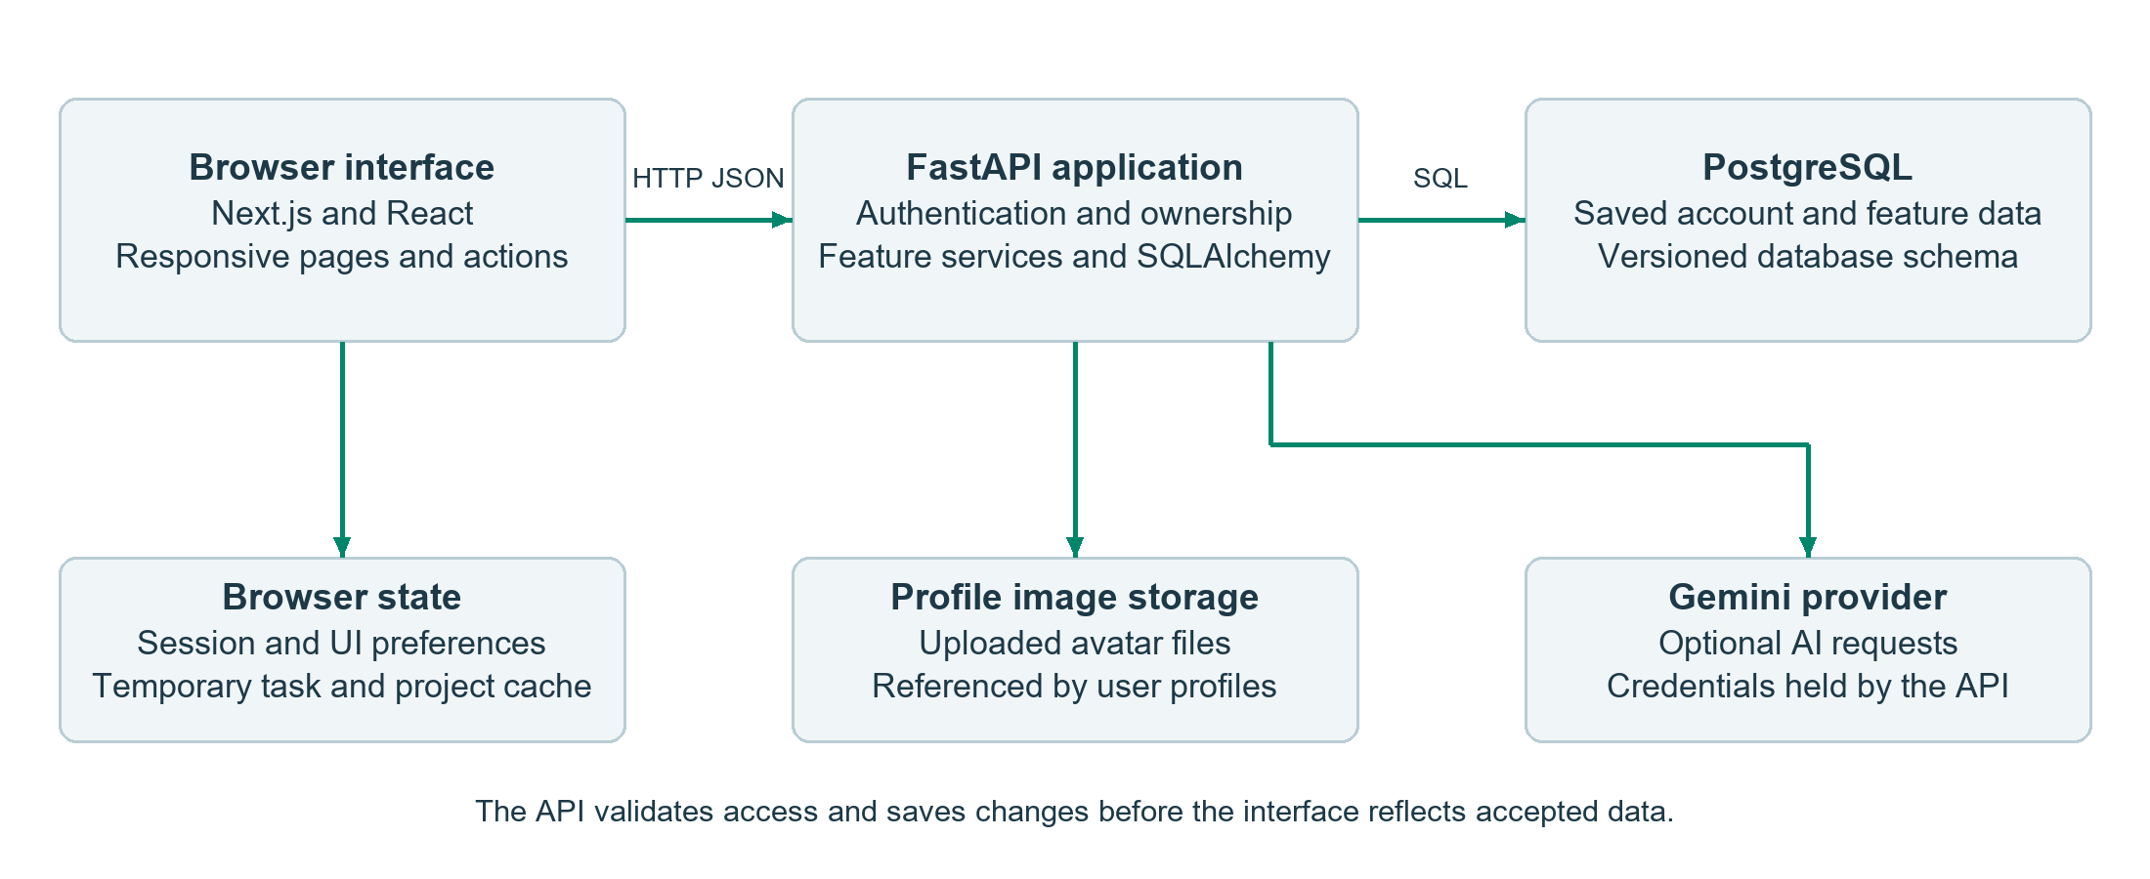
Figure 5 1 Application components and external service boundaries
Gemini requests originate from the API, keeping provider credentials outside the browser. Uploaded avatars use file storage, while account records retain their image references. Local session information, interface preferences, and temporary response data support browser behaviour; PostgreSQL remains the source of saved application records.

5 2 Frontend routing and shared layouts
The frontend uses the Next.js App Router. A root layout applies the global fonts, styles, and interface preferences. Public sign-in and registration pages use a shared authentication layout. Feature pages sit within a dashboard route group and reuse DashboardShell, which provides session verification and the authenticated workspace. The route-group name organises the source without becoming part of the browser URL.
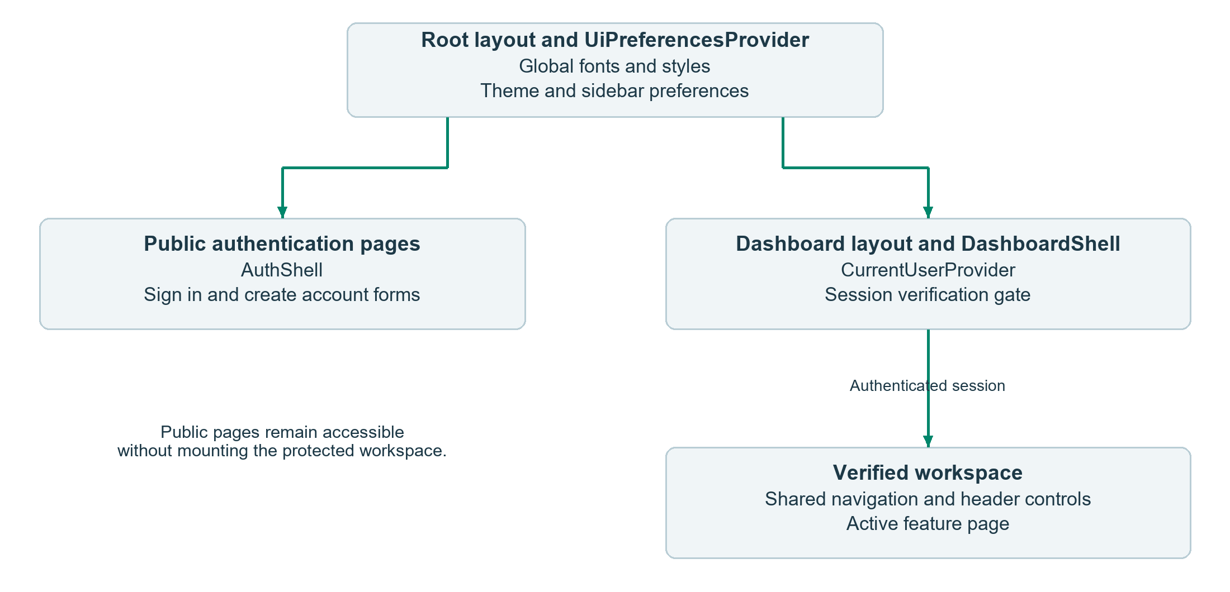
Figure 5 2 Shared layout composition and session boundary
Shared components provide the desktop sidebar, mobile bottom navigation, search, notifications, XP feedback, avatars, and page headings. The active feature page supplies its content within that shell. The layout stays shared while navigation changes the current feature; it does not keep every feature screen mounted in the background.
Interactive forms, menus, timers, and page controls use client components. Route entries provide composition, while feature components and hooks manage the current interaction. The page-entrance animation follows route changes and respects the browser’s reduced-motion preference.

5 3 State management and component responsibilities
Chrono uses React state, context, and feature hooks to give each kind of state a defined owner. Forms and selections stay close to the page that uses them, while account and appearance state are shared across the workspace. The session controller exposes updates through React’s external-store subscription mechanism.
State or responsibility | Owner | Lifetime or saved source
Verified user and session | CurrentUserProvider and session controller | Verified through the API; browser token supports the session.
Theme and navigation appearance | UiPreferencesProvider | Saved in the browser.
Task rows, totals, and feature summaries | Feature hooks and page components | API data held in the active view; eligible reads also use a temporary memory cache.
Form values, filters, and selections | Relevant form or feature page | Local interaction state, with selected task and creation parameters also carried in navigation.
Focus countdown | Focus timer hook | Local timer state and restoration snapshot, reconciled with the active API session.
Work and notification preferences | Account Settings | Saved account settings returned by the API.
The Tasks feature separates page coordination, loading, mutations, and list presentation. Calendar and Focus follow similar divisions. Shared request and domain helpers keep API operations outside the visual components, while the page remains responsible for loading indicators, validation messages, and the current selection.
Stored data and displayed state have different meanings. For example, Pending, In Progress, and Done are task workflow states; Overdue is calculated from an unfinished task’s deadline. Completing a task records a completion time used by reporting, rather than treating an arbitrary edit as completed work.

5 4 API integration and data updates
Typed domain helpers describe task, project, profile, settings, focus, and other API operations. A shared apiRequest helper resolves the public API address, attaches the current Bearer token where required, sends the request, and turns failed responses into structured errors. Public authentication requests do not use an existing token, and avatar uploads use multipart form data.
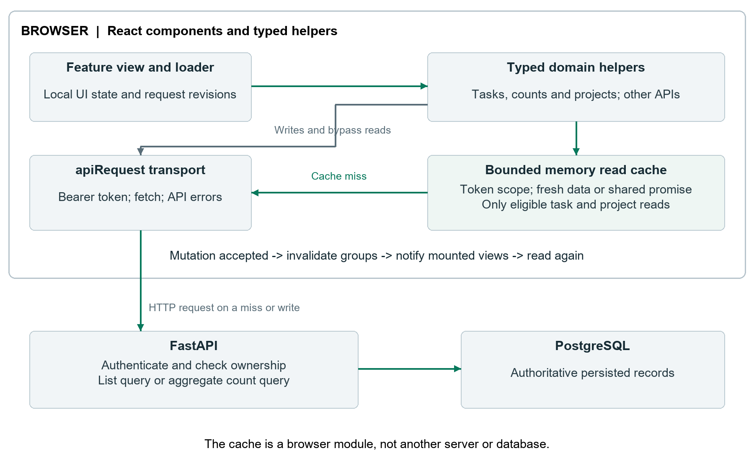
Figure 5 3 Feature requests and temporary browser response storage
Eligible task-list, status-count, and project reads can reuse recent responses or share a matching request already in progress. Abortable task-list callers keep independent requests. The bounded cache is held in browser memory and cleared when authentication changes. Task and project mutations invalidate the relevant cached groups before notifying subscribed views to reload.
Tasks now retrieves its rows, one aggregate status-count summary, and project choices. This replaces five separate status-list requests, reducing a cold Tasks visit from seven feature reads to three. Shared navigation and header requests are additional. The change uses existing database records and requires no new table, column, or schema migration.
Update notifications operate within the current browser window. They do not provide continuous synchronisation across tabs or devices. Each feature handles its own loading, retry, and refresh behaviour; selected views use cancellation or request revisions to avoid applying superseded results.

5 5 Sign in and protected routes
Sign-in sends the submitted credentials to the API. On success, the authentication helper stores the issued access token and navigation enters the dashboard. The shared session provider then requests the current user before mounting the protected workspace. Figure 5 4 shows the successful path.
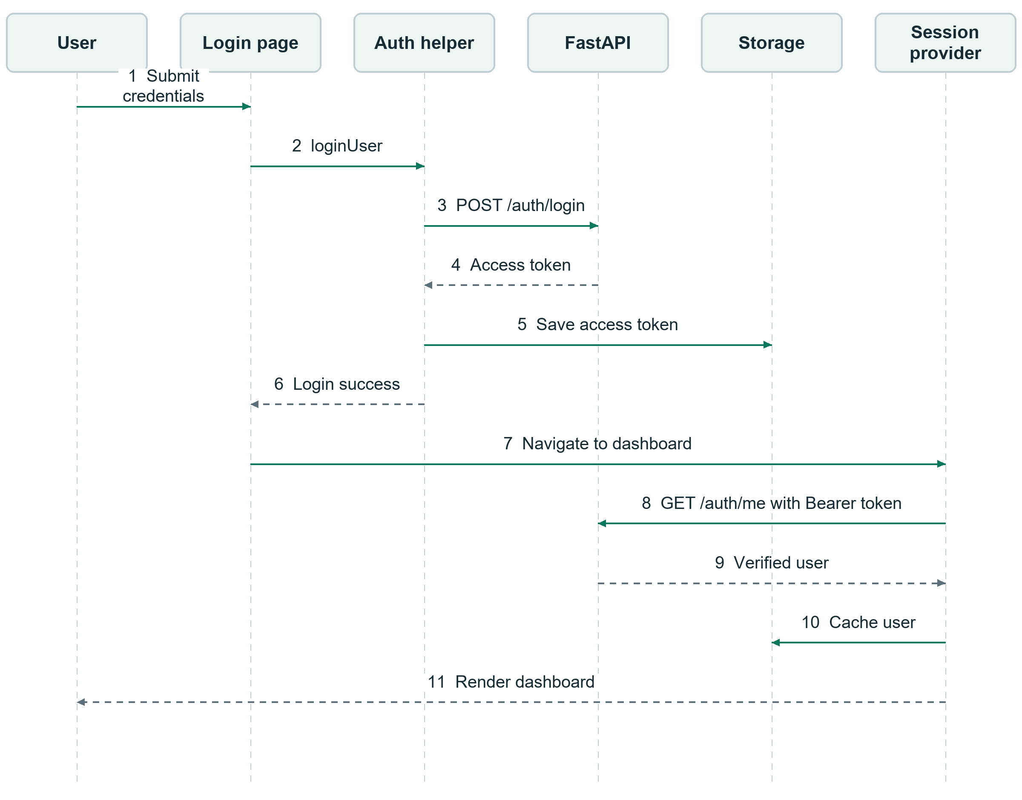
Figure 5 4 Sign in and session verification sequence
The session gate distinguishes checking, authenticated, unavailable, and unauthenticated states. Missing or invalid credentials lead back to sign-in. A temporary verification failure offers retry instead of treating every connectivity error as a logout. Navigation, notification, and XP loaders mount after verification, so they do not compete with the session check.
The browser gate controls what is rendered; FastAPI still authenticates requests and enforces ownership. A cached profile is not an access decision. After successful verification, timezone detection runs as a supporting operation and does not determine whether the session is valid.

5 6 Task creation and refresh
Task creation begins in a dialog within the current page. The form validates the supplied details and passes a typed task payload to the task helper. The API checks the account and any project reference before saving the record. A successful response triggers cache invalidation and a task-change notification; mounted consumers can then retrieve current data.
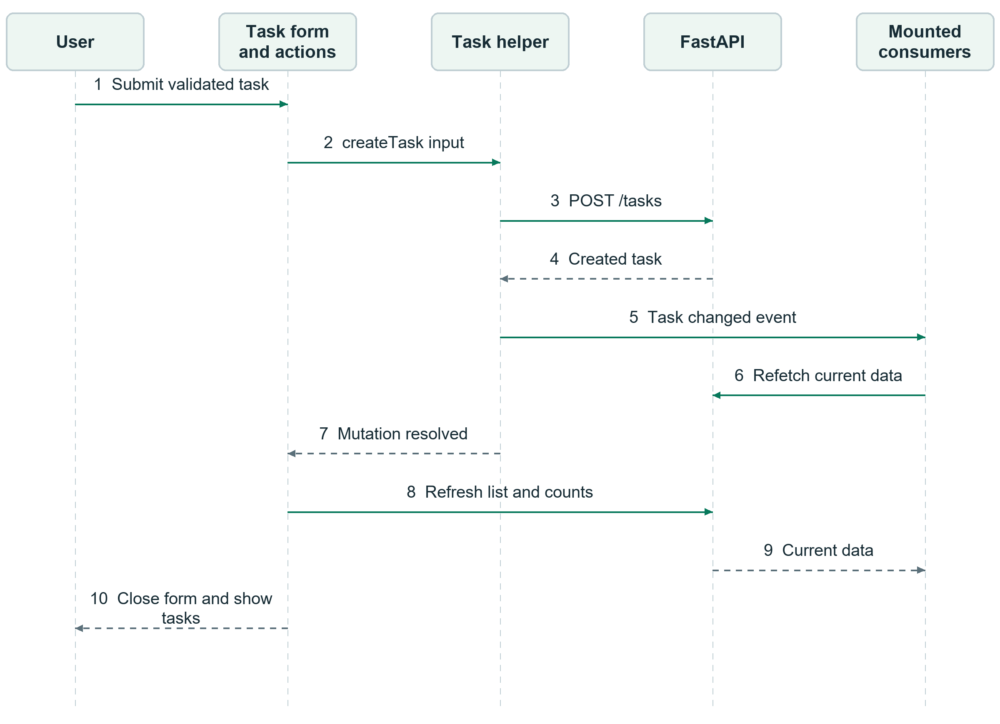
Figure 5 5 Task creation and affected view refresh sequence
The sequence shows both event-driven refresh and the explicit refresh performed by the action callback. Eligible matching reads can share pending work through the cache. If creation fails, no successful task-change event is emitted and the form presents the error. AI task generation follows a preview-and-confirm flow so proposed content is reviewed before it is saved.

5 7 Dashboard updates and progress feedback
The dashboard requests an aggregate summary containing daily progress, focus goal, streak, overdue totals, task suggestions, task lists, weekly activity, and optional forest information. Completing a Quick Win updates its task through the same task helper used by other views. Figure 5 6 follows the task update, summary refresh, and optional reward feedback.
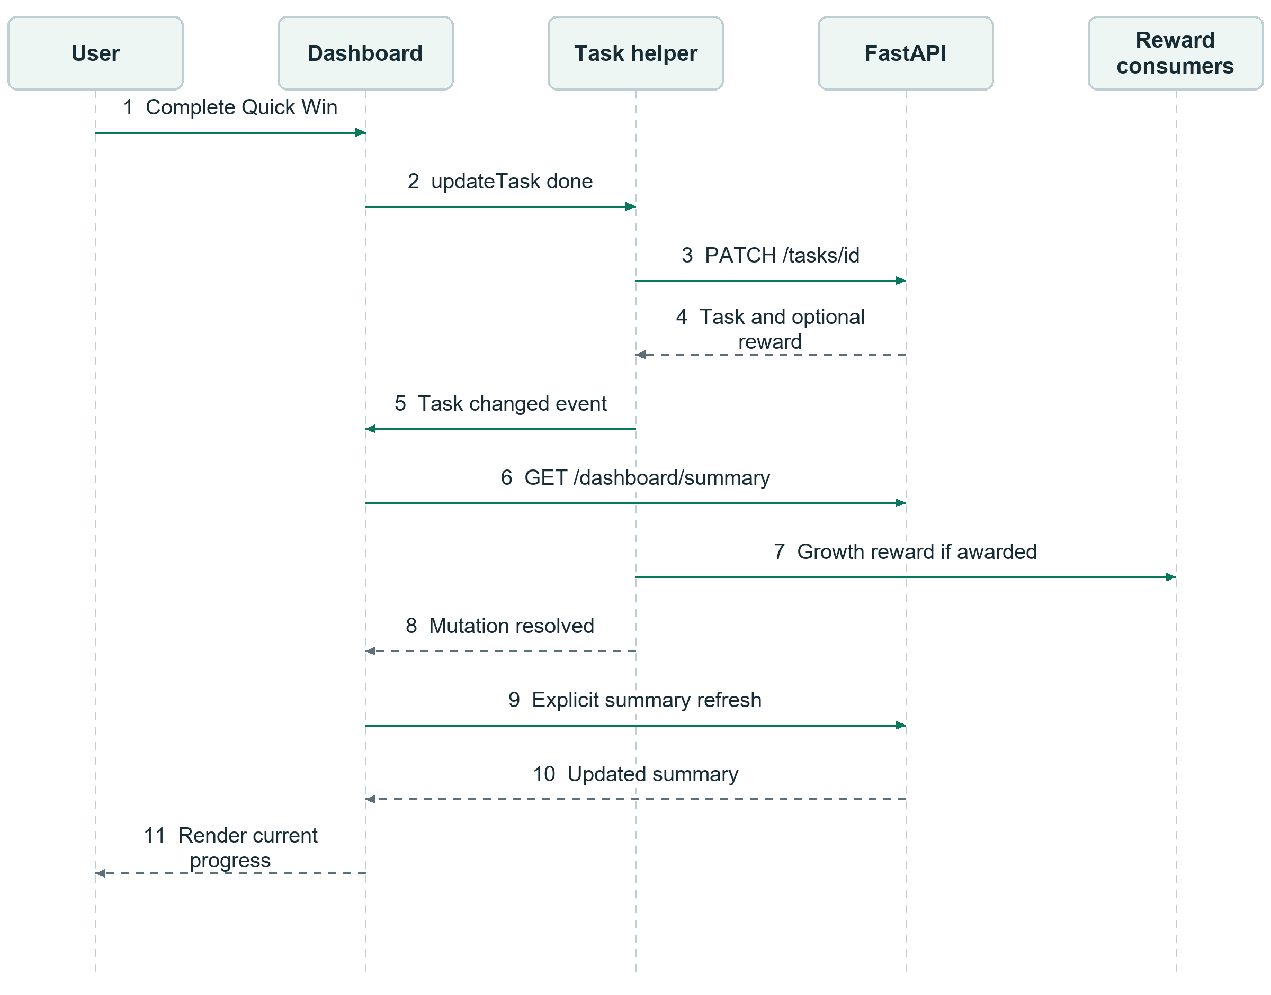
Figure 5 6 Completing a Quick Win and updating the dashboard
The dashboard listens for task and settings changes and also explicitly refreshes after its Quick Win action. These paths can overlap; dashboard summary requests do not currently use the task-and-project read cache. Initial loading and failure states provide feedback and retry, while an existing summary can remain visible during a refresh.
When a response awards growth points, reward consumers update the displayed balance and progress feedback. The sequence describes the current integration and does not imply that every change in another tab or on another device reaches the dashboard automatically.

6 Frontend and UI UX Design
Chrono’s interface brings daily planning and progress into a consistent workspace. The current design retains the navy and green identity of the earlier prototype while applying a less is more approach: fewer repeated labels, clearer primary actions, a light theme, and content placement suited to desktop and mobile use.

6 1 Navigation and screen map
Home provides the daily overview. Tasks and Calendar support planning, while Focus, AI Insights, Notifications, and Personal Forest provide related activity and progress views. Account brings profile details and personal preferences together. The map groups destinations around the dashboard for readability; shared navigation also lets people move directly between feature pages.
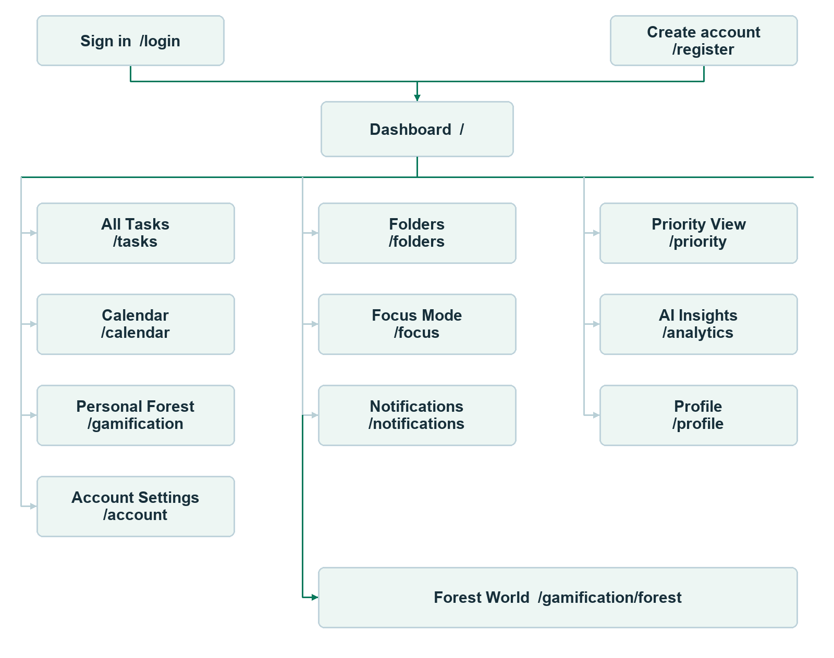
Figure 6 1 Main screens and navigation relationships
Mobile navigation prioritises Home, Tasks, Calendar, and Account, with a central create-task action. Desktop uses a wider sidebar for more direct access to supporting views. AI Insights and Personal Forest remain accessible through Account on mobile.

6 2 Visual hierarchy and themes
The current interface builds on the earlier prototype while keeping Chrono’s recognisable navy and green identity. Recent design changes make pages easier to scan, reduce duplicate labels and controls, introduce a coordinated light theme, and adapt content placement to desktop and mobile screens. The following sections describe the experience people see when they use the app.

6 2 1 Less is more
The design follows a less is more approach: each card has a clear purpose, with its title close to the information it describes. Task cards prioritise the task name, due date, priority, project, and next action. On mobile, secondary details and repeated controls are reduced so people can scan their work without opening every task. Compact cards use only the space their content needs, while dates and status colours keep important context visible.
On mobile, the bottom navigation provides direct access to Home, Tasks, Calendar, and Account, with task creation at the centre. Desktop navigation offers more direct links to supporting views, taking advantage of the wider screen. The same features remain available across screen sizes; only their placement changes to keep the mobile view focused.

6 2 2 Light and dark themes
Chrono now offers both dark and light themes. Dark mode pairs deep navy surfaces with bright green accents; light mode uses pale backgrounds, white cards, and dark text with a deeper green accent. The themes retain the same hierarchy and controls, so changing appearance does not change how a page works.
Green marks primary actions, selected navigation, and completed work. Red, yellow, and green distinguish Pending, In Progress, and Done; separate text labels keep status clear without relying on colour alone. Priority badges use their own High, Medium, and Low labels, while project colours identify task groups. Theme selection is available from the desktop header and from Account Settings on mobile. The authentication artwork retains its dark presentation in both themes.
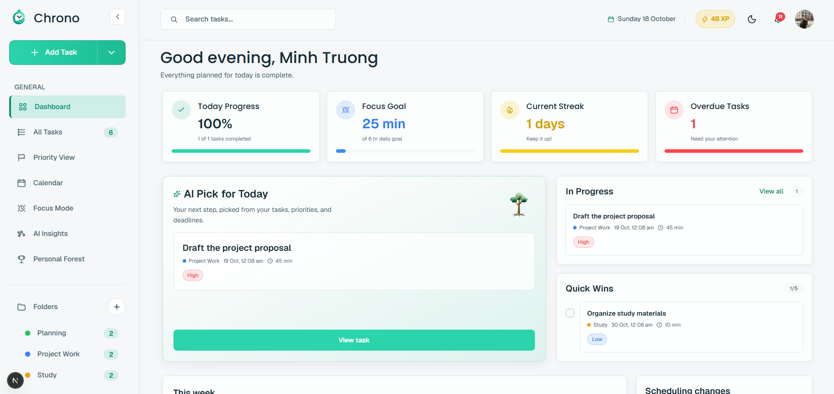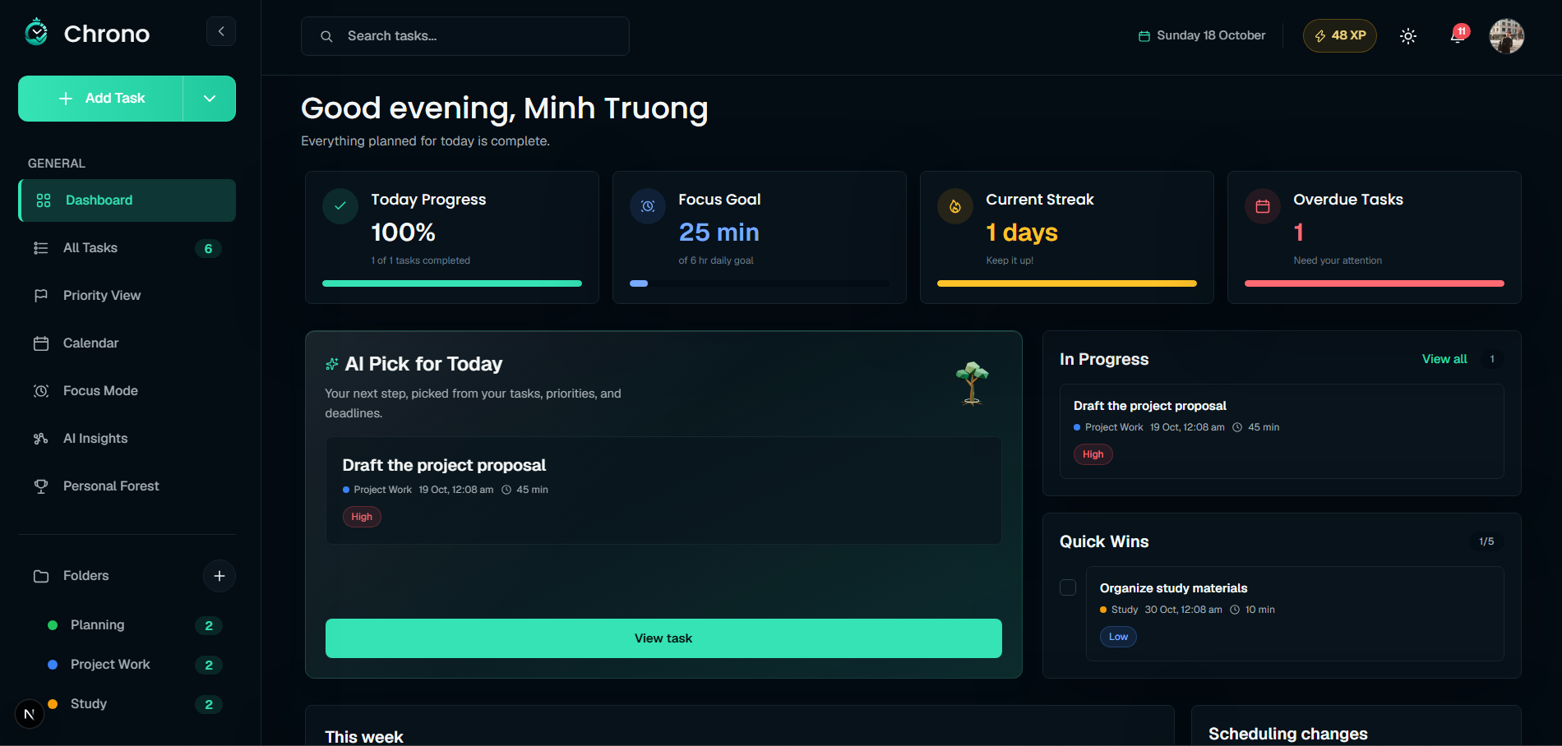
Figure 6 2 Dark and light workspace themes

6 3 Sign in and account creation
Sign-in and account-creation pages use short, direct headings and retain Chrono’s mountain artwork. On desktop, the illustration fills about 60 percent of the layout and the form 40 percent, with a soft transition between them. The logo sits at the upper left and the supporting slogan at the lower left. On mobile, the artwork moves above the form and the page becomes a single vertical flow.
Filled input bars, leading icons, and rounded corners create a consistent form style. The main action spans the form width, with the link to the alternate account flow beneath it. Google and Facebook appear as equal-width buttons for demonstration; they are visual mock-ups and do not currently sign users in through those providers. The main design changes are the clearer image-to-form balance, softer transition, and mobile-first vertical arrangement.
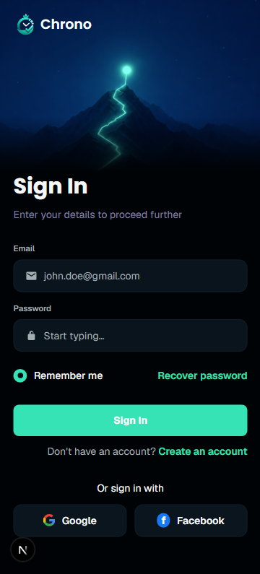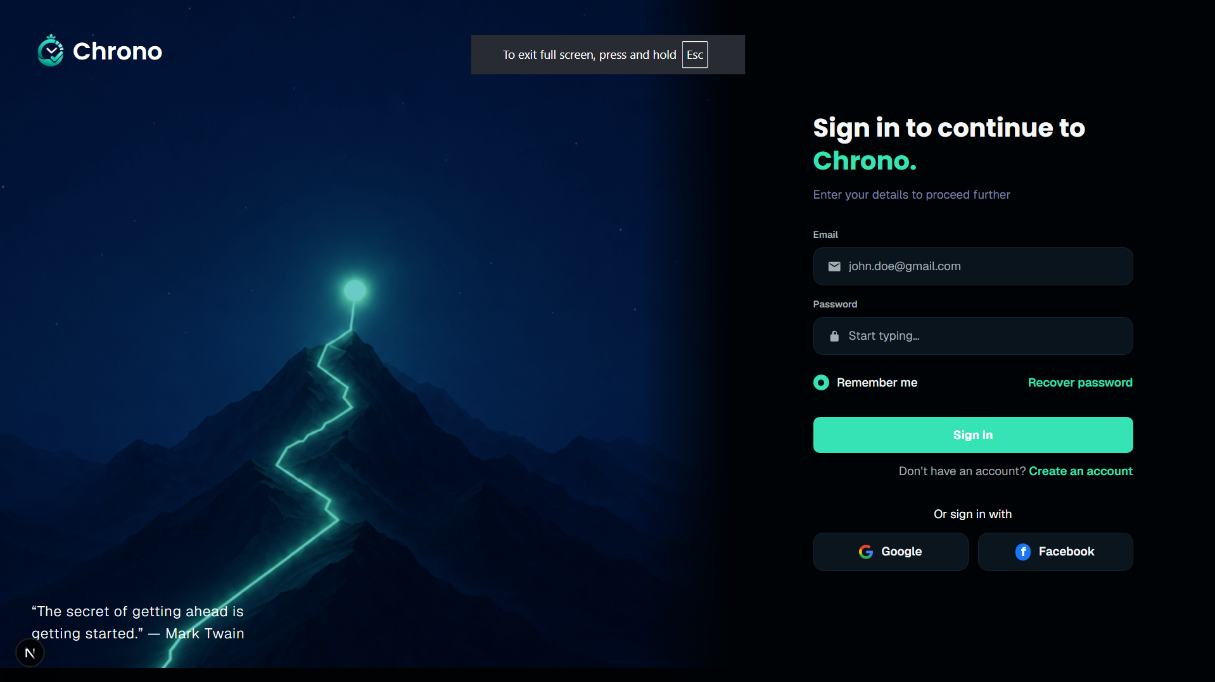
Figure 6 3 Responsive authentication layout

6 4 Home dashboard
The Home dashboard brings daily progress, focus goal, streak, and overdue tasks into summary cards, followed by AI Pick for Today, In Progress, Quick Wins, and weekly activity. Each title sits inside its card beside the information it describes. Duplicate page-level labels are removed, and related actions such as View all stay with the card they affect. The result is a calmer overview that still offers a quick route from progress to the next task.
The dashboard adapts to the available space: desktop arranges cards in a grid, while mobile stacks the main sections and keeps the compact overview cards easy to scan. Notification and XP controls keep alerts and growth feedback visible. The card layout gives the daily overview room to breathe while keeping the next task close at hand.
Poppins gives prominent card titles a clear hierarchy, while the app’s body type is used for supporting copy and controls. The AI recommendation and weekly insight use a small sparkle icon to identify AI-generated guidance. Short titles sit above concise explanations, making each card easy to understand at a glance.
Personal Forest displays the available Growth Points beside the page introduction on desktop, with the balance aligned to the right. On narrower screens, the balance moves beneath the title and supporting text. This keeps the points easy to find while leaving room for the forest and plant choices.
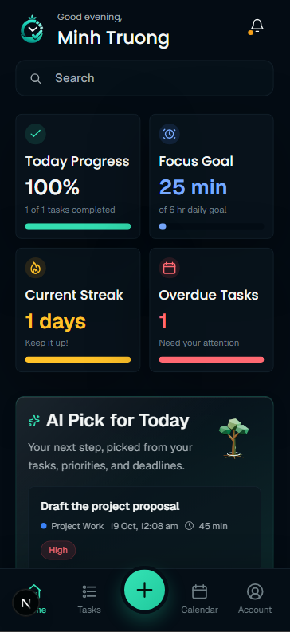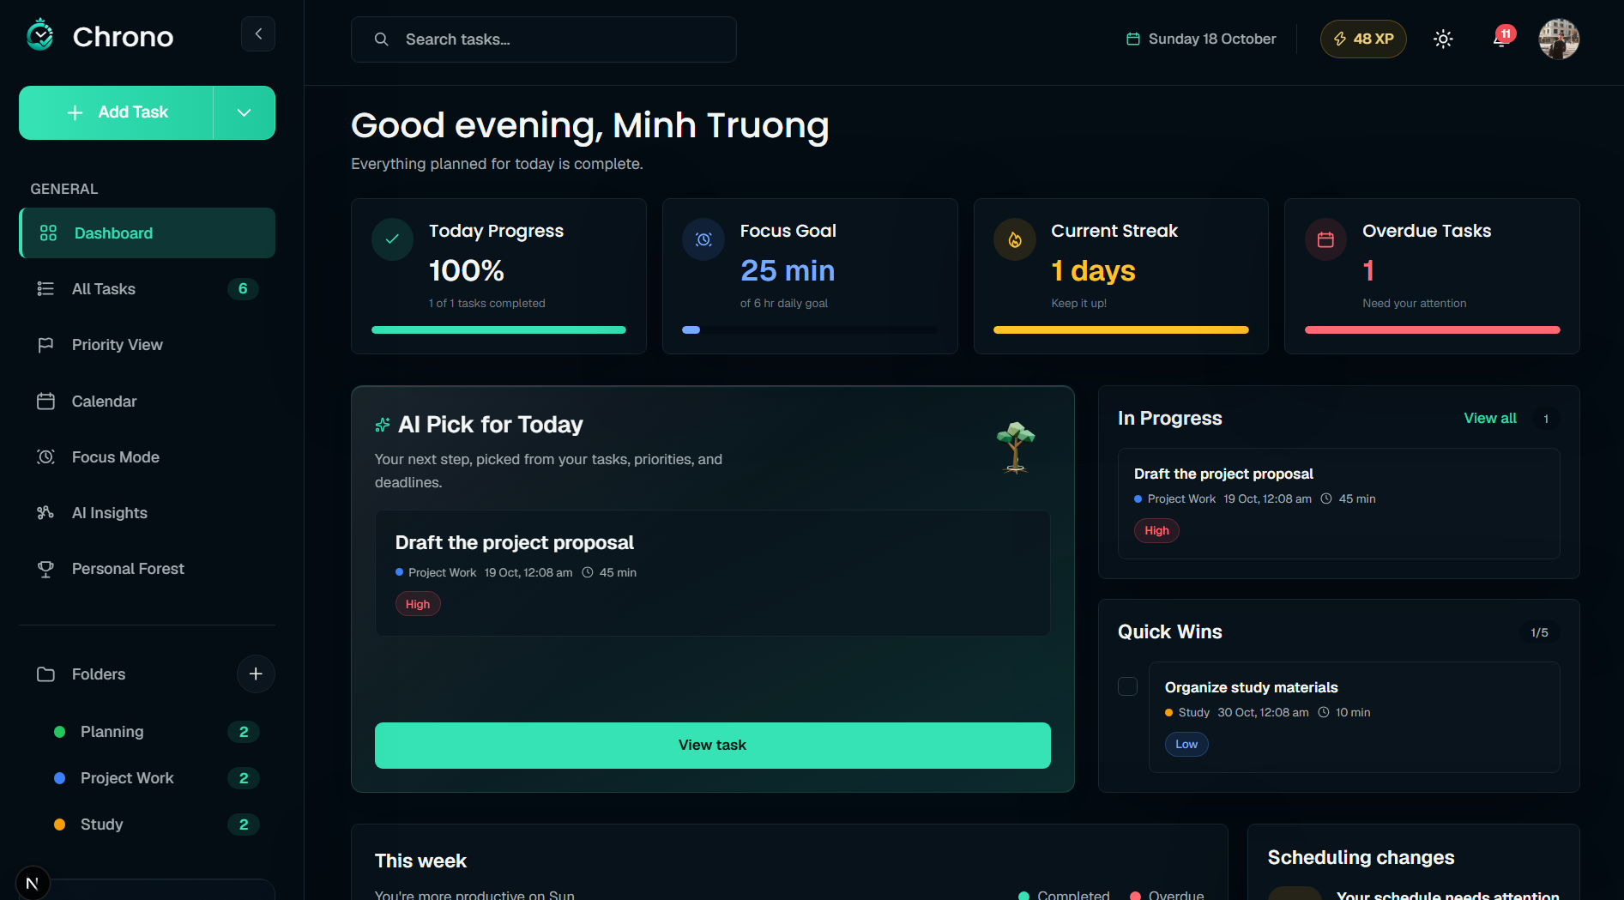
Figure 6 4 Home dashboard cards and daily planning

6 5 Tasks and calendar

6 5 1 Task management
Tasks combines search, status and priority filters, sorting, and task actions. On desktop, a table supports scanning and comparing many tasks; on mobile, compact cards put the task name, due date, project, priority, and completion action within easy reach. Overdue information appears beside the task where relevant. Filter and sort controls remain together and can scroll horizontally when space is limited, avoiding awkward wrapping at narrow widths or high zoom.
Task creation opens without leaving the current page, so people can return to the list or calendar where they started. The dialog offers Generate tasks, Break down, and manual entry. AI-suggested content is presented for review and confirmation before it is added. Typography and selection colour distinguish the dialog title, active mode, and supporting controls while keeping them consistent with the wider app.
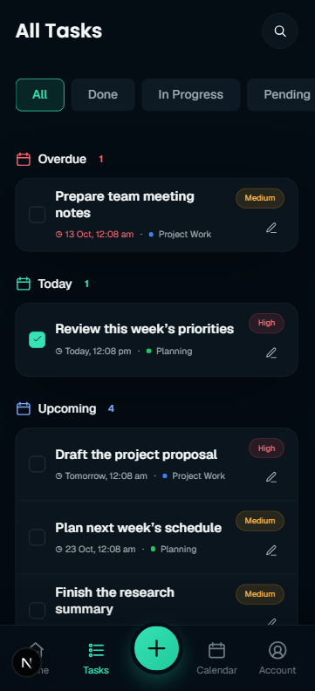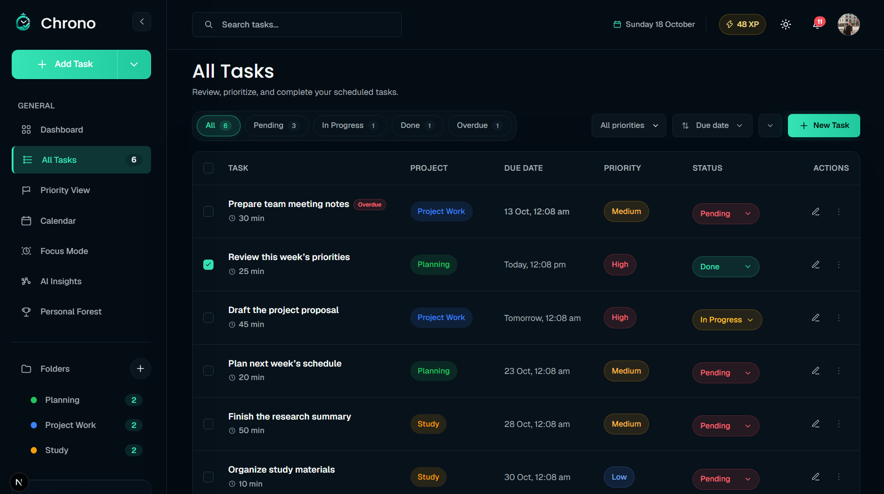
Figure 6 5 Tasks on desktop and mobile

6 5 2 Calendar views
Calendar uses the same task-card treatment, so people can recognise and complete a task without learning a second interaction pattern. Date groups and calendar placement provide the time context that does not need to be repeated on every card. Together, the table, compact cards, and calendar views support both broad planning and quick task updates.
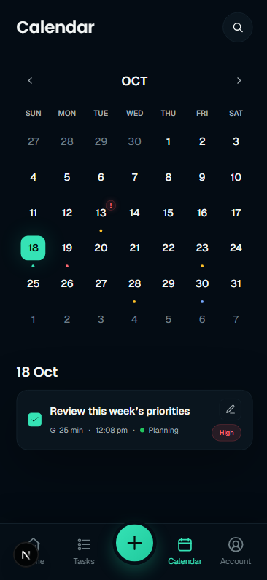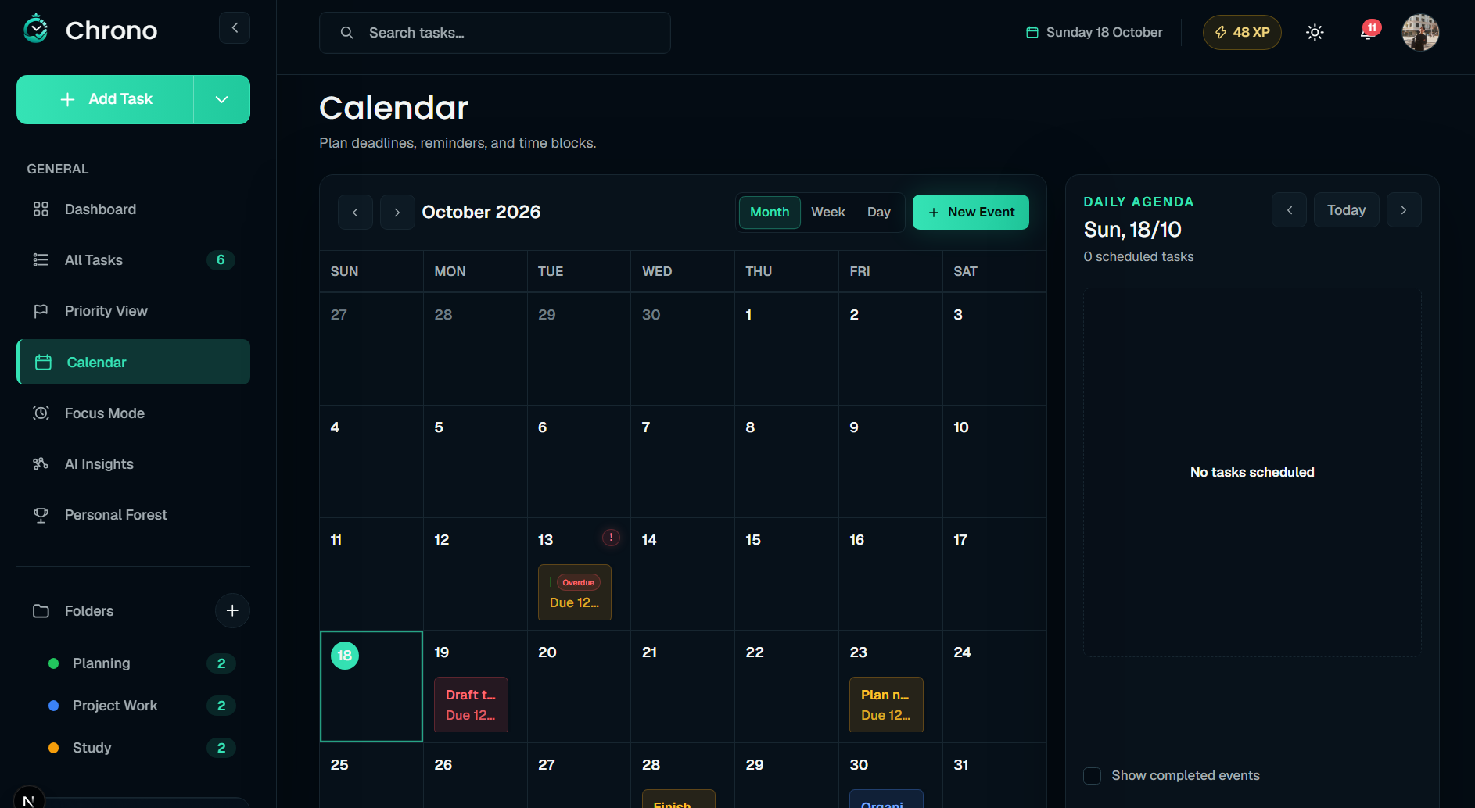
Figure 6 6 Calendar on desktop and mobile

6 6 Account settings
Account Settings brings profile information and personal preferences together. On desktop, a navigation column lists Account, Notifications, Theme, Work preferences, and Scheduling priorities beside the selected content. Log out appears beneath the navigation. On mobile, the account summary leads into Private information, Your progress, and Preferences; preference rows open within the page, and Log out remains at the bottom of the scrolling content above the bottom navigation.
The Account view presents a profile summary, private information, and links to AI Insights and Personal Forest. Mobile uses clear section labels and separators while preserving the app’s spacing; desktop uses full-width content cards beside the settings navigation. People can update their name, while email is displayed as account information. Profile, insights, and forest pages provide a clear route back to Account.
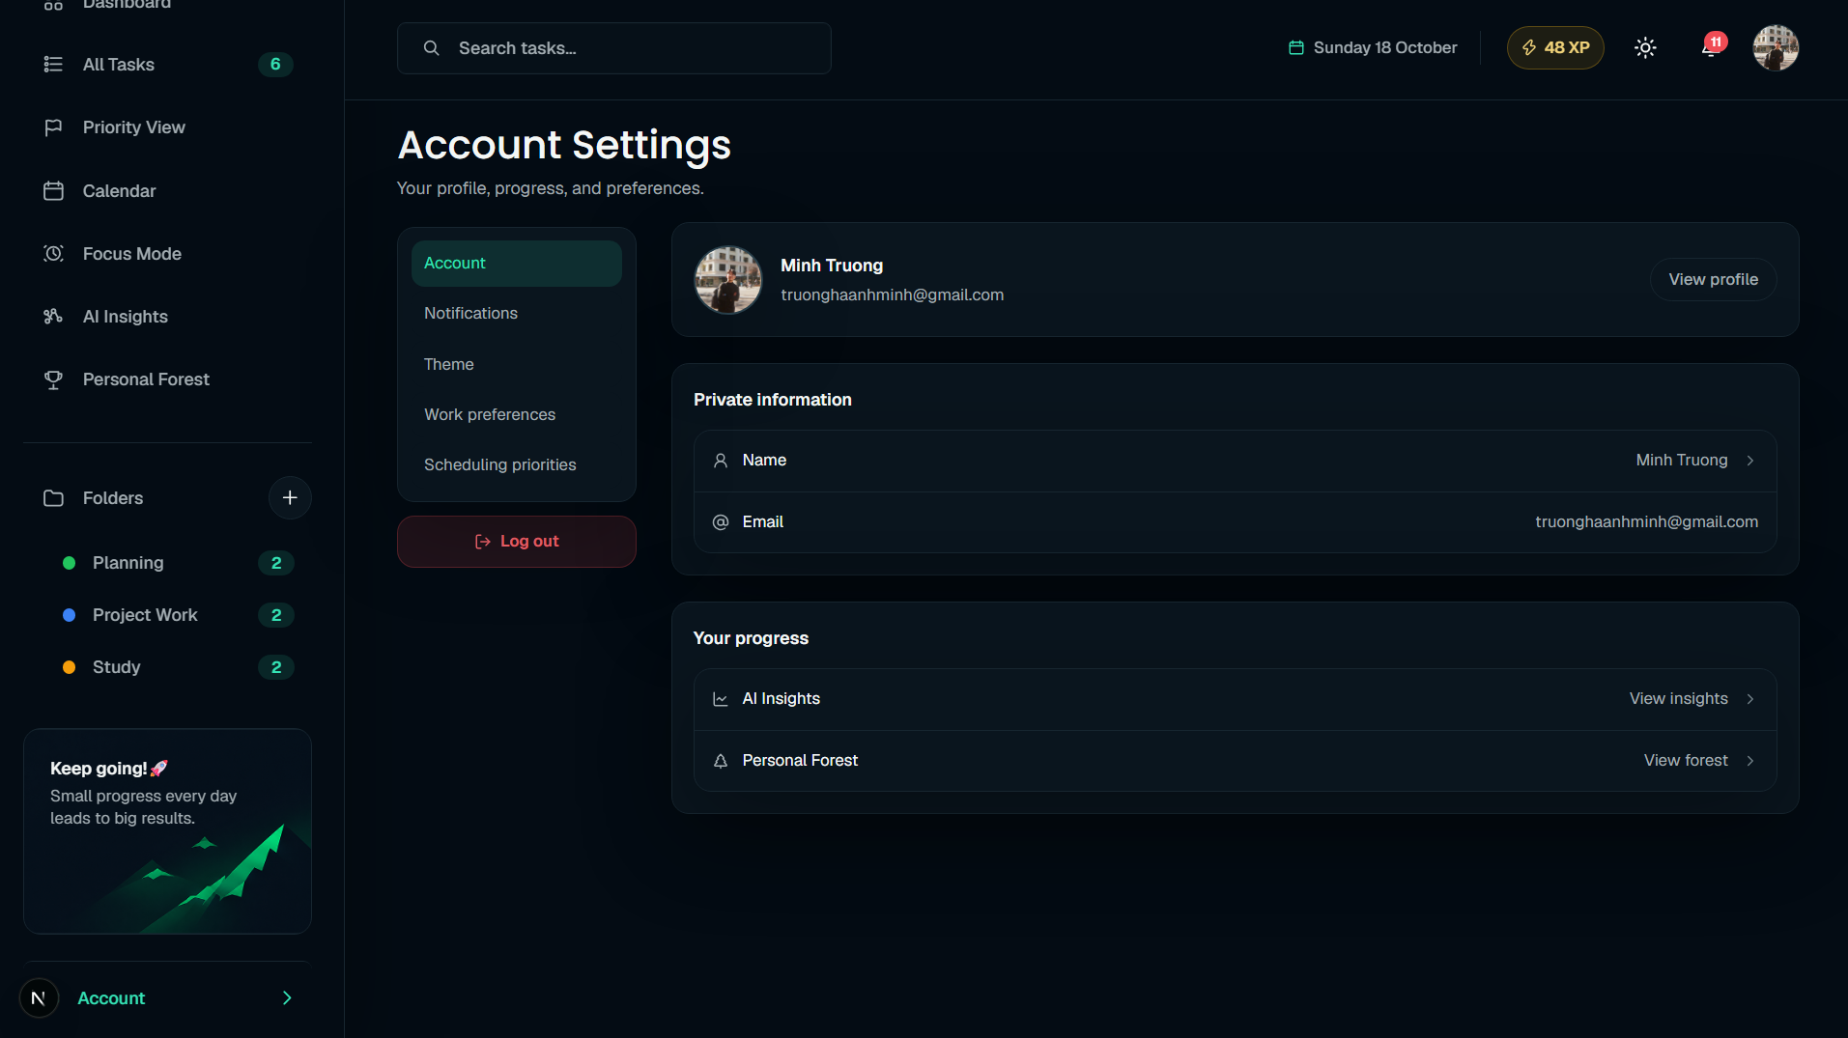
Figure 6 7 Account settings navigation and content

6 7 Profile details
Profile details separate identity editing from account information. On desktop, My Profile occupies one column, with Account Security and Account Access in the other; on mobile, the sections stack vertically. First name and Last name appear together, followed by a full-width Save changes action.
A green camera icon over the avatar opens image selection without adding a separate image button. Account Security shows read-only email and account type, while Account Access shows account status and membership details. The page focuses on profile editing and account information; it does not currently provide password-change, two-step verification, or support-access controls.
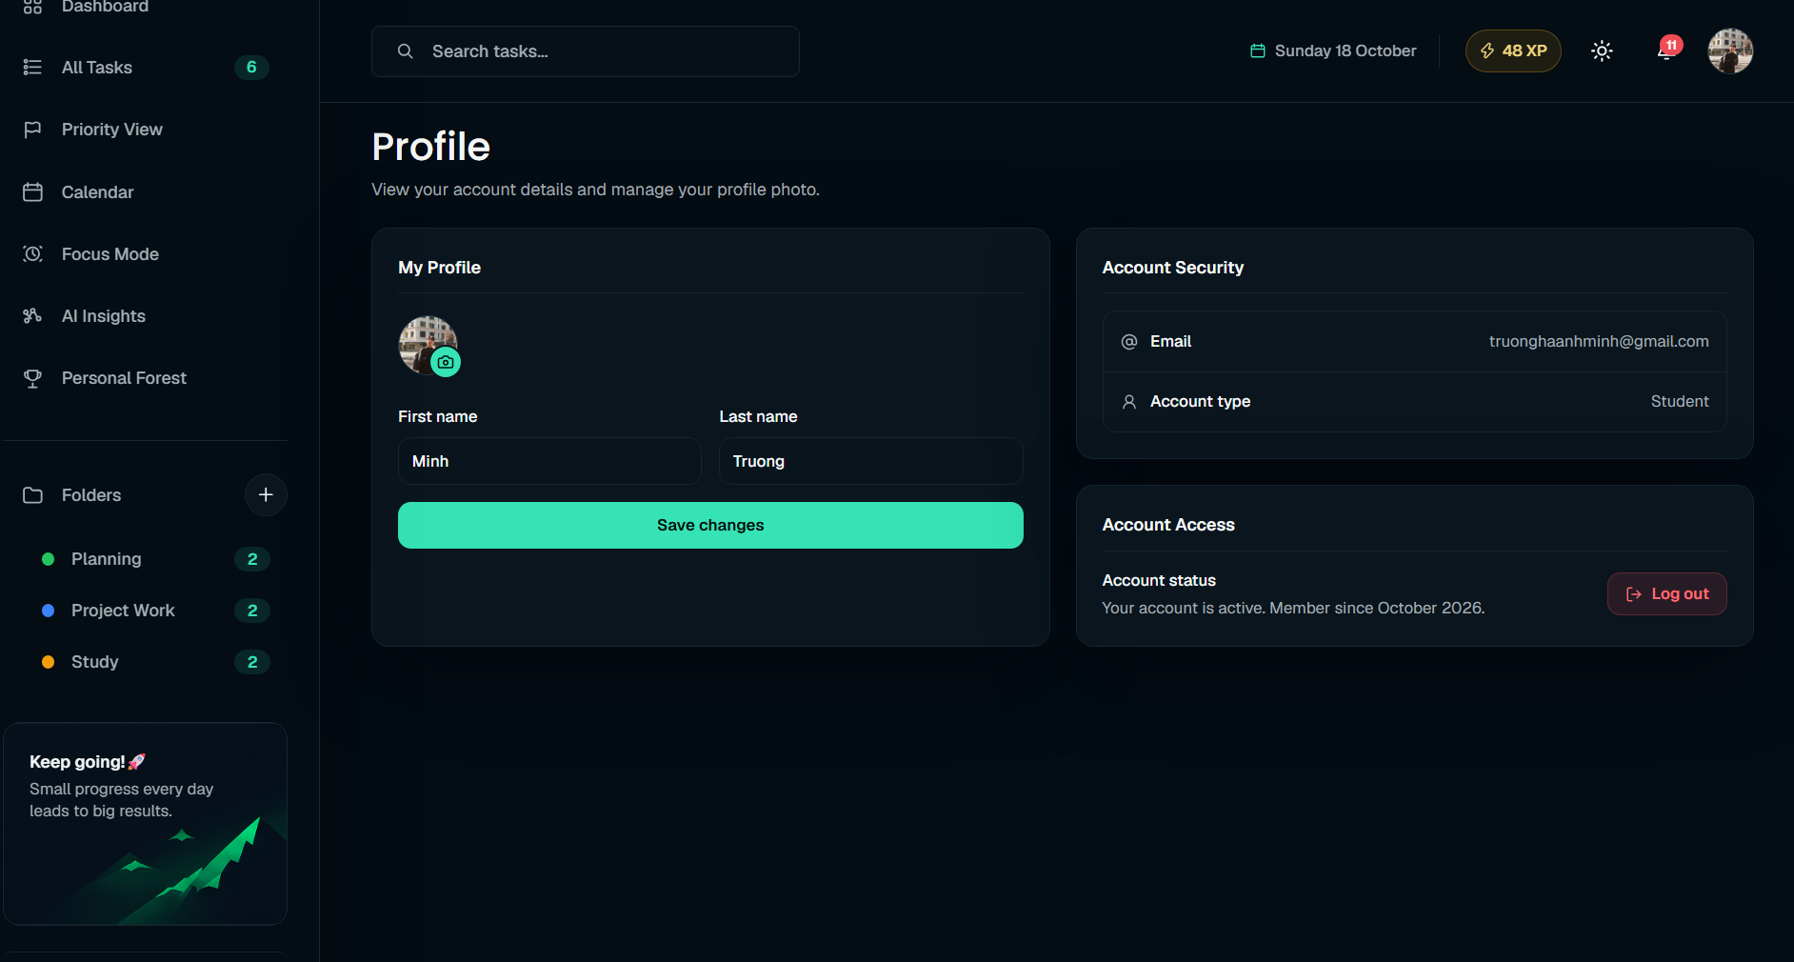
Figure 6 8 Profile editing and account information

