6 Frontend and UI UX Design
The current Chrono interface extends the A4 prototype through a less is more approach. The earlier prototype established the dark navy and teal identity and a connected task workflow. The current revision retains that identity while simplifying common actions, providing a light theme and reorganising account preferences. This chapter describes the current interface and the frontend structure that supports it.

6 4 Interface design development
The comparison baseline is the A4 Prototype Presentation of 6 August 2026. Its Interface Design section and Working Prototype pages already describe a substantial redesign from a light interface to a dark, information-dense application. The current changes therefore continue that work rather than treating A4 as an unchanged early mock-up. The following page descriptions explain what is visible in the current implementation and why content and controls have been repositioned.

6 4 1 Less is more and content placement
The current revision gives the task title and the next available action priority over secondary information. On mobile, task cards fit their contents instead of keeping a fixed aspect ratio or excess empty height. Short dates, a single completion checkbox and an edit action replace repeated status controls. Descriptions and individual overdue pills are omitted from the mobile task cards, while due-date groups and colour still communicate urgency. Completing a task changes its workflow status to Done, so a second completion symbol is unnecessary.
This approach also changes navigation. The mobile bottom bar contains Home, Tasks, a central create-task action, Calendar and Account. The previous More destination is replaced by Account, and folder, priority and focus shortcuts are omitted from that mobile bar. AI Insights and Personal Forest remain available through Account. The desktop retains a broader sidebar because its additional space supports more direct navigation. The aim is to reduce the number of controls competing for attention on a small screen, rather than remove the underlying desktop features.

6 4 2 Light mode and colour meaning
A4 emphasised the change to a dark navy and teal interface. The current application supports both dark and light presentation for the authenticated workspace. Light mode uses a pale grey page, white content surfaces and dark text; its green accent is darker than the bright teal used on dark backgrounds. Shared colour tokens change surfaces, borders, labels and icons together so that light mode is a coordinated theme rather than a white background behind unchanged text.
Green identifies primary actions, selected navigation and completed tasks. Pending status is red, In Progress is yellow and Done is green. Priority badges retain separate High, Medium and Low labels, so status and priority are not communicated by colour alone. Project colours identify task groups rather than workflow state. The same green accent is reused for the notification scrollbar, linking small controls to the wider interface. Mobile theme selection is located in Account Settings; the desktop header also retains a theme shortcut. Theme preference is stored in the browser, while work and notification preferences are saved through the backend settings API. Authentication artwork remains dark in the current implementation.

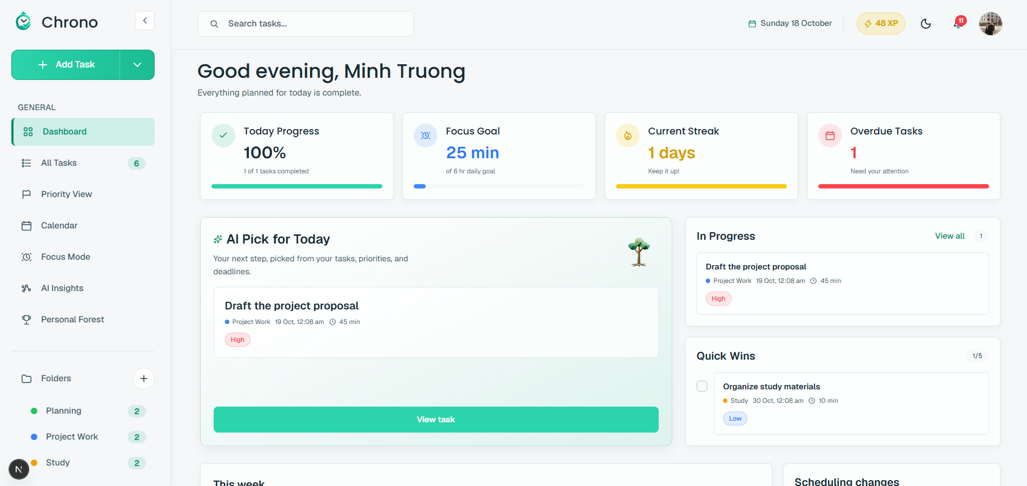
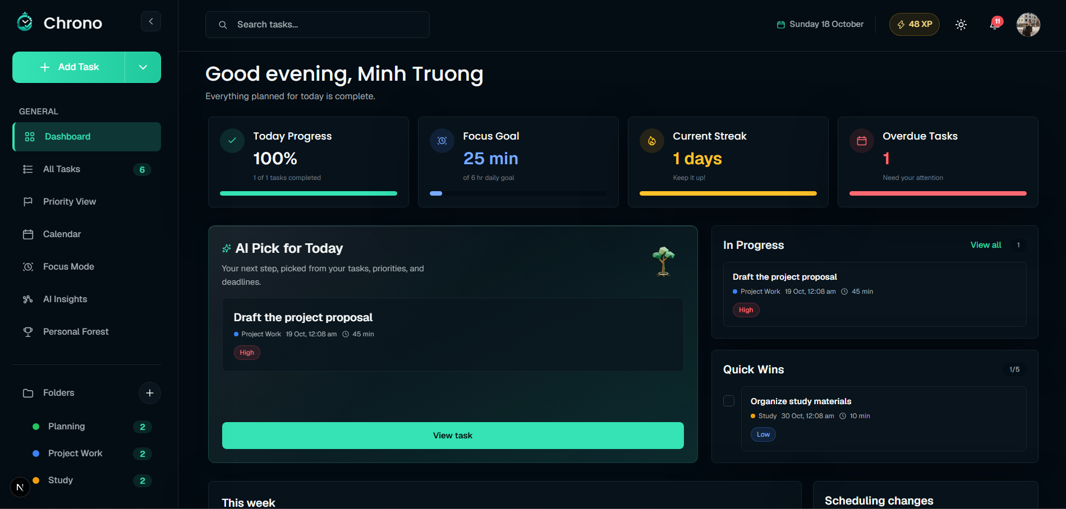
Figure 6 3 Current workspace themes

6 4 3 Sign in and account creation
The current authentication pages keep the branded mountain artwork but give the form a clearer boundary and shorter headings: Sign in and Create account. On desktop, the image occupies approximately 60 percent of the layout and the form occupies 40 percent. A soft blend joins the two areas. The logo sits in the upper-left corner of the image, while the supporting quotation sits lower in the desktop artwork. On mobile, the artwork moves above the form, allowing the page to read vertically without compressing the inputs into a narrow column.
Inputs use a consistent filled surface, leading icons and rounded corners. The main sign-in or sign-up button spans the form width, and the alternative account link appears beneath it. Google and Facebook are presented as two equal-width visual buttons. These social buttons are mock-ups and do not establish a social-authentication integration. Compared with the A4 authentication examples on page 24, the current work focuses on the image-to-form ratio, blending, mobile placement and clearer action labels rather than another change of branding.
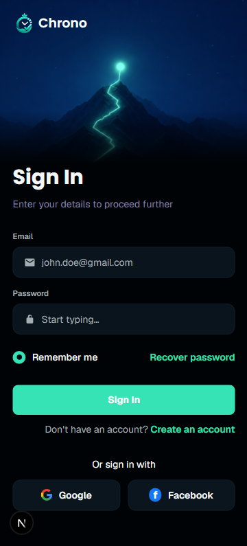

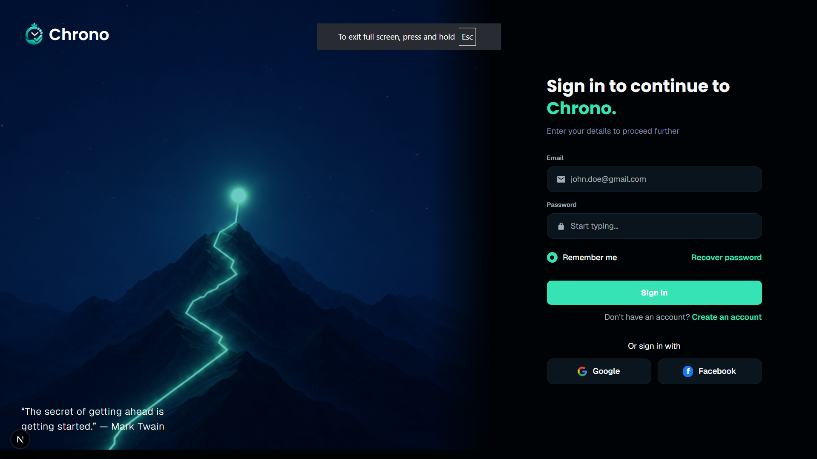
Figure 6 4 Responsive authentication layout and form hierarchy

6 4 4 Home dashboard
The A4 dashboard description on page 25 emphasised displaying more information at once through widgets, charts and compact lists. The current design organises this information into self-contained cards. Progress, focus goal, streak and overdue work provide the overview, followed by AI Pick for Today, In Progress, Quick Wins and weekly activity. Each card places its title inside its container on desktop and mobile. The external Overview, Today, Keep things moving and Progress labels are removed, and the weekly chart uses one internal This week title. View all sits inside the In Progress header. This reduces repeated headings and keeps navigation actions beside the content they affect.
Light mode applies the same hierarchy with quieter backgrounds, while green progress and action elements remain recognisable. Desktop uses the available width for a grid of cards; mobile stacks the feature cards beneath the greeting and search area, with overview cards arranged in two columns. Notification and XP controls provide access to alerts and growth feedback. These choices are intended to make the next action easier to identify; improved completion time or fewer navigation errors still require user testing.
Typography distinguishes card labels from values and supporting text. The four overview card headings use Poppins at 18 CSS pixels with weight 500. AI Pick for Today uses a larger 24-pixel semibold title, while the other main dashboard card titles use 20-pixel semibold text. Body copy and controls retain the application body font. The recommendation keeps its teal AI sparkle, and a matching sparkle now introduces the weekly insight. Titles remain concise, with explanatory text placed below them rather than combined into a large section heading.
Personal Forest places Available Growth Points and its GP value at the right of the page introduction on desktop. The title and supporting message occupy the left side. At narrower widths, the points badge follows the introduction vertically so the two areas do not compete for horizontal space. This change makes the available balance easier to locate without changing how growth points are awarded or applied to a plant.
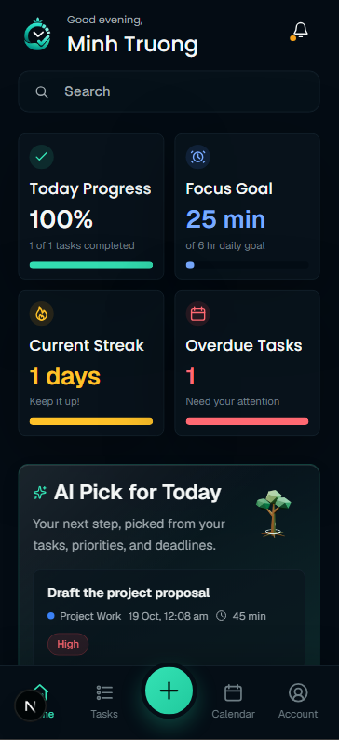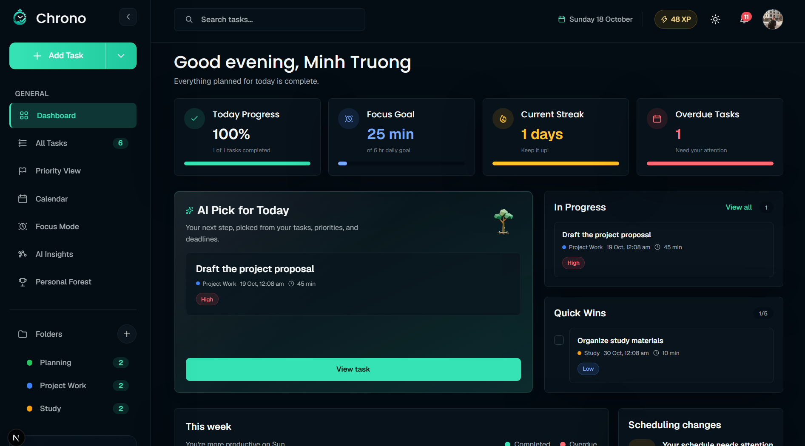
Figure 6 5 Dashboard card hierarchy and Personal Forest growth feedback

6 4 5 Tasks and calendar
The desktop Tasks page retains the table described in A4, with search, filters, sorting and task actions. The current revision gives estimated duration a compact clock icon and value, and keeps overdue information beside the task title where it is relevant on desktop. Status choices use the updated red, yellow and green mapping. Sort options use a styled menu consistent with the surrounding controls. Filter and action areas use a single-row arrangement with overflow where space is limited, reducing unpredictable wrapping at narrower widths or higher browser zoom.
Mobile task rows use a different presentation suited to touch interaction. A checkbox, readable task title, short due-date metadata, project label, priority badge and edit action form a compact card. The content is vertically centred and the card height follows its contents. A separate Done dropdown and repeated overdue pill are removed. Calendar task cards follow the same visual treatment so users can recognise and complete a task without learning a second card design. Date groups and calendar placement provide context that would otherwise be repeated within every row
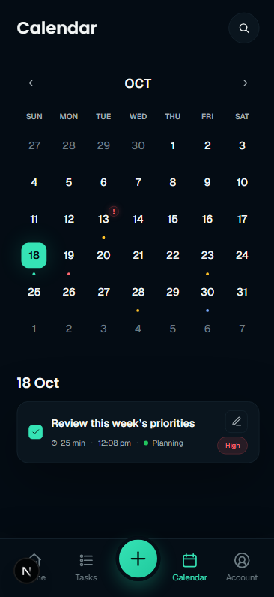
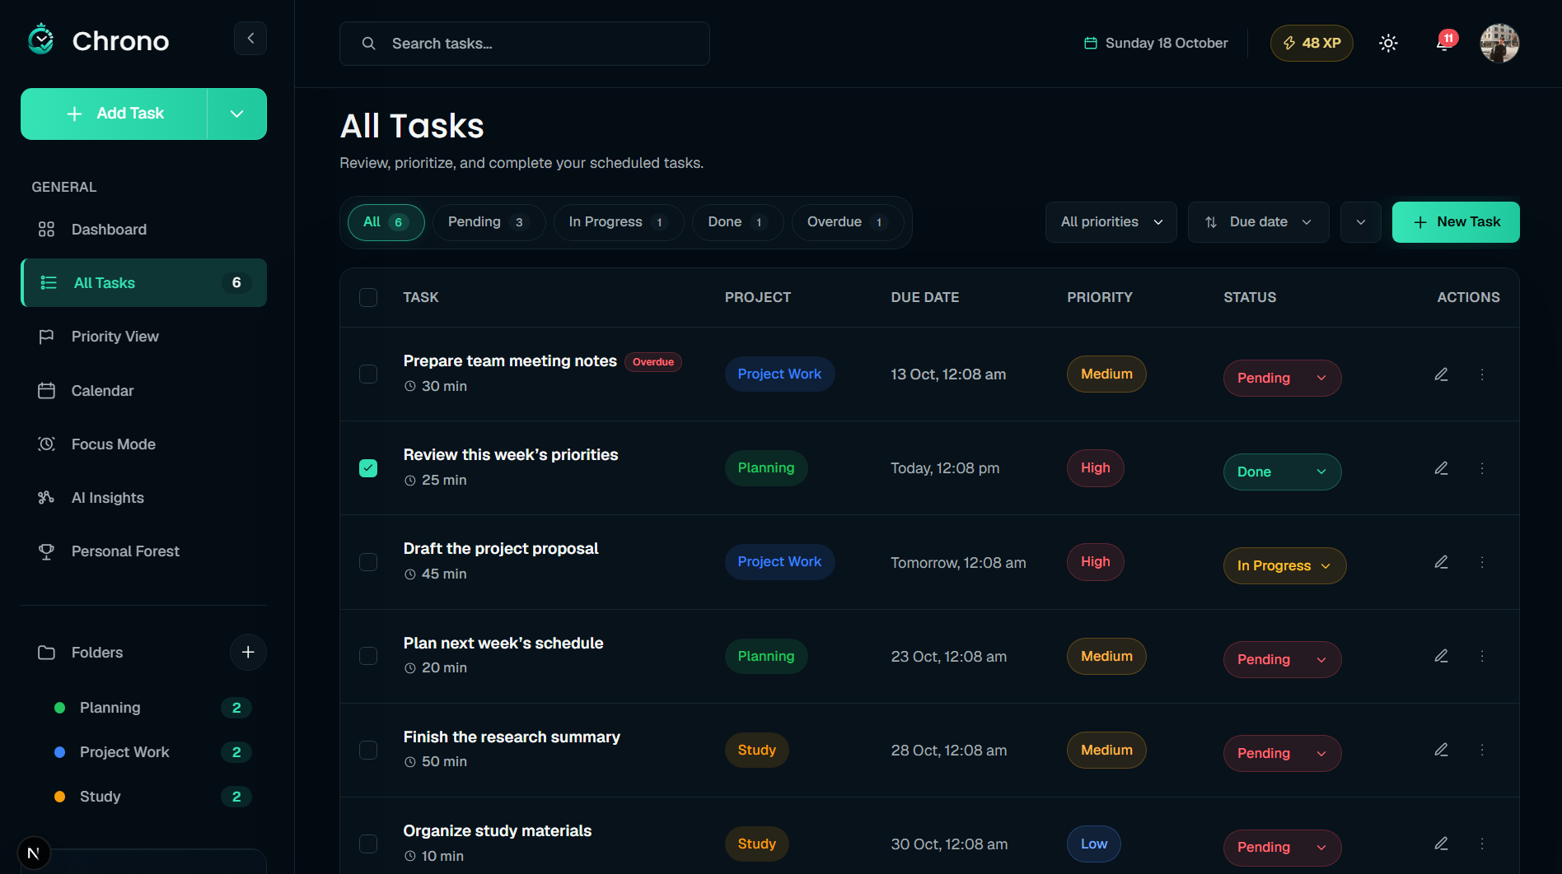
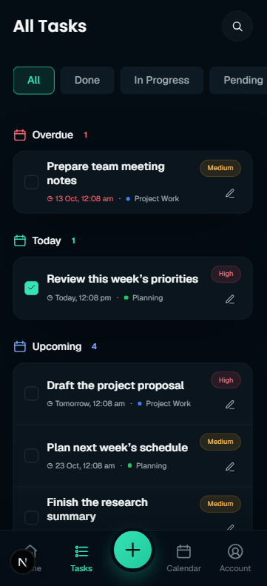
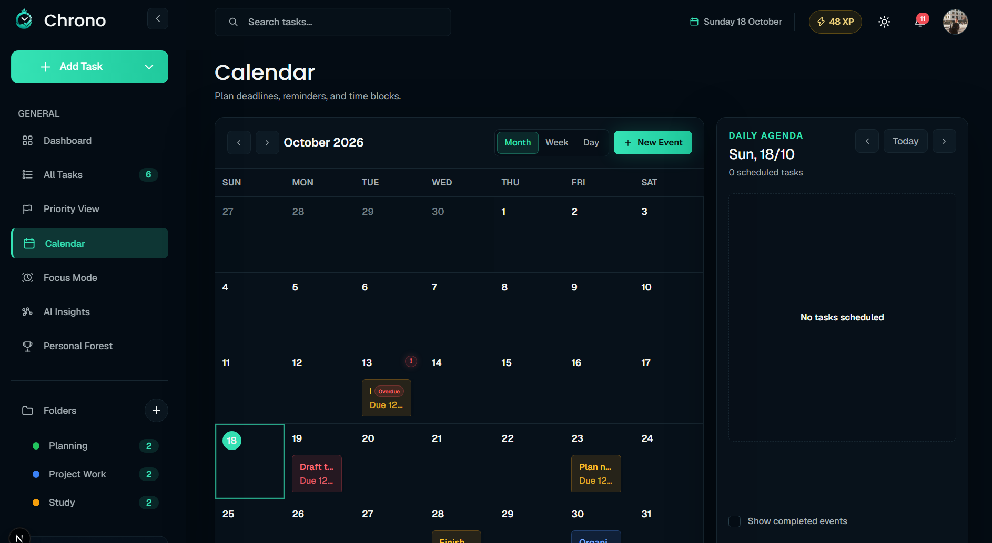
Figure 6 6 Task information hierarchy shared across Tasks and Calendar
Task creation remains a modal workflow, as introduced in A4. The current entry dialog uses concise Generate tasks and Break down choices, with manual entry as a visible alternative. Keeping task entry inside the active page preserves the user's position in a list or calendar. AI proposals still require confirmation before accepted task content is persisted; visual simplification does not remove that review step. The dialog uses Poppins for its heading and inherits the application body font for the input and actions. The inactive Generate tasks and Break down labels use a lighter text treatment while the selected mode retains its teal accent.

6 4 6 Account Settings
Account Settings provides the destination for profile information and personal preferences. On desktop, a left navigation column contains Account, Notifications, Theme, Work preferences and Scheduling priorities. Selecting an item displays its content in the right column, and Log out sits beneath the left navigation. This replaces the separate /settings route. Mobile uses a stacked account view: a centred avatar, name and email appear above Private information, Your progress and Preferences. The preference rows expand directly beneath the selected item with a slide-down transition and a visible open state. Log out is the final action in the scrolling content, above the bottom navigation.
The Account view contains the profile summary, private information and links to AI Insights and Personal Forest. Mobile groups use flat lists with separators and section labels while retaining the established spacing; desktop content retains its bordered containers. Email remains read-only, while the user can edit their name. Work patterns, notification choices and scheduling weights use their existing backend contracts. Desktop selection and mobile expansion use local page state within /account. Mobile Profile, AI Insights and Personal Forest pages provide return navigation to Account.
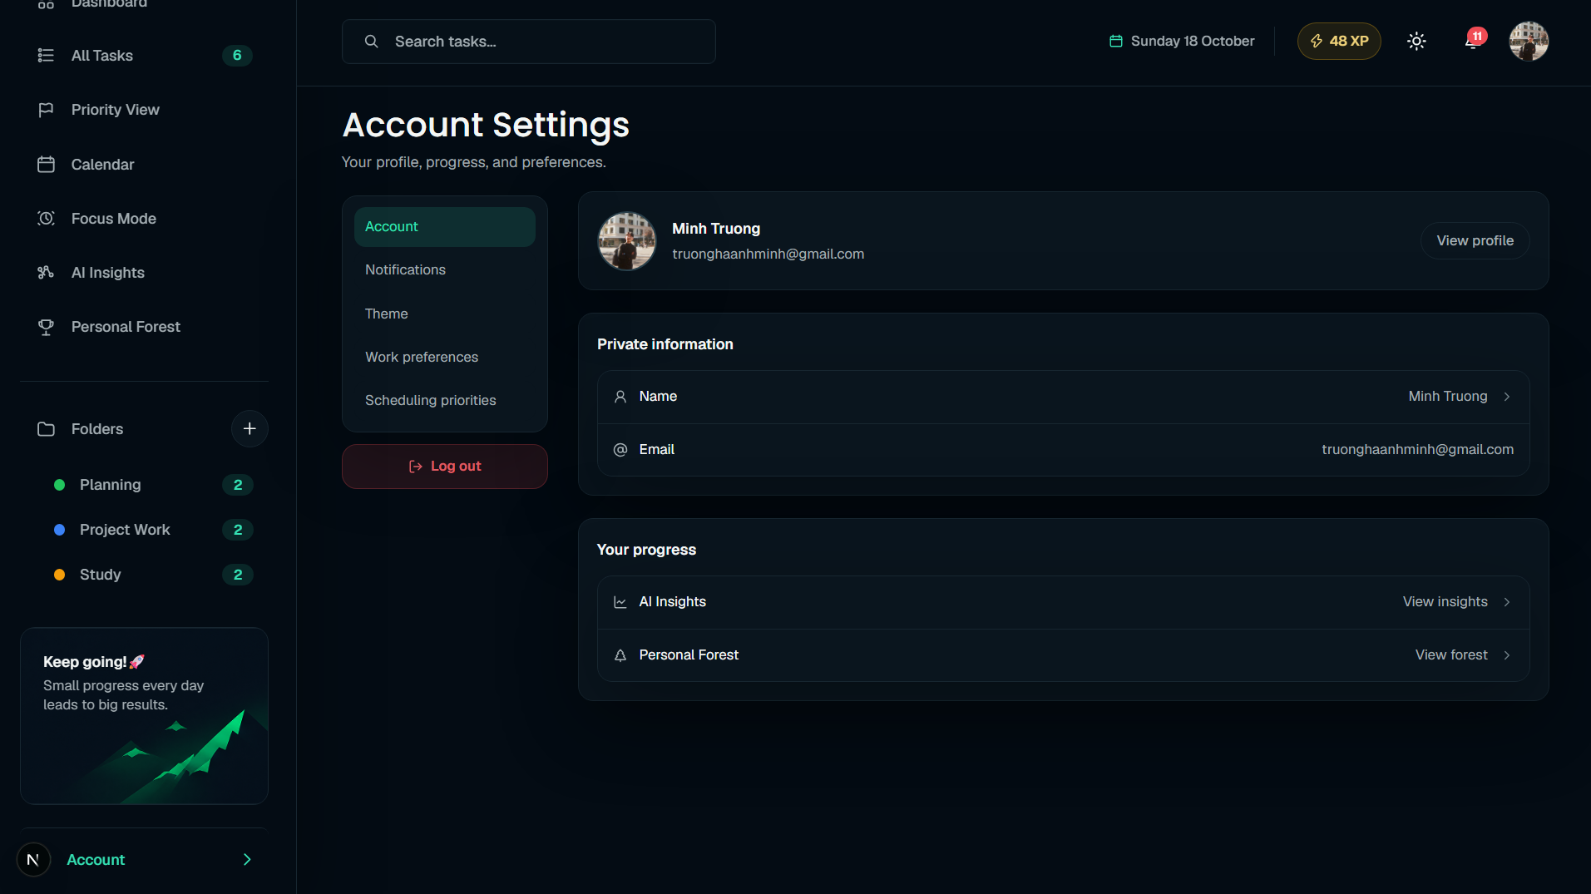
Figure 6 7 Account Settings navigation and selected content

6 4 7 Profile details
The dedicated Profile page separates editing identity from viewing account information. The current desktop layout uses two columns: My Profile, containing the photo and name form, occupies the left column; Account Security and Account Access stack in the right column. The page uses the available content width, and the columns stack vertically on mobile. First name and Last name appear together, with a full-width Save changes action below them.
A small green camera icon over the avatar opens image selection. The earlier separate Change image and Remove image buttons are no longer shown on this page. Account Security displays read-only email and account type, while Account Access displays status, membership information and the current-session logout action.
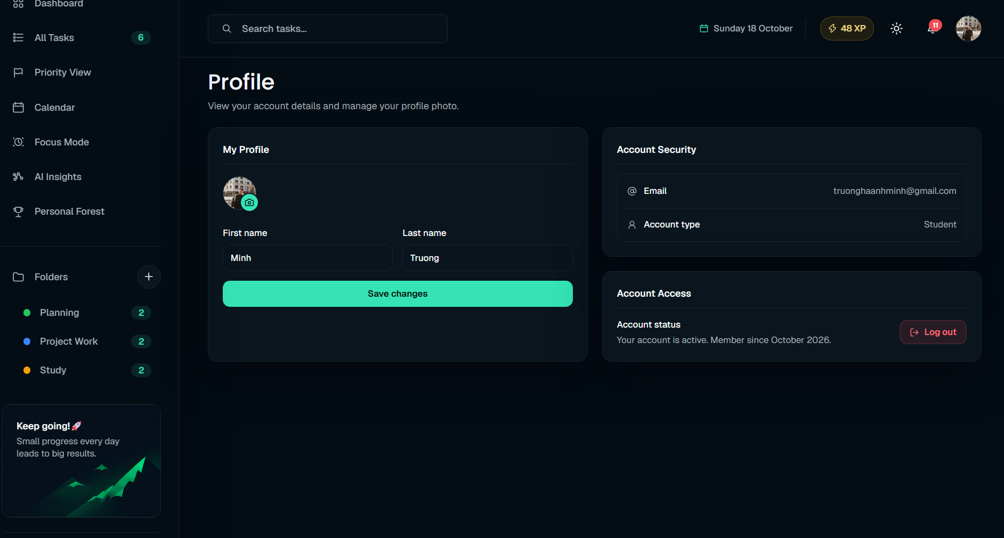
Figure 6 8 Profile editing separated from account information

6 5 Component boundaries and state management

Feature structure
The task feature separates orchestration, data loading, mutations, and presentation:
Module | Responsibility
components/tasks/task-page.tsx | Search parameters, filter/sort state, selection, modal coordination, and composition.
use-task-page-data.ts | Task/project reads, status counts, pagination totals, and event subscriptions.
use-task-page-actions.ts | Create/update/delete, status changes, bulk actions, duplication, locks, and rescheduling.
task-page-model.ts | API-to-view mappings, display/workflow statuses, labels, and filter definitions.
task-list-views.tsx | Desktop table and mobile list, driven by values and callbacks.
create-task-modal.tsx | Shared create/edit form, validation, and AI-assisted task entry.

Calendar follows a similar split: calendar-page.tsx coordinates navigation/view state, calendar-model.ts maps dates/tasks, calendar-views.tsx renders views/dialogs, and use-calendar-tasks.ts loads and mutates tasks. Focus separates the UI in FocusMode.tsx, timer/session behavior in use-focus-timer.ts, and task choices in use-focus-tasks.ts.

State ownership
State | Owner | Persistence / source of truth
Authenticated user and session status | CurrentUserProvider and createCurrentUserSession | Verified through /auth/me; local token/cache support session continuity.
Light/dark theme and sidebar collapse | UiPreferencesProvider | Local storage keys chrono-color-theme and chrono-sidebar-collapsed.
Greeting and heading actions | DashboardHeadingProvider | React context for the mounted dashboard shell.
Task lists, summaries, calendars, and insights | Feature hooks/components | Backend data in component state; task lists/counts also use a bounded, token-scoped memory cache.
Form fields, menus, selection, filters | Relevant page/form | Local React state; selected navigation parameters live in the URL.
Timer countdown and restoration snapshot | use-focus-timer | React state/refs plus focus-timer-state-v1 in local storage; active sessions reconcile with FastAPI.
Work and notification preferences | Account Settings feature | FastAPI settings endpoints and PostgreSQL.

The application uses React state, context, custom hooks and a small external session store connected through useSyncExternalStore. It does not use Redux, Zustand, SWR or TanStack Query. A bounded memory cache in lib/read-cache.ts now shares task-list, task-count and project-list reads. The backend remains the source of persisted data; cached responses support faster navigation within the current browser window.

Read cache ownership
lib/read-cache.ts owns only cached response values, timestamps and shared pending Promises. lib/tasks.ts and lib/projects.ts select eligible reads and their freshness policies; apiRequest owns HTTP, credentials and errors. useTaskPageData owns loading/error presentation, selection and request revisions. The current token scopes cache reuse, but FastAPI continues to validate every network request. Keeping these roles separate prevents temporary browser state from being mistaken for persisted application state.

API data and view data
Task payloads distinguish stored workflow status (pending, in_progress, done) from display status, which can additionally be overdue. Mapping functions preserve this distinction when presenting overdue tasks or sending status updates. Frontend display labels should be converted through the existing mapping helpers before mutation requests.
listTasks accepts the current paginated response and an older array response, normalizing both into TaskListResponse. This compatibility is specific to task lists; apiRequest<T> is a TypeScript contract, not automatic runtime schema validation for every endpoint.

6 6 API integration design

Shared transport
web/lib/api.ts provides apiRequest<T>(path, options) and ApiError.
- Resolve the API base from NEXT_PUBLIC_API_URL, defaulting to http://localhost:8000.
- Read chrono_access_token, with a legacy access_token fallback.
- Attach Authorization: Bearer <token> when auth is enabled and a token exists.
- Add JSON content type for a body unless it is FormData or a content type was supplied.
- Forward the request options, including an optional AbortSignal, to fetch.
- Return parsed JSON on success, or undefined for HTTP 204.
- Parse a failed response and throw ApiError(message, status, details). A string detail becomes the message. Network failures use status 0; aborted fetches remain abort errors.
- For an eligible authenticated 401, notify unauthorized listeners before throwing the error.
Public auth calls set auth: false. Avatar uploads use FormData, allowing the browser to supply its multipart boundary. Relative avatar paths are resolved against the API base through getApiUrl.

Domain integration map
Helper | Representative endpoints | Integration responsibility
lib/auth.ts | POST /auth/login, POST /auth/register, GET/PATCH /auth/me, POST/DELETE /auth/me/avatar | Session establishment, profile reads and name updates, avatar helpers, and local session clearing.
lib/tasks.ts | GET/POST /tasks, GET /tasks/counts, PATCH/DELETE /tasks/{id}, bulk/subtask/reschedule routes | Task contracts, query serialization, aggregate counts, cached/shared list reads, mutations and task-change events.
lib/projects.ts, lib/folders.ts | /projects, /folders | Organization data and project/task invalidation after relevant mutations.
lib/dashboard.ts | GET /dashboard/summary | Backend-computed aggregate summary; sends X-Client-Timezone.
lib/focus.ts | /focus/sessions/start, /active, /{id}, /{id}/complete, /{id}/cancel, /history | Focus lifecycle, elapsed-time persistence, and focus/reward events.
lib/settings.ts | GET/PATCH /settings, POST /settings/timezone/detect | Persisted user preferences and best-effort browser-timezone synchronization.
lib/analytics.ts | /analytics/insights, /analytics/weekly-insight | Productivity summaries and weekly interpretation.
lib/scheduling.ts | /scheduling/plan, recommendation/suggestion routes, /scheduling/reschedule/preview | Scheduling proposals, acceptance/dismissal, and applying changes.
lib/notifications.ts | /notifications, /notifications/mark-read, /notifications/mark-all-read | Notification lists and read state.
lib/gamification.ts | /gamification/profile, /plants, /forest/scene, achievement routes | Growth, plant/forest state, placement, and reward feedback.

The frontend consumes AI and scheduling results through backend contracts. Task generation and decomposition have separate preview and confirmation calls. Preview proposals include a token and expiry; confirmation persists the accepted task content and emits a task-data change. The browser does not call the AI model provider directly in these flows.

Integration configuration
The browser must reach the configured FastAPI URL. NEXT_PUBLIC_API_URL is a public frontend setting, so it must contain a service address rather than a secret. For the local demo, the backend CORS configuration permits localhost/127.0.0.1 origins across ports, including frontend ports such as 3001.
The API owns authentication, task ownership, business validation, and database writes. The frontend presents validation feedback, serializes requests, and reflects accepted server results. Client-side validation improves form feedback; it does not replace backend validation.

6 7 Protected routes and session lifecycle
CurrentUserProvider creates a session controller in lib/auth-session.ts. React subscribes to its snapshots using useSyncExternalStore. Starting the provider checks for a token. Missing credentials lead directly to sign-in navigation; an existing token is verified through /auth/me. The provider also requests prefetching of /login, which Next.js applies in production rather than development.
Session state | Shell behavior
checking | Display "Checking your session…" while user verification is pending.
authenticated | Mount the shared navigation, headers, rewards and active feature page via PageEntrance.
unavailable | Show the error and a retry action while retaining local session information.
unauthenticated | Clear local auth information and navigate with router.replace('/login').

Missing credentials or an eligible 401 invalidate the session. Network errors and non-401 failures during session verification move it to unavailable. The session controller aborts superseded checks and uses a revision counter plus token comparison to prevent old responses from overwriting a newer session. User-cache writes also check the request token and abort state.
The API transport only broadcasts a 401 when the request used authentication, carried the current token, and has not been aborted. Consequently, an invalid password on the public login request remains a form error, and an old request cannot clear a newer login.
The protected-route behavior is a client-side rendering gate. The repository has no inspected Next.js middleware/proxy auth guard. FastAPI's get_current_user dependency validates the token and active user for protected API operations. DashboardShell displays only the session checking, retry or redirect state until authentication succeeds. Sidebar, headers, notifications, rewards, bottom navigation and feature content mount after verification; the shell growth-point request also requires an authenticated user. This prevents their loaders from competing with sign-in while a session is unresolved.
NEXT_PUBLIC_BYPASS_AUTH=true is an existing local UI development option that supplies a synthetic user. It does not produce a valid backend token or grant API access. Access tokens are currently stored in local storage; no refresh-token exchange or HTTP-only-cookie session is implemented in the inspected frontend. The cached user is display data, not the authority used to grant access.

Sign-in sequence
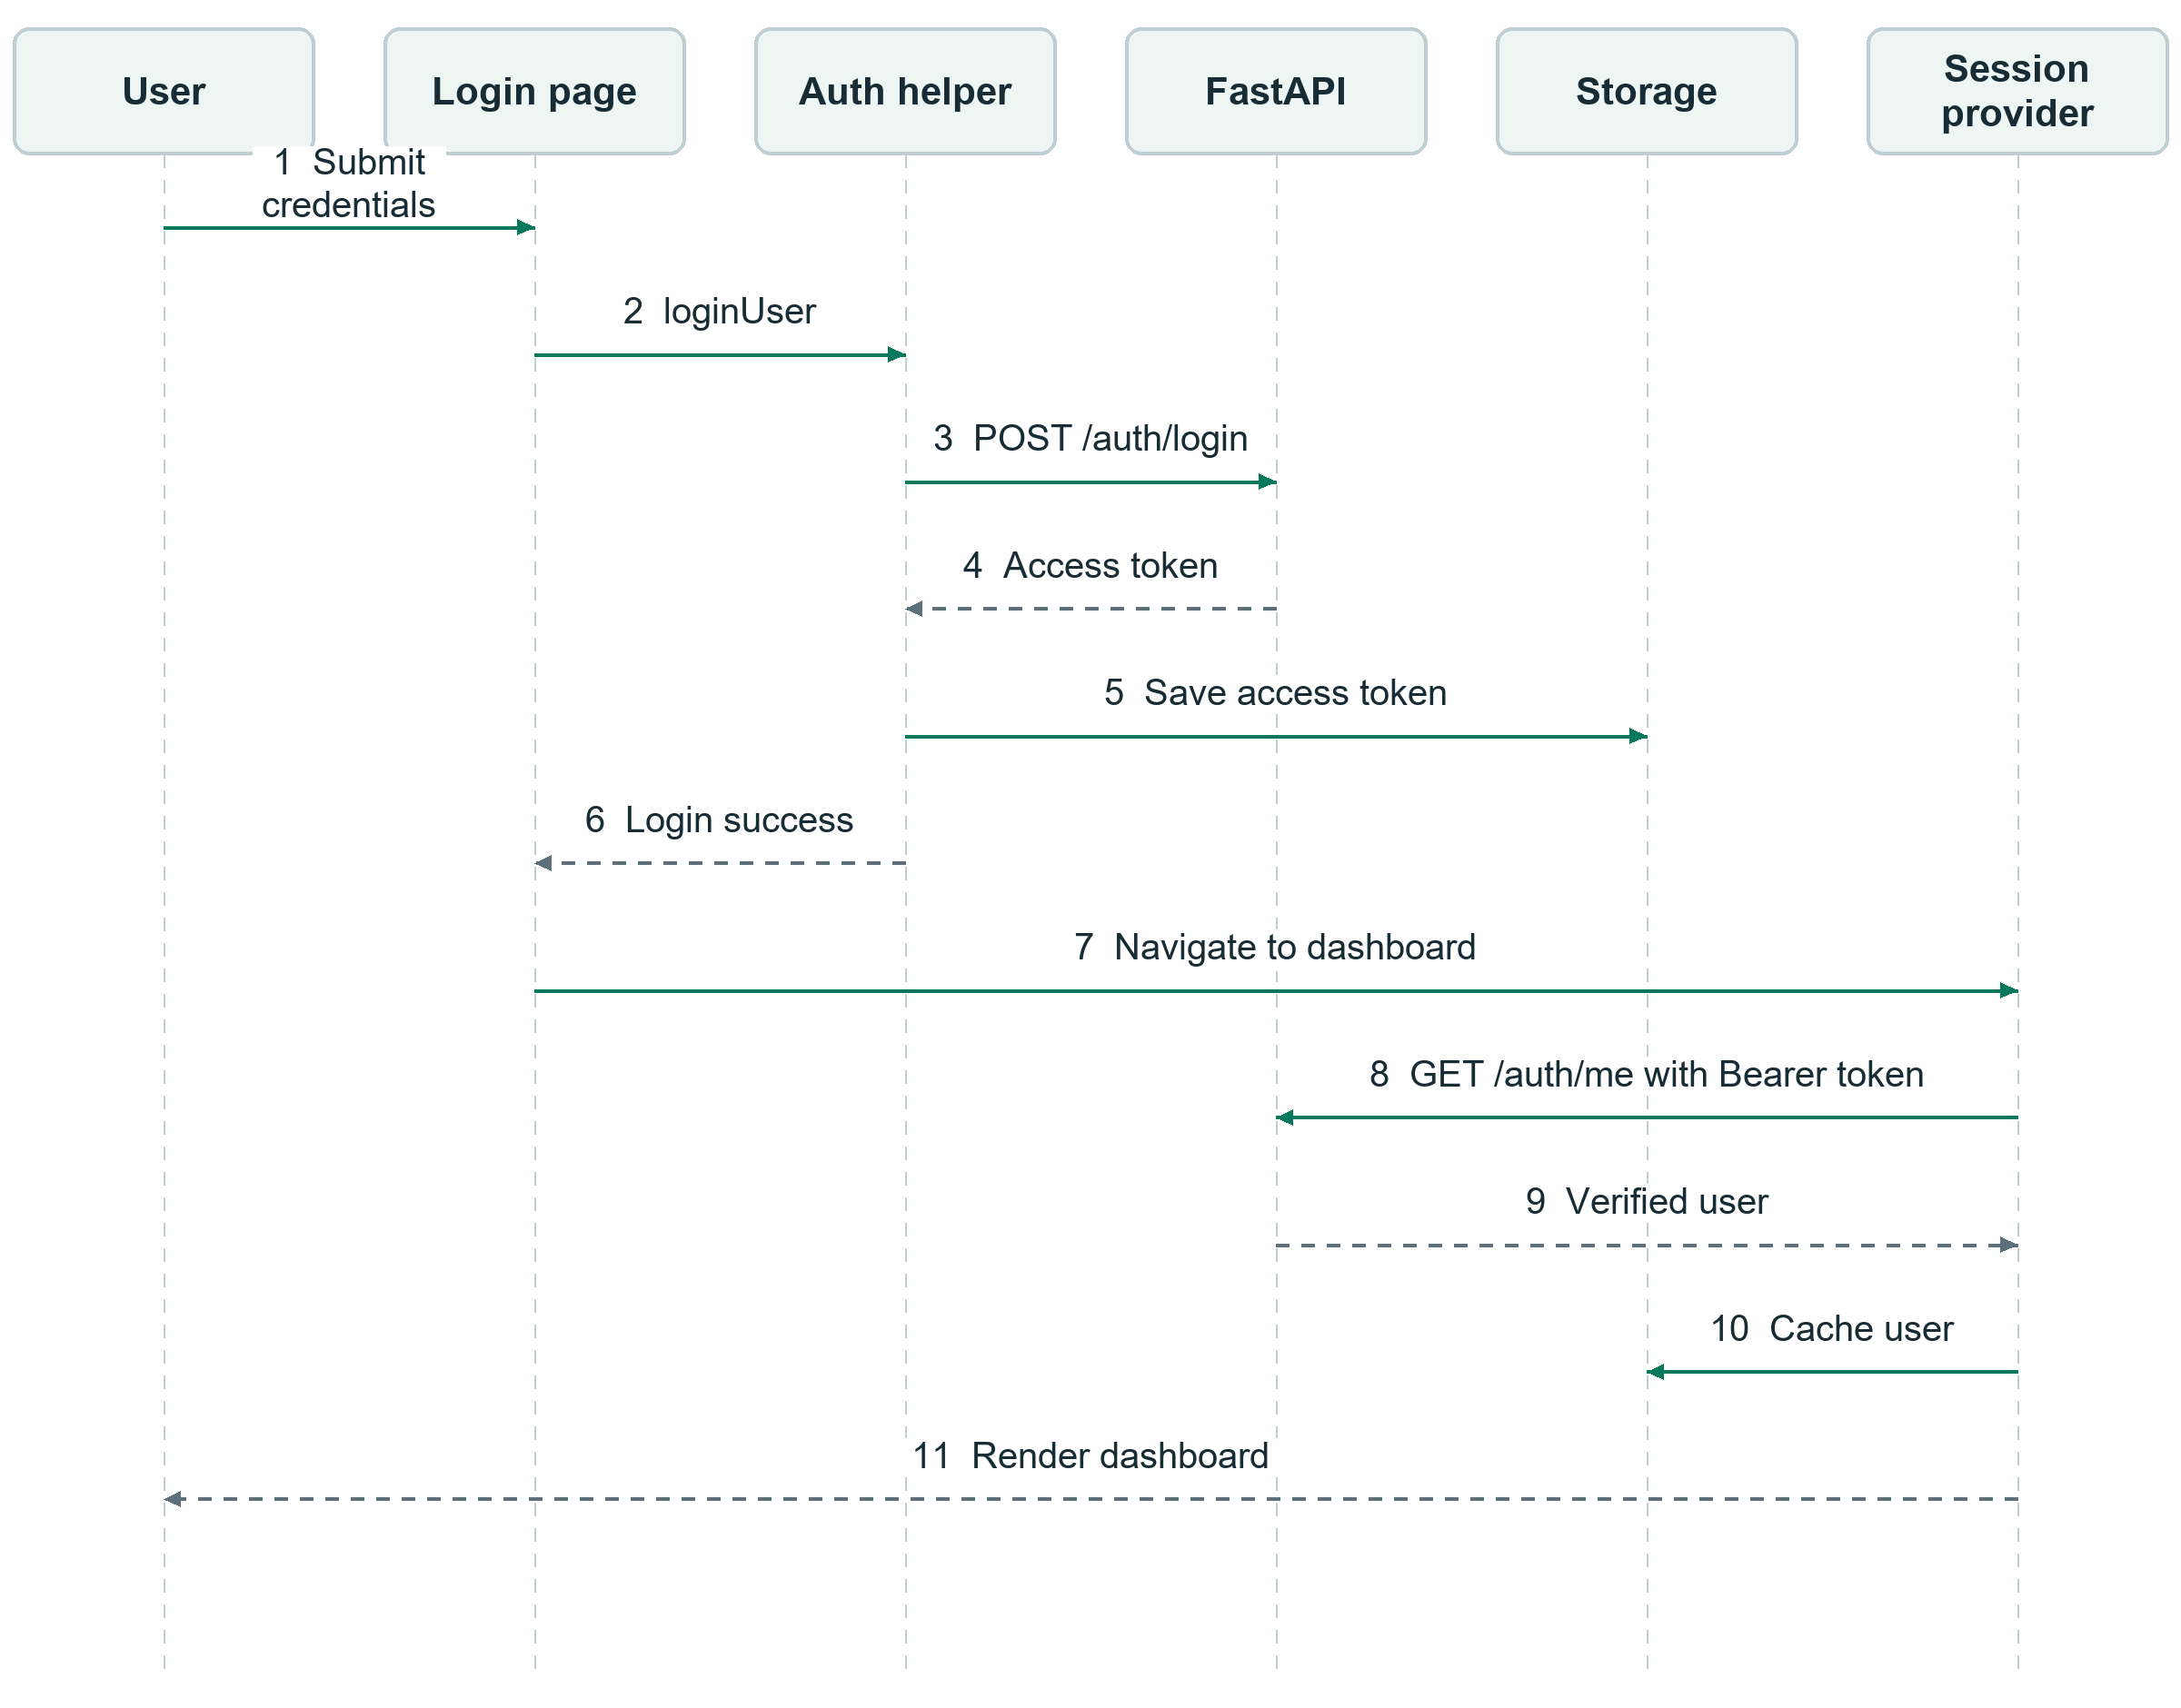
Figure 6 9 Sign in and session verification sequence
After verification, the provider starts best-effort timezone synchronization. Failure of that synchronization does not invalidate a verified session. Sign-out clears the token/user cache and returns to /login through the session controller. The sign-in page's Remember me control currently does not change loginUser persistence; the helper always stores the token in local storage. Google and Facebook buttons are visual mock-ups. Password recovery and social sign-in controls do not implement those integrations.

6 8 Data updates and consistency

Mutation and refresh pattern
After successful task or project mutations, lib/data-events.ts invalidates both task and project cache groups before dispatching browser CustomEvents. Clearing project responses also discards task-count summaries embedded in those responses. Mounted consumers still need subscriptions to refresh their local state; the cache is not a reactive observer layer. Invalidation applies even when a feature view is unmounted, but events do not reach another tab or device.
Event | Representative producers | Representative mounted consumers
chrono:task-data-changed | Task CRUD, bulk/subtask actions, accepted scheduling changes, folder update/delete. | Task data hook, calendar hook, dashboard, analytics, sidebar, header notifications, personal forest.
chrono:project-data-changed | Project/folder creation and relevant folder mutations. | Task project lists/counts, calendar, sidebar.
chrono:settings-data-changed | Account Settings after a successful preference save. | Dashboard and analytics summary loading.
chrono:focus-data-changed | Focus update, completion/cancellation, or recorded session creation. | Analytics summary loading.
chrono:growth-reward | Reward-bearing task/focus responses. | Shell growth-point total, reward toast, personal forest, forest world.
notifications-updated | Notification-page updates. | Header notification refresh.

These notifications operate within the current browser window. They do not provide server push, durable event delivery, or automatic synchronization between browser tabs. A feature opened later loads data on mount. The dashboard currently subscribes to task/settings changes, but not directly to focus changes; revisiting the dashboard loads a new summary after a focus session.

Task creation sequence
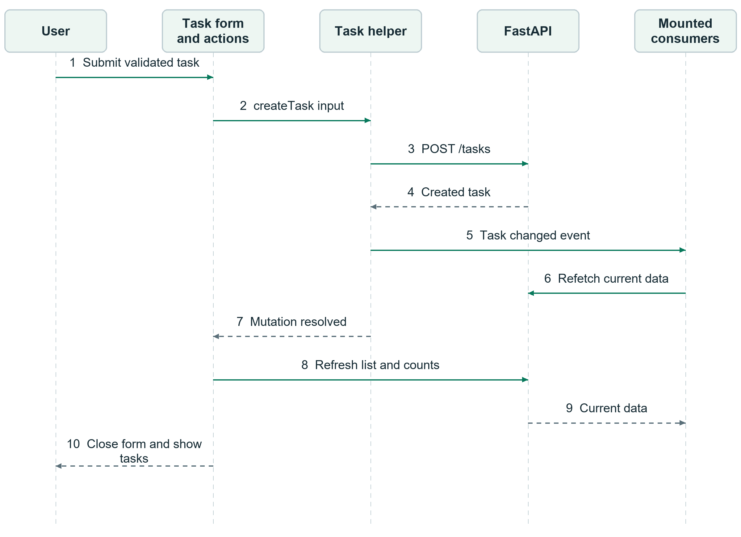
Figure 6 10 Task creation and data refresh sequence
The form trims the title, converts priority labels to API values, normalizes subtasks, validates custom duration, and converts the local due date/time to an ISO timestamp. A date without a time defaults to 23:59:00 in this form. If creation fails, the helper emits no task-change event; the action propagates the error and the form displays it.
The action callback also explicitly refreshes task data after the mutation event has fired. Existing callers can therefore ask for overlapping reads. Unsignalled task-list, count and project reads now share an in-flight request and reuse a recently completed result for the same query. This reduces repeated network work without removing the existing view-refresh callbacks. Abortable callers retain independent requests so one view cannot cancel another view's shared read.

Dashboard update sequence
The dashboard fetches one aggregate DashboardSummary, covering progress, focus goal, streak, overdue count, recommendations, task lists, weekly activity, and optional forest data. The following sequence uses completion of a dashboard Quick Win as the trigger.
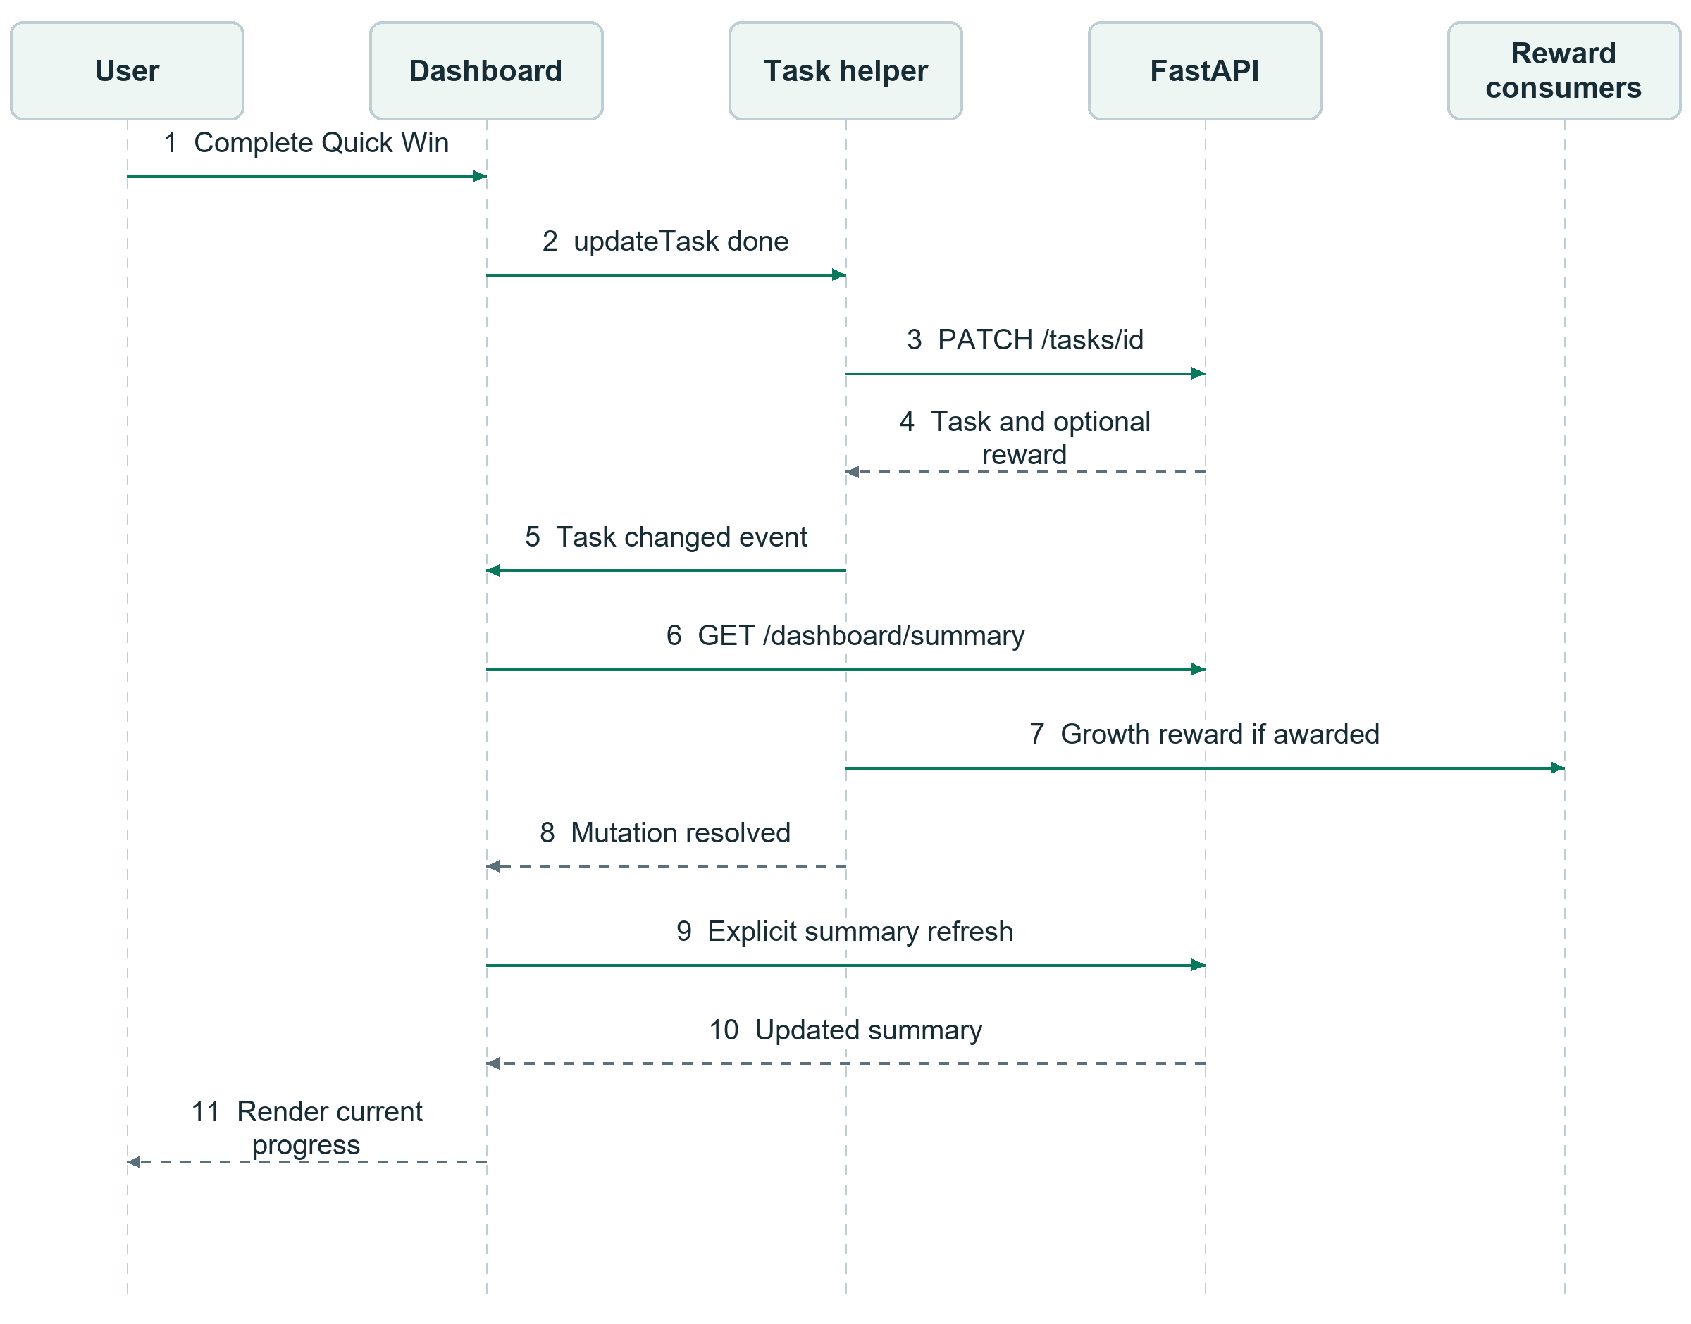
Figure 6 11 Dashboard Quick Win update sequence
On initial entry, an abortable effect loads the summary. A mounted dashboard also reloads after task/settings events and selected feature callbacks. The first load uses a loading state; an initial failure offers retry. When a previous summary exists, refresh failures retain it. In the current rendering code, the dedicated dashboard error component is used only when no summary exists, so background refresh errors do not receive the same full error view.

Focus and reward integration
The timer uses a 250 ms local tick and wall-clock deadline to update the countdown. This interval is a UI timer, not periodic API polling. The hook stores a local snapshot and reconciles with /focus/sessions/active when restoring a session. Refs track active elapsed segments so paused time is excluded from recorded focus duration.
Successful recording resets the displayed countdown. Skip records an active focus session before advancing to a fresh break/focus countdown. A failed save retains session identity and task locking so the user can retry. Focus mutations emit focus-change events, and awarded rewards emit growth-reward events. The shell can use the reward's included profile or fetch the current gamification profile to update its displayed points.

6 9 Loading errors and request coordination
Page-specific hooks own loading and mutation flags. Buttons and dialogs use these flags to avoid conflicting operations and show progress. Some actions update the UI optimistically: task status changes preserve the previous task for rollback, and notification selection adjusts unread state before the read request completes.
Abort controllers are used in session verification and several mount-time feature requests. Session verification and the shell growth-point loader guard against stale responses. The Tasks loader now uses separate request revisions for rows, counts and projects, and increments them on cleanup or superseding queries. Event-triggered dashboard refreshes still lack equivalent deduplication and ordering. Protection is therefore feature-specific rather than universal.
Task status counts now use GET /tasks/counts, replacing five separate list requests. The endpoint runs one aggregate SQL query scoped to the authenticated user and optional search/project or Inbox filters. Pending and In Progress exclude computed-overdue rows, Done counts completed tasks and Overdue retains the existing due-date rule. The Tasks page still obtains its filtered rows separately; counts do not depend on the priority filter, while pagination follows the filtered list total. A cold Tasks visit therefore needs three feature reads: tasks, counts and projects, rather than seven. Shared shell requests are additional and are not included in this comparison.
Eligible task lists and counts are fresh for 15 seconds and project lists for 60 seconds. Tasks can display snapshots younger than five minutes while stale reads revalidate. These times are checked on access; they do not create polling, automatic focus/reconnect refetch or a timed garbage collector. The memory Map holds at most 50 entries and evicts in insertion order rather than by least recent use. Token changes and sign-out clear it. Invalidated in-flight requests cannot refill discarded entries; separate loader revisions guard component state.
Folder functionality remains available. Project choices share the cache and no longer reload for each task search, but are still loaded on a cold Tasks visit. Calls with an AbortSignal bypass request sharing, and targeted getTask reads remain uncached. Sidebar, notification and XP work is outside the seven-to-three feature-read comparison. Calendar still loads all task pages and chooses scheduled_start before due_date when determining calendar placement. A future server-range query must preserve that meaning rather than simply apply a deadline filter.
The forest world loads its 3D scene dynamically with server-side rendering disabled and a loading placeholder. This defers scene rendering to that feature rather than placing the 3D renderer directly in every screen's shell.
A mounted view can retain stale component values after cache invalidation unless its event handler refreshes them. Cached task rows are preserved when a matching background read fails, with the error exposed; count errors preserve prior values without blocking rows. Expiry alone does not update overdue totals on an idle page. Cross-tab invalidation, forced refresh and explicit stale indicators remain follow-up design work. The detailed before/after explanation and prioritised proposals are recorded in Chrono Data Fetching and Performance Review, Section 3 onward.

6 10 Implementation boundaries and maintenance guidance
The following points describe the current design and useful constraints for subsequent development:
- Keep route entries small and reuse the dashboard layout. Shared navigation, session behavior, and headings belong in the shell.
- Keep API paths, payload types, response types, and data-change emission in domain helpers. Presentation components should receive data and callbacks where the feature already provides that boundary.
- Treat FastAPI as the persisted source of truth. Local UI preferences, cached user display data, and timer snapshots each have narrower storage responsibilities.
- Preserve the distinction between workflow status and derived overdue display state.
- Subscribe and unsubscribe in effects. If refresh coordination is improved later, address duplicate requests and stale-response handling consistently across consumers.
- Document event coverage explicitly. A new mutation or feature does not automatically refresh every screen.
- Keep preview/confirmation boundaries for AI-assisted task and scheduling flows, and render backend errors through existing form/feature error states.
The current optimisation shares recent task and project reads and replaces repeated status-count requests with an aggregate endpoint. Further options include server-filtered calendar reads, coordinated dashboard refreshes and a production-build navigation benchmark. The frontend and backend should be released together because the updated Tasks page expects /tasks/counts. No database migration is required for this endpoint.

6 11 Source references and verification scope
Topic | Primary source files
App Router and layouts | web/app/layout.tsx, web/app/(dashboard)/layout.tsx, web/components/layout/dashboard-shell.tsx.
Session and protected content | web/components/auth/current-user-provider.tsx, web/lib/auth-session.ts, web/lib/auth.ts.
Transport and invalidation | web/lib/api.ts, web/lib/read-cache.ts, web/lib/data-events.ts, web/lib/gamification.ts; Chrono_Data_Fetching_and_Performance_Review.docx.
Task creation and updates | web/components/tasks/task-page.tsx, web/components/tasks/create-task-modal.tsx, web/components/tasks/use-task-page-data.ts, web/components/tasks/use-task-page-actions.ts, web/lib/tasks.ts.
Dashboard layout and refresh | web/components/dashboard/dashboard-page.tsx; dashboard-stat-card.tsx; suggested-task-card.tsx; weekly-activity-card.tsx; web/lib/dashboard.ts.
Calendar and focus | web/components/calendar/use-calendar-tasks.ts, web/components/focus/use-focus-timer.ts, web/lib/focus.ts.
Shared presentation | web/components/layout/ui-preferences-provider.tsx, web/components/layout/page-heading.tsx, web/components/layout/page-entrance.tsx, web/tailwind.config.ts, web/app/globals.css.
Backend integration boundary | Repository-root backend/api/app/main.py, backend/api/app/auth/dependencies.py, and the corresponding feature routers.
Interface comparison | CSIT321 - Group27 - A4 Prototype Presentation.pdf, 6 August 2026, pages 9 to 11 and 23 to 28.
Current account and profile | web/components/profile/account-page.tsx, profile-page.tsx; web/lib/auth.ts; web/lib/settings.ts. Personal Forest placement: web/components/gamification/forest-page.tsx.
Responsive interface | web/components/auth/auth-shell.tsx; web/components/layout/mobile-bottom-navigation.tsx; web/components/tasks/task-list-views.tsx; web/components/calendar/calendar-views.tsx; web/components/layout/notification-dropdown.tsx.

This document was checked against source code and existing repository guidance. It does not claim a fresh authenticated browser demonstration or backend integration test. Existing Node regression tests cover selected auth, task, calendar, and focus behavior; their simulated API/storage/clock dependencies are documented in README.md and web/components/tasks/README.md. Demonstration evidence and its limits are maintained in DEMO_VERIFICATION.md.

