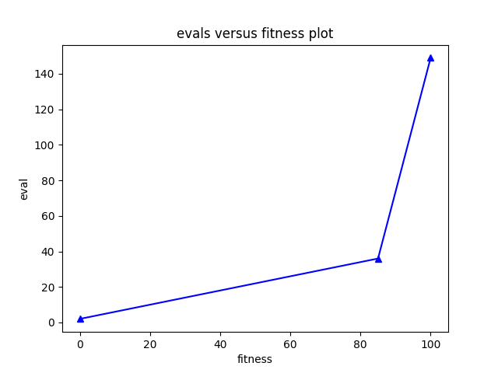

For our first problem solution we have this eval vs fitness graph. Note this is with black cell restrictions off.

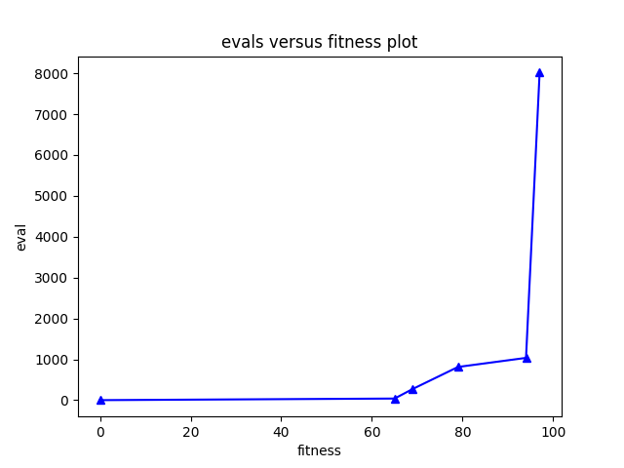

For our second problem we have this graph. This is also with the black cell restrictions off.

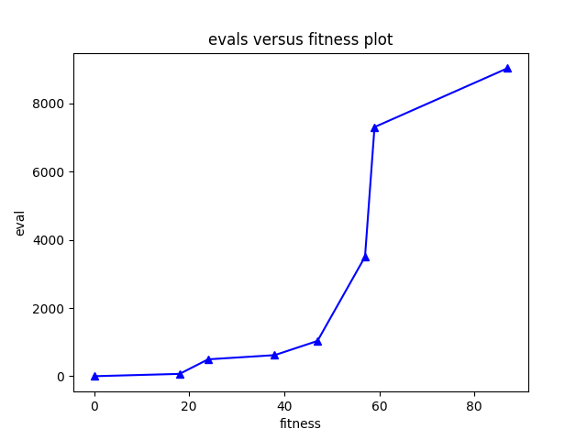

For our third problem we have this graph. This graph is also created with the black cell restriction off. With the restrictions on fitness > 0 was only found for the first problem out of the many experiements I tried.

