# Guide: Firebase/Postman

Introduction to Firebase, Kinvey and Postman for the ["JavaScript Applications" course@SoftUni](https://softuni.bg/courses/js-applications).

## Postman

Postman is an application for **testing APIs**, by sending **request** to the **web server** and getting the **response** back. It allows users to set up all the **headers** and **cookies** the **API** expects, and checks the response. You can download it from [here](https://www.getpostman.com/downloads/).

**Firebase**

Firebase is a **mobile** and **web** development platform. It provides a **realtime database** and **backend** as a service. The service provides developers an **API** that allows application data to be **synchronized** across clients and **stored** on Firebase's cloud. The **data** is **structured** as a **JSON** tree.

### Registration

**Register** at <https://console.firebase.google.com>. Afterwards, **create a new project** and start playing around with it in order to understand how the database works.

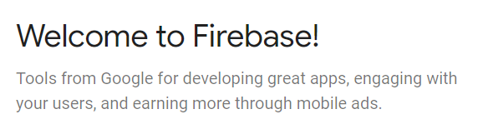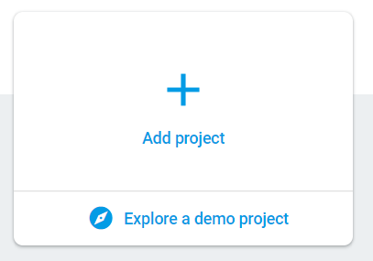

## Put Some Data in the Database

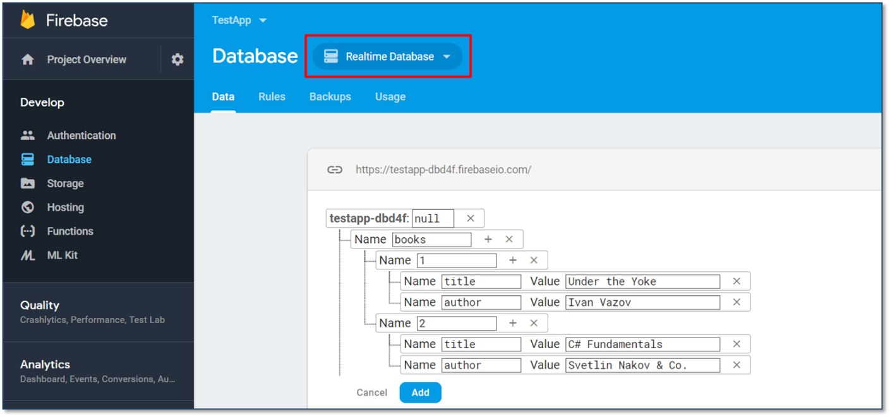

## REST API

Make sure to enable **unauthorized access** to your database. Note that this is for **educational purposes** only and you should **NOT** do it in real apps as it is a **security hole**! After you have done that, access your data through the REST API.

**GET**

<https://testapp-fc138.firebaseio.com/.json>

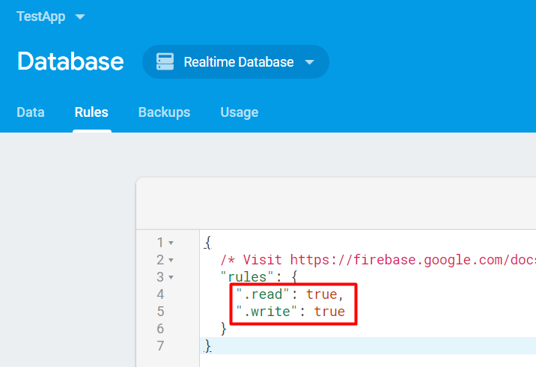

## Accessing Firebase REST API with Postman

Open **Postman** and make a **GET** request to receive all of the information in your database. In our case that would be a list of all the available books. 