ICT2142 E-Business Systems
Week 03 Practical Report
nr accessories.lk — Smartphone Accessories E-Commerce Platform
TG/2024/2147
Phase 1: Planning & Requirements
Home Page & File Structure

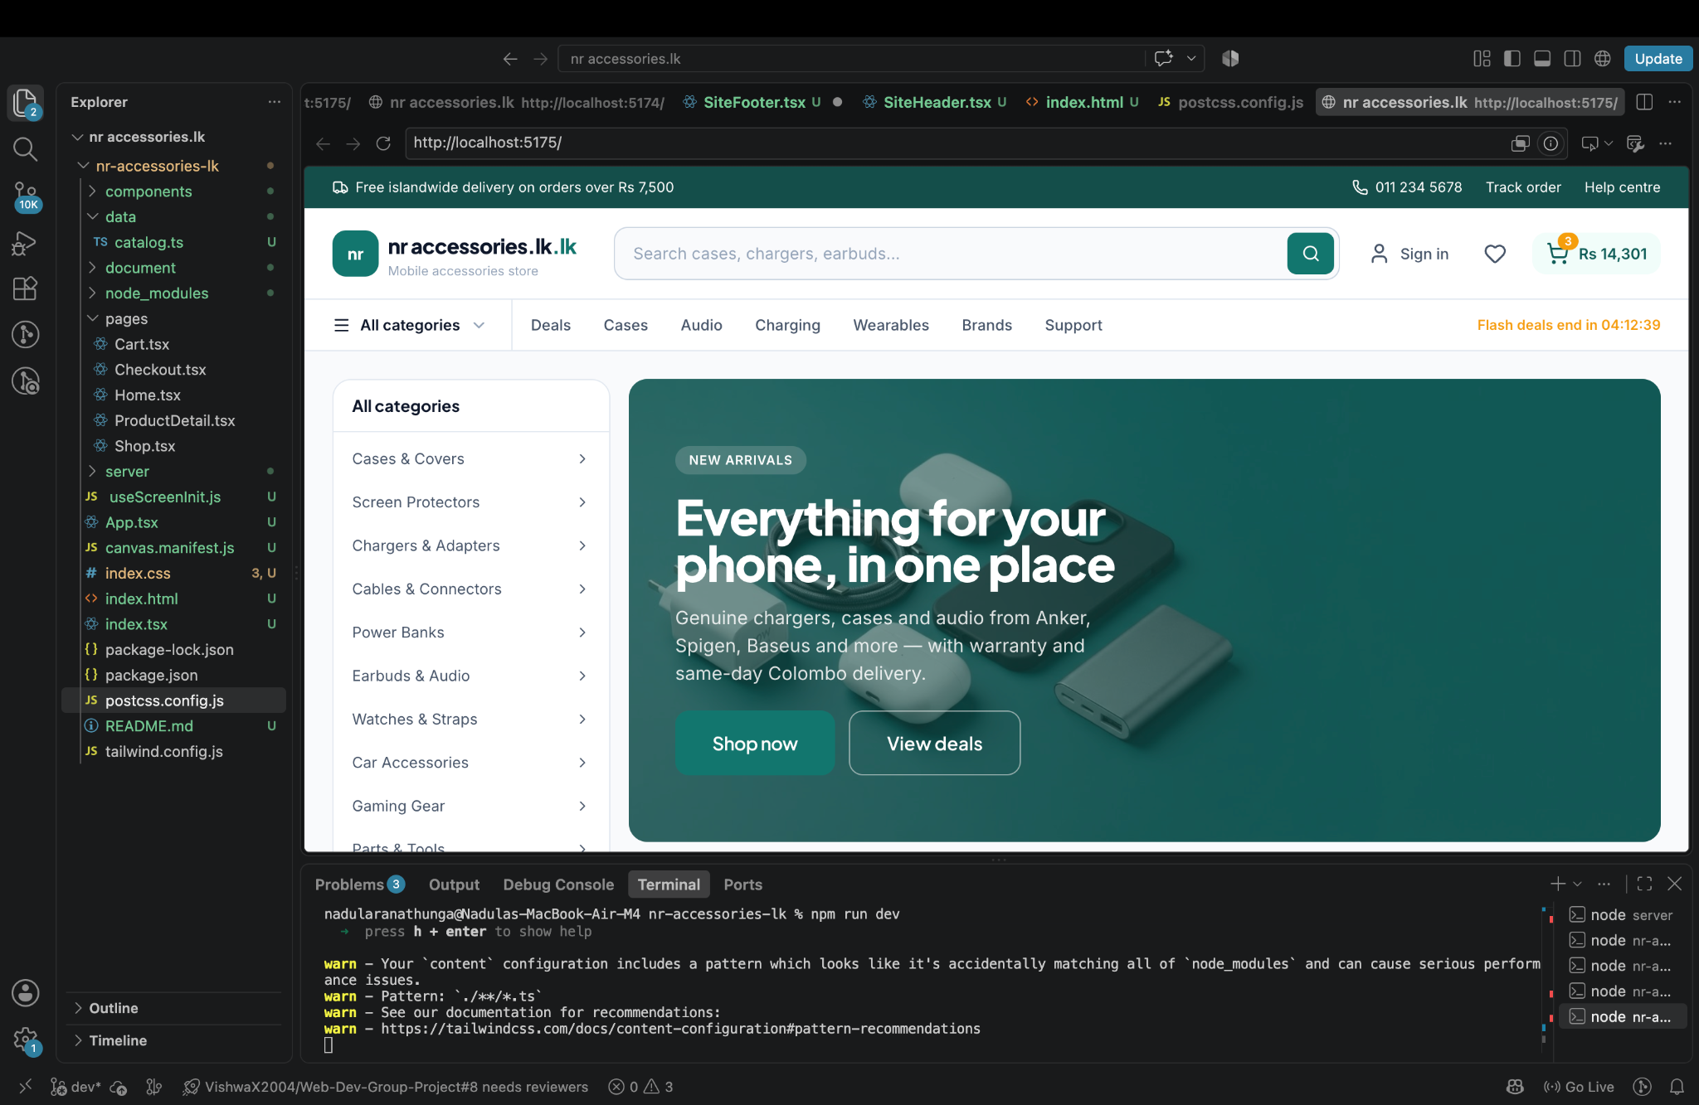
Home Page

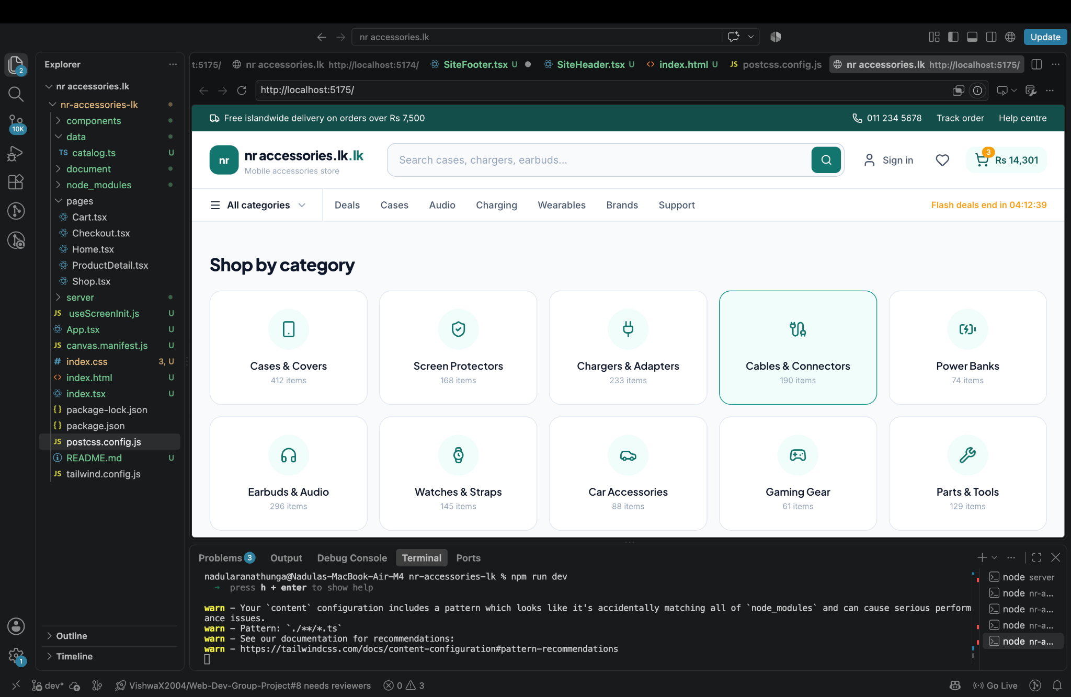

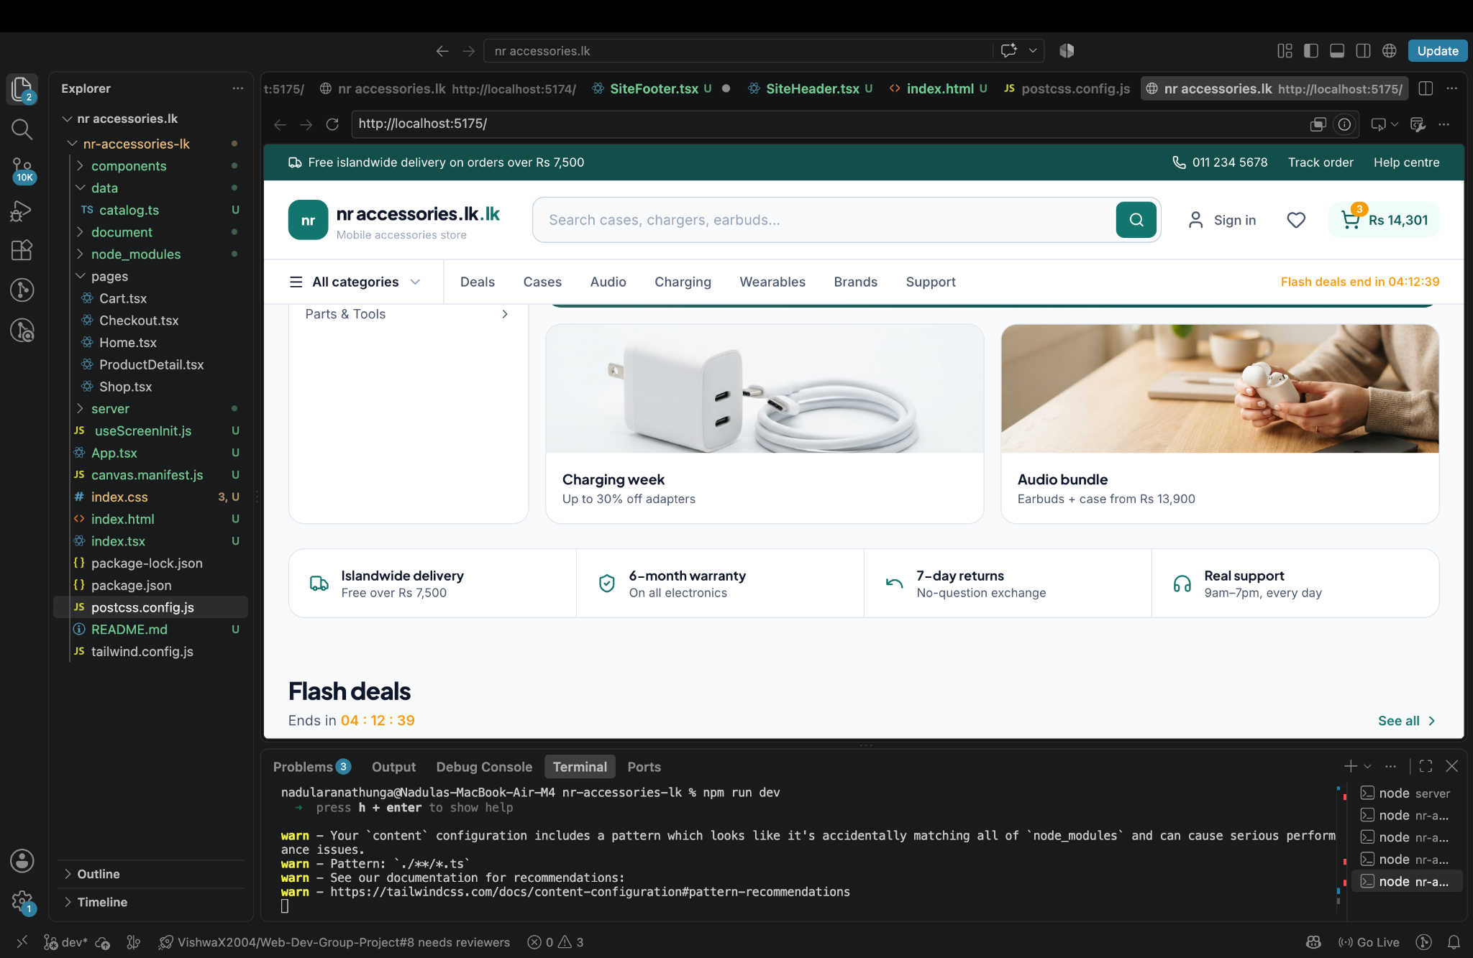

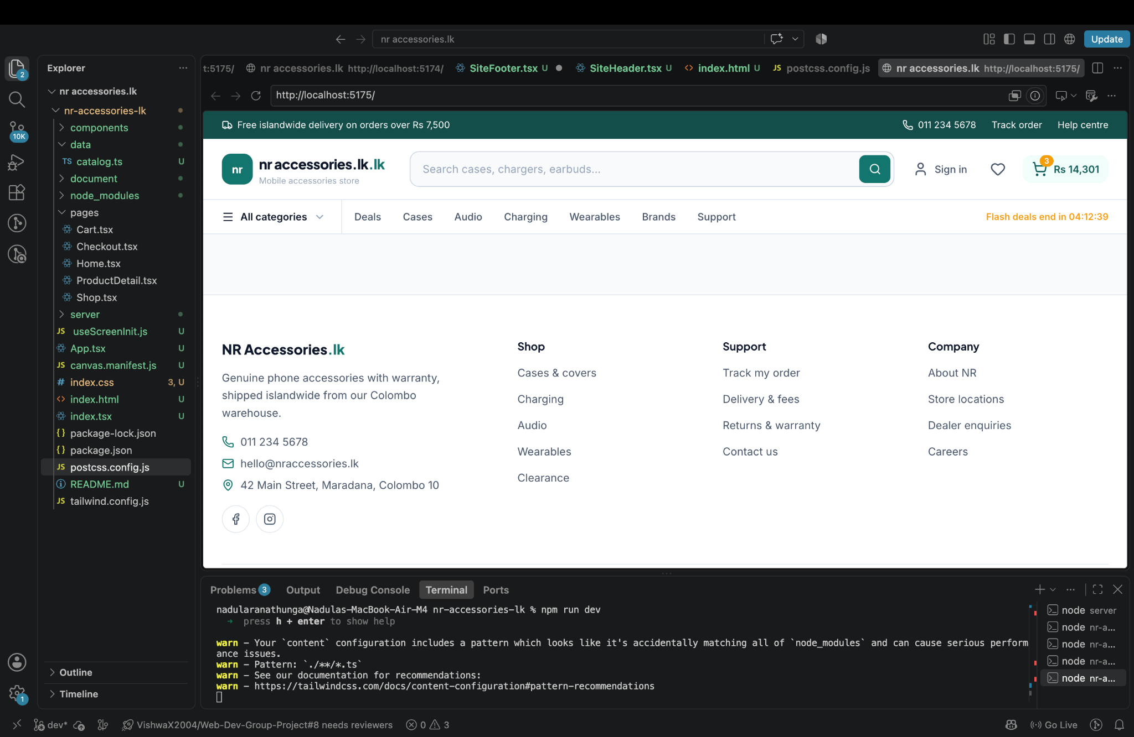

Milestones
- Project Structure & Architecture: Properly separated the Frontend (React/Vite) from the Backend (server/ Express) within the root directory.
- Development Environment Setup: Configured index.html as the entry point and updated package.json scripts ("dev": "vite") to run the Vite dev server.
- Routing & Component Fixes: Resolved file naming and import errors (e.g., renaming App.txt to App.tsx and fixing ProductDeetail.tsx path issues).
- UI & Styling Configuration: Configured PostCSS and Tailwind CSS directives to ensure styles render correctly across the application.
- Version Control Integration: Connected the local project to GitHub and published the dev branch to the remote repository.

Faced Challenges
Here are the technical challenges you faced and successfully resolved during the setup of your nr-accessories-lk project:
- Directory Structure Entanglement: The frontend files and backend server directory (server/) were mixed together without a clear root entry point.
- Missing Build Scripts: The npm run dev command failed due to missing script definitions (Missing script: "dev") and missing Vite developer dependencies in package.json.
- Incorrect File Extensions: Key React entry components had invalid file extensions (such as App.txt instead of App.tsx), breaking module exports.
- Module Import & Typo Mismatches: Vite failed to compile routes due to path typos in import statements (e.g., importing ./pages/ProductDetail when the actual file was named ProductDeetail.tsx).
- Tailwind CSS Directive Errors: The PostCSS build crashed with Missing "./base" specifier in "tailwindcss" because legacy CSS @import rules were used instead of Tailwind v3 directives.
- Unstyled HTML Rendering: The app initial view loaded plain, unstyled HTML because PostCSS wasn't linked properly and index.css was missing from index.html.
- Unpublished Git Branch: Pushing code via VS Code produced a The branch "dev" has no remote branch prompt because the local branch lacked an upstream tracking reference on GitHub.

File Structure
Git Repo - https://github.com/nadularanathunga/nr-accessories.lk.git
