ICT2142 E-Business Systems
Week 07 Practical Report
nr accessories.lk — Smartphone Accessories E-Commerce Platform
TG/2024/2147
Integration of Payment Gateway (PayHere Sandbox)

1. Building the Checkout Form
To initiate the payment process, a comprehensive and clean checkout form was developed on the frontend
- User Information Collection: The form effectively collects essential billing and shipping details including the Customer's Name, Email, Phone number, and City.
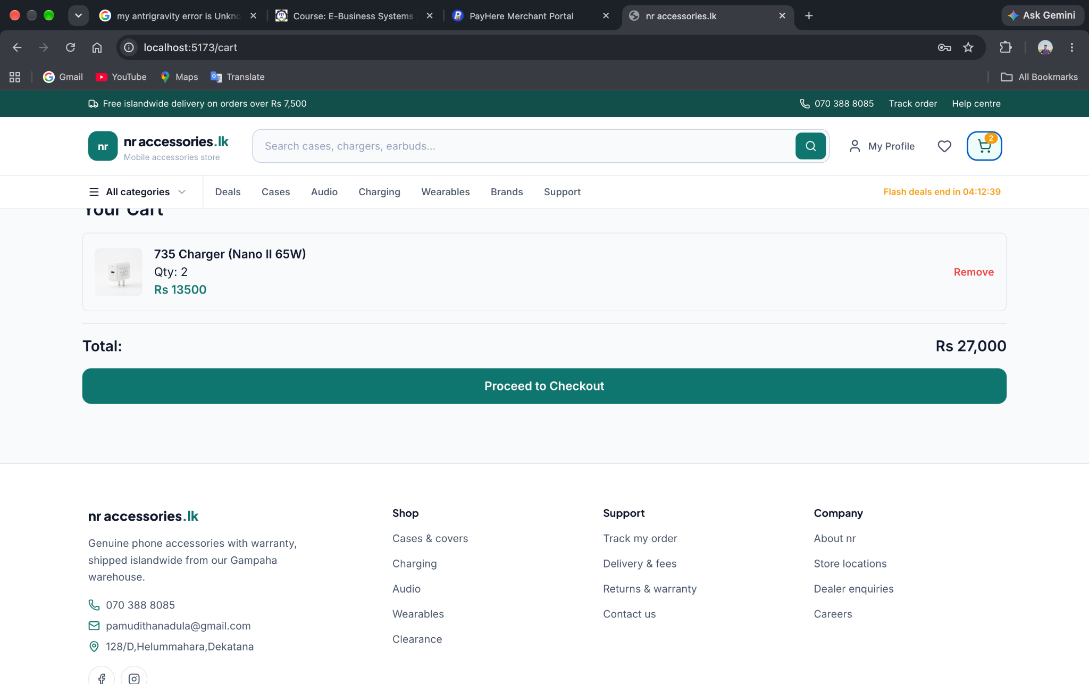
- Order Summary: Before proceeding to payment, the page dynamically displays the order item summary and the final total amount strictly formatted in LKR.

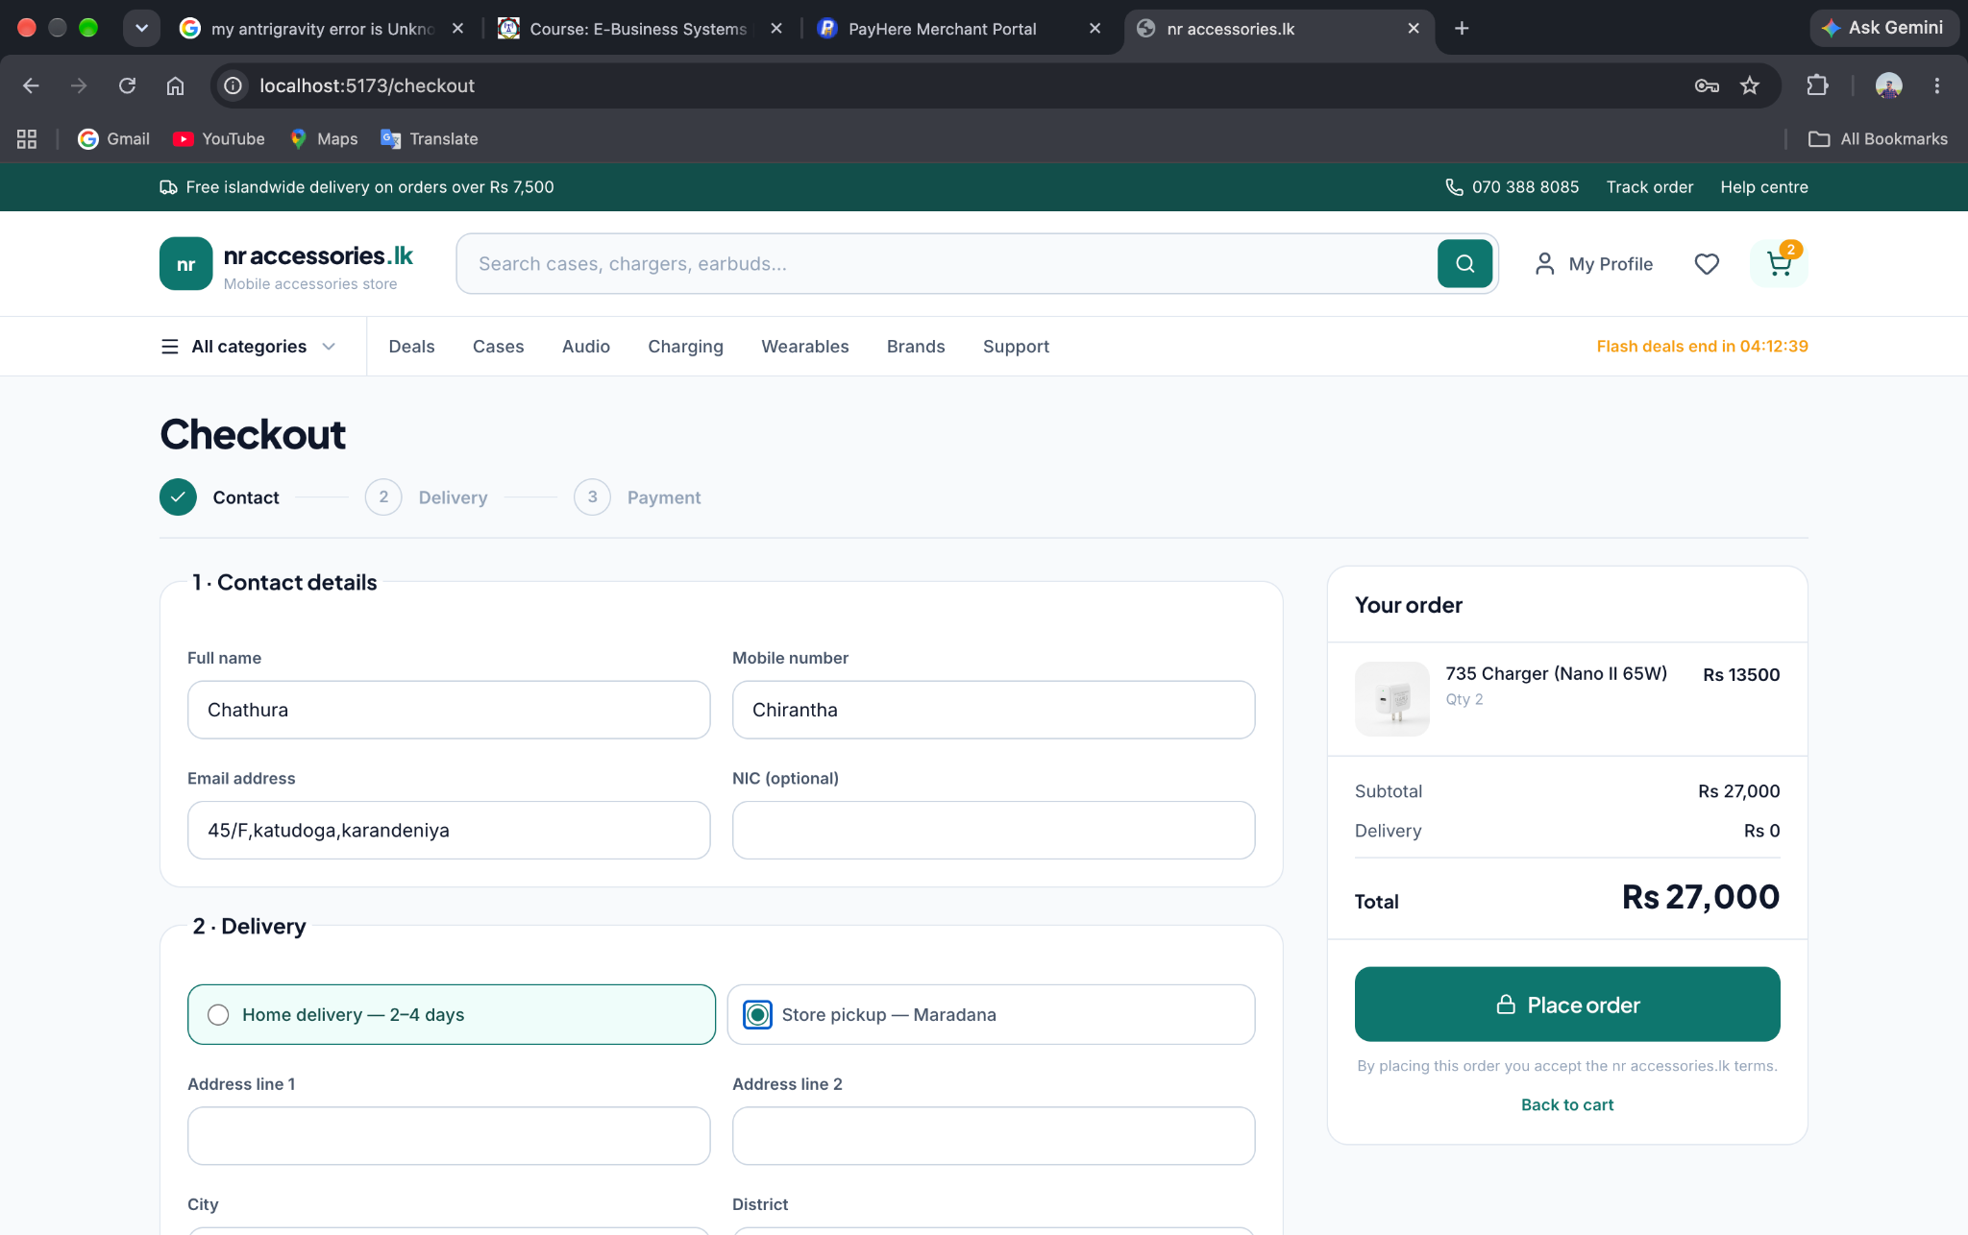

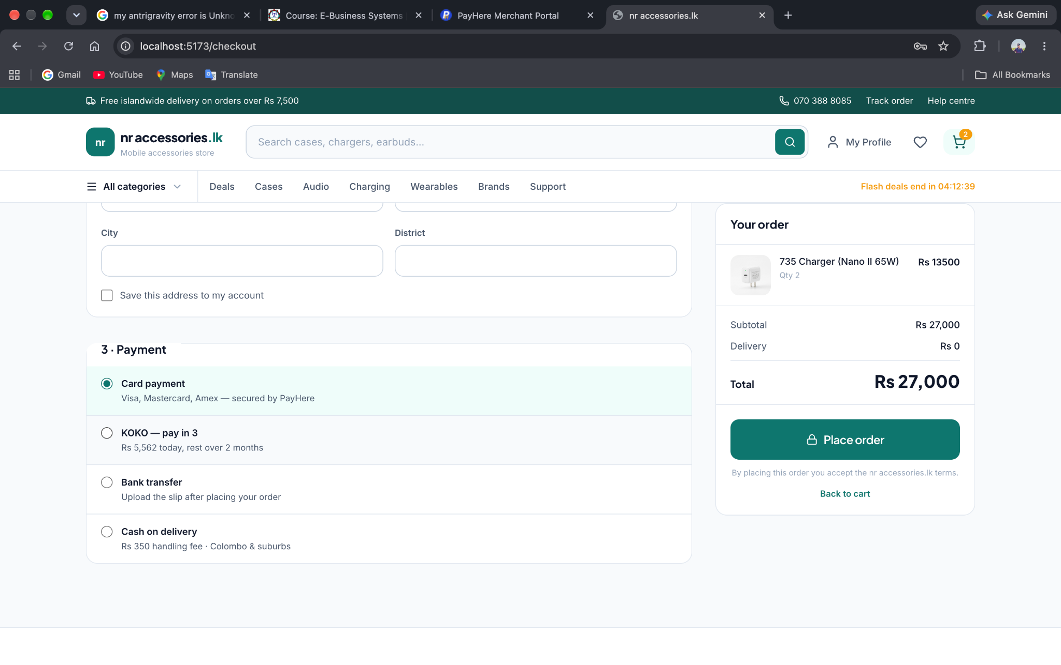

2. Connecting the Payment Gateway (PayHere)
The system was integrated with Sri Lanka's leading payment gateway, PayHere, using their Developer Sandbox environment for safe testing.
- Sandbox Configuration: A PayHere Sandbox account was created, and the localhost domain was registered to generate a unique Merchant ID and Merchant Secret.
- Security Hash Implementation: A secure backend endpoint (Node.js) was created to automatically generate the mandatory MD5 Security Hash. The hash was formatted strictly according to the PayHere algorithm: md5(merchant_id + order_id + amount + currency + md5(merchant_secret)) to prevent data tampering.
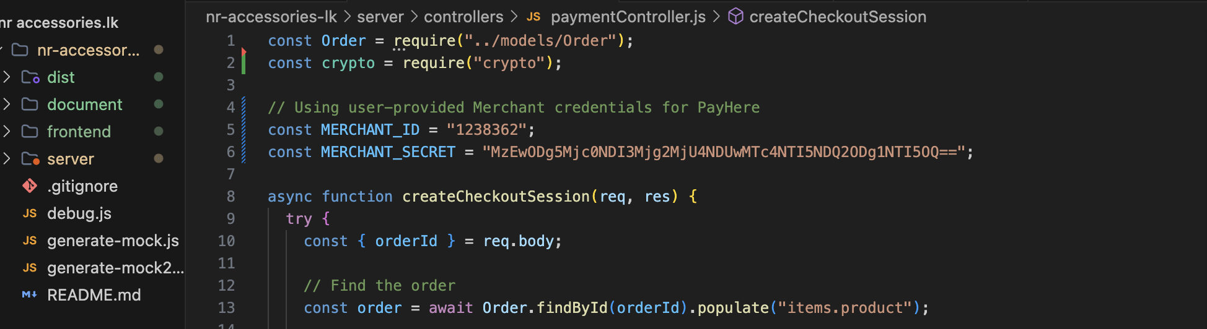
- Pay Now Button: The "Pay Now" button was bound to the payhere.js library, triggering the secure payment popup without redirecting the user away from the application.

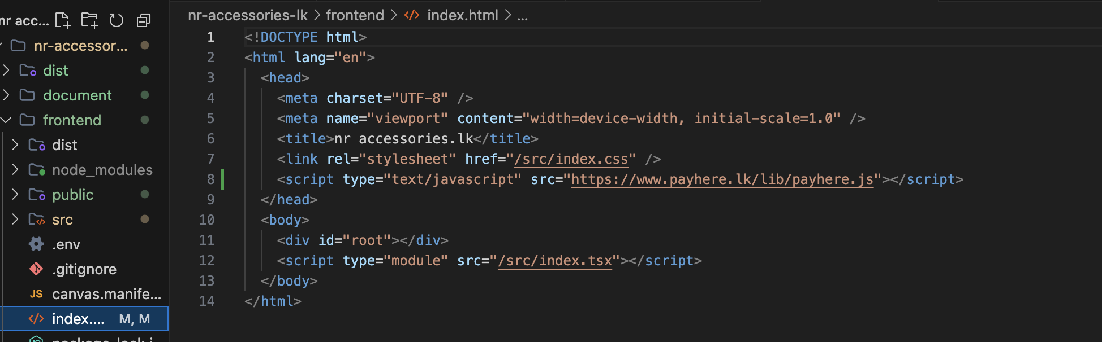

3. Testing and Validation
To ensure the end-to-end checkout flow functions perfectly, simulated payments were conducted.
- Simulating Payment: The integration was tested using PayHere's officially provided free test credit card details (Visa/Mastercard) within the sandbox payment window.
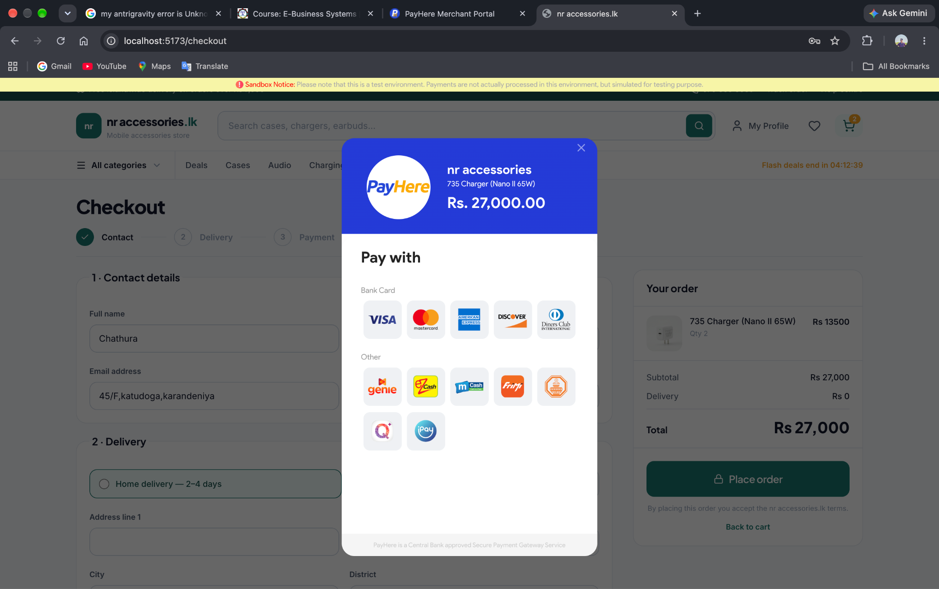
- Handling Redirects: The system was successfully configured to listen for the onCompleted and onDismissed events from the PayHere popup. Upon a successful mock transaction, the system records the payment status and automatically redirects the customer back to the payment-success page of the website.

