ICT2142 E-Business Systems
Week 05 Practical Report
nr accessories.lk — Smartphone Accessories E-Commerce Platform
TG/2024/2147
Add Cart and Quantity Updates

State Architecture Notes
How data flows from the product button into the cart state:
Component Level (ProductCard / ProductDetail): When the user clicks the "Add to Cart" button, it triggers the addToCart(productId, quantity) function provided by the CartContext.
Context API Level (CartContext.tsx): The cart state (cart, loading, error) is globally shared across the app using React Context. When addToCart is called, it triggers the apiAddToCart function (from api.ts), which sends an HTTP POST request to the backend.
Data Persistence (Backend): The Node.js/Express backend updates the specific user's cart in the MongoDB database and returns the updated cart object.
State Update: The newly returned cart data from the backend is set into the React state via setCart(data) within CartContext. This automatically triggers a re-render, instantly updating the UI (such as the item count on the Cart Badge).
Authentication Flow: Since adding to the cart requires authorization, CartContext relies on the isAuthenticated state from AuthContext to ensure the user is logged in before allowing cart operations.

Code Snippets
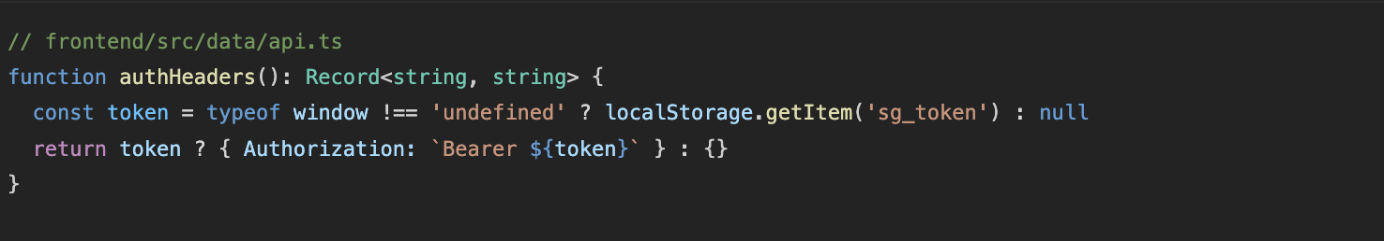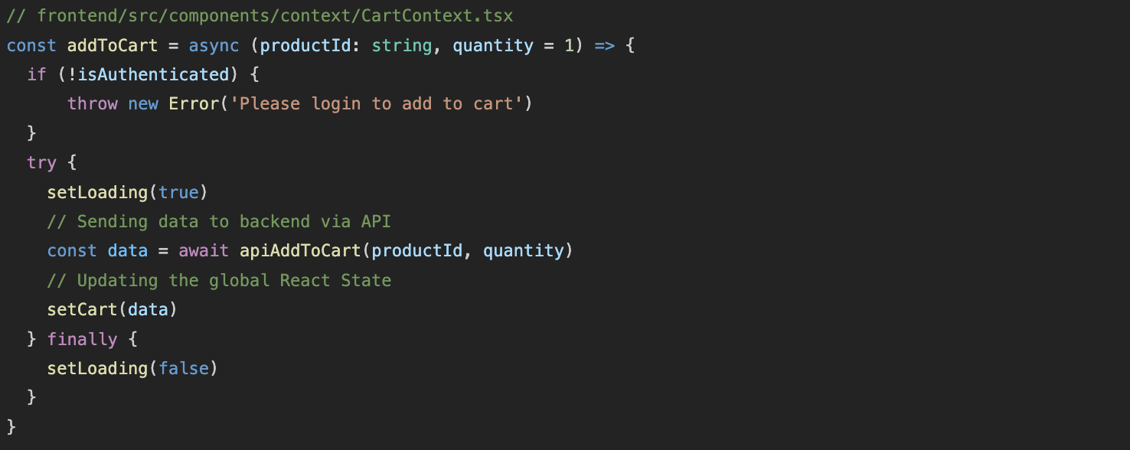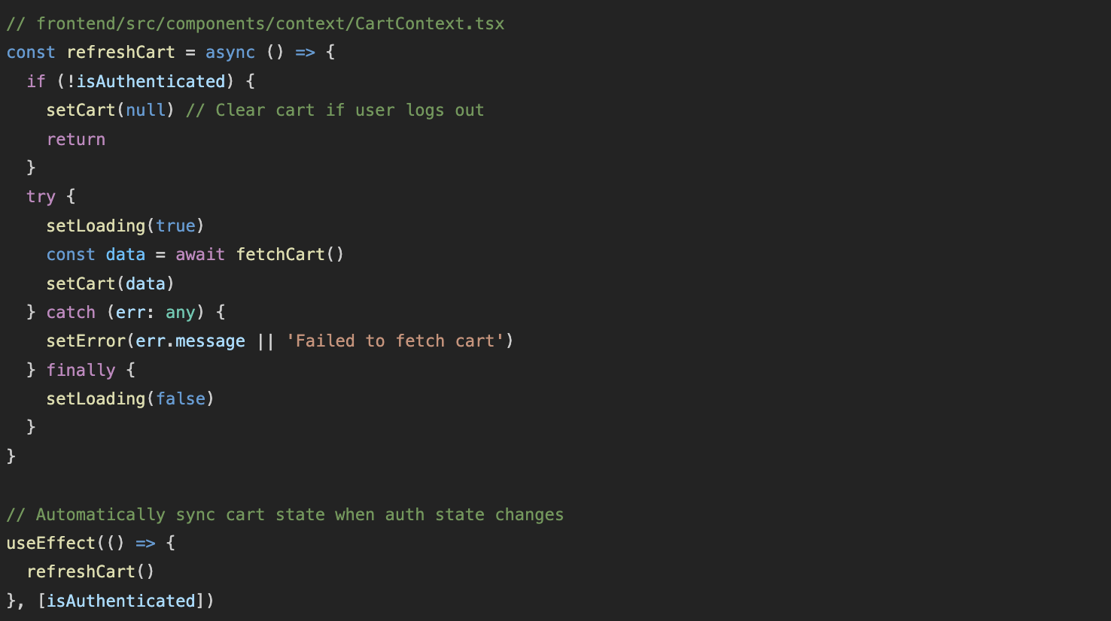
Bug Log
Issue Description: Cart badge didn’t update instantly when the user logged in, or the cart data remained from a previous session until a manual page refresh.
Root Cause: The CartContext was not reacting reactively to changes in the Authentication state. The initial cart fetch was running independently of whether the local storage token had been fully initialized.
Resolution / Fix:
Fetched the isAuthenticated boolean from useAuth() inside CartContext.
Added isAuthenticated to the useEffect dependency array so that the refreshCart() function automatically runs whenever the user logs in or logs out.
This ensures the global state remains perfectly synced without needing a manual browser refresh.

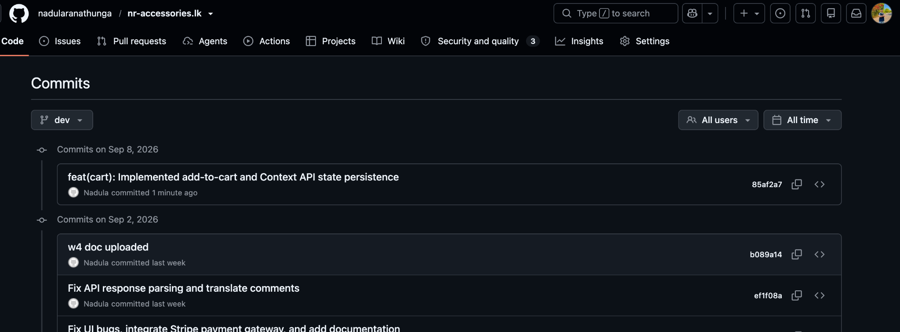
Git Commit

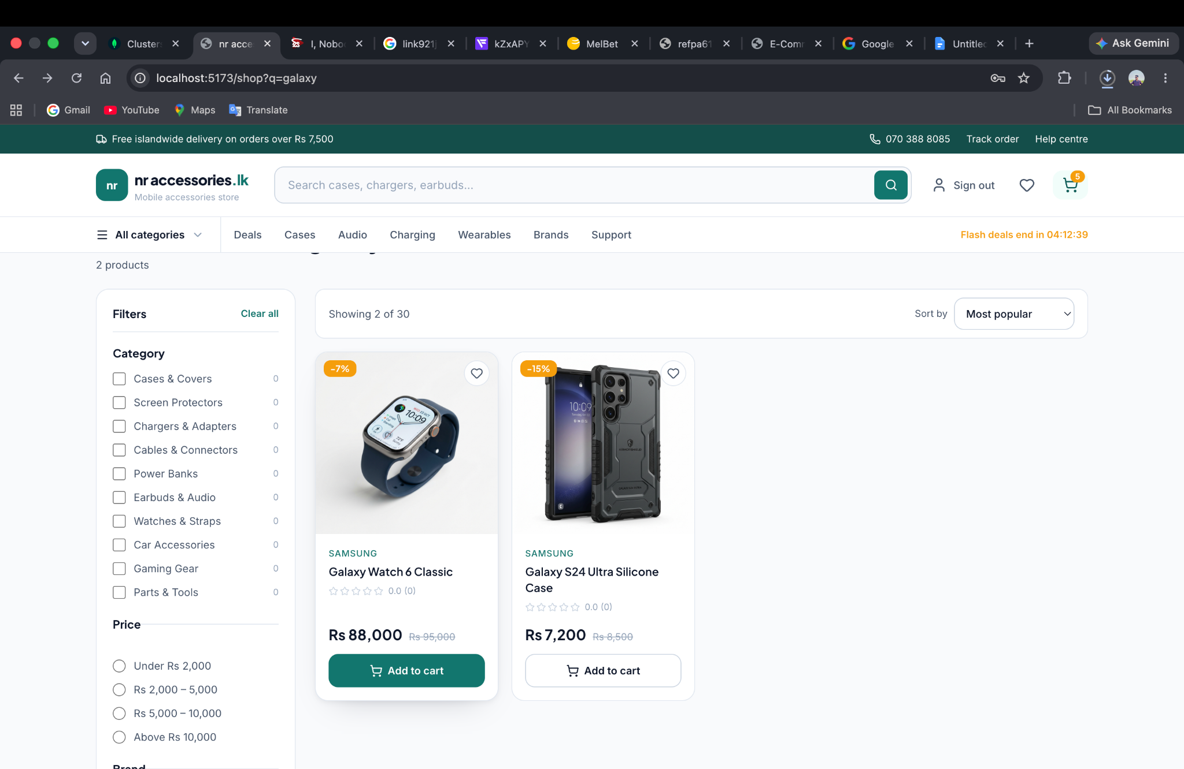
Added Add to Cart Logic

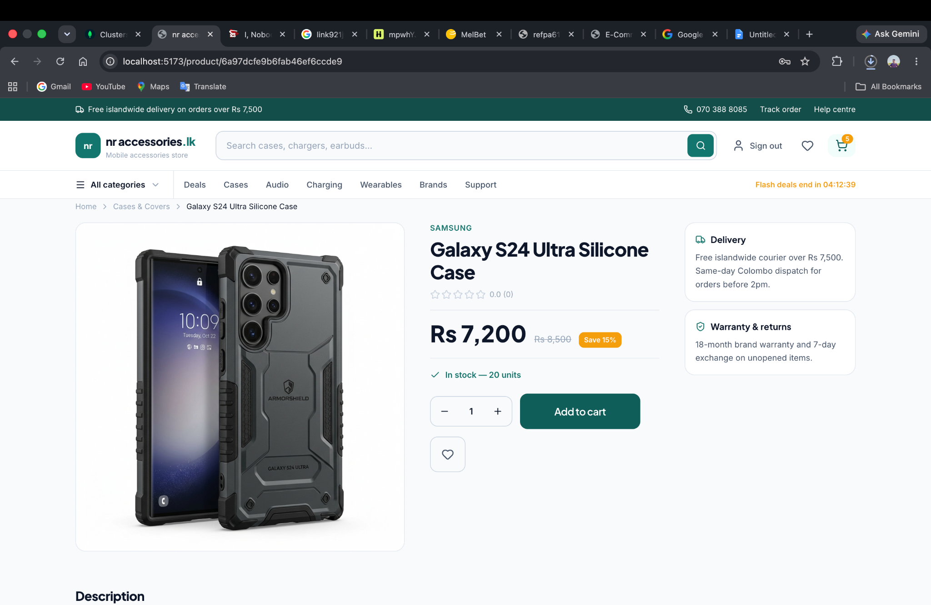

Remove Item" & Quantity Updates
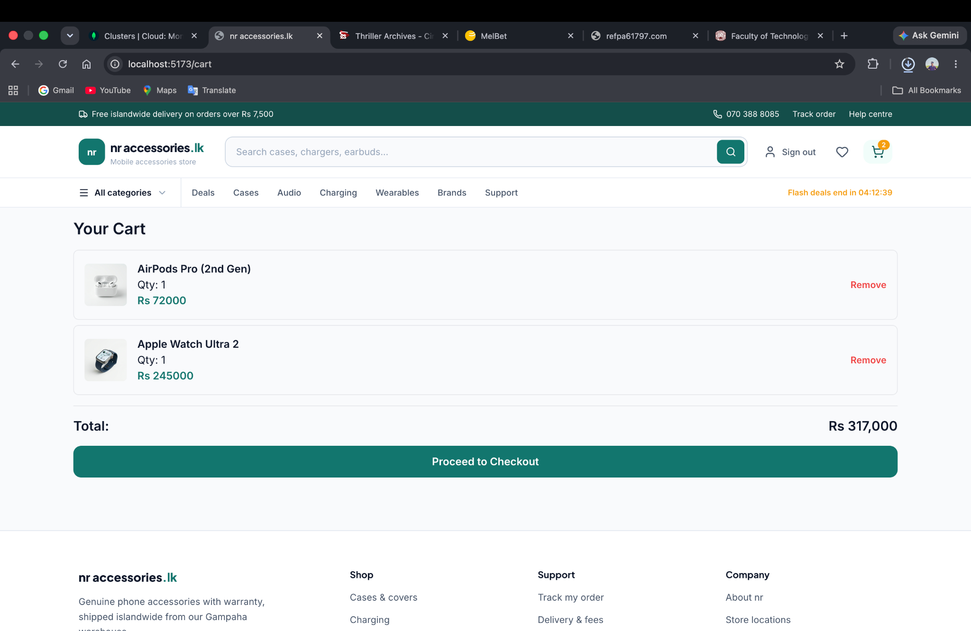

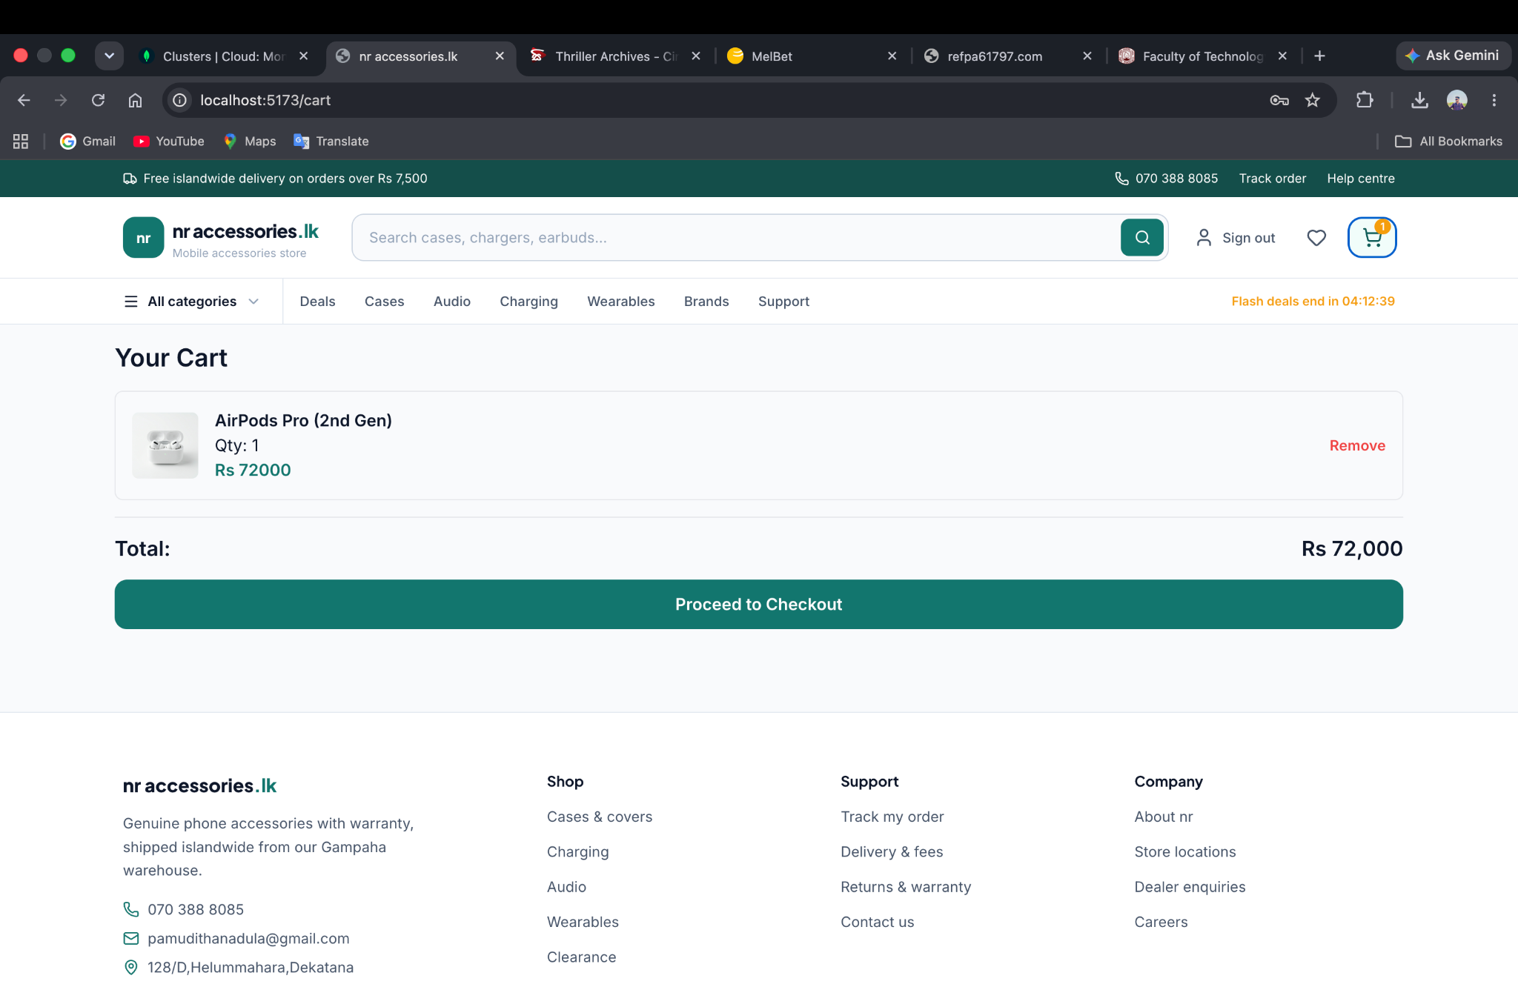

Session Storage & State Persistence
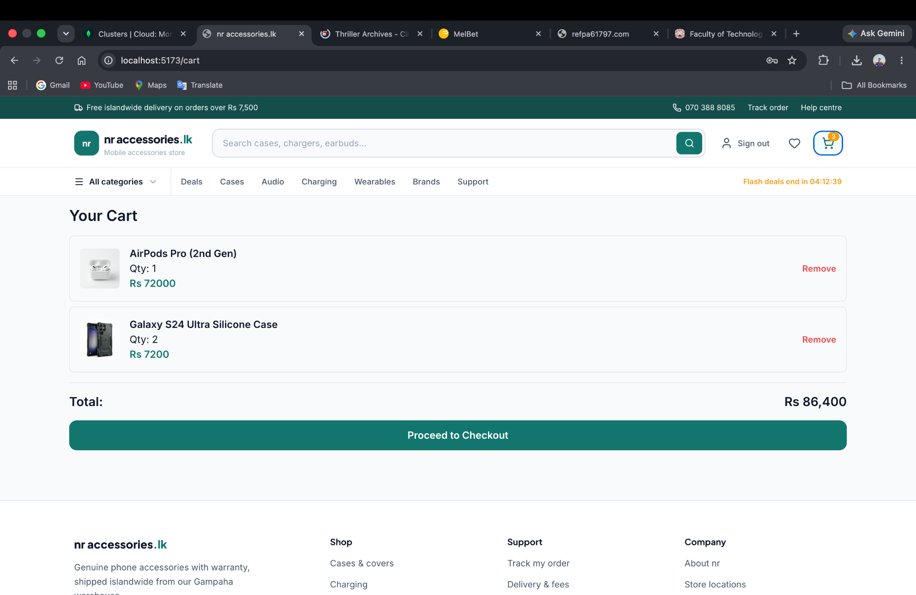

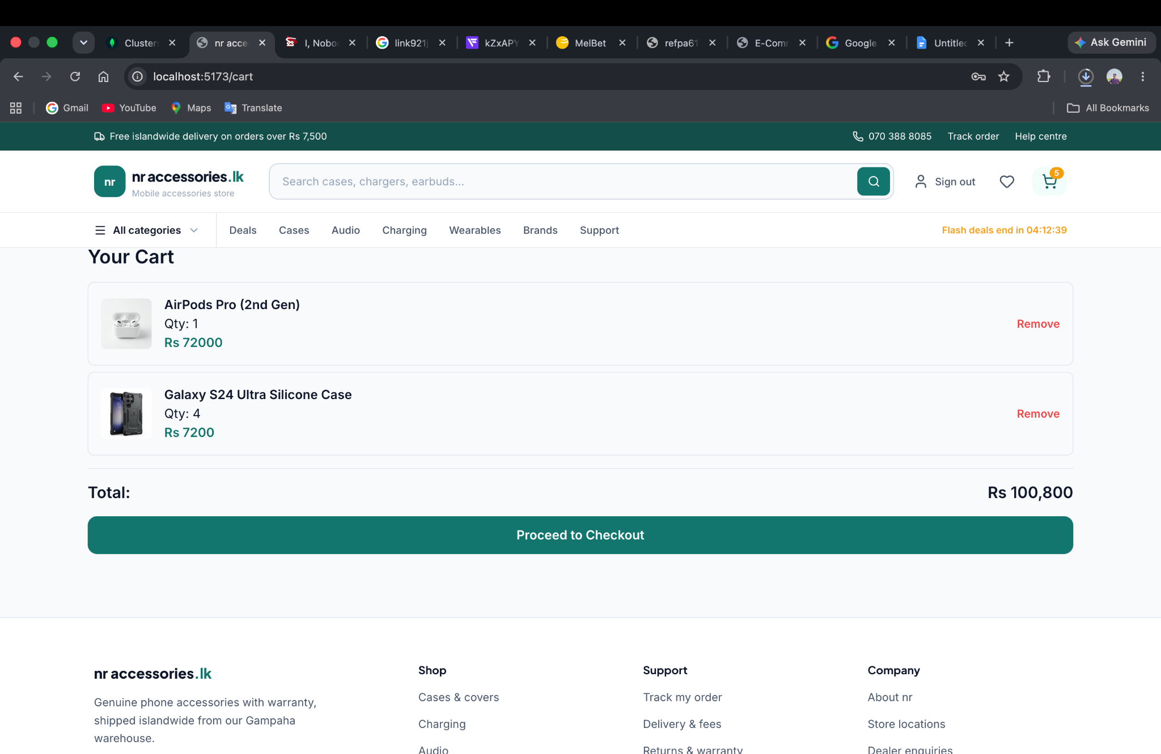

Git repo - https://github.com/nadularanathunga/nr-accessories.lk.git

