ICT2142 E-Business Systems
Week 06 Practical Report
nr accessories.lk — Smartphone Accessories E-Commerce Platform
TG/2024/2147
User Authentication & Profile Management

1. Auth Architecture Diagram
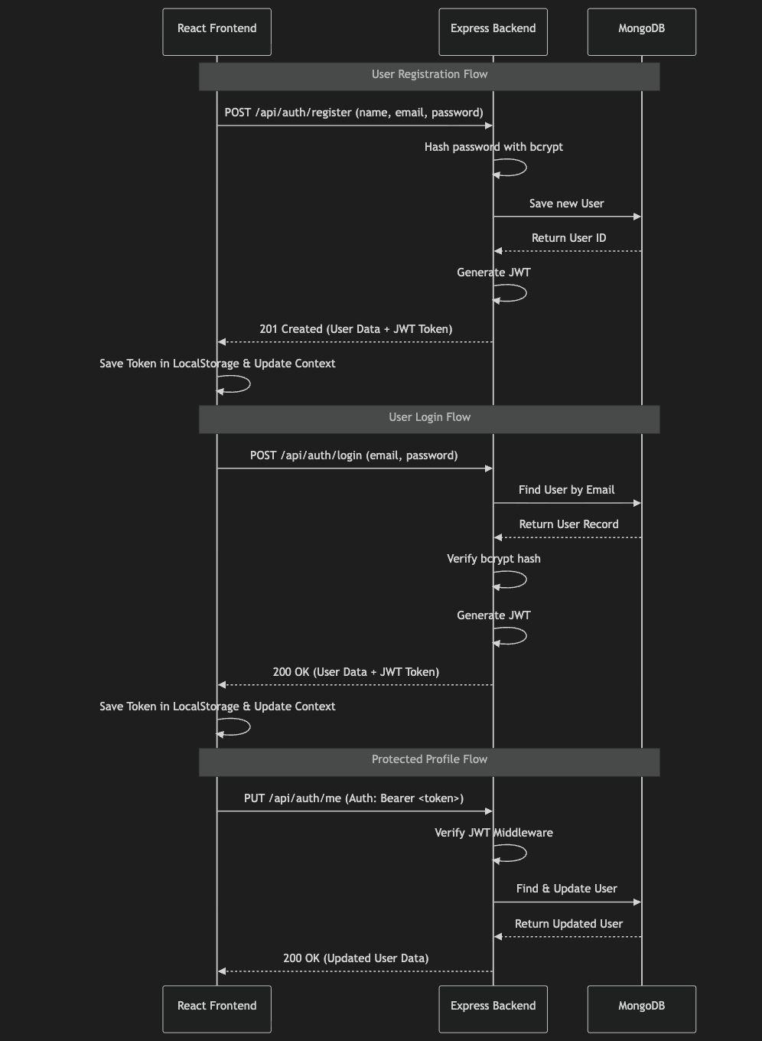
This diagram illustrates the flow of tokens between the client and server during login and subsequent API requests.

2. Security Considerations

Password Hashing:
Plaintext passwords are never stored in the database. We utilize the bcryptjs library with a salt factor of 10 to securely hash passwords during registration and compare hashes during login.

JWT Authentication:
JSON Web Tokens (JWT) are used for stateless session management. Tokens are signed with a secure JWT_SECRET stored in environment variables and are set to expire in 7 days to minimize the risk of compromised long-lived tokens.

Token Storage:
On the client side, the JWT is stored in localStorage for simplicity in this phase. (Note: For stricter security against XSS attacks, migrating to httpOnly cookies is recommended for production).

Route Guards:
Frontend routes like /profile and /checkout are protected using a higher-order component (ProtectedRoute.tsx). If an unauthenticated user attempts to access these routes, they are intercepted and redirected to the /login page.

Prevention of User Enumeration:
The login endpoint returns generic "Invalid email or password" messages to prevent attackers from determining which emails are registered in the system.

3. Debugging Notes & Edge Cases

React State Synchronization:
Issue: When navigating between authentication pages, the AuthContext sometimes held stale user data.

Resolution:
Implemented a hard refresh (window.location.href = '/') on login and logout, and ensured the useEffect hook in AuthContext re-evaluates the authentication status correctly on mount.

Protected Route Flickering:
Issue: When users refreshed the page on a protected route, they were briefly redirected to /login before the token could be read.

Resolution:
Ensure synchronous reading of localStorage during the initial state initialization of useState inside AuthProvider.

Mongoose Address Schema Updates:
Issue: Updating nested arrays (like addresses) required ensuring that we didn't accidentally overwrite the entire user object or lose existing createdAt fields.

Resolution:
Specifically targeted the fields to update (user.name, user.phone, user.addresses) and called .save() to safely run validations.

4. API Specification

POST /api/auth/register
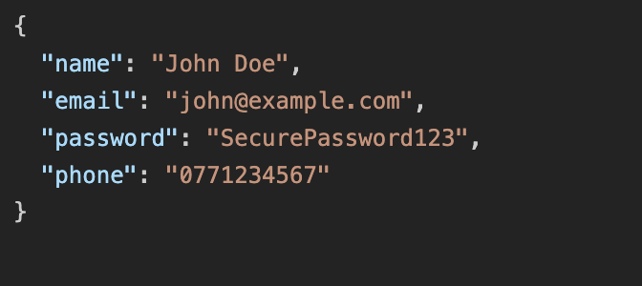
Description: Registers a new user.

Response (201 Created):
Returns user details and a JWT token.

POST /api/auth/login
Description: Authenticates an existing user and provides a JWT.

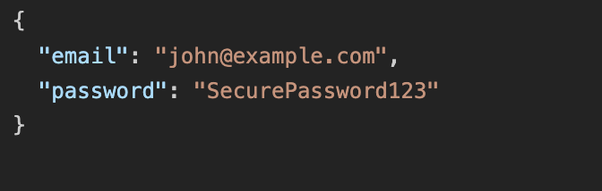
Request Body:

Response (200 OK): Returns user details and a JWT token.
GET /api/auth/me

Description:
Retrieves the logged-in user's profile details.

Headers:
Authorization: Bearer <JWT_TOKEN>

Response (200 OK): Returns the user object (excluding the password hash).
PUT /api/auth/me

Description:
Updates the logged-in user's profile details and shipping addresses.

Headers:
Authorization: Bearer <JWT_TOKEN>

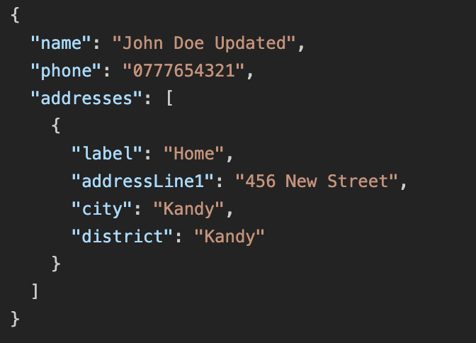
Request Body:

Response (200 OK): Returns the newly updated user object.

