ICT2142 E-Business Systems
Week 08 Practical Report
nr accessories.lk — Smartphone Accessories E-Commerce Platform
TG/2024/2147
Database Integration & Admin Dashboard

1. Database Schema & Finalized Structure
the database architecture was updated from static mock data to a persistent MongoDB schema with foreign key references and integrity constraints.
ERD & Collection Models:
- A. USERS Collection (User.js)
:- _id: ObjectId (Primary Key)
:- name: String (Customer full name)
:- email: String (Unique, lowercase email address)
:- passwordHash: String (Bcrypt hashed password)
:- phone: String
:- role: String ('customer' or 'admin', default: 'customer')
:- addresses: Array of Subdocuments (label, addressLine1, addressLine2, city, district, isDefault)
:- createdAt, updatedAt: Date
- B. PRODUCTS Collection (Product.js)
:- _id: ObjectId (Primary Key)
:- title: String (Product name)
:- description: String
:- brand: String
:- category: ObjectId (Ref: Category)
:- price: Number (Regular price in LKR)
:- discountPrice: Number (Optional discounted price)
:- stockQuantity: Number (Inventory quantity available)
:- imageURL: String (Product image link)
:- avgRating: Number
:- reviewCount: Number
- C. ORDERS Collection (Order.js)
:- _id: ObjectId (Primary Key)
:-_user: ObjectId (Ref: User)
:- items: Array of Order Items (product ObjectId, quantity Number, unitPrice Number)
:- deliveryAddress: Object (addressLine1, addressLine2, city, district)
:- deliveryMethod: String ('home_delivery' | 'store_pickup')
:- paymentMethod: String ('card' | 'koko' | 'bank_transfer' | 'cash_on_delivery')
:- paymentStatus: String ('pending' | 'paid' | 'failed')
:-totalAmount: Number (Recalculated on server)
:- orderStatus: String ('pending' | 'paid' | 'processing' | 'shipped' | 'completed' | 'cancelled')
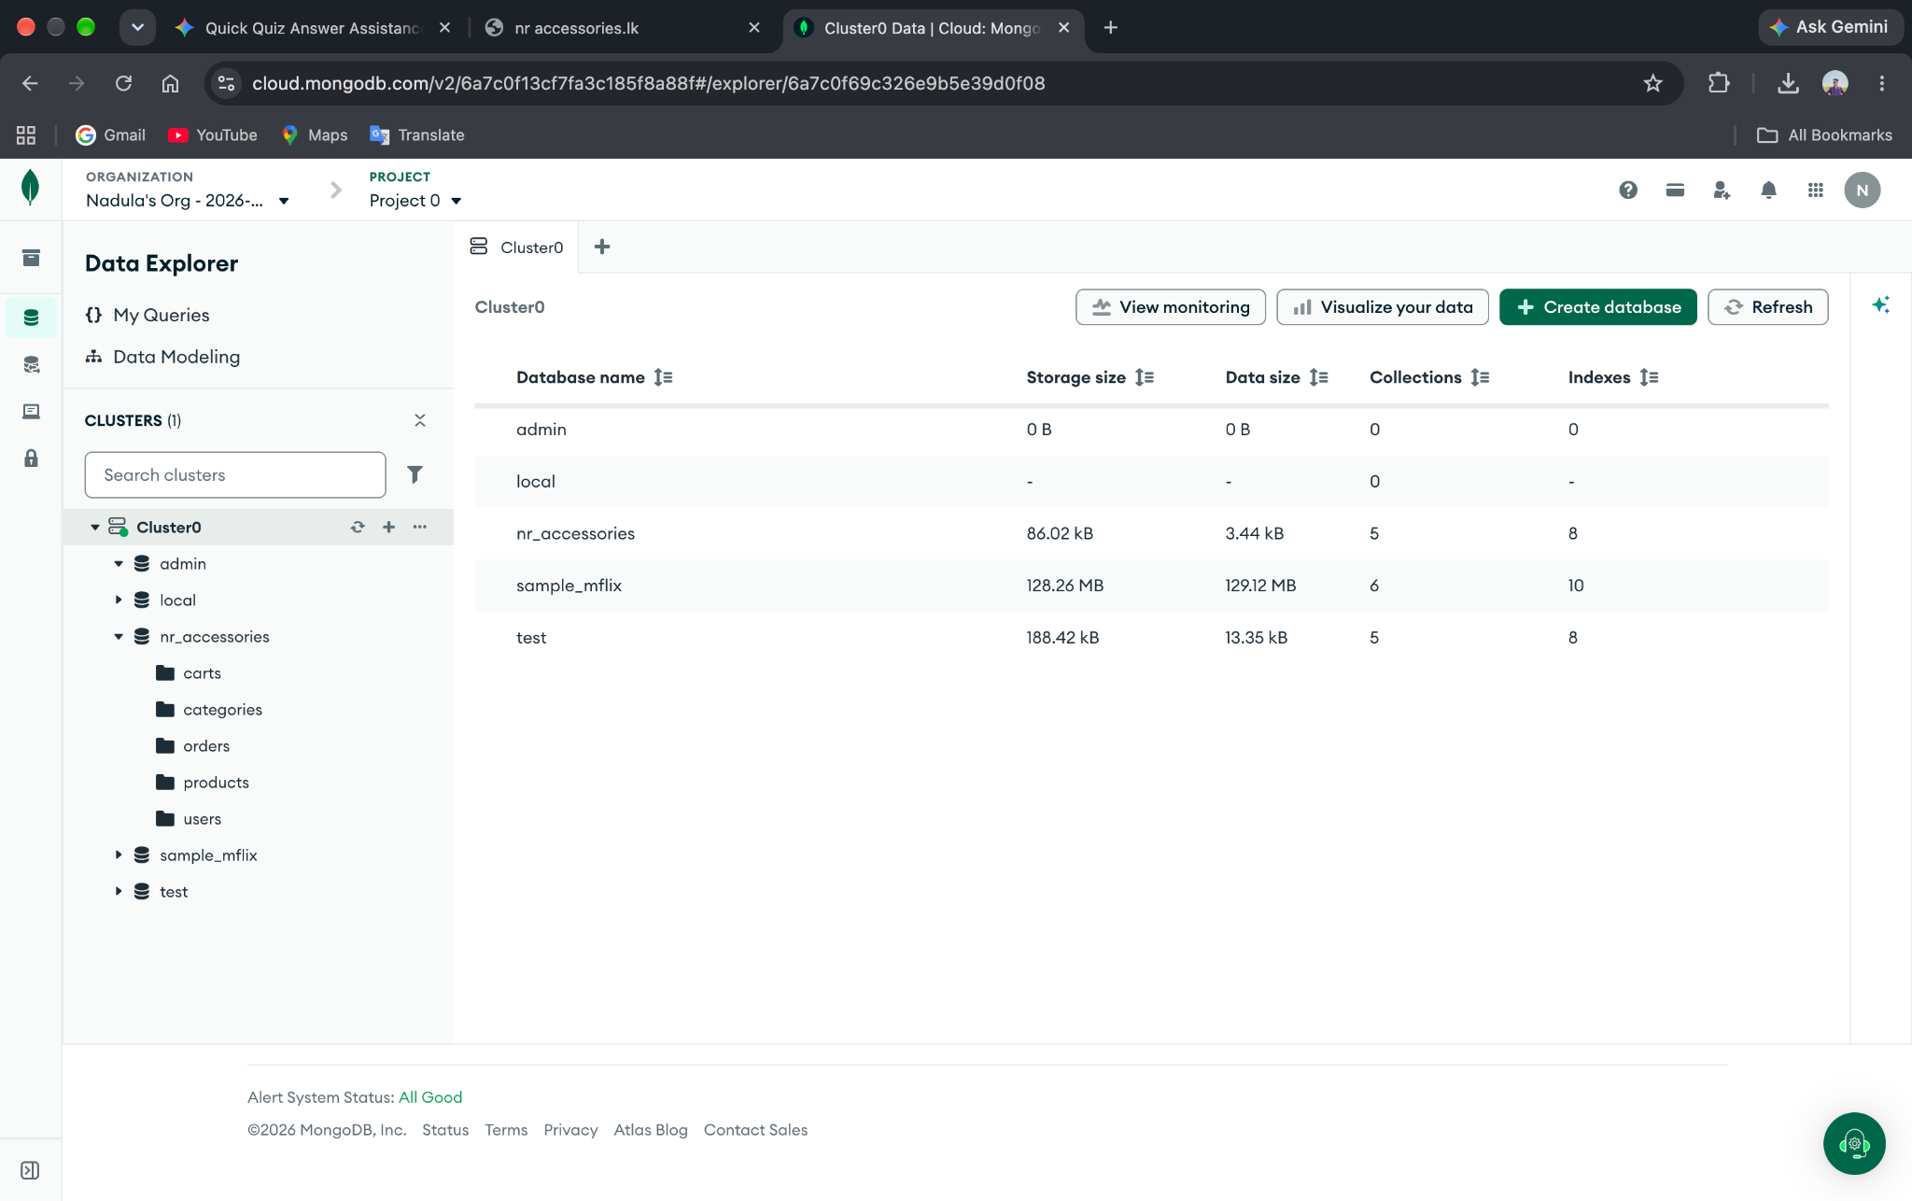
:- createdAt, updatedAt: Date

2. Integration Evidence

- Product Catalog Connection: Static arrays in Shop.tsx and ProductDetail.tsx were replaced with live API calls to GET /api/products.
- Order Persistence: When a customer completes checkout, cart items are serialized into a permanent Order document in MongoDB.
- Stock Auto-Reduction: During order creation, the server automatically updates product stock quantities (stockQuantity decreases by ordered quantity).
- Cart Cleanup: User's active database cart is automatically cleared upon successful order submission.

3. Admin Dashboard Implementation
The protected Admin Dashboard provides store managers with complete operational oversight:

- Dashboard Overview (/admin/dashboard):
:- Summary Cards: Total Products, Total Orders, and Low Stock Items counter (stock <= 5).
:- Database Connection Badge: Displays Database connected ✓ status.
:- Recent Orders Table: Preview of recent customer transactions.

- Product CRUD & Inventory Management (/admin/products):
:- Create: Add new products with title, price, brand, category, image URL, and stock.
:- Read: Search and view active product listings.
:- Update: Modify product details and adjust inventory stock levels.
:- Delete: Safely remove products from database.

- Order Management (/admin/orders):
:- View all customer orders with customer contact details, totals, and payment status.
:- Status Workflow Updates: Admin can transition order statuses: Pending → Paid → :- :- :- Processing → Shipped → Completed / Cancelled.

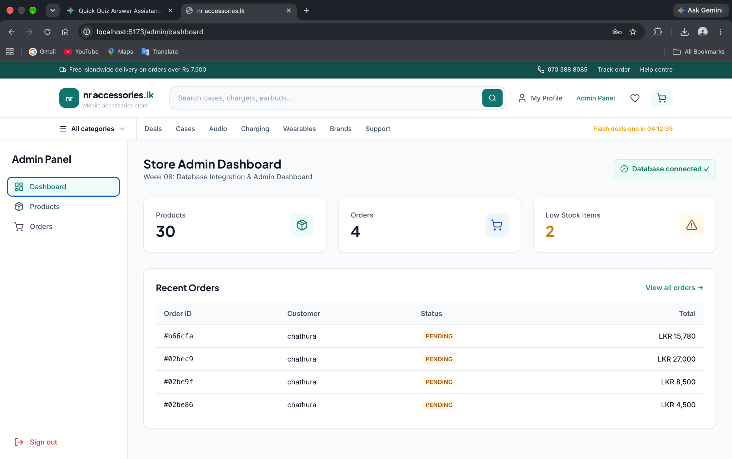

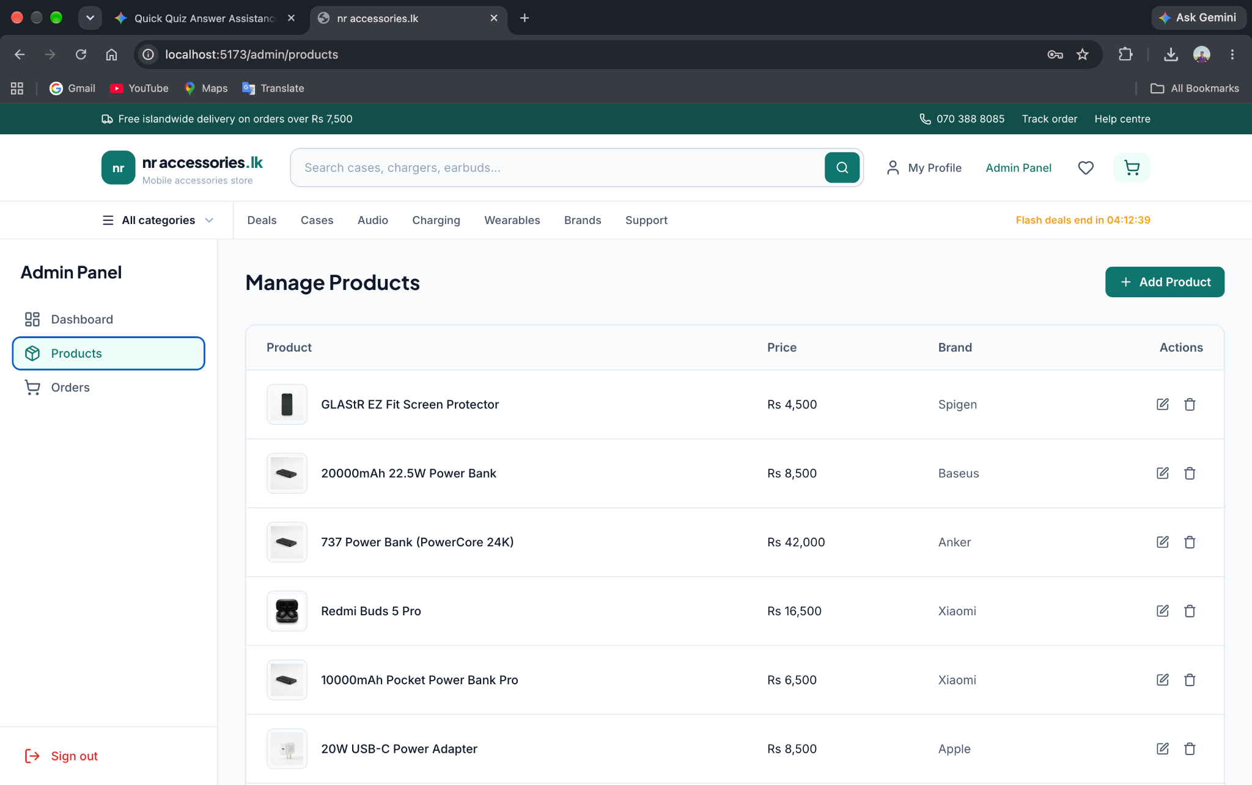

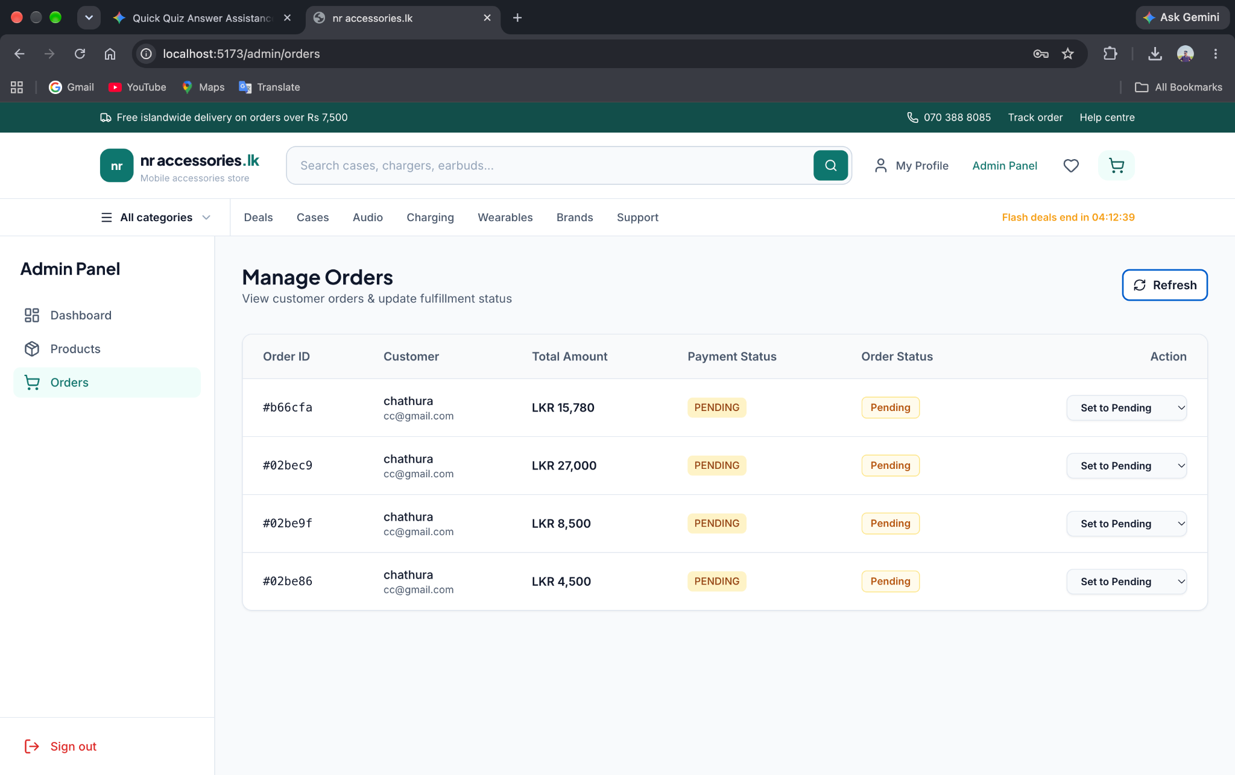

4. API Endpoint & Query Notes

Method | Endpoint | Access Level | Purpose
GET | /api/products | Public | Fetch all active products
GET | /api/products/:id | Public | Fetch single product details
POST | /api/products | Admin Only | Create new product record
PUT | /api/products/:id | Admin Only | Update product details or stock
DELETE | /api/products/:id | Admin Only | Remove product record
POST | /api/orders | Authenticated User | Place new order & decrease stock
GET | /api/orders/my-orders | Authenticated User | Fetch logged-in user's order history
GET | /api/orders/admin/all | Admin Only | Fetch all customer orders
GET | /api/orders/admin/stats | Admin Only | Fetch summary stats (products, orders, low stock)
PUT | /api/orders/admin/:id/status | Admin Only | Update order fulfillment status

5. Security & Access Control Notes

- JWT Authentication: Handled via authMiddleware checking Authorization: Bearer <token>.
- Server-Side Role Guard: Handled via requireAdmin middleware ensuring req.user.role === 'admin'. Non-admin attempts to access admin APIs receive 403 Forbidden.
- Frontend Route Protection: AdminLayout component checks user.role === 'admin' and redirects or displays Access Denied for non-admin accounts.
- Server-Side Order Total Calculation: Order totals are calculated on the server using database product prices to prevent client-side price tampering.

6. Debugging Log

Issue 1:
Cart Total Security Vulnerability
Description: Client browser was sending total price, which could be altered before sending request.
Resolution: Moved total calculation logic to backend controller (orderController.js). Server queries product unit prices from database and calculates total automatically.

Issue 2:
Stock Quantities Not Decreasing After Checkout
Description: Orders were created in DB, but product inventory levels remained unchanged.
Resolution: Added an atomic update loop using MongoDB $incoperator($inc: { stockQuantity: -quantity }) inside createOrder to automatically decrement stock levels upon order confirmation.

