ICT2142 E-Business Systems
Week 04 Practical Report
nr accessories.lk — Smartphone Accessories E-Commerce Platform
TG/2024/2147
Product Catalog and Sorting

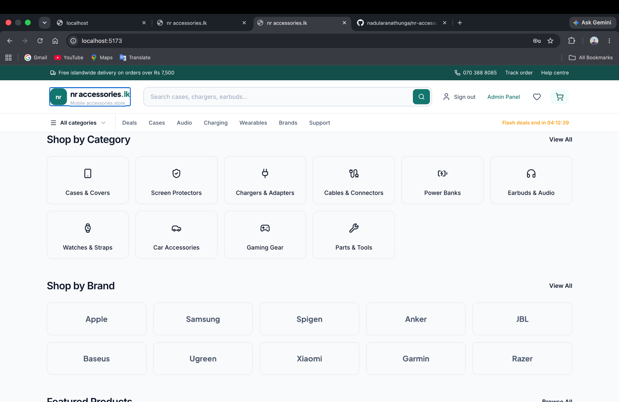
Category

- Case and Covers
- Screen Protector
- Charger and Adapter
- Cables and Connectors
- Power Banks
- Earbuds and Audio
- Watches and Straps
- Car Accessories
- Gaming Gear
- Parts and Tools

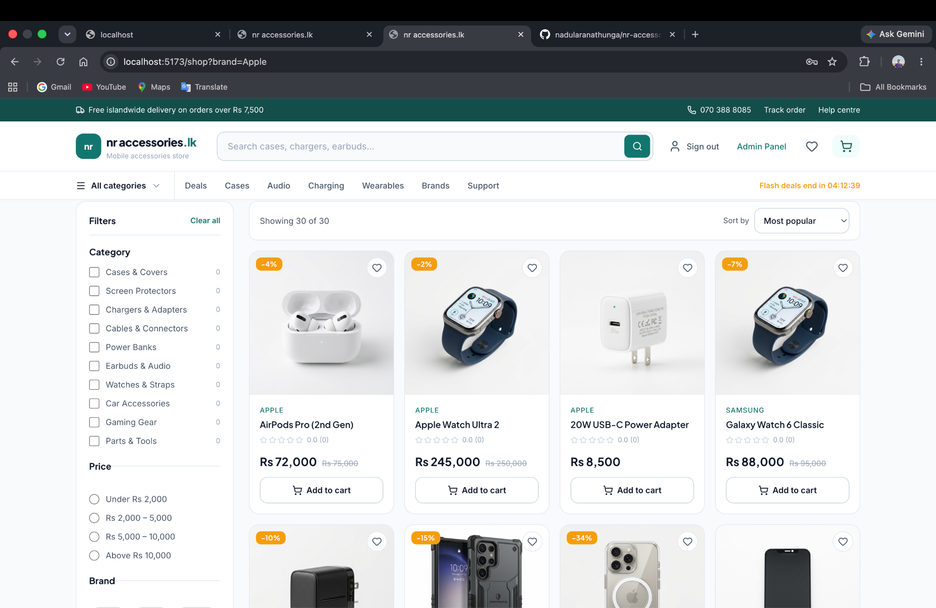
Catalog and Sorting Screenshots

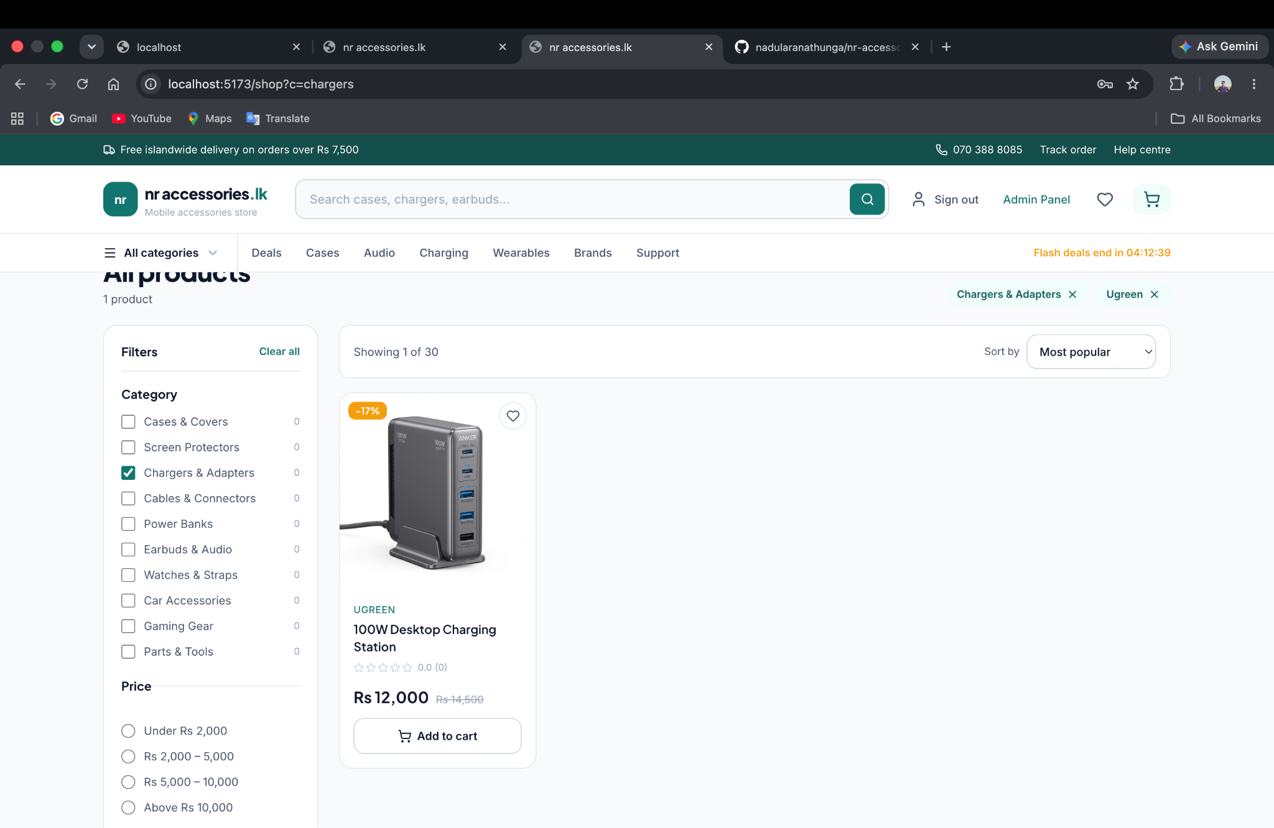

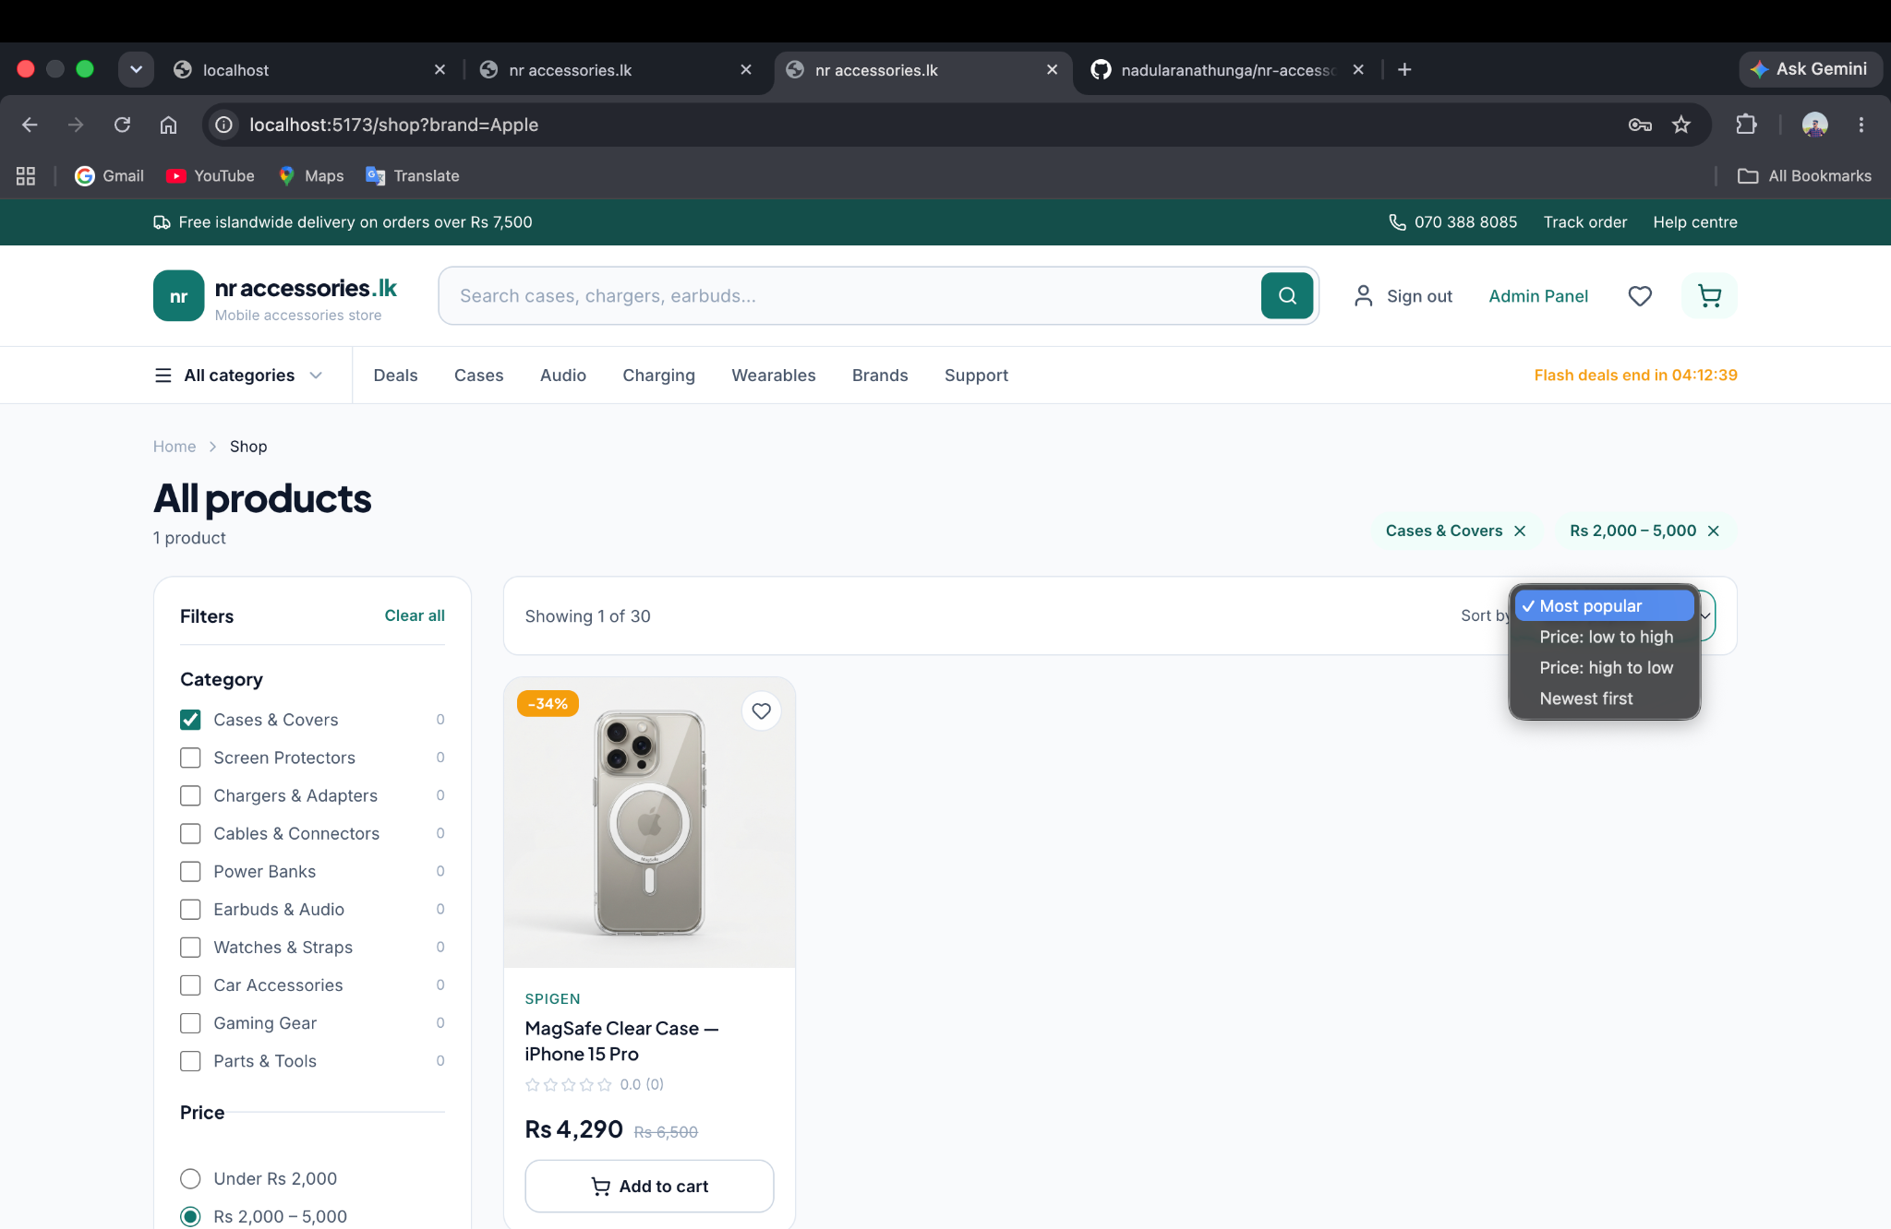

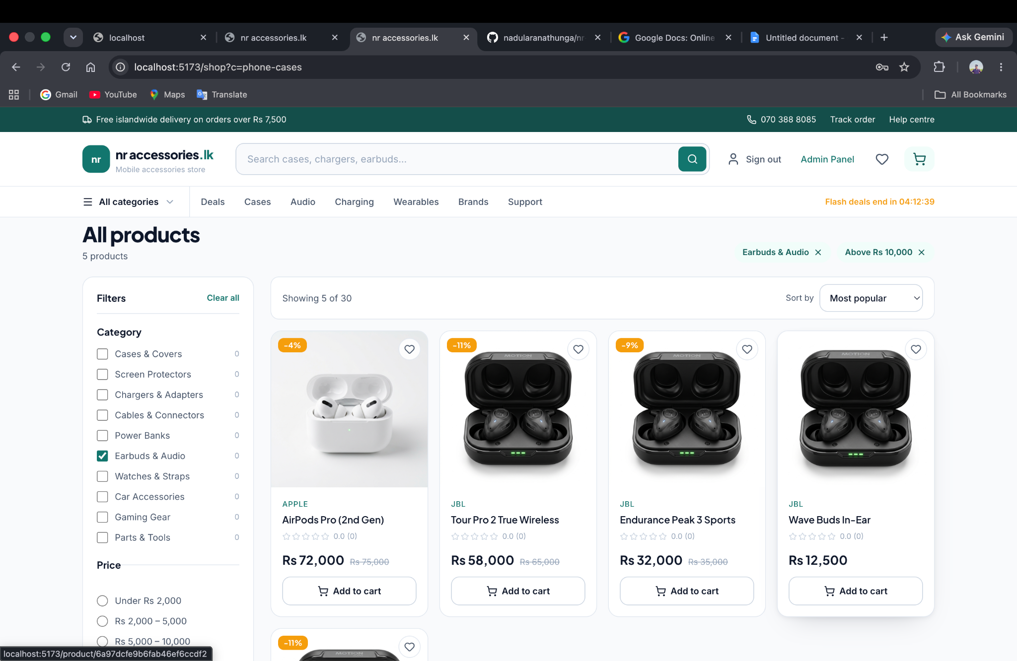

Challenges Faced
1. Category Filtering Issue
Challenge: When a user clicked on a category like "Phone Cases" in the menu, no products were showing up. This happened because the frontend was sending a simple text name (like `phone-cases`) to the backend, but the backend database was expecting a unique Database ID (`ObjectId`) to find the products.
Solution: We updated the backend code so it first takes the text name, searches the database to find the matching Database ID, and then uses that ID to successfully load the correct products.
2. Product Sorting Logic
Challenge: Creating the "Sort by Price" feature (Low to High / High to Low) was difficult because some products had a discounted price while others only had a normal price. A standard sorting code would fail because it wouldn't know which price to look at.
Solution: We wrote a custom sorting script in React. It automatically checks if a product has a discount price. If it does, it uses the discount price for sorting; if not, it uses the normal price. This ensures the list is always sorted by the actual final price the customer pays.
Git repo - https://github.com/nadularanathunga/nr-accessories.lk.git

