ICT2142 E-Business Systems
Week 02 Practical Report
nr accessories.lk — Smartphone Accessories E-Commerce Platform
TG/2024/2147
Phase 1: Planning & Requirements
Wireframing & System Architecture (Database Design)

1. Wireframing Key Pages
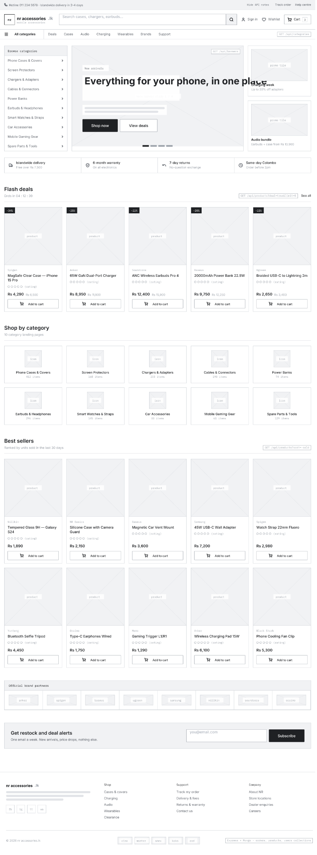
1.1 Home page

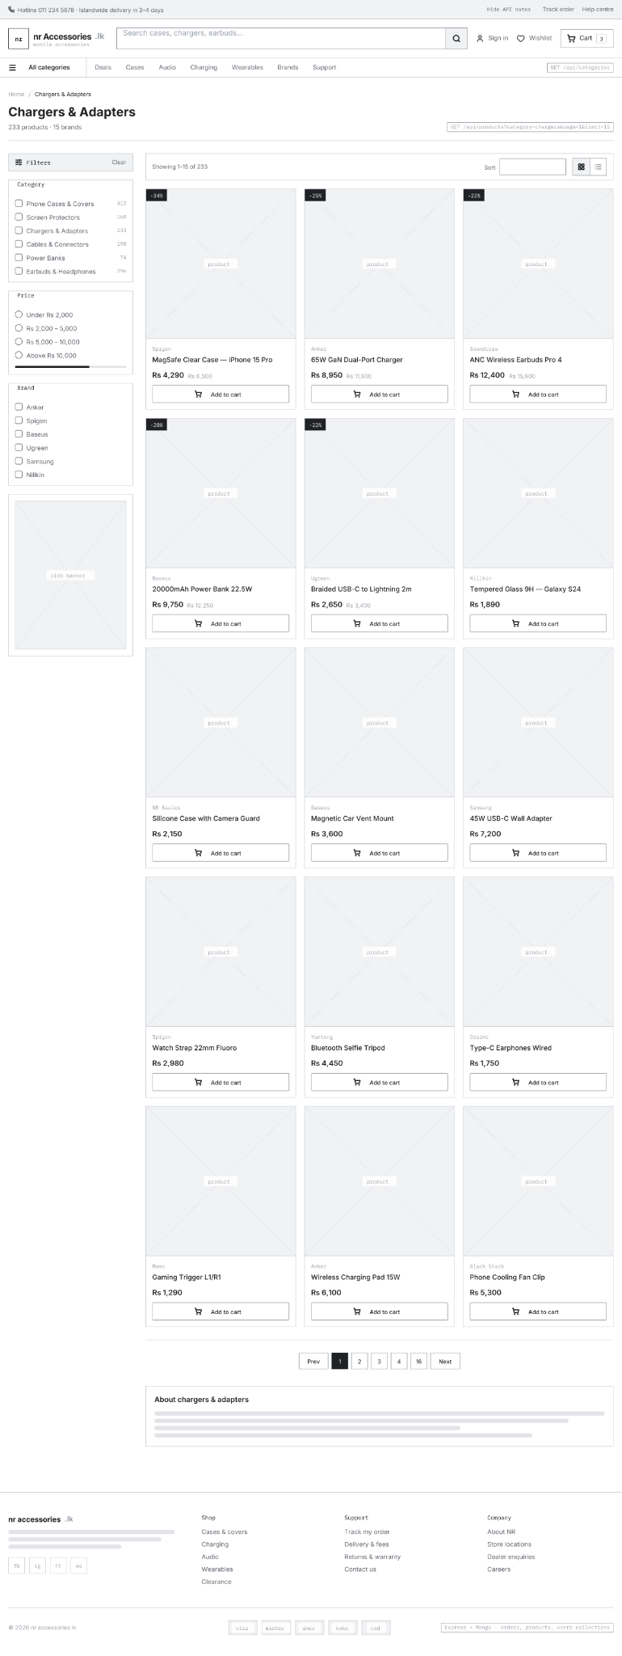
1.2 Category

1.3 Product Details
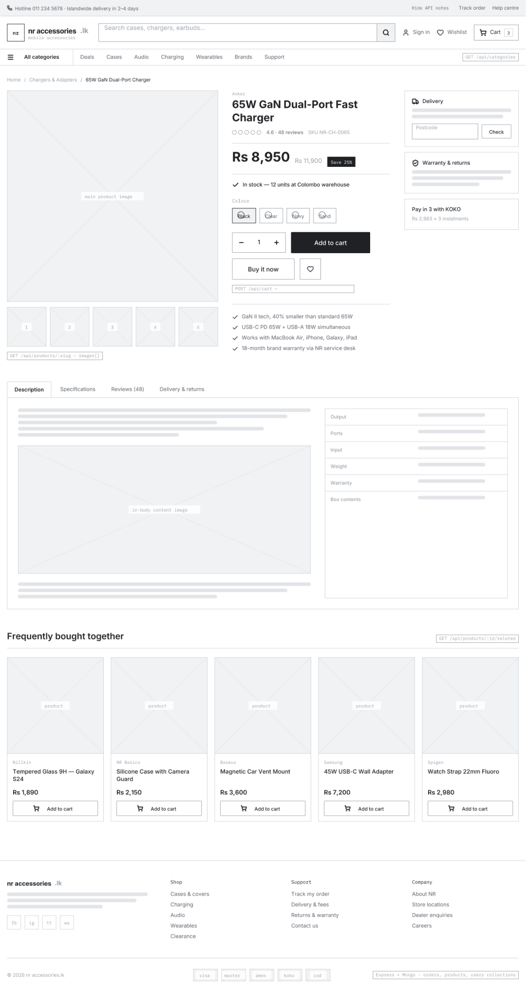

1.4 Cart
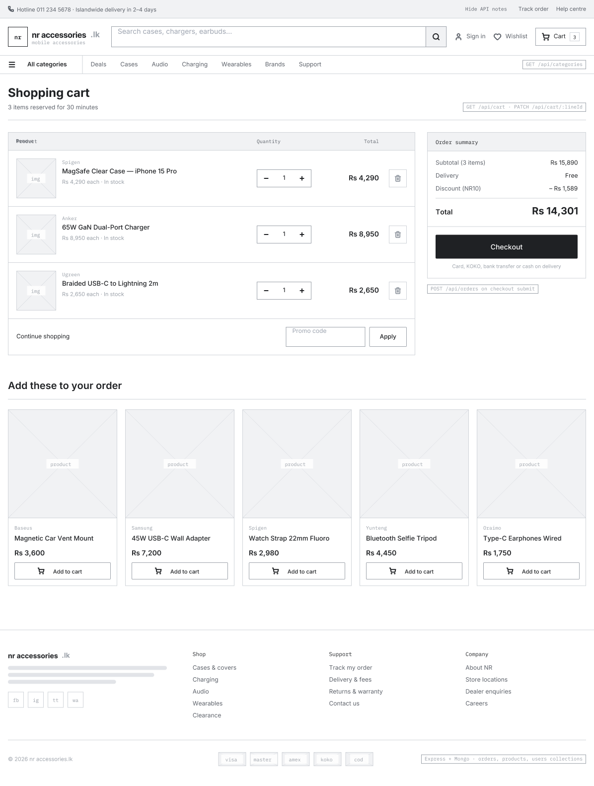

1.5 Checkout
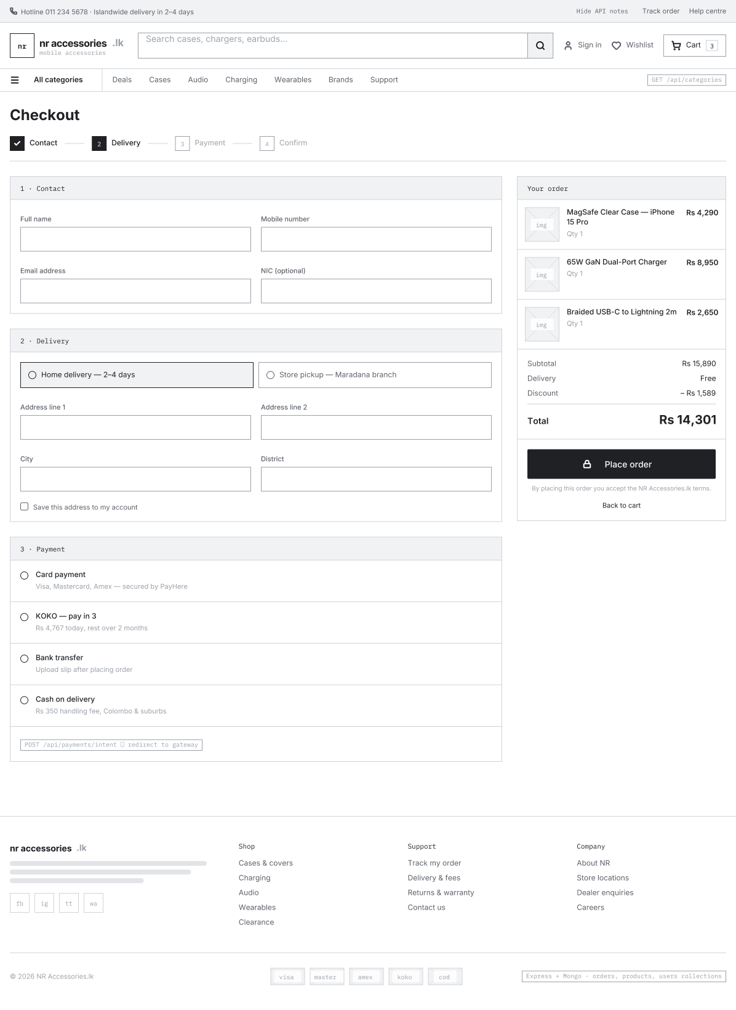

1. Entity Relationship (ER) Diagram
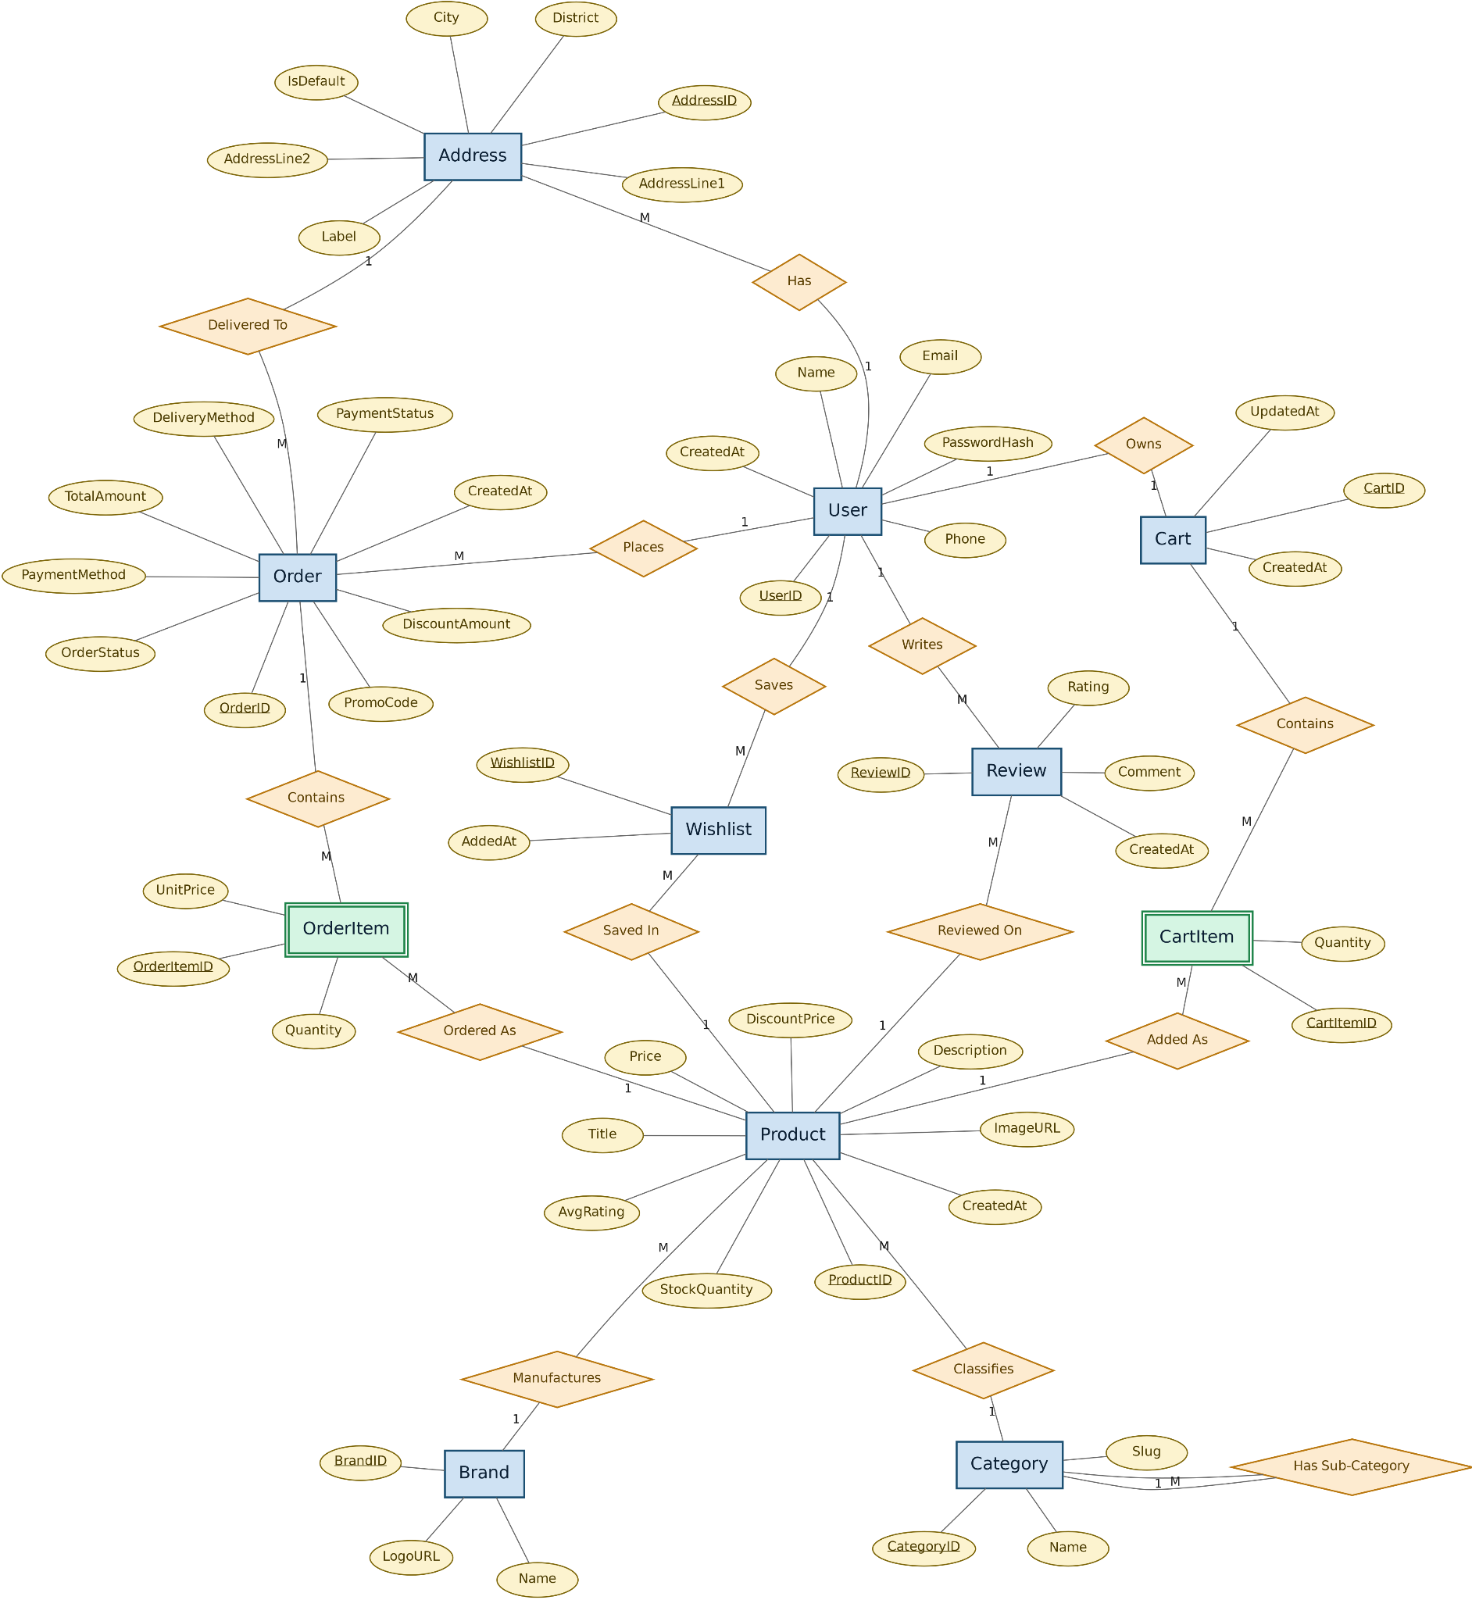
The diagram below shows the entities (collections) that make up the nr accessories.lk database and how they relate to one another. Although the project uses MongoDB (a NoSQL, document-based database) as part of the MERN stack, the relationships are still modelled in an ER-style diagram to plan out the data clearly before implementation. In MongoDB, each entity below is implemented as a collection, and the FK (foreign key) references shown are implemented as ObjectId references between documents.

2. List of Tables (Collections) and Attributes
This section lists every collection in the database along with its attributes (fields), primary keys (PK), and foreign keys (FK).
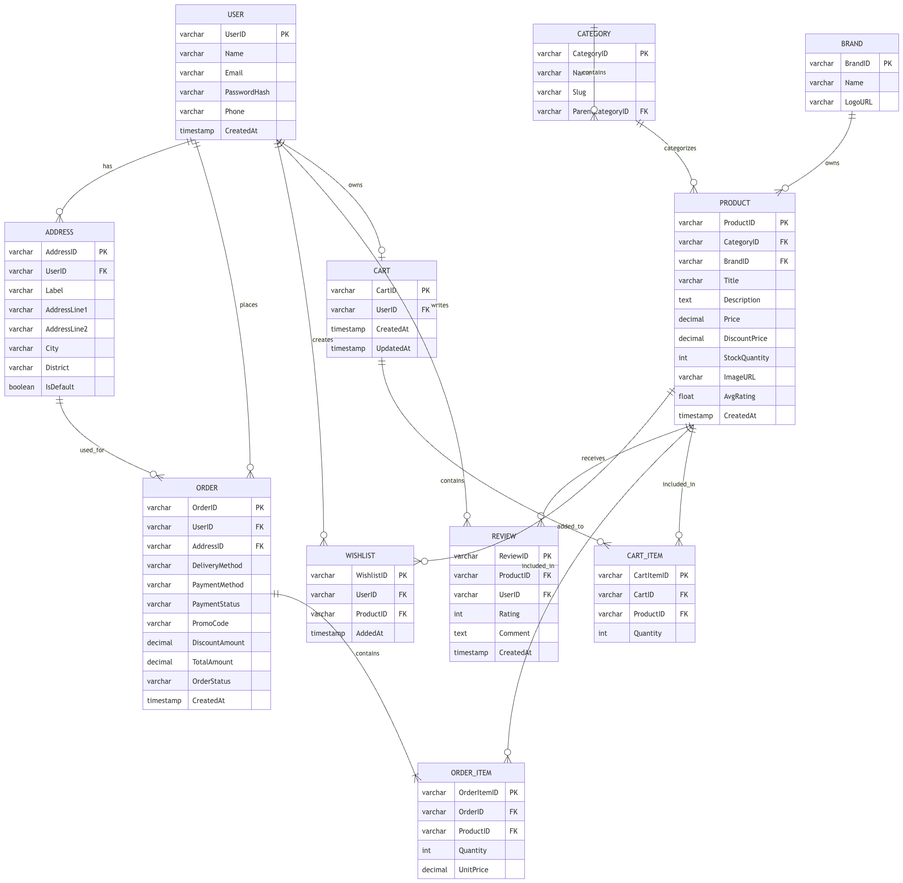

2.1 User
Stores registered customer accounts used for authentication and order history.

Attribute | Key | Description
UserID | PK | Unique identifier for the user
Name |  | Full name of the customer
Email |  | Login email address (unique)
PasswordHash |  | Hashed password for authentication
Phone |  | Contact phone number
CreatedAt |  | Account creation timestamp

2.2 Address
Stores one or more delivery addresses saved by a user, used at checkout.
Attribute | Key | Description
AddressID | PK | Unique identifier for the address
UserID | FK | References the owning User
Label |  | e.g. Home, Office
AddressLine1 |  | Street address
AddressLine2 |  | Apartment/unit (optional)
City |  | City
District |  | District/region
IsDefault |  | Whether this is the default delivery address
2.3 Category
Stores product categories and subcategories shown in navigation and filters (e.g. Phone Cases & Covers, Chargers & Adapters).
Attribute | Key | Description
CategoryID | PK | Unique identifier for the category
Name |  | Category name
Slug |  | URL-friendly identifier
ParentCategoryID | FK | References a parent Category, for subcategories

2.4 Brand
Stores accessory brands shown as filters and official brand partners on the homepage.
Attribute | Key | Description
BrandID | PK | Unique identifier for the brand
Name |  | Brand name (e.g. Anker, Spigen, Baseus)
LogoURL |  | Path/URL to the brand logo image
2.5 Product
Stores each smartphone accessory listed on the site, including price, stock, and images shown on listing and detail pages.
Attribute | Key | Description
ProductID | PK | Unique identifier for the product
CategoryID | FK | References the Category the product belongs to
BrandID | FK | References the product's Brand
Title |  | Product name
Description |  | Full product description
Price |  | Original price
DiscountPrice |  | Discounted price, if on offer
StockQuantity |  | Units available in stock
ImageURL |  | Path/URL to the main product image
AvgRating |  | Average of all review ratings
CreatedAt |  | Date the product was added

2.6 Review
Stores customer ratings and comments shown on the Product Detail page.
Attribute | Key | Description
ReviewID | PK | Unique identifier for the review
ProductID | FK | References the reviewed Product
UserID | FK | References the User who wrote the review
Rating |  | Star rating (1–5)
Comment |  | Review text
CreatedAt |  | Date the review was posted

2.7 Wishlist
Stores products a user has saved for later (nice-to-have feature).
Attribute | Key | Description
WishlistID | PK | Unique identifier for the wishlist entry
UserID | FK | References the owning User
ProductID | FK | References the saved Product
AddedAt |  | Date the item was added

2.8 Cart
Represents a user's active shopping cart, shown on the Shopping Cart page.
Attribute | Key | Description
CartID | PK | Unique identifier for the cart
UserID | FK | References the owning User (one cart per user)
CreatedAt |  | Cart creation timestamp
UpdatedAt |  | Last time the cart was modified

2.9 CartItem
Represents a single product line within a Cart, including quantity.
Attribute | Key | Description
CartItemID | PK | Unique identifier for the cart item
CartID | FK | References the parent Cart
ProductID | FK | References the Product added to the cart
Quantity |  | Number of units of this product

2.10 Order
Represents a placed order, created once checkout (contact, delivery, and payment steps) is completed.
Attribute | Key | Description
OrderID | PK | Unique identifier for the order
UserID | FK | References the customer who placed the order
AddressID | FK | References the delivery Address used
DeliveryMethod |  | e.g. Home delivery, Store pickup
PaymentMethod |  | e.g. Card, KOKO (Pay in 3), Bank transfer, Cash on delivery
PaymentStatus |  | e.g. Pending, Paid, Failed
PromoCode |  | Promo code applied, if any
DiscountAmount |  | Total discount applied to the order
TotalAmount |  | Final payable amount
OrderStatus |  | e.g. Pending, Shipped, Delivered
CreatedAt |  | Date/time the order was placed

2.11 OrderItem
Represents a single product line within a placed Order, preserving the price at the time of purchase.
Attribute | Key | Description
OrderItemID | PK | Unique identifier for the order item
OrderID | FK | References the parent Order
ProductID | FK | References the purchased Product
Quantity |  | Number of units purchased
UnitPrice |  | Price per unit at the time of purchase

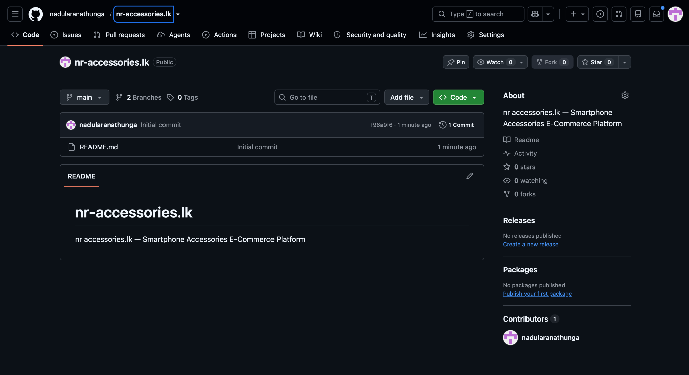
3. Setting Up Version Control
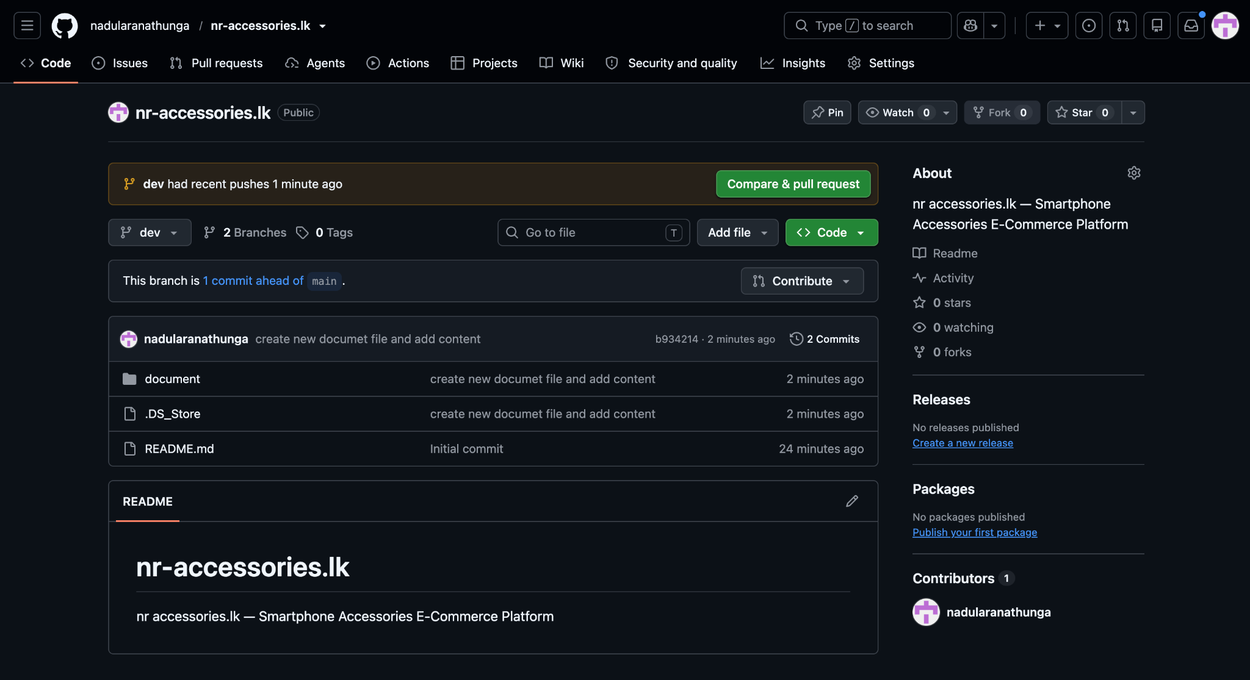

Link - https://github.com/nadularanathunga/nr-accessories.lk.git

