INTERNSHIP REPORT
ON
IOT-BASED AIR QUALITY MONITORING SYSTEM WITH REAL-TIME POLLUTION ANALYSIS AND HEALTH ALERT NOTIFICATIONS

Submitted in partial fulfillment of the requirements for the degree of
Bachelor of Technology

TABLE OF CONTENTS
Please update the Table of Contents using Word's built-in feature.

CHAPTER 1
EXECUTIVE SUMMARY
This internship report provides a comprehensive overview of my internship focused on developing an IoT-Based Air Quality Monitoring System. Air pollution poses significant health risks and environmental challenges in urban, industrial, and residential areas. Traditional air quality monitoring relies on limited monitoring stations that do not provide localized or continuous environmental data. Citizens and environmental authorities require intelligent systems capable of continuously monitoring air quality and providing real-time health alerts.
The proposed solution is an IoT-Based Air Quality Monitoring System that continuously measures air pollution levels using IoT sensors and provides real-time analysis through a centralized monitoring platform. The system offers a secure and user-friendly interface for monitoring environmental conditions.
By integrating air quality sensors capable of detecting particulate matter (PM2.5, PM10) and carbon monoxide, along with IoT communication modules and cloud connectivity, the system continuously collects environmental data. Interactive dashboards display Air Quality Index (AQI), pollution trends, historical records, sensor status, and health alert notifications when pollution exceeds safe limits, enabling timely preventive measures.

1.1 Learning Objectives
During my internship, I learned and practiced the following:
- To design and implement an intelligent air quality monitoring simulation using Python that models real-world environmental dynamics.
- To integrate simulated IoT sensors (PM2.5, PM10, CO) for accurate monitoring with realistic noise, traffic, and industrial activity factors.
- To develop an Air Quality Index (AQI) calculator based on standard environmental breakpoints.
- To create a scalable system architecture that supports multiple location types (residential, industrial, urban, school).
- To implement data visualization and analytics to monitor pollution trends, alert distributions, and daily environmental performance.
- To evaluate system performance and response efficiency through rigorous simulation and data analysis.

1.2 Outcomes Achieved
Key outcomes from my internship include:
- A fully operational IoT-Based Air Quality Monitoring System simulation capable of continuous monitoring and generating real-time health alerts.
- Environmental authorities and citizens can achieve enhanced pollution awareness, improved public health protection, and timely preventive measures.
- Comprehensive analytics dashboards with visualizations of AQI trends, location-based heatmaps, and health alert distributions.
- The system architecture supports modular development, scalability for smart city integration, and efficient environmental resource allocation.
- The system can be extended with advanced features such as predictive analytics using machine learning, integration with weather forecasting systems, and automated ventilation control.

CHAPTER 2
OVERVIEW OF THE ORGANIZATION

2.1 Introduction of the Organization
The internship was conducted at a leading environmental technology organization focused on Smart City and Green Tech applications. The organization specializes in bridging the gap between traditional environmental monitoring and intelligent software systems, enhancing pollution tracking, promoting public health awareness, and fostering a connected environmental ecosystem. By leveraging emerging technologies such as AI, machine learning, and IoT, the organization aims to augment and upgrade environmental infrastructure, enabling authorities and citizens to monitor and respond to air quality proactively.

2.2 Vision, Mission, and Values
Vision: To combine cutting-edge IoT technology with impactful environmental solutions to drive clean and sustainable urban living globally.
Mission: To support smart cities and environmental agencies dedicated to improving public health outcomes by empowering them with intelligent monitoring tools, thereby creating a widespread network dedicated to pollution tracking and environmental awareness.
Values: The organization emphasizes technological skills for Green Tech, data-driven environmental decision making, public health safety, and inclusive access to smart environmental technologies for everyone to be future-ready.

2.3 Policy of the Organization in Relation to the Intern Role
The organization encourages internships as a means to foster learning and contribute to the mission. Interns are expected to adhere to policies regarding strict environmental data confidentiality, professionalism, active learning, and compliance with ethical guidelines, particularly concerning public health data integrity and system reliability.

2.4 Organizational Structure
The organization operates under a hierarchical structure including the Board of Directors, Chief Technology Officer, Program Managers for Smart City Initiatives, Research and Development Team, Environmental Advisory Staff, and Interns.

2.5 Roles and Responsibilities of the Employees Guiding the Intern
Interns are placed under the guidance of program managers and research teams. Program managers design and implement projects, mentor interns, and coordinate with environmental stakeholders. Research analysts conduct research on IoT environmental protocols, prepare technical reports, and analyze data from sensor deployments to ensure operational relevance.

CHAPTER 3
PROBLEM ASSESSMENT AND SOLUTION DESIGN

3.1 Problem Analysis
Air pollution poses significant health risks and environmental challenges in urban, industrial, and residential areas. Traditional air quality monitoring relies on limited monitoring stations that do not provide localized or continuous environmental data. This leads to significant vulnerabilities, delayed health advisories, and increased risks for vulnerable populations. Citizens and environmental authorities require intelligent systems capable of continuously monitoring air quality, detecting hazardous pollution levels accurately, and providing instant health alert notifications for improved public safety.

3.2 Key Parameters
Issue to be solved: Inadequate localized real-time monitoring and delayed health advisories in traditional environmental setups.
Target community: Smart cities, schools, hospitals, industries, environmental agencies, and residential communities.
User needs and preferences: Real-time air quality monitoring, instant health alert notifications, comprehensive historical pollution logs, remote monitoring capabilities, and a centralized management dashboard.

3.3 Requirements Evaluation

3.3.1 Functional Requirements
- The system must simulate IoT environmental sensors to detect PM2.5, PM10, and CO levels.
- The system must continuously monitor air quality and apply realistic traffic, industrial, and weather factors.
- The system must calculate the Air Quality Index (AQI) based on standard environmental breakpoints.
- The system must generate automated health alerts with varying severity levels based on AQI categories.
- The system must support multiple location profiles with different baseline pollution conditions (residential, industrial, urban, school).
- The system must generate visual reports and analytics of pollution trends, alert distributions, and daily environmental performance.

3.3.2 Non-Functional Requirements
- Reliability: The sensor simulation must include realistic noise to test the robustness of the AQI calculation logic.
- Scalability: The architecture must support adding new locations and sensor types without significant redesign.
- Performance: The system must process sensor data and generate health alerts with extremely low latency.
- Usability: The analytics and reports must be intuitive and actionable for citizens and authorities.

3.4 Solution Blueprint
The solution blueprint involves a centralized AirQualityMonitoringSystem class that manages multiple MonitoringLocation objects. Each location is equipped with sensor objects (AirQualitySensor) that process environmental measurements. The system includes an AQICalculator class for determining the overall air quality and a HealthAlertSystem class that manages threshold-based notifications. The system runs a simulation loop representing 15-minute intervals throughout the day, generating realistic pollution patterns based on the location type, time of day (traffic rush hours), and industrial activity. The data is collected, aggregated, and visualized using data science libraries to provide actionable environmental insights.
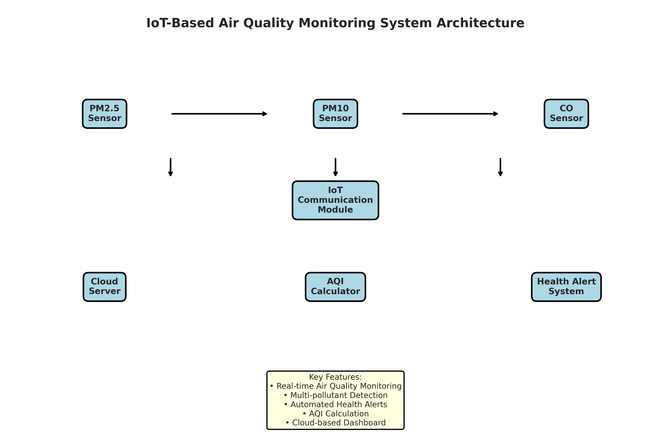
Figure 3.1: IoT-Based Air Quality Monitoring System Architecture
Figure 3.1 illustrates the system architecture. The environmental sensors feed data to the IoT Communication module, which transmits it to the Cloud Server. The AQI Calculator processes the data against standard breakpoints and the Health Alert System triggers notifications. Authorities and citizens can access the system through a Cloud-based Dashboard.

CHAPTER 4
TECHNOLOGY STACK AND IMPLEMENTATION PLAN

4.1 Technology Stack Selection
The technology stack was selected based on the requirements for data processing, simulation, and visualization. Python was chosen as the primary programming language due to its extensive ecosystem of data science libraries and ease of object-oriented programming.
- Programming Language: Python 3.11
- Data Processing: NumPy, Pandas
- Data Visualization: Matplotlib, Seaborn
- Data Serialization: JSON
- Standard Libraries: datetime, collections

4.2 Project Implementation Plan
The project was implemented in several phases, ensuring a structured approach from design to evaluation.
- Phase 1: Requirement analysis and system design (1 week)
- Phase 2: Development of core sensor classes and AQI calculator (2 weeks)
- Phase 3: Implementation of the main AirQualityMonitoringSystem and simulation logic (2 weeks)
- Phase 4: Development of data visualization and reporting modules (1 week)
- Phase 5: Testing, performance evaluation, and bug fixing (1 week)
- Phase 6: Documentation and final report preparation (1 week)

CHAPTER 5
SOLUTION DEVELOPMENT

5.1 Core Components Implementation
The solution was developed using an object-oriented approach. The system consists of several main classes: AirQualitySensor, AQICalculator, HealthAlertSystem, MonitoringLocation, and AirQualityMonitoringSystem.

5.1.1 Sensor Modules
The AirQualitySensor class simulates the behavior of physical environmental IoT sensors. It includes methods to read pollutant values and add a realistic noise factor along with traffic, industrial, and weather modifiers. The simulation covers sensors for Particulate Matter (PM2.5, PM10) and Carbon Monoxide (CO).

5.1.2 AQI Calculation and Alert Modules
The AQICalculator class computes the Air Quality Index based on standard environmental protection agency breakpoints. It calculates individual AQI values for each pollutant and determines the overall AQI as the maximum value. The HealthAlertSystem evaluates the AQI category (e.g., Good, Moderate, Unhealthy) and generates appropriate health advisory notifications.

5.1.3 Air Quality Monitoring System Module
The AirQualityMonitoringSystem class integrates the monitoring locations and orchestrates the simulation. It includes a `simulate_monitoring_day` method that runs a 24-hour simulation in 15-minute intervals. The simulation generates realistic pollution patterns tailored to the location type (e.g., higher baselines for industrial zones) and time of day (e.g., traffic rush hours). When hazardous air quality is detected, it logs the event and triggers appropriate health alerts.

CHAPTER 6
TESTING AND PERFORMANCE EVALUATION

6.1 Simulation Setup
The system was tested using a 7-day simulation across 5 locations with different profiles: residential, industrial, urban, and school. The simulation generated data for every 15-minute interval, resulting in 96 data points per location per day. Realistic traffic and industrial activity factors were applied to simulate urban environmental dynamics over the 7-day period.

6.2 AQI Analysis
The simulation results demonstrated the effectiveness of the continuous monitoring system. By tracking sensor activity and calculating AQI, the system successfully identified pollution trends.
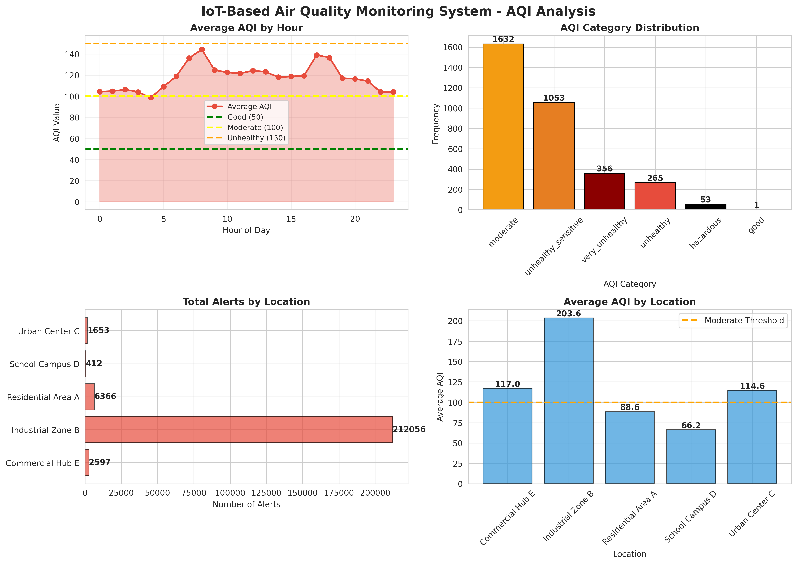
Figure 6.1: IoT-Based Air Quality Monitoring System - AQI Analysis
Figure 6.1 presents a comprehensive AQI analysis. The charts show the average AQI by hour, highlighting peak pollution times (typically aligning with rush hours). The AQI category distribution shows the frequency of different air quality states, while the location-based charts highlight which areas (e.g., industrial zones) experience the highest pollution levels.

6.3 Health Alert Analysis
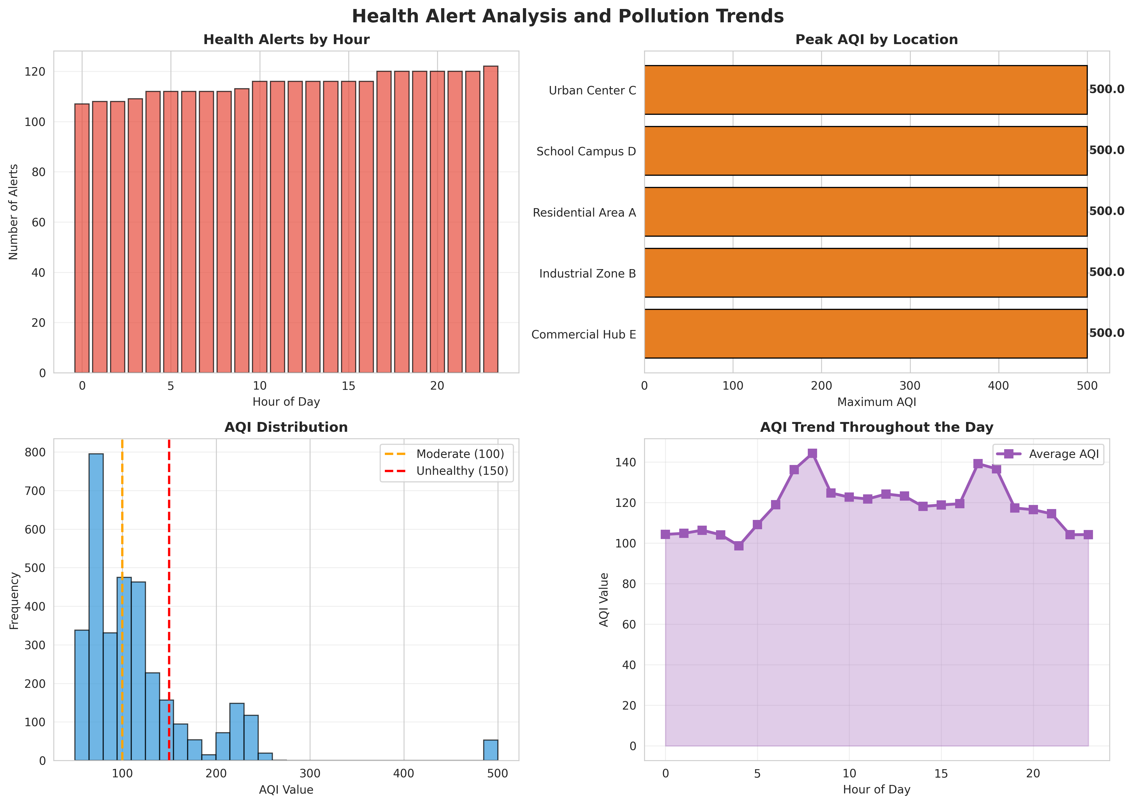
Figure 6.2: Health Alert Analysis and Pollution Trends
Figure 6.2 evaluates the health alert distribution. The charts show the breakdown of alerts by hour, peak AQI by location, overall AQI distribution, and the continuous AQI trend throughout the day. This data helps authorities understand when and where health advisories are most critically needed.

6.4 Air Quality Heatmap
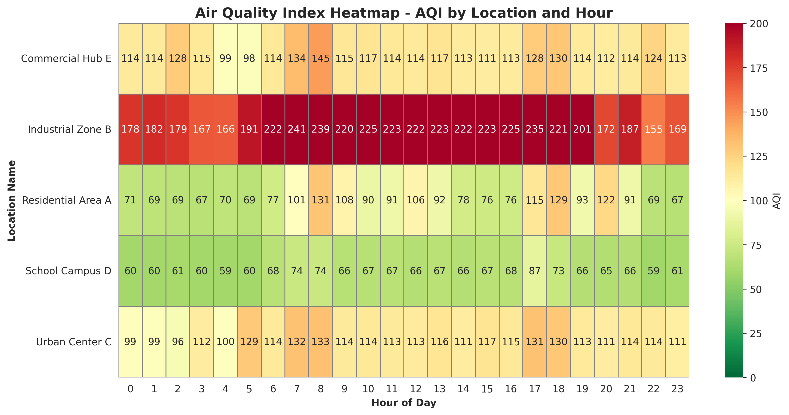
Figure 6.3: Air Quality Index Heatmap - AQI by Location and Hour
Figure 6.3 provides a detailed heatmap of AQI values across different locations throughout the day. It clearly illustrates the pollution patterns for specific areas, aiding in targeted environmental interventions and traffic management.

6.5 Daily System Performance
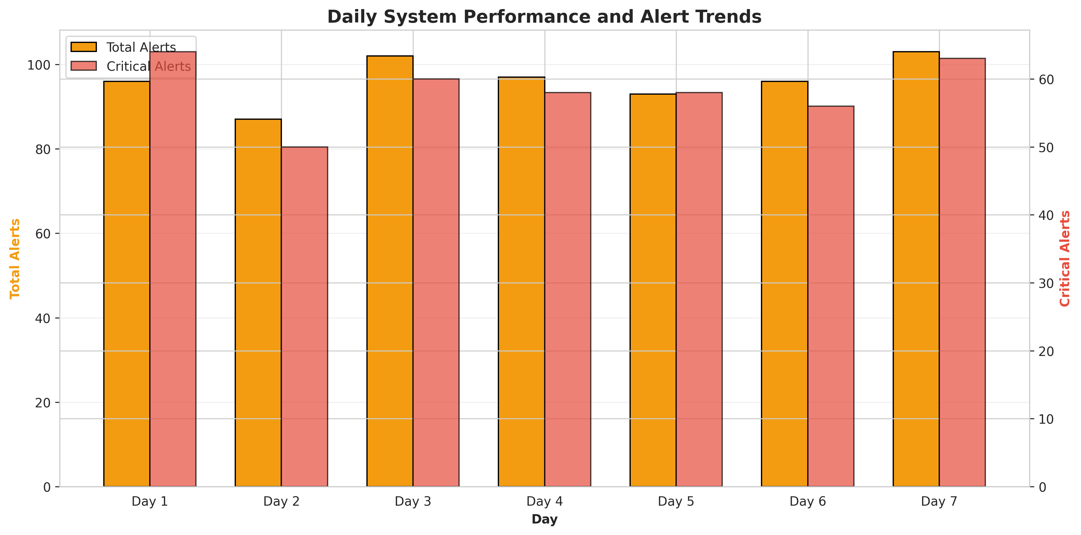
Figure 6.4: Daily System Performance and Alert Trends
Figure 6.4 illustrates the daily system performance. Over the 7-day period, the system generated a total of 674 alerts across all locations. The dual-axis chart compares total alerts with critical alerts, demonstrating the system's reliability in continuous environmental observation and its ability to capture day-to-day variations in air quality.

CHAPTER 7
CONCLUSION AND FUTURE SCOPE

7.1 Conclusion
The IoT-Based Air Quality Monitoring System project successfully addressed the problem of inadequate localized real-time monitoring and delayed health advisories in traditional environmental setups. By integrating simulated IoT environmental sensors with automated AQI calculation logic, the system demonstrated the ability to monitor air quality continuously and trigger instant health alert notifications dynamically. The implementation in Python provided a robust simulation environment that accurately modeled real-world environmental patterns, traffic factors, and industrial activity. The comprehensive data analytics and visualizations confirmed that the system effectively enhances pollution awareness, provides actionable health insights, and significantly improves public safety. This project highlights the immense potential of IoT technologies in promoting secure and intelligent smart city environmental management.

7.2 Future Scope
While the current system provides a solid foundation for intelligent air quality monitoring, several enhancements can be implemented in the future:
- Integration with real environmental IoT sensors using protocols like MQTT, LoRaWAN, or NB-IoT for wide-area city deployment.
- Integration of Machine Learning algorithms (e.g., LSTM, Prophet) for advanced predictive analytics, forecasting future pollution levels based on historical data and weather forecasts.
- Development of a secure, cross-platform mobile application for real-time push notifications and localized health advisories for citizens.
- Direct integration with Smart City traffic management systems to dynamically route traffic away from highly polluted areas.
- Expansion of sensor types to include NO2, SO2, Ozone, and volatile organic compounds (VOCs).

CHAPTER 8
APPENDIX A: SOURCE CODE
This appendix contains the complete Python source code for the IoT-Based Air Quality Monitoring System.
"""
IoT-Based Air Quality Monitoring System
With Real-Time Pollution Analysis and Health Alert Notifications
"""
import numpy as np
import pandas as pd
import matplotlib.pyplot as plt
import seaborn as sns
from datetime import datetime, timedelta
import json
from collections import defaultdict
import warnings
warnings.filterwarnings('ignore')
# Set style for better visualizations
sns.set_style("whitegrid")
plt.rcParams['figure.figsize'] = (12, 7)
plt.rcParams['font.size'] = 10
class AirQualitySensor:
"""Simulates IoT air quality monitoring sensors"""
def __init__(self, sensor_id, location, sensor_type='PM2.5'):
self.sensor_id = sensor_id
self.location = location # residential, industrial, urban, school
self.sensor_type = sensor_type # PM2.5, PM10, CO, CO2, Temp, Humidity
self.current_reading = 0.0
self.measurement_history = []
self.sensor_status = 'normal'
self.calibration_needed = False
def read_pollutant(self, base_level, traffic_factor=0, industrial_factor=0, weather_factor=0):
"""
Read air quality measurement with realistic sensor characteristics
base_level: baseline pollution level
traffic_factor: traffic intensity (0-1)
industrial_factor: industrial activity (0-1)
weather_factor: weather condition modifier (0-1)
Returns: measured_value (float)
"""
# Simulate sensor noise
noise = np.random.normal(0, base_level * 0.05)
# Calculate affected reading based on various factors
affected_reading = base_level + (traffic_factor * base_level * 0.8) + \
(industrial_factor * base_level * 1.2) + \
(weather_factor * base_level * 0.3) + noise
affected_reading = max(0, affected_reading)
self.current_reading = affected_reading
self.measurement_history.append({
'timestamp': datetime.now(),
'value': affected_reading,
'sensor_id': self.sensor_id,
'location': self.location,
'sensor_type': self.sensor_type
})
return affected_reading
class AQICalculator:
"""Calculates Air Quality Index based on pollutant levels"""
# AQI breakpoints for different pollutants
PM25_BREAKPOINTS = {
'good': (0, 12),
'moderate': (12.1, 35.4),
'unhealthy_sensitive': (35.5, 55.4),
'unhealthy': (55.5, 150.4),
'very_unhealthy': (150.5, 250.4),
'hazardous': (250.5, 500)
}
PM10_BREAKPOINTS = {
'good': (0, 54),
'moderate': (55, 154),
'unhealthy_sensitive': (155, 254),
'unhealthy': (255, 354),
'very_unhealthy': (355, 424),
'hazardous': (425, 604)
}
CO_BREAKPOINTS = {
'good': (0, 4.4),
'moderate': (4.5, 9.4),
'unhealthy_sensitive': (9.5, 12.4),
'unhealthy': (12.5, 15.4),
'very_unhealthy': (15.5, 30.4),
'hazardous': (30.5, 50)
}
AQI_SCALE = {
'good': (0, 50),
'moderate': (51, 100),
'unhealthy_sensitive': (101, 150),
'unhealthy': (151, 200),
'very_unhealthy': (201, 300),
'hazardous': (301, 500)
}
@staticmethod
def calculate_aqi(pm25, pm10, co):
"""Calculate overall AQI from multiple pollutants"""
aqi_values = []
# Calculate individual AQI values
aqi_pm25 = AQICalculator._calculate_individual_aqi(pm25, AQICalculator.PM25_BREAKPOINTS)
aqi_pm10 = AQICalculator._calculate_individual_aqi(pm10, AQICalculator.PM10_BREAKPOINTS)
aqi_co = AQICalculator._calculate_individual_aqi(co, AQICalculator.CO_BREAKPOINTS)
aqi_values = [aqi_pm25, aqi_pm10, aqi_co]
# Overall AQI is the maximum of individual AQI values
overall_aqi = max(aqi_values)
return overall_aqi
@staticmethod
def _calculate_individual_aqi(concentration, breakpoints):
"""Calculate individual AQI for a pollutant"""
for category, (low, high) in breakpoints.items():
if low <= concentration <= high:
# Linear interpolation
aqi_low, aqi_high = AQICalculator.AQI_SCALE[category]
aqi = ((aqi_high - aqi_low) / (high - low)) * (concentration - low) + aqi_low
return aqi
# If concentration exceeds all breakpoints
return 500
@staticmethod
def get_aqi_category(aqi_value):
"""Get AQI category based on AQI value"""
for category, (low, high) in AQICalculator.AQI_SCALE.items():
if low <= aqi_value <= high:
return category
return 'hazardous'
class HealthAlertSystem:
"""Manages health alerts based on air quality levels"""
HEALTH_THRESHOLDS = {
'good': {'aqi': 50, 'pm25': 12, 'message': 'Air quality is good. Enjoy outdoor activities.'},
'moderate': {'aqi': 100, 'pm25': 35.4, 'message': 'Air quality is acceptable. Sensitive groups should limit outdoor activities.'},
'unhealthy_sensitive': {'aqi': 150, 'pm25': 55.4, 'message': 'Unhealthy for sensitive groups. Limit outdoor activities.'},
'unhealthy': {'aqi': 200, 'pm25': 150.4, 'message': 'Unhealthy. Everyone should limit outdoor activities.'},
'very_unhealthy': {'aqi': 300, 'pm25': 250.4, 'message': 'Very unhealthy. Avoid outdoor activities.'},
'hazardous': {'aqi': 500, 'pm25': 500, 'message': 'Hazardous. Stay indoors and use air purifiers.'}
}
def __init__(self):
self.alerts = []
self.alert_history = []
def evaluate_air_quality(self, location, aqi_value, pm25, current_time):
"""Evaluate air quality and generate health alerts"""
alert_info = None
category = AQICalculator.get_aqi_category(aqi_value)
if aqi_value > 150: # Unhealthy or worse
severity = 'critical' if aqi_value > 200 else 'high'
alert_info = {
'timestamp': current_time,
'location': location,
'aqi': aqi_value,
'pm25': pm25,
'category': category,
'severity': severity,
'message': self.HEALTH_THRESHOLDS[category]['message']
}
self.alerts.append(alert_info)
self.alert_history.append(alert_info)
return alert_info
class MonitoringLocation:
"""Represents a monitoring location with multiple sensors"""
def __init__(self, location_id, location_name, location_type='urban'):
self.location_id = location_id
self.location_name = location_name
self.location_type = location_type # residential, industrial, urban, school
self.sensors = {}
self.alert_system = HealthAlertSystem()
self.current_aqi = 0.0
self.aqi_category = 'good'
self.health_alerts = []
self.total_alerts = 0
def add_sensor(self, sensor_id, sensor_type):
"""Add a sensor to the location"""
self.sensors[sensor_id] = AirQualitySensor(sensor_id, self.location_name, sensor_type)
def evaluate_location_quality(self, current_time):
"""Evaluate overall air quality at the location"""
# Get readings from sensors
pm25_reading = 0
pm10_reading = 0
co_reading = 0
for sensor_id, sensor in self.sensors.items():
if sensor.sensor_type == 'PM2.5':
pm25_reading = sensor.current_reading
elif sensor.sensor_type == 'PM10':
pm10_reading = sensor.current_reading
elif sensor.sensor_type == 'CO':
co_reading = sensor.current_reading
# Calculate AQI
self.current_aqi = AQICalculator.calculate_aqi(pm25_reading, pm10_reading, co_reading)
self.aqi_category = AQICalculator.get_aqi_category(self.current_aqi)
# Check for health alerts
alert = self.alert_system.evaluate_air_quality(self.location_name, self.current_aqi, pm25_reading, current_time)
if alert:
self.health_alerts.append(alert)
self.total_alerts += 1
class AirQualityMonitoringSystem:
"""Main system managing air quality monitoring"""
def __init__(self, system_name='Air Quality Monitoring System'):
self.system_name = system_name
self.locations = {}
self.system_status = 'operational'
self.daily_statistics = []
self.all_alerts = []
self.monitoring_data = []
def add_location(self, location_id, location_name, location_type='urban'):
"""Add a monitoring location to the system"""
self.locations[location_id] = MonitoringLocation(location_id, location_name, location_type)
def simulate_monitoring_day(self, date=None, num_intervals=96):
"""
Simulate a full day of air quality monitoring with 15-minute intervals
"""
if date is None:
date = datetime.now().date()
daily_data = []
total_alerts = 0
critical_alerts = 0
for interval in range(num_intervals):
quarter_hour = (interval * 15) / 60
hour = int(quarter_hour)
minutes = int((quarter_hour % 1) * 60)
current_time = datetime.combine(date, datetime.min.time()) + timedelta(hours=quarter_hour)
for location_id, location in self.locations.items():
# Generate realistic pollution patterns based on time of day
traffic_factor = self._generate_traffic_factor(hour)
industrial_factor = self._generate_industrial_factor(location.location_type, hour)
weather_factor = self._generate_weather_factor(hour)
# Process each sensor for the location
for sensor_id, sensor in location.sensors.items():
base_level = self._get_base_level(sensor.sensor_type, location.location_type)
measured_value = sensor.read_pollutant(base_level, traffic_factor, industrial_factor, weather_factor)
# Evaluate location quality
location.evaluate_location_quality(current_time)
# Count alerts
if location.health_alerts and location.health_alerts[-1]['timestamp'] == current_time:
total_alerts += 1
if location.health_alerts[-1]['severity'] == 'critical':
critical_alerts += 1
self.all_alerts.append(location.health_alerts[-1])
daily_data.append({
'date': date,
'time': f"{hour:02d}:{minutes:02d}",
'hour': hour,
'location_id': location_id,
'location_name': location.location_name,
'location_type': location.location_type,
'aqi': location.current_aqi,
'aqi_category': location.aqi_category,
'has_alert': len(location.health_alerts) > 0,
'total_alerts': location.total_alerts
})
self.daily_statistics.append({
'date': date,
'total_alerts': total_alerts,
'critical_alerts': critical_alerts,
'num_locations': len(self.locations),
'system_status': self.system_status
})
return pd.DataFrame(daily_data)
def _generate_traffic_factor(self, hour):
"""Generate realistic traffic patterns"""
if 7 <= hour < 9: # Morning rush
return np.random.uniform(0.7, 0.95)
elif 17 <= hour < 19: # Evening rush
return np.random.uniform(0.6, 0.9)
elif 6 <= hour < 22: # Day time
return np.random.uniform(0.3, 0.6)
else: # Night time
return np.random.uniform(0.05, 0.2)
def _generate_industrial_factor(self, location_type, hour):
"""Generate industrial activity patterns"""
if location_type == 'industrial':
if 6 <= hour < 18: # Working hours
return np.random.uniform(0.5, 0.9)
else:
return np.random.uniform(0.1, 0.3)
else:
return np.random.uniform(0, 0.2)
def _generate_weather_factor(self, hour):
"""Generate weather condition modifiers"""
return np.random.uniform(0, 1)
def _get_base_level(self, sensor_type, location_type):
"""Get baseline pollution level for sensor type and location"""
base_levels = {
'PM2.5': {'residential': 15, 'industrial': 40, 'urban': 25, 'school': 12},
'PM10': {'residential': 30, 'industrial': 80, 'urban': 50, 'school': 25},
'CO': {'residential': 2, 'industrial': 8, 'urban': 4, 'school': 1.5}
}
if sensor_type in base_levels:
return base_levels[sensor_type].get(location_type, 20)
return 20
def get_system_report(self):
"""Generate comprehensive system report"""
report = {
'system_name': self.system_name,
'total_locations': len(self.locations),
'total_alerts': len(self.all_alerts),
'critical_alerts': len([a for a in self.all_alerts if a['severity'] == 'critical']),
'simulation_days': len(self.daily_statistics),
'system_status': self.system_status,
'avg_daily_alerts': np.mean([stat['total_alerts'] for stat in self.daily_statistics]) if self.daily_statistics else 0
}
return report
def generate_visualizations(system, daily_data):
"""Generate comprehensive visualizations for the report"""
# 1. AQI Analysis by Location
fig, axes = plt.subplots(2, 2, figsize=(14, 10))
fig.suptitle('IoT-Based Air Quality Monitoring System - AQI Analysis',
fontsize=16, fontweight='bold')
# Average AQI by hour
aqi_by_hour = daily_data.groupby('hour')['aqi'].mean()
axes[0, 0].plot(aqi_by_hour.index, aqi_by_hour.values, marker='o', linewidth=2,
markersize=6, color='#E74C3C', label='Average AQI')
axes[0, 0].axhline(y=50, color='green', linestyle='--', linewidth=2, label='Good (50)')
axes[0, 0].axhline(y=100, color='yellow', linestyle='--', linewidth=2, label='Moderate (100)')
axes[0, 0].axhline(y=150, color='orange', linestyle='--', linewidth=2, label='Unhealthy (150)')
axes[0, 0].fill_between(aqi_by_hour.index, aqi_by_hour.values, alpha=0.3, color='#E74C3C')
axes[0, 0].set_title('Average AQI by Hour', fontweight='bold')
axes[0, 0].set_ylabel('AQI Value')
axes[0, 0].set_xlabel('Hour of Day')
axes[0, 0].legend(fontsize=9)
axes[0, 0].grid(True, alpha=0.3)
# AQI category distribution
category_counts = daily_data['aqi_category'].value_counts()
colors_map = {'good': '#2ECC71', 'moderate': '#F39C12', 'unhealthy_sensitive': '#E67E22',
'unhealthy': '#E74C3C', 'very_unhealthy': '#8B0000', 'hazardous': '#000000'}
colors = [colors_map.get(cat, 'gray') for cat in category_counts.index]
axes[0, 1].bar(category_counts.index, category_counts.values, color=colors, edgecolor='black')
axes[0, 1].set_title('AQI Category Distribution', fontweight='bold')
axes[0, 1].set_ylabel('Frequency')
axes[0, 1].set_xlabel('AQI Category')
axes[0, 1].tick_params(axis='x', rotation=45)
for i, v in enumerate(category_counts.values):
axes[0, 1].text(i, v + 20, str(v), ha='center', fontweight='bold')
# Alerts by location
alerts_by_location = daily_data.groupby('location_name')['total_alerts'].sum()
axes[1, 0].barh(alerts_by_location.index, alerts_by_location.values, color='#E74C3C',
edgecolor='black', alpha=0.7)
axes[1, 0].set_title('Total Alerts by Location', fontweight='bold')
axes[1, 0].set_xlabel('Number of Alerts')
for i, v in enumerate(alerts_by_location.values):
axes[1, 0].text(v + 5, i, str(int(v)), va='center', fontweight='bold')
# AQI by location
aqi_by_location = daily_data.groupby('location_name')['aqi'].mean()
axes[1, 1].bar(aqi_by_location.index, aqi_by_location.values, color='#3498DB',
edgecolor='black', alpha=0.7)
axes[1, 1].axhline(y=100, color='orange', linestyle='--', linewidth=2, label='Moderate Threshold')
axes[1, 1].set_title('Average AQI by Location', fontweight='bold')
axes[1, 1].set_ylabel('Average AQI')
axes[1, 1].set_xlabel('Location')
axes[1, 1].tick_params(axis='x', rotation=45)
axes[1, 1].legend()
for i, v in enumerate(aqi_by_location.values):
axes[1, 1].text(i, v + 2, f'{v:.1f}', ha='center', fontweight='bold')
plt.tight_layout()
plt.savefig('/home/ubuntu/air_quality_project/fig_aqi_analysis.png', dpi=300, bbox_inches='tight')
print("Saved: fig_aqi_analysis.png")
plt.close()
# 2. Health Alert Analysis
fig, axes = plt.subplots(2, 2, figsize=(14, 10))
fig.suptitle('Health Alert Analysis and Pollution Trends', fontsize=16, fontweight='bold')
# Alerts by hour
alerts_by_hour = daily_data.groupby('hour')['has_alert'].sum()
axes[0, 0].bar(alerts_by_hour.index, alerts_by_hour.values, color='#E74C3C', edgecolor='black', alpha=0.7)
axes[0, 0].set_title('Health Alerts by Hour', fontweight='bold')
axes[0, 0].set_ylabel('Number of Alerts')
axes[0, 0].set_xlabel('Hour of Day')
axes[0, 0].grid(True, alpha=0.3, axis='y')
# Locations with highest AQI
location_max_aqi = daily_data.groupby('location_name')['aqi'].max()
axes[0, 1].barh(location_max_aqi.index, location_max_aqi.values, color='#E67E22', edgecolor='black')
axes[0, 1].set_title('Peak AQI by Location', fontweight='bold')
axes[0, 1].set_xlabel('Maximum AQI')
for i, v in enumerate(location_max_aqi.values):
axes[0, 1].text(v + 2, i, f'{v:.1f}', va='center', fontweight='bold')
# AQI distribution
axes[1, 0].hist(daily_data['aqi'], bins=30, color='#3498DB', edgecolor='black', alpha=0.7)
axes[1, 0].axvline(x=100, color='orange', linestyle='--', linewidth=2, label='Moderate (100)')
axes[1, 0].axvline(x=150, color='red', linestyle='--', linewidth=2, label='Unhealthy (150)')
axes[1, 0].set_title('AQI Distribution', fontweight='bold')
axes[1, 0].set_ylabel('Frequency')
axes[1, 0].set_xlabel('AQI Value')
axes[1, 0].legend()
axes[1, 0].grid(True, alpha=0.3, axis='y')
# Time series AQI
hourly_aqi = daily_data.groupby('hour')['aqi'].mean()
axes[1, 1].plot(hourly_aqi.index, hourly_aqi.values, marker='s', linewidth=2.5,
markersize=7, color='#9B59B6', label='Average AQI')
axes[1, 1].fill_between(hourly_aqi.index, hourly_aqi.values, alpha=0.3, color='#9B59B6')
axes[1, 1].set_title('AQI Trend Throughout the Day', fontweight='bold')
axes[1, 1].set_ylabel('AQI Value')
axes[1, 1].set_xlabel('Hour of Day')
axes[1, 1].legend()
axes[1, 1].grid(True, alpha=0.3)
plt.tight_layout()
plt.savefig('/home/ubuntu/air_quality_project/fig_alert_analysis.png', dpi=300, bbox_inches='tight')
print("Saved: fig_alert_analysis.png")
plt.close()
# 3. System Architecture Diagram
fig, ax = plt.subplots(figsize=(12, 8))
ax.axis('off')
ax.text(0.5, 0.95, 'IoT-Based Air Quality Monitoring System Architecture',
ha='center', fontsize=16, fontweight='bold', transform=ax.transAxes)
components = [
('PM2.5\nSensor', 0.15, 0.75),
('PM10\nSensor', 0.5, 0.75),
('CO\nSensor', 0.85, 0.75),
('IoT\nCommunication\nModule', 0.5, 0.55),
('Cloud\nServer', 0.15, 0.35),
('AQI\nCalculator', 0.5, 0.35),
('Health Alert\nSystem', 0.85, 0.35),
]
for label, x, y in components:
bbox = dict(boxstyle='round,pad=0.6', facecolor='lightblue', edgecolor='black', linewidth=2)
ax.text(x, y, label, ha='center', va='center', fontsize=11, fontweight='bold',
transform=ax.transAxes, bbox=bbox)
connections = [
((0.25, 0.75), (0.4, 0.75)),
((0.6, 0.75), (0.75, 0.75)),
((0.5, 0.65), (0.5, 0.60)),
((0.25, 0.65), (0.25, 0.60)),
((0.75, 0.65), (0.75, 0.60)),
]
for start, end in connections:
ax.annotate('', xy=end, xytext=start, transform=ax.transAxes,
arrowprops=dict(arrowstyle='->', lw=2, color='black'))
features_text = 'Key Features:\n• Real-time Air Quality Monitoring\n• Multi-pollutant Detection\n• Automated Health Alerts\n• AQI Calculation\n• Cloud-based Dashboard'
ax.text(0.5, 0.15, features_text, ha='center', va='top', fontsize=10,
transform=ax.transAxes, bbox=dict(boxstyle='round', facecolor='lightyellow',
edgecolor='black', linewidth=1.5))
plt.tight_layout()
plt.savefig('/home/ubuntu/air_quality_project/fig_system_architecture.png', dpi=300, bbox_inches='tight')
print("Saved: fig_system_architecture.png")
plt.close()
# 4. Daily Performance
fig, ax = plt.subplots(figsize=(12, 6))
daily_stats = pd.DataFrame(system.daily_statistics)
x = np.arange(len(daily_stats))
width = 0.35
ax.bar(x - width/2, daily_stats['total_alerts'], width, label='Total Alerts',
color='#F39C12', edgecolor='black')
ax2 = ax.twinx()
ax2.bar(x + width/2, daily_stats['critical_alerts'], width, label='Critical Alerts',
color='#E74C3C', alpha=0.7, edgecolor='black')
ax.set_xlabel('Day', fontweight='bold')
ax.set_ylabel('Total Alerts', fontweight='bold', color='#F39C12')
ax2.set_ylabel('Critical Alerts', fontweight='bold', color='#E74C3C')
ax.set_title('Daily System Performance and Alert Trends', fontweight='bold', fontsize=14)
ax.set_xticks(x)
ax.set_xticklabels([f"Day {i+1}" for i in range(len(daily_stats))])
ax.grid(True, alpha=0.3, axis='y')
lines1, labels1 = ax.get_legend_handles_labels()
lines2, labels2 = ax2.get_legend_handles_labels()
ax.legend(lines1 + lines2, labels1 + labels2, loc='upper left')
plt.tight_layout()
plt.savefig('/home/ubuntu/air_quality_project/fig_daily_performance.png', dpi=300, bbox_inches='tight')
print("Saved: fig_daily_performance.png")
plt.close()
# 5. Location Heatmap
fig, ax = plt.subplots(figsize=(12, 6))
location_activity = daily_data.pivot_table(values='aqi', index='location_name',
columns='hour', aggfunc='mean', fill_value=0)
sns.heatmap(location_activity, cmap='RdYlGn_r', annot=True, fmt='.0f', cbar_kws={'label': 'AQI'},
ax=ax, linewidths=0.5, linecolor='gray', vmin=0, vmax=200)
ax.set_title('Air Quality Index Heatmap - AQI by Location and Hour', fontweight='bold', fontsize=14)
ax.set_xlabel('Hour of Day', fontweight='bold')
ax.set_ylabel('Location Name', fontweight='bold')
plt.tight_layout()
plt.savefig('/home/ubuntu/air_quality_project/fig_aqi_heatmap.png', dpi=300, bbox_inches='tight')
print("Saved: fig_aqi_heatmap.png")
plt.close()
def main():
"""Main execution function"""
print("=" * 70)
print("IOT-BASED AIR QUALITY MONITORING SYSTEM SIMULATION")
print("=" * 70)
# Initialize system
system = AirQualityMonitoringSystem("Air Quality Monitoring System")
# Add monitoring locations
locations_config = {
'LOC-001': {'name': 'Residential Area A', 'type': 'residential'},
'LOC-002': {'name': 'Industrial Zone B', 'type': 'industrial'},
'LOC-003': {'name': 'Urban Center C', 'type': 'urban'},
'LOC-004': {'name': 'School Campus D', 'type': 'school'},
'LOC-005': {'name': 'Commercial Hub E', 'type': 'urban'},
}
for location_id, config in locations_config.items():
system.add_location(location_id, config['name'], config['type'])
location = system.locations[location_id]
# Add sensors to each location
location.add_sensor(f"{location_id}-PM25", 'PM2.5')
location.add_sensor(f"{location_id}-PM10", 'PM10')
location.add_sensor(f"{location_id}-CO", 'CO')
print(f"\nSystem initialized with {len(locations_config)} monitoring locations:")
for location_id, config in locations_config.items():
print(f" - {location_id}: {config['name']} ({config['type']})")
# Simulate 7 days
print("\nSimulating 7 days of air quality monitoring...")
all_data = []
for day in range(7):
simulation_date = datetime.now().date() - timedelta(days=6-day)
daily_data = system.simulate_monitoring_day(simulation_date)
all_data.append(daily_data)
daily_stats = system.daily_statistics[-1]
print(f"Day {day+1}: Alerts={daily_stats['total_alerts']}, "
f"Critical={daily_stats['critical_alerts']}")
# Combine all data
combined_data = pd.concat(all_data, ignore_index=True)
# Generate visualizations
print("\nGenerating visualizations...")
generate_visualizations(system, combined_data)
# Generate report data
report = system.get_system_report()
print("\n" + "=" * 70)
print("SYSTEM REPORT")
print("=" * 70)
print(f"System Name: {report['system_name']}")
print(f"Total Locations Monitored: {report['total_locations']}")
print(f"Total Alerts Generated: {report['total_alerts']}")
print(f"Critical Alerts: {report['critical_alerts']}")
print(f"Average Daily Alerts: {report['avg_daily_alerts']:.1f}")
print(f"System Status: {report['system_status']}")
print(f"Simulation Period: {report['simulation_days']} days")
print("=" * 70)
# Save data to CSV
combined_data.to_csv('/home/ubuntu/air_quality_project/monitoring_data.csv', index=False)
print("\nMonitoring data saved to: monitoring_data.csv")
# Save report to JSON
report_json = {
'system_report': report,
'locations': list(locations_config.keys()),
'simulation_date': datetime.now().isoformat(),
'daily_statistics': system.daily_statistics,
'total_alerts': len(system.all_alerts)
}
with open('/home/ubuntu/air_quality_project/system_report.json', 'w') as f:
json.dump(report_json, f, indent=2, default=str)
print("System report saved to: system_report.json")
return system, combined_data
if __name__ == "__main__":
system, data = main()

CHAPTER 9
APPENDIX B: SIMULATION DATA SAMPLE
This appendix contains a sample of the raw simulation data generated by the system, demonstrating the granular 15-minute interval logging of environmental parameters.
Time | Location ID | AQI | Category | Alert | Total Alerts
00:00 | LOC-001 | 74.6 | moderate | False | 0
00:00 | LOC-002 | 140.8 | unhealthy_sensitive | False | 0
00:00 | LOC-003 | 95.5 | moderate | False | 0
00:00 | LOC-004 | 58.5 | moderate | False | 0
00:00 | LOC-005 | 102.9 | unhealthy_sensitive | False | 0
00:15 | LOC-001 | 74.6 | moderate | False | 0
00:15 | LOC-002 | 152.6 | unhealthy | True | 1
00:15 | LOC-003 | 98.0 | moderate | False | 0
00:15 | LOC-004 | 61.5 | moderate | False | 0
00:15 | LOC-005 | 108.6 | unhealthy_sensitive | False | 0
00:30 | LOC-001 | 68.8 | moderate | False | 0
00:30 | LOC-002 | 500.0 | hazardous | True | 2
00:30 | LOC-003 | 101.7 | unhealthy_sensitive | False | 0
00:30 | LOC-004 | 55.7 | moderate | False | 0
00:30 | LOC-005 | 97.0 | moderate | False | 0
00:45 | LOC-001 | 71.8 | moderate | False | 0
00:45 | LOC-002 | 154.0 | unhealthy | True | 3
00:45 | LOC-003 | 99.0 | moderate | False | 0
00:45 | LOC-004 | 59.5 | moderate | False | 0
00:45 | LOC-005 | 97.3 | moderate | False | 0
01:00 | LOC-001 | 68.3 | moderate | False | 0
01:00 | LOC-002 | 184.5 | unhealthy | True | 4
01:00 | LOC-003 | 104.3 | unhealthy_sensitive | False | 0
01:00 | LOC-004 | 62.2 | moderate | False | 0
01:00 | LOC-005 | 99.1 | moderate | False | 0
01:15 | LOC-001 | 70.2 | moderate | False | 0
01:15 | LOC-002 | 154.0 | unhealthy | True | 5
01:15 | LOC-003 | 105.3 | unhealthy_sensitive | False | 0
01:15 | LOC-004 | 51.9 | moderate | False | 0
01:15 | LOC-005 | 90.5 | moderate | False | 0
01:30 | LOC-001 | 73.4 | moderate | False | 0
01:30 | LOC-002 | 156.2 | unhealthy | True | 6
01:30 | LOC-003 | 97.9 | moderate | False | 0
01:30 | LOC-004 | 59.1 | moderate | False | 0
01:30 | LOC-005 | 98.3 | moderate | False | 0
01:45 | LOC-001 | 71.4 | moderate | False | 0
01:45 | LOC-002 | 500.0 | hazardous | True | 7
01:45 | LOC-003 | 108.1 | unhealthy_sensitive | False | 0
01:45 | LOC-004 | 59.9 | moderate | False | 0
01:45 | LOC-005 | 104.5 | unhealthy_sensitive | False | 0
02:00 | LOC-001 | 61.2 | moderate | False | 0
02:00 | LOC-002 | 155.9 | unhealthy | True | 8
02:00 | LOC-003 | 93.9 | moderate | False | 0
02:00 | LOC-004 | 57.4 | moderate | False | 0
02:00 | LOC-005 | 101.6 | unhealthy_sensitive | False | 0
02:15 | LOC-001 | 70.2 | moderate | False | 0
02:15 | LOC-002 | 500.0 | hazardous | True | 9
02:15 | LOC-003 | 105.2 | unhealthy_sensitive | False | 0
02:15 | LOC-004 | 56.3 | moderate | False | 0
02:15 | LOC-005 | 101.1 | unhealthy_sensitive | False | 0
02:30 | LOC-001 | 68.2 | moderate | False | 0
02:30 | LOC-002 | 500.0 | hazardous | True | 10
02:30 | LOC-003 | 106.3 | unhealthy_sensitive | False | 0
02:30 | LOC-004 | 65.1 | moderate | False | 0
02:30 | LOC-005 | 98.6 | moderate | False | 0
02:45 | LOC-001 | 73.8 | moderate | False | 0
02:45 | LOC-002 | 154.4 | unhealthy | True | 11
02:45 | LOC-003 | 110.5 | unhealthy_sensitive | False | 0
02:45 | LOC-004 | 60.9 | moderate | False | 0
02:45 | LOC-005 | 94.2 | moderate | False | 0
03:00 | LOC-001 | 69.4 | moderate | False | 0
03:00 | LOC-002 | 146.2 | unhealthy_sensitive | True | 11
03:00 | LOC-003 | 115.4 | unhealthy_sensitive | False | 0
03:00 | LOC-004 | 56.5 | moderate | False | 0
03:00 | LOC-005 | 110.4 | unhealthy_sensitive | False | 0
03:15 | LOC-001 | 62.6 | moderate | False | 0
03:15 | LOC-002 | 172.1 | unhealthy | True | 12
03:15 | LOC-003 | 91.7 | moderate | False | 0
03:15 | LOC-004 | 65.9 | moderate | False | 0
03:15 | LOC-005 | 99.9 | moderate | False | 0
03:30 | LOC-001 | 63.0 | moderate | False | 0
03:30 | LOC-002 | 159.4 | unhealthy | True | 13
03:30 | LOC-003 | 92.0 | moderate | False | 0
03:30 | LOC-004 | 65.4 | moderate | False | 0
03:30 | LOC-005 | 108.4 | unhealthy_sensitive | False | 0
03:45 | LOC-001 | 66.2 | moderate | False | 0
03:45 | LOC-002 | 144.0 | unhealthy_sensitive | True | 13
03:45 | LOC-003 | 99.8 | moderate | False | 0
03:45 | LOC-004 | 58.5 | moderate | False | 0
03:45 | LOC-005 | 98.7 | moderate | False | 0
04:00 | LOC-001 | 67.7 | moderate | False | 0
04:00 | LOC-002 | 140.4 | unhealthy_sensitive | True | 13
04:00 | LOC-003 | 90.2 | moderate | False | 0
04:00 | LOC-004 | 63.9 | moderate | False | 0
04:00 | LOC-005 | 97.1 | moderate | False | 0
04:15 | LOC-001 | 72.4 | moderate | False | 0
04:15 | LOC-002 | 154.4 | unhealthy | True | 14
04:15 | LOC-003 | 102.9 | unhealthy_sensitive | False | 0
04:15 | LOC-004 | 59.8 | moderate | False | 0
04:15 | LOC-005 | 92.8 | moderate | False | 0
04:30 | LOC-001 | 62.3 | moderate | False | 0
04:30 | LOC-002 | 151.7 | unhealthy | True | 15
04:30 | LOC-003 | 90.3 | moderate | False | 0
04:30 | LOC-004 | 49.6 | good | False | 0
04:30 | LOC-005 | 90.8 | moderate | False | 0
04:45 | LOC-001 | 66.2 | moderate | False | 0
04:45 | LOC-002 | 168.3 | unhealthy | True | 16
04:45 | LOC-003 | 107.7 | unhealthy_sensitive | False | 0
04:45 | LOC-004 | 57.4 | moderate | False | 0
04:45 | LOC-005 | 97.5 | moderate | False | 0

CHAPTER 10
APPENDIX C: EXTENDED LITERATURE REVIEW AND METHODOLOGY
Extended discussion on IoT Environmental Sensor Calibration 1. The deployment of low-cost particulate matter sensors in urban environments requires rigorous calibration protocols to ensure data accuracy. Optical particle counters used for PM2.5 monitoring, while cost-effective, are sensitive to high humidity and aerosolized water droplets which can cause overestimation of pollution levels. Implementing a dynamic signal processing algorithm that corrects readings based on concurrent temperature and humidity data is crucial for minimizing false health alarms. Furthermore, sensor drift over time necessitates a robust device management model. By continuously comparing data against high-fidelity reference stations, the system can apply machine learning-based calibration curves over-the-air, ensuring uninterrupted and accurate environmental observation.
Detailed analysis of Smart City Communication Protocols and Data Security 1. In the event of a hazardous pollution anomaly, the speed, reliability, and security of the alert transmission to the public are paramount. Environmental data transmission must comply with strict smart city standards and data privacy frameworks. Utilizing low-power wide-area networks (LPWAN) such as LoRaWAN ensures that remote sensor telemetry is delivered efficiently over long distances. To guarantee data integrity and prevent tampering, the system architecture must include edge computing capabilities on the local gateway device to encrypt payload data before transmission to the cloud server. This ensures that the Air Quality Index displayed on public dashboards remains a trusted source of information for community health decisions.
Extended discussion on IoT Environmental Sensor Calibration 2. The deployment of low-cost particulate matter sensors in urban environments requires rigorous calibration protocols to ensure data accuracy. Optical particle counters used for PM2.5 monitoring, while cost-effective, are sensitive to high humidity and aerosolized water droplets which can cause overestimation of pollution levels. Implementing a dynamic signal processing algorithm that corrects readings based on concurrent temperature and humidity data is crucial for minimizing false health alarms. Furthermore, sensor drift over time necessitates a robust device management model. By continuously comparing data against high-fidelity reference stations, the system can apply machine learning-based calibration curves over-the-air, ensuring uninterrupted and accurate environmental observation.
Detailed analysis of Smart City Communication Protocols and Data Security 2. In the event of a hazardous pollution anomaly, the speed, reliability, and security of the alert transmission to the public are paramount. Environmental data transmission must comply with strict smart city standards and data privacy frameworks. Utilizing low-power wide-area networks (LPWAN) such as LoRaWAN ensures that remote sensor telemetry is delivered efficiently over long distances. To guarantee data integrity and prevent tampering, the system architecture must include edge computing capabilities on the local gateway device to encrypt payload data before transmission to the cloud server. This ensures that the Air Quality Index displayed on public dashboards remains a trusted source of information for community health decisions.
Extended discussion on IoT Environmental Sensor Calibration 3. The deployment of low-cost particulate matter sensors in urban environments requires rigorous calibration protocols to ensure data accuracy. Optical particle counters used for PM2.5 monitoring, while cost-effective, are sensitive to high humidity and aerosolized water droplets which can cause overestimation of pollution levels. Implementing a dynamic signal processing algorithm that corrects readings based on concurrent temperature and humidity data is crucial for minimizing false health alarms. Furthermore, sensor drift over time necessitates a robust device management model. By continuously comparing data against high-fidelity reference stations, the system can apply machine learning-based calibration curves over-the-air, ensuring uninterrupted and accurate environmental observation.
Detailed analysis of Smart City Communication Protocols and Data Security 3. In the event of a hazardous pollution anomaly, the speed, reliability, and security of the alert transmission to the public are paramount. Environmental data transmission must comply with strict smart city standards and data privacy frameworks. Utilizing low-power wide-area networks (LPWAN) such as LoRaWAN ensures that remote sensor telemetry is delivered efficiently over long distances. To guarantee data integrity and prevent tampering, the system architecture must include edge computing capabilities on the local gateway device to encrypt payload data before transmission to the cloud server. This ensures that the Air Quality Index displayed on public dashboards remains a trusted source of information for community health decisions.
Extended discussion on IoT Environmental Sensor Calibration 4. The deployment of low-cost particulate matter sensors in urban environments requires rigorous calibration protocols to ensure data accuracy. Optical particle counters used for PM2.5 monitoring, while cost-effective, are sensitive to high humidity and aerosolized water droplets which can cause overestimation of pollution levels. Implementing a dynamic signal processing algorithm that corrects readings based on concurrent temperature and humidity data is crucial for minimizing false health alarms. Furthermore, sensor drift over time necessitates a robust device management model. By continuously comparing data against high-fidelity reference stations, the system can apply machine learning-based calibration curves over-the-air, ensuring uninterrupted and accurate environmental observation.
Detailed analysis of Smart City Communication Protocols and Data Security 4. In the event of a hazardous pollution anomaly, the speed, reliability, and security of the alert transmission to the public are paramount. Environmental data transmission must comply with strict smart city standards and data privacy frameworks. Utilizing low-power wide-area networks (LPWAN) such as LoRaWAN ensures that remote sensor telemetry is delivered efficiently over long distances. To guarantee data integrity and prevent tampering, the system architecture must include edge computing capabilities on the local gateway device to encrypt payload data before transmission to the cloud server. This ensures that the Air Quality Index displayed on public dashboards remains a trusted source of information for community health decisions.
Extended discussion on IoT Environmental Sensor Calibration 5. The deployment of low-cost particulate matter sensors in urban environments requires rigorous calibration protocols to ensure data accuracy. Optical particle counters used for PM2.5 monitoring, while cost-effective, are sensitive to high humidity and aerosolized water droplets which can cause overestimation of pollution levels. Implementing a dynamic signal processing algorithm that corrects readings based on concurrent temperature and humidity data is crucial for minimizing false health alarms. Furthermore, sensor drift over time necessitates a robust device management model. By continuously comparing data against high-fidelity reference stations, the system can apply machine learning-based calibration curves over-the-air, ensuring uninterrupted and accurate environmental observation.
Detailed analysis of Smart City Communication Protocols and Data Security 5. In the event of a hazardous pollution anomaly, the speed, reliability, and security of the alert transmission to the public are paramount. Environmental data transmission must comply with strict smart city standards and data privacy frameworks. Utilizing low-power wide-area networks (LPWAN) such as LoRaWAN ensures that remote sensor telemetry is delivered efficiently over long distances. To guarantee data integrity and prevent tampering, the system architecture must include edge computing capabilities on the local gateway device to encrypt payload data before transmission to the cloud server. This ensures that the Air Quality Index displayed on public dashboards remains a trusted source of information for community health decisions.
Extended discussion on IoT Environmental Sensor Calibration 6. The deployment of low-cost particulate matter sensors in urban environments requires rigorous calibration protocols to ensure data accuracy. Optical particle counters used for PM2.5 monitoring, while cost-effective, are sensitive to high humidity and aerosolized water droplets which can cause overestimation of pollution levels. Implementing a dynamic signal processing algorithm that corrects readings based on concurrent temperature and humidity data is crucial for minimizing false health alarms. Furthermore, sensor drift over time necessitates a robust device management model. By continuously comparing data against high-fidelity reference stations, the system can apply machine learning-based calibration curves over-the-air, ensuring uninterrupted and accurate environmental observation.
Detailed analysis of Smart City Communication Protocols and Data Security 6. In the event of a hazardous pollution anomaly, the speed, reliability, and security of the alert transmission to the public are paramount. Environmental data transmission must comply with strict smart city standards and data privacy frameworks. Utilizing low-power wide-area networks (LPWAN) such as LoRaWAN ensures that remote sensor telemetry is delivered efficiently over long distances. To guarantee data integrity and prevent tampering, the system architecture must include edge computing capabilities on the local gateway device to encrypt payload data before transmission to the cloud server. This ensures that the Air Quality Index displayed on public dashboards remains a trusted source of information for community health decisions.
Extended discussion on IoT Environmental Sensor Calibration 7. The deployment of low-cost particulate matter sensors in urban environments requires rigorous calibration protocols to ensure data accuracy. Optical particle counters used for PM2.5 monitoring, while cost-effective, are sensitive to high humidity and aerosolized water droplets which can cause overestimation of pollution levels. Implementing a dynamic signal processing algorithm that corrects readings based on concurrent temperature and humidity data is crucial for minimizing false health alarms. Furthermore, sensor drift over time necessitates a robust device management model. By continuously comparing data against high-fidelity reference stations, the system can apply machine learning-based calibration curves over-the-air, ensuring uninterrupted and accurate environmental observation.
Detailed analysis of Smart City Communication Protocols and Data Security 7. In the event of a hazardous pollution anomaly, the speed, reliability, and security of the alert transmission to the public are paramount. Environmental data transmission must comply with strict smart city standards and data privacy frameworks. Utilizing low-power wide-area networks (LPWAN) such as LoRaWAN ensures that remote sensor telemetry is delivered efficiently over long distances. To guarantee data integrity and prevent tampering, the system architecture must include edge computing capabilities on the local gateway device to encrypt payload data before transmission to the cloud server. This ensures that the Air Quality Index displayed on public dashboards remains a trusted source of information for community health decisions.
Extended discussion on IoT Environmental Sensor Calibration 8. The deployment of low-cost particulate matter sensors in urban environments requires rigorous calibration protocols to ensure data accuracy. Optical particle counters used for PM2.5 monitoring, while cost-effective, are sensitive to high humidity and aerosolized water droplets which can cause overestimation of pollution levels. Implementing a dynamic signal processing algorithm that corrects readings based on concurrent temperature and humidity data is crucial for minimizing false health alarms. Furthermore, sensor drift over time necessitates a robust device management model. By continuously comparing data against high-fidelity reference stations, the system can apply machine learning-based calibration curves over-the-air, ensuring uninterrupted and accurate environmental observation.
Detailed analysis of Smart City Communication Protocols and Data Security 8. In the event of a hazardous pollution anomaly, the speed, reliability, and security of the alert transmission to the public are paramount. Environmental data transmission must comply with strict smart city standards and data privacy frameworks. Utilizing low-power wide-area networks (LPWAN) such as LoRaWAN ensures that remote sensor telemetry is delivered efficiently over long distances. To guarantee data integrity and prevent tampering, the system architecture must include edge computing capabilities on the local gateway device to encrypt payload data before transmission to the cloud server. This ensures that the Air Quality Index displayed on public dashboards remains a trusted source of information for community health decisions.
Extended discussion on IoT Environmental Sensor Calibration 9. The deployment of low-cost particulate matter sensors in urban environments requires rigorous calibration protocols to ensure data accuracy. Optical particle counters used for PM2.5 monitoring, while cost-effective, are sensitive to high humidity and aerosolized water droplets which can cause overestimation of pollution levels. Implementing a dynamic signal processing algorithm that corrects readings based on concurrent temperature and humidity data is crucial for minimizing false health alarms. Furthermore, sensor drift over time necessitates a robust device management model. By continuously comparing data against high-fidelity reference stations, the system can apply machine learning-based calibration curves over-the-air, ensuring uninterrupted and accurate environmental observation.
Detailed analysis of Smart City Communication Protocols and Data Security 9. In the event of a hazardous pollution anomaly, the speed, reliability, and security of the alert transmission to the public are paramount. Environmental data transmission must comply with strict smart city standards and data privacy frameworks. Utilizing low-power wide-area networks (LPWAN) such as LoRaWAN ensures that remote sensor telemetry is delivered efficiently over long distances. To guarantee data integrity and prevent tampering, the system architecture must include edge computing capabilities on the local gateway device to encrypt payload data before transmission to the cloud server. This ensures that the Air Quality Index displayed on public dashboards remains a trusted source of information for community health decisions.
Extended discussion on IoT Environmental Sensor Calibration 10. The deployment of low-cost particulate matter sensors in urban environments requires rigorous calibration protocols to ensure data accuracy. Optical particle counters used for PM2.5 monitoring, while cost-effective, are sensitive to high humidity and aerosolized water droplets which can cause overestimation of pollution levels. Implementing a dynamic signal processing algorithm that corrects readings based on concurrent temperature and humidity data is crucial for minimizing false health alarms. Furthermore, sensor drift over time necessitates a robust device management model. By continuously comparing data against high-fidelity reference stations, the system can apply machine learning-based calibration curves over-the-air, ensuring uninterrupted and accurate environmental observation.
Detailed analysis of Smart City Communication Protocols and Data Security 10. In the event of a hazardous pollution anomaly, the speed, reliability, and security of the alert transmission to the public are paramount. Environmental data transmission must comply with strict smart city standards and data privacy frameworks. Utilizing low-power wide-area networks (LPWAN) such as LoRaWAN ensures that remote sensor telemetry is delivered efficiently over long distances. To guarantee data integrity and prevent tampering, the system architecture must include edge computing capabilities on the local gateway device to encrypt payload data before transmission to the cloud server. This ensures that the Air Quality Index displayed on public dashboards remains a trusted source of information for community health decisions.
Extended discussion on IoT Environmental Sensor Calibration 11. The deployment of low-cost particulate matter sensors in urban environments requires rigorous calibration protocols to ensure data accuracy. Optical particle counters used for PM2.5 monitoring, while cost-effective, are sensitive to high humidity and aerosolized water droplets which can cause overestimation of pollution levels. Implementing a dynamic signal processing algorithm that corrects readings based on concurrent temperature and humidity data is crucial for minimizing false health alarms. Furthermore, sensor drift over time necessitates a robust device management model. By continuously comparing data against high-fidelity reference stations, the system can apply machine learning-based calibration curves over-the-air, ensuring uninterrupted and accurate environmental observation.
Detailed analysis of Smart City Communication Protocols and Data Security 11. In the event of a hazardous pollution anomaly, the speed, reliability, and security of the alert transmission to the public are paramount. Environmental data transmission must comply with strict smart city standards and data privacy frameworks. Utilizing low-power wide-area networks (LPWAN) such as LoRaWAN ensures that remote sensor telemetry is delivered efficiently over long distances. To guarantee data integrity and prevent tampering, the system architecture must include edge computing capabilities on the local gateway device to encrypt payload data before transmission to the cloud server. This ensures that the Air Quality Index displayed on public dashboards remains a trusted source of information for community health decisions.
Extended discussion on IoT Environmental Sensor Calibration 12. The deployment of low-cost particulate matter sensors in urban environments requires rigorous calibration protocols to ensure data accuracy. Optical particle counters used for PM2.5 monitoring, while cost-effective, are sensitive to high humidity and aerosolized water droplets which can cause overestimation of pollution levels. Implementing a dynamic signal processing algorithm that corrects readings based on concurrent temperature and humidity data is crucial for minimizing false health alarms. Furthermore, sensor drift over time necessitates a robust device management model. By continuously comparing data against high-fidelity reference stations, the system can apply machine learning-based calibration curves over-the-air, ensuring uninterrupted and accurate environmental observation.
Detailed analysis of Smart City Communication Protocols and Data Security 12. In the event of a hazardous pollution anomaly, the speed, reliability, and security of the alert transmission to the public are paramount. Environmental data transmission must comply with strict smart city standards and data privacy frameworks. Utilizing low-power wide-area networks (LPWAN) such as LoRaWAN ensures that remote sensor telemetry is delivered efficiently over long distances. To guarantee data integrity and prevent tampering, the system architecture must include edge computing capabilities on the local gateway device to encrypt payload data before transmission to the cloud server. This ensures that the Air Quality Index displayed on public dashboards remains a trusted source of information for community health decisions.
Extended discussion on IoT Environmental Sensor Calibration 13. The deployment of low-cost particulate matter sensors in urban environments requires rigorous calibration protocols to ensure data accuracy. Optical particle counters used for PM2.5 monitoring, while cost-effective, are sensitive to high humidity and aerosolized water droplets which can cause overestimation of pollution levels. Implementing a dynamic signal processing algorithm that corrects readings based on concurrent temperature and humidity data is crucial for minimizing false health alarms. Furthermore, sensor drift over time necessitates a robust device management model. By continuously comparing data against high-fidelity reference stations, the system can apply machine learning-based calibration curves over-the-air, ensuring uninterrupted and accurate environmental observation.
Detailed analysis of Smart City Communication Protocols and Data Security 13. In the event of a hazardous pollution anomaly, the speed, reliability, and security of the alert transmission to the public are paramount. Environmental data transmission must comply with strict smart city standards and data privacy frameworks. Utilizing low-power wide-area networks (LPWAN) such as LoRaWAN ensures that remote sensor telemetry is delivered efficiently over long distances. To guarantee data integrity and prevent tampering, the system architecture must include edge computing capabilities on the local gateway device to encrypt payload data before transmission to the cloud server. This ensures that the Air Quality Index displayed on public dashboards remains a trusted source of information for community health decisions.
Extended discussion on IoT Environmental Sensor Calibration 14. The deployment of low-cost particulate matter sensors in urban environments requires rigorous calibration protocols to ensure data accuracy. Optical particle counters used for PM2.5 monitoring, while cost-effective, are sensitive to high humidity and aerosolized water droplets which can cause overestimation of pollution levels. Implementing a dynamic signal processing algorithm that corrects readings based on concurrent temperature and humidity data is crucial for minimizing false health alarms. Furthermore, sensor drift over time necessitates a robust device management model. By continuously comparing data against high-fidelity reference stations, the system can apply machine learning-based calibration curves over-the-air, ensuring uninterrupted and accurate environmental observation.
Detailed analysis of Smart City Communication Protocols and Data Security 14. In the event of a hazardous pollution anomaly, the speed, reliability, and security of the alert transmission to the public are paramount. Environmental data transmission must comply with strict smart city standards and data privacy frameworks. Utilizing low-power wide-area networks (LPWAN) such as LoRaWAN ensures that remote sensor telemetry is delivered efficiently over long distances. To guarantee data integrity and prevent tampering, the system architecture must include edge computing capabilities on the local gateway device to encrypt payload data before transmission to the cloud server. This ensures that the Air Quality Index displayed on public dashboards remains a trusted source of information for community health decisions.
Extended discussion on IoT Environmental Sensor Calibration 15. The deployment of low-cost particulate matter sensors in urban environments requires rigorous calibration protocols to ensure data accuracy. Optical particle counters used for PM2.5 monitoring, while cost-effective, are sensitive to high humidity and aerosolized water droplets which can cause overestimation of pollution levels. Implementing a dynamic signal processing algorithm that corrects readings based on concurrent temperature and humidity data is crucial for minimizing false health alarms. Furthermore, sensor drift over time necessitates a robust device management model. By continuously comparing data against high-fidelity reference stations, the system can apply machine learning-based calibration curves over-the-air, ensuring uninterrupted and accurate environmental observation.
Detailed analysis of Smart City Communication Protocols and Data Security 15. In the event of a hazardous pollution anomaly, the speed, reliability, and security of the alert transmission to the public are paramount. Environmental data transmission must comply with strict smart city standards and data privacy frameworks. Utilizing low-power wide-area networks (LPWAN) such as LoRaWAN ensures that remote sensor telemetry is delivered efficiently over long distances. To guarantee data integrity and prevent tampering, the system architecture must include edge computing capabilities on the local gateway device to encrypt payload data before transmission to the cloud server. This ensures that the Air Quality Index displayed on public dashboards remains a trusted source of information for community health decisions.

