# Group Project-Scheduling Algorithm

# Detailed Description on the Project Idea

----------------------------------------------------------------------------------------------------------------------

Group No: 13 **Selected Algorithm: Shortest Remaining Time Next(SRT)**

Group Name: Guide Spark

Group Members: H.P.Asela( 130045U)

B.L.N.Dewappriya( 130121B)

P.K.N.Indunil (130217B)

H.U.K.G.Uthpala( 130610A)

D.Wellappili (130645J)

----------------------------------------------------------------------------------------------------------------------

An introduction to what we are doing:

We are going to simulate this algorithm with a friendly GUI so that everyone can understand what happens.

As this is SRT, same as SPN(Shortest Process Next), beforehand the scheduler must have the estimated or rough time as service time of that process.

So, in this simulation, 1st we allow users to select

* Process type: whether IO bound or Process bound
* Service Time: this is by default set as 10 seconds. You can change it.
* Arrival time: as we have to consider different processes starting at different time.
* During the run time, we allow IO bound processes to be added to waiting queue using a user click.

Simulating guidelines:

* First, user is given the chance to add processes so that they are shown in a process table. At least 5 processes are needed to be added to go ahead.
* Then, after user ask to interpret or start processes running, by using 4 ways we allow users to visualize it.

1. Using a time line which shows different time slots each process run
2. Using progress bars to show how each process has completed
3. A detailed list that clearly categorize processes to different states
4. Updating the process table with the changing values of remaining time so as us to identify which process would run next.

Implementation scenario:

As, we have designed how the GUI would looks like, given below is an overview of what we are going to do.

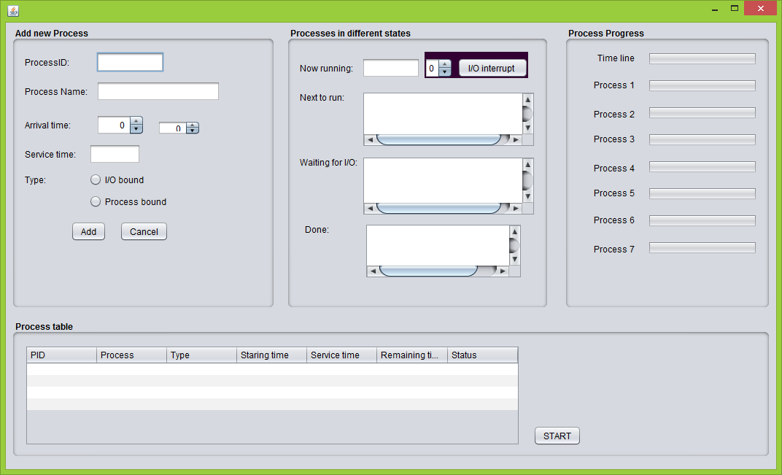

As you can see it contains 4 main sub parts in the GUI.First, you are allowed to add processes only.(Remaining panels will be inactive until then)

Here, though real world processes are so fast and may have very small service times, so that they will run and exit quickly , to enhance visualizing this scheduling algorithm we use a quite slow running of processes.

It is only after clicking start button, you will get chance to run processes. Then, processes in different states will be shown in the next box.

As process progress, we expect to show running of different processes during time slots by different colors and how each process proceeds by the progress bars. This will be helpful to show that this pre-emptive approach is too can be caused to starvation of long processes.

Talking about IO interrupts, when the running process is an IO bound process, the user is given the chance to make an IO interrupt. By default, we set the waiting time as 20 s, but you can change it too.

This, is what we are targeting to do as our scheduling algorithm and it is for a uni-processor scheduling.

What is inside:

We use Java language and Netbeans as the tool in this task.

We are going to create a process object by ourselves(not using thread class). Then, by several other classes headed by scheduler, these process objects are controlled. Priority queues, the knowledge on min-heaps, queues are to be used with waiting and ready queues.

Time class will be helpful in time management.

-END-